Forecasting Ontario Residential Building-Permit Values Using Explainable Time-Series and Machine-Learning Models
Interim Report
Debodip Gupta
Walsh College
QM640: Data Analytics Capstone
Mentor: [Insert Mentor Name]
Summer 2026 Term
July 30, 2026

GitHub Repository and Reproducibility Access
Public repository placeholder: https://github.com/REPLACE-WITH-USERNAME/ontario-building-permit-forecasting
The placeholder will be replaced with the final public URL before submission. The repository package accompanying this report contains the source manifest, data dictionary, reproducible Python modules, scripts, notebooks, unit tests, a GitHub Actions workflow, the schema-conformant dry-run dataset, preliminary output tables, and figures. Raw official data will be stored under data/raw when redistribution is permitted; otherwise, the repository will retain a scripted downloader, file hashes, and source URLs so that an evaluator can reproduce the acquisition process.

Interim Project Status (Progress Snapshot)
- Completed: scope and four research questions; official source verification; repository structure; data dictionary; sample-size logic; data-download and cleaning code; feature-engineering module; time-aware validation module; evaluation metrics; statistical comparison functions; unit tests; and end-to-end software dry run.
- In progress: final acquisition and frozen snapshot of the full Statistics Canada tables; category-label audit; construction of the official five-CMA analytic dataset; and documented cleaning counts from the official files.
- Pending: empirical rolling-origin model fitting on official data; final hyperparameter selection; robustness analysis using constant-dollar values; final explainability outputs; stakeholder recommendations; and final report synthesis.
Important interim evidence boundary. The numerical preliminary results in this report are generated from a schema-conformant synthetic dry-run dataset using a fixed random seed. They validate the code path, research design, metric calculations, model-comparison logic, figures, and reporting workflow. They are not empirical findings about Ontario building permits and will be replaced by results from the frozen government-data snapshot. This distinction is maintained to avoid presenting unverified software-test output as substantive evidence.

Introduction

Background and Context
Construction activity influences employment, municipal infrastructure, housing supply, financing, and demand for materials and professional services. Builders, suppliers, lenders, workforce planners, and government analysts therefore need indicators that provide a credible view of near-term construction intentions. Building permits are issued before most on-site activity begins and are consequently useful as a leading indicator. Statistics Canada identifies the monthly Building Permits Survey as an indicator of residential and non-residential construction activity and as an input to national investment and capital-stock measures (Statistics Canada, 2026b).
This project focuses on monthly residential building-permit values in five Ontario census metropolitan areas (CMAs): Toronto, Hamilton, Kitchener-Cambridge-Waterloo, London, and Windsor. The regional panel creates an operationally meaningful unit of analysis while providing more observations than a single provincial series. The primary source, Statistics Canada Table 34-10-0292-01, is monthly, begins in 2018, and supports selection by geography, seasonal adjustment, value type, structure, and type of work (Statistics Canada, 2026a). Ontario unemployment is drawn from Table 14-10-0287-01, while the target for the overnight rate is drawn from Bank of Canada series V39079 (Bank of Canada, n.d.; Statistics Canada, 2026c).
Forecasting this outcome is not trivial. Permit values can exhibit annual seasonality, serial dependence, gradual trend, regional scale differences, policy sensitivity, temporary disruptions, and large spikes caused by individual projects. A model that fits historical data closely can still fail when applied to future months. Forecasting research therefore emphasizes strong simple benchmarks, out-of-sample evaluation, time-aware resampling, and interpretable metrics (Bergmeir et al., 2018; Hyndman & Koehler, 2006; Makridakis et al., 2018; Tashman, 2000).
The project combines statistical analysis and machine learning within a governance-oriented decision framework. Seasonal-naive forecasting is treated as the control condition. Elastic net provides a transparent regularized regression benchmark, while random forest and extreme gradient boosting (XGBoost) test whether nonlinear interactions improve accuracy. Model selection is not based on novelty alone. The preferred approach must beat the benchmark, remain stable across regions, provide credible uncertainty information, and be sufficiently explainable for operational use.

Problem Statement
Public building-permit tables are primarily descriptive and do not directly provide reproducible, next-month regional forecasts, model comparisons, or explanations of forecast drivers. Planning based only on the latest observation or informal judgment can be distorted by seasonality, temporary shocks, and unusually large projects. The research problem is therefore to determine whether a transparent, reproducible framework using official monthly data can generate accurate one-month-ahead forecasts for selected Ontario CMAs, establish whether macroeconomic predictors add practical value, compare statistical and machine-learning models under time-aware validation, and identify where forecast uncertainty limits operational use.

Purpose of the Study
The purpose of this quantitative secondary-data study is to forecast next-month residential building-permit values, describe temporal patterns, test incremental predictive information from macroeconomic indicators, compare candidate model families, and explain the preferred model. The study is predictive rather than causal. It will not claim that interest rates or unemployment directly cause a particular permit outcome. Instead, it will evaluate whether variables available at the forecast origin improve out-of-sample prediction.

Current Deliverables
The repository currently contains a configurable source manifest, automated official-data download routines, cleaning functions that audit category labels and quality flags, leakage-resistant feature engineering, expanding-window validation, model pipelines, metric calculations, paired comparison tests, regional analysis, permutation importance, SHAP integration, sample-size calculations, and tests. Figure 1 summarizes the end-to-end research framework used to connect these components.
Figure 1
End-to-End Research Framework
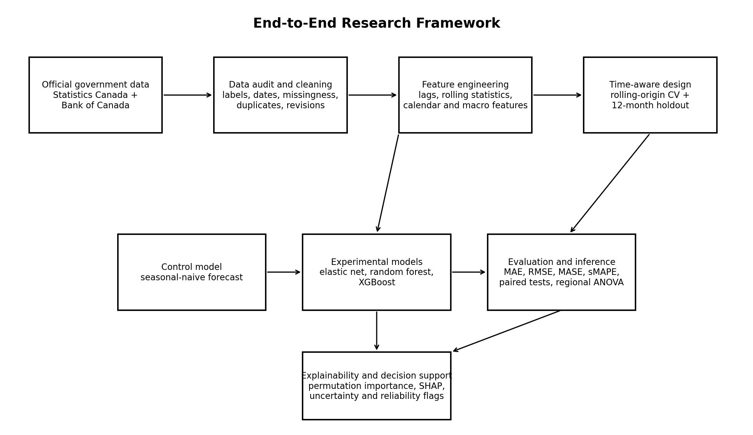
Note. The seasonal-naive model is the control. Experimental models are evaluated under the same chronological splits. No random k-fold cross-validation is used for the primary time-series comparison.

Scope and Objectives

Study Scope
The unit of analysis is one CMA-month. The planned period is January 2018 through the latest complete month available at the frozen interim extraction, with the synopsis planning window extending through May 2026. Five CMAs are included. After a 12-month lag requirement and a one-month target lead, the expected analytic dataset is approximately 440 to 445 observations, subject to source availability and valid category matches. The primary outcome is the next month's seasonally adjusted residential building-permit value in thousands of current Canadian dollars.
The primary predictors are current and lagged permit values; three-month rolling level and volatility; cyclical month encodings; time trend; CMA; a prespecified pandemic-disruption indicator; the prior-month target overnight rate; and the prior-month Ontario unemployment rate. The forecast horizon is one month. The main analysis uses total residential structures and total type of work to avoid fragmenting the data into small subgroup models. A constant-dollar sensitivity analysis is planned if the required series is consistently available.

Research Questions
RQ1: What trend, seasonal, persistence, volatility, and structural patterns characterize monthly residential building-permit values across the selected Ontario CMAs?
RQ2: Do the Bank of Canada target for the overnight rate and the Ontario unemployment rate provide statistically and practically significant incremental predictive information beyond permit history, seasonality, and CMA effects?
RQ3: Which candidate model produces the most accurate and stable one-month-ahead forecasts across time and regions?
RQ4: Which variables contribute most to the preferred model, and does forecast performance differ materially across the five CMAs?

Measurability, Ethics, and Feasibility
Every construct is measurable from public aggregated data or a documented transformation. No personally identifiable information, addresses, individual permit applicants, or protected administrative records are used. The project presents minimal privacy risk, although all Walsh College requirements for research review will be followed. Feasibility is supported by one primary outcome, three official sources, four capped model families, a one-month horizon, and a reproducible code base. The 10-week completion plan reserves the final two weeks for interpretation, writing, verification, and revision.

Literature Survey

Literature Review Approach
The focused literature search used combinations of the terms building permits, residential construction demand, construction forecasting, economic indicators, time-series cross-validation, forecast accuracy, random forest, gradient boosting, explainable machine learning, and predictive versus explanatory modeling. Priority was given to peer-reviewed journal articles, foundational methods papers, official government research, and sources that directly supported one or more research questions. Sources were included when they addressed construction or housing forecasting, time-aware validation, forecast metrics, statistical inference for dependent data, nonlinear ensemble methods, or model explainability. Purely descriptive industry commentary and studies without a transferable method were excluded.

Summary of Key Literature
Goh (1996). Compared artificial neural networks with multiple regression for residential construction demand using economic indicators. The nonlinear approach improved forecasting in the study setting. This supports including both a transparent linear benchmark and nonlinear alternatives for RQ2 and RQ3.
Goh (2000). Evaluated a hybrid neural-network and genetic-algorithm approach for construction-demand forecasting. The study shows that model tuning can improve results, but it also reinforces the need to control complexity and test on unseen periods. It informs the bounded tuning plan for RQ3.
Sing et al. (2015). Used a vector autoregression framework with economic indicators to forecast private-sector construction work. The article supports testing macroeconomic predictors and lag structures, directly informing RQ2.
Cheung and Granovsky (2016). Examined housing registrations as a leading indicator of economic activity in British Columbia. The government study supports the broader premise that pre-construction administrative measures can contain useful forward-looking information.
Coble and Pincheira (2017). Assessed whether timely external information could improve building-permit nowcasts. The study supports an incremental-value design in which exogenous predictors must improve a history-only benchmark rather than being assumed useful.

Summary of Key Literature (Continued)
Hyndman and Koehler (2006). Reviewed forecast-accuracy measures and proposed the mean absolute scaled error (MASE), which permits comparison across series and is interpretable relative to a naive benchmark. MASE is a primary metric for RQ3.
Tashman (2000). Reviewed out-of-sample forecasting tests and emphasized that accuracy must be evaluated on future-like observations. This supports the chronological holdout and rolling-origin design.
Bergmeir et al. (2018). Examined conditions under which cross-validation is valid for autoregressive forecasting. The paper reinforces the need to preserve temporal order and avoid random data splits that allow future information to leak backward.
Breiman (2001). Introduced random forests as an ensemble of decorrelated trees that can capture nonlinear relationships and interactions while providing variable-importance measures. It supports one nonlinear candidate for RQ3 and RQ4.
Chen and Guestrin (2016). Presented XGBoost as a scalable gradient-boosting system. Its regularized tree boosting can model nonlinear patterns in lagged and calendar features, making it an appropriate bounded-complexity candidate for RQ3.
Diebold and Mariano (1995). Developed a formal framework for comparing predictive accuracy. A Diebold-Mariano-style test is included as a sensitivity check when comparing paired forecast errors.
Lundberg and Lee (2017). Unified additive feature-attribution methods through SHAP. This supports explanation of global and local model behavior for RQ4.
Shmueli (2010). Distinguished explanatory modeling from prediction. The distinction supports cautious interpretation: macroeconomic variables are tested for predictive utility, not causal effects.

Literature Relevance Matrix
Table 1
Literature Relevance Matrix
Author | Domain | Dataset/Setting | Method | Key Finding | Project Link
Goh (1996) | Construction demand | Economic indicators | ANN; regression | Nonlinear model improved forecast | RQ2-RQ3 model comparison
Goh (2000) | Residential construction | Singapore sector | NN + genetic algorithm | Hybrid tuning reduced error | RQ3 bounded tuning
Sing et al. (2015) | Private construction | Macroeconomic series | VAR | Indicators supported forecasting | RQ2 macro features
Coble & Pincheira (2017) | Building permits | Permit nowcasting | Benchmark + external data | Timely predictors can add value | RQ2 incremental design
Hyndman & Koehler (2006) | Forecast evaluation | Multiple domains | Metric analysis | MASE supports scale-free comparison | RQ3 primary metric
Bergmeir et al. (2018) | Time-series validation | Autoregressive data | CV theory | Temporal dependence must be respected | All model validation
Breiman (2001) | Machine learning | General datasets | Random forest | Ensemble captures nonlinearities | RQ3-RQ4
Chen & Guestrin (2016) | Machine learning | Large/tabular data | Gradient boosting | Regularized boosted trees | RQ3-RQ4
Diebold & Mariano (1995) | Forecast inference | Paired errors | Accuracy test | Tests error-loss differences | RQ3 inference
Lundberg & Lee (2017) | Explainable AI | General ML | SHAP | Consistent feature attribution | RQ4 explanation

Thematic Synthesis
Three themes shape the research design. First, construction forecasting benefits from lagged economic and administrative indicators, but the added value of external predictors is context dependent. This justifies RQ2 as a nested comparison rather than an assumption that interest rates and unemployment must improve accuracy. Second, forecasting evidence must be generated out of sample. Random cross-validation would violate the operational order of the data, whereas expanding-window folds simulate repeated historical forecast origins. Third, complexity must earn its place. Tree ensembles are included because they can capture nonlinearities, but they will be rejected if they fail to improve the seasonal-naive control or if gains are unstable across CMAs.
The literature also supports a dual emphasis on predictive performance and responsible interpretation. MASE, MAE, RMSE, symmetric mean absolute percentage error (sMAPE), and weighted absolute percentage error (WAPE) measure different dimensions of error. Paired tests evaluate whether error differences are more than random variation, while regional analysis determines whether pooled gains conceal local harm. Permutation importance and SHAP are used to explain the selected model, but explanations are treated as descriptions of model behavior rather than causal effects.

Data Description

Data Sources and Access
The project uses three official public sources. Statistics Canada Table 34-10-0292-01 provides monthly building and demolition permit values by geography, seasonal adjustment and value type, structure, and type of work. Statistics Canada Table 14-10-0287-01 provides monthly labour-force characteristics, including the seasonally adjusted Ontario unemployment rate. Bank of Canada series V39079 provides the target for the overnight rate. The repository source manifest records landing pages, application programming interface (API) endpoints, planned filters, extraction dates, and cryptographic hashes for frozen raw files.
Table 2
Official Data Sources
Source | Variables | Coverage/Frequency | Public URL
Statistics Canada 34-10-0292-01 | Residential permit values; geography; adjustment/value type; structure; type of work | Monthly; 2018-present | https://doi.org/10.25318/3410029201-eng
Statistics Canada 14-10-0287-01 | Ontario unemployment rate, seasonally adjusted | Monthly | https://doi.org/10.25318/1410028701-eng
Bank of Canada V39079 | Target for the overnight rate | Daily; aggregated/lagged monthly | https://www.bankofcanada.ca/valet/observations/V39079/json

Dataset Overview
The planned official dataset contains approximately 101 source months per CMA before lag and target construction. With five CMAs, this corresponds to approximately 505 source rows. A 12-month lag and one-month-ahead target reduce the initial usable period by about 13 months, yielding approximately 440 observations. The exact count will be reported after the official data snapshot is frozen and any missing or suppressed observations are audited. The primary target is permit_value_t_plus_1, the within-CMA one-month lead of the seasonally adjusted residential permit value.
The dry-run dataset mirrors the expected schema and contains 440 modeling rows, 88 per CMA, and the same feature names planned for official analysis. It is stored in data/demo and is deliberately separated from data/raw and data/processed. Figure 2 displays a small preview and includes an explicit warning that the values are synthetic.
Figure 2
Schema-Conformant Dry-Run Dataset Preview
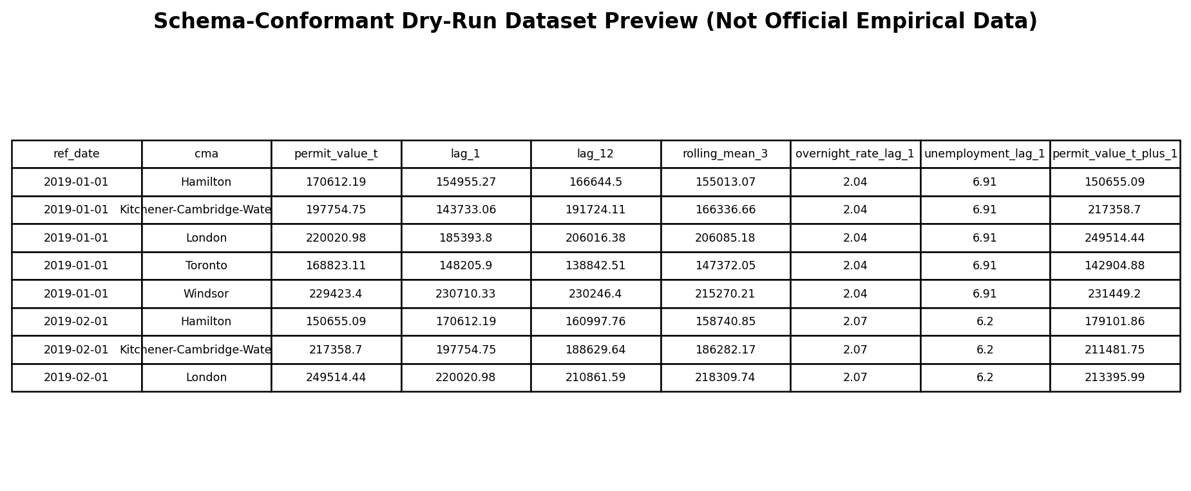
Note. This figure is software-validation evidence only. Values are generated with a fixed random seed and must not be interpreted as Ontario permit statistics.

Data Dictionary
Table 3
Mandatory Data Dictionary
Variable | Definition | Datatype | Range | Missing-Value Handling | Role
ref_date | Reference month | Date | 2018-01 onward | Must form monthly sequence | Key
cma | Selected census metropolitan area | Categorical | Five named CMAs | No imputation; unmatched labels rejected | Grouping/predictor
permit_value_t | Residential permit value at month t | Continuous; $000s | Nonnegative | Source missing values retained for audit | History predictor
permit_value_t_plus_1 | Next-month permit value | Continuous; $000s | Nonnegative | Rows without future target removed | Target
lag_1 / lag_3 / lag_6 / lag_12 | Prior within-CMA values | Continuous; $000s | Nonnegative | Created after sorting by CMA/date | Predictor
rolling_mean_3 | Mean of prior three months | Continuous; $000s | Nonnegative | Uses only prior observations | Predictor
rolling_sd_3 | SD of prior three months | Continuous | Nonnegative | Uses only prior observations | Predictor
month_sin / month_cos | Cyclical month encoding | Continuous | -1 to 1 | Complete from date | Predictor
time_index | Elapsed months from start | Integer | 0 and above | Complete from date | Trend predictor
pandemic_indicator | Prespecified disruption period | Binary | 0 or 1 | Complete from date | Sensitivity predictor
overnight_rate_lag_1 | Prior-month policy rate | Percent | Observed range | Forward fill only within source rules | Macro predictor
unemployment_lag_1 | Prior-month Ontario unemployment | Percent | Observed range | No future values used | Macro predictor
seasonal_naive_pred | Value from t-12 | Continuous; $000s | Nonnegative | Requires 12-month history | Control prediction

GitHub Data Availability Statement
Raw data: data/raw/. Processed official data: data/processed/modeling_dataset.csv. Dry-run software-test data: data/demo/synthetic_modeling_dataset.csv. Code: src/capstone/ and scripts/. Notebooks: notebooks/. Figures and tables: outputs/. Documentation: docs/. The repository README distinguishes official empirical data from synthetic software-test data and provides exact execution commands. Figure 3 shows the repository organization planned for evaluator access.

Research Design and Methodology

Overall Design
The study uses a quantitative, longitudinal, predictive research design with secondary public data. The experimental unit is a CMA-month, and prediction is evaluated chronologically. The seasonal-naive model functions as the control condition because it predicts the next value using the value from the same month of the previous year. Elastic net, random forest, and XGBoost function as experimental alternatives. Every model receives features that would have been available at the forecast origin and is evaluated on identical future periods.

Technique Selection
The outcome is continuous, so regression and time-series forecasting techniques are appropriate. Elastic net is selected as the principal linear model because regularization reduces instability when lagged and rolling predictors are correlated. A single decision tree is not used as a primary candidate because it is sensitive to noise and can produce unstable forecasts; instead, random forest averages many trees to reduce variance. XGBoost is included as a regularized boosting method that can learn nonlinearities and interactions. A neural network is excluded from the primary comparison because the expected sample contains fewer than 500 observations and a larger architecture would create unnecessary overfitting and interpretability risk.

Statistical Methods
Descriptive statistics include mean, median, standard deviation, interquartile range, coefficient of variation, minima, maxima, autocorrelation, and visual inspection of time and seasonal profiles. Inferential analysis includes heteroskedasticity and autocorrelation consistent regression for RQ1, nested predictive comparisons for RQ2, paired forecast-error tests for RQ3, and analysis of variance on absolute errors for RQ4. Ninety-five percent confidence intervals will be reported where estimable. Statistical significance is evaluated at alpha = .05, but practical thresholds and effect sizes are emphasized so that small numerical differences are not overstated.
Regression diagnostics include residual-versus-fitted plots, quantile-quantile plots, autocorrelation of residuals, and variance inflation factors (VIFs). A VIF above 10 is treated as a strong multicollinearity warning, while values above 5 prompt review. Adjusted R-squared, Akaike information criterion, and Bayesian information criterion may be reported for explanatory regression models; however, they do not replace out-of-sample forecast metrics for predictive model selection.

Data Collection and Preparation

Collection Procedure
The official tables are acquired through documented Statistics Canada download endpoints and the Bank of Canada Valet API. Each raw file is saved without manual editing. The pipeline records the source URL, extraction timestamp, file size, and SHA-256 hash. A frozen snapshot prevents later revisions from changing the reported analysis without detection. Category labels are inspected before filtering because official terminology can change over time. The pipeline fails visibly when required labels cannot be resolved rather than silently selecting a similar category.

Preprocessing Procedures
Dates are converted to first-of-month timestamps and sorted within CMA. Duplicate CMA-month keys are rejected unless an explicit aggregation rule is documented. Numeric values are parsed after source-status symbols are separated. Missing target values are not imputed. Predictor missingness created by lags is expected and those leading rows are removed after feature construction. Unexpected internal gaps are reported and investigated. Median imputation is available inside model pipelines only for isolated numeric predictor missingness, while one-hot encoding is used for CMA. Elastic net numeric features are standardized; tree models do not require scaling but use the same imputation and categorical encoding framework for consistency.
Outliers are not automatically deleted because a very large project may be a genuine and decision-relevant permit event. Detection uses robust z-scores, interquartile-range flags, and time-series plots. The primary analysis retains valid values and uses robust error metrics. Sensitivity analyses will evaluate log1p transformation, winsorization only when justified, and constant-dollar values. All transformations are fitted using training data only to prevent leakage.
Table 4
Data Cleaning Log and Decision Rules
Issue | Variables | Detection | Treatment | Rationale
Missing values | Targets and predictors | Null counts by variable/date/CMA | Remove unavailable targets; pipeline imputation for isolated predictors | Avoid inventing outcomes; preserve reproducibility
Duplicates | CMA-month key | Duplicate-key assertion | Reject or aggregate only with documented source reason | Prevents double counting
Outliers | Permit values | Robust z-score; IQR; plots | Retain valid events; sensitivity transforms | Large projects may be real signals
Category drift | Source dimensions | Exact/token label audit | Fail and require documented mapping | Prevents silent misclassification
Temporal leakage | Lags, scaling, tuning | Date-order tests | Within-CMA shifts; train-only fitting; chronological folds | Protects out-of-sample validity

Current Cleaning Status
Cleaning functions and automated tests are complete. The software dry run confirmed that the target lead, lag features, seasonal-naive forecast, and chronological ordering behave as intended. Official-data cleaning counts remain pending until the full frozen files are downloaded and the final category filters are verified. This status is reported explicitly rather than substituting dry-run counts for official-data counts.

Exploratory Data Analysis

EDA Strategy
Exploratory data analysis (EDA) is organized around RQ1 and the requirements of model design. Time plots assess trend, disruptions, and regional scale. Monthly seasonal profiles assess whether the same calendar pattern recurs. Autocorrelation at lags 1 and 12 assesses short-term persistence and annual seasonality. Coefficients of variation compare volatility relative to each regional mean. Distribution plots and robust outlier flags identify unusually large observations without presuming they are errors.
Figure 4
Dry-Run Monthly Permit-Value Paths by CMA
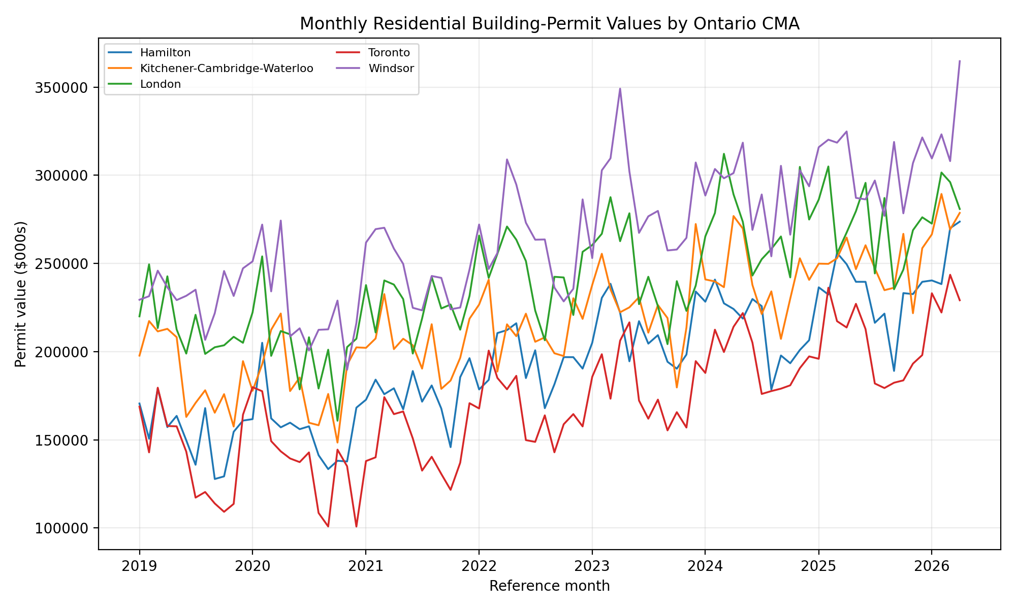
Note. Synthetic software-validation output. The figure demonstrates that the plotting and grouping pipeline can represent trend, seasonality, regional levels, and disruption periods; it is not evidence about actual Ontario values.
As shown in Figure 4, the dry-run generator creates five regionally distinct series with a common upward trend, seasonal movement, and a temporary disruption. This is a useful software test because it verifies that the EDA code detects expected temporal structure and maintains region identity. In official analysis, the same graph will be interpreted only after source values and units are validated. The key decision supported by this figure is whether pooled modeling requires CMA indicators, region-specific scaling, and sensitivity to structural breaks.

EDA Results and Interpretation
Figure 5
Dry-Run Seasonal Profile by Calendar Month
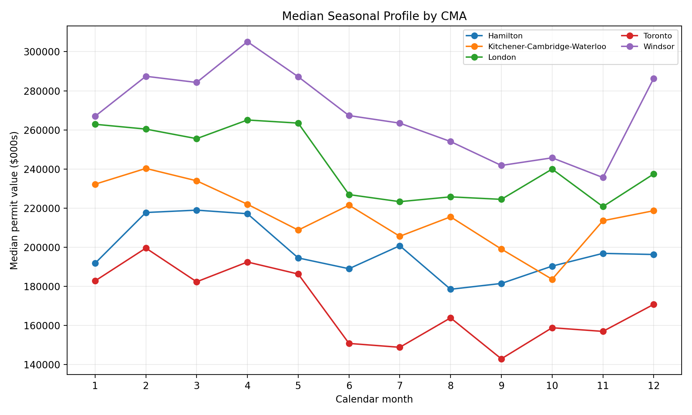
Note. Synthetic software-validation output. The recurring monthly pattern is intentionally generated to test seasonal aggregation and the annual benchmark.
Figure 5 confirms that the monthly grouping logic and cyclical feature construction reproduce a seasonal profile in the dry run. This validates the decision to include month_sin, month_cos, and a 12-month seasonal-naive control. It does not establish that the official series follows the same shape. The official analysis will compare the magnitude and consistency of monthly patterns by CMA and will determine whether seasonality changes after the pandemic-disruption period.
Table 5
Dry-Run EDA Summary (Software Validation Only)
CMA | N | Mean | SD | CV | ACF(1) | ACF(12)
Hamilton | 88 | 194,122 | 34,500 | 0.178 | 0.814 | 0.553
Kitchener-Cambridge-Waterloo | 88 | 217,828 | 31,773 | 0.146 | 0.738 | 0.522
London | 88 | 241,787 | 32,701 | 0.135 | 0.684 | 0.514
Toronto | 88 | 170,156 | 33,426 | 0.196 | 0.803 | 0.575
Windsor | 88 | 266,898 | 37,209 | 0.139 | 0.714 | 0.603

The dry-run autocorrelations are positive at both lags, which is expected from the generator and demonstrates that the persistence calculations work. The coefficient of variation differs across CMAs, confirming that pooled errors should not be interpreted without regional metrics. For the official dataset, the analysis will add median, interquartile range, change rates, missingness, and potential-break diagnostics. The modeling decision is to retain both scale-dependent metrics, such as MAE, and scaled/percentage metrics, such as MASE, sMAPE, and WAPE.

Modeling

Choice of Models With Justification
Seasonal-naive. Control model; transparent; strong benchmark for monthly seasonal data. A candidate must demonstrate value beyond this forecast.
Elastic net regression. Interpretable regularized linear baseline. It handles correlated lags and permits a clean history-only versus macro-augmented comparison for RQ2.
Random forest regression. Nonlinear ensemble that captures interactions and is less unstable than a single decision tree. Permutation importance supports interpretation.
XGBoost regression. Regularized gradient boosting that can learn nonlinear effects and interaction patterns with a bounded grid and early complexity control.

Feature Set and Engineering
Table 6
Feature Set and Usage
Feature | Origin | Type | Reason for Inclusion | Used In
permit_value_t | Original | Continuous | Most recent observed level | All fitted models
lag_1, lag_3, lag_6, lag_12 | Engineered | Continuous | Persistence and annual history | All fitted models
rolling_mean_3, rolling_sd_3 | Engineered | Continuous | Recent level and volatility | All fitted models
month_sin, month_cos | Engineered | Continuous | Cyclical seasonality without ordinal month distortion | All fitted models
time_index | Engineered | Integer | Long-run trend | All fitted models
pandemic_indicator | Engineered | Binary | Prespecified structural disruption sensitivity | All fitted models
overnight_rate_lag_1 | Engineered from official series | Continuous | Policy/financing environment known at origin | Macro models
unemployment_lag_1 | Engineered from official series | Continuous | Provincial labour-market condition | Macro models
cma | Original | Categorical | Regional level and pattern differences | All fitted models

Hyperparameter and Overfitting Controls
The parameter grids are intentionally small. Elastic net varies penalty strength and lasso-ridge mixture. Random forest varies depth and minimum leaf size. XGBoost varies tree count and depth while holding conservative learning and subsampling rates. Tuning uses expanding-window cross-validation within the training period. The final 12 months remain untouched until all candidate settings are selected. This design prevents the holdout from becoming an informal tuning set.

Evaluation Metrics and Experimental Comparisons
Table 7
Regression Evaluation Metrics and Formulae
Metric | Formula | Interpretation
MAE | $MAE = (1/n) \u2211 |y_i - \u0177_i|$ | Average absolute error in $000s; directly interpretable.
RMSE | $RMSE = \u221a[(1/n) \u2211 (y_i - \u0177_i)^2]$ | Penalizes large errors more strongly than MAE.
MASE | $MASE = MAE / [(1/(n-m)) \u2211 |y_t-y_{t-m}|]$ | Error relative to seasonal-naive scale; below 1 is desirable.
sMAPE | $sMAPE = (100/n) \u2211 [2|y_i-\u0177_i|/(|y_i|+|\u0177_i|)]$ | Scale-free percentage error with symmetric denominator.
WAPE | $WAPE = 100 \u00d7 \u2211|y_i-\u0177_i|/\u2211|y_i|$ | Absolute error as a percentage of total actual value.
Interval coverage | $Coverage = (1/n) \u2211 I(L_i \u2264 y_i \u2264 U_i)$ | Share of actual outcomes contained in prediction intervals.

For example, if actual values are 100, 120, and 140 and forecasts are 110, 115, and 150, the absolute errors are 10, 5, and 10. MAE is (10 + 5 + 10) / 3 = 8.33. RMSE is the square root of (100 + 25 + 100) / 3 = 8.66. These formulas are implemented in unit-tested functions and calculated on identical holdout rows for every model.

Statistical Comparison Plan
RQ1 uses descriptive statistics, autocorrelation, and a Newey-West heteroskedasticity and autocorrelation consistent regression. RQ2 compares absolute errors from history-only and macro-augmented elastic net models; macro variables are judged useful only when pooled MAE improves by at least 5% and regional stability is acceptable. RQ3 uses paired t tests, Wilcoxon signed-rank tests, and a Diebold-Mariano-style loss-differential test as complementary evidence. RQ4 compares absolute-error distributions across CMAs using one-way analysis of variance, with a nonparametric sensitivity test planned if assumptions are weak. Confidence intervals and effect sizes accompany p values where possible.

Experiment Design and Reproducibility
The seasonal-naive forecast is the control and all other models are experimental conditions evaluated on the same observations. Expanding-window folds preserve temporal order. Preprocessing, imputation, scaling, and one-hot encoding are fitted inside each training fold. The final holdout comprises 12 target months across five CMAs, producing 60 paired forecasts. Random seeds, package versions, configuration files, source hashes, and output manifests are recorded. Continuous integration runs unit tests on every repository update.

Preliminary Findings

RQ1: Temporal and Regional Structure
Completed work includes code for summary statistics, persistence at lags 1 and 12, seasonal profiles, trend plots, and a pooled regression with Newey-West standard errors. In the dry run, lag-1 autocorrelation ranges from .684 to .814 and lag-12 autocorrelation ranges from .514 to .603. The generated month_sin term is statistically detectable, while the current-value coefficient is not significant at alpha = .05 after the synthetic trend, seasonal terms, and CMA indicators are included. These values confirm that the statistical procedures recover known structure from the generator; they do not answer RQ1 for official data.
What remains is to run the same workflow on the frozen official series, inspect breaks and revisions, report robust descriptive statistics, and determine whether annual seasonality and short-term persistence are consistently present across CMAs. The official RQ1 conclusion will be based on actual effect sizes, uncertainty, plots, and residual diagnostics rather than on the dry-run output.

RQ2: Incremental Value of Macroeconomic Predictors
The nested model architecture is complete. The history-only and macro-augmented elastic net models use identical temporal folds, preprocessing, and tuning ranges, with the only difference being prior-month overnight-rate and unemployment features. In the dry run, the two elastic-net variants produce identical holdout MAE of 20,272.91 because the synthetic target generator does not use the macro variables. The measured improvement is therefore 0%, below the prespecified 5% practical threshold.
This is a desirable software-validation result: it shows that the analysis does not manufacture improvement when the added variables contain no designed signal. On official data, RQ2 will require both practical and statistical evidence. A small p value without at least 5% MAE improvement will not be described as operationally meaningful, and a pooled improvement that causes substantial degradation in several CMAs will not be accepted.
Table 8
Dry-Run RQ2 Incremental-Value Test
N | History MAE | Macro MAE | Improvement | Threshold Met
60 | 20,272.91 | 20,272.91 | 0.0% | No

RQ3: Preliminary Model Performance
Table 9
Dry-Run Preliminary Model Performance (Software Validation Only)
Model | N | MAE | RMSE | MASE | sMAPE | WAPE
Xgboost | 60 | 13,975.87 | 17,836.17 | 0.651 | 5.46% | 5.45%
Random Forest | 60 | 14,468.68 | 18,659.80 | 0.671 | 5.65% | 5.64%
Seasonal Naive | 60 | 17,944.44 | 22,183.45 | 0.848 | 7.21% | 6.99%
Elastic Net History | 60 | 20,272.91 | 25,113.95 | 0.940 | 7.94% | 7.90%
Elastic Net Macro | 60 | 20,272.91 | 25,113.95 | 0.940 | 7.94% | 7.90%

The dry-run comparison selects XGBoost, with MAE of 13,975.87 and MASE of .651, compared with seasonal-naive MAE of 17,944.44 and MASE of .848. The dry-run reduction in MAE is 22.1%. The paired absolute-error t test yields p = .019, the Wilcoxon test yields p = .041, and the Diebold-Mariano-style test yields p < .001. Random forest also improves on the control by 19.4%, although its paired t-test result is marginal at p = .063. Elastic net performs worse than seasonal naive in the dry run.
These results demonstrate that the code can fit all candidate pipelines, preserve common holdout rows, calculate multiple metrics, execute paired comparisons, and apply the prespecified selection rule. They do not establish that XGBoost will be preferred on official data. The final selection rule requires MASE below 1, lower pooled MAE than seasonal naive, no material degradation in three or more CMAs, and reproducible execution. If no candidate passes, the seasonal-naive control will be retained and the negative result reported.

Prediction Intervals
A split-conformal procedure is implemented to provide a 90% prediction interval around the selected model. In the dry run, the conformal radius is 30,795.28 and empirical holdout coverage is 86.7%, slightly below the nominal 90% target. The result correctly signals that interval calibration must be assessed rather than assumed. Final intervals will be recalibrated on official training residuals and reported with coverage and average width by CMA.

RQ4: Explainability and Regional Reliability
Figure 6
Dry-Run Permutation Importance for the Selected Model
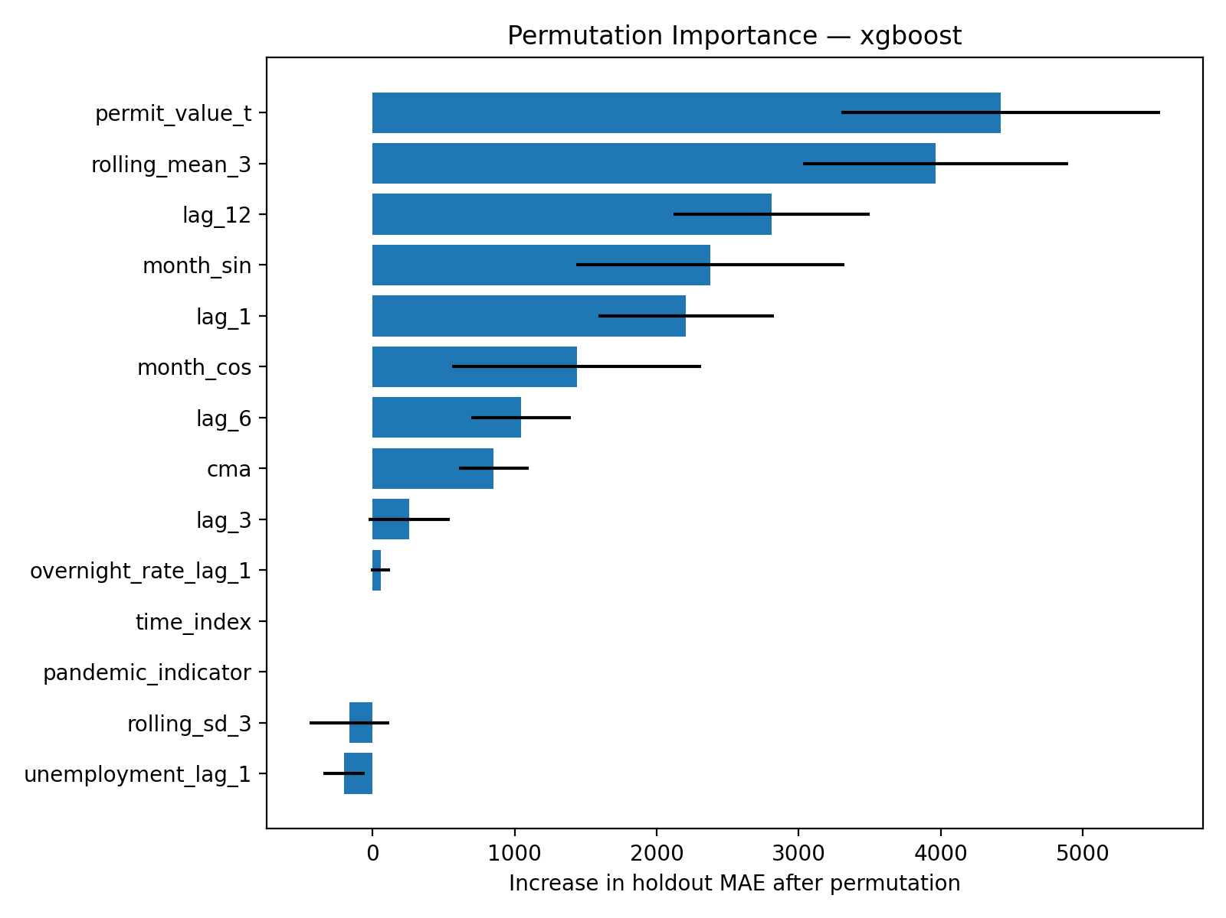
Note. Synthetic software-validation output. Positive values show the increase in holdout MAE after a feature is permuted. The ranking describes the dry-run model, not the Ontario economy.
Figure 6 indicates that current permit value, the three-month rolling mean, the 12-month lag, calendar seasonality, and the one-month lag are the strongest dry-run predictors. This ranking is consistent with the known generator and confirms that the explainability pipeline can recover designed temporal structure. The macro variables have near-zero or negative permutation importance because they were not used to generate the synthetic target. Negative permutation values are interpreted as sampling noise or an unhelpful feature, not as evidence of a beneficial inverse causal effect.
Table 10
Dry-Run XGBoost Regional Reliability
CMA | N | MAE | RMSE | MASE | WAPE
Hamilton | 12 | 13,847.07 | 15,694.68 | 0.716 | 5.83%
Kitchener-Cambridge-Waterloo | 12 | 13,510.48 | 17,494.65 | 0.674 | 5.25%
London | 12 | 16,868.54 | 19,033.86 | 0.729 | 6.13%
Toronto | 12 | 9,375.33 | 10,916.79 | 0.459 | 4.57%
Windsor | 12 | 16,277.91 | 23,596.49 | 0.676 | 5.29%

Dry-run MASE remains below 1 in every CMA, ranging from .459 in Toronto to .729 in London. The one-way analysis of variance on absolute XGBoost errors yields F = 0.833, p = .510, which does not indicate a regional mean-error difference in the dry run. The official analysis will supplement this test with confidence intervals, a robust/nonparametric sensitivity analysis, interval coverage by CMA, and direct comparison with each region's seasonal-naive error. Regional reliability flags will be used even when pooled performance is favorable.
SHAP computation has also been validated and produces both global and observation-level explanations. Final interpretation will compare SHAP and permutation rankings, investigate discrepancies, and avoid causal language. Explanations will be reported only for the accepted model and will be accompanied by a statement that feature attribution describes how the model uses correlated inputs, not how policy interventions would change permit activity.

Interim Limitations and Risks
Official-data acquisition and revision risk. Full-table files are large and historical values may be revised. Mitigation: frozen snapshot, extraction timestamp, source hashes, and revision note.
Category-label mismatch. Exact labels can change or differ from the planned candidates. Mitigation: inspect unique labels, use auditable token matching, and fail when ambiguity remains.
Short time history. The current table begins in 2018, limiting pre-pandemic history. Mitigation: pooled CMA-month design, simple model set, time-aware validation, and cautious generalization.
Outlier sensitivity. Large legitimate projects may dominate value-based errors. Mitigation: MAE/MASE/WAPE, robust plots, log sensitivity, and no automatic deletion.
Temporal dependence. Ordinary independence assumptions may be invalid. Mitigation: chronological validation, Newey-West standard errors, and paired forecast comparisons.
Common macro series across CMAs. Interest rate and provincial unemployment vary over time but not across CMAs within a month. Mitigation: interpret them as temporal predictors, not regional causal drivers.
Synthetic interim outputs. Dry-run results could be misread as findings. Mitigation: explicit labels in text, tables, figures, filenames, README, and repository paths.

Next Steps for the Final Report
- Download and freeze the complete official source files; record SHA-256 hashes and extraction metadata.
- Run source-label audit and finalize filters for seasonal adjustment, current dollars, total residential structures, total work, and five CMAs.
- Produce the official data-cleaning log with row counts, missingness percentages, duplicate counts, category exclusions, and outlier flags.
- Complete official RQ1 EDA and diagnostics, including residual checks, VIF, structural-break sensitivity, and region-specific plots.
- Fit all models under expanding-window validation; tune only within training data; evaluate the untouched 12-month holdout.
- Complete RQ2 practical-threshold testing, RQ3 paired comparisons, and RQ4 regional reliability and explainability.
- Replace every dry-run table and figure in the final report with official empirical output.
- Finalize recommendations, limitations, APA 7 review, reproducibility test, and repository publication.

10-Week Completion Control
The remaining work aligns with the capstone schedule: official cleaning and EDA, baseline modeling, nonlinear modeling, validation and explanation, recommendations and full drafting, then final reproduction and APA review. The code-first approach reduces schedule risk because tables and figures are regenerated from configuration rather than manually copied. A negative empirical result remains acceptable if the benchmark cannot be improved, provided the finding is rigorously validated and clearly interpreted.

Recommendation and Application

Target Users
Primary users are municipal and provincial economic-development analysts, builders and developers, building-material suppliers, construction workforce planners, lenders, and industry associations. The proposed output is a monthly regional scorecard containing the next-month forecast, uncertainty interval, recent trend, benchmark comparison, leading model drivers, and a reliability label. The tool is designed to support planning and discussion rather than automate investment, lending, hiring, or policy decisions.
Table 11
Target Users, Decisions, and Benefits
End User | Decision Supported | Expected Benefit
Municipal/provincial analysts | Monitor regional construction intentions and investigate turning points | Earlier reproducible signal with uncertainty
Builders/developers | Compare internal pipeline expectations with public regional evidence | Structured scenario and timing discussions
Material suppliers | Plan inventory and distribution by region | Reduce purely reactive overstock/stock-out risk
Workforce planners/colleges | Discuss hiring, apprenticeship, and training capacity | Identify possible near-term regional pressure
Lenders/risk teams | Add transparent external market context | Portfolio monitoring without individual borrower inference

Conditional Recommendation Logic
The final recommendation is conditional on empirical evidence. If a nonlinear model achieves a meaningful and stable reduction in MASE and MAE, the project will recommend a monitored forecasting tool with region-specific reliability flags and scheduled recalibration. If elastic net performs similarly, the simpler model will be preferred because it is easier to audit and explain. If no candidate consistently beats seasonal naive, the control will be retained and the report will identify what additional data or longer history may be required. This rule prevents the project from treating machine learning as the desired answer regardless of evidence.
Users will be warned that permit value measures construction intentions rather than completed construction, housing units delivered, affordability, or future prices. Large projects can produce spikes, permits can be revised, and relationships can change. Recommended governance includes monthly data refresh, annual model review, source-revision checks, performance monitoring by CMA, interval-coverage monitoring, and a human review before consequential decisions. The principal doctoral contribution is therefore a reproducible and explainable decision framework, not only a forecast leaderboard.

References
Bank of Canada. (n.d.). Valet API: How-to guide. Retrieved July 30, 2026, from https://www.bankofcanada.ca/valet-api-how-to/
Bergmeir, C., Hyndman, R. J., & Koo, B. (2018). A note on the validity of cross-validation for evaluating autoregressive time series prediction. Computational Statistics & Data Analysis, 120, 70-83. https://doi.org/10.1016/j.csda.2017.11.003
Breiman, L. (2001). Random forests. Machine Learning, 45(1), 5-32. https://doi.org/10.1023/A:1010933404324
Chen, T., & Guestrin, C. (2016). XGBoost: A scalable tree boosting system. In Proceedings of the 22nd ACM SIGKDD International Conference on Knowledge Discovery and Data Mining (pp. 785-794). Association for Computing Machinery. https://doi.org/10.1145/2939672.2939785
Cheung, C., & Granovsky, D. (2016). New housing registrations as a leading indicator of the BC economy (Staff Discussion Paper 2016-3). Bank of Canada. https://www.bankofcanada.ca/wp-content/uploads/2016/02/sdp2016-3.pdf
Coble, D., & Pincheira, P. (2017). Nowcasting building permits with Google Trends (MPRA Paper No. 76514). Munich Personal RePEc Archive. https://mpra.ub.uni-muenchen.de/76514/
Diebold, F. X., & Mariano, R. S. (1995). Comparing predictive accuracy. Journal of Business & Economic Statistics, 13(3), 253-263. https://doi.org/10.1080/07350015.1995.10524599
Friedman, J. H. (2001). Greedy function approximation: A gradient boosting machine. The Annals of Statistics, 29(5), 1189-1232. https://doi.org/10.1214/aos/1013203451
Goh, B. H. (1996). Residential construction demand forecasting using economic indicators: A comparative study of artificial neural networks and multiple regression. Construction Management and Economics, 14(1), 25-34. https://doi.org/10.1080/01446199600000004
Goh, B. H. (2000). Evaluating the performance of combining neural networks and genetic algorithms to forecast construction demand: The case of the Singapore residential sector. Construction Management and Economics, 18(2), 209-217. https://doi.org/10.1080/014461900370834
Hyndman, R. J., & Koehler, A. B. (2006). Another look at measures of forecast accuracy. International Journal of Forecasting, 22(4), 679-688. https://doi.org/10.1016/j.ijforecast.2006.03.001
Lundberg, S. M., & Lee, S.-I. (2017). A unified approach to interpreting model predictions. Advances in Neural Information Processing Systems, 30, 4765-4774.
Makridakis, S., Spiliotis, E., & Assimakopoulos, V. (2018). The M4 Competition: Results, findings, conclusion and way forward. International Journal of Forecasting, 34(4), 802-808. https://doi.org/10.1016/j.ijforecast.2018.06.001
Newey, W. K., & West, K. D. (1987). A simple, positive semi-definite, heteroskedasticity and autocorrelation consistent covariance matrix. Econometrica, 55(3), 703-708. https://doi.org/10.2307/1913610
Shmueli, G. (2010). To explain or to predict? Statistical Science, 25(3), 289-310. https://doi.org/10.1214/10-STS330
Sing, M. C. P., Edwards, D. J., Liu, H. J., & Love, P. E. D. (2015). Forecasting private-sector construction works: VAR model using economic indicators. Journal of Construction Engineering and Management, 141(11), 04015037. https://doi.org/10.1061/(ASCE)CO.1943-7862.0001016
Statistics Canada. (2026a). Building permits, by type of structure and type of work (Table 34-10-0292-01). https://doi.org/10.25318/3410029201-eng
Statistics Canada. (2026b). Building Permits Survey (Record No. 2802). https://www23.statcan.gc.ca/imdb/p2SV.pl?Function=getSurvey&Id=1584733
Statistics Canada. (2026c). Labour force characteristics, monthly, seasonally adjusted and trend-cycle (Table 14-10-0287-01). https://doi.org/10.25318/1410028701-eng
Tashman, L. J. (2000). Out-of-sample tests of forecasting accuracy: An analysis and review. International Journal of Forecasting, 16(4), 437-450. https://doi.org/10.1016/S0169-2070(00)00065-0

Appendix A

Research Framework and Repository Evidence
Appendix A is referenced in the Current Deliverables and GitHub Data Availability sections. Figure A1 restates the research framework, while Figure A2 displays the repository tree. These artifacts demonstrate how the proposed design is implemented as a reproducible sequence rather than as disconnected notebooks.
Figure A1
Research Framework
Note. All preprocessing and tuning are confined to training data. The final holdout is evaluated once.
Figure A2
Repository Structure
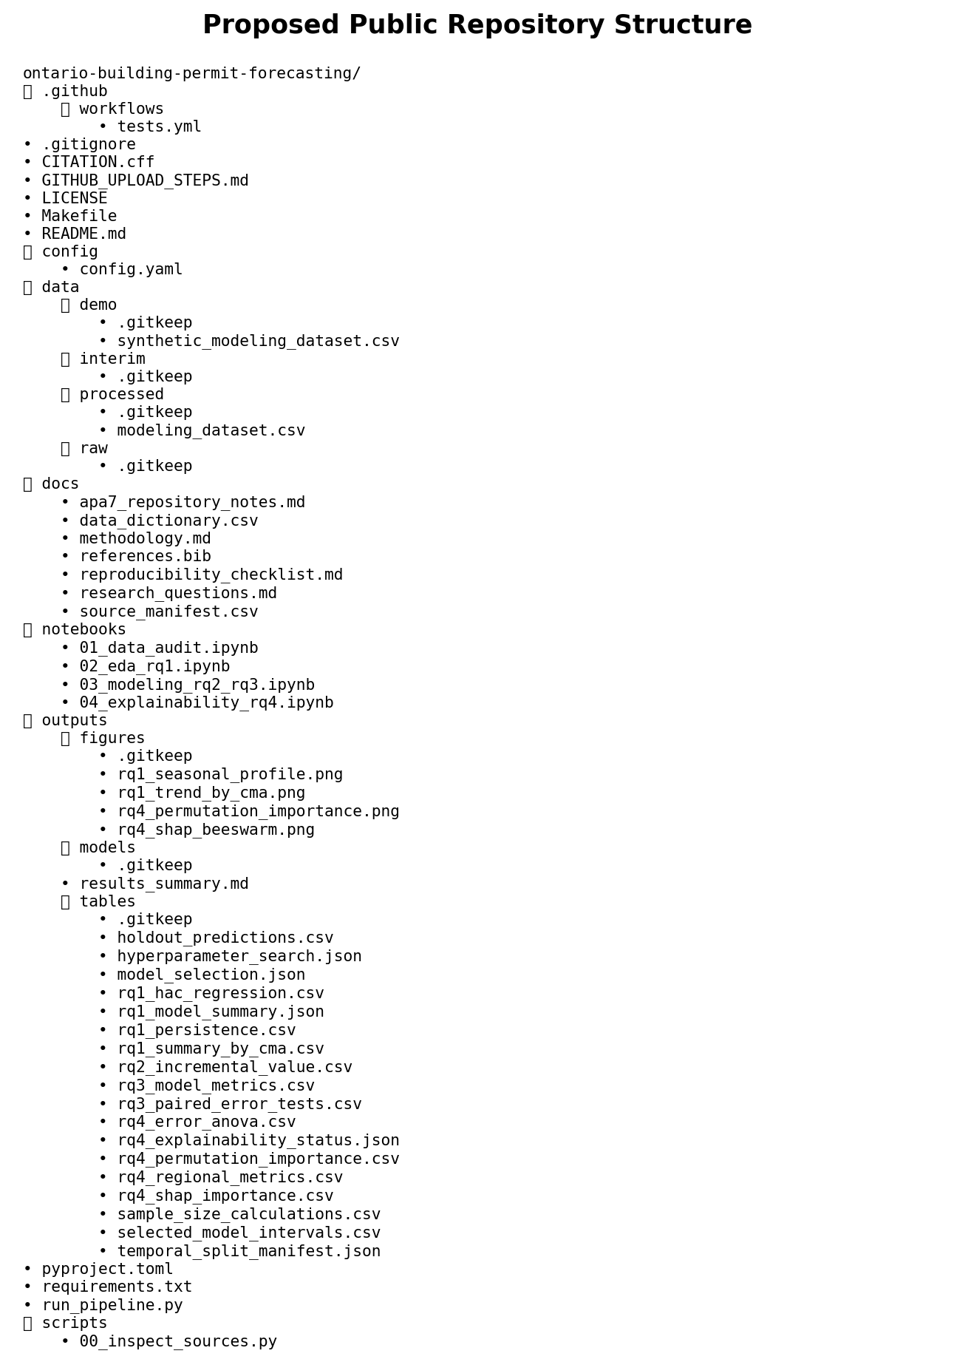
Note. Model binaries are not required for evaluator reproduction because they can be regenerated from code and configuration.

Appendix B

Sample-Size Assumptions and Decision Rules
The synopsis specified separate calculations for each research question. RQ1 uses a two-sided correlation test with alpha = .05, power = .80, and expected r = .30, producing a minimum of 85 observations. RQ2 uses a multiple-regression F test with alpha = .05, power = .80, f-squared = .15, and 10 tested predictors, producing 118 observations. RQ3 uses a paired-error comparison with alpha = .05, power = .80, and standardized paired effect d = .35, producing 67 paired forecasts. RQ4 uses one-way analysis of variance with alpha = .05, power = .80, Cohen f = .25, and five CMA groups, producing 196 total observations. The maximum minimum is therefore 196, below the planned official analytic sample of approximately 440 observations.
Table B1
Sample-Size Calculations
RQ | Method | Parameters | Minimum N
RQ1 | Correlation/Fisher z | alpha=.05; power=.80; r=.30 | 85
RQ2 | Multiple regression F test | alpha=.05; power=.80; f2=.15; 10 predictors | 118
RQ3 | Paired error test | alpha=.05; power=.80; d=.35 | 67 paired forecasts
RQ4 | One-way ANOVA | alpha=.05; power=.80; f=.25; 5 groups | 196 total

Primary Decision Rules
- Select the simplest model that achieves pooled MASE below 1.0, lower MAE than seasonal naive, acceptable regional stability, and reproducible execution.
- Conclude that macroeconomic predictors add practical value only when pooled rolling-origin MAE improves by at least 5% and the gain is not driven by harmful regional instability.
- Do not interpret feature importance, SHAP values, regression coefficients, or macro predictors as causal effects.
- Replace all dry-run evidence with official empirical outputs before the final report and preserve the dry-run only as software testing documentation.

