General Information

Group One – Members are officials and general employees including clerical, administrative and technical workers, laborers, mechanics, and all others not otherwise classified.

Group Two – Members in this group include probation officers, court officers, certain correctional positions whose major duties require them to have the care, custody, instruction or supervision of prisoners, and certain positions who provide direct care, custody, instruction or supervision of persons with mental illness or developmental disabilities.

Group Three – Members are exclusively State Police officers.

Group Four – Members include certain public safety officers and officials, correction officers and certain other correction positions, and parole officers or parole supervisors.

Generally, in order for the current position held by a member of the State Retirement System to be classified by the Board, the member: (1) must be actively employed by the Commonwealth, or by an agency or governmental entity subject to the State Retirement System; (2) must actively hold the position for which they seek classification; and, (3) must be actively performing the duties of the position for which he/she seeks classification for not less than twelve consecutive months immediately preceding retirement at the time of classification.

Members who entered state service on or after April 2, 2012 will have their group classifications service pro-rated at the time of retirement depending on how long they service in a particular group. Members hired prior to April 2, 2012 may elect to have their service prorated at the time of retirement. Please consult the Board’s Group Classification policy available on our website or upon request, for additional details and information.

State Police - Group 3 Any member of the State Police who has at least 20 years of creditable service with the State Police may elect to retire at any age prior to age 55. State Police officers should contact the State Board of Retirement for more information with regard to their retirement benefits.

Option A - No Survivor Benefit Option A will provide you with your full retirement allowance in monthly payments as long as you live. However, all allowance payments stop when you die and no benefits are provided to survivors.

Option B - Protects Your Annuity Option B provides a lifetime allowance to you that is approximately 1% to 5% less per month than Option A.\* The annuity portion of your allowance is reduced to allow a benefit for your beneficiary. Upon your death, your surviving beneficiary of record, or if there is no beneficiary living, the person or persons appearing in the judgment of the State Retirement Board to be entitled, will be paid the remaining balance of your accumulated total deductions from your annuity reserve account. \*Approximate Reduction 1% 3% 5% Age of Member 50 60 70 During your retirement, the balance in your annuity savings account decreases by an amount equal to the annuity portion of your pension. In most cases, your annuity savings account will be depleted after 15 years. Upon your death, the balance remaining in your account will be paid in a lump sum to your beneficiary or your estate. If your annuity savings account is depleted while you are receiving your allowance, you will continue to receive your full Option B pension for life; but your beneficiary will not receive any payment upon your death. Your Retirement Allowance mass.gov/retirement BENEFIT GUIDE FOR THE MASSACHUSET TS STATE EMPLOYEES’ RETIREMENT SYSTEM 19 You may choose more than one person as your Option B beneficiary and this beneficiary does not need to be related to you. You may change your Option B beneficiary at any time, even after you retire. Option C - Joint Survivor Allowance Option C, also known as the joint and last survivor allowance, provides you with a lifetime allowance approximately 7-15% less than that which you would receive under Option A. However, this reduction could be greater depending on the age difference between you and your beneficiary. Upon your death, your designated beneficiary will be paid a monthly allowance for the remainder of his or her life. The survivor benefit will be equal to two-thirds of the allowance that was being paid to you at the time of your death. Your monthly allowance received under Option C depends upon life expectancy factors for you and your designated beneficiary. Eligible beneficiaries under Option C include: spouse, parent, unmarried former spouse, sibling or child. The Option C factor used for calculating your retirement benefit is based on the nearest birthday of the retiree and the beneficiary. For example: for a retiring member who is 58 years and 8 months old, and beneficiary who is 57 years and 2 months old, the factor used would be age 59 for the retiring member and age 57 for the beneficiary. Special circumstances concerning

Option C: If you choose Option C and your beneficiary predeceases you, you cannot name a different Option C beneficiary. However, your monthly benefit will “pop up” to the Option A benefit amount that you would have received on the date of your retirement, plus any cost-of living adjustments. The new, higher amount is then paid to you as of the date of the death of your beneficiary and until you die.

Disability Retirement

1. Ordinary disability - an illness or injury which is not job related. You must be vested with ten years of full-time creditable service. If you are a veteran, you would receive 50% of your last year’s salary average. Nonveterans younger than their minimum retirement age (either 55 or 60 depending on when you enter service) will have their regular retirement calculated as if you had reached the minimum retirement age.

2. Accidental Disability - a job related illness or injury. Members approved for accidental disability will receive 72% of their last 12 months salary average. You do not need to be vested.

Superannuation – Regular Retirement

Cannot exceed 80% of average annual rate of regular compensations

Started Before April 2, 2012:

Eligible if 20 years of creditable service OR if 10 years of creditable service and at least 55 years old

Started on or after April 2, 2012

Eligible if 10 years of creditable service and at least 60 years old

Calculating Pension

Do for all jobs held in different groups and add totals. If jobs are the same group, add the time spent together and use highest pay from either job in that group. Refer to charts for age factor (age factor is a percent). Cannot exceed 80% of salary average.

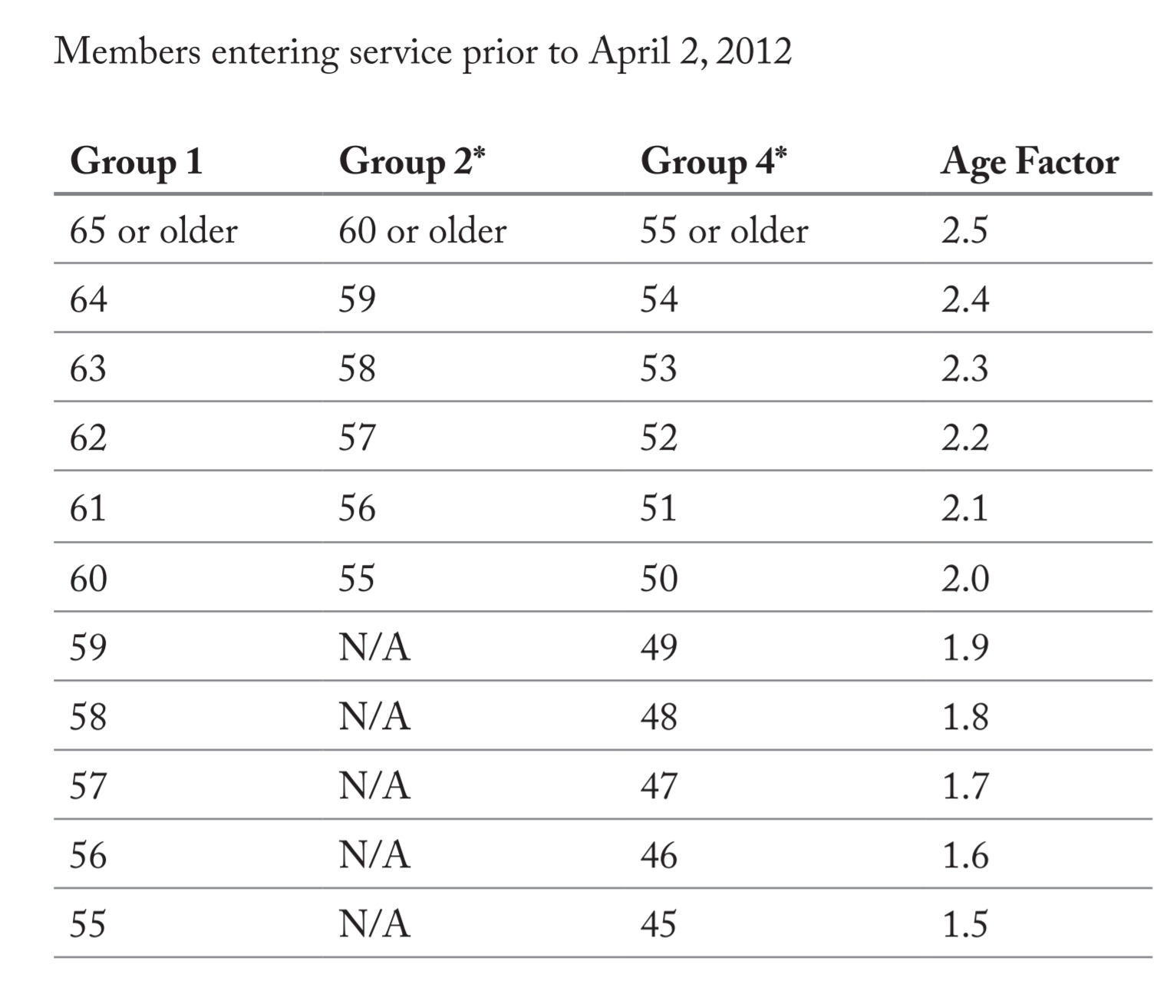

Prior to April 2, 2012

**Age factor \* Years of Creditable Service \* Highest 36 consecutive month average of annual pay = Option A annual allowance**

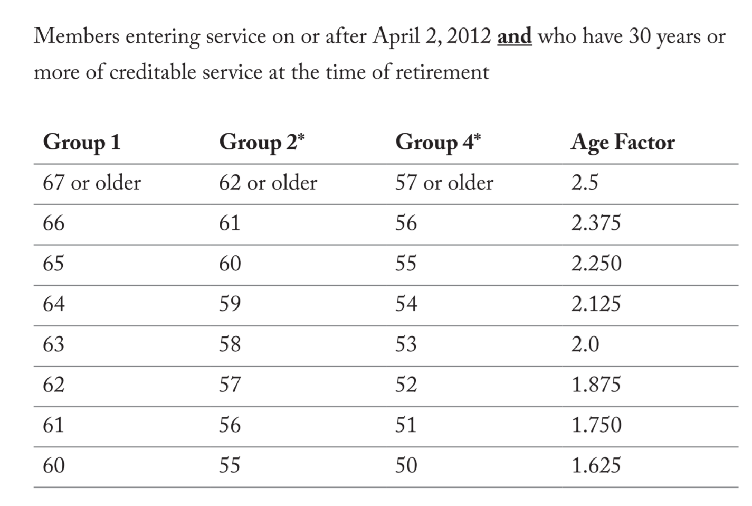

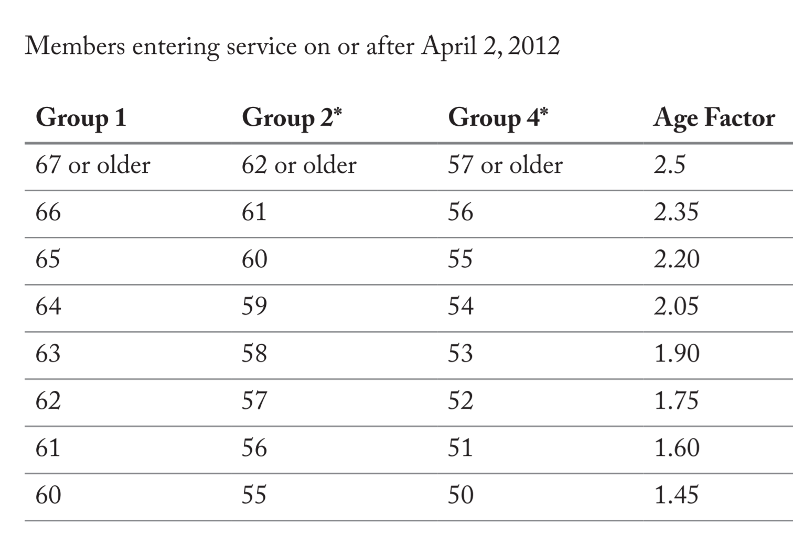

After April 2, 2012

**Age factor \* Years of Creditable Service \* Highest 5 year average of annual pay = Option A annual allowance**

If a veteran, add $15 for every year served (partial years included) in either calculation. Maximum of $300.

If option A, use number returned from this calculation as pension amount.

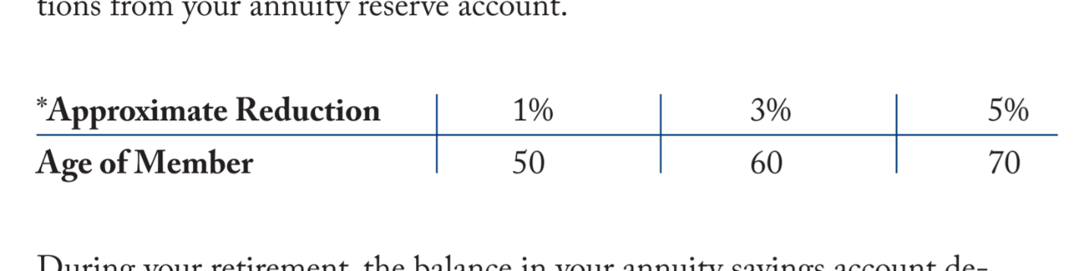

If option B, reduce pension amount using above chart.

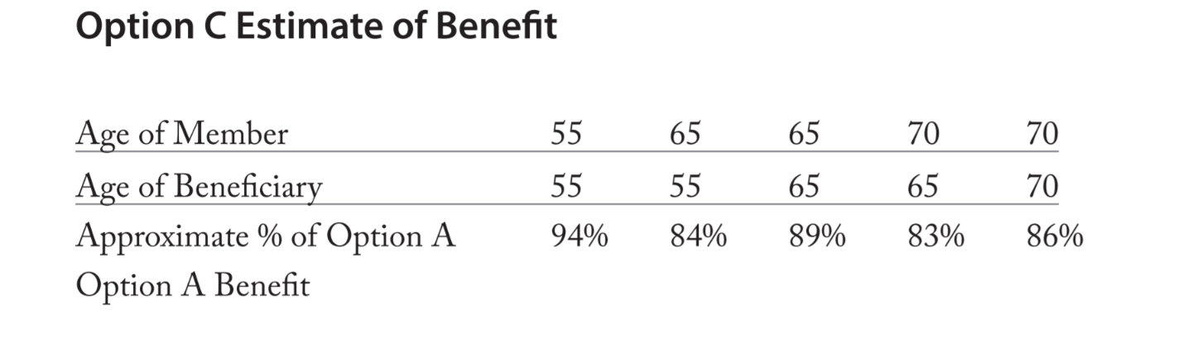

If option C, reduce pension amount using above chart.

Examples

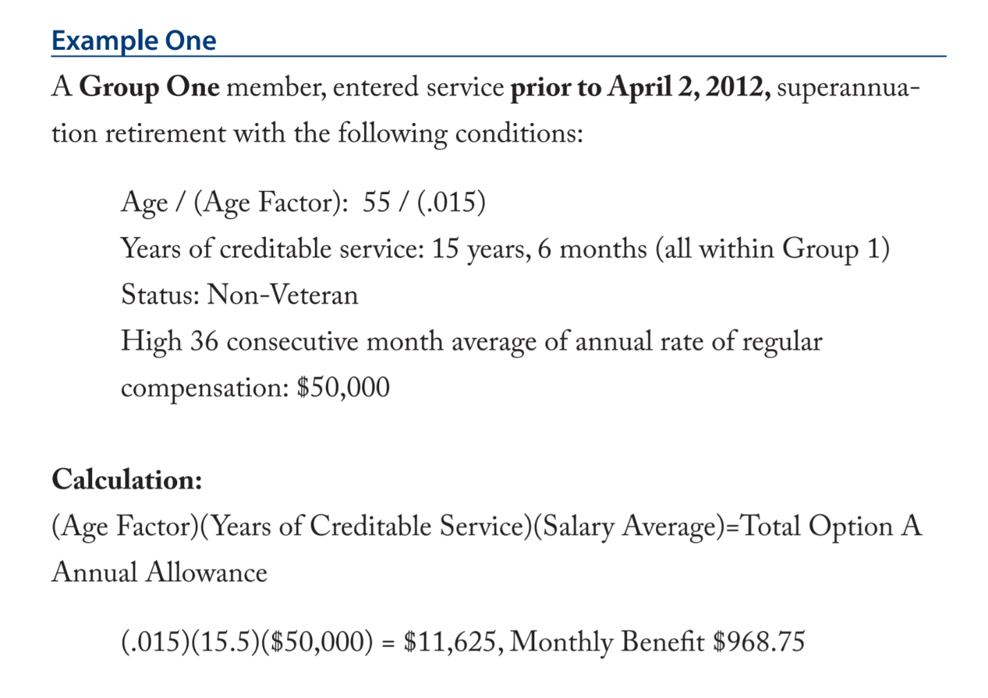

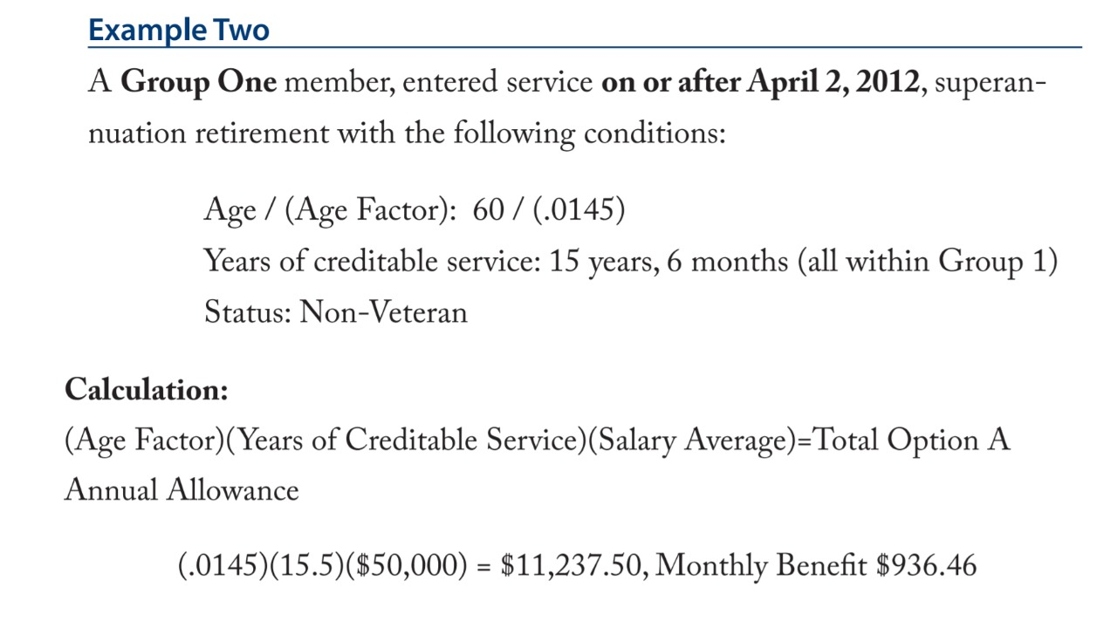

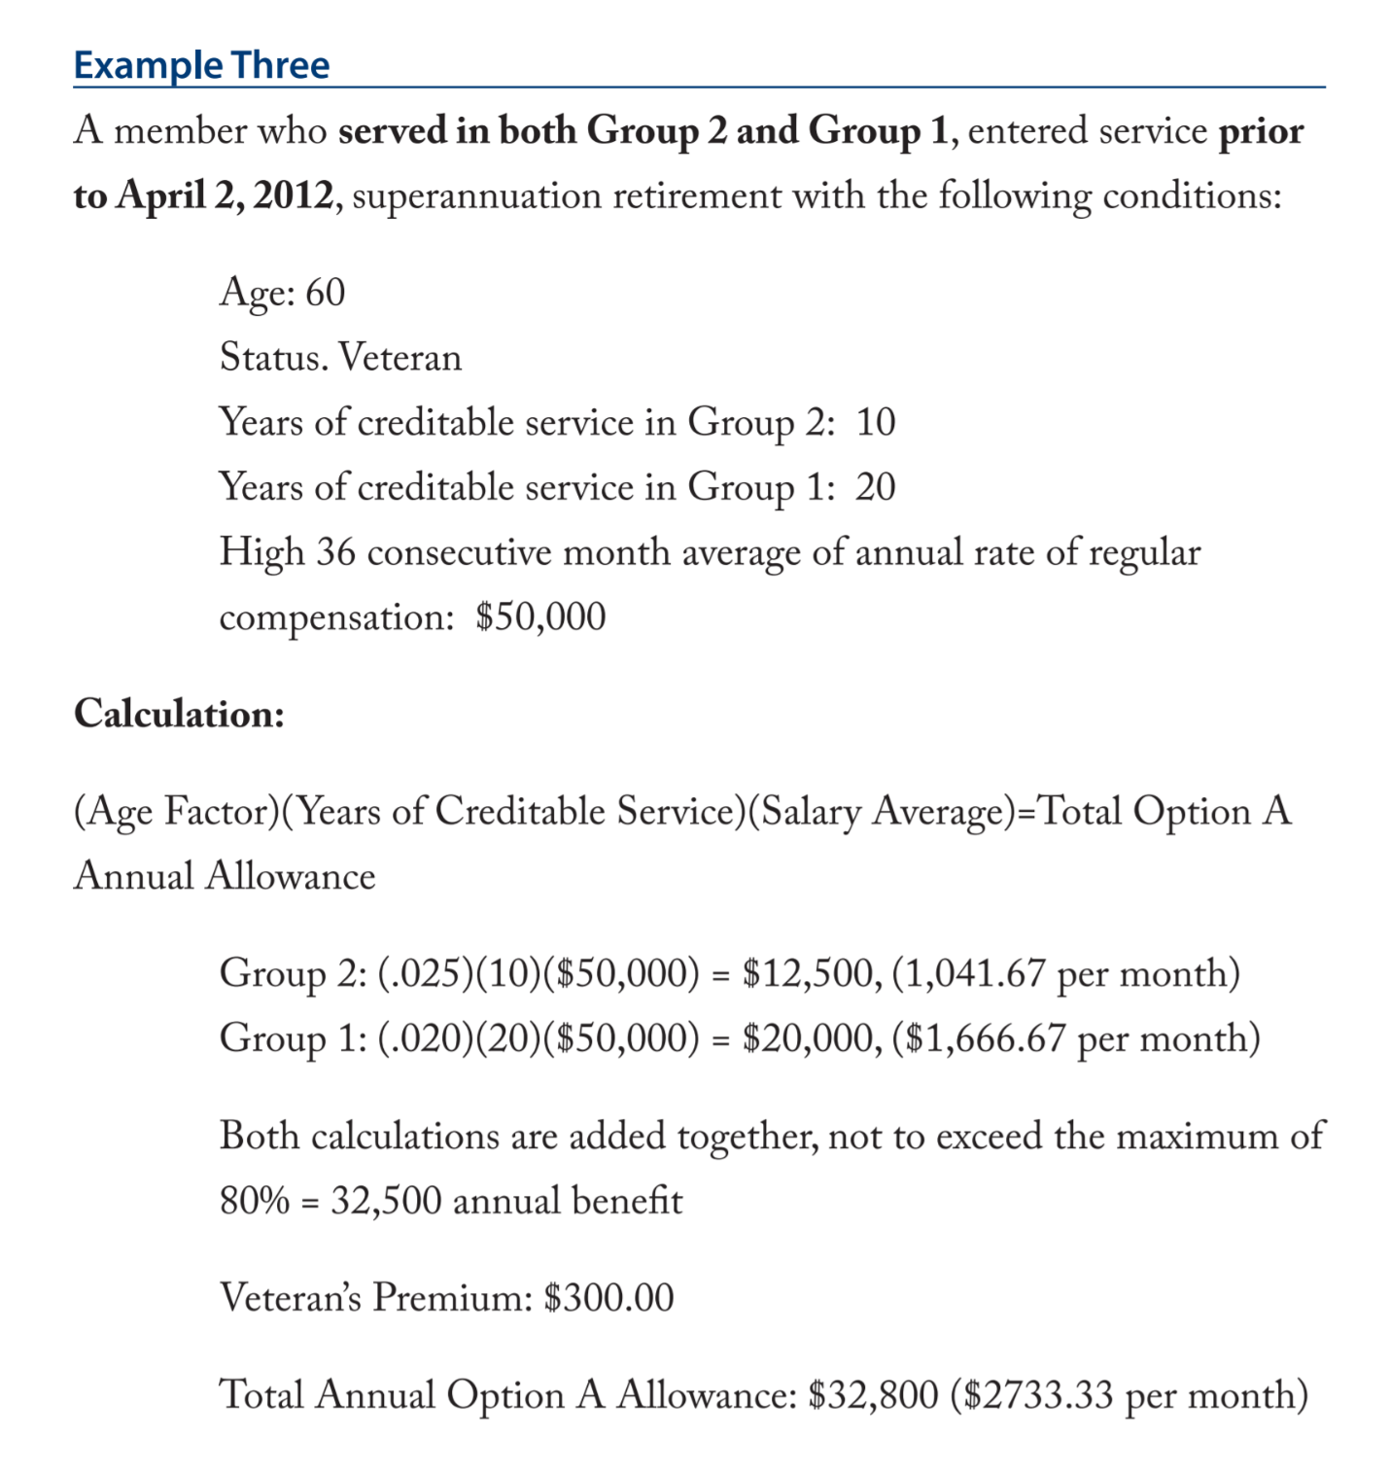

Anti-Spiking Provisions of Chapter 32

Due to Pension Reform legislation, Chapter 176 of the Acts of 2011, two anti-spiking provisions have been added to Chapter 32. Anyone who retires on or after April 2, 2012 and who has a benefit calculated under Section 5, 6, 10(1) or 12(2)(d) is affected by these provisions. The two anti-spiking provisions are summarized as follows:

1. If in the last 5 years of creditable service your rate of regular compensation increased by more than 100% between two consecutive years, then a violation results. In such a situation the Board must use the average of your last 5 years of compensation in calculating your retirement benefit rather than a thirty-six month average.

2. In determining the thirty-six month salary average of regular compensation used to calculate your retirement allowance (or 60 month salary average if you became a member on or after April 2, 2012), if that rate of regular compensation in any year exceeds the average of the regular compensation of the two previous years by more than 10%, then retirement boards are not permitted to use any regular compensation in excess of 10% of the average of your two previous years.

If a member is found to have violated these provisions a retirement board is required to return any retirement payroll deductions related to the excess compensation. If your salary increase was attributable to one of the following exceptions, then a retirement board may utilize the higher rate of compensation in your benefit calculation:

• Increase in the number of hours worked

• Overtime wages (not regular compensation, but included in #2)

• Bona fide change in position

• Modification in salary attributable to a collective bargaining agreement

Section 10-Termination Allowance

If you entered state service prior to April 2, 2012 and your position is either eliminated, abolished or if you are laid off or terminated you may qualify for a termination allowance provided you have at least 20 years of creditable service and meet other requirements. Please contact the State Retirement Board for more information and for other requirements which may need to be met.