#### TP: recruitment exercise

* Author: DG
* Date: 29DEC2016
* Last mod. date: 07JAN2017
* Input data: data.csv

## 0. Reading packages, setting working directory

set.seed(1234567)  
rm(list = ls())  
if (!require("pacman")) install.packages("pacman")

## Loading required package: pacman

pacman::p_load(data.table, dplyr, ggplot2, caret, nortest, corrplot)  
  
library(data.table)  
library(dplyr)  
library(ggplot2)  
library(caret)  
library(nortest) # Anderson-Darling test for normality  
library(corrplot)

## 1. Reading data

# setting working directory...  
  
wd <- "F:\\Damian\\Praca\\2016\\Toolplox Data Scientist\\Tooploox_Data_Scientist_Exercise (1)\\Tooploox_Data_Scientist_Exercise"  
setwd(wd)  
  
data.videos <- fread(".\\Input_data\\data.csv") %>% as.data.frame

Checking the class of read object (data.frame), the first & last 6 observations to check if data was loaded correctly. Results are not outputted due to their size.

class(data.videos) # checking object class  
head(data.videos) # checking the first...  
tail(data.videos) # ...and last 6 observations of the data set to check if it was loaded correctly

dim(data.videos) # Number of rows & columns

## [1] 916 169

sum(is.na(data.videos)) # checking if there are any missing values

## [1] 0

Naming variables properly: id and the number of views after i-th hour

names(data.videos) <- c("id", paste0("V", 1:168))

### 1.1 Basic stats for v(24), v(72), v(168)

summary(data.videos[, c("V24", "V72", "V168")])

## V24 V72 V168   
## Min. : 21173 Min. : 26162 Min. : 27139   
## 1st Qu.: 124866 1st Qu.: 148326 1st Qu.: 153346   
## Median : 194358 Median : 237418 Median : 252287   
## Mean : 376766 Mean : 613303 Mean : 743210   
## 3rd Qu.: 326667 3rd Qu.: 433612 3rd Qu.: 522259   
## Max. :15284639 Max. :22916701 Max. :27898237

boxplot(data.videos[, c("V24", "V72", "V168")])

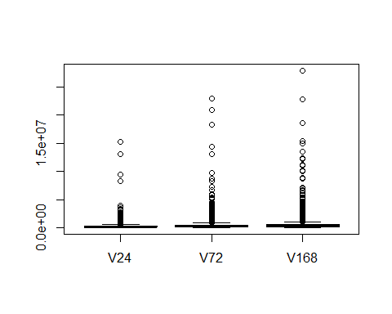

boxplot(data.videos[, c("V24")])

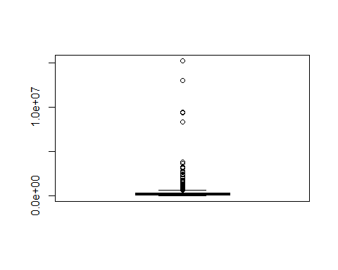

### 1.2 Distribution of v(168)

qplot(data.videos[, "V168"])

## `stat_bin()` using `bins = 30`. Pick better value with `binwidth`.

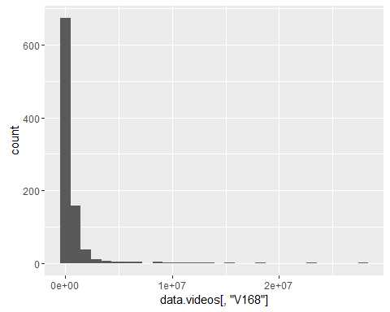

plot(ecdf(data.videos[, "V168"]))

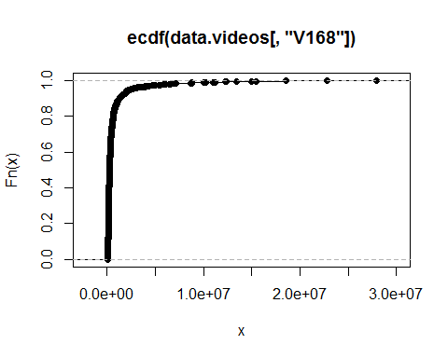 The distribution reminds some kind of Weibull distribution?

### 1.3 Distribution of log-transformed v(168)

qplot(log(data.videos[, "V168"]))

## `stat_bin()` using `bins = 30`. Pick better value with `binwidth`.

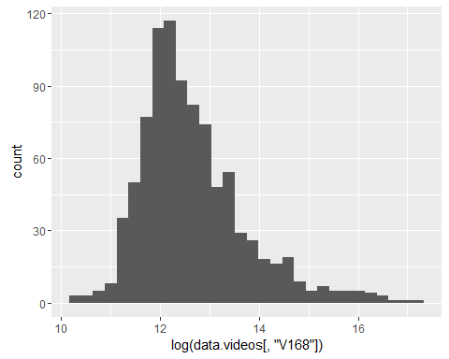

ad.test(log(data.videos[, "V168"]))

##   
## Anderson-Darling normality test  
##   
## data: log(data.videos[, "V168"])  
## A = 17.512, p-value < 2.2e-16

shapiro.test(log(data.videos[, "V168"]))

##   
## Shapiro-Wilk normality test  
##   
## data: log(data.videos[, "V168"])  
## W = 0.92821, p-value < 2.2e-16

The distribution looks a bit similar to the normal one, however both Shapiro and Anderson Darling test suggest rejection of null hypothesis of the data being distributed normally.

### 1.4 Outliers of v(168)

data.videos$ln.V168 <- log(data.videos$V168)  
mean.ln.V168 <- mean(data.videos$ln.V168)  
sd.ln.V168 <- sd(data.videos$ln.V168)  
low.3sigma <- mean.ln.V168-sd.ln.V168*3  
high.3sigma <- mean.ln.V168+sd.ln.V168*3

Removing outliers

data.videos <- data.videos[data.videos$ln.V168>=low.3sigma &  
 data.videos$ln.V168<=high.3sigma,]

As a result of outlier removal process, 15 observations were removed.

### 1.5 Correlations between log-transformed v(1:24) and log-transformed v(168)

for(i in 1:24){  
   
 # Adding log-transformed V1-V24  
   
 data.videos[[paste0("ln.V", i)]] <- log(data.videos[[paste0("V", i)]])  
   
 # If calculating a natural logarithm results in Inf, mean from this variable  
 # is inputted  
   
 data.videos[[paste0("ln.V", i)]] <- ifelse(data.videos[[paste0("ln.V", i)]] == -Inf,  
 mean(data.videos$ln.V1[data.videos$ln.V1 != -Inf]),  
 data.videos[[paste0("ln.V", i)]])  
}  
  
log.cor <- cor(data.videos[, c(paste0("ln.V", c(1:24, 168)))])  
  
corrplot.mixed(log.cor, lower = "pie", upper = "number", tl.pos = "lt",   
 tl.cex = 1, number.cex=0.4, pch.cex = 5)

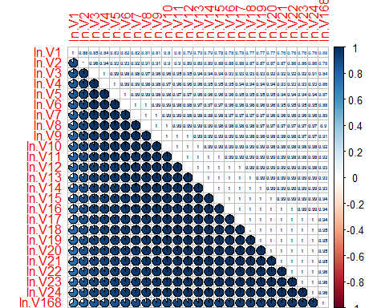

### 1.6 Split

Spitting data into training (90%) and test (10%) sets:

split.vec <- sample(1:nrow(data.videos), size = floor(0.9*nrow(data.videos)))  
data.train <- data.videos[split.vec,]  
data.test <- data.videos[-split.vec,]

### 1.7-9 OLS, multiple-input OLS & evaluation of predictors

Creating a vector with variable names:

(pred.single.var <- paste0("ln.V", 1:24))

## [1] "ln.V1" "ln.V2" "ln.V3" "ln.V4" "ln.V5" "ln.V6" "ln.V7"   
## [8] "ln.V8" "ln.V9" "ln.V10" "ln.V11" "ln.V12" "ln.V13" "ln.V14"  
## [15] "ln.V15" "ln.V16" "ln.V17" "ln.V18" "ln.V19" "ln.V20" "ln.V21"  
## [22] "ln.V22" "ln.V23" "ln.V24"

Prediction for models with single regresors:

mRSE.single.var <- pred.mRSE(vars = pred.single.var,  
 target = "ln.V168",  
 train = data.train,  
 test = data.test)  
mRSE.single.var$mRSE.test

## [1] 0.0068298057 0.0023124753 0.0017890998 0.0015863300 0.0014522931  
## [6] 0.0013673630 0.0013013972 0.0012069497 0.0010908590 0.0010252535  
## [11] 0.0009869171 0.0009440198 0.0009012966 0.0008546808 0.0008066865  
## [16] 0.0007626109 0.0007155447 0.0006733554 0.0006366968 0.0006012064  
## [21] 0.0005676787 0.0005363355 0.0005060792 0.0004748116

The model which minimizes mRSE is the 24th one, so it is the one with log-transformed V24

mRSE.single.var$RMSE.train

## [1] 0.41928326 0.34403177 0.26357309 0.24023410 0.22066449 0.20123536  
## [7] 0.18329548 0.16663618 0.15254138 0.14118357 0.13226730 0.12427461  
## [13] 0.11750035 0.11136646 0.10532627 0.09972780 0.09435373 0.08993844  
## [19] 0.08610465 0.08252391 0.07912080 0.07592840 0.07310578 0.07052027

The model which minimizes mRSE is the ` rwhich(mRSE.single.var $RMSE.train==min(mRSE.single.var$ RMSE.train))``th one, so it is the one with log-transformed V24

Prediction for models with multiple regresors:

pred.multiple.vars <- c()  
for(i in 1:24){  
 pred.multiple.vars <- c(pred.multiple.vars,  
 paste0("ln.V", 1:i, collapse = " "))  
}  
  
mRSE.multiple.vars <- pred.mRSE(vars = pred.multiple.vars,  
 target = "ln.V168",  
 train = data.train,  
 test = data.test)  
  
mRSE.multiple.vars$mRSE.test

## [1] 0.0068298057 0.0025615451 0.0019911602 0.0014003344 0.0012792466  
## [6] 0.0012669012 0.0012092244 0.0010941569 0.0008991543 0.0009235673  
## [11] 0.0008641742 0.0007871492 0.0006727876 0.0006051535 0.0005535804  
## [16] 0.0005270796 0.0004935108 0.0004796801 0.0004554811 0.0003880751  
## [21] 0.0003494044 0.0003057818 0.0002718681 0.0002517738

Model resulted in minimum mRSE was the 24th one, therefore it contained all log-transformed 24 variables.

mRSE.multiple.vars$RMSE.train

## [1] 0.41928326 0.34280709 0.25467486 0.22427517 0.19664600 0.16867020  
## [7] 0.15034439 0.13481625 0.12624182 0.11643074 0.10869342 0.09819476  
## [13] 0.09313077 0.08754225 0.07847271 0.07467053 0.07356452 0.07311675  
## [19] 0.06968463 0.06544018 0.06063189 0.05782865 0.05582976 0.05223296

Model resulted in minimum RMSE was the 24th one, therefore it also contained all log-transformed 24 variables.

### 1.10 mRSE visualization----

Preparing data for ggplot2 - melting in order to plot multiple lines on one plot:

mRSE.compare <- cbind(index = seq_along(mRSE.single.var$mRSE.test),  
 mRSE.single.var = mRSE.single.var$mRSE.test,   
 mRSE.multiple.vars = mRSE.multiple.vars$mRSE.test) %>%  
 data.frame %>%  
 melt(id = "index")  
  
head(mRSE.compare) # checking the first 6 observations

## index variable value  
## 1 1 mRSE.single.var 0.006829806  
## 2 2 mRSE.single.var 0.002312475  
## 3 3 mRSE.single.var 0.001789100  
## 4 4 mRSE.single.var 0.001586330  
## 5 5 mRSE.single.var 0.001452293  
## 6 6 mRSE.single.var 0.001367363

Adding labels for data for ggplot2:

mRSE.compare[,2] <- ifelse(mRSE.compare[,2] == "mRSE.single.var",  
 "Linear Regression",  
 "Multiple-input Linear Regression")  
head(mRSE.compare) # checking the first 6 observations

## index variable value  
## 1 1 Linear Regression 0.006829806  
## 2 2 Linear Regression 0.002312475  
## 3 3 Linear Regression 0.001789100  
## 4 4 Linear Regression 0.001586330  
## 5 5 Linear Regression 0.001452293  
## 6 6 Linear Regression 0.001367363

Plot in ggplot2:

ggplot(mRSE.compare, aes(x = index, y = value, colour = variable)) +   
 geom_line(size = 1.2) +  
 geom_point() +  
 xlab("Reference time (n)") +  
 ylab("mRSE") +  
 scale_x_continuous(breaks = seq(0, 25, 3)) +  
 # scale_y_continuous(breaks = seq(0, 0.003, 0.0005)) +  
 ggtitle("Performance of linear regression models for n in <1: 24> hours  
 measured as mean Relative Squared Error (mRSE)") +  
 theme_minimal() +  
 theme(legend.position = "bottom", legend.title=element_blank())

