**Problem Statement:**

Efficacy of Price action trading strategies in the context of the Indian Equities market

Report

**Universe:**

Top 10 most significant stocks in Nifty50.

**Hypothesis:**

The volatility of a time -series can be very nearly mapped out buy the historical data of that time-series.

**Strategy Overview**

The goal of this strategy is to predict and trade on breakouts, where a stock’s price moves sharply above or below its normal range. The normal range is defined by the stock’s simple moving average (SMA) and its second standard deviation (±2σ).

To confirm whether a breakout is real or just a temporary fluctuation, you use the GARCH(2,1) model to predict volatility for the next period. If the predicted volatility is similar to the current level, the breakout is more likely to continue. If the volatility changes significantly, the breakout might be temporary, and the price could return to its usual range.

Steps:

1. Identify Breakouts:
   * A breakout above +2σ (two standard deviations above the SMA) suggests the stock is moving higher than usual.
   * A breakout below -2σ means the stock is moving lower than usual.
2. Use GARCH(2,1) to Predict Volatility:
   * The GARCH model helps predict whether the volatility will stay the same or change for the next period.
   * If the predicted volatility is close to the current level, the breakout is likely to continue in the same direction.
   * If the predicted volatility is much higher or lower, the breakout might not last, and the stock could return to trading within the +2σ to -2σ range.

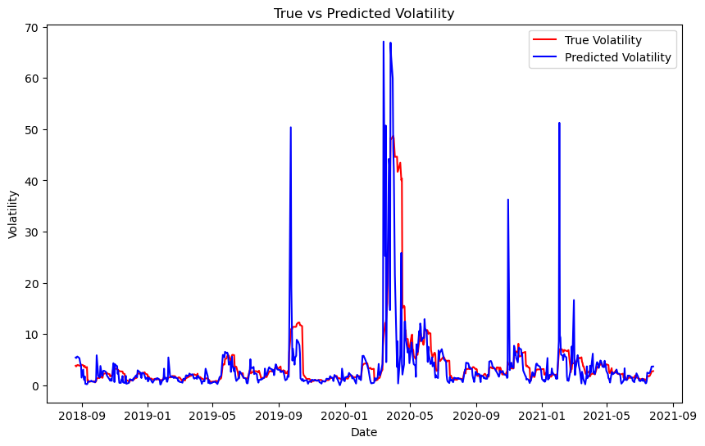

Figure 1 True volatility v/s predicted volatility for L&T

1. Trading Decisions:
   * Breakout above +2σ:
     + If predicted volatility stays the same, go long (buy more of the stock).
     + If predicted volatility increases, hold off, as the breakout may not last.
   * Breakout below -2σ:
     + If predicted volatility stays the same, sell some stock.
     + If predicted volatility decreases, the stock may return to its normal range, so hold your position.

**Summary**

This strategy helps determine whether breakouts are genuine trends or just temporary moves by combining a stock’s price movement with predicted volatility. The GARCH(2,1) model helps you decide if the stock is likely to keep moving in the breakout direction or fall back within the normal range.

**BENCHMARKS**

Back testfrom : **2018-07-27 to 2021-07-27**

**Sharpe ratio: 1.26**

**Total Return: 112.29%**

**Annualized Return: 23.27%**

