OMS Cartridge Introduction Process

2018/08/28

Ver 1.0

# Revised history

|  |  |  |
| --- | --- | --- |
| Version | Released date | Revised content |
| 1.0 | 2018/08/28 | New creation. |
|  |  |  |
|  |  |  |
|  |  |  |
|  |  |  |
|  |  |  |
|  |  |  |
|  |  |  |

contents

Revised history 2

1. Summary 4

2. Functional Overview 4

3. Implementation guide 5

3.1. Installation 5

3.1.1. Creating a project 5

3.1.2. Importing project 5

3.1.3. Project Reference 5

3.2. Configuration 6

3.2.1. Importing meta data 6

3.2.2. Custom site configuration settings 9

3.2.3. Uploading host key for SFTP connection 12

3.2.4. Importing the job schedule 13

3.2.5. Confirmation of settings of each job schedule 16

4. Note (Cautionary Note) 18

# Summary

This document will guide you through the installation of OMS cartridge and its configuration.

# Functional Overview

The cartridge which cooperates with OMS can work on the Salesforce Commerce Cloud Job Schedule

The cartridge provides the following features:

■Output of order data

* Output order data to a file and sending file to the FTP server, where this FTP server is indicated by configuration.
* Back up the sent file.

This feature is provided by OmsExportOrdersJob of the job schedule.

■Importation of the order history

* Acquire order history files from the FTP server and change the status of the corresponding order data.
* Back up the acquired files.

This feature is provided by OmsImportJob of the job schedule.

■Deletion of backups

* + - Delete back-up files after the storage period.

This feature is provided by OmsCleanUpJob of the job schedule.

# Implementation guide

## Installation

### Creating a project

Create the following cartridge:

-　Digital Server cartridge

### Importing project

Import the following cartridge:

-　 dh_oms_cartridge

### Project Reference

Show the project reference of DigitalServer Cartridge and make sure if the following cartridge is linked.

-　 dh_oms_cartridge

## Configuration

### Importing meta data

Click [アップロード(upload)] in Import & Export page.  
Business Manager -> 管理(Management) -> サイトの開発(Site development) -> インポート＆エクスポート(import & export)

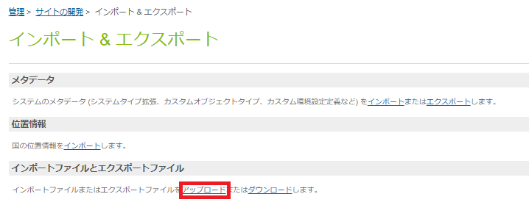

Click[ファイルを選択(select file)] -> Select “metadata.xml”, Click [アップロード(upload)].

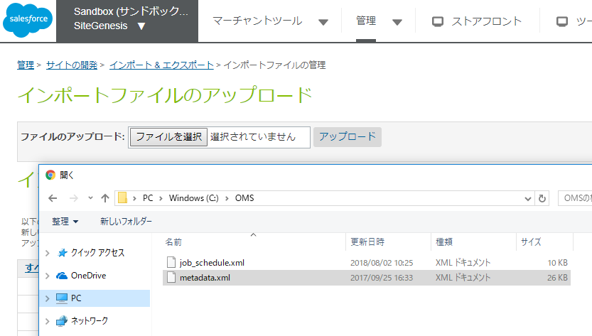

Click [インポート(import)] in import & export.

Business Manager -> 管理(manage) -> サイトの開発(site development) -> インポート＆エクスポート(import & export)

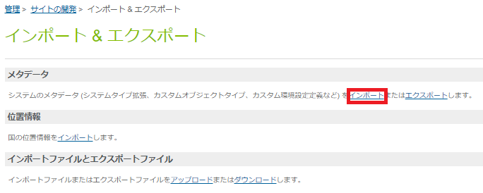

Select “metadata.xml” and Click [次へ(to the next)].

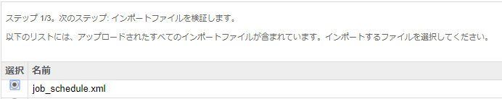

Click the link [更新(reload)] in the page.

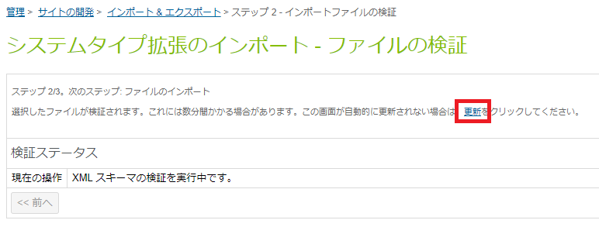

Click the [インポート(import)] button to import the metadata.

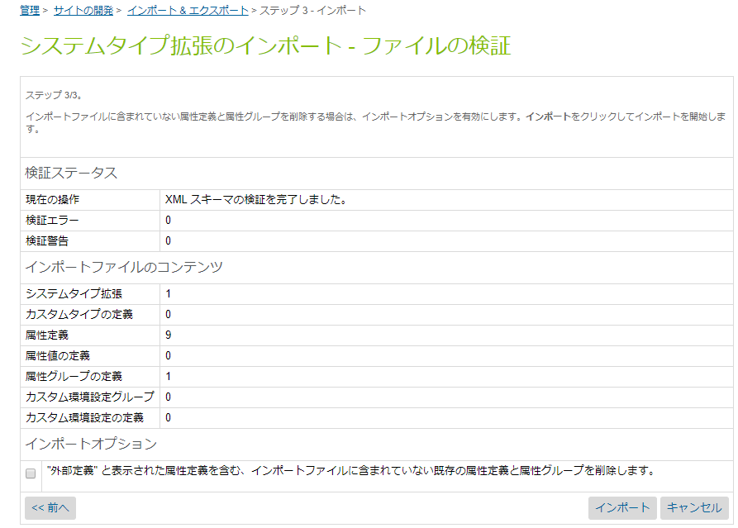

### Custom site configuration settings

Business Manager -> Select your site -> マーチャントツール(merchant tool) -> サイト環境設定(site configuration setting) -> transfer toカスタムサイト環境設定(custom site configuration setting ), Click [oms].

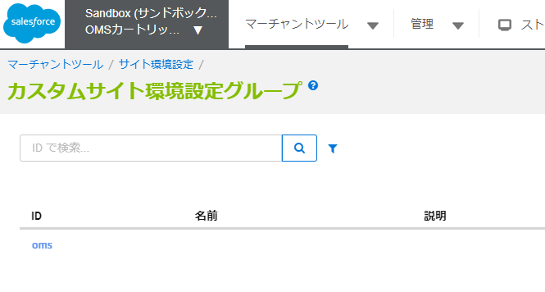

Enter values in required fields.

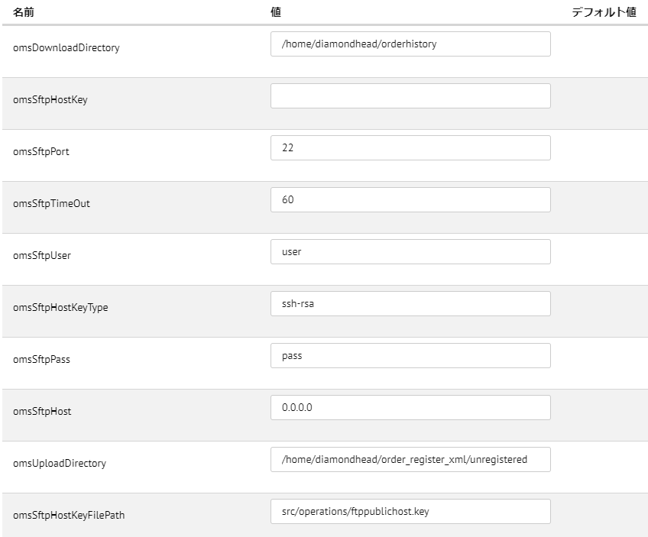

Fields list

|  |  |  |
| --- | --- | --- |
| name | description | example |
| omsSftpHost | IP address of the FTP server |  |
| omsSftpPort | Port number of the FTP server | 22 |
| omsSftpHostKeyType | Public authentication key type when connecting to FTP server.  OPTIONAL | ssh-rsa |
| omsSftpHostKeyFilePath | The path of the file with the host key when connecting to the FTP server.  OPTIONAL | src/operations/ ftppublichost.key |
| omsSftpUser | Username for connecting to the FTP server. |  |
| omsSftpPass | Password for connecting to the FTP server. |  |
| omsSftpTimeOut | Timeout time for FTP server connection. It is specified in milliseconds. If omitted, this value is assigned to 30000 milliseconds. | 60000 |
| omsUploadDirectory | A directory path on the FTP server for storing outputted order data | /home/diamondhead/order_register_xml/unregistered |
| omsDownloadDirectory | A directory path on the FTP server for storing outputted order history data | /home/diamondhead/orderhistory |

### Uploading host key for SFTP connection

Perform this procedure when you use SFTP connection. To obtain the host key, contact the administrator of the FTP server.

You need to upload the host key file to IMPEX/src/operations directory before you use SFTP connection.

Upload to the IMPEX / src / operations directory.

Click [アップロード(upload)] in Import & Export page.

Business Manager -> 管理(Management) -> オペレーション(Operation) -> インポート＆エクスポート(import & export)

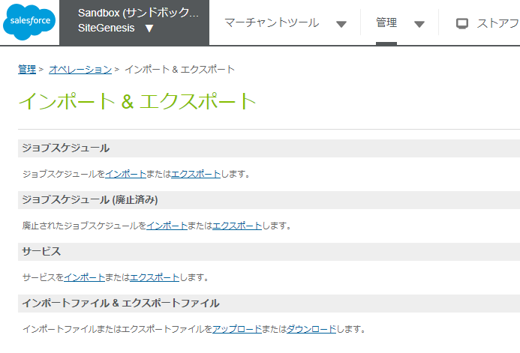

Click [ファイルを選択(select file)]-> Select the host key file, Click [アップロード(upload)].

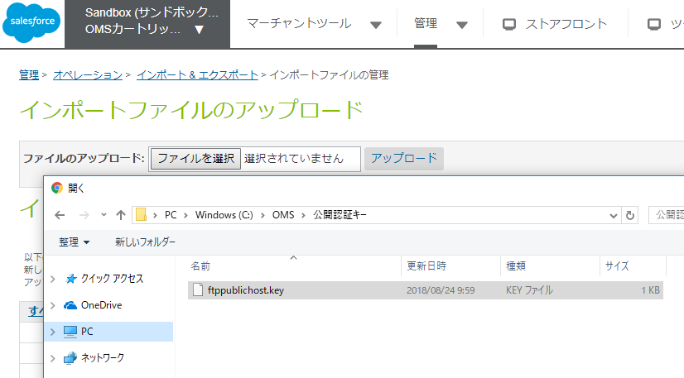

### Importing the job schedule

Click [アップロード(upload)] in Import & Export page.  
Business Manager -> 管理(Management) -> オペレーション(Operation) -> インポート＆エクスポート(import & export)



Click [ファイルを選択(select file)]-> select “job_schedule.xml”, Click [アップロード(upload)].

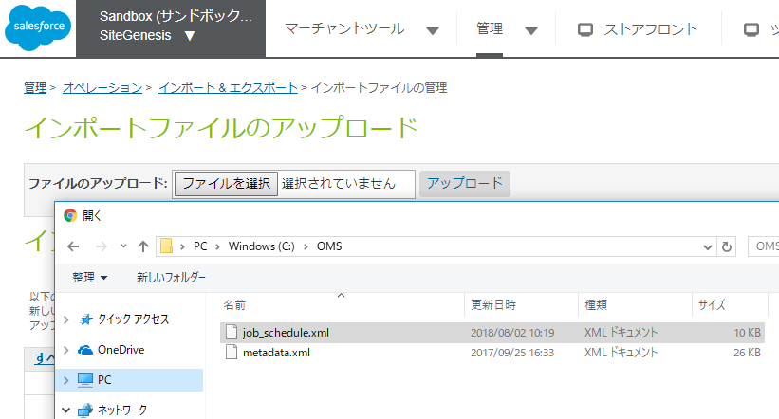

Click [インポート(import)] in import& export page.

Business Manager -> 管理(management) -> オペレーション(Operation) -> インポート&エクスポート(import & export)



Select [job_schedule.xml] -> Click [次へ(go next)].



Click the link [更新(upload)].

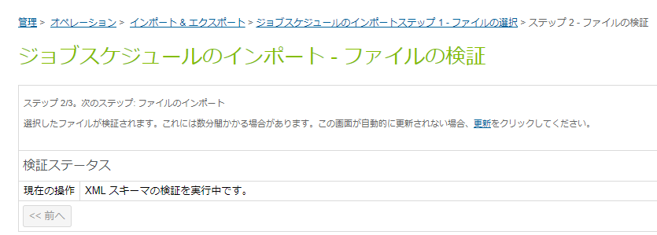

Click [次へ(go next)].

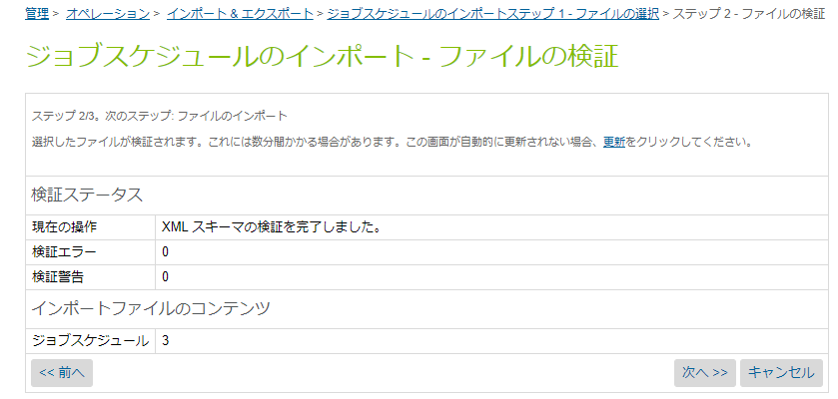

Select [置換(replace)], click [インポート(import)].

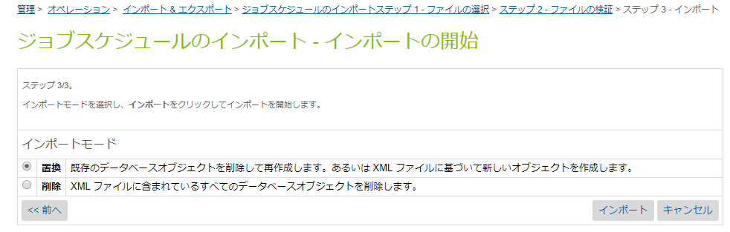

### Confirmation of settings of each job schedule

Configure OmsExportOrdersJob according to instructions in Section 3.2.5.1 to 3.2.5.3. The following description explains the process in case of OmsExportOrdersJob.

Repeat the instruction for configuration of OmsImportOrdersJob, OmsCleanUpJob.

Click [OmsExportOrdersJob] in job schedule page.

Business Manager -> 管理(management) -> ジョブスケジュール(Job schedule)

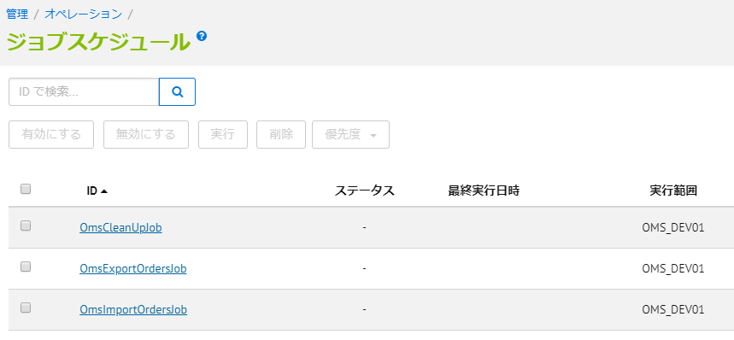

#### Schedule

Click [スケジュールと履歴(Schedule and History)].

Set operation start date and time at start date and time.

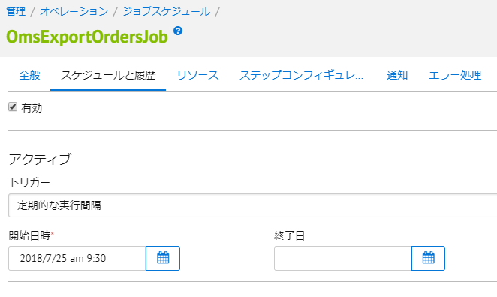

#### Scope in the workflow

Click [ステップコンフィギュレータ(Step Configurator)],

Click site ID in the workflow scope,

Check use site ID of the site list,

Click [割り当てる(Assign)].

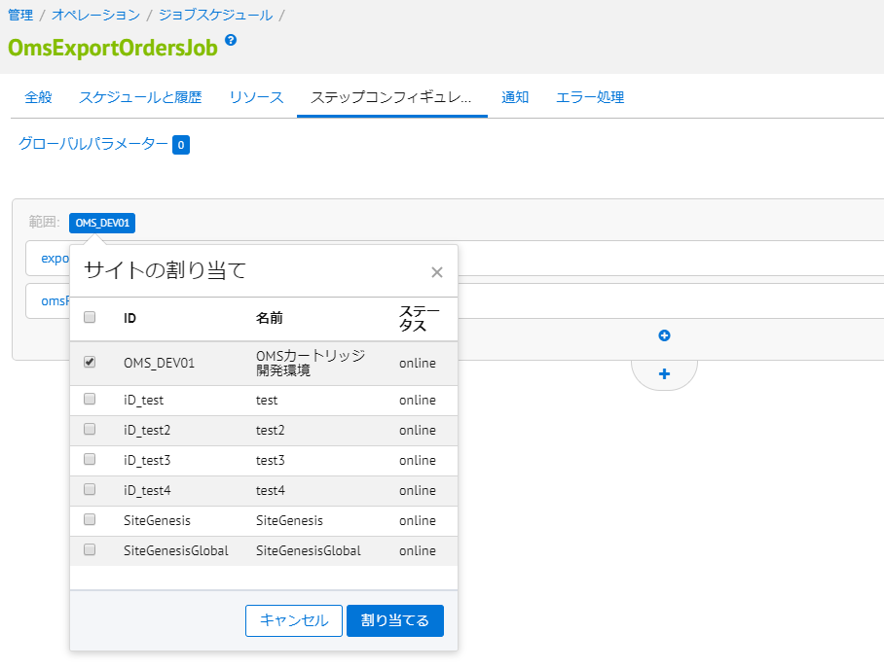

#### Notification

Click [通知(Notification)],

Enter email address for sender and destination.

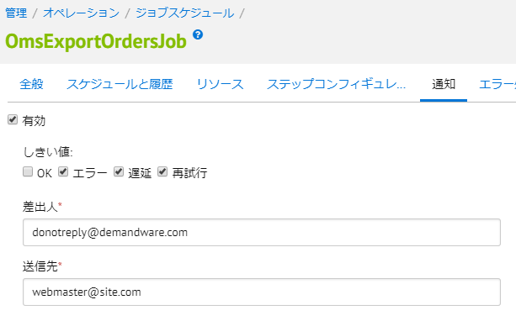

# Note (Cautionary Note)

Nothing.