GMO Cartridge Introduction Process

2018/07/18

Ver 1.7

# Revised history

|  |  |  |
| --- | --- | --- |
| Version | Released date | Revised content |
| 1.0 | 2017/09/09 | New creation |
| 1.1 | 2018/01/15 | Modified process 3.2.6 from zip file import to GUI operation procedure |
| 1.2 | 2018/02/06 | Added CreatePaymentInstrument.ds to revised 3.3.1. Added modification about app.js to 3.4. |
| 1.3 | 2018/03/09 | 3.2.6 Changed payment-processor name.  (“GMO PAYMENT” -> “GMO_PAYMENT”)  Modified cartridge name 3.1.2, 3.1.3, 3.2.2.  “bm_orderhistory” -> “bm_gmo” |
| 1.4 | 2018/03/30 | Added the files to be revised for 3.2.4, 3.2.6GMO post-payment.  Added the files to be revised for 3.3 GMO post payment. |
| 1.5 | 2018/04/12 | 3.3.1 Correction of errors |
| 1.6 | 2018/04/17 | 3.3.1 Correction of required files. |
| 1.7 | 2018/07/18 | 3.2.4 Modified item of GMO setting.  3.2.5 Added note on URLs of service.xml. |

目次

Revised history 2

1. Sammary 4

2. Function summary 4

3. Implementation guide 5

3.1 Set up 5

3.1.1 Create Storefront project 5

3.1.2Import the project 5

3.1.3 Reference setting for project 5

3.1.43.1.4 Create GMO account 5

3.2 Setting 6

3.2.1 Cartridge distribution to the site 6

3.2.2 Allocation of cartridge to Business Manger - site 7

3.2.3 Enable order history for its order 8

3.2.4 Import meta data 10

3.2.5 Import searvice 20

3.2.6 Creating payment processor 23

3.2.7 Custom log setting 28

3.3 Custome code 30

3.3.1 List of the target files for revision 30

3.4 Cartridge name 32

4. Note 33

# Summary

Integrate the GMO payment gateway and Salesforce Commerce Cloud.

Set the GMO cartridge and change the cartridge code of Storefront.

# 2. Function summary

Construct GMO payment method cartridge based on the default checkout process of Salesforce Commerce Cloud.

Provide following features.

■Marchant information setting function for Business Manager

■Integration to payment method

■Credit card process

　・Authorize/ Cancel authorization

　・Process actual sales

　・Manage credit card information(save the credit card information and display them at user account page)

　・Support for payment by installment

　・Identification support

■Rakuten-peyment process

　・Authorize/ Cancel authorization

　・Actual sales process

　・Amount change process

■GMO post-peyment process

　・Authorize/ Cancel authorization

　・Actual sales process

　・Order change process

# 3. Implementation guide

## 3.1 Set up

### 3.1.1 Create Storefront project

Create following cartridge.

-　Digital Server cartridge

-　app_gmo cartridge

※The following cartridges will be automatically created when app_gmo cartridge is made.

　　・app_gmo_contorollers cartridge

　　・app_gmo_core cartridge

　　・app_gmo_pipelines cartridge

### 3.1.2 Importing project

Import following cartridge.

-　int_gmo

-　bm_gmo

### 3.1.3 Reference setting for project

Make sure if these following cartridges are linked by referring the project of DigitalServer cartridge.

-　 app_gmo_contorollers cartridge

-　 app_gmo_core cartridge

-　 int_gmo cartridge

-　 bm_gmo cartridge

### 3.1.4 Create GMO account

* *Entry point:* <https://service.gmo-pg.com/cyllene/entry/trialStart.htm>

Transit to the site, create a GMO account. An E-mail will be sent to the registered E-mail address. Those information will be used on the step **‘3.2.4 Custom Preferences -> GMO’**.

## 3.2 Setting

### 3.2.1 Cartridge distribution to the site

Transfer to your site, click the setting tab.

Business Manager -> 管理(Management) -> サイト(Site) -> サイトの管理(Site management) -> あなたのサイト(Your site)（eg.：SiteGenesis）

Set up the cartridge. Use information from step 3.1.1 (Creating Storefront cartridge).

Mention 「app_gmo_contorollers : app_gmo_core : int_gmo」 to 「カートリッジ(cartridge)：」.

Setting example：

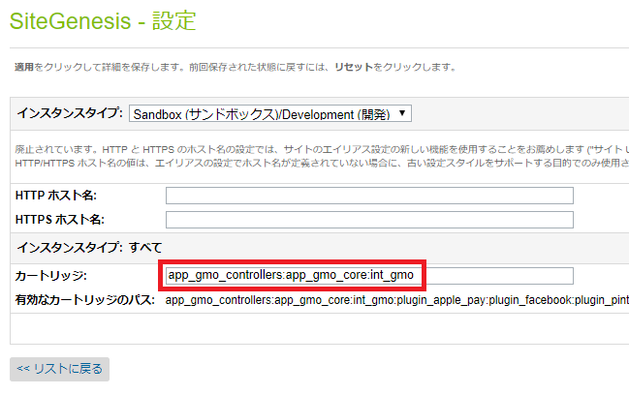

### 3.2.2 Allocation of cartridge to Business Manger - site

Transfer to Site Management, click “Business Manager”.

Business Manager -> 管理(Management) -> サイト(Site) -> サイトの管理(Site management)

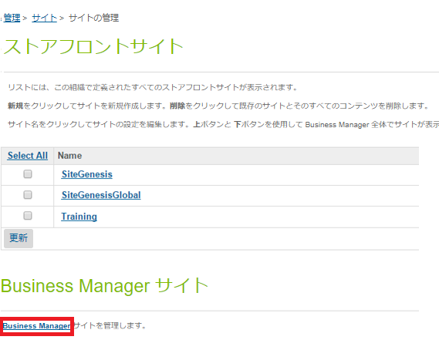

Add the cartridge「bm_gmo」 to「カートリッジ(cartridge)：」 as below.

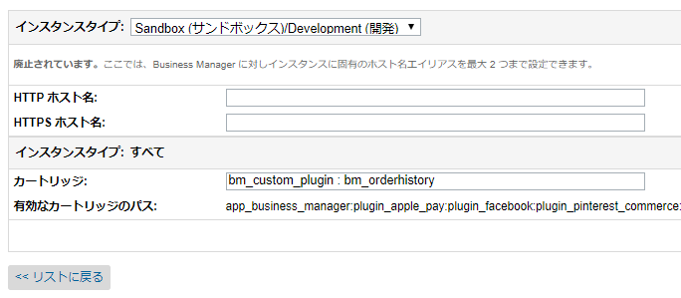

Click [適用(apply)] and save.

### 3.2.3 Enable order history for its order

Click Administrator in [役割＆許可(role& permission)]

Business Manager -> 管理(Management) -> 組織(System) -> 役割＆許可(Role& permission ).

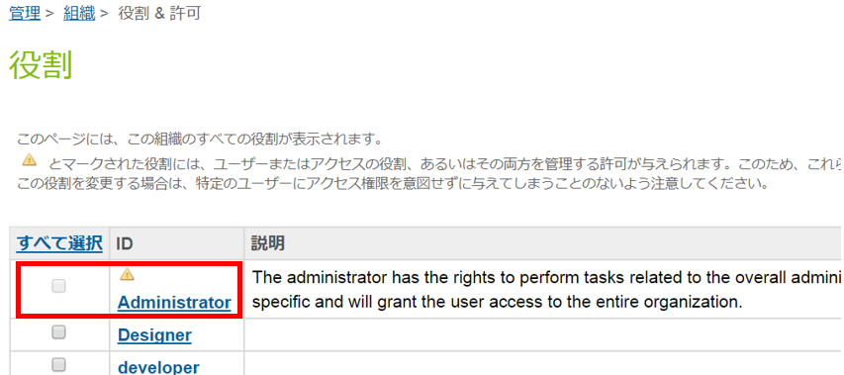

Select Business Manager Modules tab -> Select[あなたのサイト(Your site)] -> Click[適用(apply)].

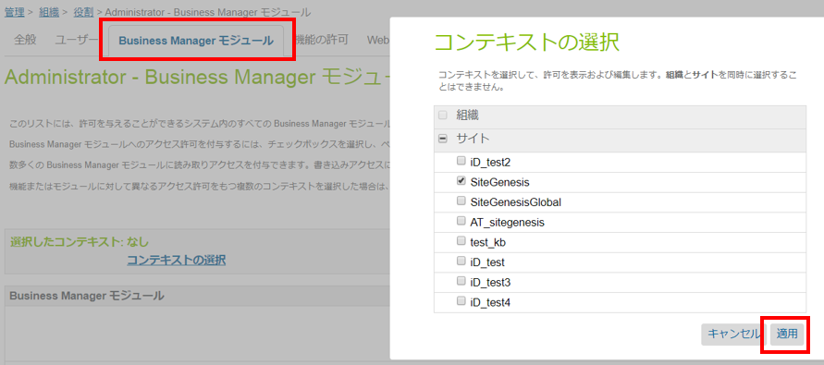

Search the options for“注文(order)” -> Cilck[適用(apply)] ->Search item「注文(order)」.

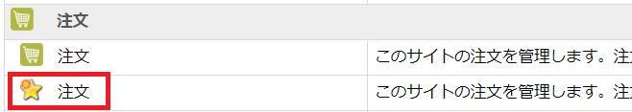

Check “注文(order)” for the check-box. -> Scroll down-> Click [更新(reload)]button.

Business Manager -> transfer to Marchant Tool, click“注文(order)”.

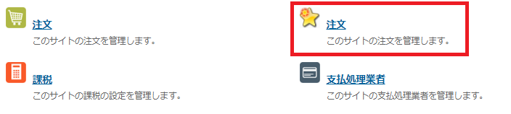

In order history, all order is shown. This Business Manager Module provide these following function; In order history, all the order is shown. This Business Manager Module provide following those; actual sales for the order, cancellation, amount change of Rakuten-payment.

### 3.2.4 Importing meta data

Click [アップロード(upload)] in Import& Export page.  
upload Business Manager -> 管理(Management) -> サイトの開発(Site development) -> インポート＆エクスポート(import& export)

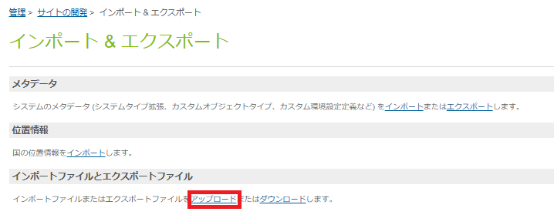

Click[ファイルを選択(select file)] -> Select “metadata.xml” ->Clilck [アップロード(upload)]button

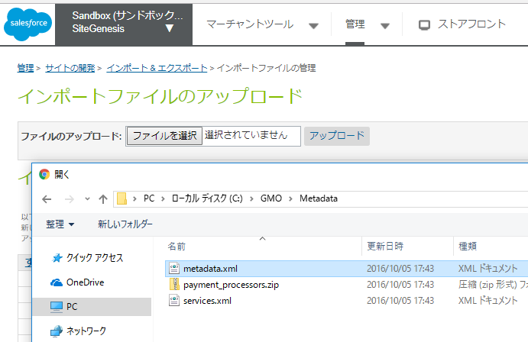

Click [インポート(import)] in import& export.

Business Manager -> 管理(manage) -> サイトの開発(site development) -> インポート＆エクスポート(import& export)

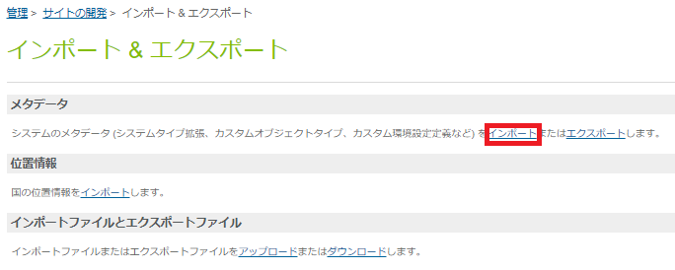

Select “metadata.xml”, Click [次へ(to the next)]

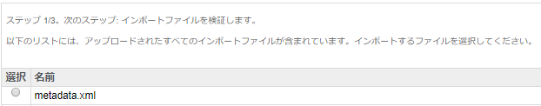

Click [更新(reload)]

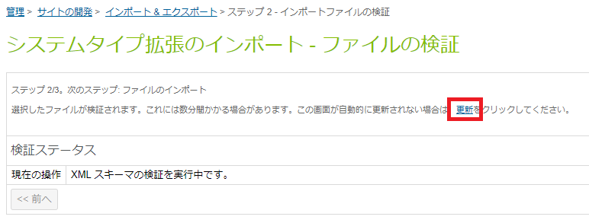

Click[インポート(import)]

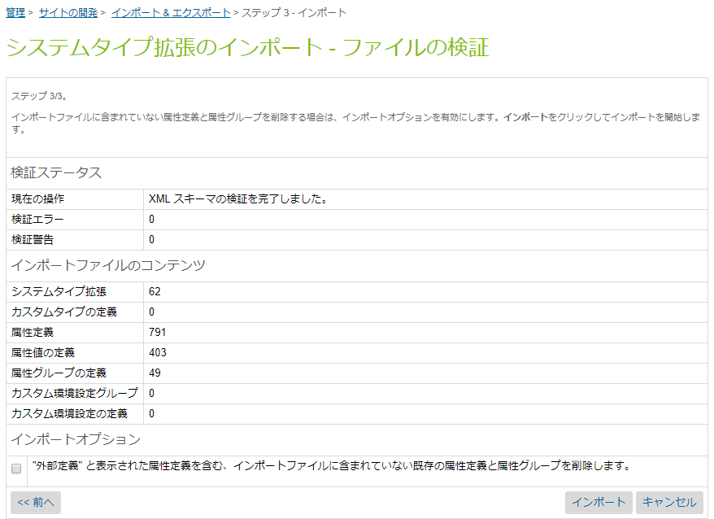

#### 3.2.4.1 Setting GMO

Business Manager -> Select your site -> マーチャントツール(merchant tool) -> サイト環境設定(site configuration setting) -> transfer toカスタムサイト環境設定(custom site configuration setting ), Click [gmo]

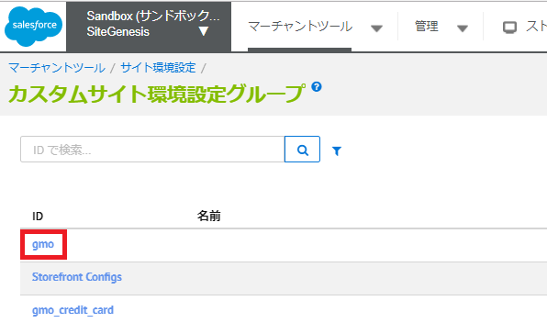

Use the same information as step 3.1.

スクリーンショット が含まれている画像

非常に高い精度で生成された説明

Fields list

|  |  |  |
| --- | --- | --- |
| 名前 | 内容 | 例 |
| gmo_api_base_url | Base URL of GMO API.  It is different for production and test environment. | https://pt01.mul-pay.jp |
| gmo_siteID | ID that is notified by GMO | tsite00019310 |
| gmo_sitePass | Password that is notified by GMO | fcsn2gam |
| gmo_shopID | Shop ID that is notified by GMO | tshop00020773 |
| gmo_shopPass | Shop password that is notified by GMO | 84z6g8qz |
| gmo_enable_catridge | Set up the availability of credit card use |  |
| gmo_authorization_mode_only | Set 「はい(yes)」for「仮売上(Authorized/ Provisional Sale)」,  Set 「いいえ(no)」for 「即時売上（immediate sales）」for credit card payment. |  |
| gmo_number_of_credit_card | Biggest number of the card that one user can resister. | 5 |
| gmo_save_card_mode | Set up the availability of saving credit card information. |  |
| gmo_enable_rakutenid | Set up the availability of Rakuten-payment use. |  |
| gmo_rakutenid_auth_mode_only | Set 「はい(yes)」for「仮売上(Authorized/ Provisional Sale)」,  Set 「いいえ(no)」for 「即時売上（immediate sales）」for Rakuten-payment. |  |
| gmo_enable_postpay | Set up the availability of GMO post-payment. |  |

#### 3.2.4.2 GMO credit card setting

Business Manager -> Select your site -> マーチャントツール(Marchant tool) -> サイト環境設定(Site configuration setting) -> transfer toカスタムサイト環境設定(Custom site configuration setting ), click [gmo_credit_card].

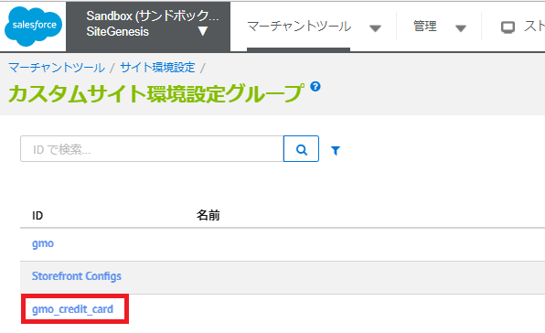

Set up the credit card information for credit card payment.

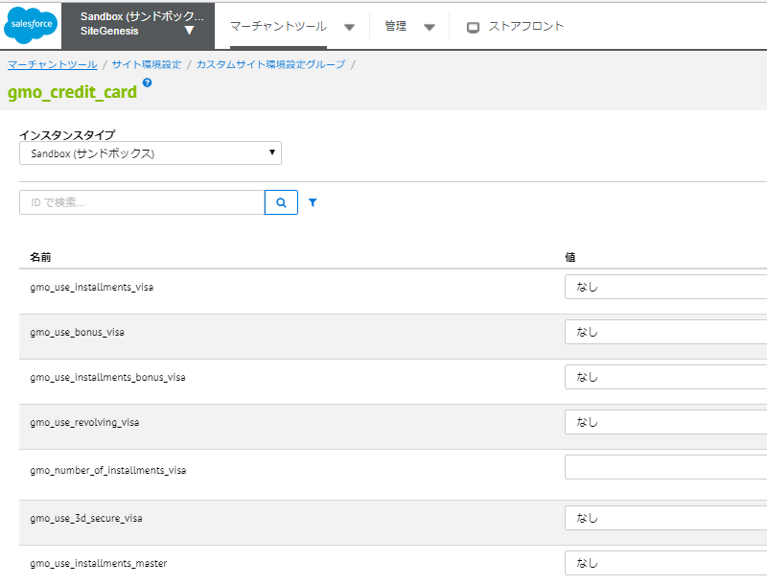

Fields list

|  |  |
| --- | --- |
| 名前 | 内容 |
| gmo_use_installments_XXXX | Enable「分割払い(installment payment)」as payment option. |
| gmo_use_bonus_XXXX | Enable「ボーナス払い(bonus payment)」as payment option. |
| gmo_use_installments_bonus_XXXX | Enable「ボーナス分割払い(bonus installment payment)」as payment option. |
| gmo_use_revolving_XXXX | Enable「リボ払い(revolving payment)」as payment option. |
| gmo_number_of_installments_XXXX | Set the number of the time to devide for 「分割払い(installment payment)」. To set up multiple options, use comma between.  (e.g.：2,3,5) |
| gmo_use_3d_secure_XXXX | Set the eligibility for 3D secure . |

※The「XXXX」in the table above stands for the available credit card brands that is shown in the table below.

|  |  |
| --- | --- |
| カードタイプ | 名前 |
| visa | VISA card |
| master | Master card |
| jcb | JCB card |
| amex | American Express card |
| diners | Diners club card |

#### 3.2.4.3 GMO post-payment setting

Click [gmo_postpay] in Custom site configuration setting.

Business Manager -> select your site -> マーチャントツール(Marchant tool) -> サイト環境設定(Site configuration setting) -> カスタムサイト環境設定(Custom site configuration setting), click [gmo_postpay].

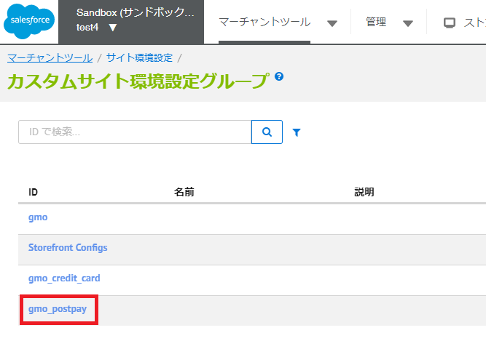

Resister the information for GMO post-payment.

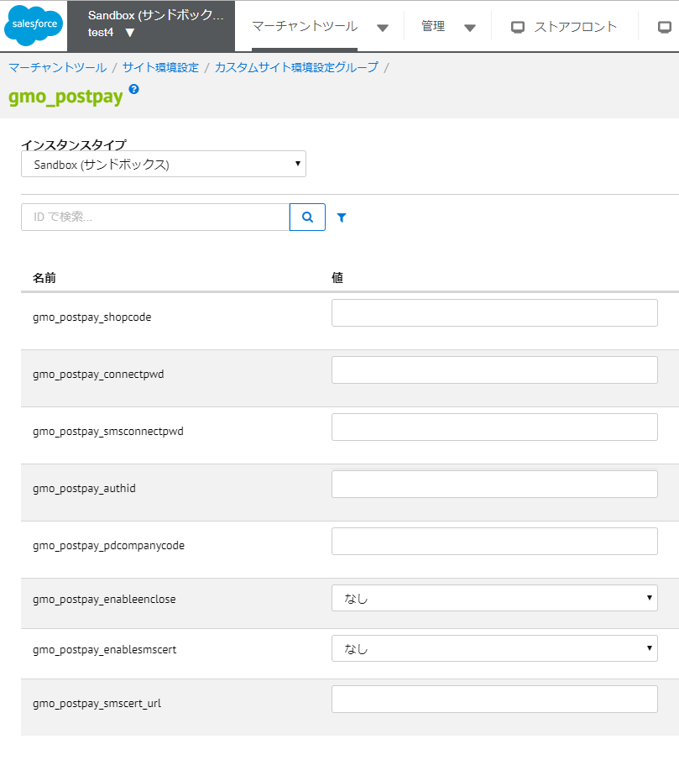

Fields list

|  |  |
| --- | --- |
| 名前 | 内容 |
| gmo_postpay_shopcode | Set the affiliate shop code for GMO post-payment. |
| gmo_postpay_connectpwd | Set the password for automated link service use. |
| gmo_postpay_smsconnectpwd | Set the connection password for SMS authentication use. |
| gmo_postpay_authid | Set the ID for access point of GMO post payment. |
| gmo_postpay_pdcompanycode | Set the default value for shipping company code. |
| gmo_postpay_enableenclose | Set the availability of invoice including service. |
| gmo_postpay_enablesmscert | Set the availability of SMS authentication service. |
| gmo_postpay_smscert_url | Set the URL of JavaScript that calls transaction resistratioSMS authentication. |

### 3.2.5 Importing the service

Register GMO API as services that accessed from this cartridge. If necessary, modify the URLs in service.xml specified by GMO.

Click [アップロード(upload)] in import & export.

Business Manager -> 管理(manage) -> オペレーション(operation) -> サイト環境設定(site configuration setting) ->(site configuration setting), click [アップロード(upload)].

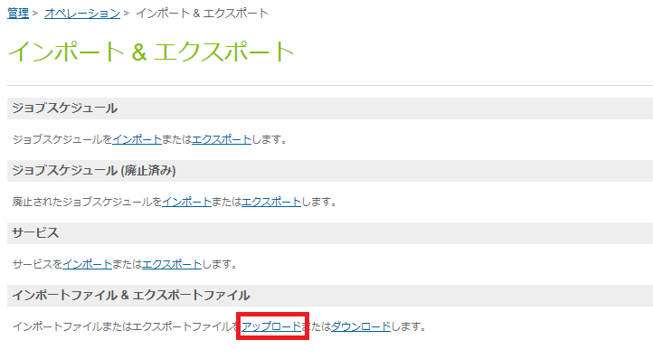

Click [ファイルを選択(select file)]-> select “services.xml” -> Click [アップロード(upload) button].

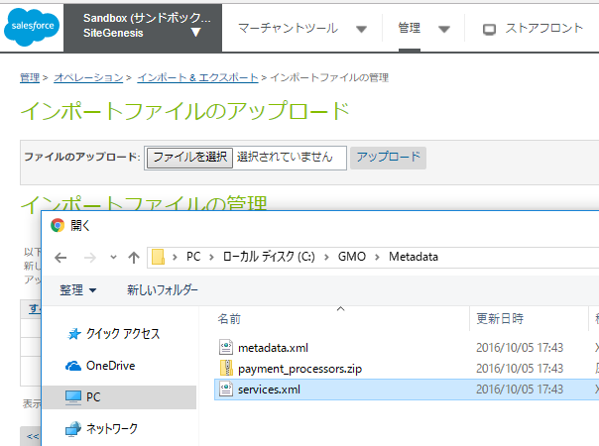

Click [インポート(import)] in import& export page.

Business Manager -> 管理(management) -> オペレーション(operation) -> サイト環境設定(site configuration setting) ->インポート&エクスポート(import& export)に移動しサービスの[インポート(import)].

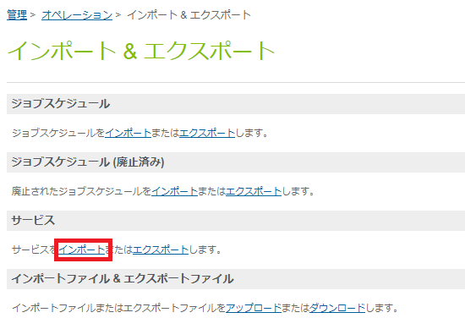

Select [services.xml -> Click [次へ(go next)].

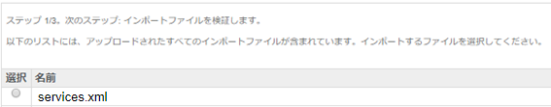

Click [更新(upload)], Click [インポート(import)] in the next page.

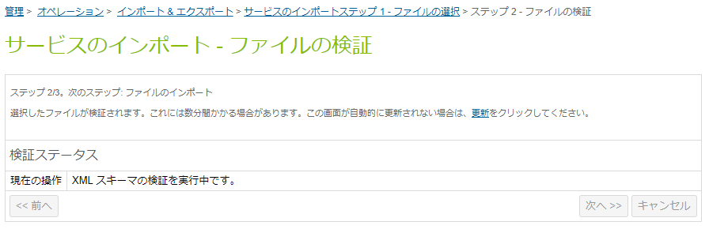

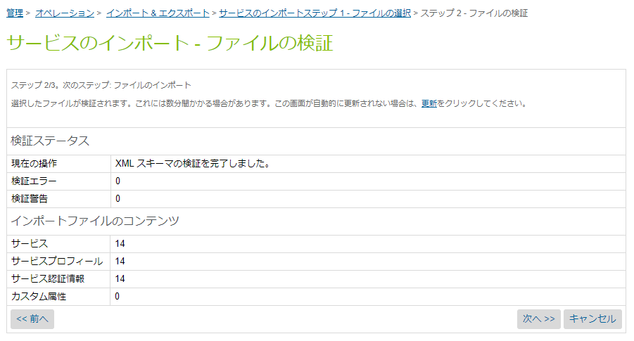

Select「マージ(marge)」, click [インポート(import)].

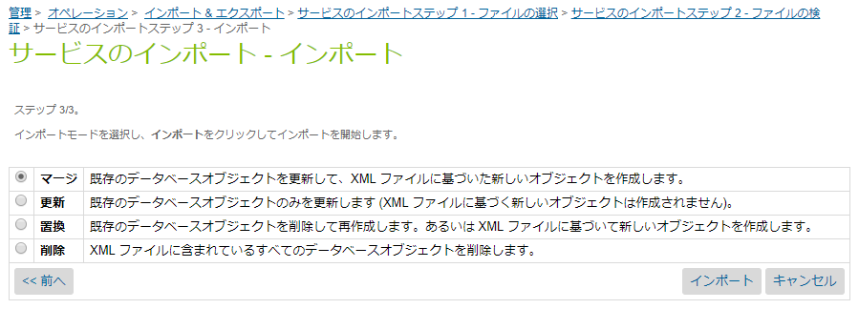

Business Manager -> 管理(management) -> オペレーション(operation) -> transfer to the service

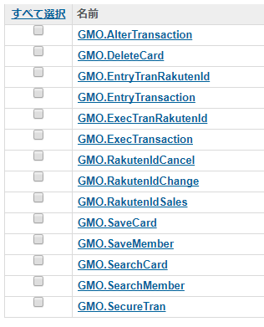

### 3.2.6 Create payment processor

Business Manager -> select your site -> マーチャントツール(merchant tool) -> 注文(order) ->transfer to payment processor.

Add those three below as additional button.

|  |  |
| --- | --- |
| ID | 備考 |
| GMO_PAYMENT | GMO – credit card |
| GMO_RAKUTENID | GMO – Rakuten-peyment |
| GMO_POSTPAY | GMO – GMOpost-payment |

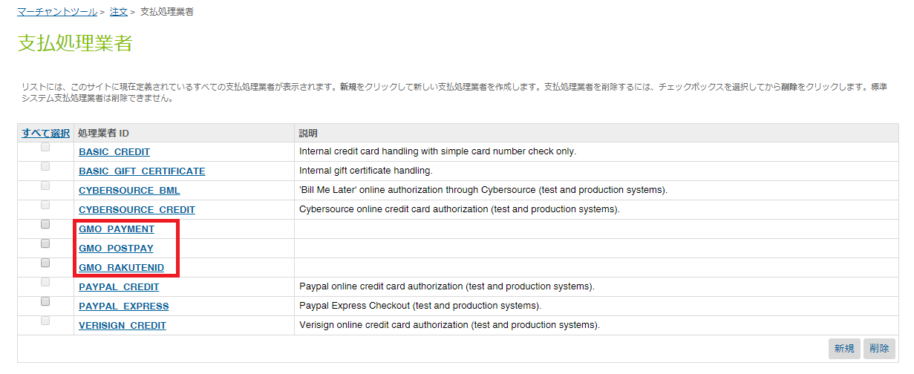

Business Manager -> select your site -> マーチャントツール(merchant tool) -> 注文(order) -> transfer to paymentmethod

・

#### 3.2.6.1Credit card payment

Modify as below.

・Select「CREDIT_CARD」in 「ID」.

・Select GMO_PAYMENT < GMO_PAYMENT >」as 「支払処理業者(payment processor)」.

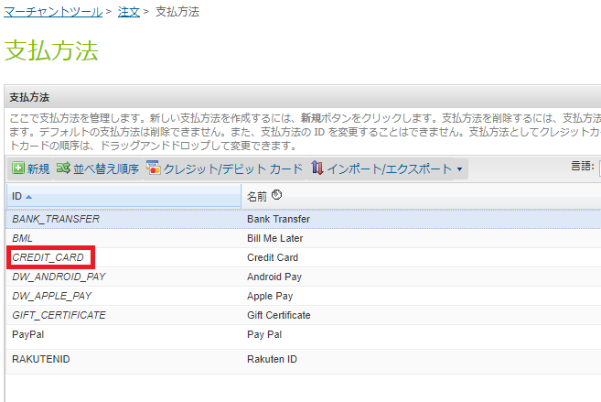

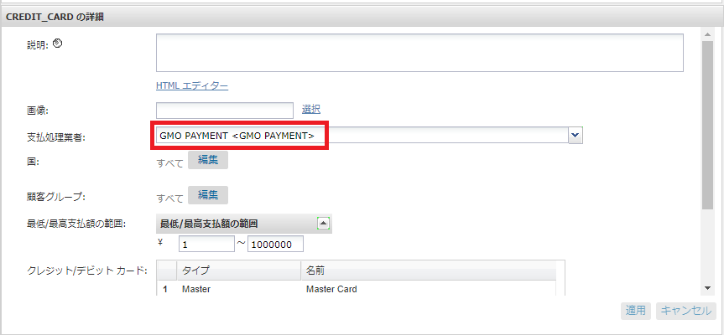

「Visa、Amex、Master、JCB、Diners」are the available credit card brand options for GMO.（It has to be typed as it shown.）

Set the 「有効(available)」as「はい(yes)」for the card brand you are setting.

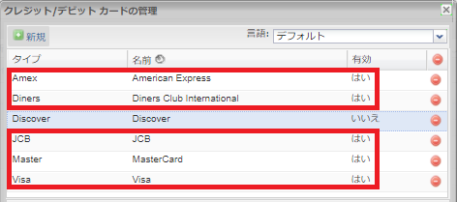

注意：To disable GMO credit card payment feature, クレジットカードの支払処理業者(payment processor) must be set as (BASE_CREDIT).

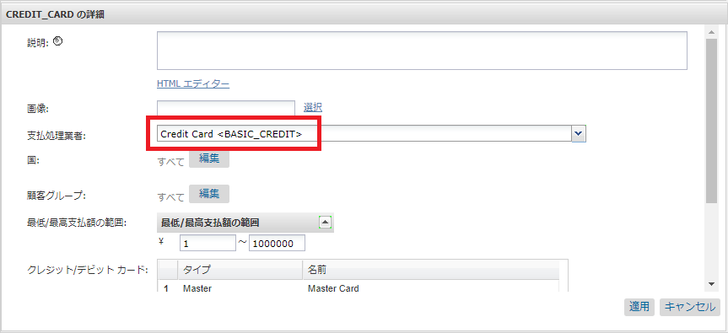

#### 3.2.6.2 Rakuten-payment

Modify as below.

・In[＋新規(create new)], add「RAKUTENID」for「ID」.

・Select 「GMO_RAKUTENID <GMO_RAKUTENID>」as「支払処理業者(payment processor)」.

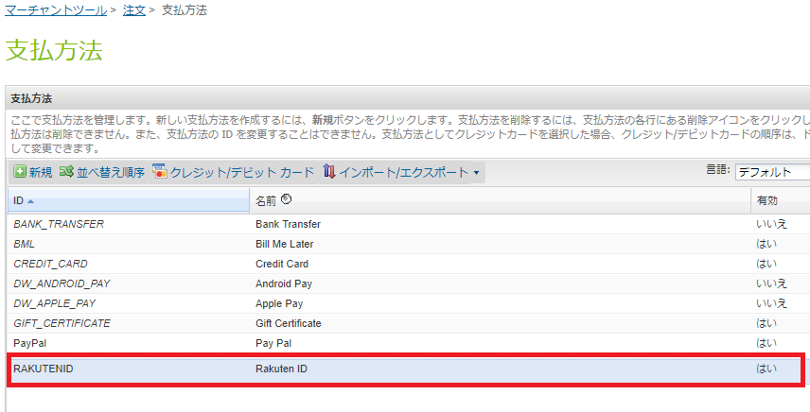

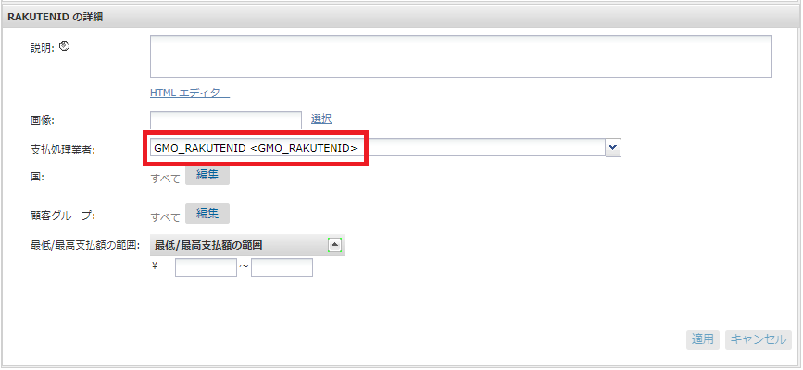

#### 3.2.6.3 GMO post-payment

Modify as below.

・In[＋新規(create new)], add「GMOPOSTPAY」for「ID」.

・Select 「GMO_POSTPAY<GMO_POSTPAY>」as「支払処理業者(payment processor)」.

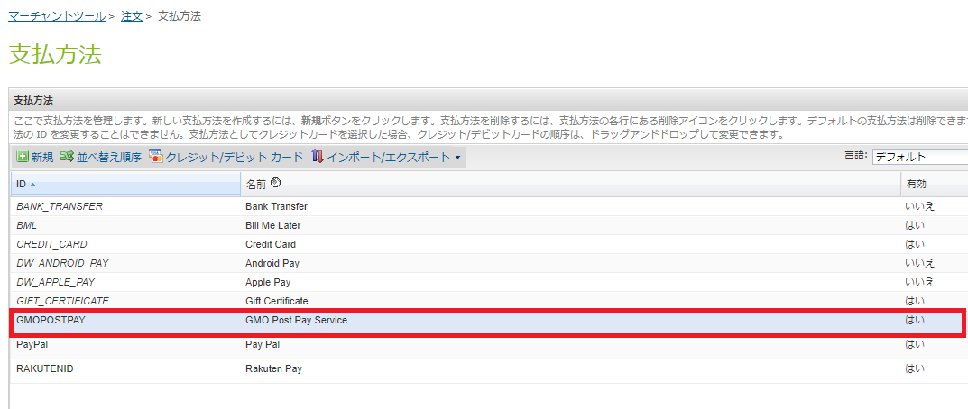

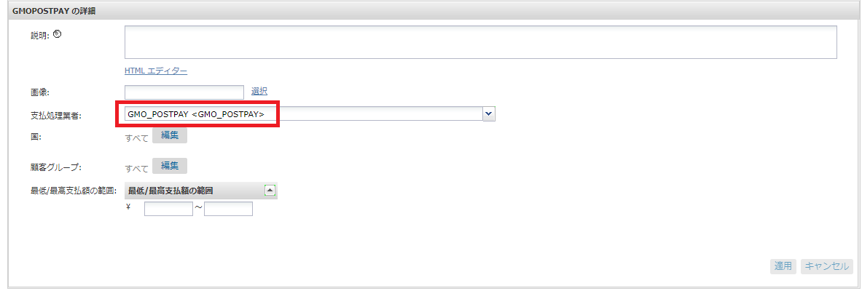

### 3.2.7 Custom log setting

Transfer to custom log setting.

Business Manager -> 管理(management) -> オペレーション(operation) ->カスタムログ

Step1：Add new GMO log category (log level: DEBUG) - >Click 追加(add)button

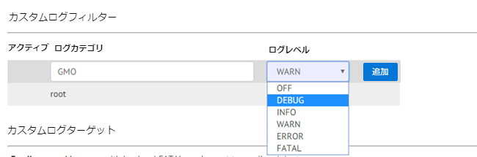

Step2：To receive the message which log level is FATAL,　specify the Email address and click [追加(add)]button.

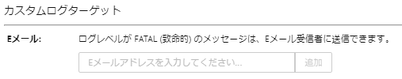

Step3：Select all log level.

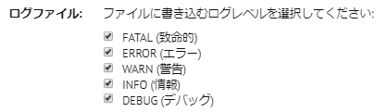

Step4：To save information , click [保存(save)]button .

To check custom log file in Business Manager, transfer to development set up page. And click the log file URL, log in with sand box account.

管理(management) -> サイトの開発(site development) -> 開発セットアップ(development set up)

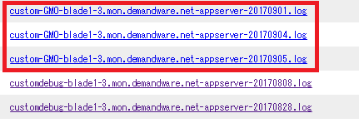

## 3.3Custome code

### 3.3.1 List of the target files for revision

To check the specific difference of the sources, refer the difference with comparison target files in the cartridge.

|  |  |  |
| --- | --- | --- |
| app_gmo_controllers_compare | | |
| Target file | Contents of revision | type |
| controllers/COBilling.js  (comparison target：  COBilling_GMO.js) | ・Addition of the process to get the registered credit car d.  ・Addition of the processto loading the data for payment method, numbers of payment and 3d secure(identification).  ・Adjustment of the credit card validation process.  ・Modification of the resetting process of payment method option for Rakuten-payment  ・Modification of the resetting process of payment method option for GMO post-payment | Modification |
| controllers/COPlaceOrder.js  (comparison target：  COPlaceOrder_GMO.js) | ・Addition of judging process response parameter for saving card information process  ・Addition of receiving process of SMS authentication for both credit card payment and Rakuten payment.  ・Addition of the function to receive the result of credit card payment (with identification)  ・Addition of the function to receive the result of GMO post-payment redirect | Modification |
| controllers/COSummary.js  (comparison target：  COSummary_GMO.js) | ・Addition of receiving process of SMS authentication for Rakuten payment. | Modification |
| controllers/PaymentInstruments.js  (comparison target：  PaymentInstruments_GMO.js) | ・Adjustment of getting process of credit card information  ・Adjustment of process for generating the process (credit card information, confirmation, deletion process)  ・Addition of the function to resister credit card information | Modification |
| scripts/int_gmo.js | ・Addition of the process to get the controller of GMO cartlidge | Addition |
| scripts/hooks.json  (comparison target：hooks_GMO.json) | ・Addition of the definition of the controller pass for credit card payment and Rakuten-payment  ・Addition of the definition of the controller pass for GMO post-payment | Modification |
| Scripts/models/CartModel.js | Addition of the process to issue OrderID in advance for GMOpost-payment（with SMS authentication） | Addition |

|  |  |  |
| --- | --- | --- |
| app_gmo_core_compare | | |
| 対象ファイル | 修正内容 | 区分 |
| forms/default/creditcard.xml  (comparison target：creditcard_GMO.xml) | ・Deletion of mask setting for card number and card type | Modification |
| forms/ ja_JP/creditcard.xml  (comparison target：creditcard_GMO.xml) | ・Addition of the fields(payment method, number of payment time, availability setting for authentication service) | Modification |
| templates/default/account/payment/minicreditcard.isml  (comparison target：  minicreditcard_GMO.isml) | ・Addition of card number for GMO, card type and setting process for card type | Modification |
| templates/default/account/payment/paymentinstrumentdetails.isml  (comparison target：  paymentinstrumentdetails_GMO.isml) | ・Addition of including process for ISML file for GMO  ・Addition of holder name setting process for GMO | Modification |
| templates/default/account/payment/paymentinstrumentlist.isml  (comparison target：  paymentinstrumentlist_GMO.isml) | ・Addition of including process for ISML file for GMO  ・Changed from secureKeyValue to Tokensetting process | Modification |
| templates/default/checkout/pt_checkout.isml  (comparison target：  pt_checkout_GMO.isml) | ・Addition of script “gmo.js” process | Modification |
| templates/default/checkout/pt_checkout_VARS.isml  (comparison target：  pt_checkout_VARS_GMO.isml) | ・Addition of load template steps for GMO postpay. | Modification |
| templates/default/checkout/billing/billing.isml  (comparison target：billing_GMO.isml) | ・Addition of credit card token setting process | Modification |
| templates/default/checkout/billing/paymentmethods.isml  (comparison target：  paymentmethods_GMO.isml) | ・Addition of check-box for credit card registrations function  ・Addition of including process for ISML file for GMO  ・Modification by adding payment method(Rakuten-peyment)  ・Addition of note for GMO postpay. | Modification |
| templates/default/checkout/summary/summary.isml  (comparison target: summary_GMO.isml) | ・Addition of SMS authorize steps for GMO postpay | Modification |
| templates/default/components/header/htmlhead.isml  (comparison target: htmlhead_GMO.isml) | ・Addition of style sheet for GMO | Modification |
| templates/resources/checkout_ja_JP.properties  (comparison target:  checkout_ja_JP_GMO.properties) | ・Addition of note for GMO postpay | Modification |
| templates/resources/forms_ja_JP.properties  (comparison target:  forms_ja_JP_GMO.properties) | ・Addition of resources for payment method and number of the time to devide for installment payment | Modification |
| cartridge/scripts/checkout/CreatePaymentInstrument.ds  (comparison target:  CreatePaymentInstrument_GMO.ds) | ・Addition of ‘exports’ | Modification |

|  |  |  |
| --- | --- | --- |
| 対象ファイル | 修正内容 | 区分 |
| templates/resources/forms_ja_JP.properties  (comparison target：  forms_ja_JP_GMO.properties) | ・Add the resources that are related to payment method and numbers of payments . | Modification |
| cartridge/scripts/checkout/CreatePaymentInstrument.ds  (comparison target：  CreatePaymentInstrument_GMO.ds) | ・Add “exports” | Modification |

## 3.4Cartlidge name

Set the Storefront cartridge name to “int_gmo/cartridge/scripts/app.js”

|  |  |
| --- | --- |
| 項目 | 内容 |
| STORE_FRONT_CORE | Storefront core cartridge name  (default: app_gmo_core) |
| STORE_FRONT_CONTROLLER | Storefront controller cartridge name。  (default: app_gmo_controllers) |

# 4. Note

・When order with payment method Rakuten payment has change(cancelation, change of sales, change of amount of charge), Salesforce Commerce Cloud will reflect the change, not GMO side.（It twill change in 5～30min approximately.）Please check the latest condition on GMO management page.

・To continue the process it is necessary to get redirect from external site for identification feature of Rakuten payment and credit card payment. When Salesforce Commerce Cloud doesn’t get redirect, no operation for change is available. P Please check the latest condition on GMO management page.