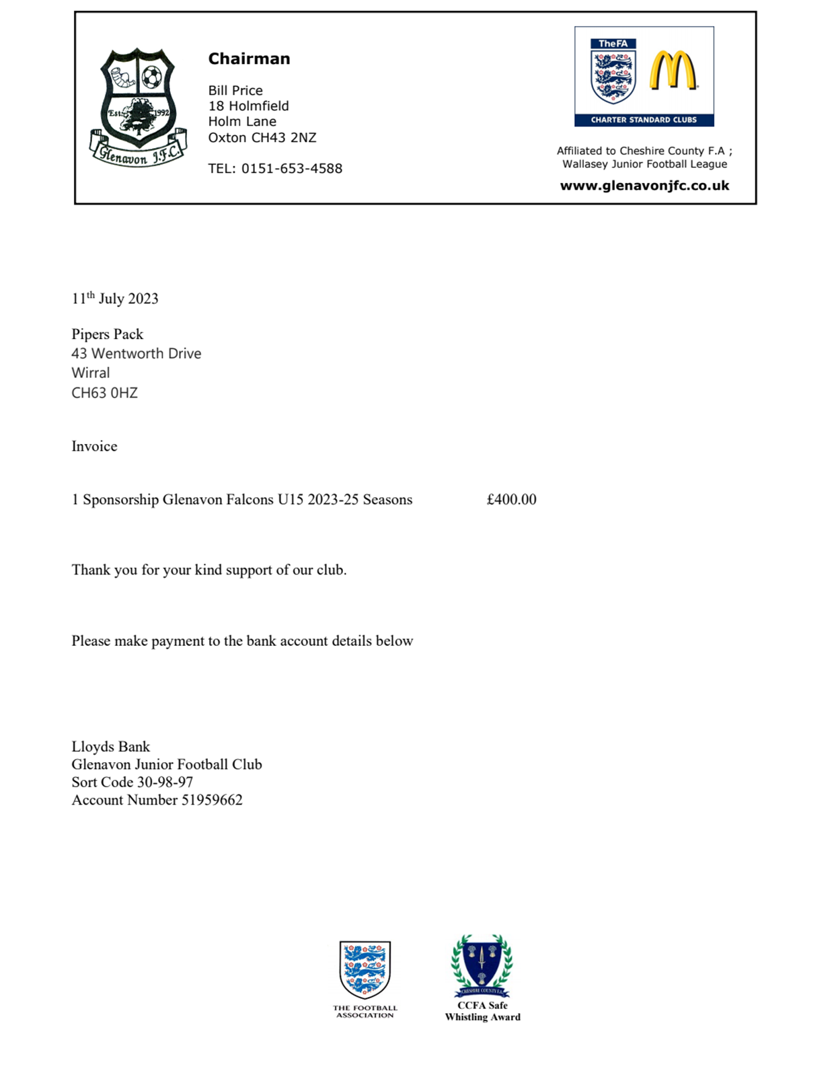

Friday, 16 May 2025
<Insert Sponsor Name>
Invoice

1 Sponsorship Glenavon <Insert Team Name> Season <Insert Season>

<Add Kit Details>

Total cost = £xxx

Thank you for your kind support of our club.

Please make payment to the bank account details below:

Lloyds Bank
Glenavon Junior Football Club
Sort Code 30-98-97
Account Number 51959662

