D603 Machine Learning Task 1
Donovan Hall
B. Describe the purpose of this data mining report by doing the following:
1. Propose one question relevant to a real-world organizational situation that you will answer using one of the following classification methods:
- Random forest: Random Forest classification (RFC) works by taking random samples of data and makes a predicition by making many small decision trees using aspects of the data. Not every variable is used in each tree, so they are different enough from each other. The key features of RFC are that it handles missing data, shows which variables are most useful for making predictions, works well with big and complex data, and can be used for both classification and regression. The assumptions of RFC are as follows: each tree makes its own decision, data is sampled randomly, there is enough data to ensure the decision trees are different, and that different predictions improve accuracy.
- AdaBoost: AdaBoost (AB) works by initially assigning an equal weight to multiple training samples and iteratively adjusts weights by focusing on misclassified data points. By training the data on incorrect predictions the model builds on itself. While this makes this technique resistant to overfitting, it also means that noise in the data set has a disproportionate effect on the quality of the analysis.
- Gradient boost: Gradient boost (GB) is another iterative model that works by repeated attempting to minimize the MSE of the training set. After predictions are made, they are added to the all models prediction to improve the final model. The model prevents overfitting by reducing the weight of each successive prediction, and the final prediction is calculated by summing the shrunk predictions.
Based off the data and methods provided, I will be using random forest classification to attempt to determine which variables are most impactful on churn rate. (Question: Can a random forest classification be an effective method to determine churn rate in a data set?)

2. Define one goal of the data analysis. Ensure that your goal is reasonable within the scope of the scenario and is represented in the available data.
My analysis aims to run the churn data set through a random forest classification model in order to make accurate predictions on churn rate.
C. Explain the reasons for your chosen classification method from part B1 by doing the following:
1. Explain how the classification method you chose analyzes the selected dataset. Include expected outcomes.
Random Forest classification (RFC) works by taking random samples of data and makes a predicition by making many small decision trees using aspects of the data. Not every variable is used in each tree, so they are different enough from each other. The key features of RFC are that it handles missing data, shows which variables are most useful for making predictions, works well with big and complex data, and can be used for both classification and regression. The assumptions of RFC are as follows: each tree makes its own decision, data is sampled randomly, there is enough data to ensure the decision trees are different, and that different predictions improve accuracy.
The expected outcomes of RFC are as follows: predictions derived from the test dataset and corresponding accuracy score, a ranking of features by importance, and a confusion matrix that shows a detailed breakdown of the model’s performance.

2. List the packages or libraries you have chosen for Python or R, and justify how each item on the list supports the analysis.
I used the pandas library to group data into dataframes, and for general manipulation to the data.
I used matplotlib.pyplot to construct my visuals and show/save them as pngs.
From sklearn.model_selection I used train_test_split to split my data into train/validation/test sets, and GridSearchCV to tune my hyperparameters
From sklearn.ensemble I used RandomForestClassifier to make my RFC model.
From sklearn.metrics I used the following packages to calculate/show my metrics: accuracy_score, precision_score, recall_score, f1_score, roc_auc_score, confusion_matrix, and ConfusionMatrixDisplay to display it.

D. Perform data preparation for the chosen dataset by doing the following:
1. Describe one data preprocessing goal relevant to the classification method from part B1.
The basic preprocessing requirements for RFC are: fixing/removing null values, encoding categorical data, and making a test/train split. One-hot encoding is frequently using in machine learning. A categorical variable is split into multiple Boolean dummy variables, which allows your analysis to treat it as a numerical value. An example of this would be turning the variable housecolor (with options or red, green, or blue) into the dummy variables housecolor_red and housecolor_green. If the value is 1 for either of these variables then that is the color of the house. If they are both 0 then the house color is blue.

2. Identify the initial dataset variables that you will use to perform the analysis for the classification question from part B1, and classify each variable as continuous or categorical.
I will be using the following variables in my analysis:
The variable Population is a numerical variable.
The variable Area is a categorical variable.
The variable Children is a numerical variable.
The variable Age is a numerical variable.
The variable Income is a numerical variable.
The variable Marital is a categorical variable.
The variable Gender is a categorical variable.
The variable Churn is a categorical variable.
The variable Outage_sec_perweek is a numerical variable.
The variable Email is a numerical variable.
The variable Contacts is a numerical variable.
The variable Yearly_equip_failure is a numerical variable.
The variable Techie is a categorical variable.
The variable Contract is a categorical variable.
The variable Port_modem is a categorical variable.
The variable Tablet is a categorical variable.
The variable InternetService is a categorical variable.
The variable Phone is a categorical variable.
The variable Multiple is a categorical variable.
The variable OnlineSecurity is a categorical variable.
The variable OnlineBackup is a categorical variable.
The variable DeviceProtection is a categorical variable.
The variable TechSupport is a categorical variable.
The variable StreamingTV is a categorical variable.
The variable StreamingMovies is a categorical variable.
The variable PaperlessBilling is a categorical variable.
The variable PaymentMethod is a categorical variable.
The variable Tenure is a numerical variable.
The variable MonthlyCharge is a numerical variable.
The variable Bandwidth_GB_Year is a numerical variable.
The variable Item1 is a categorical, ordinal variable.
The variable Item2 is a categorical, ordinal variable.
The variable Item3 is a categorical, ordinal variable.
The variable Item4 is a categorical, ordinal variable.
The variable Item5 is a categorical, ordinal variable.
The variable Item6 is a categorical, ordinal variable.
The variable Item7 is a categorical, ordinal variable.
The variable Item8 is a categorical, ordinal variable.

3. Explain each of the steps used to prepare the data for the analysis. Identify the code segment for each step.
Removing Null Values: I viewed the number of nulls in each column using the below function.
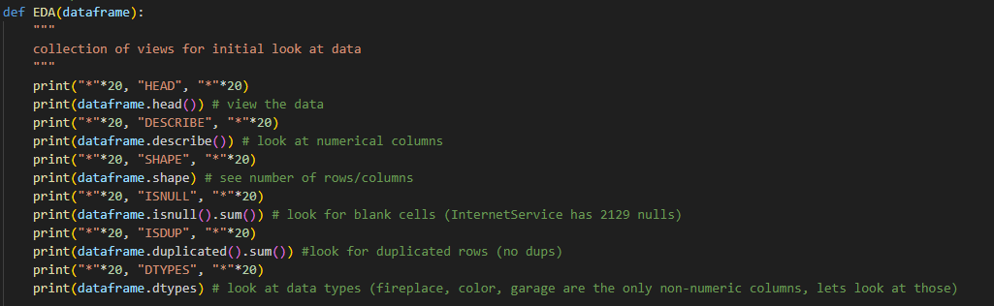
The only column with nulls was InternetService, and after looking at the data dictionary it became clear that the reason for this was because the if a customer did not have a service provider it was marked “None” which got translated to nan. Because these were the only nulls in the entire data set I was able to use a more efficient strategy and used the below line of code to replace all nulls with “No Service”
Encoding Categorical Data: I made a new xlsx file with 2 columns: the variables I will be using and their data type (categorical or numerical). I made a list object containing the categorical variables, and removed the categorical ordinal data from it. Then, I used pd.get_dummies() to one-hot encode the non-ordinal data. Finally, I replaced all “Yes” and “No” in the data set to 1 and 0.
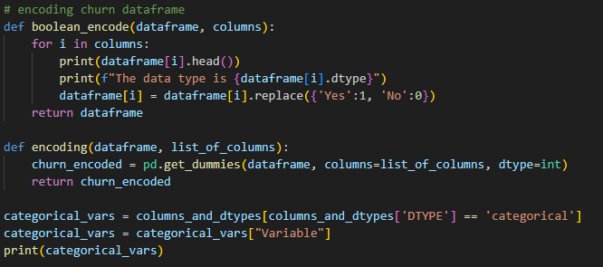
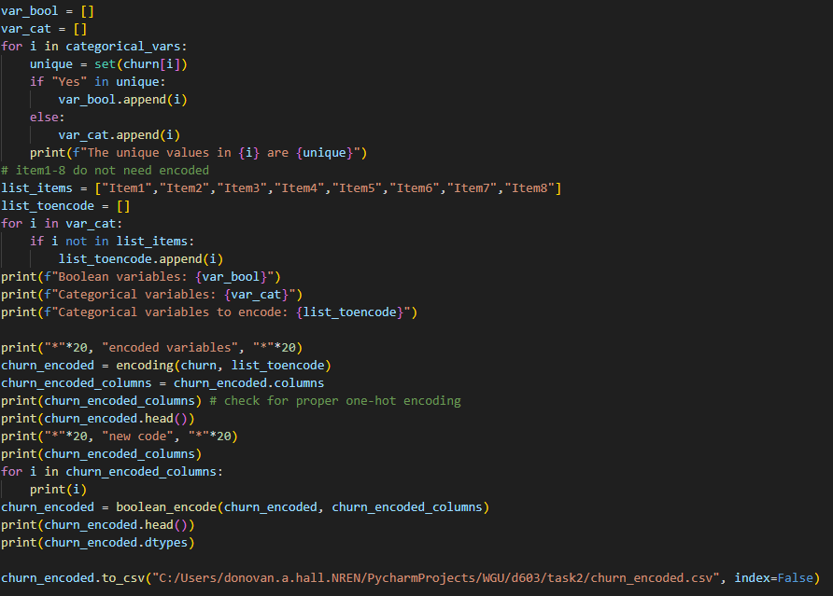
Test Train Split: After splitting my encoded data into X (independent) and y (dependent, Churn) variables, I used sklearn’s train_test_split function to split my data into an 85/15 train/test set. Then I split the training set into a 82.36/17.64 train/validation split in order to make the final data set 70/15/15 train/validation/testing split.
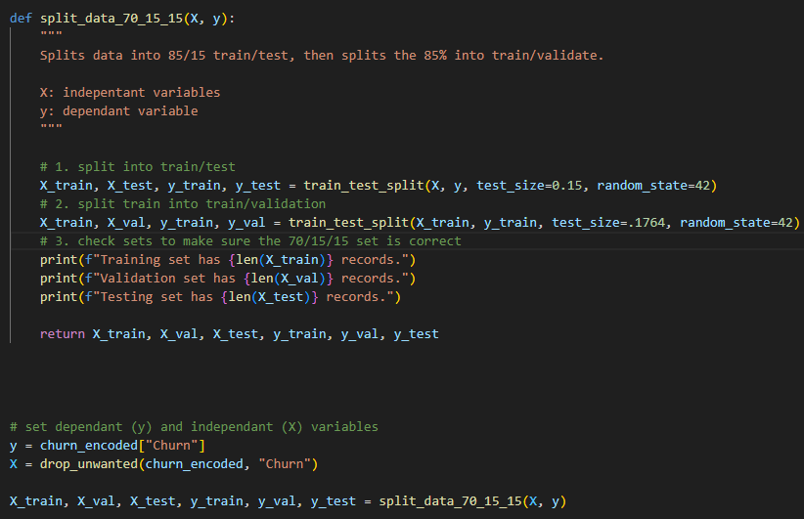
4. Provide a copy of the cleaned dataset.
The clean data set churn_encoded.csv will be uploaded along with this report.
E. Perform the data analysis and report on the results by doing the following:
1. Split the data into training, validation, and test datasets and provide the file(s).
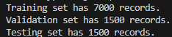
2. Create an initial model using the training dataset and provide a screenshot of the following metrics:
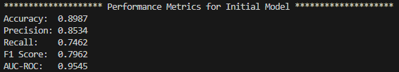
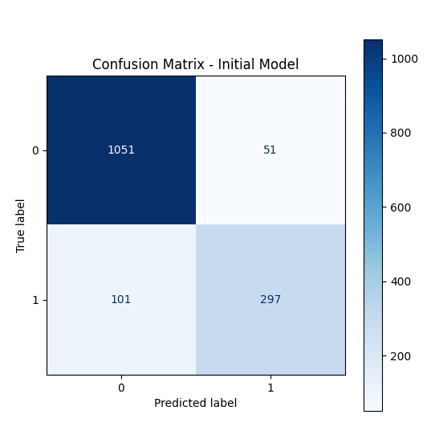
3. Perform hyperparameter tuning on the validation dataset using k-fold cross validation to find the optimized model. Provide the following in the submission:
There are 4 hyperparameters I used for tuning the model: number of trees, max depth of each tree, minimum sample/leaf, and max features. Number of trees controls the number of decision trees used in the RFC model. The more trees that are used, the more accurate the model. However, each tree adds a diminishing return on overall performance at a cost of time spent training the model. 100 trees is the default value for this hyperparameter using scikit learn, and I am comparing 50 and 200 trees to see the difference in overall performance between a faster but less complex model and a slower, but more complex (and theoretically better overall performance) model is.
The second hyperparameter I am testing is the maximum number of splits each tree can have. If the max depth is too low, the trees are too simple to fully capture the data, and are heavily affected by trends (underfitting). If there are too many splits, the model essentially memorizes the data instead of doing an analysis of the data and overfits to the validation set, which results in a model that is heavily influenced by large ranges in the data (overfitting). The default value is none, or no restrictions on max depth. I will be comparing the most complex model to max depths of 10 and 20 splits. If either of these models have a better overall performance than the default model then that tells us that there are probably overfitting problems in the most complex model, and fewer splits are needed to accurately capture the data.
The third hyperparameter I am testing is the minimum number of samples that each tree terminates in. 1 is the default value, and is used to show the model that is most prone to overfitting. Because each sample only has 1 data point, any outliers or large ranges have outsized effect on the final model. I will be comparing it to 2 and 4 samples per leaf, to determine how increasing group size to determine how much noise affects the model.
The last hyperparameter I am testing is the number of features to consider at each split. Too few features and many trees won’t lead to useful results. Too many splits reduces the diversity of the trees. The default value is the square-root of the total number of variables. I will be comparing this to the base-2 logarithm of the number of features to see if a fewer number of splits (and therefore increased diversity of the trees) improves overall performance.
• screenshot of the best hyperparameters
Below is a screenshot of my best hyperparameters:

4. Use the optimized model identified in part E3 to make predictions using the test dataset and provide a screenshot of the following metrics:
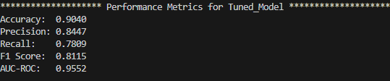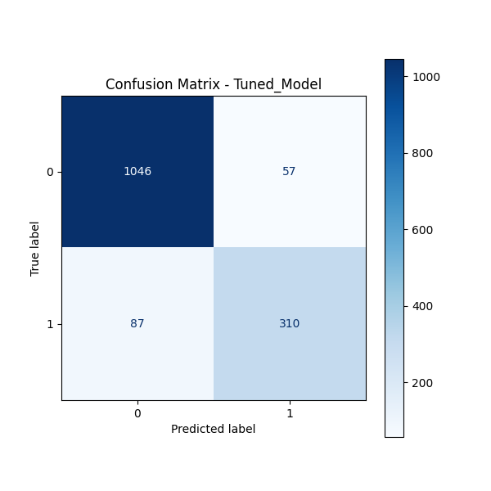

F. Summarize your data analysis by doing the following:
1. Compare and discuss the metrics of accuracy, precision, recall, F1 score, and AUC-ROC from the use of the optimized model on the test dataset and the initial model on the training dataset to evaluate the performance of the optimized model.
Accuracy: The overall percentage the model correctly predicted. The optimized model took the accuracy from 89.87% to 90.40%, a 0.53% increase. Guessing over 90% correctly is a strong initial metric, as opposed to a percentage in the high 90s, which is a sign of overfitting.
Precision: The percentage of customers who churned that the model correctly predicted, or the confidence the model has when it says someone will churn. The optimized model took the precision from 85.34% to 84.47%, a 0.87% decrease in precision. This means that the optimized model is slightly more likely to predict a false positive. This number is more important if the cost of a false positive is higher than a false negative.
Recall: The percentage of customers who churned that the model correctly identified, or percentage of churned customers that the model identified. The optimized model took the precision from 74.62% to 78.09%, a 3.47% increase in recall. This means that the optimized model is slightly less likely to predict a false negative. This number is more important if the cost of a false positive is lower than a false negative.
F1 Score: The overall measure on how effective the model is when predicting a positive result (customer will churn). The optimized model took the F1 score from 79.62% to 81.15%, a 1.53% increase. This number is more important if the cost of predicting a false positive and negative is similar.
AUC-ROC: Area under the curve of the plot of recall versus false positive rate, or how well the model can distinguish between a churning and non-churning customer. The optimized model took the precision from 95.45% to 95.52%, a 0.07% decrease in precision. This means that the optimized model is slightly at distinguishing between churning and non-churning customers.
2. Discuss the results and implications of your classification analysis.
Overall, the optimization of the model slightly improved the overall quality of the model. The highest improvement was in the recall score, and the only metric that got worse was precision. The initial model was by no means a terrible model, and the slight improvements made by the train/validate/test optimization points to a similar conclusion. The recall score remained the lowest, and in a business setting I would want to do more analysis before calling it good. Every other metric was over 80%, which is pretty good for the way the data was split. RFC looks to be an effective tool for determining a Boolean dependent variable like “Will a customer churn?”
3. Discuss one limitation of your data analysis.
Due to my lack of experience with this industry I am highly reliant on the dataset for data that makes sense. Because this is an assignment for school instead of a real world example, I cannot go to the person who collected the data to ask questions about any anomalies in the dataset. Additionally, I can’t get a new set of data collected to compare against the original.
4. Recommend a course of action for the real-world organizational situation from part B1 based on your results and implications discussed in part F2.
This is a relatively strong model overall. Before using it to influence business decisions, I would recommend a real-world organization to investigate the cause the comparatively low recall percentage and do further analysis to improve it.

Works Cited
- https://www.geeksforgeeks.org/machine-learning/random-forest-algorithm-in-machine-learning/
- https://www.geeksforgeeks.org/machine-learning/adaboost-in-machine-learning/
- https://www.geeksforgeeks.org/machine-learning/ml-gradient-boosting/
The above links were to help with my understanding of the classification methods I needed to choose from. No code was written or copied from these sites.

