D603 Machine Learning Task 2
Donovan Hall

B. Describe the purpose of this data mining report by doing the following:
1. Propose one question relevant to a real-world organizational situation that you will answer using one of the following clustering techniques:
A k-means clustering algorithm divides the dataset into a predetermined number of distinct, non-overlapping clusters by iterating over the data and moving the centerpoint each time.
A hierarchical clustering algorithm creates a dendrogram (it sorts clusters into a tree diagram). Because it measures distance between clusters, it does not require a number of clusters to be specified. It does this by working from a data cluster containing all data and separating into multiple clusters, or by having each data point be its own cluster and merging clusters.
The question I will be answering with this report is: Can a hierarchical clustering method be used to construct effective customer profiles based off of their churn rate and customer history?

2. Define one goal of the data analysis. Ensure your goal is reasonable within the scope of the selected scenario and is represented in the available data.
This analysis aims to run the churn dataset through a hierarchical clustering algorithm to separate the customers into discrete profiles based off churn history. By creating these profiles, the company can investigate solutions to reduce churn rate in high risk groups.

C. Explain the reasons for your chosen clustering technique from part B1 by doing the following:
1. Explain how the clustering technique you chose analyzes the selected dataset. Include expected outcomes.
Hierarchical clustering starts with either a data cluster containing all data points and separating into multiple clusters, or by having each data point be its own cluster and merging clusters. This creates a tree diagram that the analyst can break apart into various sized clusters. The expected outcomes are a measure of distance between different clusters. This in turn allows for the tree-like structure, which allows you to determine relationships between clusters.
2. Summarize one assumption of the clustering technique.
Data must be numeric. This means that any categorical data must be one-hot encoded. Additionally data must be on a comparable scale, such as standard scaling. Finally, there must not be any missing values.

3. List the packages or libraries you have chosen for Python or R, and justify how each item on the list supports the analysis.
I used the pandas library to group data into dataframes, and for general manipulation to the data.
I used matplotlib.pyplot to construct my visuals and show/save them as pngs.
I used StandardScaler from sklearn.preprocessing to scale my data.
I used dendrogram and linkage from scipy.cluster.hierarchy to construct my linkage dataframe and to construct my dendrogram
I used AgglomerativeClustering from sklearn.cluster to train my model using agglomerative clustering.
I used seaborn to construct my heatmap.

D. Perform data preparation for the chosen dataset by doing the following:
1. Describe one data preprocessing goal relevant to the clustering technique from part B1.
The basic preprocessing requirements for this technique are: fixing/removing null values, encoding categorical data, and feature scaling. One-hot encoding is frequently using in machine learning. A categorical variable is split into multiple Boolean dummy variables, which allows your analysis to treat it as a numerical value. An example of this would be turning the variable housecolor (with options or red, green, or blue) into the dummy variables housecolor_red and housecolor_green. If the value is 1 for either of these variables the that is the color of the house. If they are both 0 then the house color is blue.

2. Identify the initial dataset variables you will use to perform the analysis for the clustering question from part B1, and label each as continuous or categorical.
I will be using the following variables in my analysis:
The variable Population is a numerical variable.
The variable Area is a categorical variable.
The variable Children is a numerical variable.
The variable Age is a numerical variable.
The variable Income is a numerical variable.
The variable Marital is a categorical variable.
The variable Gender is a categorical variable.
The variable Churn is a categorical variable.
The variable Outage_sec_perweek is a numerical variable.
The variable Email is a numerical variable.
The variable Contacts is a numerical variable.
The variable Yearly_equip_failure is a numerical variable.
The variable Techie is a categorical variable.
The variable Contract is a categorical variable.
The variable Port_modem is a categorical variable.
The variable Tablet is a categorical variable.
The variable InternetService is a categorical variable.
The variable Phone is a categorical variable.
The variable Multiple is a categorical variable.
The variable OnlineSecurity is a categorical variable.
The variable OnlineBackup is a categorical variable.
The variable DeviceProtection is a categorical variable.
The variable TechSupport is a categorical variable.
The variable StreamingTV is a categorical variable.
The variable StreamingMovies is a categorical variable.
The variable PaperlessBilling is a categorical variable.
The variable PaymentMethod is a categorical variable.
The variable Tenure is a numerical variable.
The variable MonthlyCharge is a numerical variable.
The variable Bandwidth_GB_Year is a numerical variable.
The variable Item1 is a categorical, ordinal variable.
The variable Item2 is a categorical, ordinal variable.
The variable Item3 is a categorical, ordinal variable.
The variable Item4 is a categorical, ordinal variable.
The variable Item5 is a categorical, ordinal variable.
The variable Item6 is a categorical, ordinal variable.
The variable Item7 is a categorical, ordinal variable.
The variable Item8 is a categorical, ordinal variable.

3. Explain each of the steps used to prepare the data for the analysis. Identify the code segment for each step.
Removing Null Values: I viewed the number of nulls in each column using the below function.
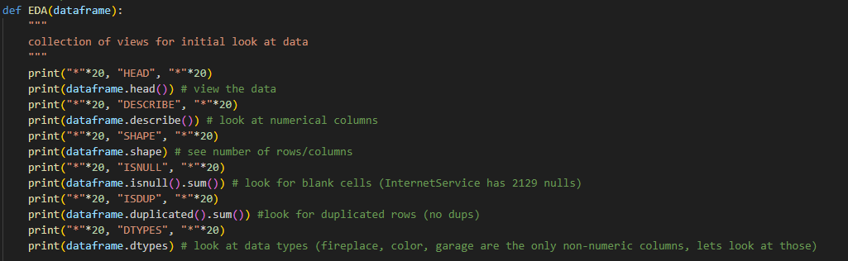
The only column with nulls was InternetService, and after looking at the data dictionary it became clear that the reason for this was because the if a customer did not have a service provider it was marked “None” which got translated to nan. Because these were the only nulls in the entire data set I was able to use a more efficient strategy and used the below line of code to replace all nulls with “No Service”
Encoding Categorical Data: I made a new xlsx file with 2 columns: the variables I will be using and their data type (categorical or numerical). I made a list object containing the categorical variables, and removed the categorical ordinal data from it. Then, I used pd.get_dummies() to one-hot encode the non-ordinal data. Finally, I replaced all “Yes” and “No” in the data set to 1 and 0.
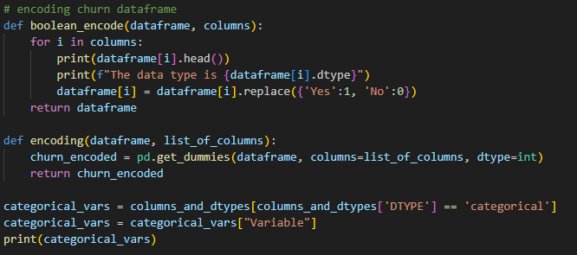
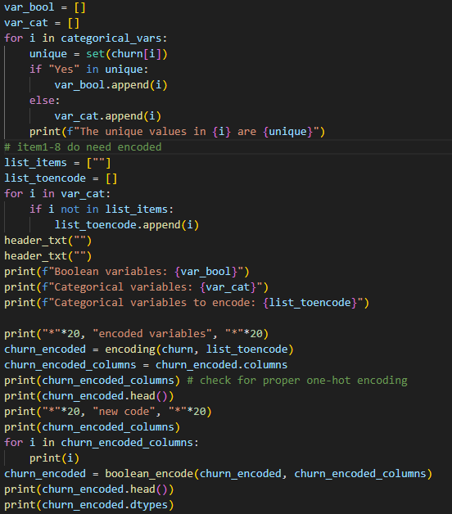
Scaling Data: I imported StandardScaler and used fit.transform to apply it to my encoded dataset.
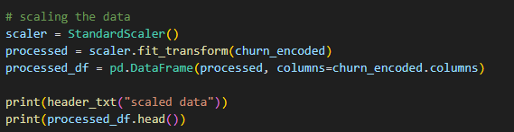

4. Provide a copy of the cleaned dataset.
A copy of the dataset will be submitted with this report.
E. Perform the data analysis and report on the results by doing the following:
1. Determine the optimal number of clusters in the dataset, and describe the method used to determine this number.
The correct way to determine optimum number of clusters when using a hierarchical algorithm is to construct a dendrogram to visualize a linkage matrix measuring Euclidian distance between data points. Euclidian distance is the technical term for the measure of how different two scaled records are. The linkage function uses a merge method to perform a hierarchical clustering algorithm and stores this data in a linkage matrix. I am using the default – Ward – method to merge my data, which tries to create the most compact clusters possible by minimizing the spread after a merge. Below is a tabular visualization of the final 20 merges of my linkage matrix as well as my dendrogram.
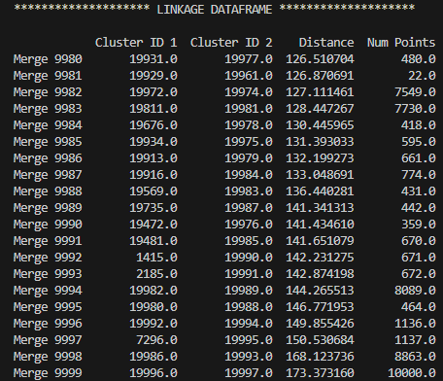
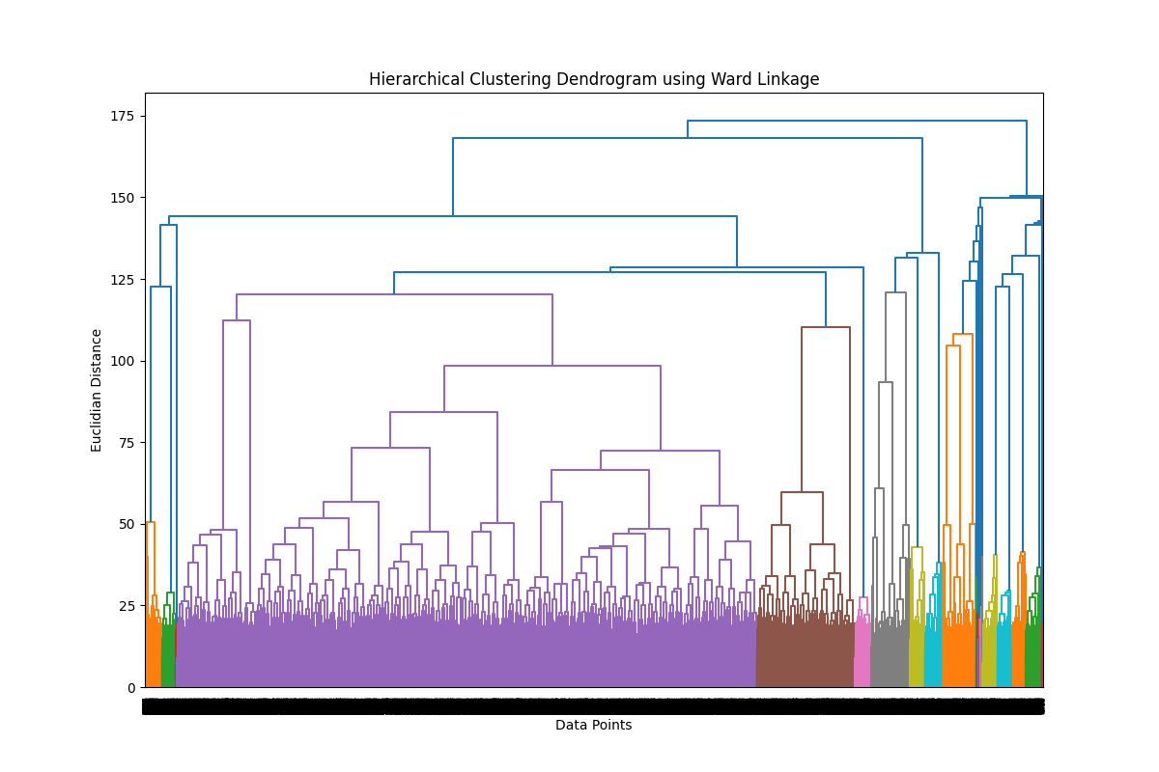

The value from the Euclidian distance is relative; IE the fewer variables the larger the impact of the distance. The presence or absence of scaling also has a massive effect on the usefulness of this metric. I am using many standard scaled variables, so I need to look for large jumps to determine which merges are unnatural. It looks like there is a massive jump (distance delta of over 17) moving from 3 clusters to 2, meanwhile the merges from 10 clusters and fewer are much smaller. Using the elbow rule I can confidently say that a useful number of clusters to start with is 3.
Once I figured out my ideal number of clusters, I trained an agglomerative clustering model on my data set. This works by setting every data point as its own individual cluster, and then merging them using the ward linkage discussed above.
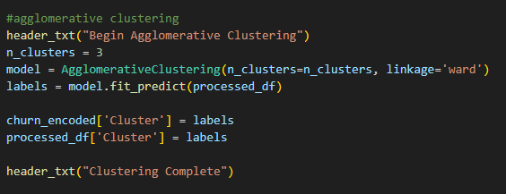
F. Summarize your data analysis by doing the following:
1. Visualize the clusters and explain the quality of the clusters created. Include a screenshot of the cluster visualizations.
In order to visualize my clusters I first had to determine the most important variables in each cluster. I found the range of each scaled variable, sorted by cluster, and listed them out in descending order. The data had to be scaled so that different variables could be compared with each other. Otherwise a relatively small change in yearly income (around $1000) would completely overshadow the results of my survey response (one-hot encoded). This let me use the ‘elbow rule’ to see if there was a dropoff in the importance of the average range for each cluster.
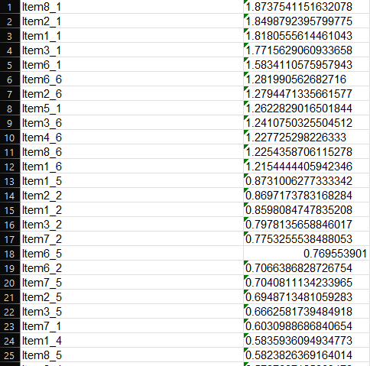
I found the largest dropoff was between row 12 and 13, with a smaller dropoff between row 22 and 23. I decided to graphically represent both of these drop-offs to see if the increased granularity improved my overall analysis. I used a heatmap to visualize the difference between scaled clusters, shown below:
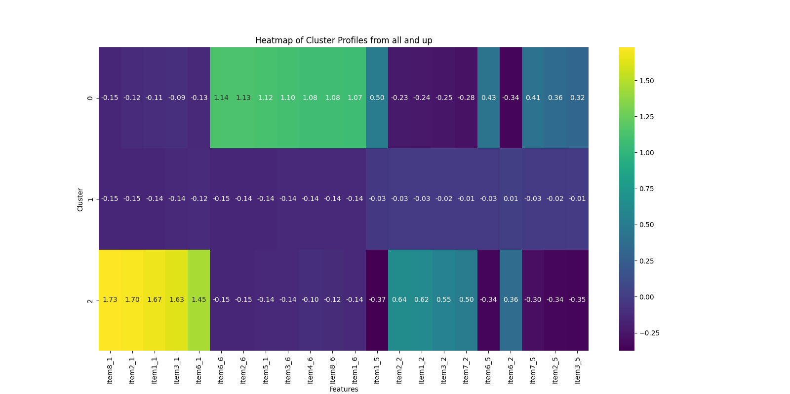
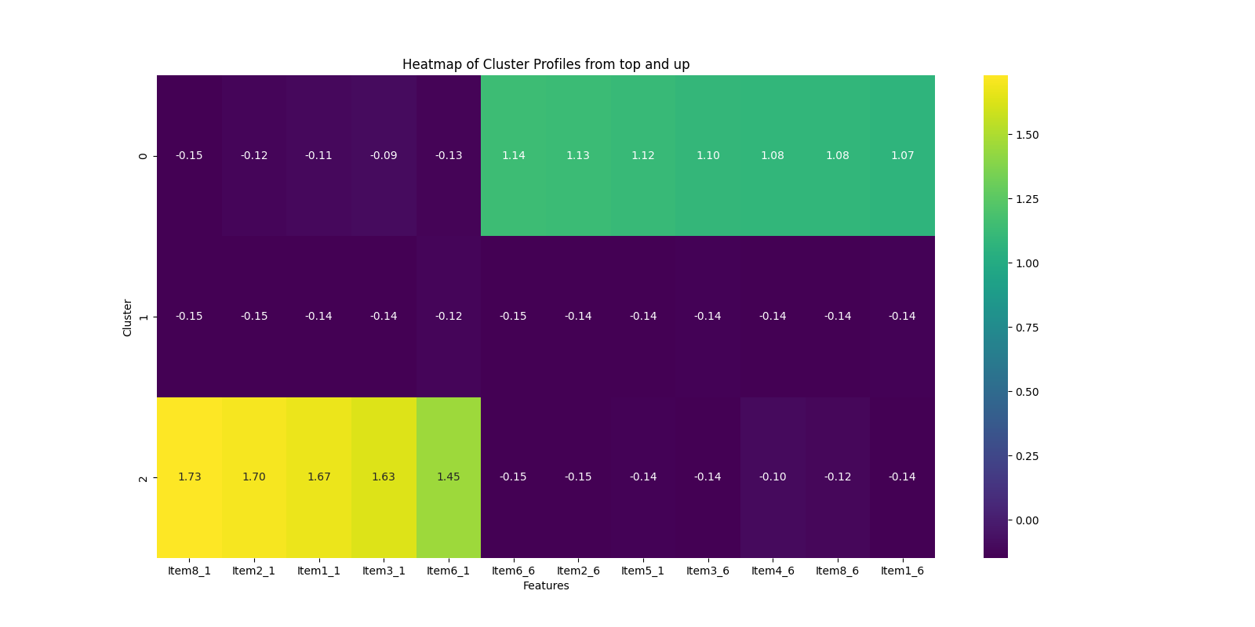

2. Discuss the results and implications of your clustering analysis.
All of the largest ranges in the scaled model involve the survey questions, and group the customers into 3 groups: Those who think timely responses, fixes, replacements, respectful response, and active listening are important, those who don’t feel strongly either way, and those who think Options are very important, and think timely responses, fixes, replacements, respectful response, and active listening are not important. To summarize, group 1 cares very strongly about options, and not much else. Group 3 cares very strongly about customer service. And the survey data does not capture Group 2’s thoughts about what is important.
3. Discuss one limitation of your data analysis.
My analysis suggests that the customers are sharply divided based on how they answered the survey question. Unfortunately, the provided data doesn’t give me the actual questions so the implications of the analysis are much less impactful than they could be.
4. Recommend a course of action for the real-world organizational situation from part B1 based on the results and implications discussed in part F2.
My recommendation for a real world organization would be to take the clusters found in this analysis and run them by the important business metrics such as churn rate. They can then tailor their approach to the cluster with the worst churn rate to attempt to ameliorate it.
Works Cited
- https://www.geeksforgeeks.org/machine-learning/hierarchical-clustering/
- https://www.geeksforgeeks.org/machine-learning/k-means-clustering-introduction/
The above links were to help with my understanding of the classification methods I needed to choose from. No code was written or copied from these sites.

