Statistical Data Mining: Linear Regression Analysis on Airline Data

Donovan Hall

A. Describe the purpose of this data analysis by doing the following:
1. Propose one research question that is relevant to a real-world organizational situation captured in the provided dataset that you will answer using multiple linear regression in the initial model.
The question that this analysis will answer is: “What aspect of a house most strongly influences its final price?”
2. Define one goal of the data analysis. Ensure that your goal is relevant within the scope of the scenario and is represented in the available data.
The goal of this analysis will be to provide a list to prospective homeowners of the 5 most impactful changes they can make to lower the final price of their house. For example, if school rating had a large impact on final price, then a family that planned to homeschool their children could look for houses with lower school ratings to save money.

B. Summarize the data preparation process for multiple linear regression analysis by doing the following using Python or R:
1. Identify the dependent variable and 10 or more independent variables that are required to answer the research question and justify your selection of all variables.
The dependent variable for this MLR analysis is the Price column. My research question requires a ranking of how impactful each variable is to the final price, so I will be using all variable provided with the exception of ID, as that is an index column and not actually useful for analysis, and doing a stepwise elimination to remove those that don’t interact significantly with the dependent variable.
2. Provide at least one screenshot of the descriptive statistics (e.g., mean, median, range, standard deviation, variance, percentiles, quartiles) for the quantitative (i.e., numeric) variables selected (e.g., frequency counts and percentages) from part B1 and for the qualitative (i.e., categorical) variables if selected. 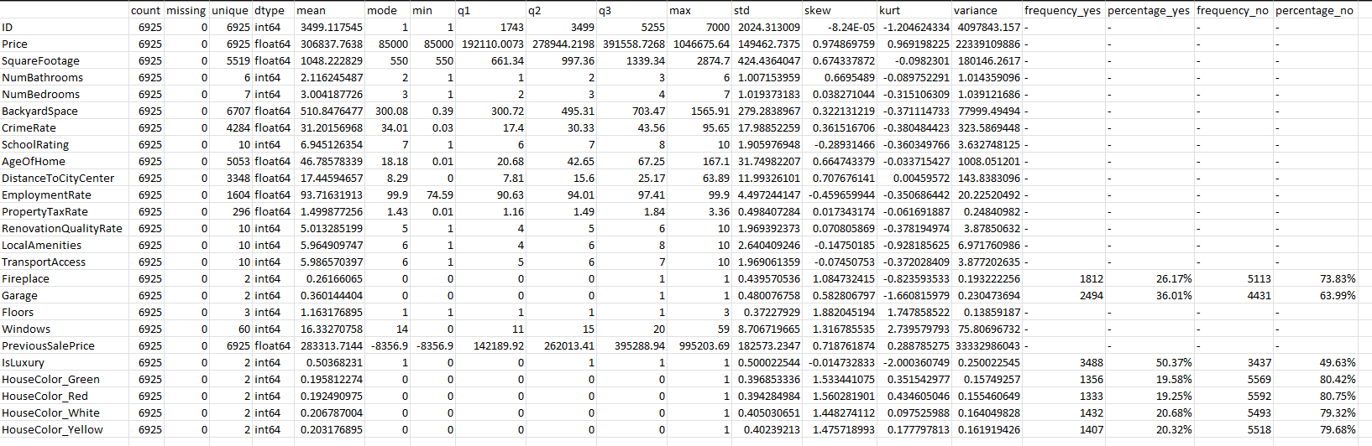

3. Generate univariate and bivariate visualizations of the distributions of the dependent and independent variables from part B1, including the dependent variable in the bivariate visualizations.

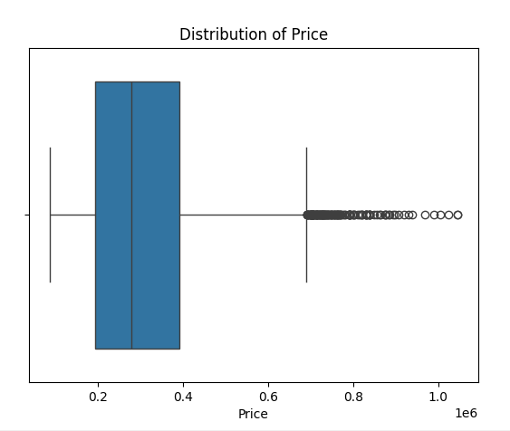
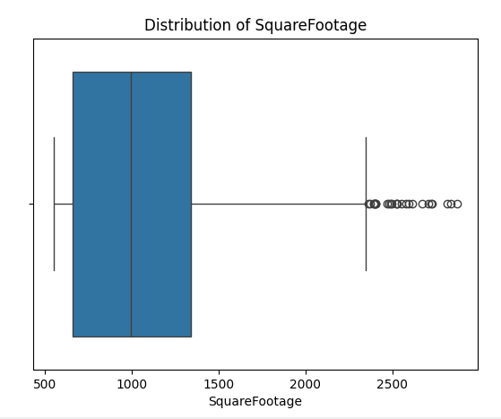
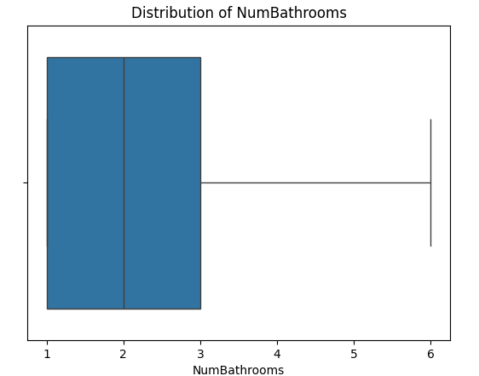
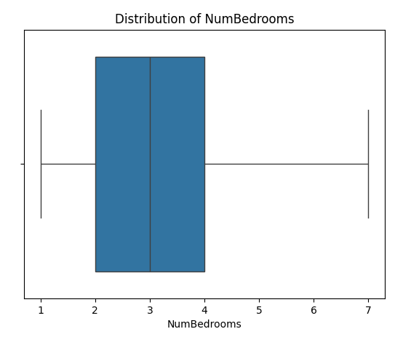
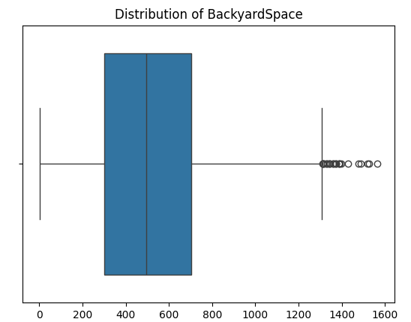
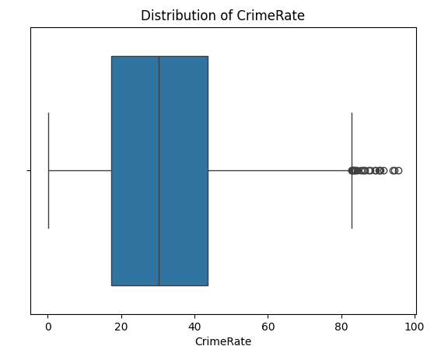
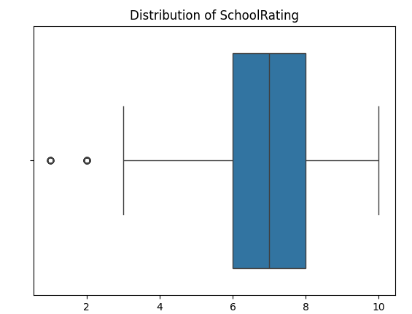
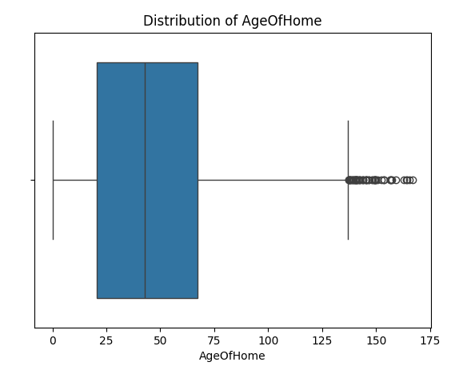
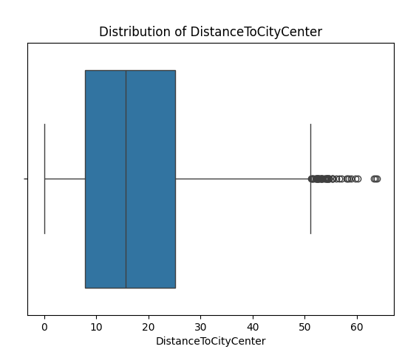
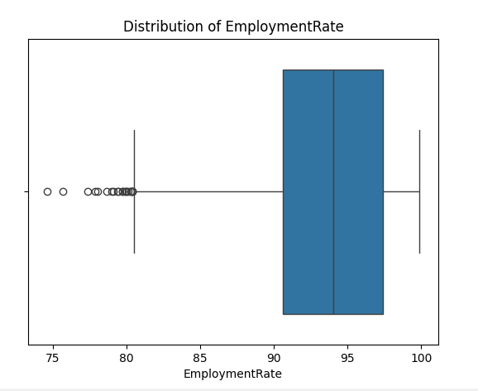
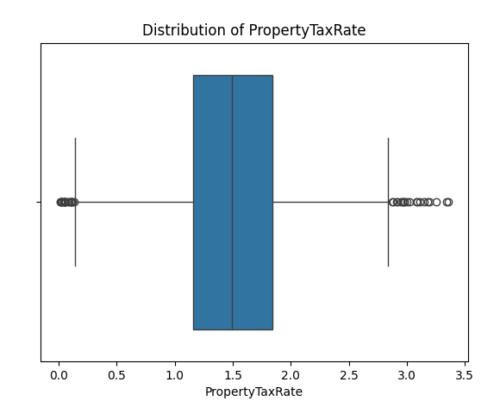
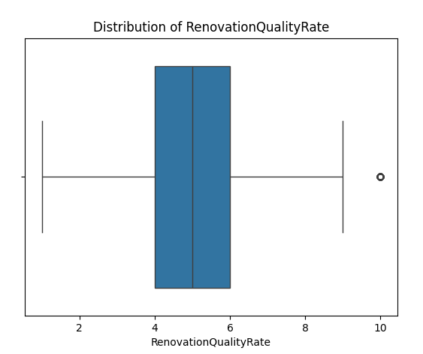
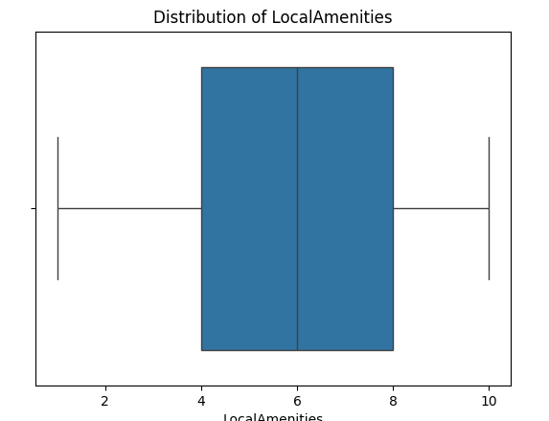
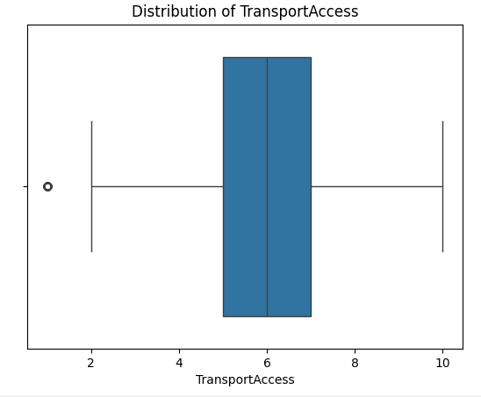
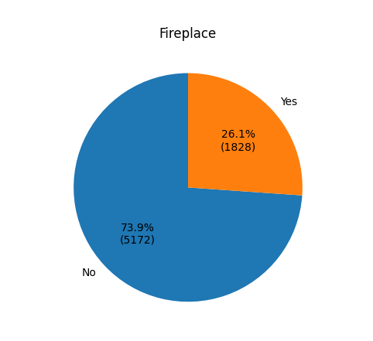
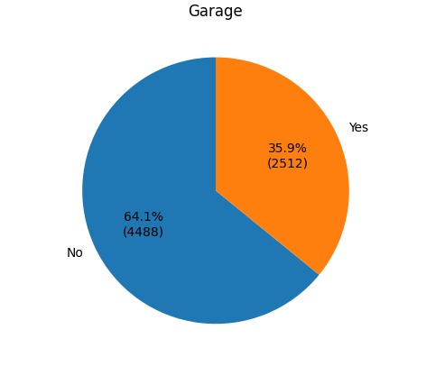
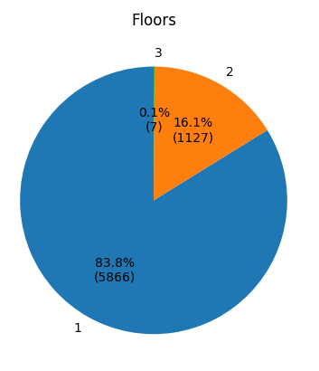
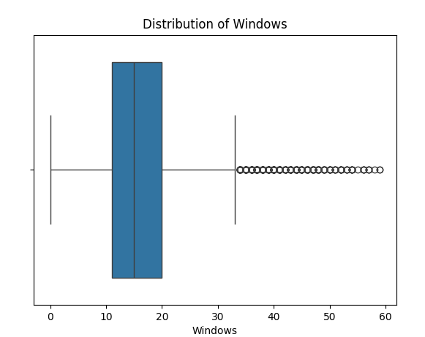
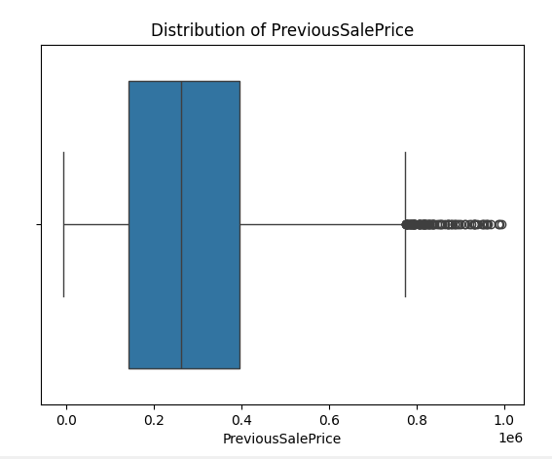
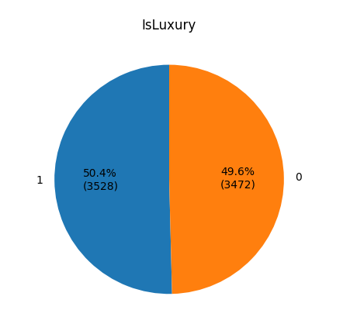

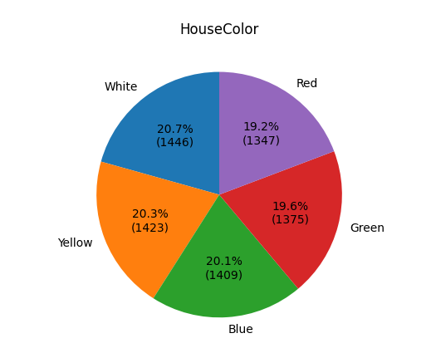

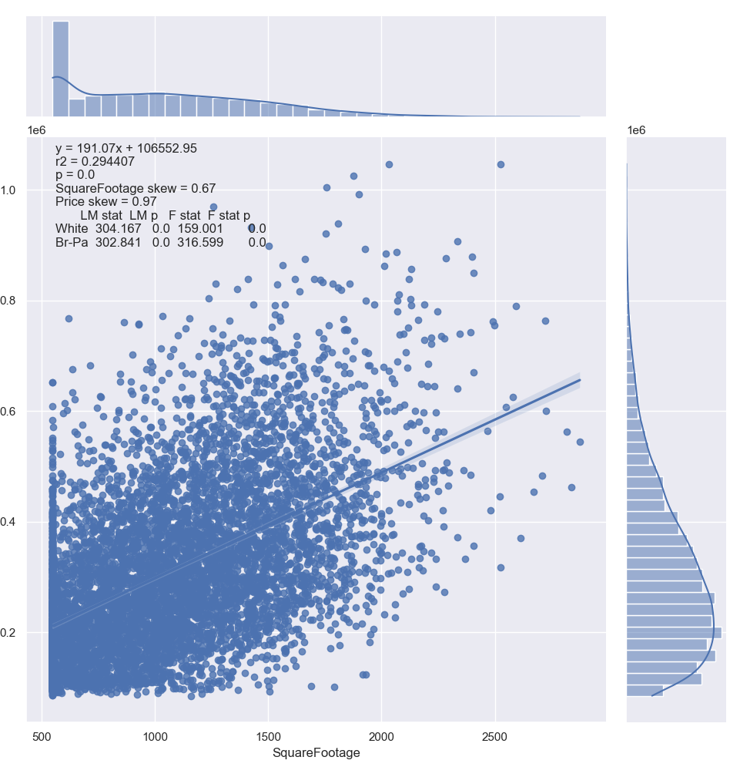
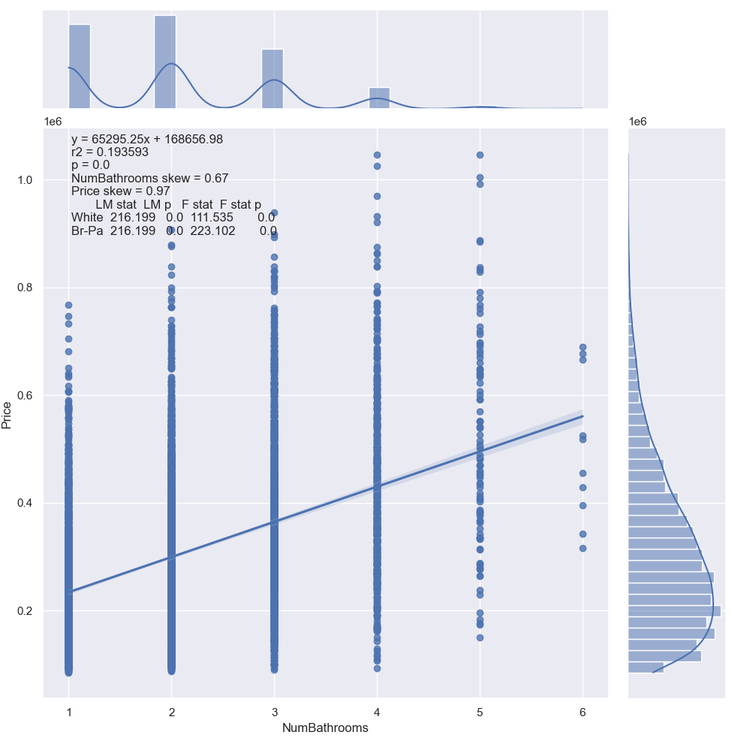
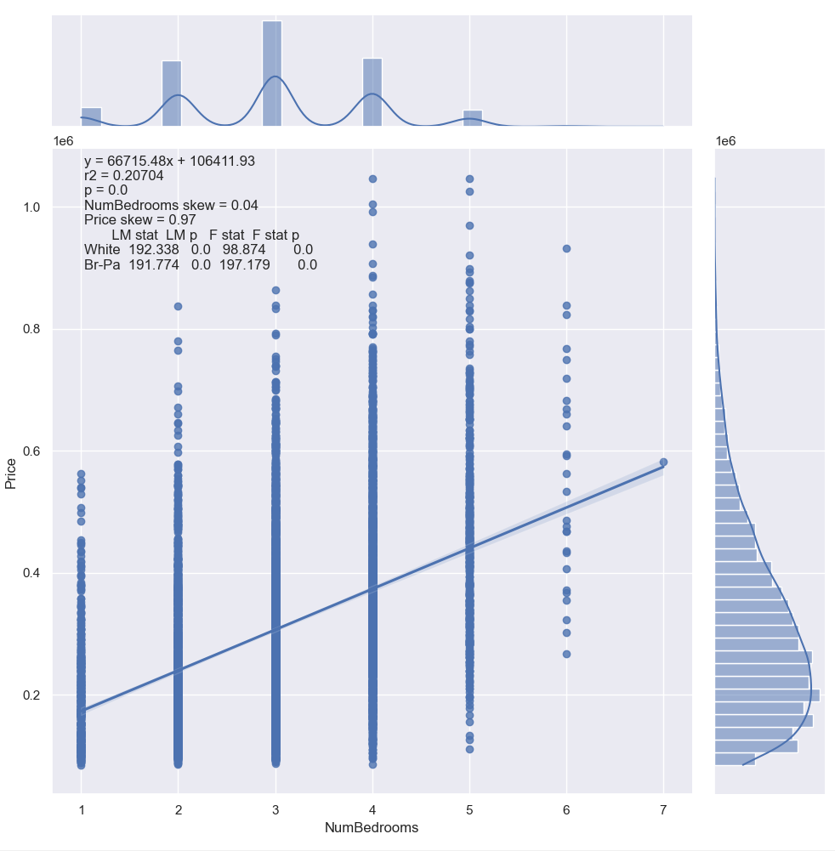
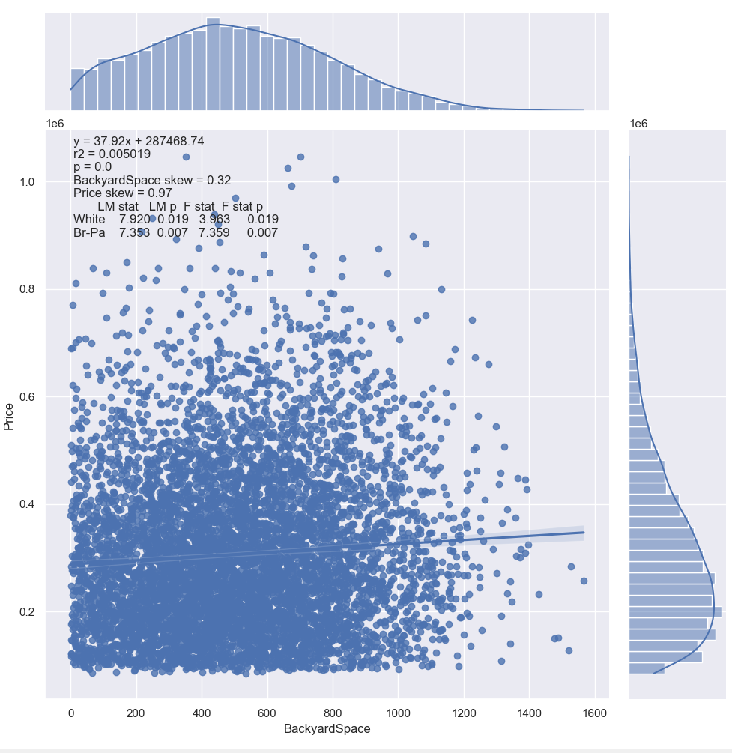
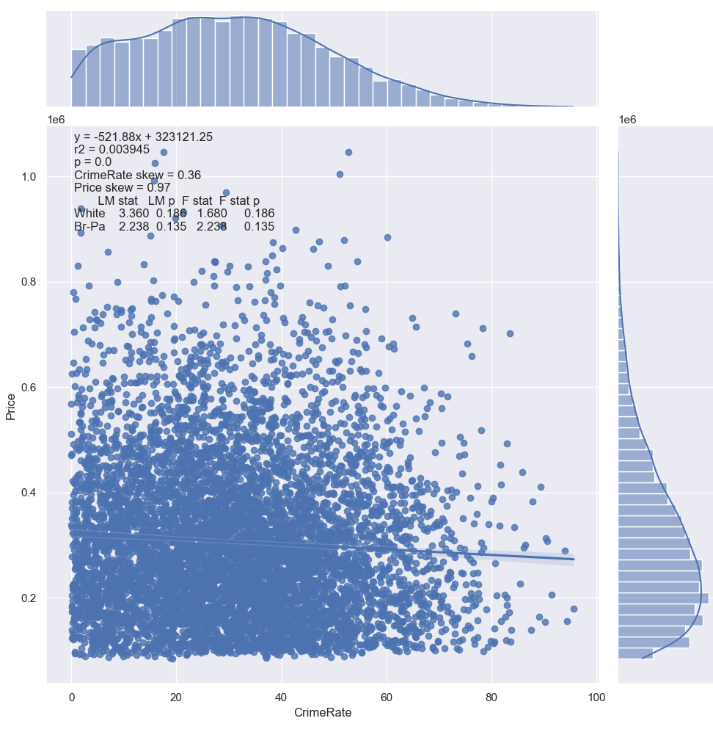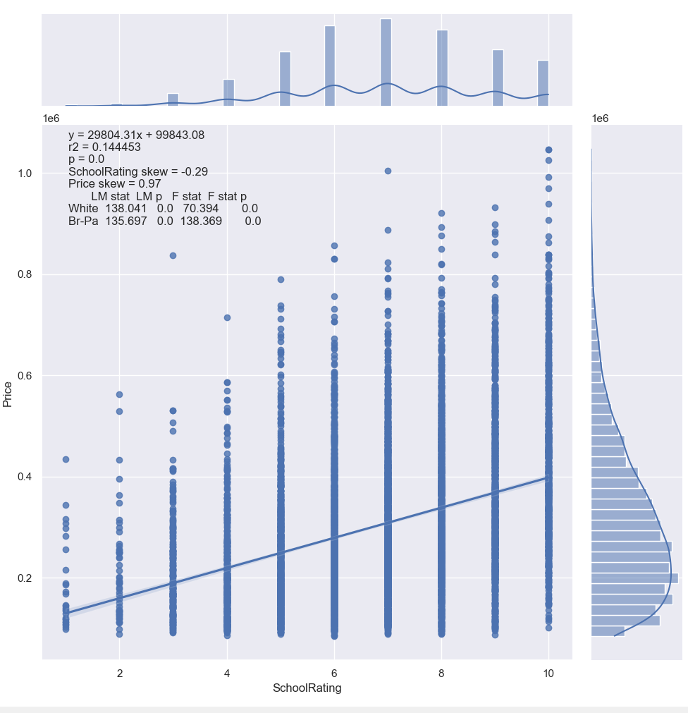
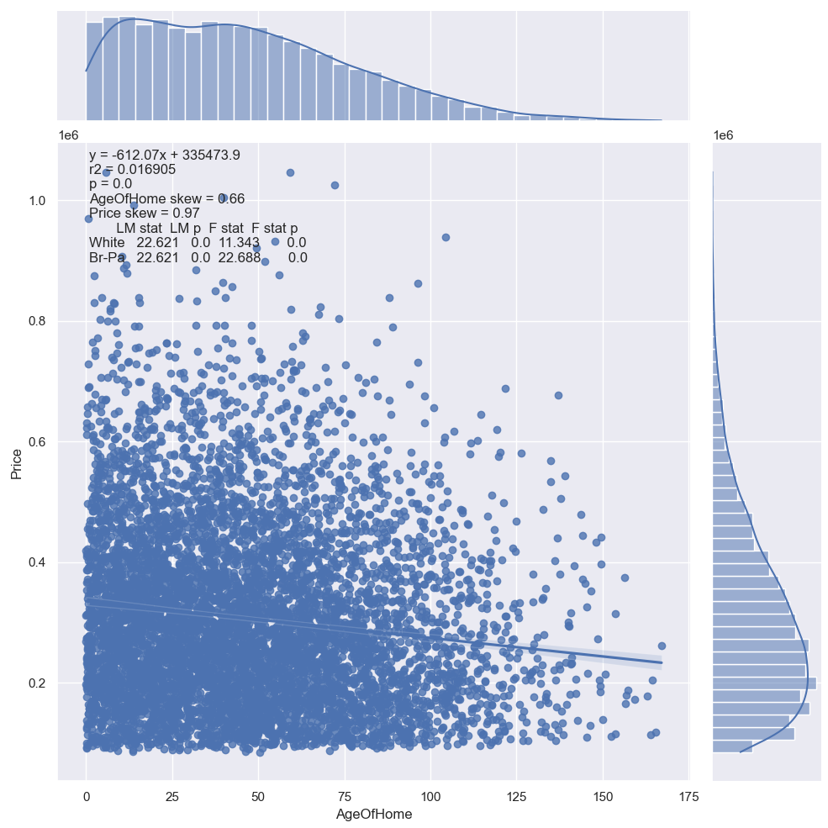
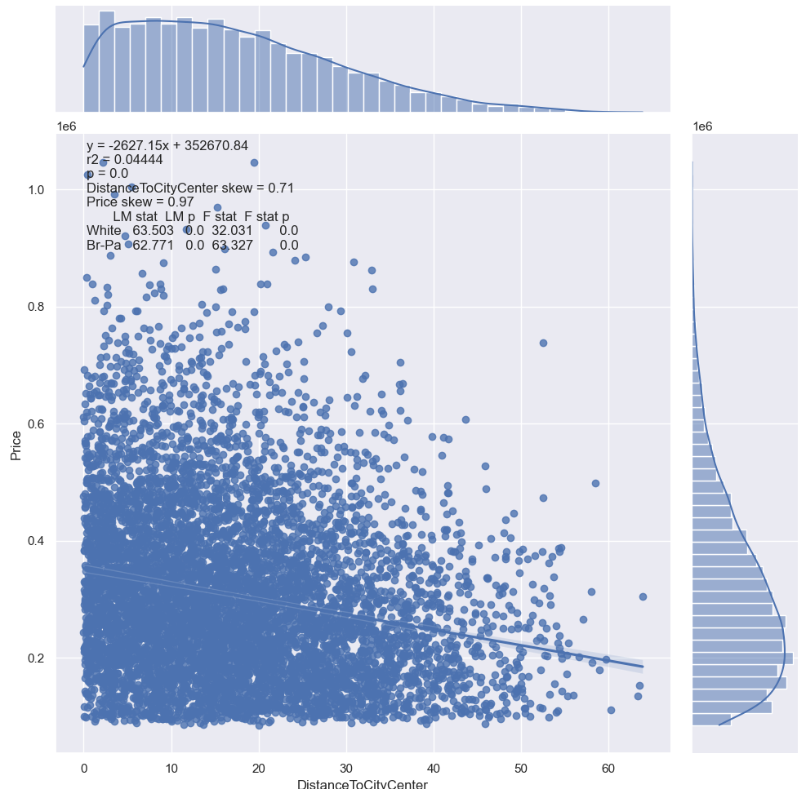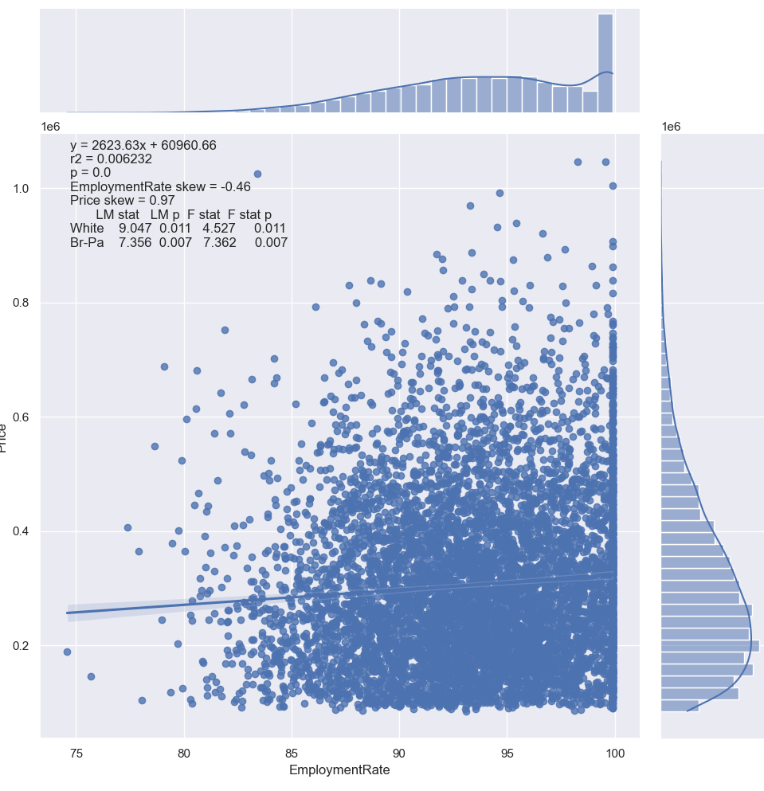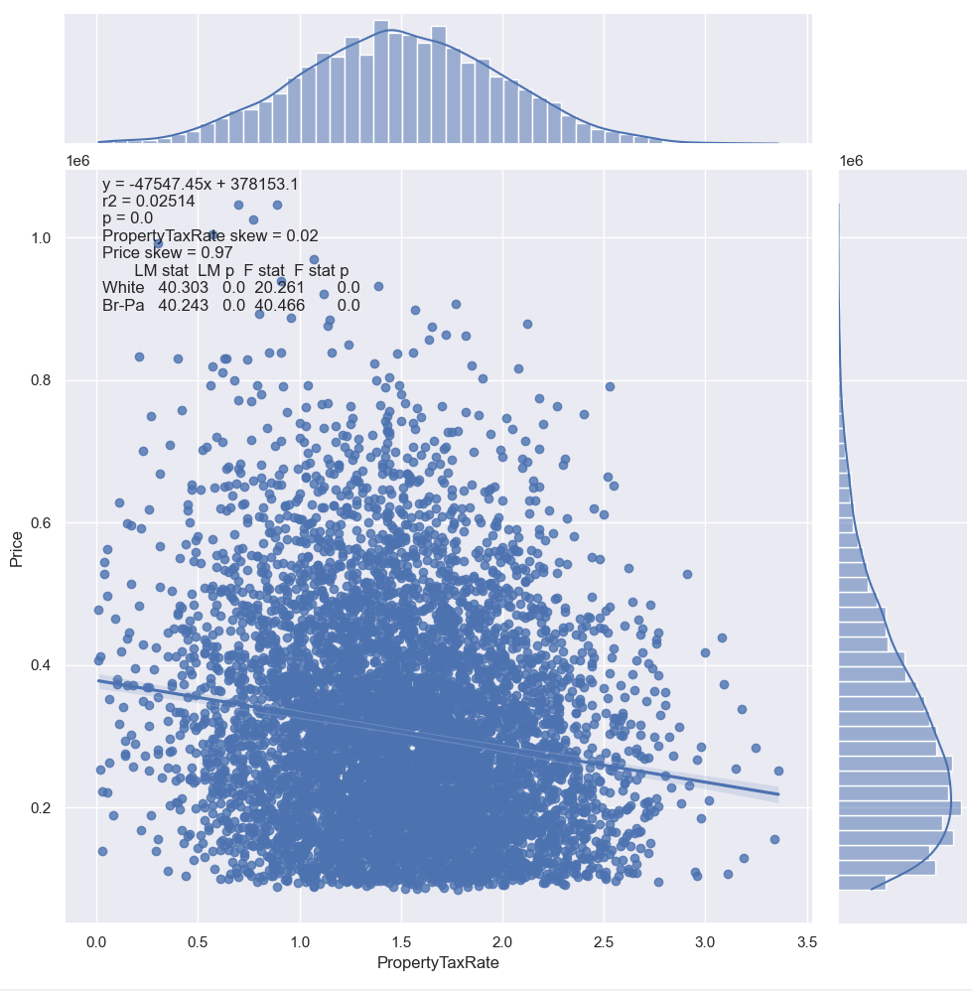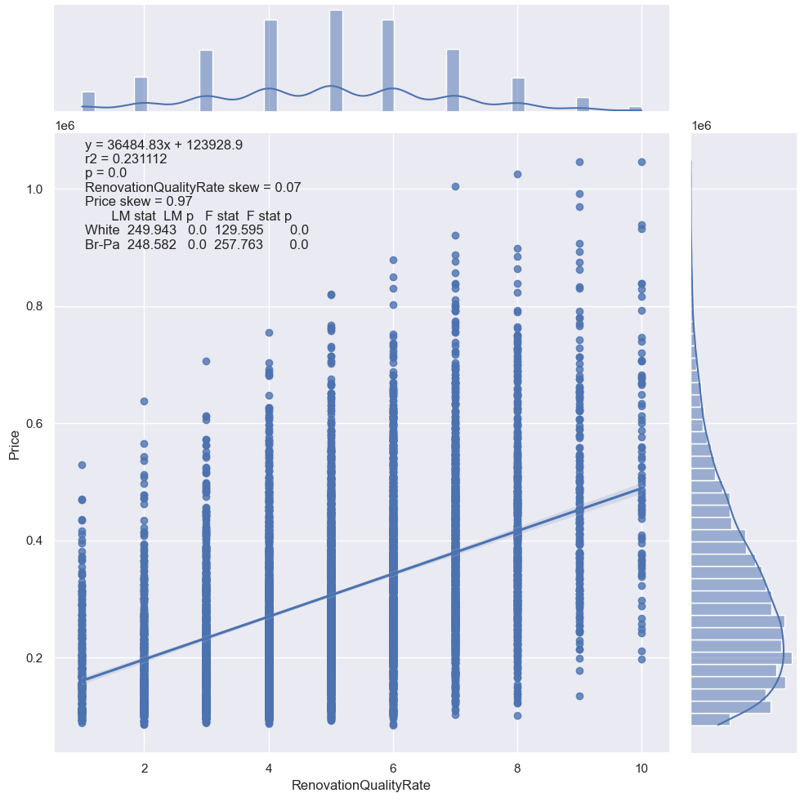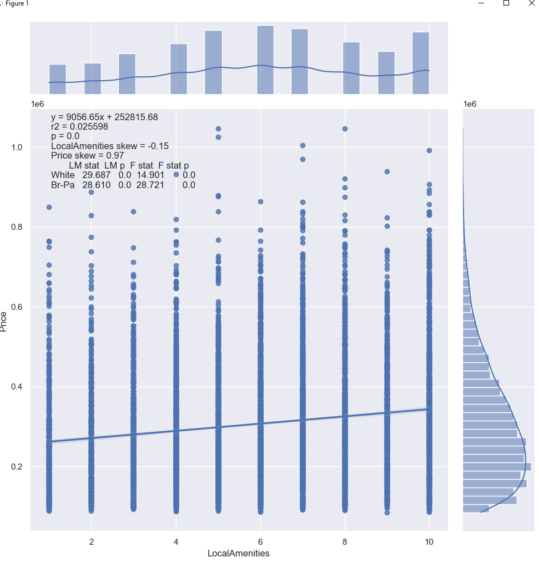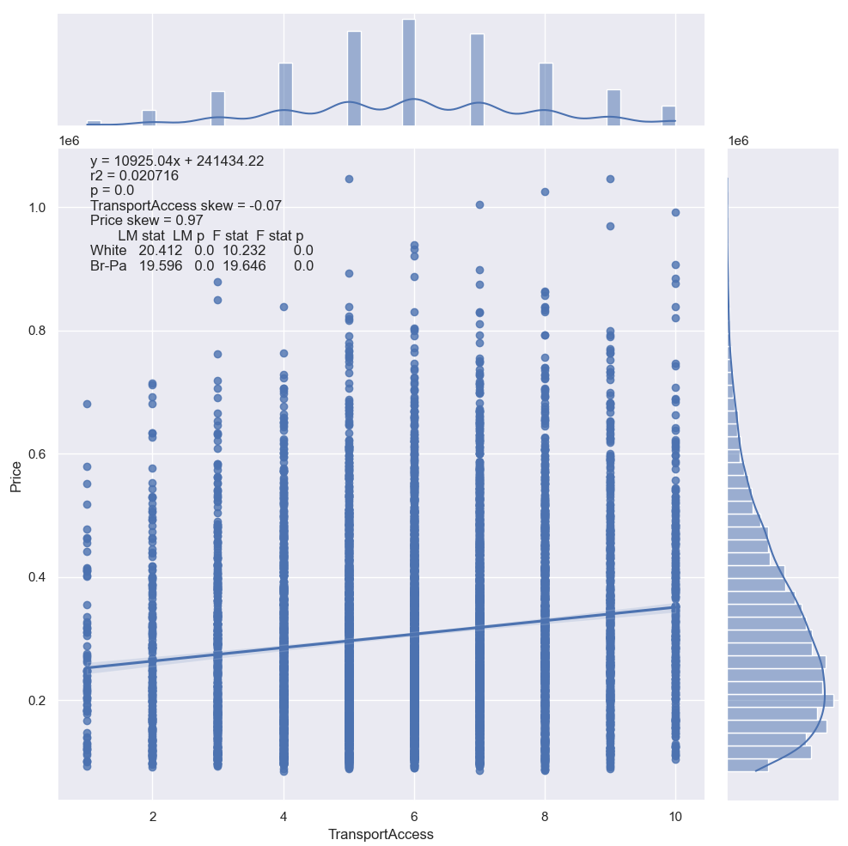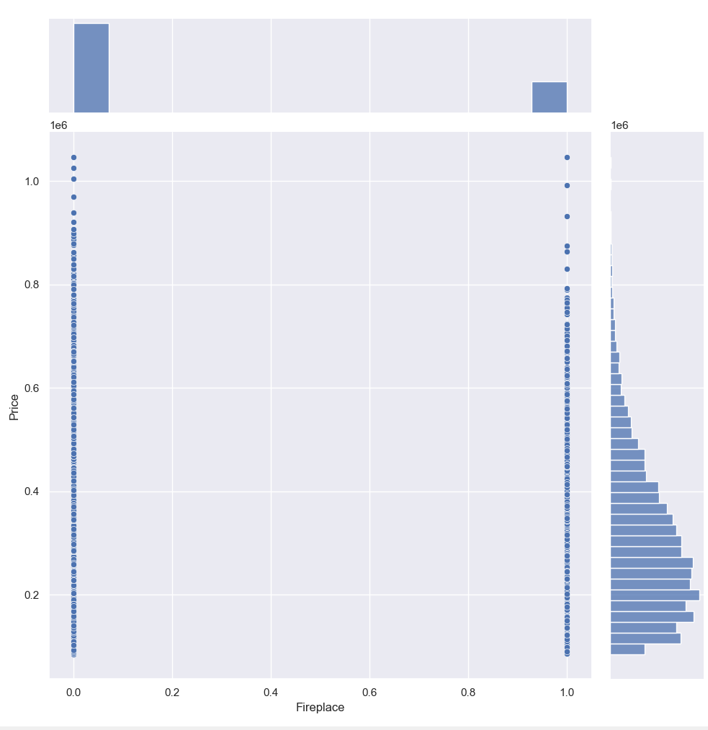
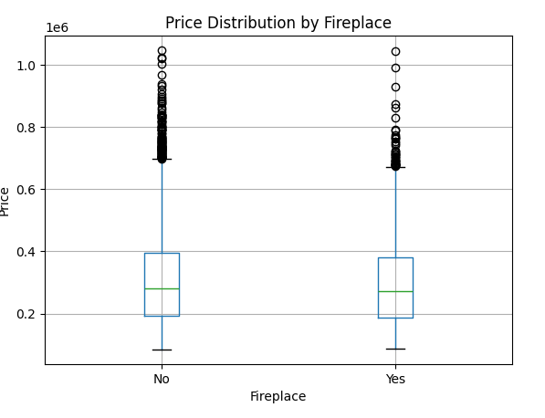
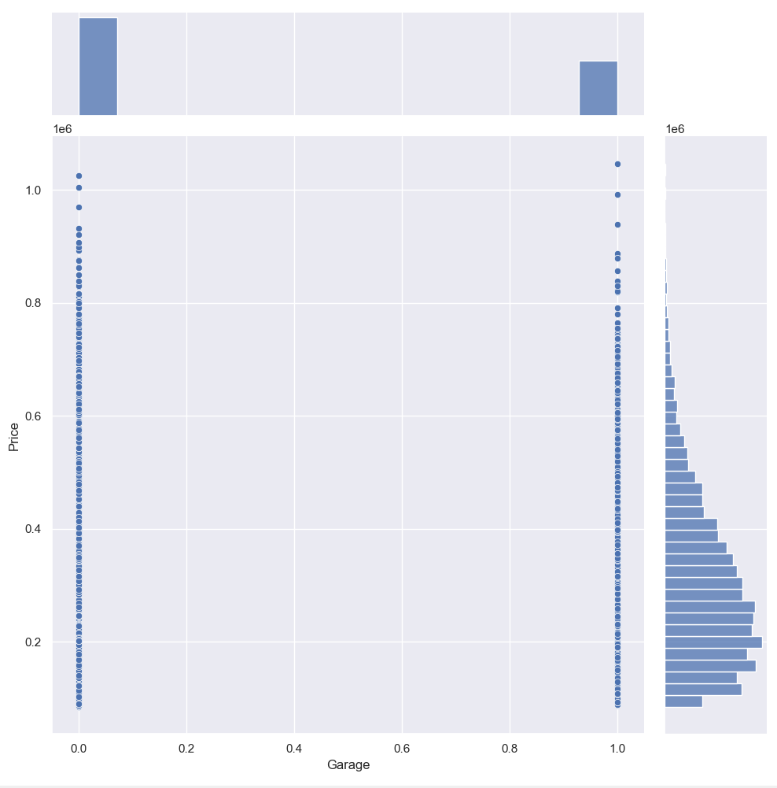
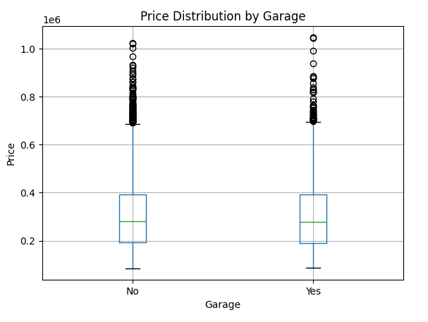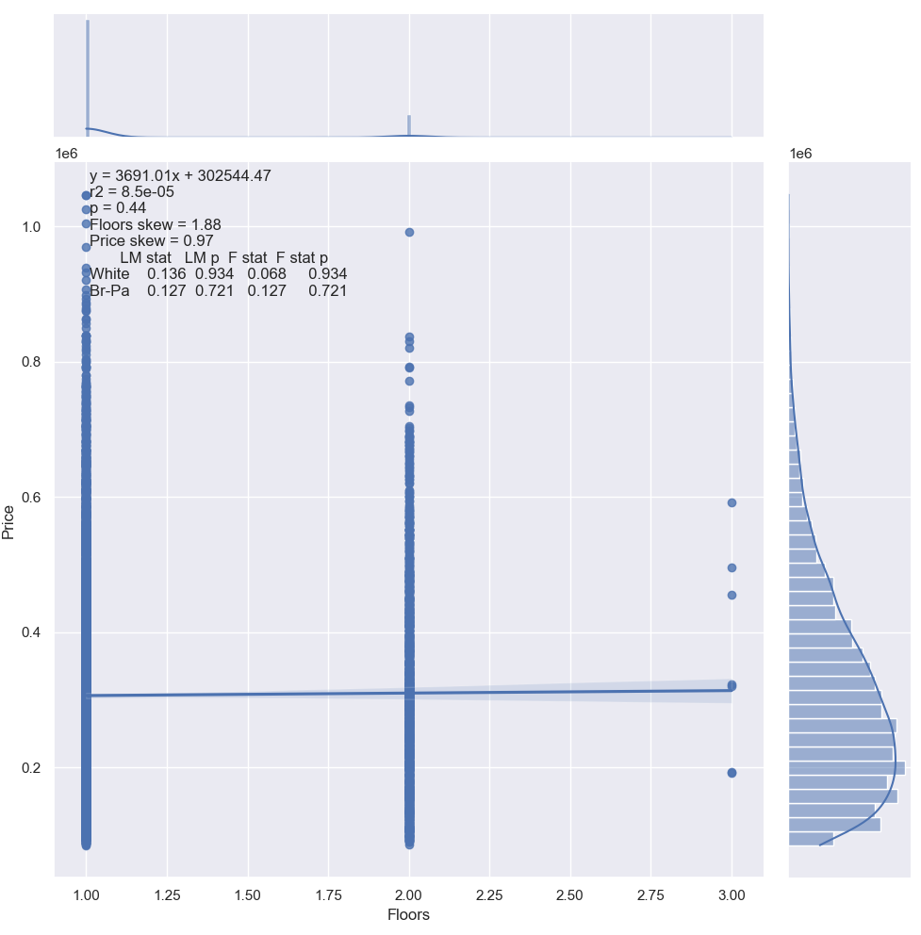
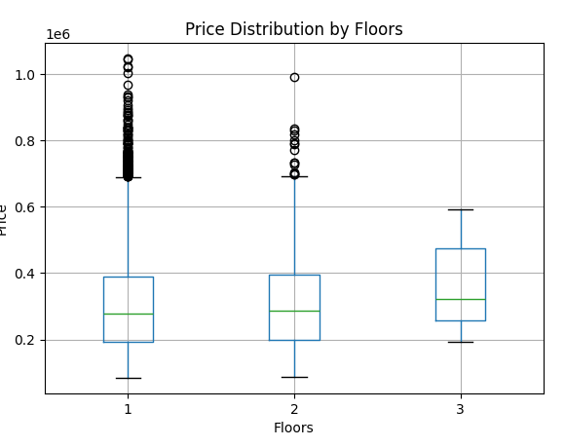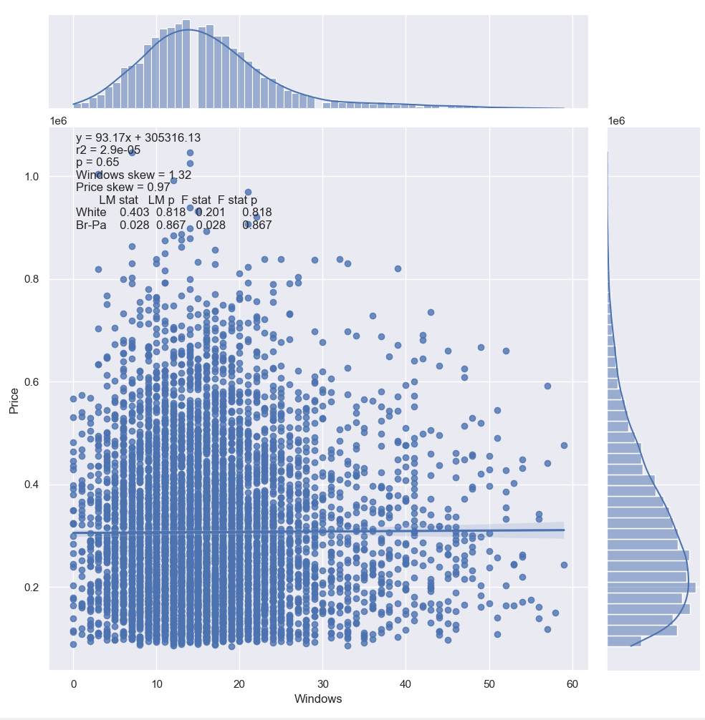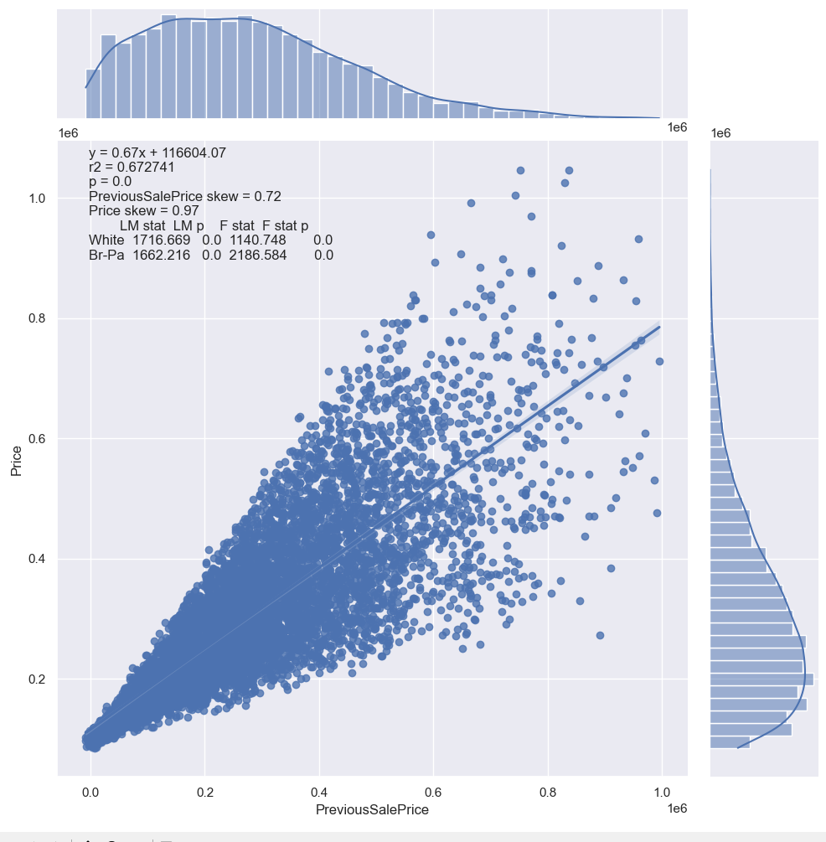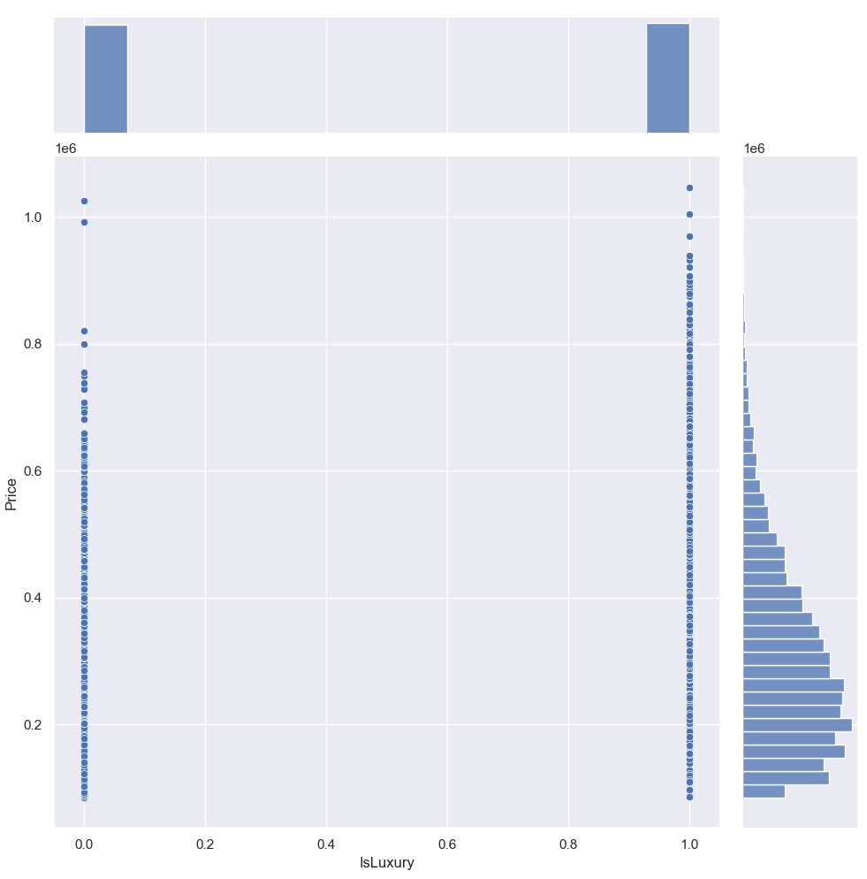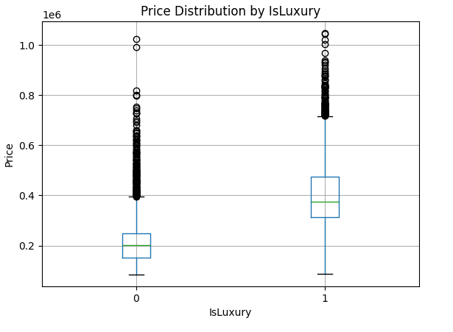
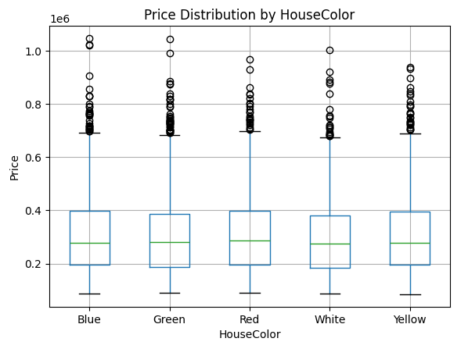
4. Perform the following data cleaning techniques to prepare the data for modeling and provide a screenshot of the completed steps:
• Handling missing values
Missing and duplicate values were logged in the EDA(dataframe) function using .shape(), .isnull().sum(), and .duplicated().sum(). The results of this test was the determination of 0 duplicated rows and 0 blank cells.
• Mitigating outliers
Outliers were tested using a box plot. However due to the nature of the breadth of analysis done it did not make sense to remove any outliers initially. After learning that the initial RMSE was approximately 25% of the average home price I went through the outliers again to see if I could find any that should be removed. Below are a list of columns with outliers and why they should or should not be removed.
Price – As this is the dependent variable of the analysis it is incredibly important that it is clean/logical. Houses are expensive, so the maximum price of $1,046,676 while staggeringly large to may households, is a believable price. No data was removed because of price outliers.
SquareFootage – Similarly to Price, while this column has many data points that are over the 3rd standard deviation, they are relatively tightly grouped, and the max is still believable. I removed the 3 highest due to a small gap there.
BackyardSpace - Similarly to Price, while this column has many data points that are over the 3rd standard deviation, they are relatively tightly grouped, and the max is still believable. I removed the highest due to a small gap there.
CrimeRate - Similarly to Price, while this column has many data points that are over the 3rd standard deviation, they are relatively tightly grouped, and the max is still believable. removed the highest due to a small gap there.
SchoolRate - This column has a few data points that are under the 1st standard deviation, they are still believable, provided that the quantification of SchoolRate is sound. I removed the 3 highest due to a small gap there.
AgeOfHome - Similarly to Price, while this column has many data points that are over the 3rd standard deviation, they are relatively tightly grouped, and the max is still believable. I removed the highest due to a small gap there.
DistanceToCityCenter
RenovationQualityRate – I thought this would be an excellent variable to remove outliers from, but there are over 800 ratings of the highest level, so it is not a valid variable to alter.
TransportAccess – There are 81 outliers, but as this is a categorical variable I should not remove them.
Floors – There are over 2200 outliers, but as this is a categorical variable I should not remove them.
Windows – These look normally distributed, so I removed the upper and lower ends of the outliers

• Encoding categorical variables, if used
I encoded all categorical variables in case my research question needed to change. The Fireplace and Garage columns were encoded by using a replace() function to change ‘yes’ to 1 and ‘no’ to 0. The IsLuxury column only needed to have its data type changed to .astype(‘bool’) as it was already stored as a 0 or a 1. I used the pandas pd.get_dummies() function to encode the HouseColor variable.

Below is a screenshot of my dataframe.head()
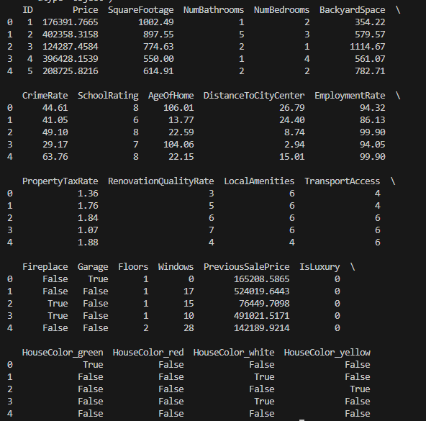

C. Perform the data analysis and report on the results by doing the following using Python or R:
1. Split the data into two datasets, with a larger percentage assigned to the training dataset and a smaller percentage assigned to the test dataset. Provide at least one screenshot of the code used to split the data into training and testing datasets.
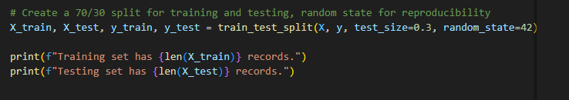
2. Use the training dataset to create a model using multiple linear regression as a statistical method.
3. Create a screenshot of the summary of the initial linear regression model or the following extracted model parameters:
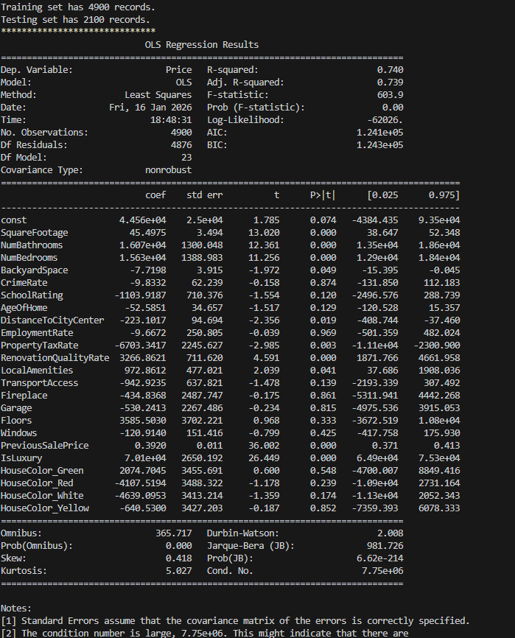

4. Optimize the regression model using a process of your selection (e.g., backward stepwise elimination, recursive selection, etc.).
The following code was used to optimize the regression model:
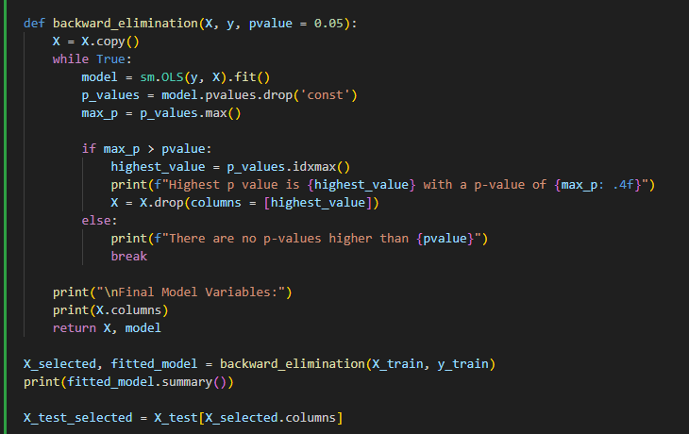
It works by running the OLS regression, and then printing/removing the variable with the highest p-value. Once there are no more p-values higher than the given value (0.05) The function returns the final variables in the model, and provided variables are used to filter the original X_test dataframe.
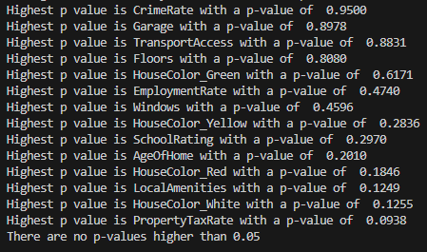

5. Create a screenshot of the summary of the optimized model or the following extracted model parameters: 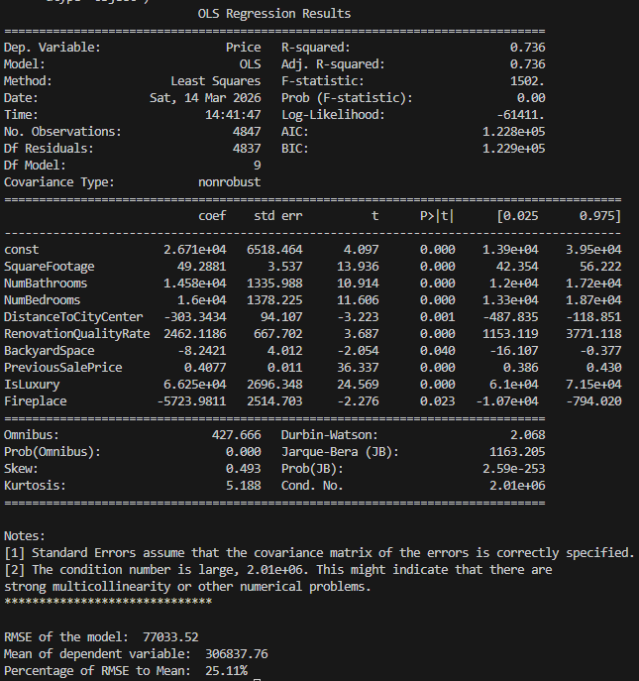
6. Run the prediction on the test dataset using the variables from the optimized regression model to give the prediction model accuracy based on the root mean squared error (RMSE). Provide a screenshot of the results.
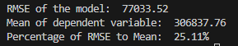
D. Summarize your data analysis by doing the following:
1. List the packages or libraries you have chosen for Python or R and justify how each item on the list supports the analysis.
Pandas – I used pandas in all of my scripts for this project. It is primarily used to group data into dataframes and alter them in a pythonic way.
Statistics – I used the statistics package to determine the variance of my numeric data in my univariate.py file.
Matplotlib.pyplot was used in both my univariate and bivariate analysis to facilitate making visuals
Seaborn – I used seaborn in both my univariate and bivariate analysis to make boxplots and jointplots respectively.
In my mlr.py file I used sklearn.model_selection to make my 70/30 train_test_split dataframes, the statsmodels.api for the linear regression functions, and used sklearn.metrics to calculate mean_squared_error.
Finally, in my bivariate stats file, I used statsmodels.stats.diagnostic to perform the breuchpagan and white tests, and scipy to perform the oneway and pearson tests.

2. Discuss the method used to optimize the model, providing justification for the approach.
I initially ran my tests without removing any outliers. This was because all variables with outliers had believable ones. After I got the results from my initial RMSE test, I removed non categorical outliers and redid my backwards stepwise elimination using a while loop instead of by hand, which compared the P values of the remaining variables and removing the highest pvalue that is over 0.05. This was to ensure that only variables that were statistically significant were included in the final model. My final RMSE is below. By removing the variables that had the highest Pvalue, and only stopping once all the remaining variables I was able to improve the RMSE of the of the model by over $15,000.
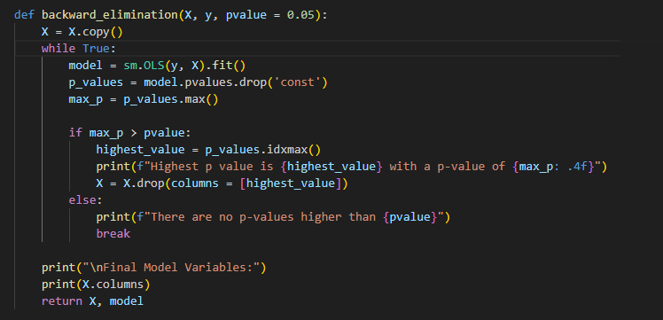
3. Complete the following for the optimized model:
a. Create a regression equation by using the coefficients from the optimized model.
Price = 49.2881(SquareFootage) + 14580(NumBathrooms) + 16000(NumBedrooms)-303.3434(DistanceToCityCenter) + 2462.1186(RenovationQualityRate)-8.2421(BackyardSpace)+0.4077(PreviousSalePrice)+66250(IsLuxury)- 5234.9811(Fireplace)
b. Provide an interpretation for each coefficient in the regression equation.
Increasing only the SquareFootage by 1 square foot would increase Price by $49.352.
Increasing only the NumBathrooms by 1 would increase Price by $14540.
Increasing only the NumBedrooms by 1 would increase Price by $15960.
Increasing only the DistanceToCityCenter by 1 mile would increase Price by $299.7801.
Increasing only the RenovationQualityRate by 1 would increase Price by $2443.5584.
Increasing only the BackyardSpace by 1 square foot would decrease Price by $49.352.
Increasing only the PreviousSalePrice by $1 would increase Price by $0.4083.
Changing IsLuxury from False to True would increase Price by $66340
If there is a Fireplace, the price would decrease by 5234.9811

c. Discuss the adjusted R².
The R² explains the variance in Price caused by the independent variables. In this case 73.6% of the variance of Price can be explained by the model. However, it always either increases or remains the same when you add additional variables, so it isn’t the best way to test a model’s ability to explain a system. The adjusted R² is reduced when you add variables that are not statistically significant. Because both R² values are identical it is safe to assume that all the variable in the model are statistically significant.
d. Discuss the accuracy of the optimized model with that of the test dataset based on the RMSE.
The initial RMSE was $79,483.1521, and the improved model had an RMSE of $77,033.52. While the accuracy of the predictions improved, the R-Squared fell from 0.739 to 0.736, which means that the model predicts slightly less of the variance between predicted and actual price.
4. Summarize at least two assumptions of multiple linear regression.
The assumptions of multiple linear regression (MLR) are as follows: there is a linear relationship between the explanatory and outcome variables, and none of the explanatory variables are highly correlated with each other. The observations are independent. In the linear model, the residuals have constant variance are normally distributed.¹ The Prob (F-Statistic) is below 0.05, which means that the model explains more that a constant only model. Additionally Durbin-Watson value of 2.068 shows that there is not a strong autocorrelation.
5. Provide evidence that the assumptions from part D4 were verified by providing code snippets or screenshots.
6. Discuss a limitation of your analysis.
The degree of separation between myself and the data made it so I had to make several assumptions, which greatly affected my ability to understand the data and through that the parsing of outliers. All I had to rely on was the data dictionary which, while helpful, was not specific enough to know exactly what I was dealing with. My own lack of knowledge about housing prices made me assume that there was a lot of variation in types, prices and characteristics of houses. The end result being that I was dealing with a lot of numbers that didn’t actually have much meaning to me as an analyst.
7. Recommend a course of action for the real-world organizational situation from part A1 based on the results of your data analysis.
Instead of making one model for any prospective homeowner to use to estimate housing value, I would recommend making two models, one for luxury homes and one for non-luxury homes. The IsLuxury value is a statistically significant variable, while also not defined as anything concrete. This means that, as an analyst, I can’t know if the reason a house is luxurious is because it has more expensive components or some other reason. While this would reduce the number of records to build both models on, it would almost certainly result in two models that are both better at predicting a more specific outcome.
3rd Party Code/Sources:

- https://www.statology.org/multiple-linear-regression-assumptions/
- No other 3rd party code was used, but when I initially started this class it was D208, so I’ve used the class materials from both classes to finish this project.

