This evening marks the end of the first day of Phaendar’s market festival. The 2-day affair, held once every 3 months, gathers farmers and herders from across the Nesmian Plains, as well as woodcutters from the nearby Fangwood and prospectors from the Hollow Hills, to trade for supplies and raw materials. Even traders from the “big city” of Tamran make their way to the event, swelling the town’s population to half again its normal size.
Have each player give a fun fact about how this area of Nirmathas celebrates the spring equinox.
You are all inside the Taproot Inn- or, The Root if you’re a local - the finest (and only) inn in Phaendar. Outside, the celebration continues, as raucous shouts carry on the night air. Warmed by the firelight after a long day, any levity comes as a welcome reward to the rough, earthy souls of this riverside trade town. “So there I am, thinking, when will I ever be able to talk to a bear again? So before the grizzly can stand back up, I turn to it and say, ‘All I need is the honey. You can keep the bees!’” The room erupts into laughter as Aubrin finishes her winding story and takes another draught from her tankard. “But it’s fine now. All’s good. She named a cub after me. Someday I’m going to have to check in on little Ow Oh Gods That’s Too Many Bees.” As she sits back down other members of the crowd stand up and share their own boasts and jokes.
Ask if any of the party wants to share a story
Eventually someone tops off Aubrin’s tankard and pushes her back into the center of the room. “All right, all right! Don’t shove,” she slurs a bit. “Okay, Cayden strike me down if this isn’t true—“The front door explodes into flinders. A cry of agony pierces the chaos. Aubrin lies on the floor, gasping and clutching at the blood gushing from a wound in her chest. A crystalline spear still quivers in the wall behind her. Three goblins in military dress stand beyond the shattered door, two with drawn blades, the other staring at awe at a rapidly disintegrating scroll. Behind them, lit by the glow of burning homes, dozens—perhaps hundreds—of hobgoblin soldiers march the street. Phaendar burns, shouts of celebration now replaced by the panicked screams of the frightened and dying. Behind them, above the flames and humble rooftops, rises a tower of black stone.

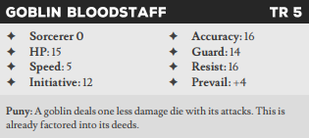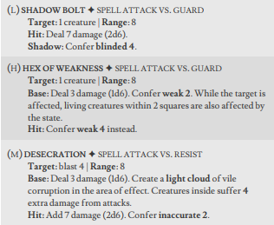
The Root – 3 exits (outside, kitchen, upstairs)
- Encounter! – read the highlighted bit.
After the battle is over – The goblinoids all wear an insignia on the shoulder of their uniforms. A int|folklore TN 10 with a slow shadow identifies the insignia as the emblem of the Ironfang Legion, a mercenary army responsible for the Ramgate Massacre 2 years ago, but absent from the battlefield ever since
- Treasure - The hobgoblins already carry the spoils of some looting: a masterwork backpack stuffed with a crossbow, 2 crude rations, and 3 value worth of jewelry. Additionally, each goblin has a crude helm and leather armor that can be salvaged (roll depletion)
- Detail – As the shock of the sudden battle fades you hear a groan. Aubrin is still alive!
- Sign – You hear the sounds of heavy objects scraping upstairs.
- Sign - The innkeeper, Jet, is hurrying out from the kitchen behind the bar
- Sign – Looking out the shattered front door, you look down the hill to see a massive tower of black stone standing in the center of Phaendar’s town square. Dozens of figures are swarming around the base of the tower.

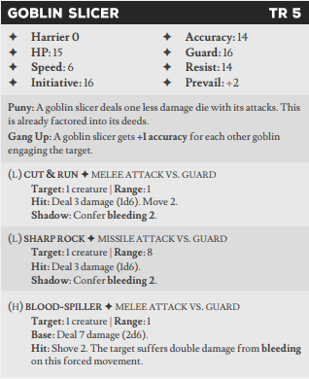
Southern End of Town – 4 exits (Oreld’s Fine Shop, residential district,town square, Riverwood Shrine)
- As you leave the inn you see the remains of a pitched and one-sided battle.
- Sign - A dead villager (Jett will recognize him) lies face down with a smoldering torch. It looks like he was shot while fleeing from the town square.
- Sign - Oreld’s Fine shoppe lies to the northeast. Its shutters are pulled and the lights are off. Does anyone know him? (If so you’d know that he normally throws a houseparty on market festivals)
- Sign – You hear raucous laughter coming from the Riverwood Shrine
- Sign – The crowded streets that make up the residential districts are filled with the sound of looting.
The Root Upstairs – 1 exits (common room)
- The Taproot’s upper floor consists of several rooms for rent, from the smelly but warm common room to large private rooms for travelers with more coin to spend.
- Detail – At the end of the hall stands the inn’s “vault,” a locked closet Jet offers for visitors to store their valuables. The door has already been forced open and the closet looted.
- Detail – The door to the private suite has been locked, and you can hear the sounds of furniture being shoved against the door.
- Detail/Encounter: 2 merchants are upstairs locked in a barricaded room and are too scared to leave.
- They each carry backpacks with 2 fine rations 2 fine torches, and 3 wealth of goods. Spirit | Speech TN: 10 Shadow: Slow
- Sign – Looking out the window towards the town, your vantage gets you a slightly better view of what’s going on. An army of goblins?... has invaded through the tower. An entire regiment looks to be securing the main road leading south to Tamran.
The Kitchen – 2 exits (Common room, outside)
- The Root’s kitchen and pantry line the back wall of the building. The room is lit by the cheery glow of a chandelier.
- Detail – There is a massive amount of food Stored in the cellar. The party can attempt a group agility | alchemy TN 10 (Slow) to gain 2d4 fine rations.
- Detail – A fine lantern sits on a hook next to the door next to a cloak and a backpack.
- Detail – an urn inscribed with runes sit in the back of the highest shelf. A previous traveler paid for his stay with a jar that summoned an animated servant. He failed to mention it was made of mud.
- Sign – Through the window leading outside you can see multiple squads of goblins head south past the inn towards Phaendar’s residential district.

Riverwood Shrine – 5 exits (Shrine Sanctuary, Parsonage, Phaendar Trading Co, residential district, town square)
- A wooden deck surrounds the front of an octagonal structure with broad archways leading into a place of worship. To its left stands a moss-encrusted stone parsonage. Carved birds, branches, and fruits decorate the wooden supports of the temple’s entryway. A dead villager is curled up on the wooden deck before the temple.
- Detail - The body is Noelan, an elderly human man who served as the shrine’s caretaker. Surprisingly, his intricately carved walking stick (Fine rod) is still in his grip.
- Detail: You can hear cursing and *THUNK*ing inside as someone is taking a bladed weapon and repeatedly chopping into something. If you time it right you can enter right as the weapon gets stuck.
- Sign – The back door of the sanctuary is open, with several partially spent candles lining the trail to the parsonage.
- Sign – You see figures running away from the Phaendar trading company. They’re shouting at each other but you can’t make out the words.
- Sign – The first soldiers have returned to the tower. It looks like they are building something.
- Sign – The crowded streets that make up the residential districts are filled with the sound of looting.
Riverwood Sanctuary – 2 exits (Riverwood Shrine, Parsonage)
- Wooden statues of both Erastil and Desna—both now chopped and marred by hobgoblin weapons—stand in their own alcoves in the northwest end of the shrine, while alcoves on either side serve as general shrines to the variety of other gods and spirits worshiped by the locals. A dozen human bodies lie scattered across the floor and pews, and have been left to rot as invaders go about tearing apart the building. Oddly enough, any commoners that go to the temple regularly still feel the sense of peace they normally would.
- Encounter! A massive hobgoblin barbarian slams and axe into the central alter while three goblin minions break windows and vandalize the walls, she shouts something about how there is always something hidden under them in the stories.
- Detail – In addition to the weapons and armor there are 3 backpacks partially filled with the looters spoils. Crude wand, silver cup, ironwood butterfly carving, 3 bottles of superior whiskey, 3value of money (tiny), elven holy amulet (tiny)
- Detail – The temple is ruined. It has somehow resisted the flames, but the sense of peace you are used to feeling is getting quickly weaker. Dungeon Action: dedicate/close the temple (TN 14) gives the party a lasting state of fortified 1. Cleansing the temple is an INT | Magic 10 SLOW/EXPENSIVE) and if the party does it without prompting give them a roll on a boon table. Each attempt costs a depletion roll on the soap and one holy symbol. The expensive shadow results in a second roll for both.
- Altar Alcove (Hidden 3): purification soap(tiny), silver holy symbols x2 (tiny, value 3 each)
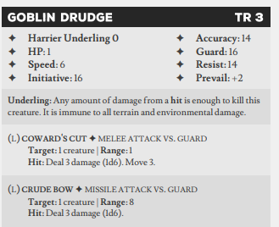
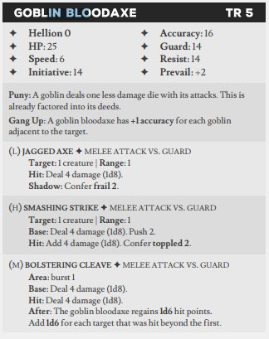
Riverwood Parsonage – 4 exits (Phaendar Trading Co, residential district,town square, Riverwood Shrine)
- The humble stone parsonage usually looks inviting with its moss covered walls. Instead, he smoke and darkness fill you with a sense of foreboding. (Int | Perception 10 Harmful) to realize the Nunn is hidden behind the door with a shovel.
- Sign – there are villagers hiding here being led by Nunn. They can be convinced with a (Spirit | Speech 10 SLOW) to come with you. They scrounge together provision points/3 rations
- Detail – There is a storage container with another vial of purification soap and a bronze holy symbol over the sink (Value 2)
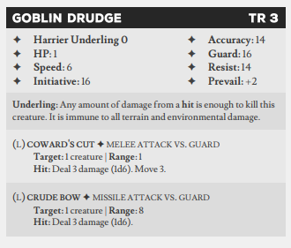
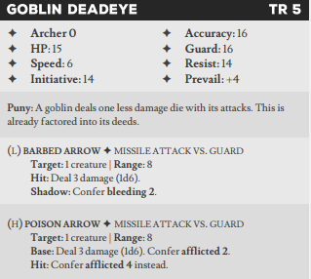
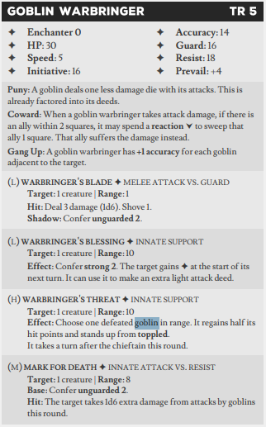
Oreld’s Fine Shoppe – 3 exits (Southern end of town, residential district, Phaendar Trading Co)
- Oreld’s Fine Shop—labeled with a small shingle hanging out front—is one of the few buildings in town made entirely of stone. Mortared white blocks form the walls of this odd shaped cottage. Scorch marks that shift in color from black to dark blue to glimmering violet mar one wall. The door to the shop stands open and bloody footprints lead inside.
- Encounter! A goblin band is looking through the increasingly shattered wreckage of this apothecary. They have bows, knives, and each have an oil of affliction. The warbringer has a dust of mending and a staff.
- Detail – Oreld doesn’t look well, mainly due to blackening veins leading from an arrow wound. An intellect | Perception 10 SLOW means you can find an antidote either on the goblins or in the store.
- Detail - One of the shelves has gear to pick herbs. You can salvage a fine torch and 1 backpack.
- Detail – The herb rack has been pawed through but still has plenty of material to swipe. (2 ingredients, 2 materials)
- The glass display case has been broken and most of the vials are missing. A ceramic pot leaks a brown ooze dripping off the side of the table. The only usable product is a dust of mending.
- Huddled in the corner is an ooze. It does not appear harmful (INT | Nature 10 to identify as a sourdough ooze)
- A closed door leads to the backroom. Despite the mess of the front of the shop it hasn’t been opened or broken yet.
Backroom 2 – exits (Cellar, Shop)
- Beyond the shop lie a workroom and part-time clinic, and a comfortable bedroom.
- Oreld’s portable alchemy lab is dry from its weekly cleaning. You might be able to pack it up.
- There are a few finished productes on the work bench. They aren’t labled. (dust,
- Sign - A cellar door here has a rug hastily kicked over it and a line of twine leads from under the rug to the rafters.
Oreld’s Fine Shoppe – 3 exits (Southern end of town, residential district, Phaendar Trading Co)
- Oreld’s Fine Shop—labeled with a small shingle hanging out front—is one of the few buildings in town made entirely of stone. Mortared white blocks form the walls of this odd shaped cottage. Scorch marks that shift in color from black to dark blue to glimmering violet mar one wall. The door to the shop stands open and bloody footprints lead inside.
- Encounter! A goblin

