Phần 1: Các lệnh cơ bản của docker.
- Docker –version
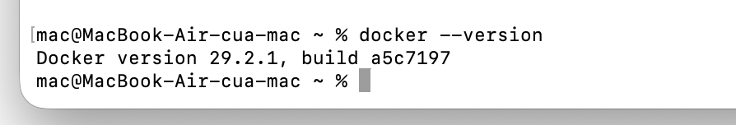
- Docker run hello-world
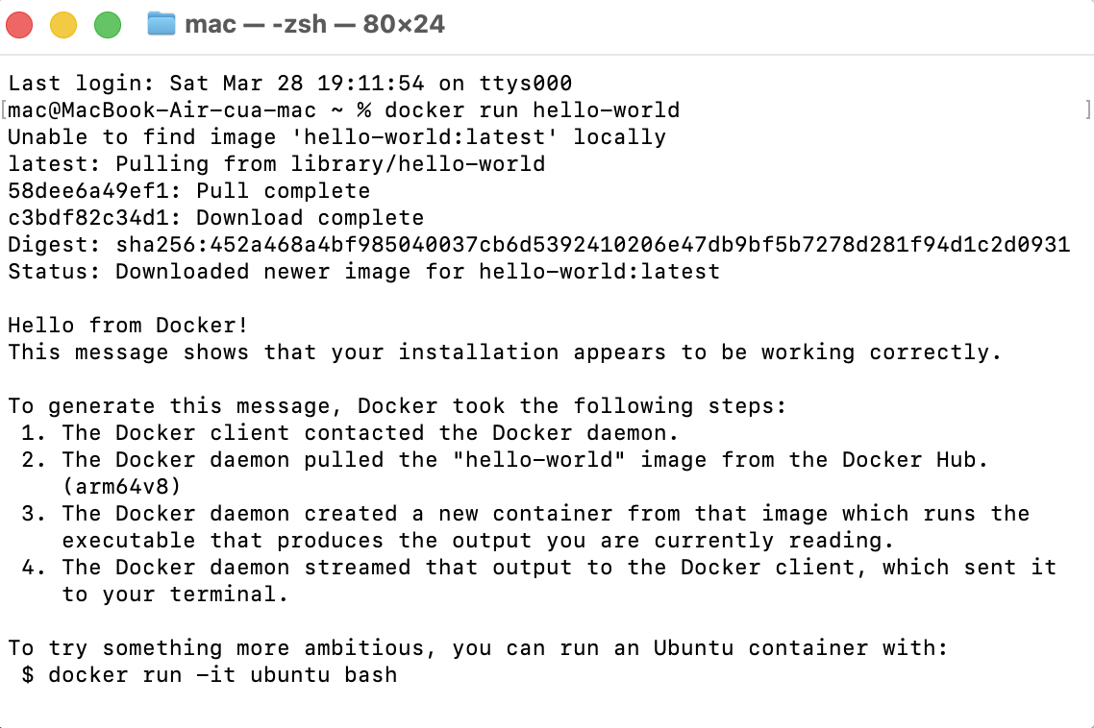

- Docker pull nginx
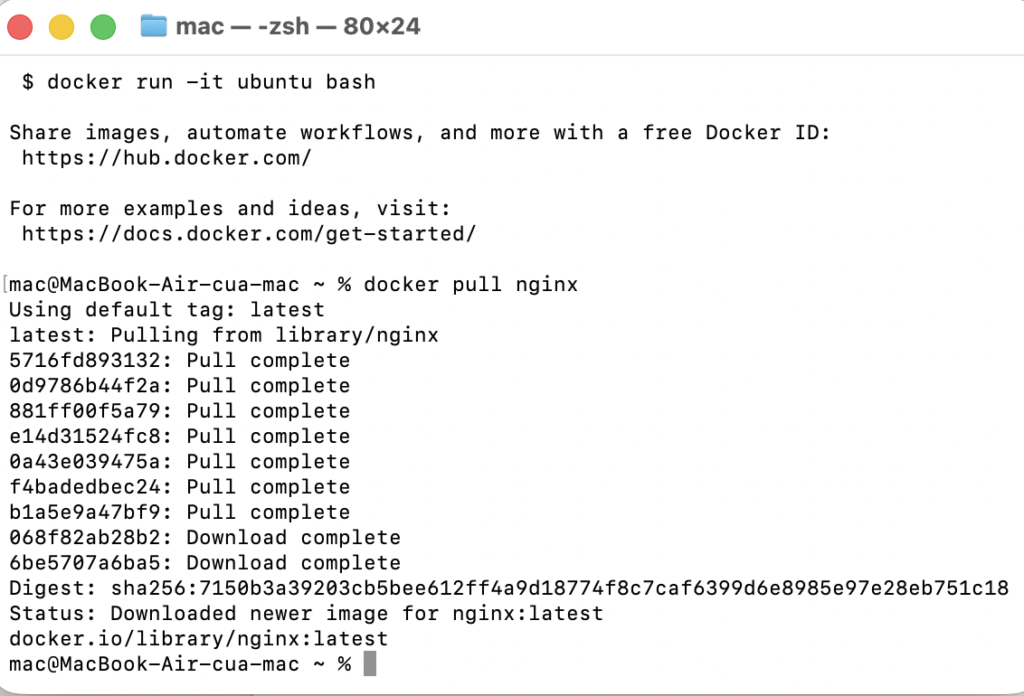
- Docker images
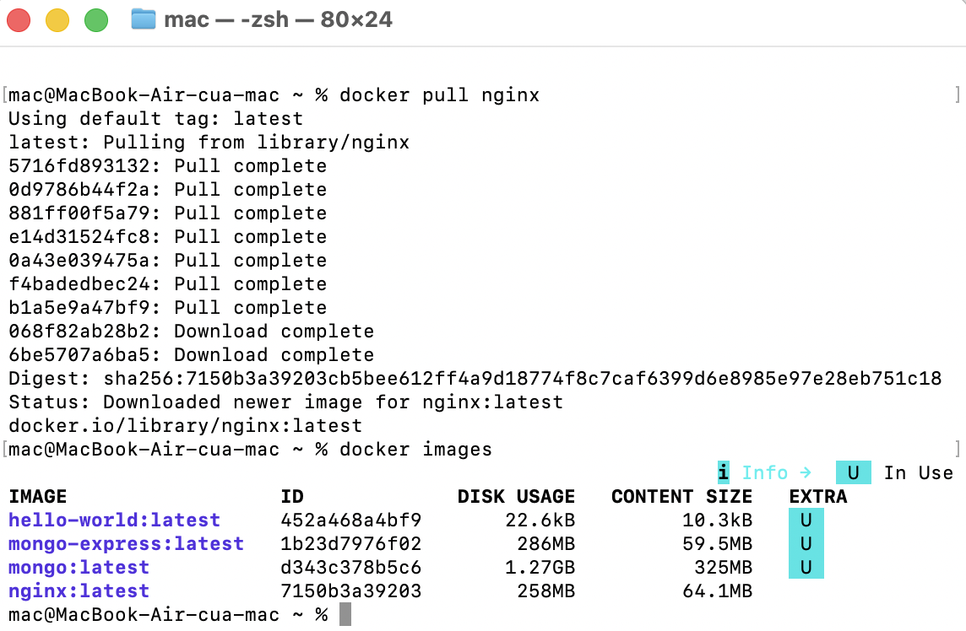
- Docker run -d nginx
- Docker ps
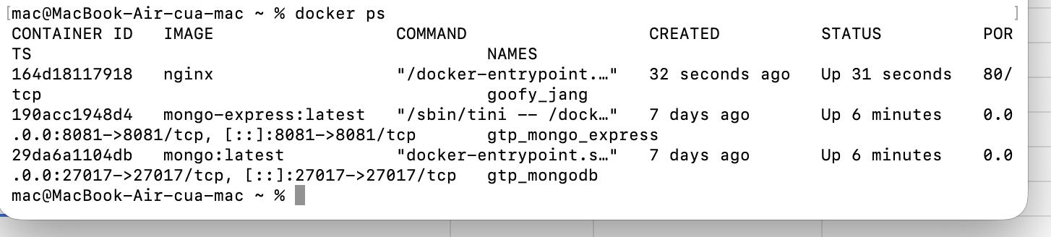
- Docker ps -a
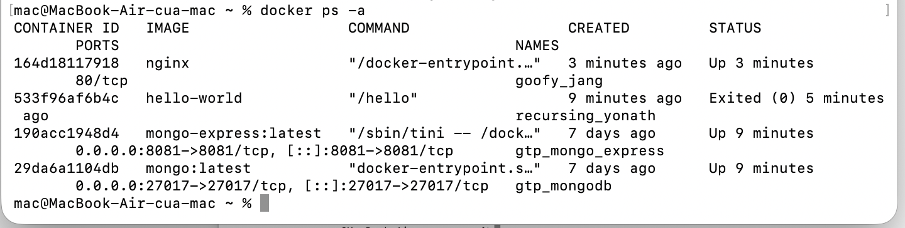
- Docker logs <container_id>
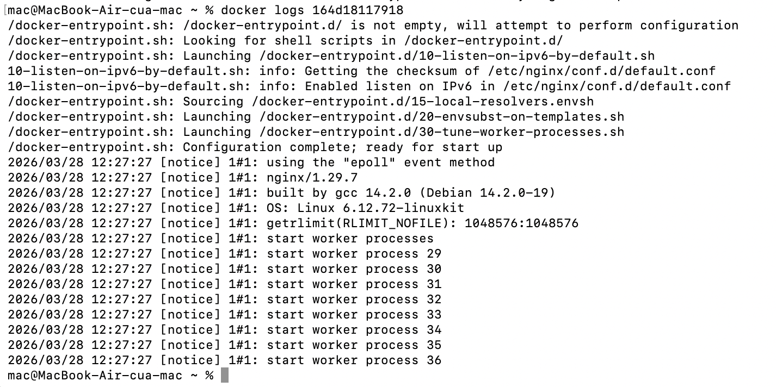
- docker exec -it <container_id> /bin/sh
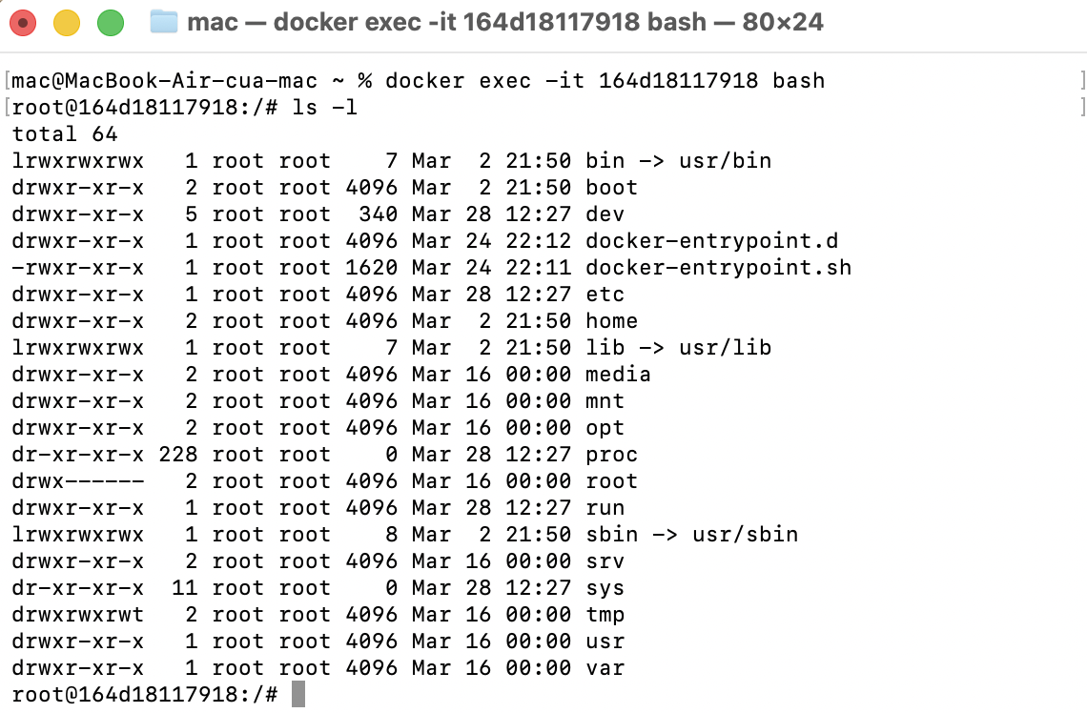
- docker stop <container_id>
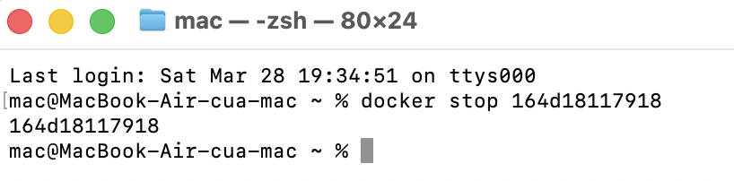
- docker restart container_id
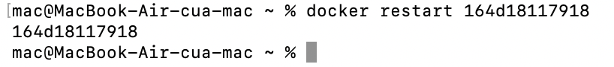
- docker rm <container_id>
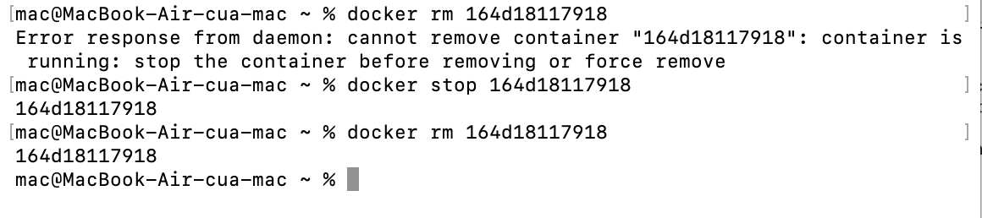
- docker container prune
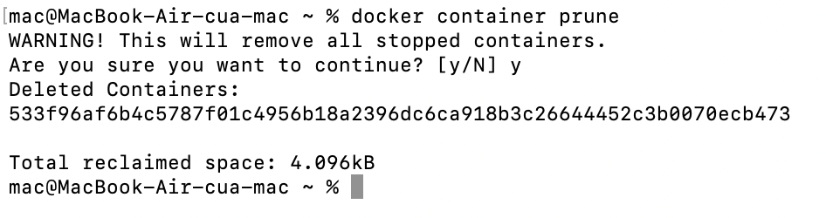
- Docker rmi <image_id>
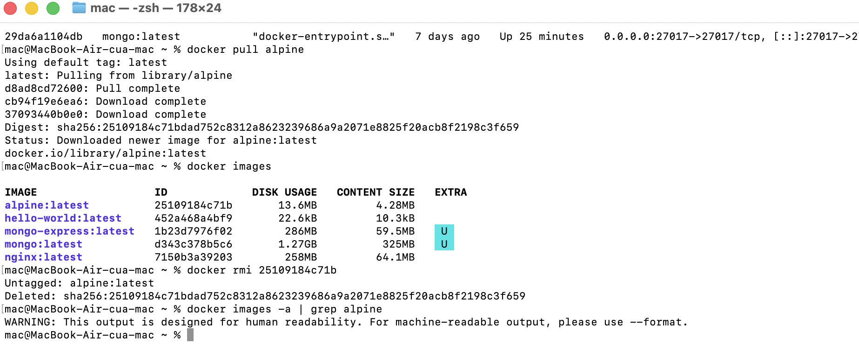
- docker image prune -a
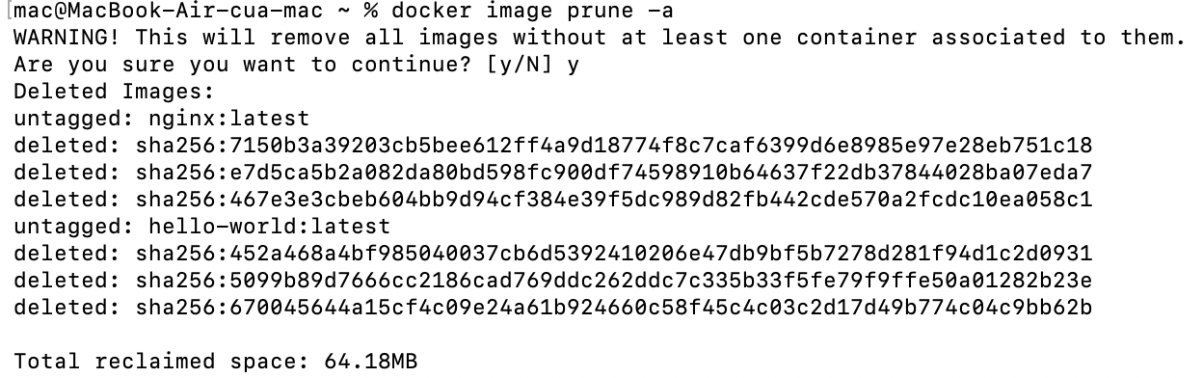
- docker run -d -p 8080:80 nginx
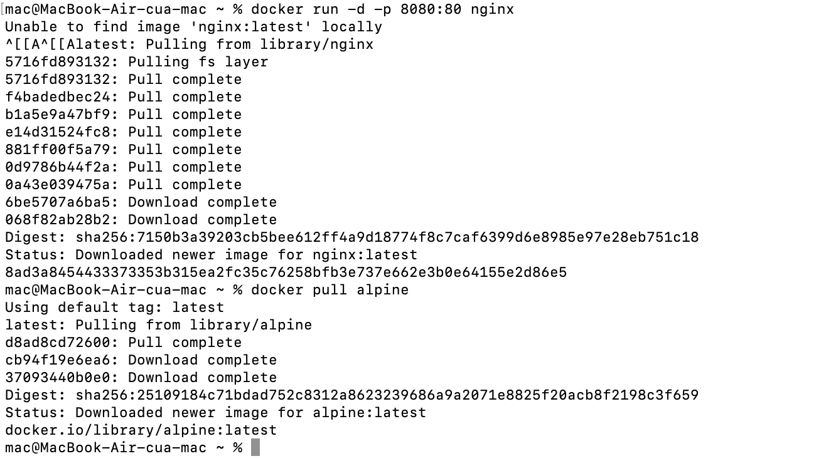
- docker inspect <container_id>
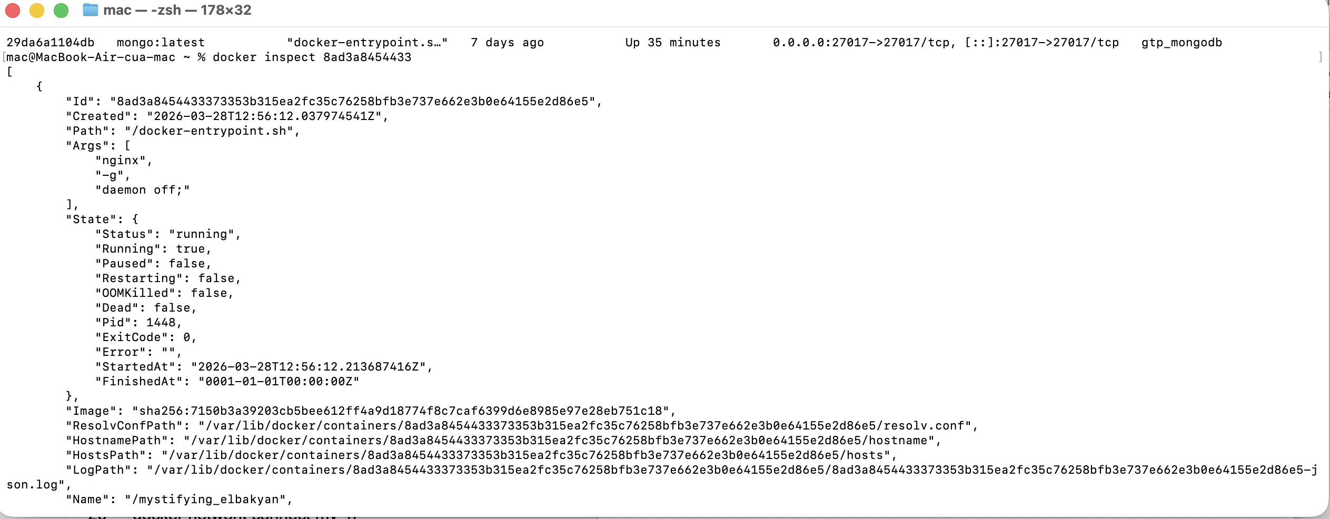
- docker run -d -v mydata:/data nginx
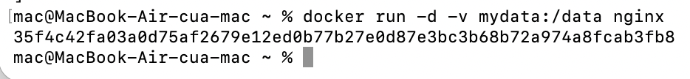
- docker volume ls
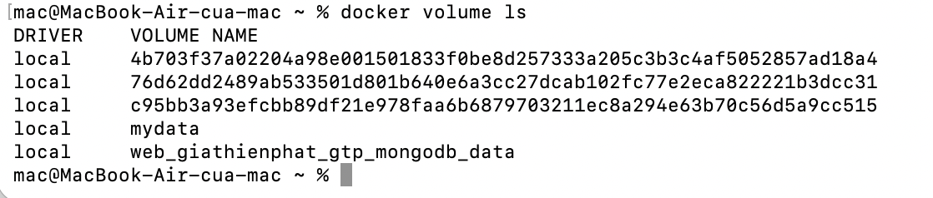
- docker volume prune
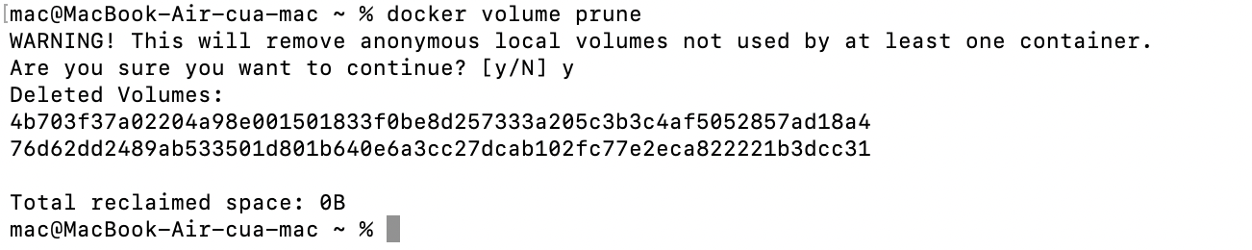
- docker run -d --name my_nginx nginx
- docker stats
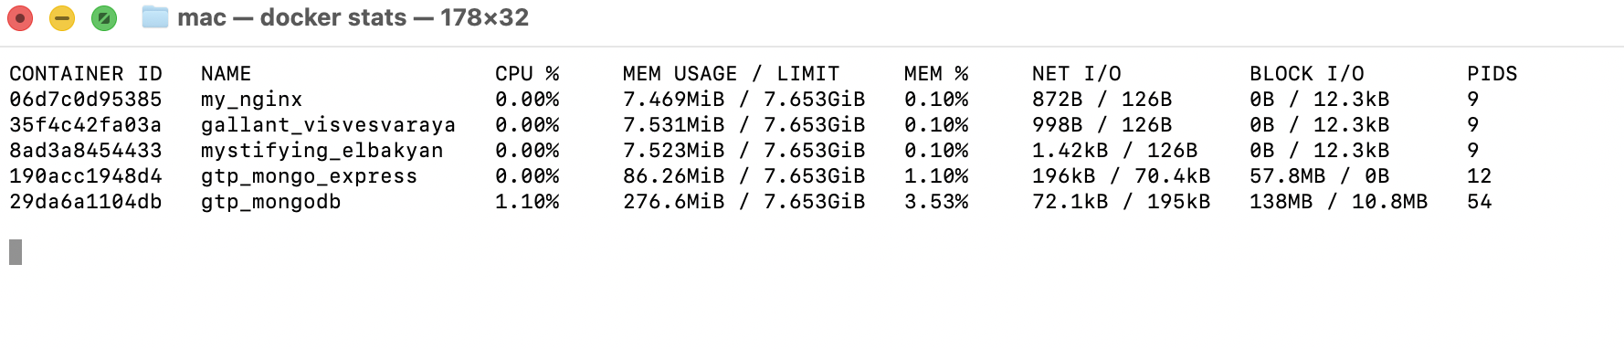
- docker network ls
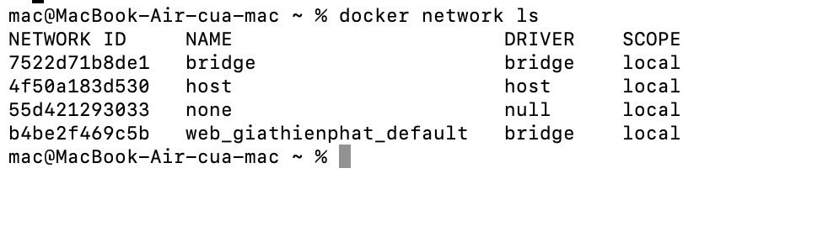
- docker network create my_network
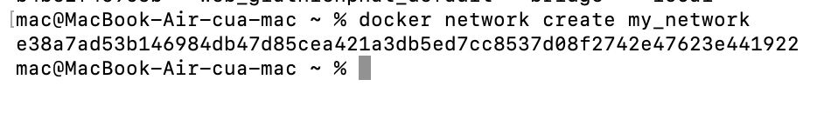
- docker run -d --network my_network --name my_container nginx
