**Software Design Specification**

**Document**

**[Commercials Calculation Engine]**

**Version: (1.0.0)** **Date: (01/22/2017)**

**Table of Contents**

1 Introduction 1

1.1 System Overview 1

1.2 Definitions, Acronyms, and Abbreviations 1

1.3 References 1

1.4 Document Map 1

2 Design Considerations 2

2.1 Assumptions 2

2.2 Constraints 2

2.3 System Environment 2

2.4 Design Methodology 2

3 Architectural (High-level) Design 3

3.1 Overview 3

3.2 Rationale 3

3.3 Conceptual (or Logical) View 3

3.4 Other Views 3

4 Low Level Design 4

4.1 Component 1 4

4.2 Component 2 4

4.n Component n 4

5 User Interface Design 5

5.1 Application Control 5

5.2 Screen 1 5

5.3 Screen 2 5

5.n Screen n 5

# Introduction

**The following subsections of the Software Design Specifications (SDS) document should provide an overview of the entire SDS. The thing to keep in mind as you write this document is that you are telling how the system should do what it is supposed to do, so that the system can be implemented.**

## System Overview

**Consumption Flow:**

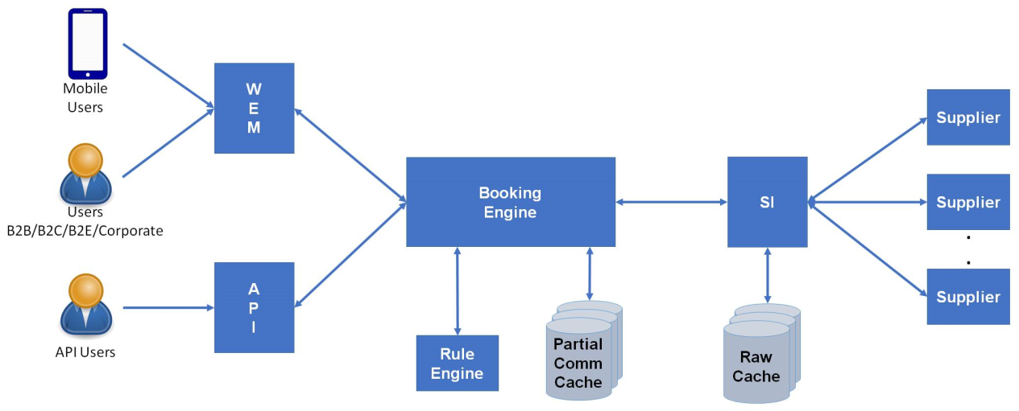

1. A user will request a product (flights, buses, hotels etc.) search from user portal or through API. This request will be routed to Booking Engine (BE) by Web Experience Management (WEM) layer or API layer.
2. The Booking Engine will check if a similar search was performed by the client previously and whether the results of this previous search are available in Commercials cache.
   1. If the results are found in Commercials cache, advanced filtering for current search (if any) will be applied on the retrieved cached results. These filtered and enriched search results will be returned to WEM for rendering to the user.
   2. If the Booking Engine does not find search results in cache, the request will be forwarded to Supplier Integration (SI) layer.
3. The SI layer will have its own atomic raw cache. The SI services will check if the same search was performed previously and whether the results of this previous search are available in the atomic raw cache.
   1. If the results are found in atomic raw cache, the results will be retrieved from cache and returned to the Booking Engine for further processing.
   2. If the results are not available in cache, the request is sent to various suppliers. The search results in responses received from these suppliers are cached for future use, consolidated together and sent to the Booking Engine for further processing.
4. When Booking Engine receives results from SI layer, it will apply advanced filtering for current search (if any).
5. The result is then sent to Commercials Calculation Engine. Commercials Calculation Engine applies various configured Supplier commercials (e.g. Standard Commercial, Overriding Commercial, and Productivity Linked Bonus etc.) and sends back the response to Booking Engine.
6. Booking Engine then enriches the supplier commercials response with client context information like client entity type, client entity name etc. and sends the request to Commercials Calculation Engine to apply Client commercials. After applying Client commercials, CCE sends back the response to Booking Engine.
7. Booking Engine sends the filtered and enriched search results to WEM for rendering to the user or to API users.
   1. Booking Engine will store the search results in Commercials Cache for future use.
8. The user will browse through the results and may select a result to look at details of that result. The WEM/API layer will request price verification for the selected search result to the Booking Engine.
9. The Booking Engine will forward this price verification (re-price) request to SI layer.
10. The SI layer will call supplier service to fetch the latest price for selected product. The latest price will be returned to Booking Engine for further processing. The latest price will also be updated in SI side atomic raw cache.
11. The Booking Engine will receive the latest price, send request to Commercials Calculation Engine to perform all commercial calculations (supplier & client specific commercials) and return the results of price verification to WEM for displaying it to the user or to API users. The Booking Engine will update its Commercials Cache with the latest price information.

**Configuration Flow:**

## Definitions, Acronyms, and Abbreviations

| **Term/Acronym** | **Definition** |
| --- | --- |
| CAPIOT | CAPIOT Software Pvt. Ltd, the proposed vendor of services in this proposal |
| Cnk | Cox and Kings |
| CCE | Commercials Calculation Engine |
| ESB | Enterprise service bus |
| MDM | Master Data Management |
| OMS | Order Management System |
| ODS | Operational Data Store |
| BE | Booking Engine |
| SI | Supplier Integration |

## References



## Document Map

N/A

# Design Considerations

## Assumptions

2.1.1. If there are conflicting rules being configured in the UI, then Business needs to set the priority of the conflicting rules and send to CCE.

E.g.: Rule 1: Travel date -"5-07-2017 to 5-09-2017"

Rule 2: All conditions same as Rule 1 except Travel date which is "20-07-2017 to 31-07-2017". If rule 2 has to be executed, then UI will send higher priority for Rule2.

2.1.2. If the supplier commercial is configured on fare component as “Base Fare +Tax1”, then CCE expects Base fare and Tax1 to be present in the input coming from Booking Engine. If any component (e.g. Tax1) is not present in the input, then commercials will not be applied on that component.

2.1.3. Currency Conversion and tax calculation will be out of scope for CCE.

2.1.4. In Packages, CCE will receive total base fare (sum total base fare of all the included products like Acco, Insurance etc.) , total taxes (sum total taxes of all the included products like Acco, Insurance etc.), total surcharge, total discount etc. from Booking Engine for set packages.

2.1.5. Attaching policy is not being handled currently in CCE.

2.1.6. In case of the commercials which are payable to the supplier (e.g. Service charge), the company will have a retention of minimum 100% while applying the client commercials so that the company does not bear the losses.

2.1.7. Client commercials: In fixed model, even if we are not getting a supplier commercial (E.g.: PLB), still if configured at client side, client may apply a fixed amount/percentage on PLB.

Supplier commercials: Slab values [e.g.: Total turnover] will not be checked for commercials during the transactional flow. Slab values will be checked and applied when the actual settlement will happen.

2.1.8. Markup (Client commercials): Cnk Company has a client "Akbar Travels" and "Akbar Travels" has a client "ABC". If Cnk applies a markup, it is applied on the passenger fare.

Now if "Akbar Travels" doesn’t apply any markup but "ABC" applies a markup, then it will be applied on the fare calculated by Cnk and not on the passenger fare.

## Constraints

BRMS uses JDK 1.8

BRMS uses Apache Ant 1.10.1

## System Environment

* AWS server would be used for deploying web services of CCE.
* **Software Requirements:**
* Apache Ant 1.10.1
* Java (Jdk 1.8)
* BRMS 6.5
* Eclipse

## Design Methodology

Object oriented programming is used in CCE. Data objects are created in BRMS Rule Engine to store facts/information. BRMS uses RETE algorithm to decide the rule that needs to be triggered based on various conditions and conflict resolution cycle. The services are exposed as REST services for consumption.

# Architectural (High-level) Design

The architectural patterns followed here are Rule based architecture (using RETE algorithm) and Representational State Transfer (REST).

CCE services have been exposed as RESTful web services.

## Overview

* This section provides a high level overview of the structural and functional decomposition of CCE.
* CCE calculates the commercial amount and the split up of all the commercial names and commercial amounts will be sent to Booking Engine.
* Booking Engine sends the request for various operations like search, re-price, booking etc. to CCE.
* CCE calculates the commercials based on various input conditions like supplier, supplier market, travel date, travel destination etc.
* CCE provides the functionality to block out certain dates when the business may choose to not give any commercials.
* Commercials can be configured on below fare components:

1. Base Fare
2. Total Fare
3. Base Fare +Taxes (YQ, RT etc.)
4. Taxes (YQ, RT etc.)

* Client commercial includes Retention commercial (amount retained from supplier commercials), Additional commercials and Markup.
* Below mentioned are the list of commercials covered:

**Supplier Transactional Commercials:**

1. Standard Commercial (IATA)
2. Overriding Commercial
3. Productivity Linked Bonus (PLB)
4. Destination Incentive
5. Sector-wise Incentive
6. Segment Fees
7. Management Fees
8. Issuance Fees
9. Commission (Flights)

**Supplier Settlement Commercials:**

1. MSF Fees
2. Remittance Fees
3. Sign Up Bonus
4. Termination Fees
5. Penalty Fees
6. Incentive On Top Up
7. LookToBook
8. Listing Fees
9. Content Access Fees
10. Integration Fees
11. License Fees
12. Loyalty Bonus
13. Maintenance Fees
14. Preference Benefit
15. Retainer Fees
16. Sign Up Fees
17. Training Fees
18. Web service Fees
19. Free Of Cost

**Client Transactional Commercials:**

1. Standard Commercial (IATA)
2. Overriding Commercial
3. Productivity Linked Bonus (PLB)
4. Destination Incentive
5. Sector-wise Incentive
6. Segment Fees
7. Service Charge
8. Management Fees
9. Mark Up
10. Discount

**Client Settlement Commercials:**

1. MSF Fees
2. Remittance Fees
3. Sign Up Bonus
4. Termination Fees
5. Penalty Fees
6. Incentive On Top Up
7. LookToBook
8. Listing Fees
9. Content Access Fees
10. Integration Fees
11. License Fees
12. Loyalty Bonus
13. Maintenance Fees
14. Preference Benefit
15. Retainer Fees
16. Sign Up Fees
17. Training Fees
18. Web service Fees
19. Free Of Cost

* CCE has been configured to calculate commercials for the below products:

1. Air
2. Accommodation
3. Activities
4. Holidays
5. Transfers
6. Bus
7. Rail
8. Car Rentals
9. Insurance
10. Cruise
11. Visa

## Rationale

REST architecture has been chosen as REST-compliant Web services allow requesting systems to access and manipulate textual representations of Web resources using a uniform and predefined set of stateless operations. REST systems aim for fast performance, reliability, and the ability to grow, by re-using components that can be managed and updated without affecting the system as a whole.

Rule based architecture is used to derive an action based on certain set of conditions. It includes a set of rules (Rule base), inference engine (that manages evaluation conditions, conflict resolution and actions).

## Conceptual (or Logical) View

**Air**:

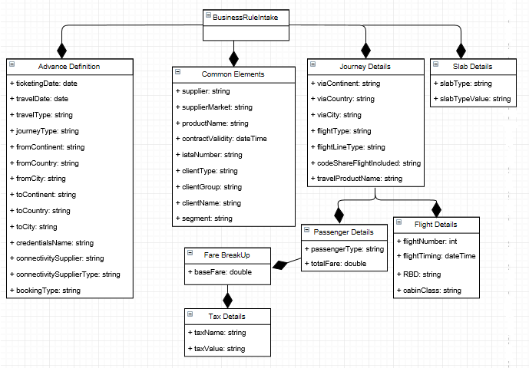

**Accommodation**: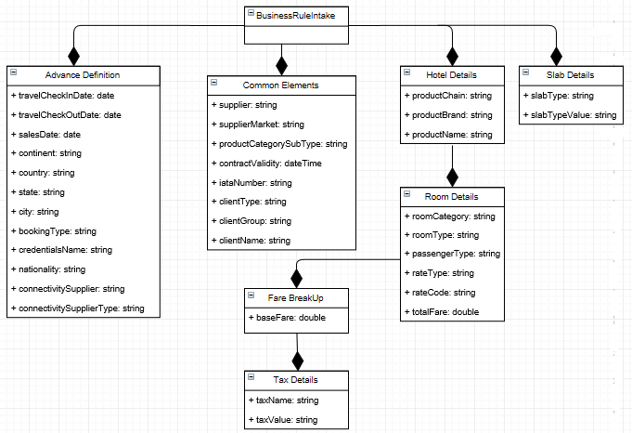**Activities**: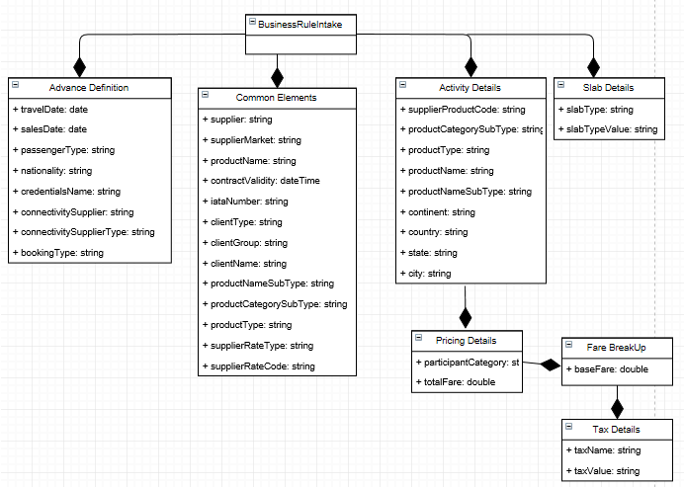

**Transfers**: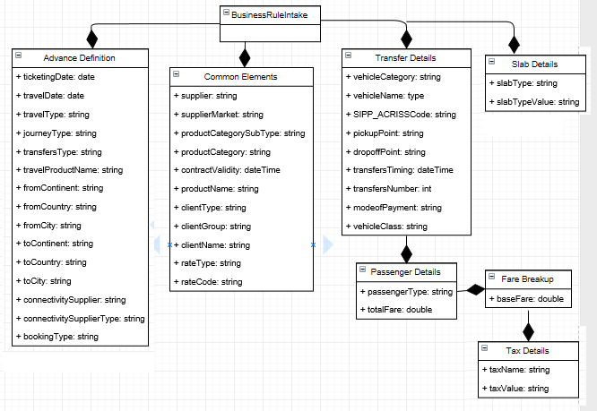

**Holidays**:

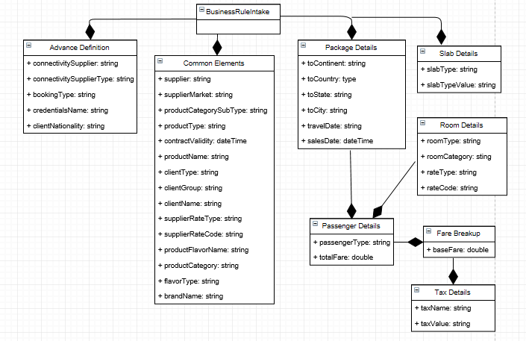

**Bus**:

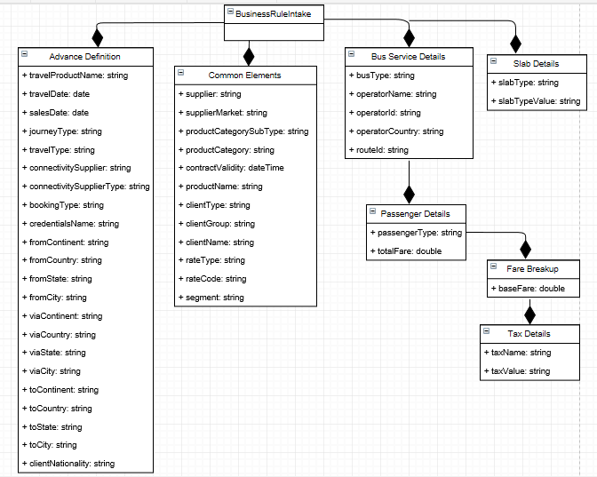

**Rail**:

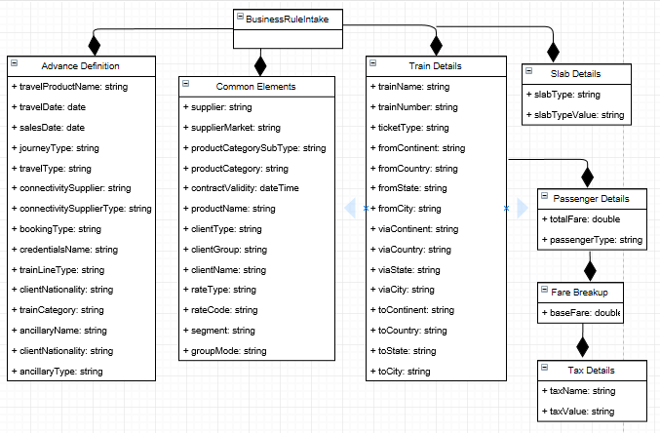

**Car-Rentals**:

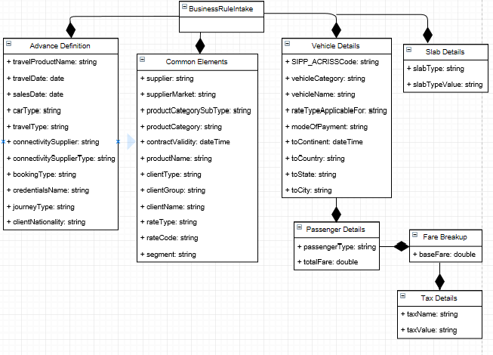

**Insurance**:

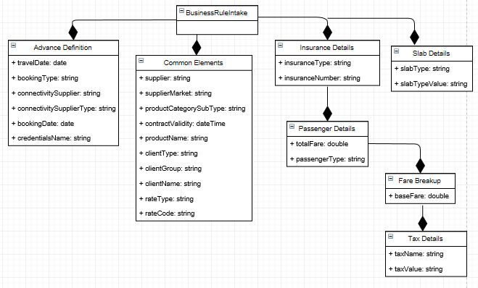

**Cruise**:

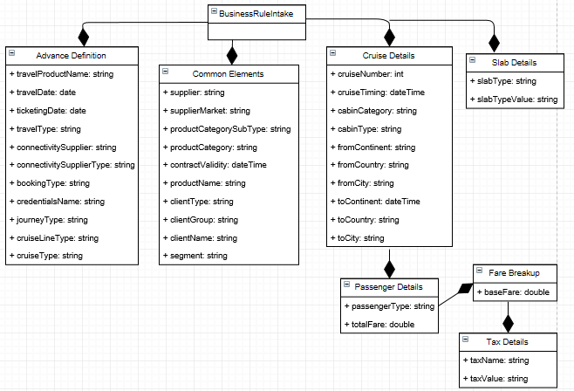

**Visa**:

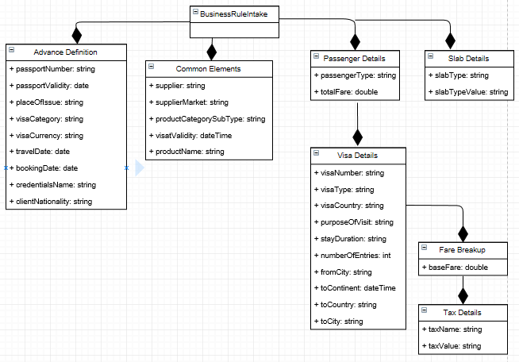

## Other Views

# Low Level Design

## Air

***Consumption Flow:*** Booking Engine sends the accumulated list of air fares from suppliers to CCE. CCE then calculates the supplier commercials and sends back the result to Booking Engine. Booking engine enriches this with client context information and sends a request to calculate Client commercials. The client commercials response is sent back to booking engine which then sends it to front end system.

***Configuration Flow:*** The commercials configured in MDM will be received over Kafka messaging channel and transformed to CCE format, and then it would be passed through a java API layer which automatically inserts, updates and deletes the Rules in CCE.

## Accommodation

***Consumption Flow:*** Booking Engine sends the accumulated list of hotel fares from suppliers to CCE. CCE then calculates the supplier commercials and sends back the result to Booking Engine. Booking engine enriches this with client context information and sends a request to calculate Client commercials. The client commercials response is sent back to booking engine which then sends it to front end system.

***Configuration Flow:*** The commercials configured in MDM will be received over Kafka messaging channel and transformed to CCE format, and then it would be passed through a java API layer which automatically inserts, updates and deletes the Rules in CCE.

## Activities

***Consumption Flow:*** Booking Engine sends the accumulated list of activity details including fare details from suppliers to CCE. CCE then calculates the supplier commercials and sends back the result to Booking Engine. Booking engine enriches this with client context information and sends a request to calculate Client commercials. The client commercials response is sent back to booking engine which then sends it to front end system.

***Configuration Flow:*** The commercials configured in MDM will be received over Kafka messaging channel and transformed to CCE format, and then it would be passed through a java API layer which automatically inserts, updates and deletes the Rules in CCE.

## Holidays

***Consumption Flow:*** Booking Engine sends the accumulated list of package details along with fare details from suppliers to CCE. CCE then calculates the supplier commercials and sends back the result to Booking Engine. Booking engine enriches this with client context information and sends a request to calculate Client commercials. The client commercials response is sent back to booking engine which then sends it to front end system.

***Configuration Flow:*** The commercials configured in MDM will be received over Kafka messaging channel and transformed to CCE format, and then it would be passed through a java API layer which automatically inserts, updates and deletes the Rules in CCE.

## Transfers

***Consumption Flow:*** Booking Engine sends the accumulated list of transfer details along with fare details from suppliers to CCE. CCE then calculates the supplier commercials and sends back the result to Booking Engine. Booking engine enriches this with client context information and sends a request to calculate Client commercials. The client commercials response is sent back to booking engine which then sends it to front end system.

***Configuration Flow:*** The commercials configured in MDM will be received over Kafka messaging channel and transformed to CCE format, and then it would be passed through a java API layer which automatically inserts, updates and deletes the Rules in CCE.

## Bus

***Consumption Flow:*** Booking Engine sends the accumulated list of bus fares from suppliers to CCE. CCE then calculates the supplier commercials and sends back the result to Booking Engine. Booking engine enriches this with client context information and sends a request to calculate Client commercials. The client commercials response is sent back to booking engine which then sends it to front end system.

***Configuration Flow:*** The commercials configured in MDM will be received over Kafka messaging channel and transformed to CCE format, and then it would be passed through a java API layer which automatically inserts, updates and deletes the Rules in CCE.

## Rail

***Consumption Flow:*** Booking Engine sends the accumulated list of rail fares from suppliers to CCE. CCE then calculates the supplier commercials and sends back the result to Booking Engine. Booking engine enriches this with client context information and sends a request to calculate Client commercials. The client commercials response is sent back to booking engine which then sends it to front end system.

***Configuration Flow:*** The commercials configured in MDM will be received over Kafka messaging channel and transformed to CCE format, and then it would be passed through a java API layer which automatically inserts, updates and deletes the Rules in CCE.

## Car Rentals

***Consumption Flow:*** Booking Engine sends the accumulated list of car rental fares from suppliers to CCE. CCE then calculates the supplier commercials and sends back the result to Booking Engine. Booking engine enriches this with client context information and sends a request to calculate Client commercials. The client commercials response is sent back to booking engine which then sends it to front end system.

***Configuration Flow:*** The commercials configured in MDM will be received over Kafka messaging channel and transformed to CCE format, and then it would be passed through a java API layer which automatically inserts, updates and deletes the Rules in CCE.

## Insurance

***Consumption Flow:*** Booking Engine sends the accumulated list of insurance details along with fare details from suppliers to CCE. CCE then calculates the supplier commercials and sends back the result to Booking Engine. Booking engine enriches this with client context information and sends a request to calculate Client commercials. The client commercials response is sent back to booking engine which then sends it to front end system.

***Configuration Flow:*** The commercials configured in MDM will be received over Kafka messaging channel and transformed to CCE format, and then it would be passed through a java API layer which automatically inserts, updates and deletes the Rules in CCE.

## Cruise

***Consumption Flow:*** Booking Engine sends the accumulated list of cruise fares from suppliers to CCE. CCE then calculates the supplier commercials and sends back the result to Booking Engine. Booking engine enriches this with client context information and sends a request to calculate Client commercials. The client commercials response is sent back to booking engine which then sends it to front end system.

***Configuration Flow:*** The commercials configured in MDM will be received over Kafka messaging channel and transformed to CCE format, and then it would be passed through a java API layer which automatically inserts, updates and deletes the Rules in CCE.

## Visa

***Consumption Flow:*** Booking Engine sends the accumulated list of visa details along with fare details from suppliers to CCE. CCE then calculates the supplier commercials and sends back the result to Booking Engine. Booking engine enriches this with client context information and sends a request to calculate Client commercials. The client commercials response is sent back to booking engine which then sends it to front end system.

***Configuration Flow:*** The commercials configured in MDM will be received over Kafka messaging channel and transformed to CCE format, and then it would be passed through a java API layer which automatically inserts, updates and deletes the Rules in CCE.

# User Interface Design

**N/A**

## Application Control

**N/A**