

Part -3: Password Cracking with Files using CUDA

Student Id : 2407710
Student Name : Dhadkan K.C.
Group : L6CG4
Lecturer : Mr.Yamu Poudel

Table of Contents
Overview 1
Header Files Used 1
Password Cracking Implementation 2
Password Generation 2
Source Code 2
Compile and run 3
Output: 3
SHA-512 Hashing 4
Source Code 4
Compile and run 5
Output: 5
CUDA (GPU) Password Generation 7
Source Code 7
Compile and run 9
Output: 9
SHA-512 Hashing of CudaCrypt 10
Compile and run 10
Output: 10
Password Cracking and Matching 11
Source Code 11
Compile and run 14
Output: 15
Comparison: CPU vs CUDA Implementation 15
Limitations 16
Conclusion 16

Table of Figures
Figure 1 Header file 1
Figure 2 PasswordGeneratorToText.c 2
Figure 3 passowrd.txt 4
Figure 4 EncryptSHA512.c 4
Figure 5 file_hashes.txt 6
Figure 6 CryptForCuda.cu 7
Figure 7 cuda_passwords.txt 9
Figure 8 cuda_hashes.txt 10
Figure 9 CudaCrackPasswords.cu 12
Figure 10 decrypted_passwords.txt 15

Overview
This work executes a full password cracking pipeline based on a CPU and a CUDA. The encryption passwords are produced and hashed on the CPU and parallel hash matching and all possible encrypted passwords are generated by the CUDA. The aim is to decode the initial 4-character passwords (aa00-zz99) out of a file of hashed passwords encrypted. Its implementation is correct in file operations, using dynamic blocks and threads to execute CUDA kernel operations, in host-device memory transfers, and memory deallocation.

Header Files Used
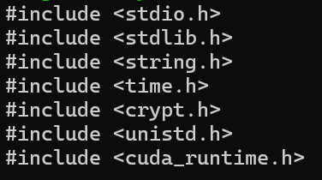
Figure 1 Header file
- stdio.h – File and console input/output
- stdlib.h – Dynamic memory allocation
- string.h – String operations
- time.h – Random number seeding
- crypt.h – SHA-512 hashing
- cuda_runtime.h – CUDA runtime support

Password Cracking Implementation

Password Generation

Source Code
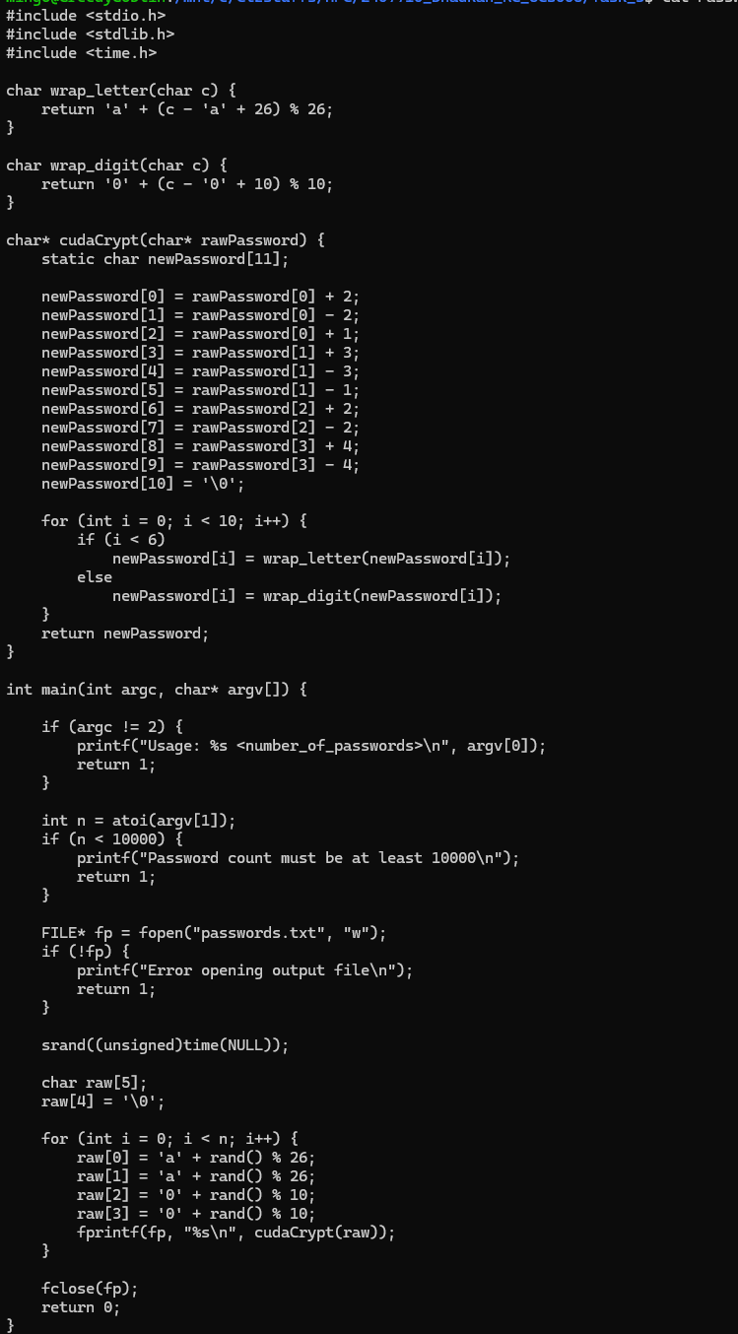
Figure 2 PasswordGeneratorToText.c
At this stage, the random raw passwords are created in the CPU. The passwords are in a standard format of two lower case letters and then two numbers, where the first one starts with aa00 and the last is zz99. This restricted format will have a limited password space that is vulnerable to brute force cracking.
Every generated raw password is encrypted by means of the offered cudaCrypt () function. The amount of passwords to be generated is entered by the user in the command line, and the amount must be at least 10,000 passwords as indicated in the task specification. The coded passwords are then written in a text file in line by line to be processed further.
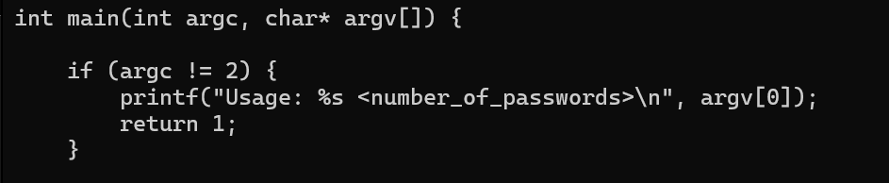 it ensures that the user provides the number of passwords to generate. It allows the dataset size to be controlled dynamically and enforces correct program usage.
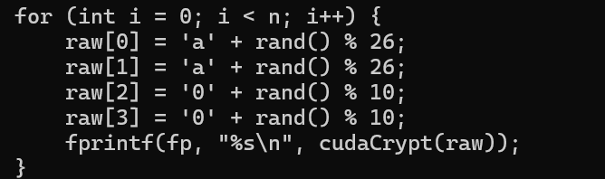
It generates raw passwords using valid ASCII ranges. The first two characters are lowercase letters, and the last two characters are digits, forming passwords in the required format.

Compile and run
Compile:
Run:

Output:
Filename: Passwords.txt
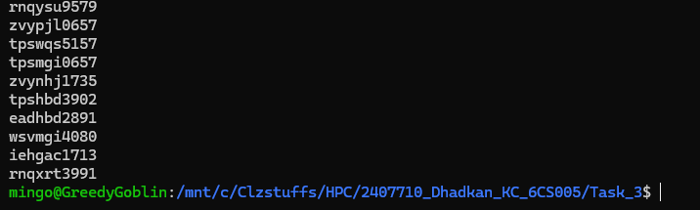
Figure 3 passowrd.txt

SHA-512 Hashing

Source Code
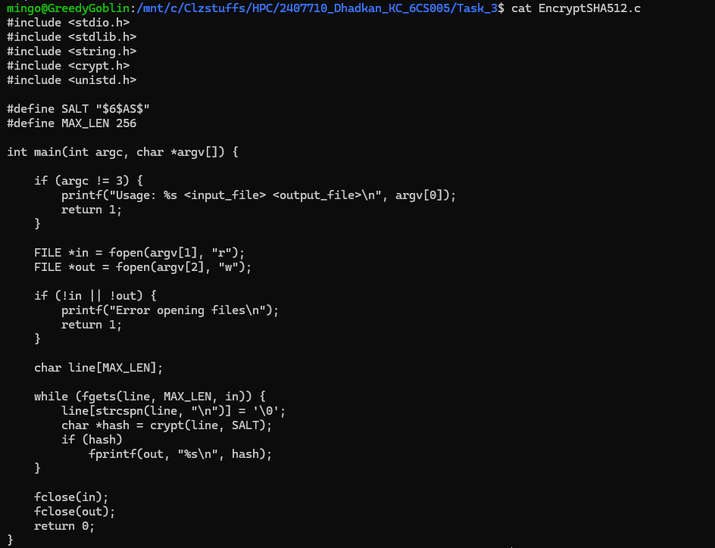
Figure 4 EncryptSHA512.c
Here, cryptographic hashing is done on the encrypted passwords formed in Step 1. The program deciphers encrypted passwords in an input file known through command line arguments. All the passwords are hashed by the crypt() function using the fixed salt and hashing algorithm SHA-512.
The resultant hashes are appended in a new output file, where the output has one hash per line. This file is the password dataset hashed which will subsequently be broken with the help of CUDA.
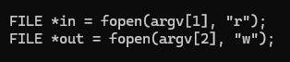
This block opens the input and output files passed through the command line, allowing the same hashing program to be reused for multiple steps.
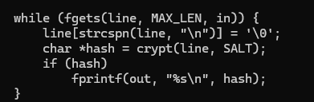
The crypt() function applies SHA-512 hashing using a fixed salt. This produces a secure, fixed-length hash for each encrypted password.

Compile and run
Compile:
Run:

Output:
Filename: file_hashes.txt
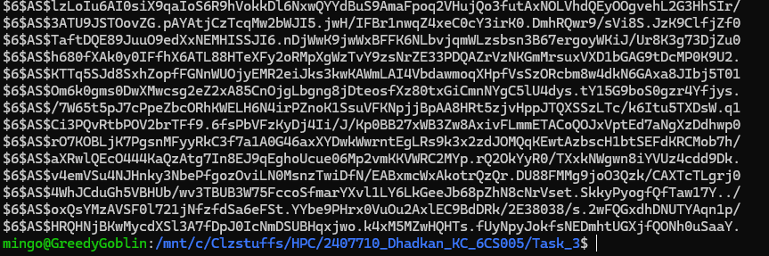
Figure 5 file_hashes.txt

CUDA (GPU) Password Generation

Source Code
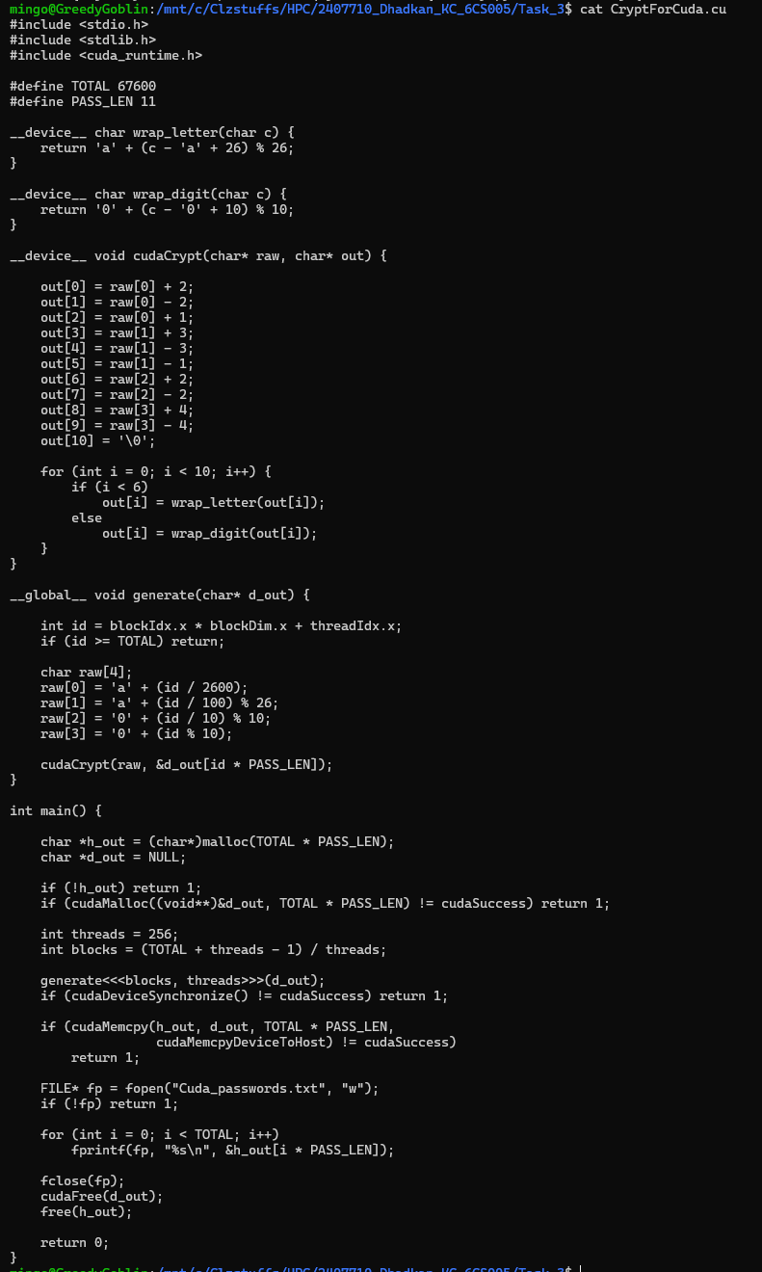
Figure 6 CryptForCuda.cu
This step involves changing the cudaCrypt function written in this case by a CPU-based cudaCrypt into a CUDA device function meaning this can be executed on the GPU. A CUDA kernel is created to generate all combinations of raw passwords between aa00 and zz99 which give rise to 67 600 unique combinations. One password is encrypted by each CUDA thread. On the x-dimension, several blocks and threads are employed to make sure the workload is spread effectively on the GPU. The passwords that are encrypted in the GPU are sent back to the host and stored in an output file.
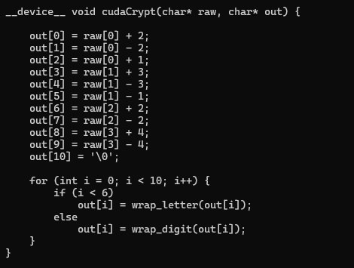
It is the GPU analog of the CPU encryption functionality. It provides the same logic in order to make sure that encrypted passwords are created on the GPU are the same as those created on the CPU.
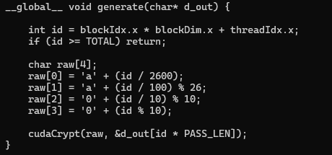
Each CUDA thread computes a unique password combination based on its thread ID. Bounds checking ensures that threads do not access invalid memory.
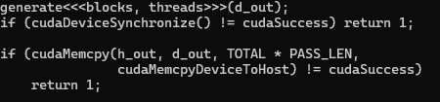
kernel is launched using multiple blocks and threads. Synchronisation ensures that all GPU computations finish before results are copied back to the CPU.

Compile and run
Compile:
Run:

Output:
Filename: cuda_passwords.txt
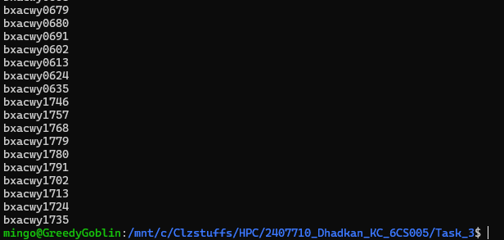
Figure 7 cuda_passwords.txt

SHA-512 Hashing of CudaCrypt
This step involves changing the cudaCrypt function written in this case by a CPU-based cudaCrypt into a CUDA device function meaning this can be executed on the GPU. A CUDA kernel is created to generate all combinations of raw passwords between aa00 and zz99 which give rise to 67 600 unique combinations. One password is encrypted by each CUDA thread. On the x-dimension, several blocks and threads are employed to make sure the workload is spread effectively on the GPU. The passwords that are encrypted in the GPU are sent back to the host and stored in an output file.

Compile and run
Compile:
Run:
It is the GPU analog of the CPU encryption functionality. It provides the same logic in order to make sure that encrypted passwords are created on the GPU are the same as those created on the CPU.

Output:
Filename: cuda_hashes.txt
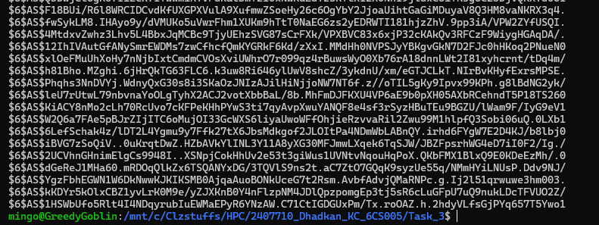
Figure 8 cuda_hashes.txt

Password Cracking and Matching

Source Code
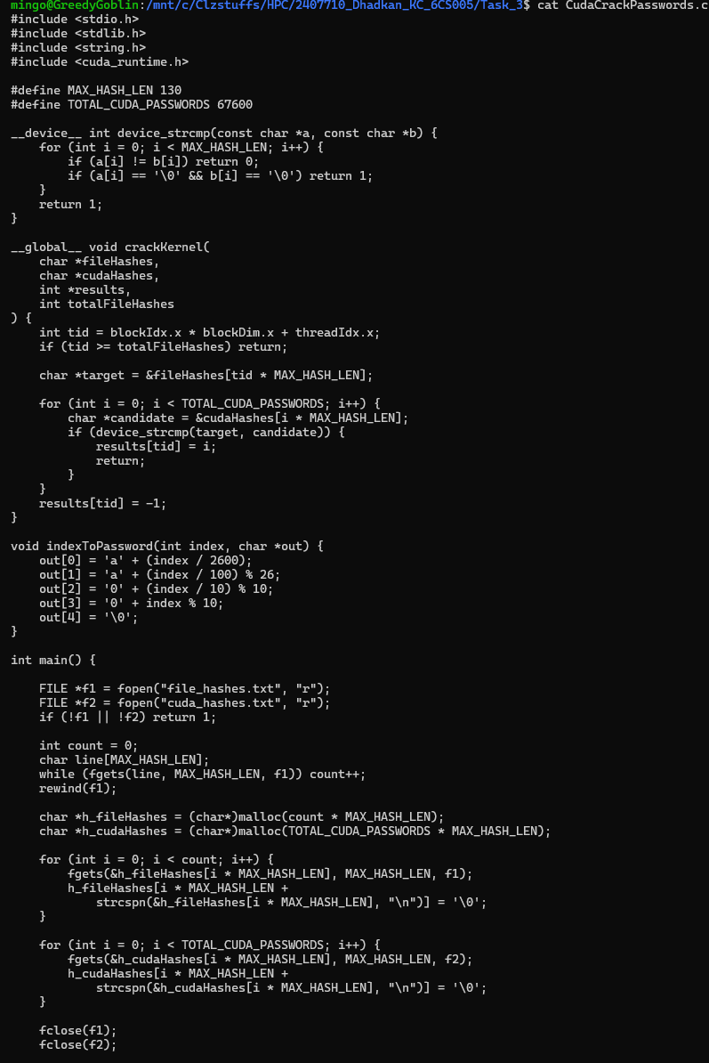
Figure 9 CudaCrackPasswords.cu
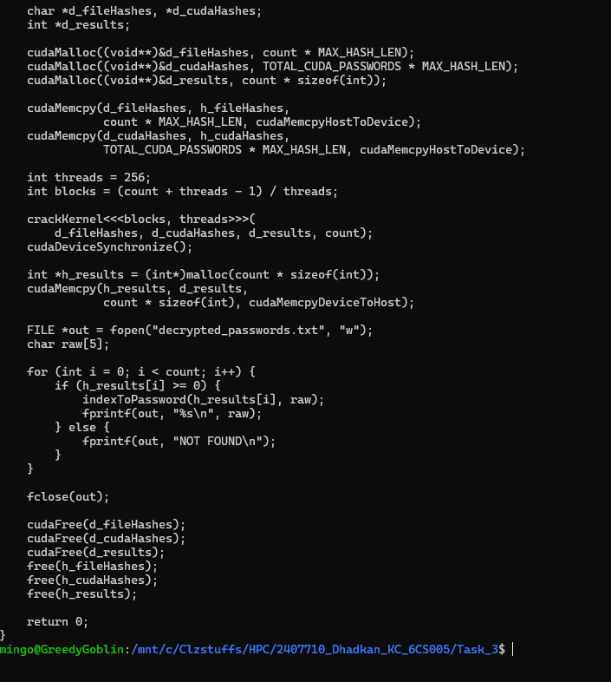
This is the last process of the password cracking pipeline. The hashed passwords produced by the original dataset (Step 2) are compared with the hashed passwords produced with CUDA (Step 4) in this step. The matching of hashes and recovery of original raw passwords is efficiently done using CUDA parallelism. Both hash files are initially loaded into the memory of the CPU and transmitted to the GPU memory. Parallel hash comparison is done by a CUDA kernel. Upon the identification of a match on a hash, the index is transformed back to the raw password form (aa00-zz99). The retrieved passwords are then loaded back into the CPU and stored in an output file.

This block opens the two input files with the hashes of the SHA-512. The first file has the hash of passwords produced in Step 1 and the second file has the hash of all the possible passwords produced by CUDA.
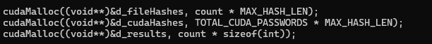
The processor allocates the memory of the GPUs to store the hash datasets and an array to store matching indices. The allocations are calculated using the number of hashes read on the input files and this defines an efficient use of memory.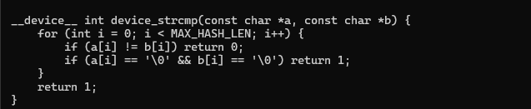
This operation does a direct hash string comparison in the GPU. It is necessary since C library functions of dealing with strings are not applicable within CUDA device code.
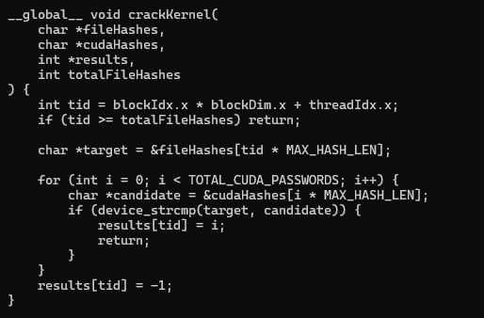
Every CUDA thread works with one hashed password of the original dataset. This hash is compared by the thread to all the CUDA produced hashes. When a match is discovered, the index of the matching CUDA password is saved. 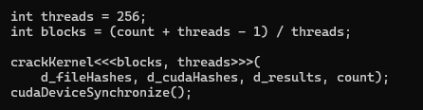
The x-dimension involves the use of several blocks and threads to launch the kernel. The threads operate independently and perform one hash comparison task each, making them very efficient to execute in parallel.

Compile and run
Compile:
Run:
It is the GPU analog of the CPU encryption functionality. It provides the same logic in order to make sure that encrypted passwords are created on the GPU are the same as those created on the CPU.

Output:
Filename: decrypted_passwords.txt
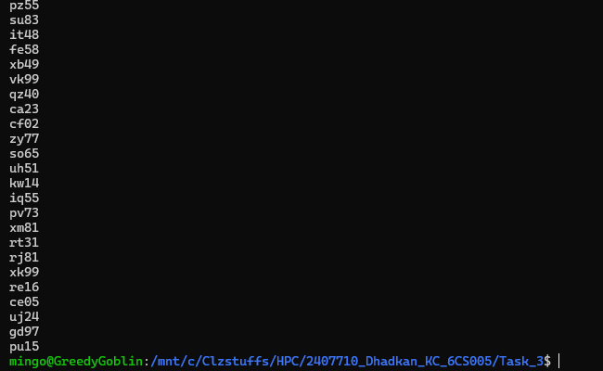
Figure 10 decrypted_passwords.txt
This step completes the password cracking process by leveraging CUDA parallelism to efficiently match SHA-512 hashes and recover original passwords. By distributing the workload across multiple GPU threads, the cracking process is significantly faster than a CPU-only approach.

Comparison: CPU vs CUDA Implementation
Password generation and cracking and hashing are performed using a CPU-only method, and computationally inexpensive, with the operations occurring sequentially which is computationally expensive as the size of the password dataset expands. Conversely, the CUDA implementation uses massive parallelism to allocate a single task of password related operation to each thread on the GPU. Generation of passwords and hash matching are thus performed in thousands of threads, therefore cutting on the execution time considerably. Also, block and thread allocation in the C UDA implementation is dynamic which provides efficient utilization of the resources of the GPU. All said and done, CUDA strategy has better performance, scalability as well as efficiency when compared to purely CPU based solution especially in brute force password cracking.

Limitations
- The password structure is only limited to two lower case letters, then two digits (aa00-zz99), which prevents the maximum address space of a password.
- SHA-512 hash is calculated solely on the CPU since cryptographic hash is not performed on the graphic card.
- Memory optimizations such as shared memory are not used and this could also be optimized to enhance performance.
- CUDA debugging is limited and can be extended to a stronger one.
- The implementation is sensitive to valid input files and does not deal with corrupted and malformed data largely.

Conclusion
This assignment has managed to show how CUDA is used to speed up password cracking by using CPU preprocessing and parallel computation on the company of the GPUs. The passwords are encrypted and hashed on the CPU and the GPU is efficient in generating all the possible password combinations and parallel match hash. The implementation has properly handled file input/output, dynamic memory allocation and thread allocation, host-device memory transfers and memory deallocation. The retrieved passwords testify to the appropriateness of the method, and the solution fits all the requirements of the tasks and demonstrates the obvious benefits of the work in terms of performance of the use of GPUs.

