University of Wolverhampton
School of Mathematics and Computer Science
Student Number: 2407710
Name: Dhadkan K.C.
6CS005 High Performance Computing Week 10 Workshop
Revision on CUDA
Tasks – CUDA Block, Grid and Thread

From what you have learnt in the Lecture, using only multiple blocks and threads, produce the following programs:
Revision on CUDA
Tasks – CUDA Block, Grid and Thread
From what you have learnt in the Lecture, using only multiple blocks and threads, produce the following programs:

- The below cuda program attempts to launch a GPU kernel that calls a function to print "Hello World".
#include <stdio.h>
void displayHelloWorld(){
printf("Hello World\n");
}
__global__ display(){
displayHelloWorld();
}
int main(){
display<<<1,1>>>();
cudaDeviceSynchronize();
return 0;
}
- Does the code work ?
Ans: No this code did not work. It did not worked because the function type of kernel is not given.
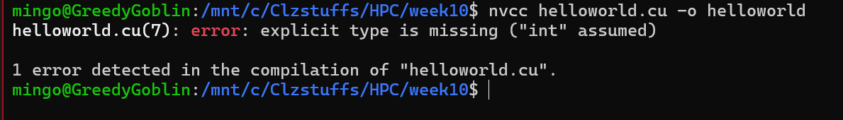

- Modify the code such that the function displayHelloWorld is callable inside the kernel.
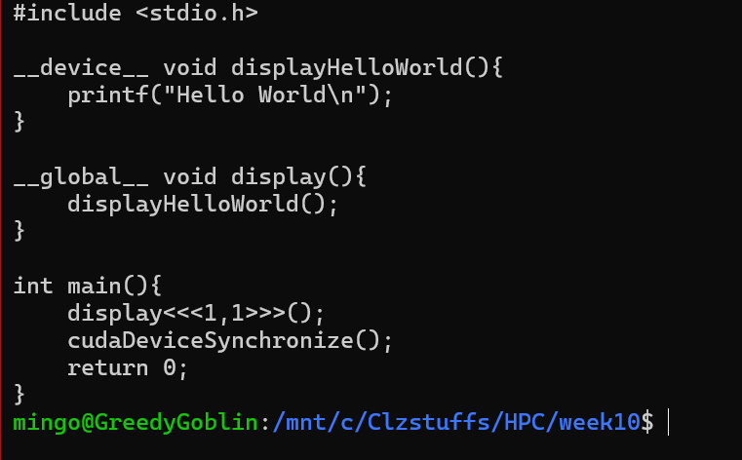
kernel function display was missing the __global__ return type (void), it must be declared as __global__ void display().

- Run and observe the output of the following code:

#include <stdio.h>
#include <cuda_runtime.h>

__global__ void display() {
int threadID =threadIdx.y;
int blockID = blockIdx.x;
printf("Block %d -> ThreadId = %d\n", blockID, threadID);
}
int main() {
dim3 gridSize(1, 1, 1);
dim3 blockSize(5, 1, 1);
display<<<gridSize, blockSize>>>();
cudaDeviceSynchronize();
return 0;
}

Expected Output:

Block 0 -> ThreadId = 0
Block 0 -> ThreadId = 1
Block 0 -> ThreadId = 2
Block 0 -> ThreadId = 3
Block 0 -> ThreadId = 4

- Does the actual output match the expected output? Identify the problem.
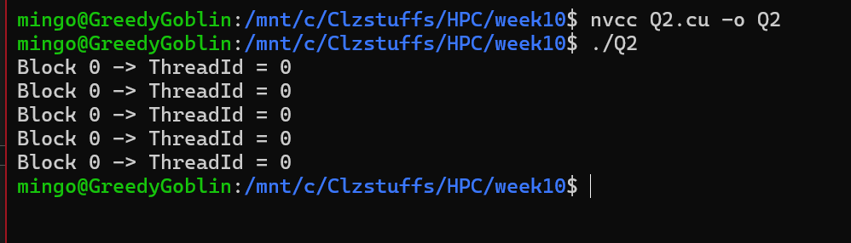
Ans : No, The actual output does not match the expected output because the block size (5,1,1) creates 5 threads in the x-direction and only 1 thread in the y-direction, but the code uses threadIdx.y to get the thread ID. Since there is only one thread in the y-direction, threadIdx.y is always 0, so every thread prints 0.
- Modify the code so that it produces the correct output and explain your changes.
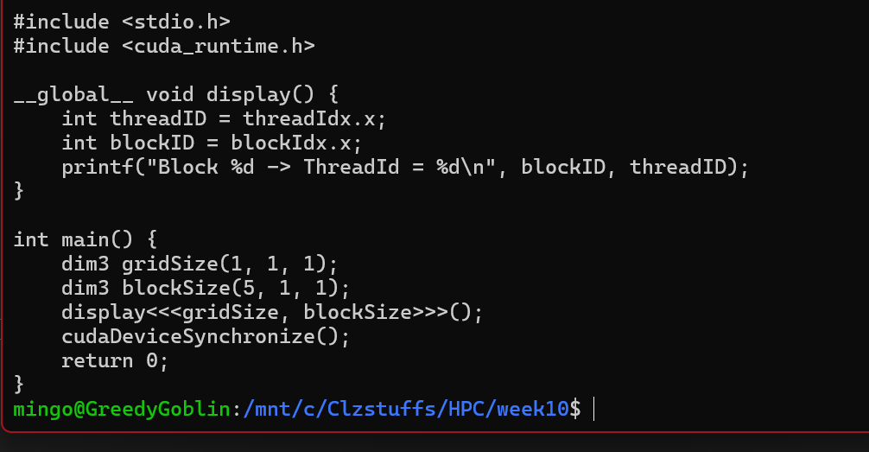
Ans: The block is launched with 5 threads in the x-direction and only 1 thread in the y-direction, so threadIdx.y is always 0. Changing threadID to threadIdx.x correctly accesses the x-direction thread index, producing thread IDs from 0 to 4 as expected.
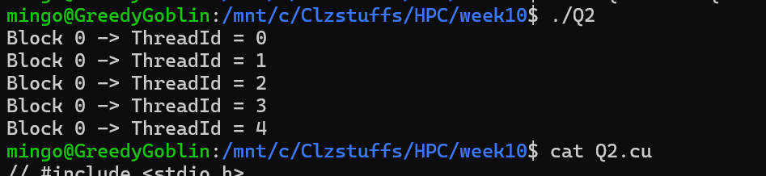
- In the code above, the block dimension is specified as dim3 blockSize(5, 1, 1). Which means that the block has:
- 5 threads in the x-dimension
- 1 thread in the y-dimension
- 1 thread in the z-dimension
This typically means that the block we created is a 1D block with 5 threads in the x-direction.
- Modify the code so that it creates a 2D block instead of a 1D block. Also print thread ids along its corresponding directions/axis. For example if you are using a 2D block specified as dim3 blockSize(5, 1, 3) print thread ids along x and z direction/axis similar to the one given below:

Block : 0 -> ThreadX = 0, ThreadZ = 0
Block : 0 -> ThreadX = 1, ThreadZ = 0
Block : 0 -> ThreadX = 2, ThreadZ = 0
Block : 0 -> ThreadX = 3, ThreadZ = 0
Block : 0 -> ThreadX = 4, ThreadZ = 0
Block : 0 -> ThreadX = 0, ThreadZ = 1
Block : 0 -> ThreadX = 1, ThreadZ = 1
Block : 0 -> ThreadX = 2, ThreadZ = 1
Block : 0 -> ThreadX = 3, ThreadZ = 1
Block : 0 -> ThreadX = 4, ThreadZ = 1
Block : 0 -> ThreadX = 0, ThreadZ = 2
Block : 0 -> ThreadX = 1, ThreadZ = 2
Block : 0 -> ThreadX = 2, ThreadZ = 2
Block : 0 -> ThreadX = 3, ThreadZ = 2
Block : 0 -> ThreadX = 4, ThreadZ = 2
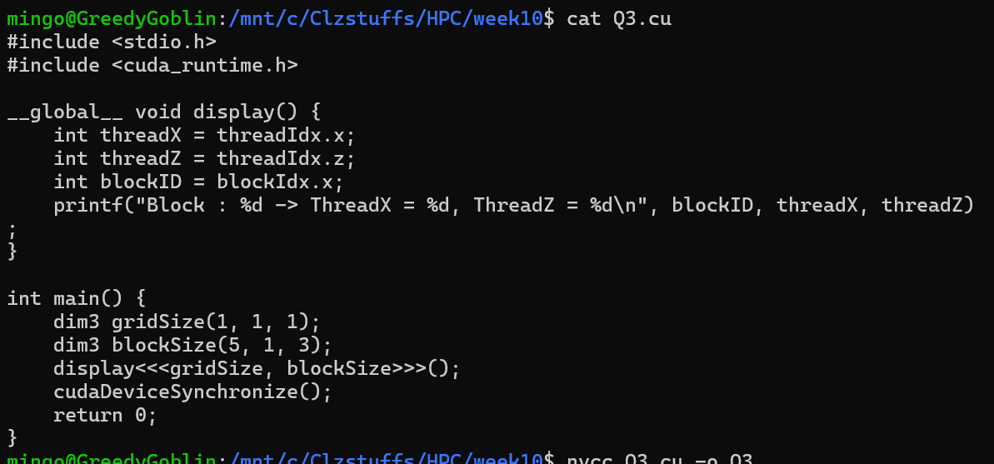
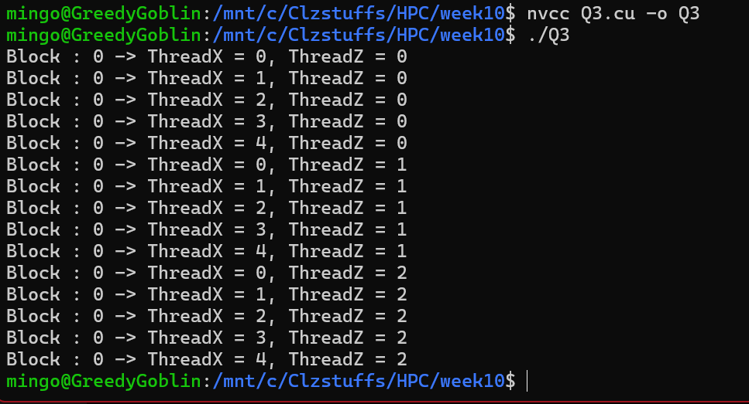

- Modify the code again so that it creates a 3D block instead of 2D block. Also print thread ids along its corresponding directions/axis.
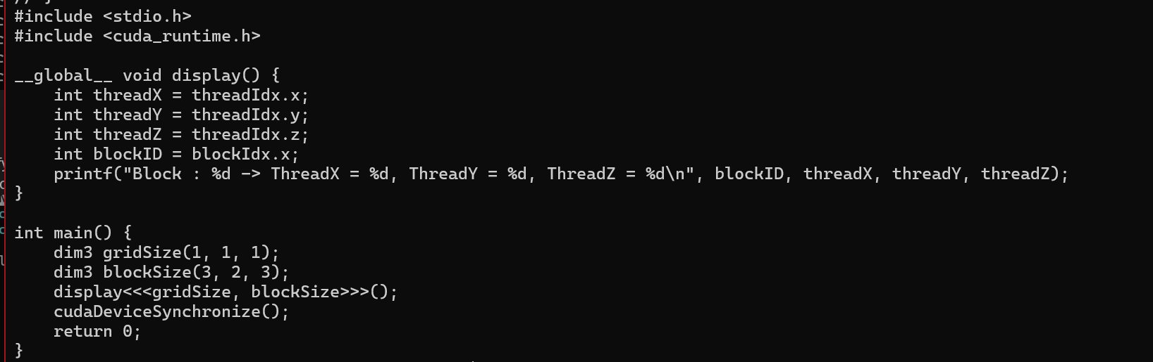
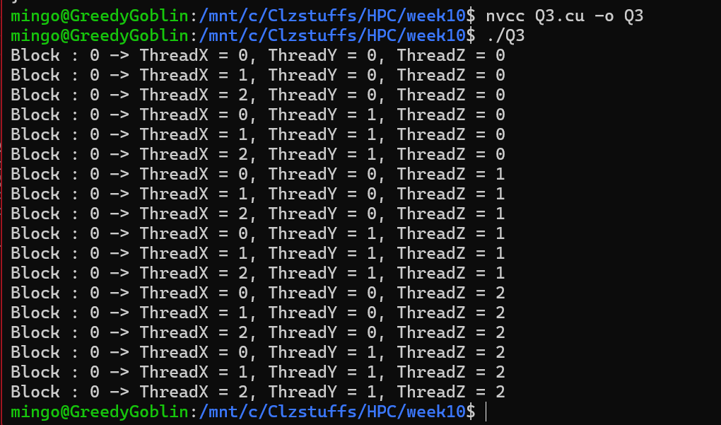
- The below code takes an integer n from the user and prints all numbers between 0 to n - 1 using the kernel function.

#include <stdio.h>
#include <cuda_runtime.h>
__global__ void displayIdx(){
int tid = threadIdx.x;
printf("%d\n", tid);
}
int main(){
int n;
printf("Enter n : ");
scanf("%d", &n);
dim3 gridSize(1, 1, 1);
dim3 blockSize(n, 1, 1);
displayIdx<<<gridSize, blockSize>>>();
cudaDeviceSynchronize();
return 0;
}

- Does the code work when the user enters n as 1025 ? Explain.

Ans: No the code does not work. This is the max number of threads to use in a block is 1024. blockSize.x=1025 exceeds 1024.

- Does the code still work when changing the dim3 blockSize(n, 1, 1) line of code to dim3 blockSize(n, n, 1) ? Modify the code so that the values are correctly printed out.
Hint:

__global__ void displayIdx(){
int tid = threadIdx.x; // Try changing this line of code.
printf("%d\n", tid);
}
Note:
If n = 5, the code should print the value 0 to 24.
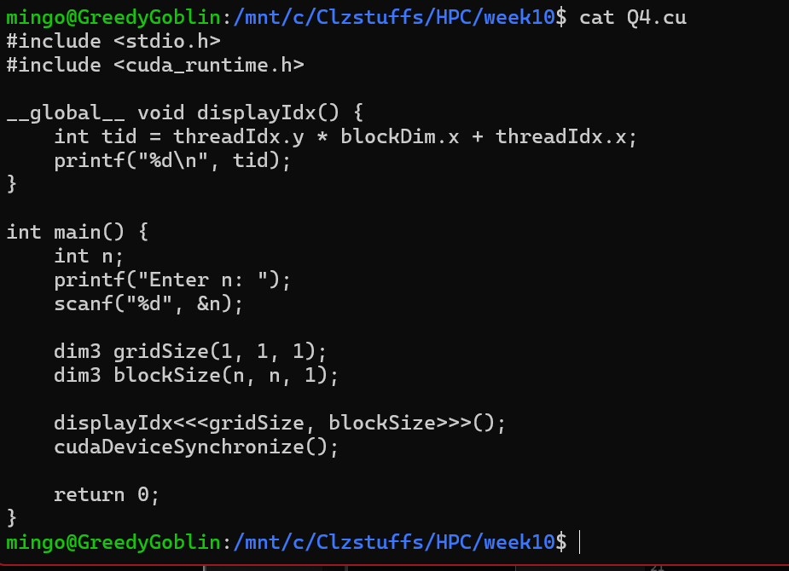

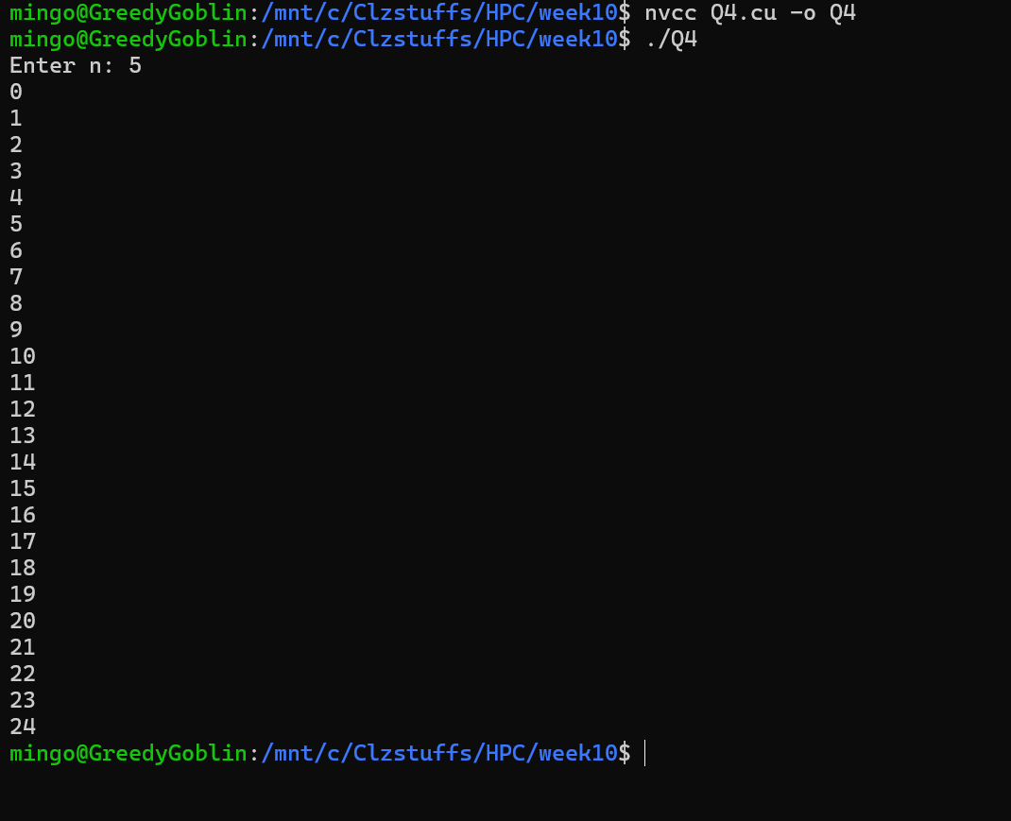
- Now change the dim3 blockSize(n, n, 1) to dim3 blockSize(n, n, n) and also modify the code so that it correctly prints out the value. Example if n = 5, the code should print the value 0 to 124.
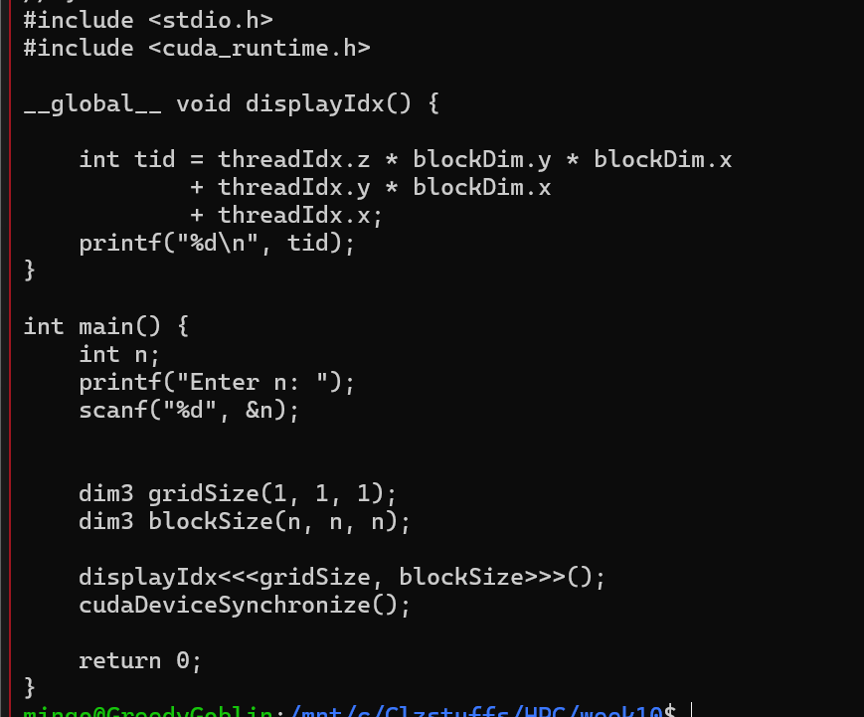
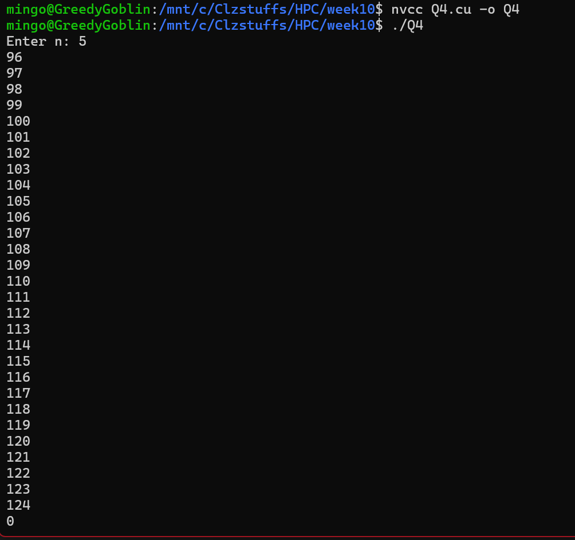
6. Create a CUDA program to solve quadratics (find the roots). You will be given a text file containing 3 integers on each row which represent a, b and c for the following formula:
