

Part - 1 : High Performance Computing

Student Id : 2407710
Student Name : Dhadkan K.C.
Group : L6CG4
Lecturer : Mr.Yamu Poudel

Table of Contents
Task – 1 1
Word Occurrence Counting using Multithreading (Pthread) 1
Main Function 3
Compiling 6
InputFIle 7
Output Result.txt 8
Task 2 9
Multiple Operations with Matrices using Multithreading (OpenMP) 9
Main Function 10
Summary of Runs 15
Matrices file 16
Input File (Matrices) 16
Compiling 16
OutputFile 17
MatData file 19
Input File (MatData) 19
MataData with 2 threads 20
MatData with 6 threads 21
Output File 22

Task – 1

Word Occurrence Counting using Multithreading (Pthread)
The task is aimed at writing a multithreaded C program with the help of Pthread library to enumerate the number of times words in a text file appear. The input file name and the number of threads are the command-line arguments that the program takes. The biggest goal is to enhance the speed of the processing by sharing the work load across several threads but is that the results are correct by ensuring proper synchronization.
The program starts by reading the input file line by line and dynamically storing these lines in the memory. These lines are separated parts of work which can be generated at the same time. Rather than simply assigning lines to threads on a static basis, a dynamic allocation system is provided wherein a thread loads in the next available line by means of a shared index. This will provide enhanced load balancing, in cases where the length of the lines are not equal.
The threads read through their respective lines one character at a time. Alphabetic letters are clustered together to create words, marks of punctuation are not taken into account and all characters have been turned into lower-case. This normalization can make the words like Word, word and WORD the treatment of a single entity. When a word is created, it is included in a common word list in which its frequency will be updated
Mutex lock is employed to eliminate race conditions. The mutex guards access to the shared line index in order to ensure that two threads do not work on the same line. The shared word and frequency arrays are another mutex that guarantees that updates to word counts can be made across multiple threads that are trying to update the word counts at the same time.
The management of memories is done attentively during the program. The file lines are stored using dynamic allocation, and all the memory allocated is released appropriately upon the termination of the program. Error checking is also provided on file opening, memory allocation, and thread creation so that it can be executed robustly.
Once all the threads have been executed, the words are arranged in a descending order (according to their frequency) and sorted by the program. The resulting whole line is saved in an output file which is called result.txt with the word preceded by the number of times it appears.
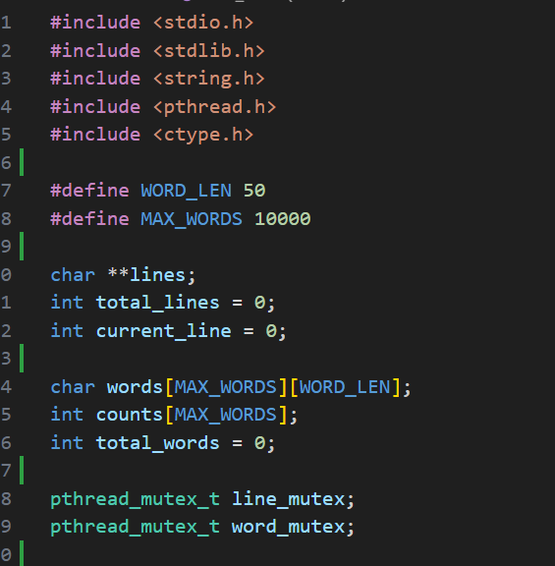
This section includes the required libraries, sets constants for maximum word length and total words, and declares all global variables. Arrays lines, words, and counts store the text data and word frequencies. Mutexes ensure safe access to shared resources when multiple threads run concurrently.

Main Function
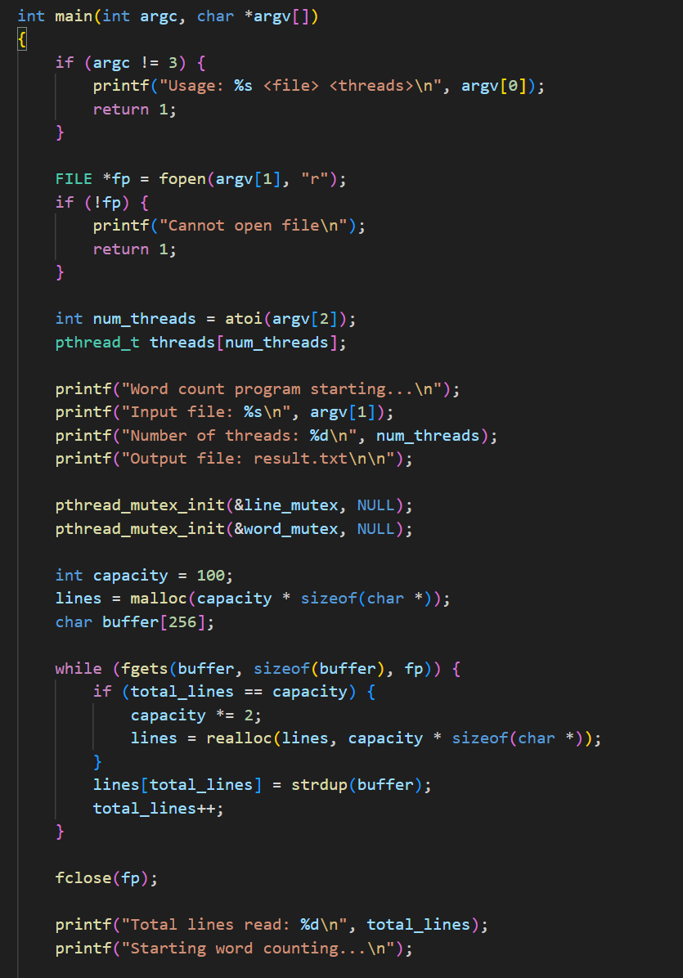
The principal role begins by checking the command-line parameters. The program will be given two arguments namely the input file name and the number of threads. In case the arguments are wrong, then a usage message is displayed and the program is terminated. The input file is then read in read mode and the execution halts in case the file cannot be accessed. The thread count is transformed into string and then into an integer number which is used to form an array of thread identifiers.

This section includes the required libraries, sets constants for maximum word length and total words, and declares all global variables. Arrays lines, words, and counts store the text data and word frequencies. Mutexes ensure safe access to shared resources when multiple threads run concurrently.
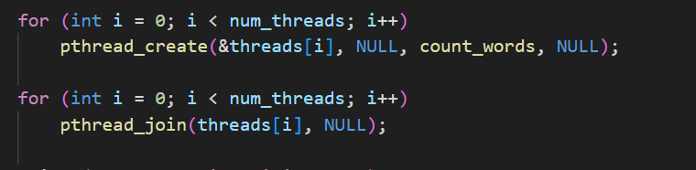
threads are created to process lines in parallel. Each thread runs the count_words function. pthread_join ensures that the main function waits until all threads have finished counting before proceeding.
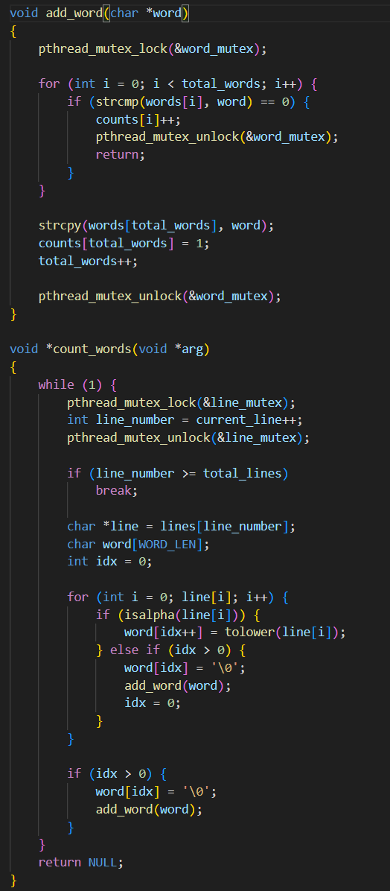
These functions handle word extraction and counting. count_words runs in each thread and processes one line at a time. add_word adds a new word or increments the frequency, with mutex locking to avoid conflicts between threads.
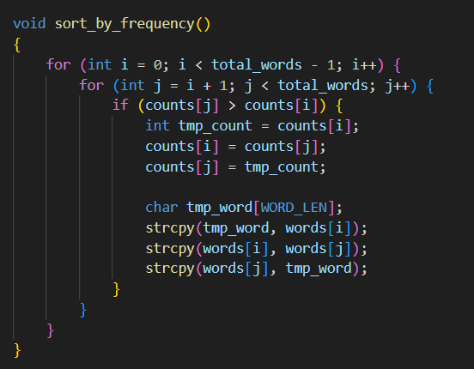
After counting is complete, the words are sorted by frequency and written to result.txt. This ensures the most frequent words appear first, and the program produces a clean, readable output.

Compiling
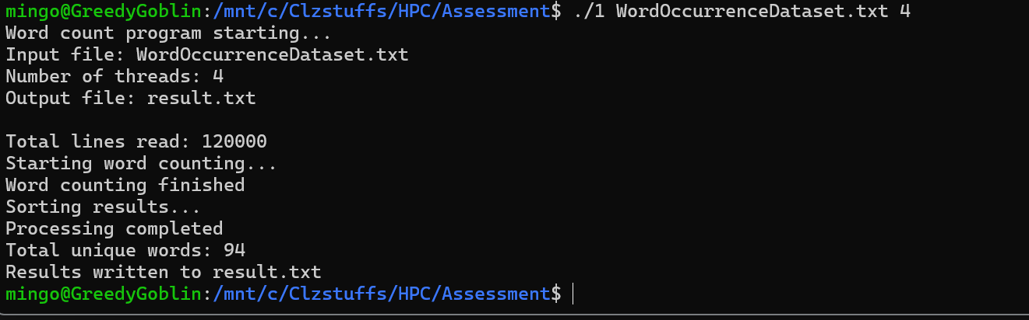

InputFIle
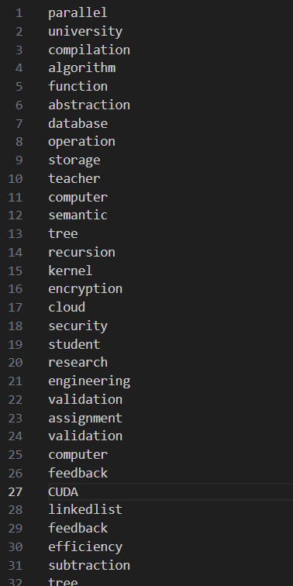

Output Result.txt
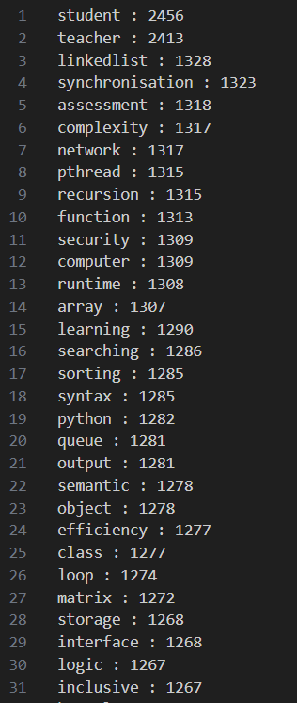

Task 2

Multiple Operations with Matrices using Multithreading (OpenMP)
This assignment is based on the creation of an OpenMP based C program that can use multiple processors to perform different operations on matrices. The program reads many matrices in a text file that is given through command line and it dynamically stores them in memory. Matrices are manipulated in pairs, and all the valid operations including addition, subtraction, multiplication and division of elements, transpose, and conventional multiplication of matrices are possible, depending on the dimensions of the pair of matrices.
The program gives the user an option of the number of threads to use. OpenMP instructions, specifically the use of the omp parallel for directive, are used to parallelise the most CPU intensive processes, e.g., when looping through rows and columns to carry out element wise processes or even matrix multiplication. In order to remain efficient, the number of threads is dynamically limited depending on the size of the matrices and over-threading can be avoided with a large number of threads compared to work items.
Such invalid operations like adding matrices of dissimilar dimensions or multiplying matrices of different sizes are treated in a graceful manner with easy to understand messages in the output file. All the findings are captured in a readable and structured data format and the dynamically allocated memory is freed adequately to avoid any memory leakages.
The most significant advantage of this implementation is that the organization uses OpenMP parallelization intelligently, so that the operations with matrices are performed effectively without losing their correctness and stability based on a variety of input files and different numbers of threads.

Main Function
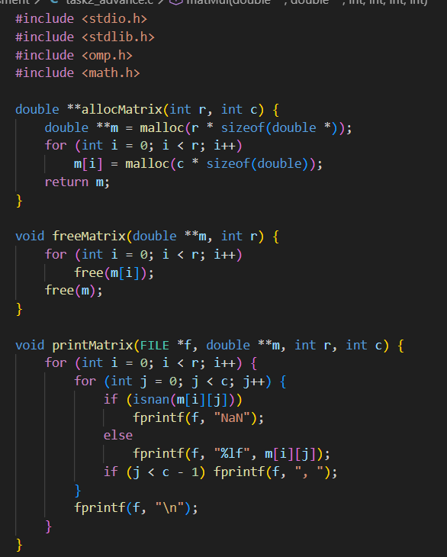
This section sets up the necessary libraries for matrix operations and OpenMP parallelization. Functions allocMatrix and freeMatrix handle dynamic allocation and deallocation of matrices, allowing matrices of any size to be processed safely.
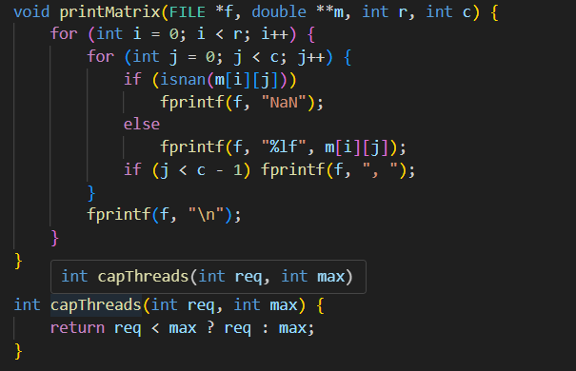
printMatrix prints matrices into the output file, using "NaN" for invalid values. capThreads ensures that requested threads do not exceed the number of rows, which optimizes OpenMP parallelization.
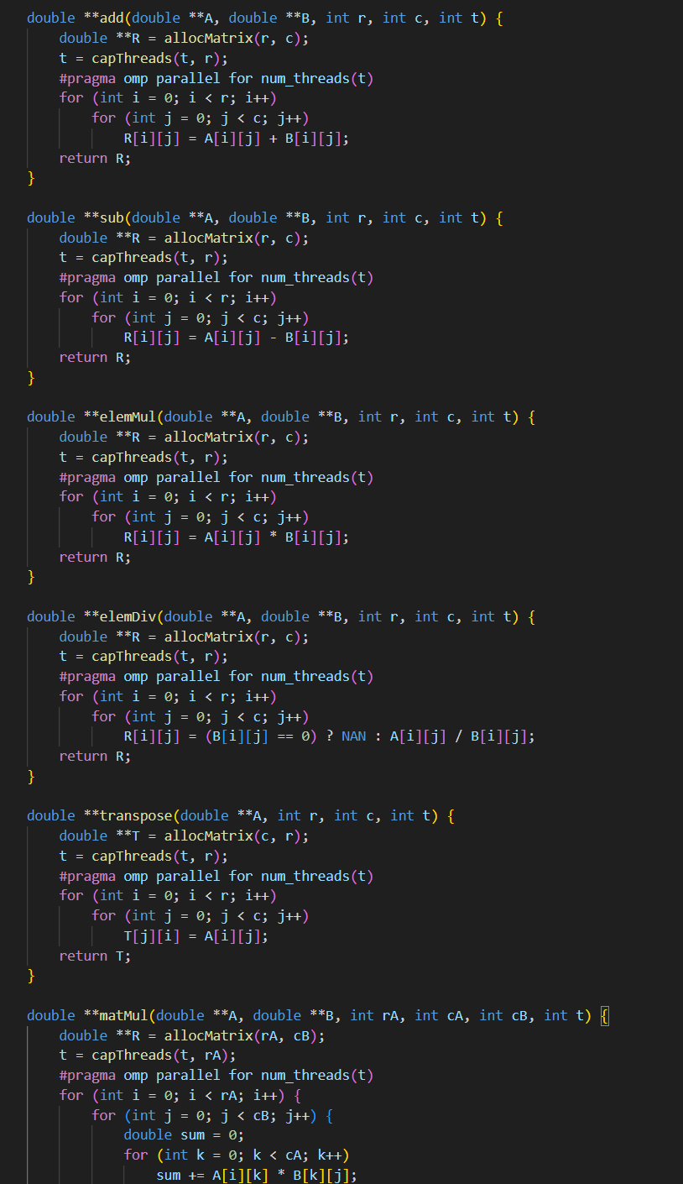
These functions implement addition, subtraction, element-wise multiplication/division, transpose, and matrix multiplication. All heavy loops are parallelized with OpenMP (#pragma omp parallel for) to use multiple threads efficiently. capThreads ensures thread count is safe for small matrices.
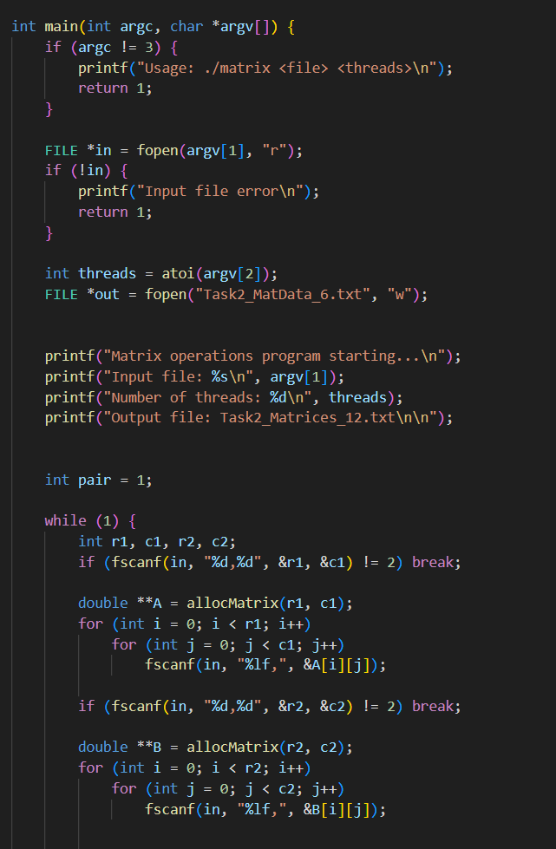
The main loop reads pairs of matrices from the input file. Dynamic memory is allocated for each matrix, and the program will continue until the end of the file. Each pair is then processedfor all operations.
The main loop reads pairs of matrices from the input file. Dynamic memory is allocated for each matrix, and the program will continue until the end of the file. Each pair is then
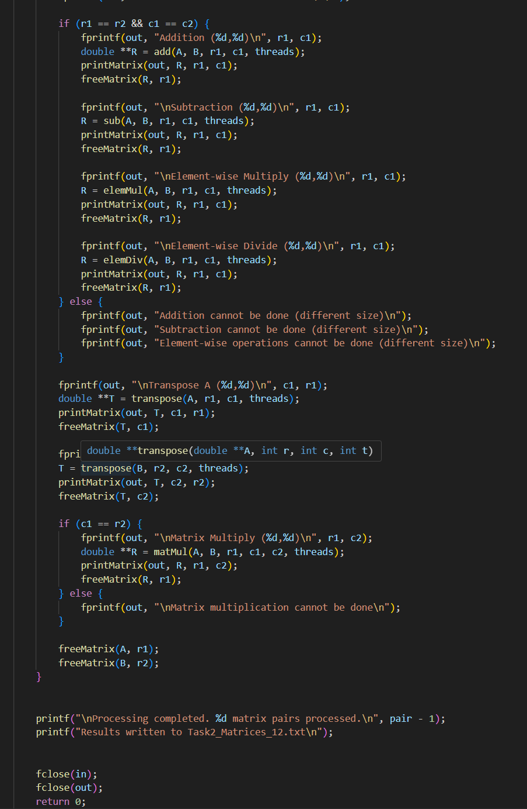
In this case, the program does every possible operation of all pairs of matrices:
Addiction, subtraction, element-wise multiply/divide - only on same sized matrices. Transpose - always possible.
Multiplication of matrices - it is only possible when the columns of A and the rows of B are equal.

In case the dimensions are not matched, the program displays messages such as, the multiplication of two matrixes is not possible. This is why your run with Matrices.txt provokes this message: Matrices.txt and Blank.txt have incomparable dimensions.

Summary of Runs
Input File | Threads | Result Notes
MatData.txt | 2 | All operations possible
MatData.txt | 6 | All operations possible
Matrices.txt | 2 | Some multiplications skipped (dimension mismatch)
Matrices.txt | 12 | Some multiplications skipped (dimension mismatch)

Matrices file

Input File (Matrices)
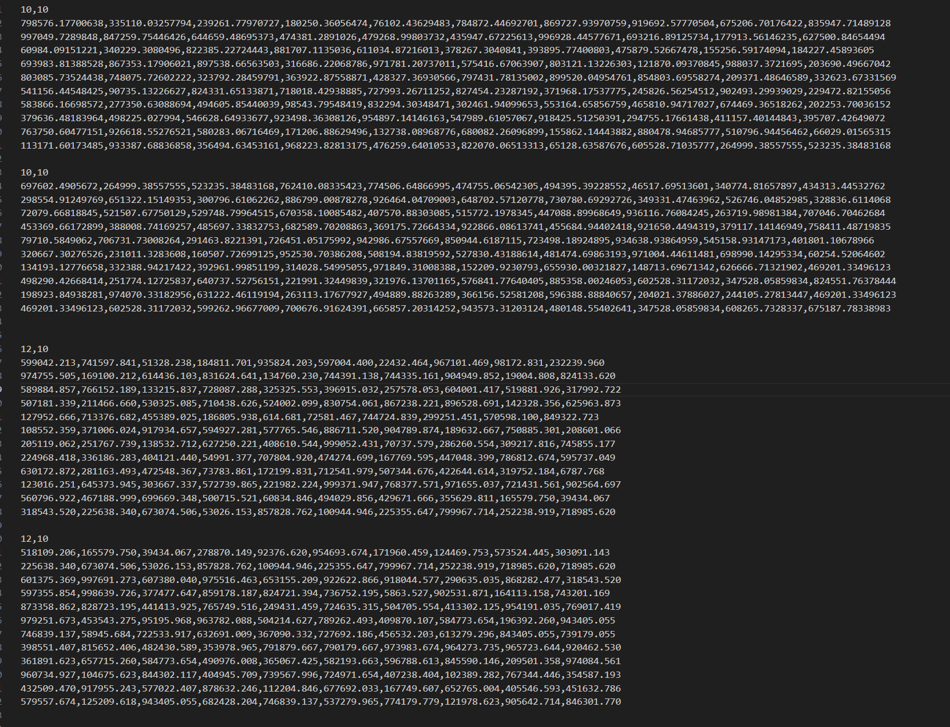

Compiling
Martices.txt with 12 thread
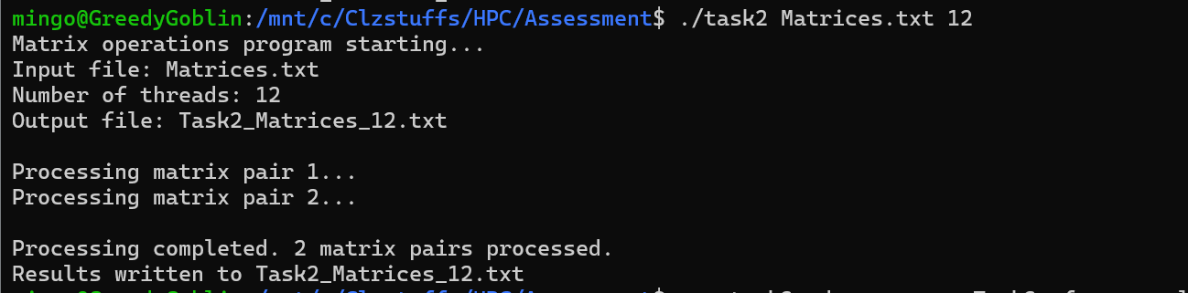

Matrices.txt with 2 threads
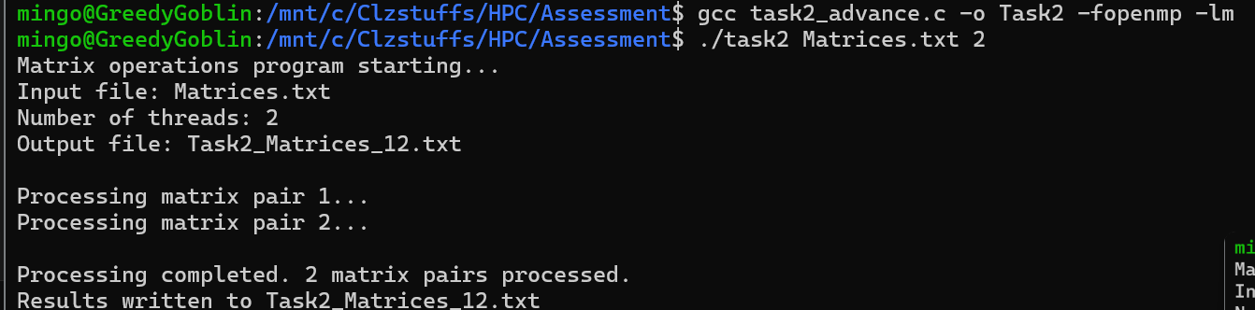

OutputFile
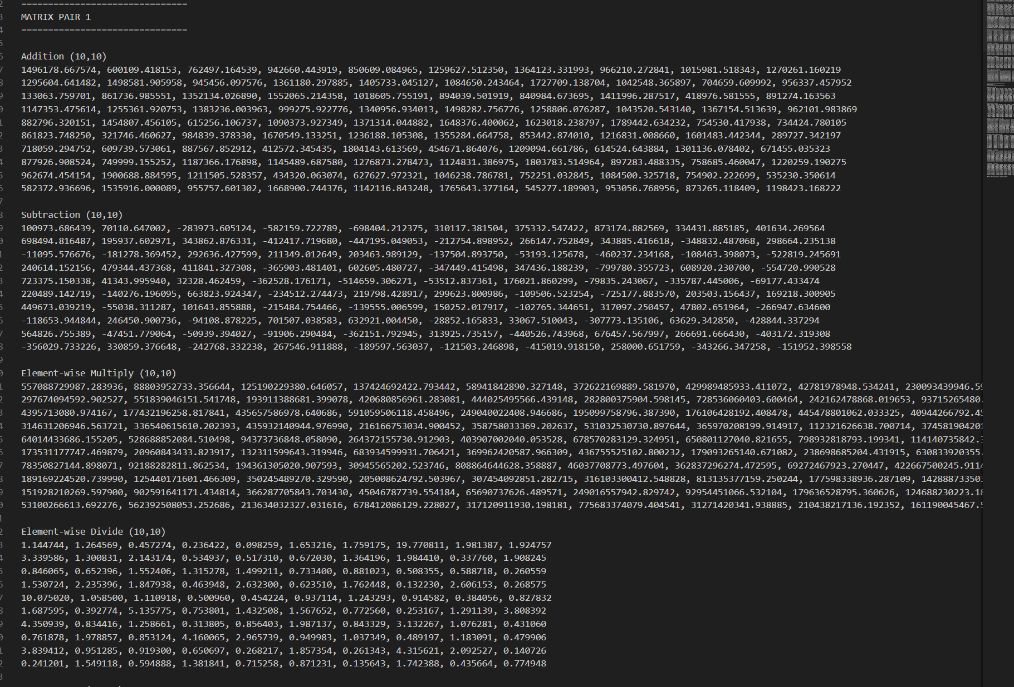
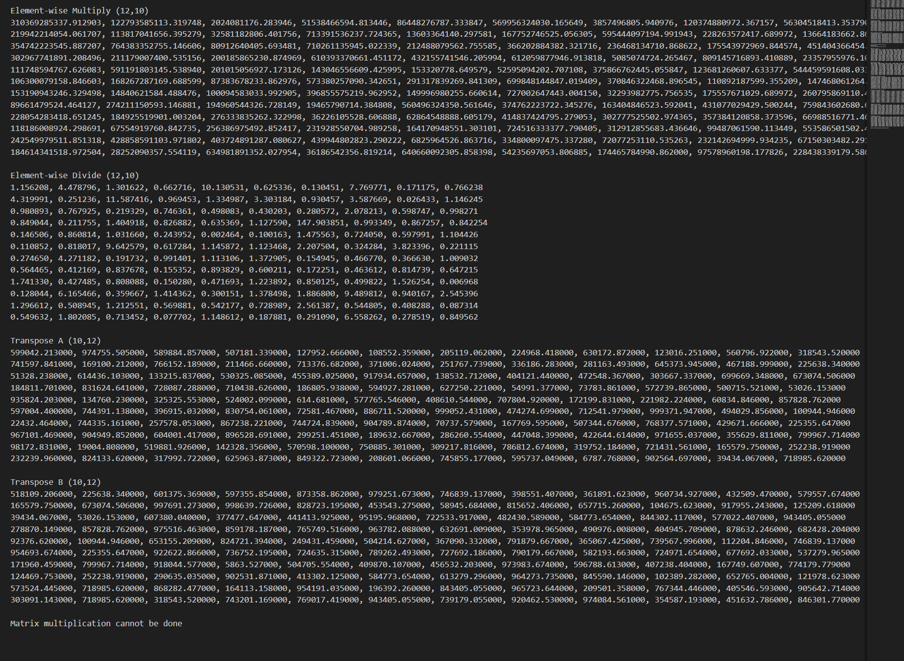

MatData file

Input File (MatData)
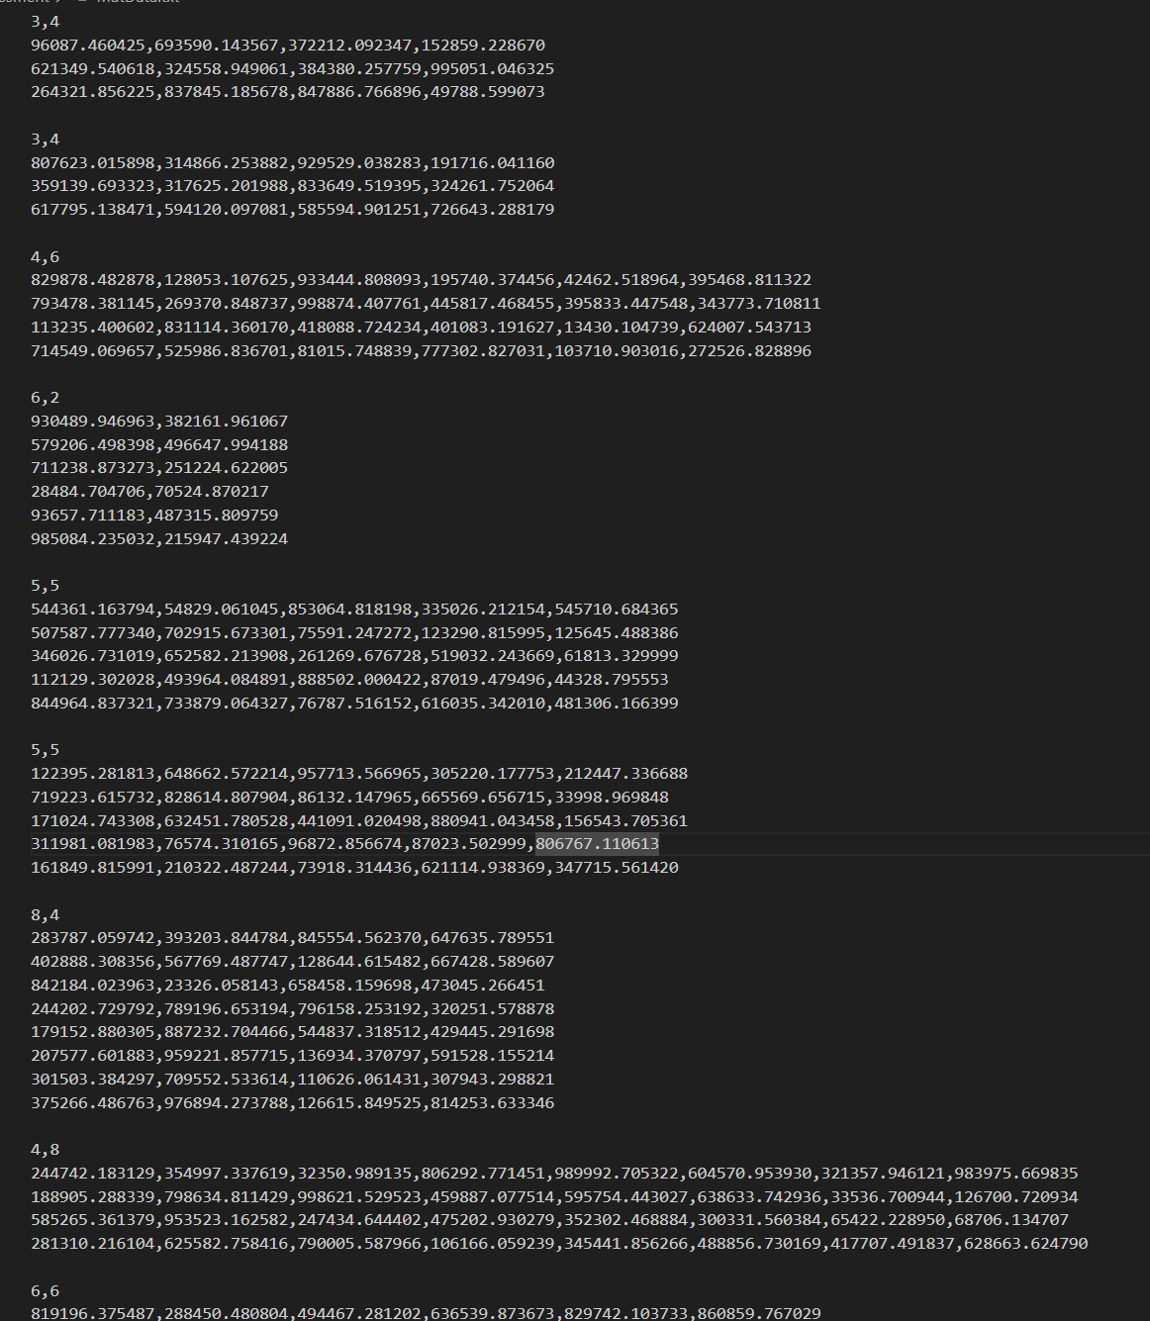

MataData with 2 threads
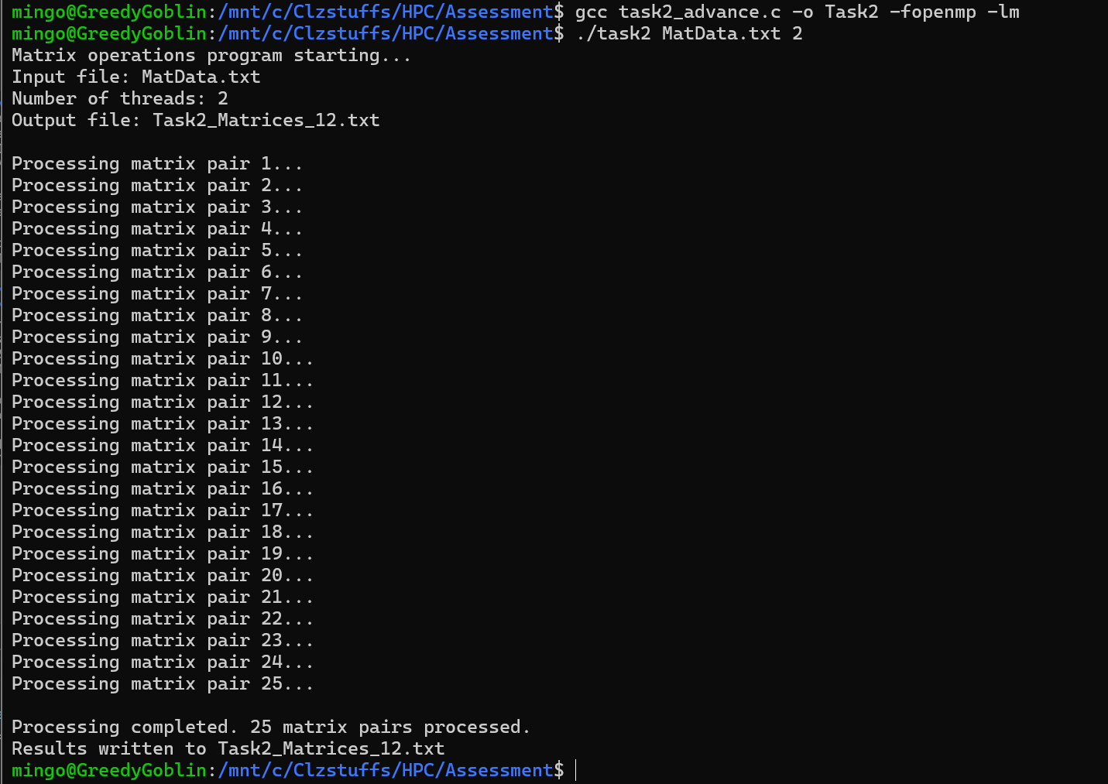

MatData with 6 threads
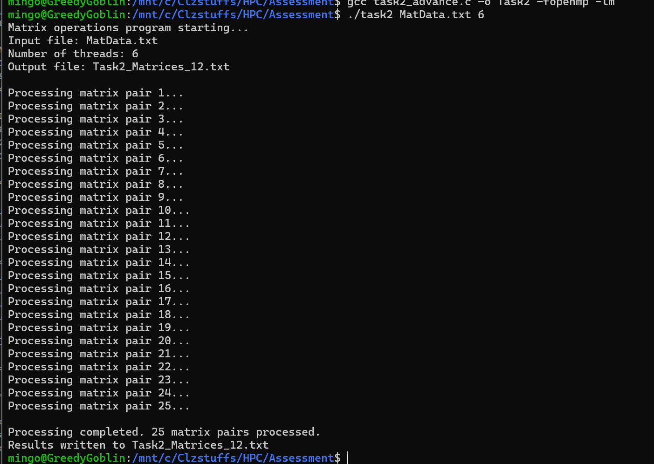

Output File
