NormalNegative
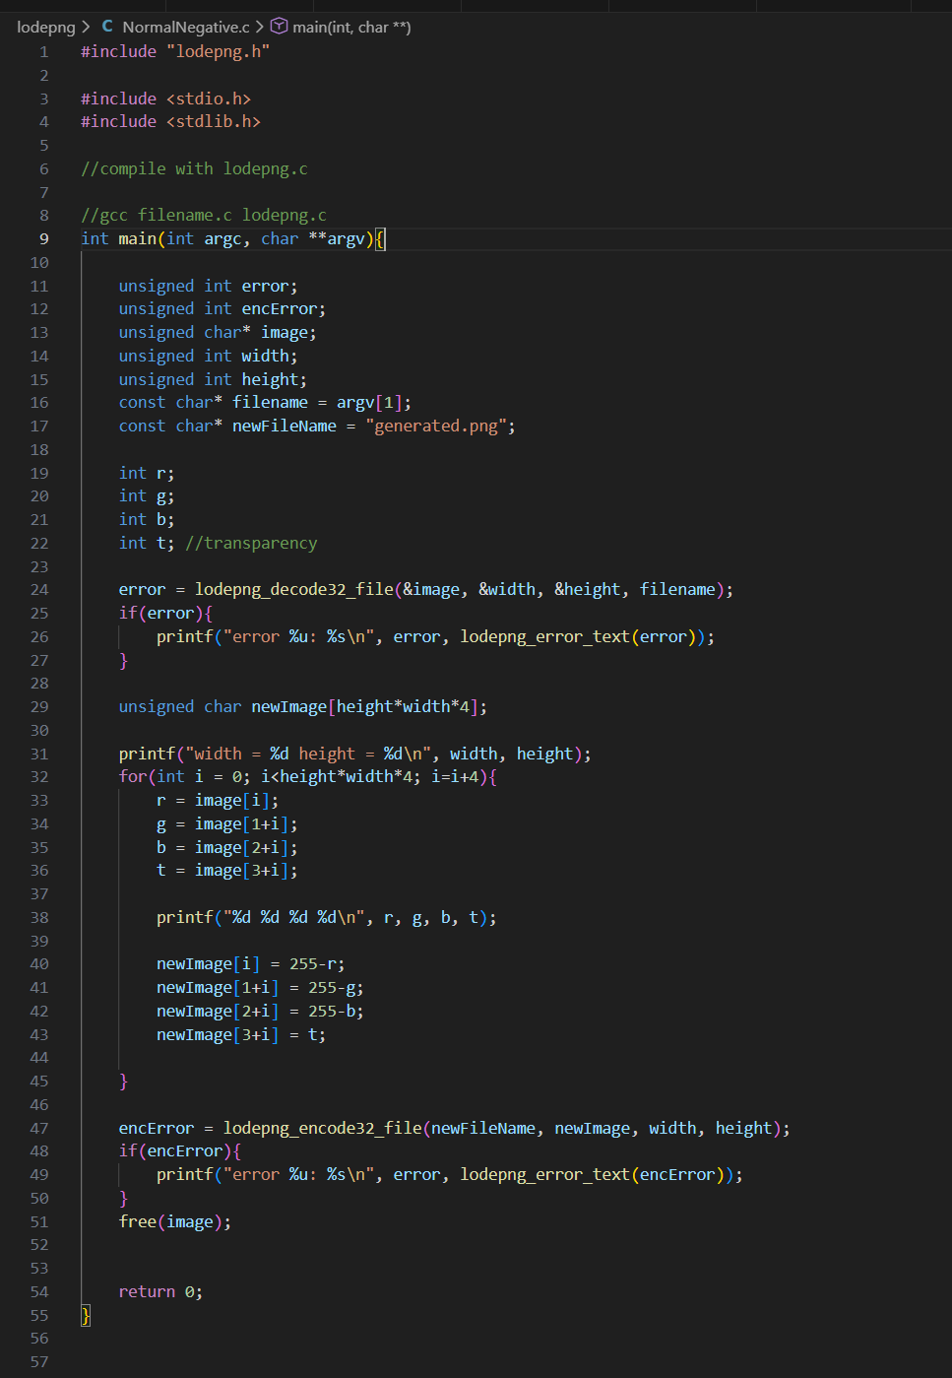
Input 
Output


This program loads a PNG image with the Lodepng library and inverts the color values of the image giving a negative effect, and saves the result as a different PNG file named generated.png. It keeps the alpha channel intact but each pixel in RGBA format is processed. The input PNG file is accepted as a command-line argument by the program followed by the process of decoding the image to the memory and later inverting the colors and saving the inverted image back.
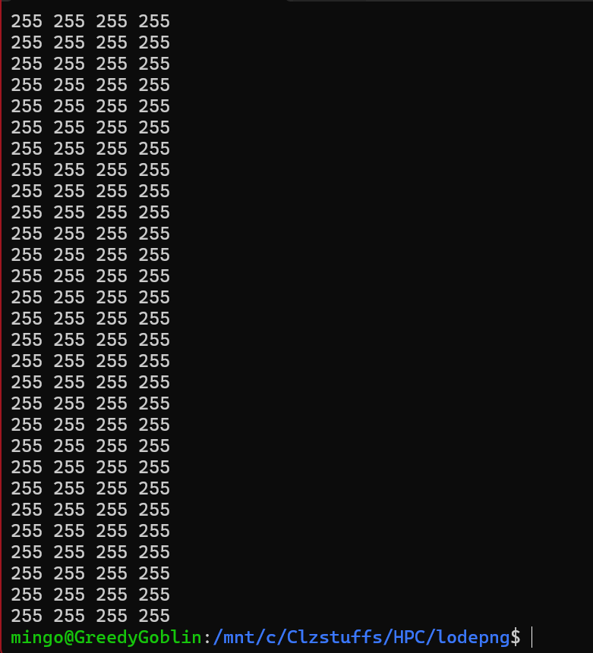

CudaNegative
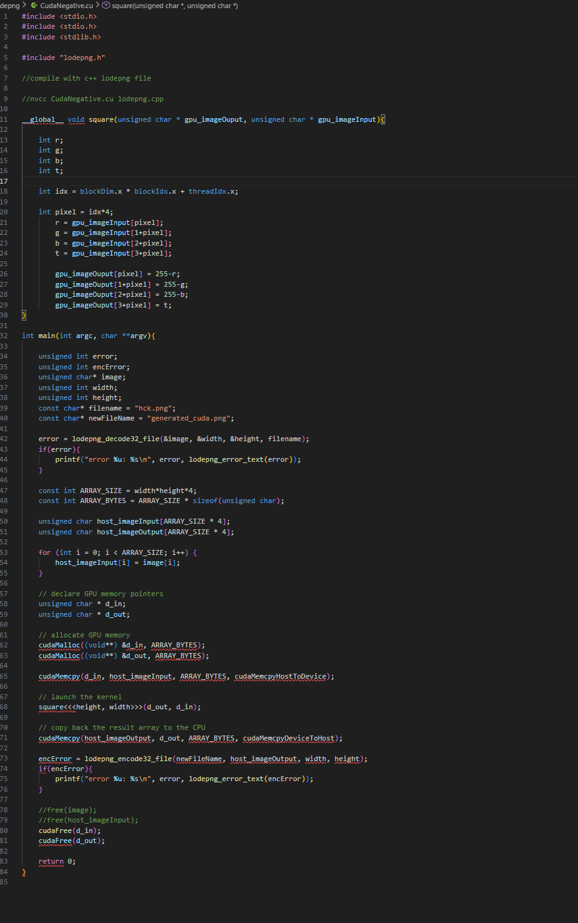
Input

Output

It is a program that takes a PNG image and loads it with the help of Lodepng and then flips the color RGB values to the inverted form, maintaining the alpha channel of the image. The CPU is tasked with reading image off disk, allocating host memory and writing final PNG file. The square kernel is used to invert the color per-pixel of pixels and the colors are inverted parallel using the square kernel with one thread per pixel. The copying of memory to the CPU and its copying to the GPU are performed before the kernel executes and after that. This application of CUDA enables the color inversion process to take a lot less time than would otherwise take place on the CPU alone, particularly to large images.

