PTSC Receiver with Hollow Twisted Square Promoter
Effect of Twist Pitch Ratio
Stage 1 of 3 · geometry screening · 14 of 18 runs complete
Three twist pitches (Pt = 200, 300, 400 mm) were each swept across six Reynolds numbers from 5,000 to 30,000 at fixed Tin = 500 K, with promoter size and wall thickness held at level 1. Performance is referenced to a smooth tube through f/fo, Nu/Nuo and PEC.
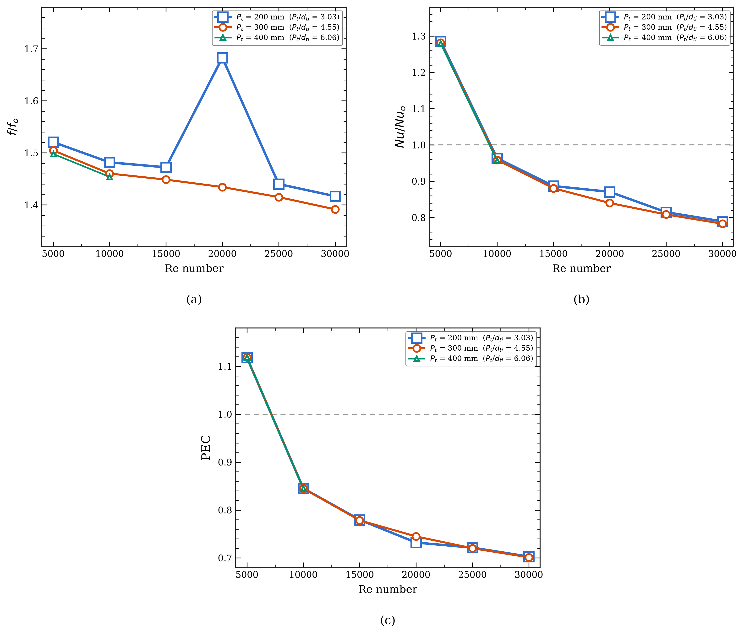
Figure 1: Effects of twist pitch ratio on thermal-hydraulic performance for dpo/dti = 0.23 and tp/dpo = 0.07, at Tin = 500 K: (a) friction-factor ratio, (b) Nusselt-number ratio, and (c) performance evaluation criterion (PEC). Runs 15–18 (Pt = 400 mm, Re ≥ 15,000) are pending.

What the figures show
Friction (a). The promoter raises friction by 40–50 % across the whole range and the penalty eases slightly as Re rises. Pitch has only a weak influence — the tightest twist (200 mm) is consistently the most resistive and the loosest (400 mm) the least, but the curves stay within about 2 % of each other. The point at Re = 20,000 for Pt = 200 mm departs from its own trend and is flagged for re-running; that run also returned an inconsistent inlet pressure.
Heat transfer (b). Enhancement is confined to the low-Re end. At Re = 5,000 the promoter lifts Nu by about 28 %, but the ratio crosses below unity near Re = 9,000 and falls to 0.78–0.79 at Re = 30,000. The promoter helps most when the unaided flow mixes poorly; once turbulence alone does the mixing, the insert mainly occupies flow area and runs a hotter wall.
Overall (c). PEC exceeds unity only at Re = 5,000 (1.12) and falls to about 0.70 at Re = 30,000. The three pitches collapse onto essentially one curve.

PEC by twist pitch and Reynolds number
Pt (mm) | Re 5000 | Re 10000 | Re 15000 | Re 20000 | Re 25000 | Re 30000
200 | 1.118 | 0.845 | 0.780 | 0.732 | 0.722 | 0.703
300 | 1.119 | 0.845 | 0.778 | 0.745 | 0.720 | 0.701
400 | 1.119 | 0.845 | pending | pending | pending | pending

Reading and next step
Twist pitch does not separate the designs. The spread across pitch is under 2 %, far smaller than the spread across Reynolds number, so no pitch can be declared a winner on PEC alone. If a tie-break is needed to proceed, 400 mm is marginally best on friction. The dominant result is instead the Reynolds dependence: enhancement exists below roughly Re = 9,000 and disappears above it.
Two items qualify the numbers. First, only one smooth-tube CFD run exists (Re = 10,000); the reference curve at the other five points comes from the Petukhov and Gnielinski correlations scaled to reproduce that run exactly, so the ratios at Re = 10,000 are pure CFD-to-CFD while the rest carry the correlations' Re-scaling. Second, the smooth-tube run absorbed 16,106 W against 15,657 W for every promoter run — a 2.9 % difference in applied heat that should be equal, and which shifts Nu/Nuo by about the same margin.
Proposed next step. Complete Runs 15–18 to close the 400 mm sweep, run the smooth tube at the remaining five Reynolds numbers so the reference curve is entirely CFD, then move to Stage 2 (promoter size, dpo/dti) — the more likely lever, given how little pitch changed.

