# Pretotyping - Pickleball

1. Market Hypothesis (Who what why)
2. XYZ hypothesis
3. If tests aren’t working - List All assumptions - turn them upside down (opposites to rethink positioning)

## Pickleball

**Next steps**:

Leverage GPT to find out how to find the right channels for each market

YouTube Video (Pickleball account) and Landing Page (via diffferent bitly links to show where they’ve come from) with Google form

1. Who, What, Why

People over the **age of 55,** enjoy playing **pickleball** because it’s **fun**, **easy**, **social**, keeps them **active**, gets them **outdoors**, they can play with **family**, make **friends**

* Living my best life
* Outdoor with friends

1. XYZ (localized target market, % of people, take action)
   1. People over the age of 55 in Bayside
   2. At least 10% of CAE participants/learners in X course (55+)
   3. At least 10% of X FB group who see the CTA for a new weekly playing group will ‘sign up’ to the new group
   4. Retry multiple times with different hooks, in different locations
      1. After email and ask $10 from each person
   5. In the form find a way to determine instigtators (or who could lead a group like this) - give them a how to kit, target them as sales reps later
      1. Give phone number if you’d like to be more heavily involved (with organization, running it).
      2. Get them to collect feedback in certain ways for their group
2. Casual **Beach volley ball** players in St Kilda enjoy playing **pickleball** because it’s **social**, a way to meet **new people**, involves drinking, latest trend, increases their image of how they think others view them
   1. 20% (BVA FB group) will give their email to
3. Boulderers (not rock climbers) enjoy playing **pickleball** because, it’s something else fun to do which **aligns with their values**,
   1. 20% in X FB group xx who live in Port Melbourne

**Country towns** because

10% of local pages

RSL forums / FB groups

**Tennis fans** …. Because they feel like they can enjoy the sport too

* FB groups

## Longer TtD DtD

Response: Ready to go - sorry just waiting while more stock arrives. In the meantime give us your customized preferences.

**Alcohol** companies in Melbourne to stand out as a **differentiator** at an event. And capitlize on a trend.

* partnerships with **Gordon’s**, **somersby**
* Use Adele’s contacts, Stef’s contacts
* Set up their whole promotional event

**Health Insurance** companies - trending preventative health options toinspire their customer base

* Skin in the game (Let us Pretotype on their behalf with their customer data) to find the best hook

Events (festivals, **CoM**)

* Leverage CoM contacts (Sarah, Tegan (Smart Cities), Events? Ross Harding - Developers)

**Corporations** (lower TtD and DtD)

As a team bonding excercise (Infiltrator in their webpages)

LinkedIn post in Corporate groups (HR specific groups)

* HR roles in large corporations who are reposible for team bonding excercises

BM: Corporate team bonding events.

* 1 person contractor
* Paid online
* 4 sets

## Key prompts (The Right It)

* One night stand (as quick as possible)
* **Inflitrator** (sneaking your product into an existing sale epxerience with similar products)
* Fake door
* Facade

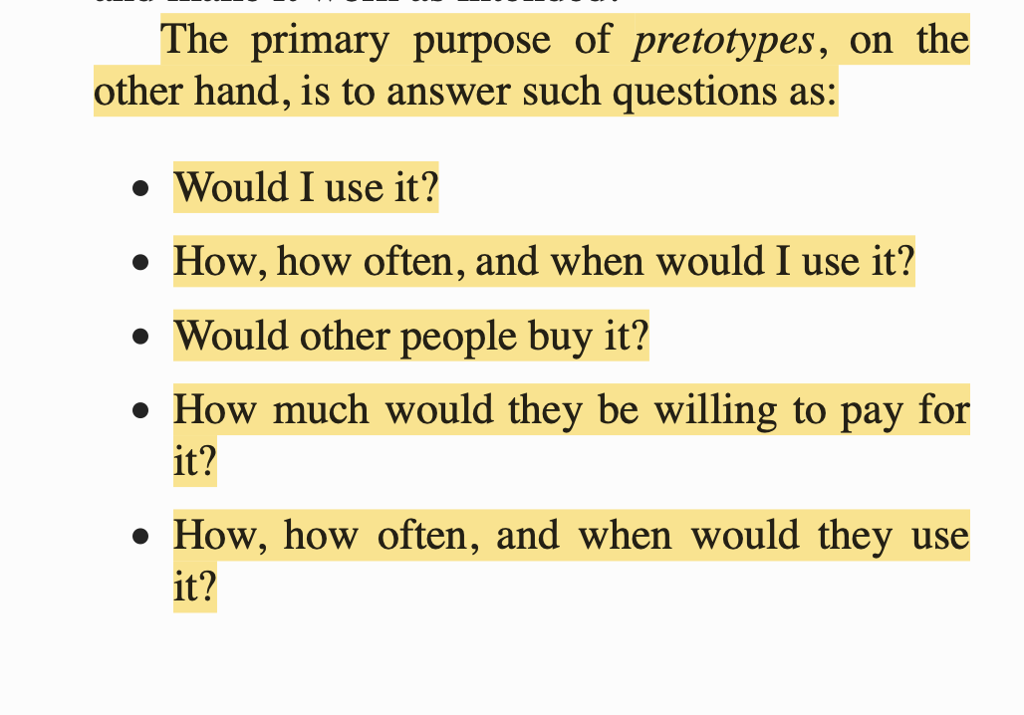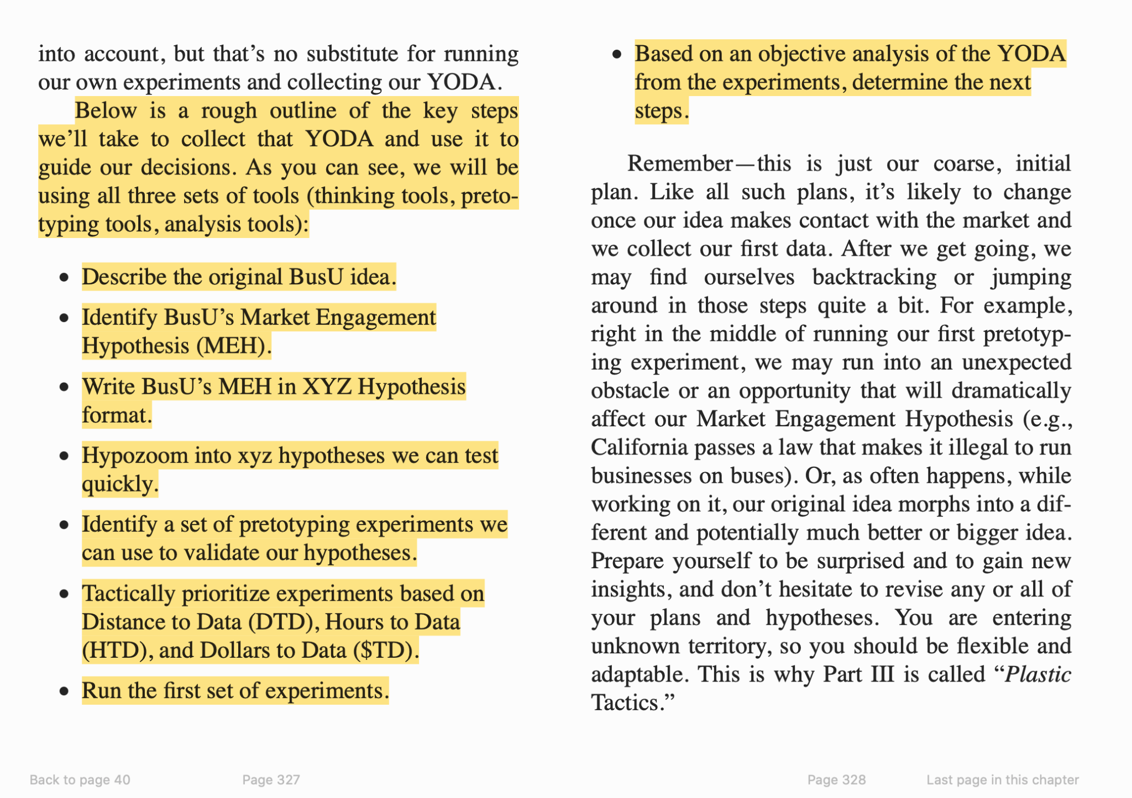

Skin in the game score

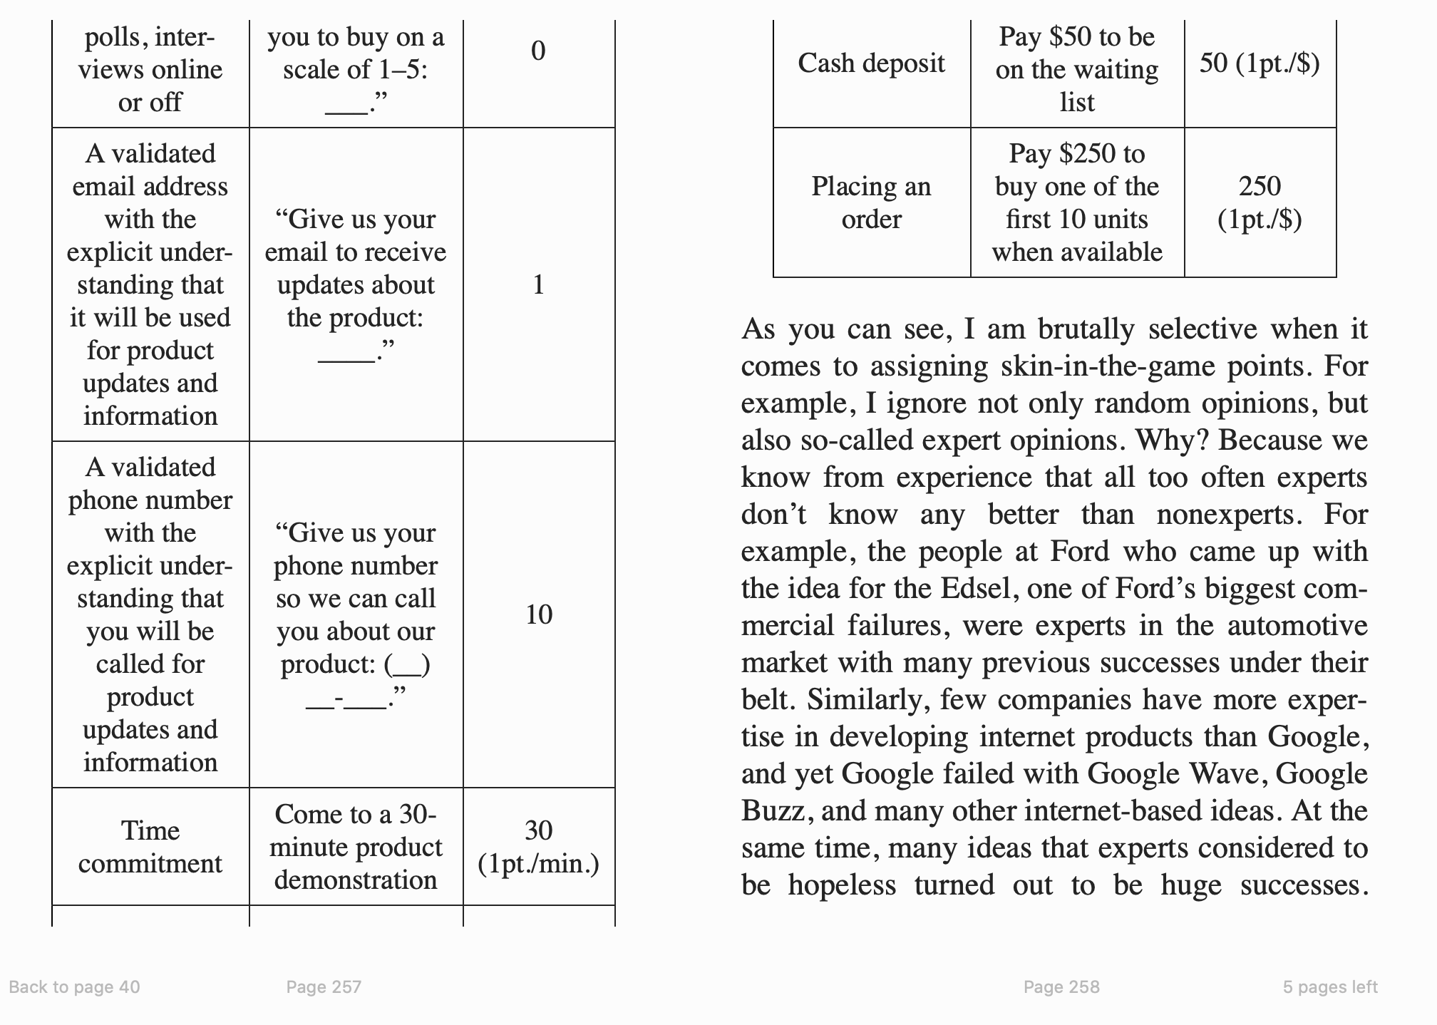

XYZ Hyperzoomed examples

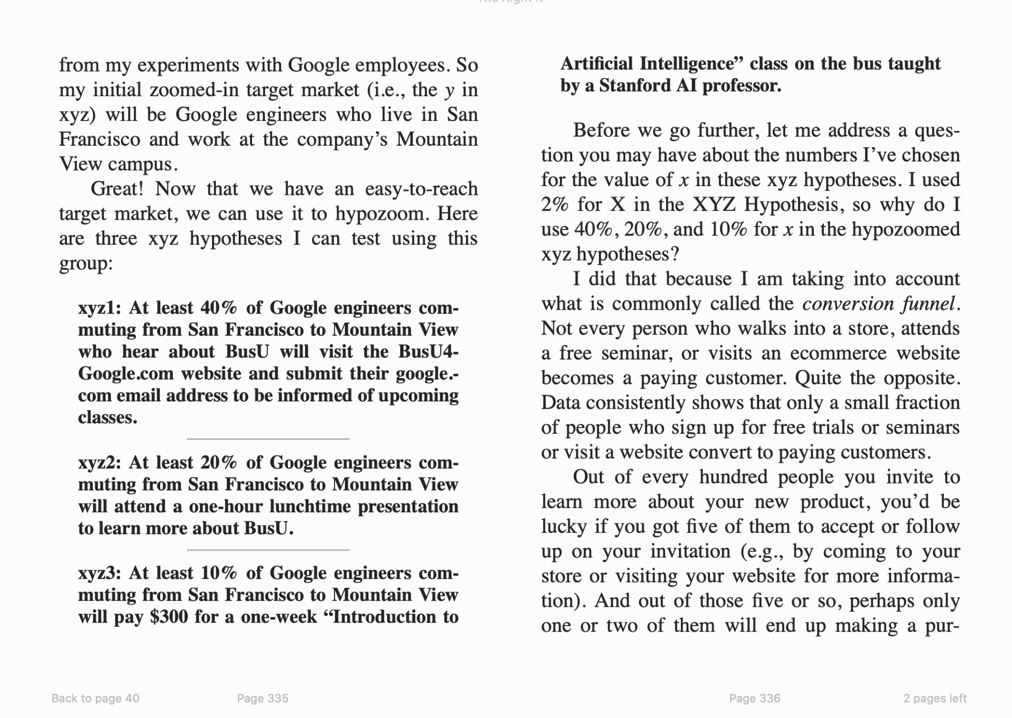

TRI Meter

