High Performance Computing

Assignment 1 - Problem 2

Anurag Dhaipule

1. Code attached.
2. Code also prints all residue in every line. Below is pasted a screen shot of the residue value at the end. Notice that it decrease with every iteration.

Also to be noticed is that initial decrease is fast and later on the decrease is slow.

This is why the plots look like parabola.

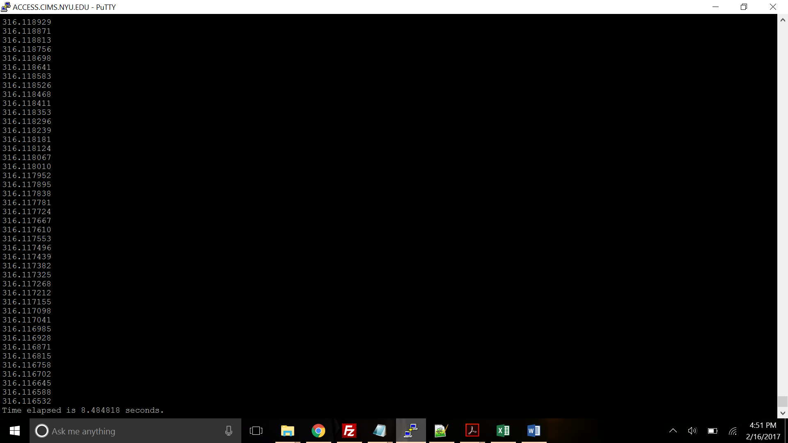

1. Ideally Gauss Seidel should converge faster because it makes use of updates values.

Following are the plots of residue value with iteration for N = 1000 and N = 100000.

With Compilation flags -o0, timings are:

N = 1000: 0.18 seconds

N = 100000:8.5 seconds

With compilation flags –o1, timings are:

N = 1000: 0.05 seconds.

N = 100000: 2.63 seconds

The machine used for this running are intel-2016, CIMS, x86-64.