Assignment 5

Anurag Dhaipule

2. a)

Following table shows the result of running the convolution 100 times on different GPU.

|  |  |
| --- | --- |
| Tesla-1 GPU | Tesla-0 GPU |
| 320.778781 MPixels/s  2.566230 GBit/s  15.620069 GFlop/s | 320.762337 MPixels/s  2.566099 GBit/s  15.619268 GFlop/s |

Following is the result of running the program with size 4*4

146.067072 MPixels/s

1.168537 GBit/s

7.064713 GFlop/s

There is reduction in the performance.

b) Below is the result of image after different levels of convolution.

1. Iteration = 2



1. Iterations = 5

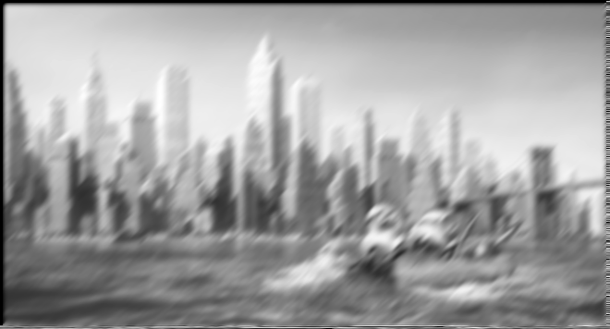

1. Iteration = 10

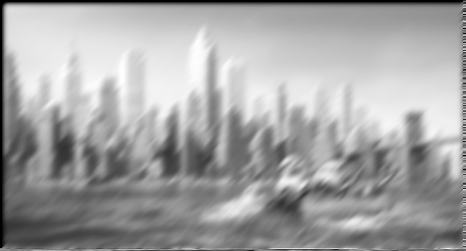

1. Iterations = 100

