22North Product Engineering Challenge 2026 · Challenge 1
SkyJet Flight Recovery
Architecture Board
One document to understand the whole system and every feature. A self-service experience that lets a disrupted passenger rebook, refund, or get an answer in under 30 seconds — with complex cases handed to a human, full context attached.
PRODUCT  Self-service IRROPS recovery | SHAPE  Modular monolith · Next.js 16 | STATUS  Deployable MVP · Vercel-ready | UPDATED  2026-07-03

Boards in this document
01 Whole-system architecture | 02 Golden-path sequence
03 Eligibility rules engine | 04 Disruption Assistant · RAG
05 Data model & booking state machine | 06 Feature map (P0–P3)
07 Scale & non-functional story

01 Whole-system architecture
A modular monolith — one deployable Next.js process with clean domain seams, so any layer could later split into its own service without a rewrite. The request flows top → bottom through six layers. High-frequency, low-risk decisions are automated; high-risk, low-frequency ones get a warm agent handoff.
■ Entry | ■ Client / API / Data | ■ Eligibility engine | ■ Assistant / RAG

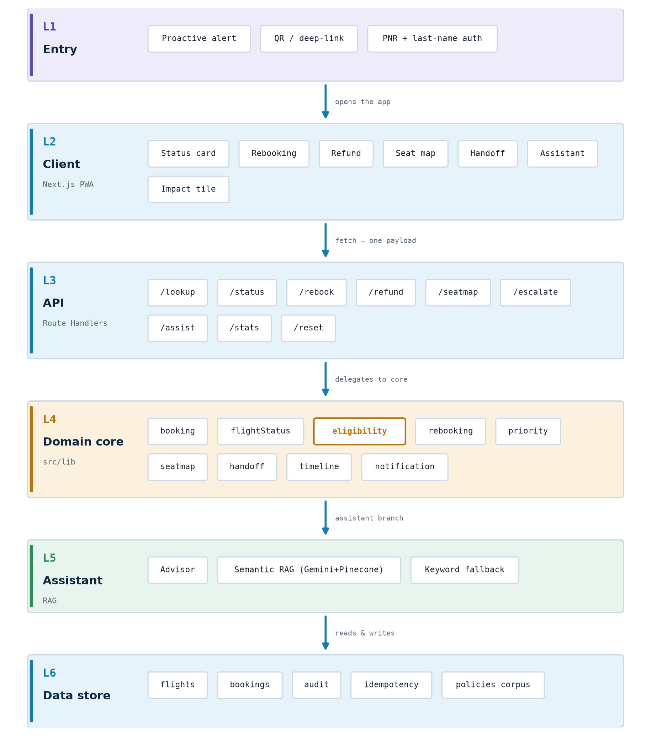
Fig 1 — Six layers, request flowing top → bottom. Eligibility (L4) highlighted.

Why this shape
▪ Modular monolith: one deployable, one process, zero infra to provision — runs identically on a laptop and on Vercel. The six clean module seams make “microservices-ready” credible without a rewrite.
▪ Explain, don’t just decide: every eligibility result carries a human reason and a DGCA rule citation — the same facts ground both the UI and the assistant, so the product defends every answer aloud.
▪ Spike-survivable writes: idempotency-key replay + optimistic version + revalidate-against-fresh-options mean a double-tap or a stale tab can never double-book during a disruption surge.
Cross-cutting — the spike-survival story
Idempotent, race-safe writes  Key replay + revalidate-vs-fresh-options — a double-tap can never double-book. | Optimistic concurrency  Every booking carries a version; a stale tab is rejected.
Append-only audit  Every mutation logs action + before/after; powers the impact tile. | Stateless handlers  No per-request state → scale flat behind a load balancer.
Typed contracts  Zod at every boundary; typed { error } responses. | Deterministic time  All formatting pinned to Asia/Kolkata — the demo never drifts.
Guarded admin surface  Rate-limit + admin token on reindex / flight controls. | Async-ready notification  The mock alert is the seam for a queue + outbox in production.

Module responsibilities (L4 domain core)
Module | File(s) | Responsibility | Deployable as
booking | store.ts · lookup/route.ts | PNR + surname lookup; assemble the booking view | booking-service
flightStatus | eligibility.ts · store.ts | Classify CANCELLED / LONG_DELAY; expose route inventory | flight-status-service
eligibility ★ | eligibility.ts | DGCA rules engine — refund / rebook / compensation / duty-of-care with reasons + rule refs | eligibility-service (pure)
rebooking | service.ts · rebook/route.ts | Scored alternatives + recommended pick; idempotent rebook; boarding pass | rebooking-service
priority / seatmap | priority.ts · seatmap.ts | Passenger priority rank; priority-aware seat map build + allocation | seat-service
handoff | service.ts · escalate/route.ts | Detect out-of-policy cases; package the warm-handoff context pack | handoff-service
notification | UI + mock | Render the proactive alert that would be sent (deep link + held seat) | notification-service (async)

02 Golden-path sequence
The ~90-second demo, as a flow: proactive alert → identified status card → recommended rebook → boarding pass, with the refund and agent-handoff branches, closing on the impact tile.
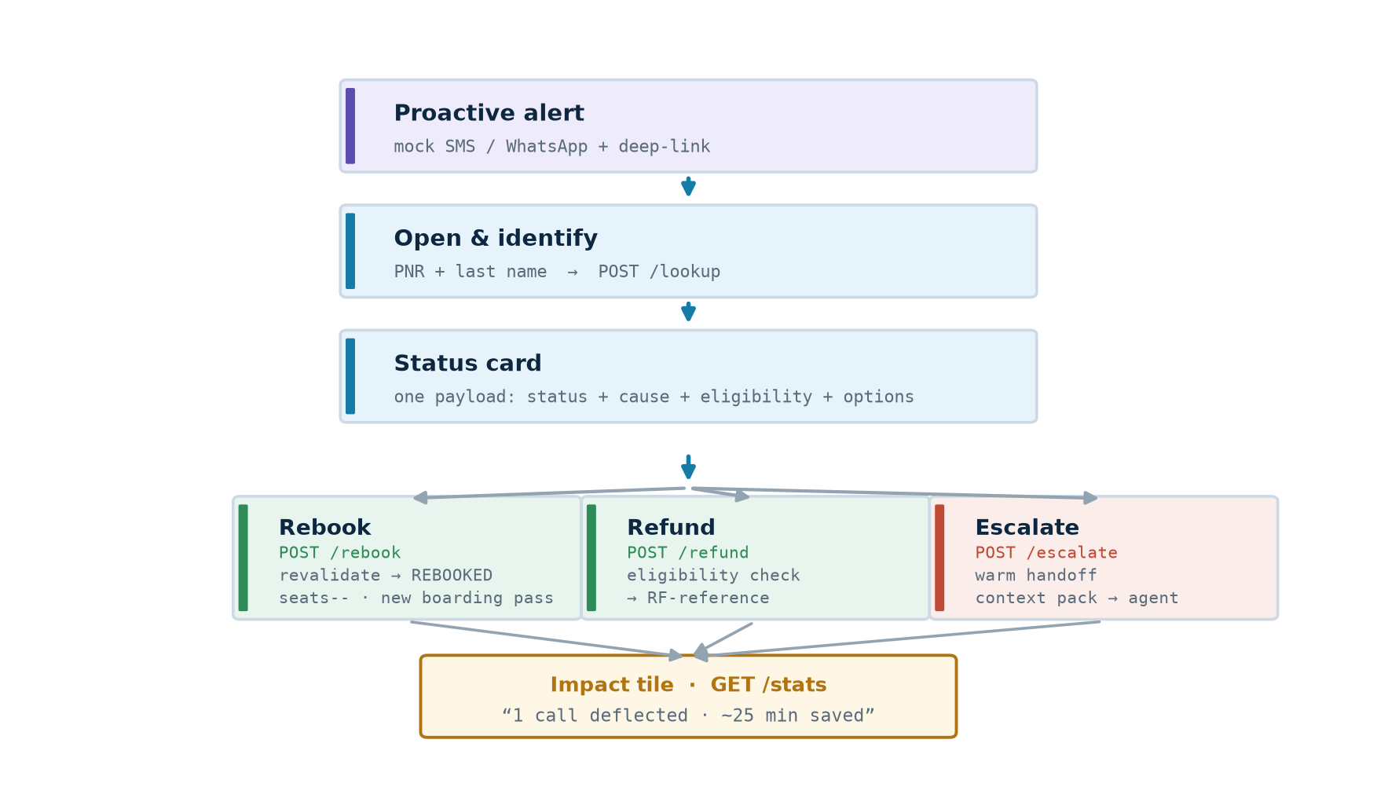
Fig 2 — One identify call, then the passenger's choice branches, all converging on the impact tile.
1 | Proactive alert Passenger  Mock SMS/WhatsApp with a deep-link — the airline reaches out before the passenger calls.

2 | Open & identify Passenger → App → /lookup  PNR pre-filled from the link; passenger adds last name. One call returns status + cause + eligibility + options.

3 | See the status App  “Cancelled · Weather” with a plain-English explanation of exactly what they’re owed.

4a | Rebook /rebook (idempotencyKey)  Tap the recommended option → revalidate against fresh inventory → REBOOKED, seats−−, audit → new boarding pass (< 30s).

4b | Refund /refund (idempotencyKey)  Eligibility check → issue RF-reference → explainable decision. No payment integration — reference only.

4c | Escalate /escalate  Minor / medical / group / no valid option → package warm-handoff context so the agent never asks the passenger to repeat.

5 | Impact tile /stats  “1 call deflected · ~25 min saved”, derived from the audit log.

03 Eligibility rules engine — the crown jewel
src/lib/eligibility.ts — pure, deterministic, unit-tested. The defensible rule, cross-validated by DGCA (India) and Delta: the cause of the disruption drives entitlement.
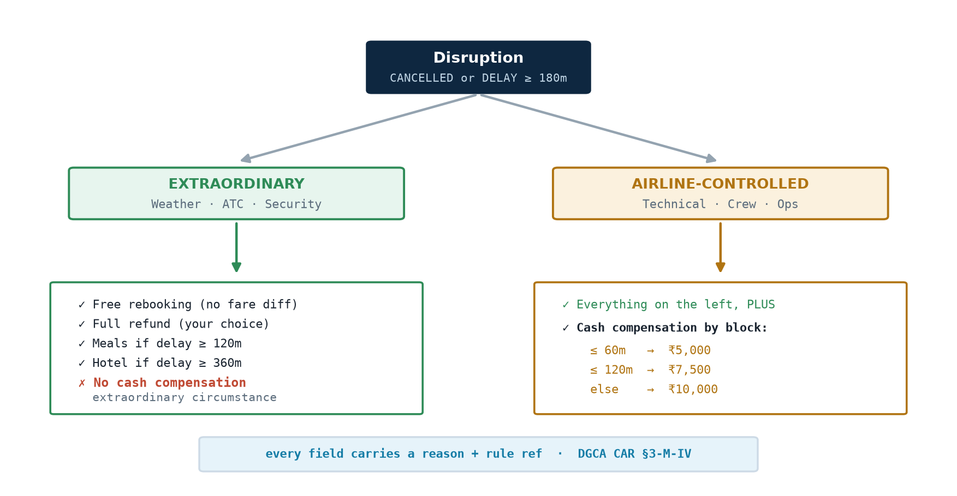
Fig 3 — Cause drives entitlement: extraordinary vs airline-controlled, each with its rule reference.
Trigger: disrupted = CANCELLED, or DELAYED ≥ 180 min. Every field carries a human-readable reason and a rule citation (DGCA CAR §3-M-IV) — the direct answer to competitor tools criticised as opaque.
Rebooking recommendation
Each candidate starts at 100: −30 next-day, −5/h later (cap −40), +10 if within 2h of the original time-of-day. The top score is flagged recommended with a plain-English reason (“Same day · 3h later · direct”). Options are recomputed live from inventory, so a shown option is never stale.
Escalation triggers
Special flags (unaccompanied minor, medical, pet, group, partner ticket), party size > 4, or no valid self-service rebooking → route to an agent with context attached.

04 Disruption Assistant · RAG
A layered design where every layer is grounded — the model can explain policy but never invent it, and the demo survives any vendor outage. /api/assist walks the ladder top-down and stops at the first tier that answers.
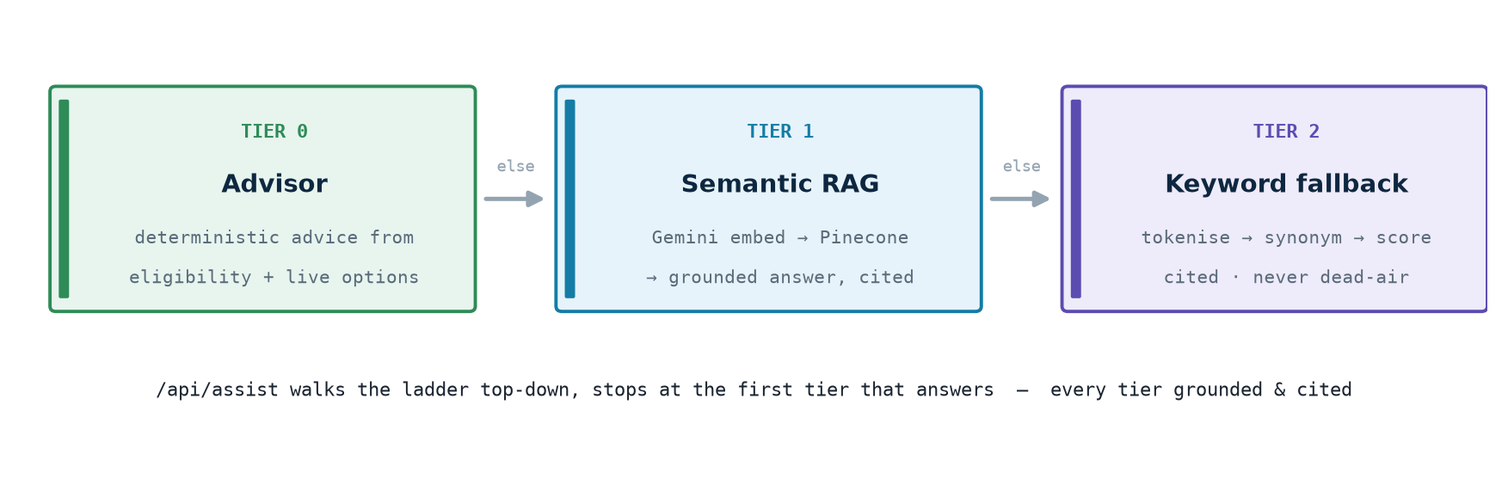
Fig 4 — The fallback ladder: stop at the first tier that answers; every tier grounded and cited.
▪ Tier 0 · Advisor — deterministic advice — “Should I refund or rebook?” → turns this passenger’s own eligibility + live rebooking options into a recommendation. The LLM (when configured) only rephrases it.
▪ Tier 1 · Semantic RAG — Gemini + Pinecone — Gemini embeds the question → Pinecone finds the top policy clauses → Gemini Flash writes a short answer using only those clauses + verified eligibility facts → citations attached. Returns null on outage/irrelevance.
▪ Tier 2 · Keyword fallback — always on — If embeddings/Pinecone are unconfigured: a deterministic tokenise → synonym-expand → score engine answers over the policy corpus, still cited. So it can never dead-air.

05 Data model & booking state machine
Runtime uses an in-memory seeded store (src/lib/store.ts) that mirrors prisma/schema.prisma field-for-field — including the optimistic-version and idempotency-key columns, so the production swap is mechanical.
▪ Flight — flightNo · origin/destination + cities · departure/arrival (ISO UTC) · durationMin · status (SCHEDULED/CANCELLED/DELAYED) · cause · delayMinutes · seatsAvailable. Indexed on (origin, destination, status, departure).
▪ Passenger — name · masked email · tier (STANDARD/SILVER/GOLD).
▪ Booking — ref (PNR, PK) · flightId (+ optional connectingFlightId) · status · fareClass · farePaid (INR) · specialFlags[] · partySize · mutation trail (rebookedFlightId, refundReference, handoffReference) · version (optimistic concurrency).
▪ AuditEntry — bookingRef · action (LOOKUP/REBOOK/REFUND/ESCALATE/ACKNOWLEDGE) · detail · before/after · idempotencyKey (unique) for race-safe, replayable writes.
Booking lifecycle
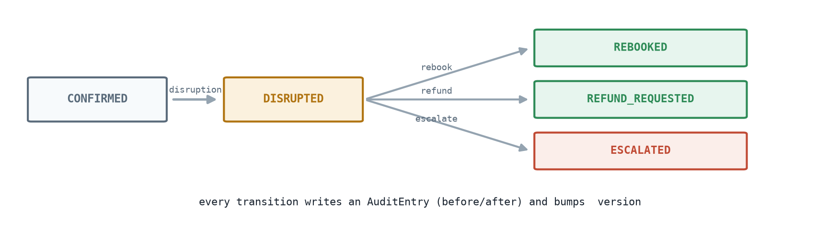
Fig 5 — A disruption moves CONFIRMED → DISRUPTED; the passenger's choice lands in one terminal state.
Every transition writes an AuditEntry (before/after) and bumps version — the basis of race-safe writes and the impact tile.

06 Feature map (P0–P3)
What ships in the MVP, what’s built beyond it, and what’s deliberately deferred — deferring on purpose is a scored signal of product judgment.
P0 — MVP core  · Identify booking (PNR + last name)  · Explainable status + cause  · Scored rebooking + recommended pick  · Refund eligibility + reference  · Warm agent handoff with context  · Impact tile (calls deflected) | P1 — Shipped beyond core  · Proactive alert + QR deep-link  · Priority-aware seat map  · Grounded Disruption Assistant (RAG)  · Idempotent, race-safe writes  · Flight timeline view | P2 — Credible on paper  · Prisma/Postgres schema (1:1)  · Async notification seam (queue/outbox)  · Cached flight status + read replicas  · Admin reindex + flight controls | P3 — Deliberately deferred  · Real payments  · Real auth / SSO / OTP  · Live inventory + interline/award  · Loyalty redemption · multi-language  · Predictive pre-disruption alerts  · Cost/OR-optimized selection

07 Scale & non-functional story
Disruptions are traffic spikes — everyone asks the same three questions at once. The design answers that; each MVP mechanism maps to a production shape.
Concern | In this MVP | Production mapping
Statelessness | Route handlers hold no state; store is a module singleton | Stateless services behind a load balancer (ECS/Lambda)
Read spikes | flightStatus reads are cheap; route index modelled | Cache flight status (Redis/CDN); read replicas
Race-safe writes | Idempotency replay + optimistic version + revalidate | Same keys enforced by a DB unique constraint
Async fan-out | Notification is a mock “would-send” | Queue (SQS/Kafka) + outbox + DLQ
Auditability | Every mutation writes an AuditEntry (before/after) | Append-only audit table; PII redaction
Typed contracts | Zod at every boundary; typed { error } | RFC-7807 problem+json
Key assumptions
▪ Mock data — realistic, deterministic seed pinned to a fixed disruption day in IST.
▪ Auth = PNR + last name (OTP / IdP is future work).
▪ No payments — refund and compensation issue a reference number only.
▪ Airline-caused disruption ⇒ no fare difference on rebooking.
▪ Thresholds: long delay 180 min · meals ≥ 120 min · hotel ≥ 360 min · compensation ₹5,000 / ₹7,500 / ₹10,000 by block time.
▪ In-memory store resets on cold start / POST /api/reset; production is the Prisma/Postgres schema.

SkyJet Flight Recovery · Architecture Board Next.js 16 · React 19 · TypeScript · Zod · Vitest · Vercel-ready
22North Product Engineering Challenge 2026 · Challenge 1

