

CSE541 Computer Vision

Weekly Report 2

**Landing Error Scoring System for Basketball: A Computer Vision Approach**

Submitted to faculty: Mehul Raval

Date of Submission: 02-03-24

Student Details

| Roll No. | Name of the Student |
| --- | --- |
| AU2140133 | Dhairya Shah |
| AU2140159 | Aayushi Shah |
| AU2140163 | Raj Dave |
| AU2140213 | Vanaja Agarwal |

2023-2024 (Winter Semester)

### **Aim:**

Comparing MediaPipe and OpenPose for pose estimation.

### **Introduction:**

MediaPipe and OpenPose are both widely used Human Pose Estimation (HPE) libraries, especially in Sports Analytics. **[3] [4] [5] [6].** The aim for this week was to take a decision on whether to choose MediaPipe or OpenPose for our work.

### **Work Completed:**

* We reviewed the existing literature for a detailed comparison of the two leading libraries for HPE. We came across **[1]** which carried out a detailed analysis and comparison of 4 different HPE libraries, MediaPipe and Openpose being a part of that list.

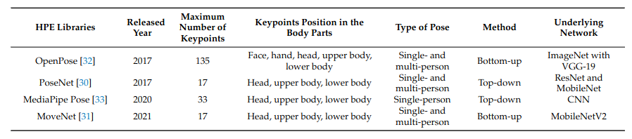

### The above figure from **[1]** shows the specifications of all the four HPE libraries.

* **[1]** has also conducted experimental comparisons between the libraries.

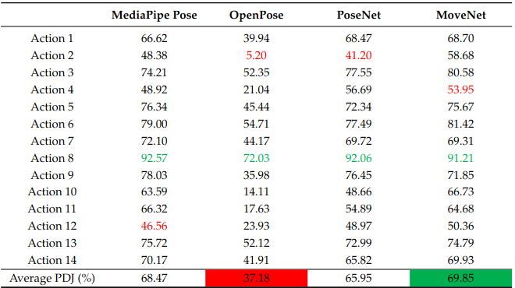

* The above table from **[1]** shows the comparison between total percentage joints detected in different actions. We can clearly see that MediaPipe Pose is outperforming OpenPose in multiple actions and on an average as well.
* However, **[1]** only considered PDJ as a performance metric and there are a lot of underlying nuances of choosing a HPE library.

### **Conclusion:**

After careful consideration, we have decided to go with MediaPipe Pose for the pose estimation. **[2]** is using MediaPipe as well. MediaPipe, as discussed, is lighter on the system and provides definite and reliable outputs. Thus, we came to the conclusion that MediaPipe Pose would be a better choice, given our time and resources

### **Next steps and goals:**

* Applying MediaPipe Pose to the dataset once we get it.
* Annotating the points by using Kinovea.

### **References**

1. Chung, J.-L., Ong, L.-Y., & Leow, M.-C. (2022). Comparative Analysis of Skeleton-Based Human Pose Estimation. Future Internet, 14(12), 380. <https://doi.org/10.3390/fi14120380>
2. Sharma, S., Divakaran, S., Kaya, T., Taber, C., & Raval, M. S. (2023). A Framework for Biomechanical Analysis of Jump Landings for Injury Risk Assessment. In 2023 IEEE 28th Pacific Rim International Symposium on Dependable Computing (PRDC) (pp. 327-331). IEEE. doi:10.1109/PRDC59308.2023.00052
3. Park, H.J.; Baek, J.W.; Kim, J.H. Imagery based Parametric Classification of Correct and Incorrect Motion for Push-up Counter Using OpenPose. In Proceedings of the 2020 IEEE 16th International Conference on Automation Science and Engineering (CASE),Hong Kong, China, 20–21 August 2020; pp. 1389–1394.
4. Li, Y.C.; Chang, C.T.; Cheng, C.C.; Huang, Y.L. Baseball Swing Pose Estimation Using OpenPose. In Proceedings of the 2021 IEEE International Conference on Robotics, Automation and Artificial Intelligence (RAAI), Hong Kong, China, 21–23 April 2021; pp. 6–9.
5. Nguyen, H.T.P.; Woo, Y.; Huynh, N.N.; Jeong, H. Scoring of Human Body-Balance Ability on Wobble Board Based on the Geometric Solution. Appl. Sci. 2022, 12, 5967
6. Patil, A.; Rao, D.; Utturwar, K.; Shelke, T.; Sarda, E. Body Posture Detection and Motion Tracking using AI for Medical Exercises and Recommendation System. ITM Web Conf. 2022, 44, 03043