

CSE541 Computer Vision

Weekly Report 3

**Landing Error Scoring System for Basketball: A Computer Vision Approach**

Submitted to faculty: Mehul Raval

Date of Submission: 02-03-24

Student Details

| Roll No. | Name of the Student |
| --- | --- |
| AU2140133 | Dhairya Shah |
| AU2140159 | Aayushi Shah |
| AU2140163 | Raj Dave |
| AU2140213 | Vanaja Agarwal |

2023-2024 (Winter Semester)

### **Aim:**

Formulating an Approach for a Landing Error Scoring System for Basketball

### **Introduction:**

In this week's report, our goal has been to use computer vision techniques to formulate an approach for a landing error scoring system (LESS) exclusively for basketball. We carefully designed a processing flow to calculate the landing error score (LESS) and real-time (RT-LESS) score, taking inspiration from the body of current research and base papers. The primary responsibility involved is formulating a thorough methodology utilizing OpenPosev1.7.0 or MediapipPose to annotate frontal and lateral frames.

### **Work Completed:**

* Approach for the landing error score system

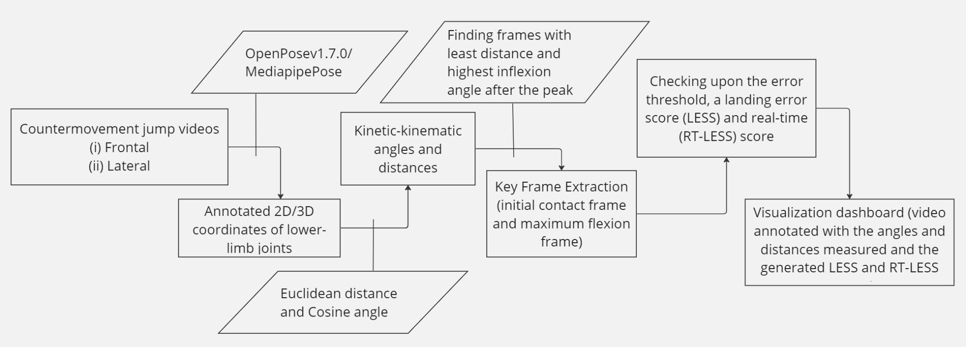

Using the base paper and doing the literature review, we made a flow of processing tasks to calculate the landing error score (LESS) and real-time (RT-LESS) score. We understood each of the blocks individually to know what should be done in each step.

The steps to be followed are as follows:

* Annotation on frontal and lateral frames using OpenPosev1.7.0 or MediapipPose.
* Calculate the Euclidean distance and cosine angle
* Keyframe (frames with the least distance and highest inflection angle after the peak) extraction.
* Calculate the LESS and RT-LESS score
* Visualizing using a dashboard

### **Next steps and goals:**

* Find the third jump from the videos and do annotation using Openposev1.7.0 or Mediapipe pose.

### **Conclusion:**

This week's development represents a significant advancement in our effort to create a methodology and flow for basketball landing error scoring system (LESS) using computer vision methods. By carefully designing a processing flow and identifying essential computing jobs, we have prepared the way for developing a comprehensive system that can evaluate landing faults in real-time. In the future, we will concentrate on improving our methodology even more, especially by annotating the third leap in video and carrying out more visualization technique research.

### **References:**

1. Sharma, S., Divakaran, S., Kaya, T., Taber, C., & Raval, M. S. (2023, October). A Framework for Biomechanical Analysis of Jump Landings for Injury Risk Assessment. In 2023 IEEE 28th Pacific Rim International Symposium on Dependable Computing (PRDC) (pp. 327-331). IEEE. <https://ieeexplore.ieee.org/abstract/document/10356423/?casa_token=yM-1J2vMKG8AAAAA:QnMMyph1mKa6BfvljAqSSABrReChb5hvsEvxFUEv3z5Fiiv1daHpTdbG2oXllJYQ-WQPUijJ6wZr>
2. Hébert-Losier, K.; Hanzlíková, I.; Zheng, C.; Streeter, L.; Mayo, M. The ‘DEEP’ Landing Error Scoring System. Appl. Sci. 2020, 10, 892. <https://doi.org/10.3390/app10030892>
3. Zheng, C., Wu, W., Chen, C., Yang, T., Zhu, S., Shen, J., Kehtarnavaz, N., & Shah, M. (2020). Deep Learning-Based Human Pose Estimation: A Survey. <https://arxiv.org/abs/2012.13392>
4. N. Blanchard, K. Skinner, A. Kemp, W. Scheirer and P. Flynn, ""Keep Me In, Coach!": A Computer Vision Perspective on Assessing ACL Injury Risk in Female Athletes," 2019 IEEE Winter Conference on Applications of Computer Vision (WACV), Waikoloa, HI, USA, 2019, pp. 1366-1374, <https://doi.org/10.1109/wacv.2019.00150>