

CSE541 Computer Vision

Weekly Report 4

**Landing Error Scoring System for Basketball: A Computer Vision Approach**

Submitted to faculty: Mehul Raval

Date of Submission: 02-03-24

Student Details

| Roll No. | Name of the Student |
| --- | --- |
| AU2140133 | Dhairya Shah |
| AU2140159 | Aayushi Shah |
| AU2140163 | Raj Dave |
| AU2140213 | Vanaja Agarwal |

2023-2024 (Winter Semester)

### **Aim:**

Applying MediaPipe Pose and OpenPose.

### **Introduction:**

This report provides an update on our progress on the project which is aimed at analyzing basketball countermovement jump videos. It outlines the initial steps taken in applying the MediaPipe pose estimation algorithm, a tool that helps us accurately find and track important body landmarks in these videos. Additionally, we've compared and implemented MediaPipe with another tool called OpenPose to practically evaluate their effectiveness.

### **Dataset Description:**

### The dataset includes 50 countermovement jump videos of Division I female basketball players. They serve as the primary data source for developing the described framework model of pose estimation. These videos are recorded from both frontal and lateral angles which offers us different perspectives and aids us in analyzing the jumps accurately from different viewpoints.

### **Pose Estimation(MediaPipe) Algorithm:**

The chosen algorithm for our project is mediapipe as it is capable of accurately detecting and tracking key body landmarks, including joints and body segments. It can efficiently handle variations in poses, lightning conditions and messy backgrounds which makes it suitable for processing basketball jump videos in different environments from different perspectives. MediaPipe is well suited for this task because of its high accuracy in estimating the 2D/3D coordinates of lower limb joints which plays an important role in calculating the kinematic angles and distances to assess the jump quality and risks. While OpenPose also offers accurate pose estimation, MediaPipe stands out for its efficiency, real-time capability, and ease of integration as described in the table below.  
  
Steps involved:

1. Initializing the MediaPipe pose estimation model with certain confidence thresholds for detection and tracking.
2. Image processing: Conversion of the input frame (image) from the BGR color space to the RGB color space. In this step, we consider two frames (initial landing frame and the maximum knee bending point) for processing.
3. The model processes the RGB image and detects and tracks the landmarks representing various body parts, such as joints and body segments.
4. Conversion of the RGB image back to the BGR color space along with the detected landmarks and connections on the image for visualization purposes.
5. Extraction of the coordinates of specific body landmarks from the pose estimation results for further calculating angles and distances.

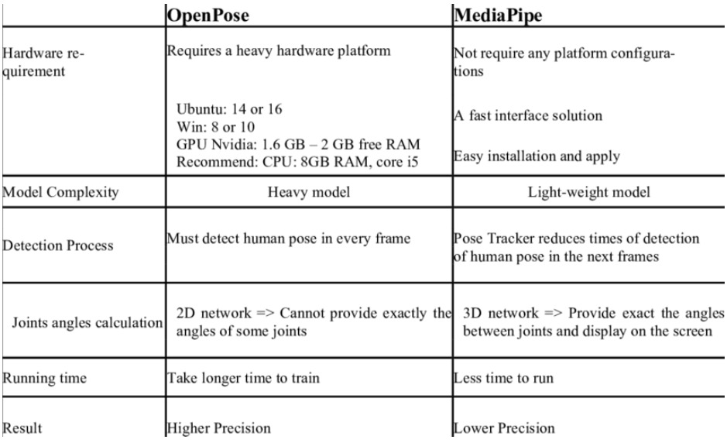

Link to the collab:

<https://colab.research.google.com/drive/1vS7o5w5o4_yAQ8Vf51OL7PR_Ht649_dE?usp=sharing>

<https://colab.research.google.com/drive/1ERenGegIvMH6VNrPAJlE79gpbPyVwrM3?usp=sharing>

### **Conclusion:**

Although there has been significant progress in implementing the MediaPipe pose estimation algorithm and harnessing the landmarks to analyze the biomechanics of basketball jumps in videos, the implementation of the Landing Error Scoring System (LESS) is still pending. After the integration of LESS into our algorithm, we will have better knowledge and understanding of how these players jump and land, thereby preventing injuries and improving performance for Division I female basketball athletes.

### **Next steps and goals:**

1. LESS(Landing Error Scoring System) Algorithm Development
2. Integration of LESS into Framework

### **References**

1. Chung, J.-L., Ong, L.-Y., & Leow, M.-C. (2022). Comparative Analysis of Skeleton-Based Human Pose Estimation. Future Internet, 14(12), 380. <https://doi.org/10.3390/fi14120380>
2. Sharma, S., Divakaran, S., Kaya, T., Taber, C., & Raval, M. S. (2023). A Framework for Biomechanical Analysis of Jump Landings for Injury Risk Assessment. In 2023 IEEE 28th Pacific Rim International Symposium on Dependable Computing (PRDC) (pp. 327-331). IEEE. doi:10.1109/PRDC59308.2023.00052
3. Park, H.J.; Baek, J.W.; Kim, J.H. Imagery based Parametric Classification of Correct and Incorrect Motion for Push-up Counter Using OpenPose. In Proceedings of the 2020 IEEE 16th International Conference on Automation Science and Engineering (CASE),Hong Kong, China, 20–21 August 2020; pp. 1389–1394.
4. Li, Y.C.; Chang, C.T.; Cheng, C.C.; Huang, Y.L. Baseball Swing Pose Estimation Using OpenPose. In Proceedings of the 2021 IEEE International Conference on Robotics, Automation and Artificial Intelligence (RAAI), Hong Kong, China, 21–23 April 2021; pp. 6–9.
5. Nguyen, H.T.P.; Woo, Y.; Huynh, N.N.; Jeong, H. Scoring of Human Body-Balance Ability on Wobble Board Based on the Geometric Solution. Appl. Sci. 2022, 12, 5967
6. Patil, A.; Rao, D.; Utturwar, K.; Shelke, T.; Sarda, E. Body Posture Detection and Motion Tracking using AI for Medical Exercises and Recommendation System. ITM Web Conf. 2022, 44, 03043