

CSE541 Computer Vision

Weekly Report 6

**Landing Error Scoring System for Basketball: A Computer Vision Approach**

Submitted to faculty: Mehul Raval

Date of Submission: 23-03-24

Student Details

| Roll No. | Name of the Student |
| --- | --- |
| AU2140133 | Dhairya Shah |
| AU2140159 | Aayushi Shah |
| AU2140163 | Raj Dave |
| AU2140213 | Vanaja Agarwal |

2023-2024 (Winter Semester)

### **Aim:**

Deciding which model to use or what kind of model to make so that it suits our dataset and gives the best results for error detection and scores.

### **Introduction:**

With respect to the dataset, currently we have one video which we have divided into 211 frames. We will be using a deep learning model or a machine learning model based on the dataset size that we would be getting. If we get more videos, it would be possible to use a DL based CNN to accurately predict the error scores through the video frames, however, it would be really difficult to manually annotate the new frames in a short span of time. On the other hand, with the help of a smaller dataset which we are currently using, we can apply something like SVM to predict the values.

### **Work Completed:**

From the literature, we found the following model comparison.  
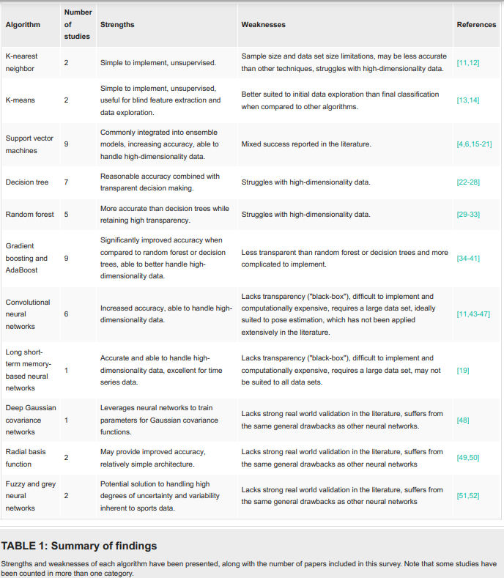

| **Model** | **Key Features** | **Advantages** | **Limitations** | **Data Requirements** |
| --- | --- | --- | --- | --- |
| RCNN | - Uses regions to detect objects  - Good accuracy  - Works well with various objects | - Accurate  - Handles different object sizes and orientations | - Slow during training  - Slower to detect objects compared to some other methods | Needs lots of data to train because it's complex |
| MoveNet | - Small and efficient  - Good for real-time pose estimation  - Works on phones and small devices | - Fast  - Real-time performance  - Works on devices with limited resources | - Might not be as accurate as larger models | Needs moderate to large amounts of data for training |
| PoseResNet | - Based on ResNet - Made for pose estimation  - Can capture fine details | - Accurate  - Handles detailed poses  - Doesn't need as much data as some other models | - Can be slow with deep versions - Needs moderate to large amounts of data for training | Needs moderate to large amounts of data for training |
| HRNet | - Keeps high detail throughout  - Captures detailed poses  - High accuracy | - Accurate  - Handles detailed poses  - One of the best for pose estimation | - Needs lots of computing power - Might be slow with detailed versions | Needs lots of data for training due to its complexity |

### **Conclusion:**

Considering the dataset size, we can first start with PoseResNet. Although it requires moderate to large amounts of data for training, it is less demanding than MoveNet and HRNet.

### **Next steps and goals:**

* Decide upon what architecture should be used for error prediction.
* After getting valuable insights from our TA, we will decide how to move forward in the direction of model creation or choosing a model.
* Creating a Model to quantify the degree of error.

### **References**

1. Sharma, S., Divakaran, S., Kaya, T., Taber, C., & Raval, M. S. (2023). A Framework for Biomechanical Analysis of Jump Landings for Injury Risk Assessment. In 2023 IEEE 28th Pacific Rim International Symposium on Dependable Computing (PRDC) (pp. 327-331). IEEE. doi:10.1109/PRDC59308.2023.00052
2. Amendolara, A., Pfister, D., Settelmayer, M., Shah, M., Wu, V., Donnelly, S., Johnston, B., Peterson, R., Sant, D., Kriak, J., et al. "An overview of machine learning applications in sports injury prediction," Cureus, vol. 15, no. 9, 2023.
3. J. Bansal, "Understanding and Implementing Faster R-CNN: A Step-by-Step Guide," *Towards Data Science*, 2018. [Online]. Available: <https://towardsdatascience.com/understanding-and-implementing-faster-r-cnn-a-step-by-step-guide-11acfff216b0> [Accessed: March 23, 2024].
4. P. Peter, "Overview of Human Pose Estimation Neural Networks — HRNet + HigherHRNet, Architectures and FAQ," Towards Data Science, Jun. 14, 2020. [Online]. Available: <https://towardsdatascience.com/overview-of-human-pose-estimation-neural-networks-hrnet-higherhrnet-architectures-and-faq-1954b2f8b249> [Accessed: March 23, 2024].
5. D. Cochard, "MoveNet: Pose Estimation for Video with Intense Motion," axinc-ai, Sep. 2, 2021. [Online]. Available: <https://medium.com/axinc-ai/movenet-pose-estimation-for-video-with-intense-motion-2b92f53f3c8> [Accessed: March 23, 2024].