

CSE541 Computer Vision

Weekly Report 8

**Landing Error Scoring System for Basketball: A Computer Vision Approach**

Submitted to faculty: Mehul Raval

Date of Submission: 06-04-24

Student Details

| Roll No. | Name of the Student |
| --- | --- |
| AU2140133 | Dhairya Shah |
| AU2140159 | Aayushi Shah |
| AU2140163 | Raj Dave |
| AU2140213 | Vanaja Agarwal |

2023-2024 (Winter Semester)

### **Aim:**

To finalize a pre-trained computer vision model and do transfer learning in order to annotate the frames and classify the errors as required.

**Introduction:**

Our primary objective is to identify a computer vision-based pre-trained model or architecture and train our dataset on it to identify and classify two specific types of errors – lateral trunk flexion and stance width – observed during an athlete's countermovement jump. Our dataset consists of manually annotated 210 frames extracted from the countermovement jump video, each labeled with the respective error classes. We narrowed down our choices to YOLO-v8 and Detectron2 for the final analysis. Based on the further research done, we have finalised the Detectron2 object detection model. Detectron2 includes all the models such as Faster R-CNN, Mask R-CNN, RetinaNet, and DensePose as well as some newer models including Cascade R-CNN, Panoptic FPN, and TensorMask. Detectron2 aids in key point detection, object detection, and semantic segmentation.

### **Work Completed:**

* We have trained the Detectron model and tried it on our dataset. We are able to get almost accurate bounding boxes along with a decent accuracy for the classification of the couple of errors: lateral trunk flexion and stance width.

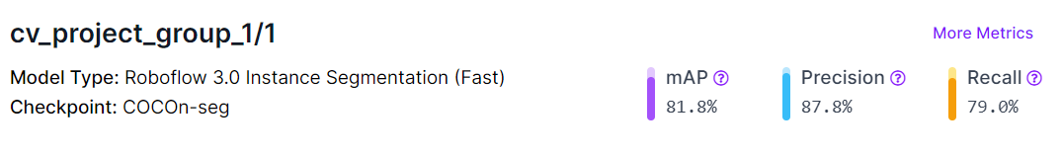

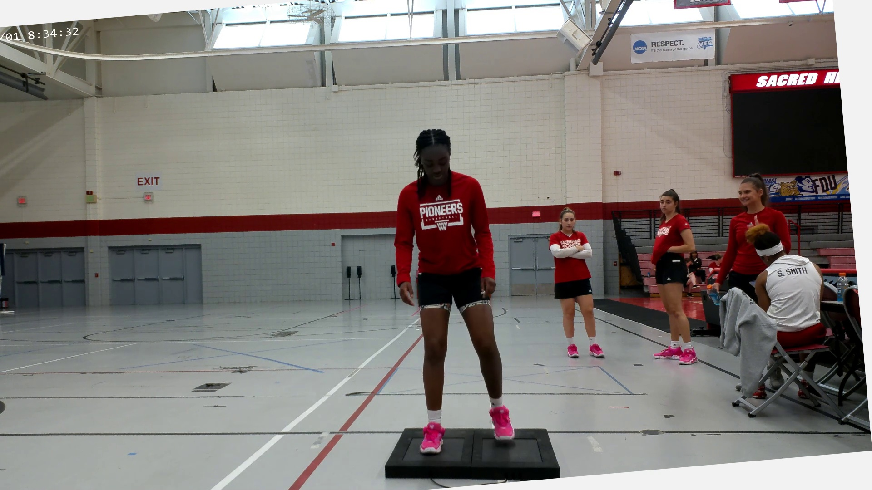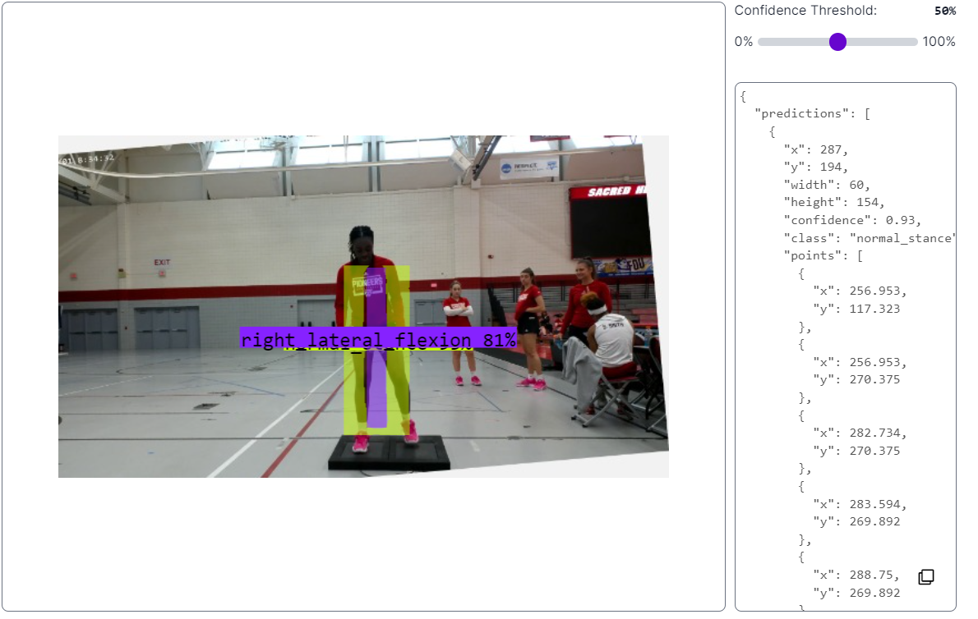

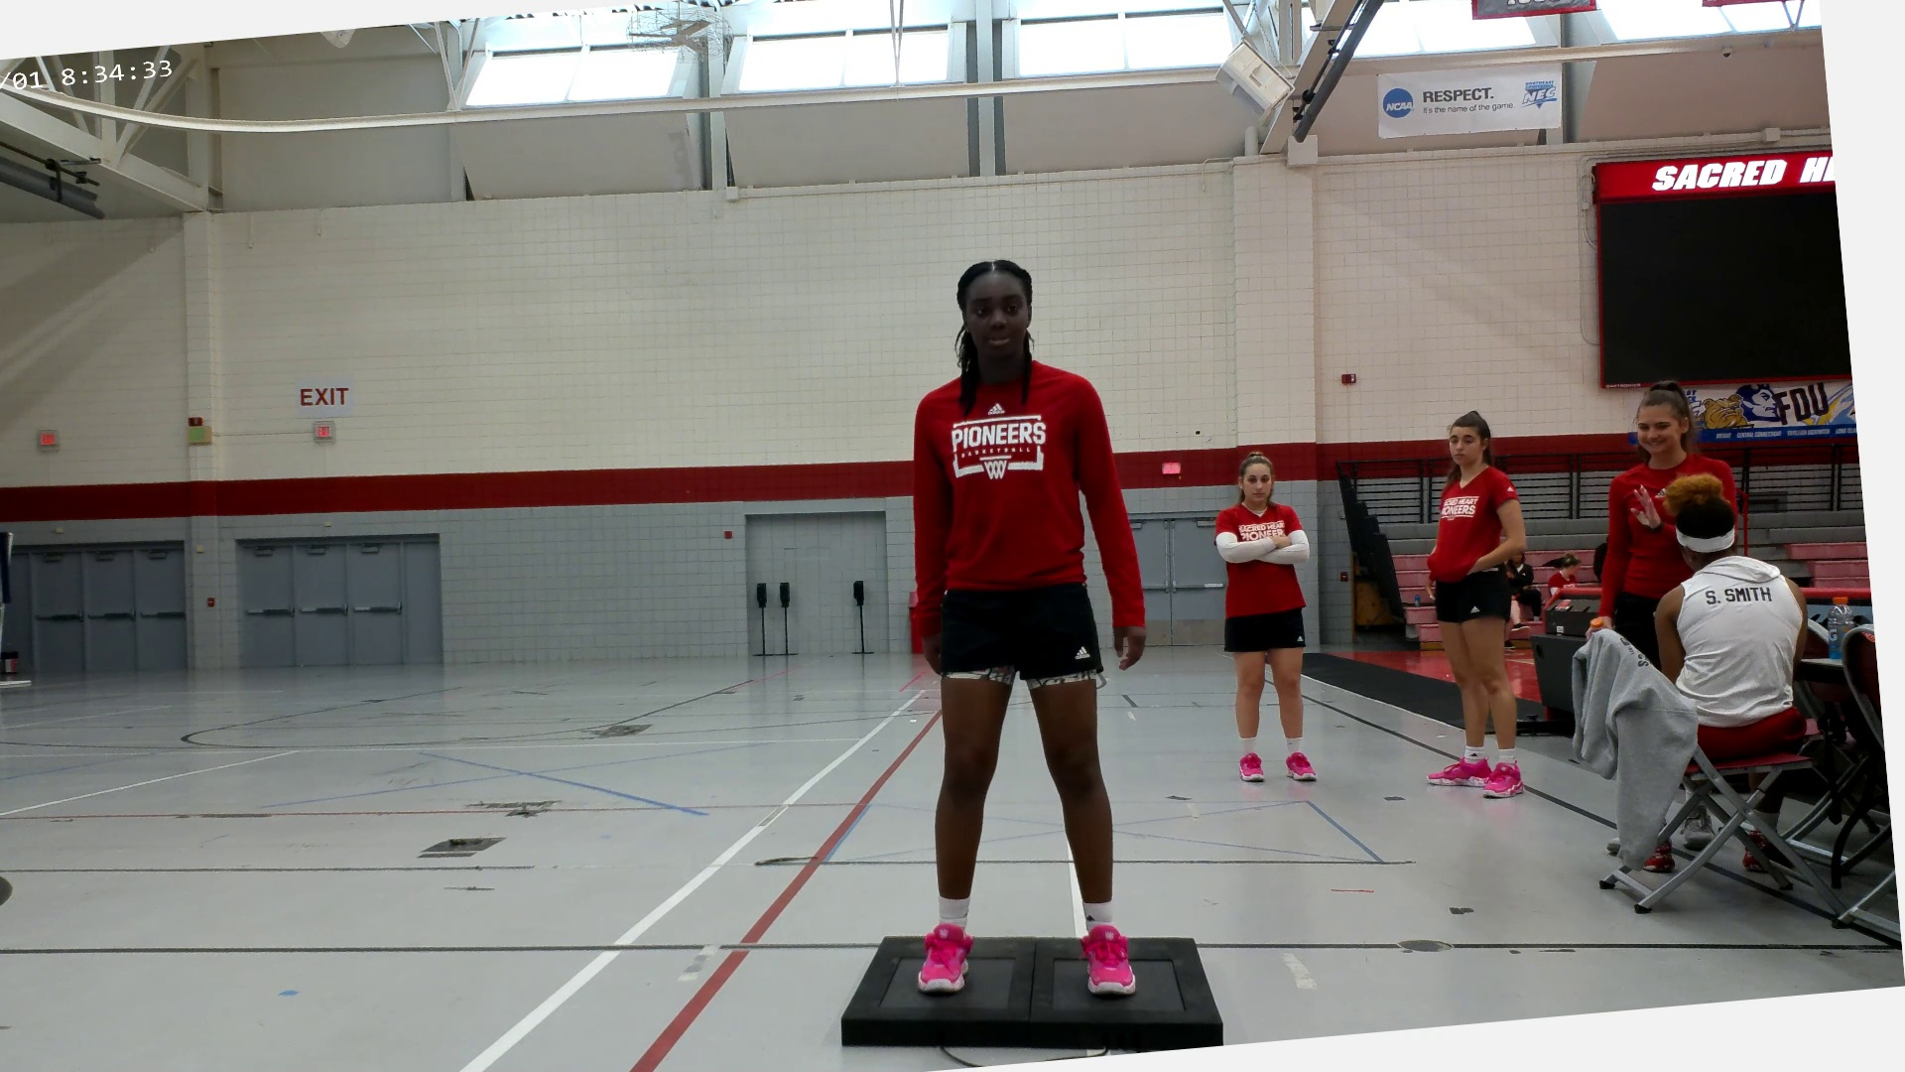

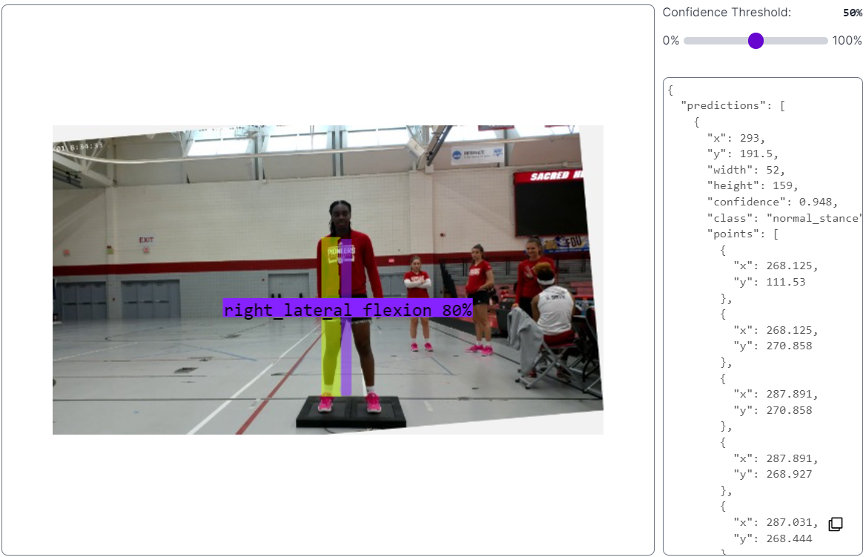

### **Next steps and goals:**

* Write the end-semester report.

### **Conclusion:**

After an extensive research and employing a technique of trail and error, we have finalised the Detectron-2 model. We also used YOLO-v8 model for the same but we figured out that the accuracy of the bounding box was not that great in this case. When we trained Detectron-2 model on our dataset, we were able to get the bounding boxes at the same place as our input frame and also we were able to classify the couple of errors: lateral trunk flexion and stance width with a fairly high accuracy.

### **References:**

1. Adrian Rosebrock, "Human Activity Recognition with OpenCV and Deep Learning," November 25, 2019. [Online]. Available: <https://pyimagesearch.com/2019/11/25/human-activity-recognition-with-opencv-and-deep-learning/> [Accessed: March 30, 2024].
2. TensorFlow, "MoViNet for streaming action recognition," [Online]. Available: <https://www.tensorflow.org/hub/tutorials/movinet> [Accessed: March 30, 2024].
3. TensorFlow, "Transfer learning for video classification with MoViNet," [Online]. Available: <https://www.tensorflow.org/tutorials/video/transfer_learning_with_movinet> [Accessed: March 30, 2024].
4. J. Brownlee, "Deep Learning Models for Human Activity Recognition," Deep Learning for Time Series, Aug. 5, 2019. [Online]. Available: <https://machinelearningmastery.com/deep-learning-models-for-human-activity-recognition/> [Accessed: March 23, 2024].
5. "Detectron2," [Online]. Available: <https://roboflow.com/model/detectron2#:~:text=Detectron2%20includes%20all%20the%20models,object%20detection%2C%20and%20semantic%20segmentation> [Accessed: April 04, 2024].