Predicted Images

Drive Link: <https://drive.google.com/drive/folders/1pqQjUWSC8WjQRSd98ro0zSa6d54sawIh?usp=sharing>

Confusion Matrix:

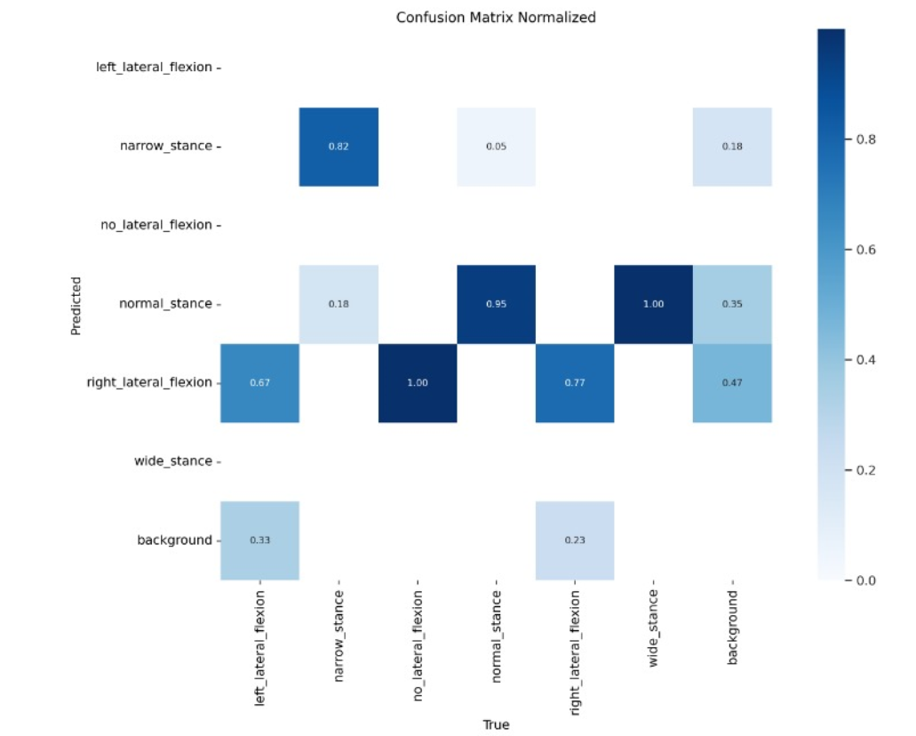

PR Curve:

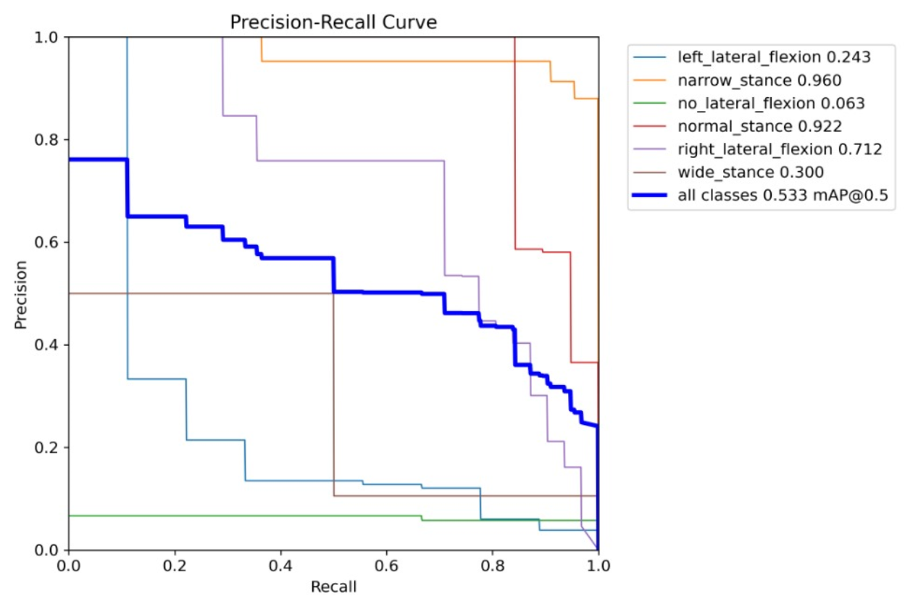

Other plots:

