PROJECT REPORT

THETA BETA MACH RELATIONSHIP

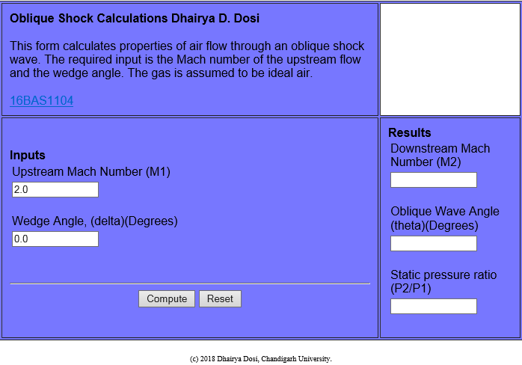

**Dhairya Dosi**

16BAS1104

5-AERO-2

# INTRODUCTION

At supersonic speeds air is not warned before object shows up .is because the object is traveling faster than the speed of pressure waves ..or to be more general sound waves, as a result, an oblique shock comes up ahead of the object that drastically deflects the upstream resulting an increase in pressure,temperature,enthalpy and density off course now it all depends on how much we`re deflecting the air. . suppose there is an angle theta we have a beta we have mach number. so how we`re gonna find out theta.the programme is for this purpose

# HYPOTHESIS

It has been already observed that the Mach number normal to the shock is repsonsible for all the property variations for given shock angle. However this shock angle can be easily calculated from the upstream or freestream Mach number for given wedge or deflecion angle. Consider the same control volume shown in Fig.18.3. Reation between velocties and angles before and after the shocks are,  
  
   
 Before the shock  
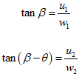

After the shock  
  
But we know that,  
  
w1 = w2  
Hence,  
  
  
  
But  
ρ1u1 = ρ2u2 hence,   
  
Therefore,  
  
  
  
From density ratio Eq (5.4), we have  
  
  
  
From the expression of upstream Mach number,   
  
  
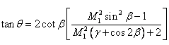  
  
  
This is the expression between upstream Mach number, shock angle and wedge angle. In most general case, we need to know the shock angle for given Mach number and wedge angle. Following figure provides the information about the same (Fig. 19.1). In this figure, each curve corresponds to various possible shock angles for a given Mach number and flow deflection angle.

# Programming languages

1. Python for backend
2. Javascript for frontend

# DATA AT M=3

|  |  |  |
| --- | --- | --- |
| BETA | THETA | PRESSURE RATIO |
| 15 | 32.2404 | 2.82156 |
| 19 | 36.5999 | 3.56591 |
| 35>theta max. | DETACHED | nil |

# RESULTS

The result was easily showed that to get more efficiency at supersonic speeds we gotta he an optimum angle of attack at supersonic airfoil or wedge/cone for compression in supersonic inlets in jet engines

1. Finding out different AOA at different speeds
2. wedge/cone optimization for max pressure recovery
3. Assisting students.

# REFERENCES

1. Modern compressible flow by john.d.Anderson
2. Mechanics and thermodynamics of propulsion by hill and Peterson
3. And the holy bible of aviation flight without formula by A.C. kermode