

**Team Name: NameNotFound**

**Team Members: Raghav Jindal , Sachin Agrawal ,Raman Kumar, Dhairya**

**Problem Statement**: Utilizing barren lands to provide employment to people for contributing in our GDP.

**Case study**: From user perspective Farm Friendzy is a platform for those people who are busy in their daily life work and have no one to look after their farming land.

We Farm Friendzy as a company are contributing towards society as:

* Utilizing barren lands to enhance the crop production
* To provide employment to people who wants to do farming but they do not have their own land
* To contribute in the Smart Agriculture which will be somehow boost our GDP (Gross Development Product)

**Proposed Solution:** Farm Friendzy is an Internet of things (IoT) sensing, notifications, dashboard and analytics platform for urban and large-scale agriculture, with automated irrigation technology

Our solution to the problem is to create a sustainable platform for sensing and irrigation automation with predictive analysis via Machine Learning algorithm. With one objective in mind: SAVE RESOURCES.

Whenever our clients approaches us with their uncultivated land, we will discuss all the policies with them. After signing an agreement with our customer , the sensors network will be installed in their farms.

Customers can interact with Farm Friendzy employee through our chat box and get notified anytime about the status of their farm. farmfriendzy_chatbox is a web app build using node.js runtime engine and websocket.io and express module.

The Chatbox is embedded with our website and is deployed on Elastic Compute Cloud Service of AWS Cloud Service Provider.

**Link to ChatBox**: <http://ec2-35-154-13-5.ap-south-1.compute.amazonaws.com:3000/>

The Chatbox is embedded within our website

Our Website depicts overview of answers to the following questions:

* What is our service?
* How we are implementing our service?

**Link to Website**: h[ttps://sansartech2018.wordpress.com](https://sansartech2018.wordpress.com/)

Sensors Installation:

Raspberry Pi, has to collect data, use the Wifi module to connect to the Webhooks and update them regularly (say once every 10mins)

We are using:

1)Temperature sensor:DS18B20

2)pH or Conductivity sensor

3)water level sensor: HC-SR04

4)soil moisture sensor

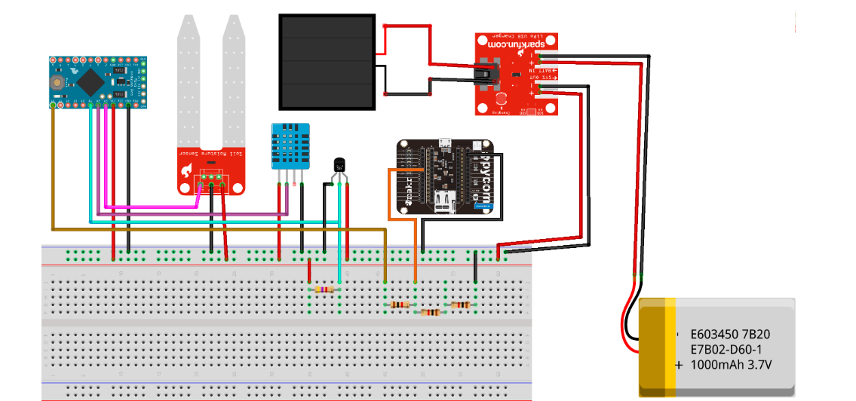

we have created an Arduino setup whose source code is present in Arduino directory.

The setup will give results like farm's current situation in terms of humidity, temperature and Ph

and this dataset will then be provided to our machine learning algorithm which will then predict that which crop would be better in that geographical region.

The source code of our machine learning algorithm is given ml algorithm folder.

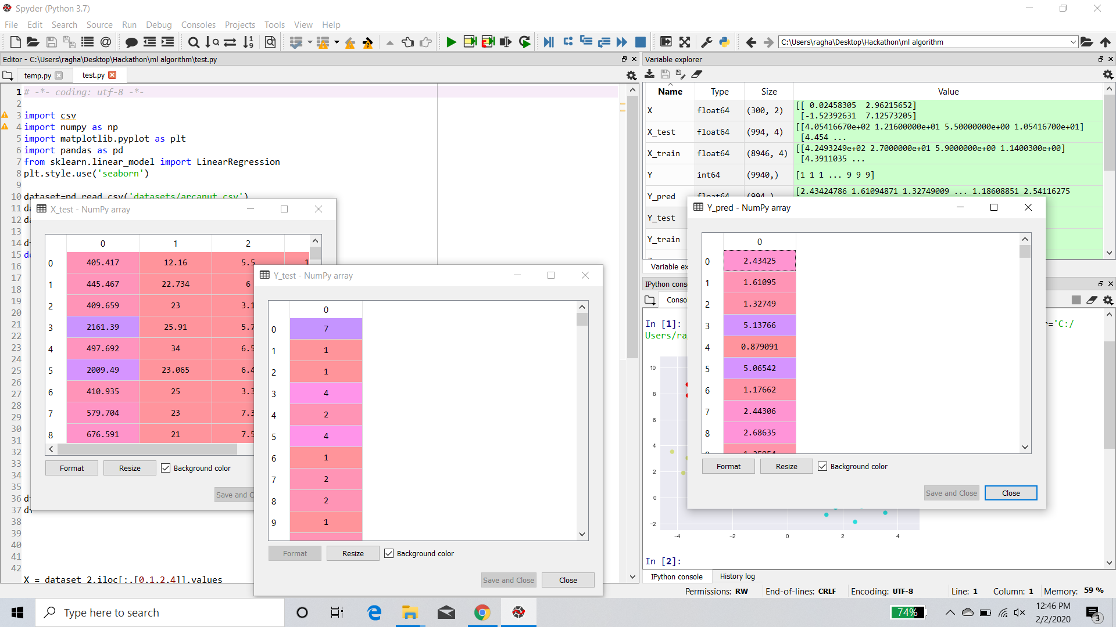

**Our Mobile App**: It is a small Android app in terms of memory with an easy interface to use. This android application provides current situation of the crop. It also ensures quality of services delivered to our customers

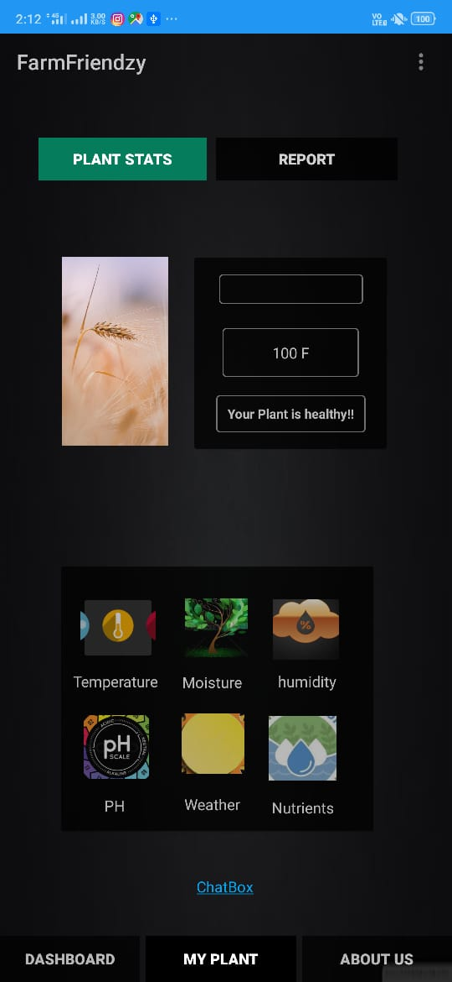 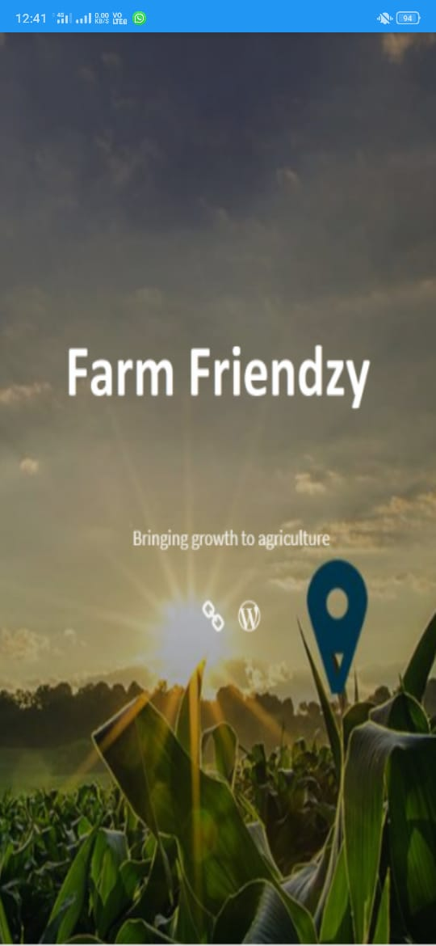

Bussiness Relevance:

