VV Enrollment Platform
Complete flow catalog and diagram screenshots
Purpose: a newcomer reference for every explicitly documented user, staff, AI, reliability, integration, and leadership flow.
SCOPE  57 documented flow families | EVIDENCE  Current architecture and flow documents | STATUS  Current, preview/dummy, or target design

Reading guide. “Current” means it is implemented in the portal/production-oriented slice. “Preview/dummy” means it works in the synthetic local or hosted demo, but it is not an institutional production capability. “Target design” is an explicit documented future flow.

Complete flow inventory
This catalog is deliberately broader than page navigation: it includes the end-user journeys, staff operations, controlled AI paths, reliability/integration behavior, and documented future leadership flows.

Student lifecycle and self-service
ID | Flow | Purpose / main path | Availability | Source
S01 | Registration, sign-in and bootstrap routing | Student establishes a session; bootstrap chooses sign-in, onboarding or dashboard. | Current preview | docs/03, 10, 14
S02 | Ordered onboarding and resume | Eight server-versioned steps save and resume at the first incomplete task. | Current | docs/03, 14, 17
S03 | Admission offer decision | Student accepts an offer idempotently; the API creates an enrollment journey. | Current | docs/03, 14
S04 | Dashboard and next action | Student sees authoritative progress, deadlines, unread messages and the next action. | Current | docs/03, 14
S05 | Requirement applicability and dependencies | Server instantiates only applicable requirements and prevents blocked work from advancing. | Current | docs/02, 03, 12
S06 | Profile verification and save conflict | Student saves permitted profile fields with expected version; stale writes receive a conflict. | Current | docs/03, 23
S07 | Housing plan and roommate preference | Student chooses a housing path and related preferences as part of onboarding. | Current | docs/03, 14
S08 | Family permissions / FERPA delegation | Student records or revokes family access permissions; authorization governs future use. | Current onboarding; production auth target | docs/03, 08
S09 | Onboarding signature and signed packets | Completion creates immutable tenant-branded signed PDFs visible in My Documents. | Current | docs/03, 10
S10 | Document upload and extraction | Original bytes and metadata persist before the worker parses a document. | Current | docs/03, 11, 14
S11 | Document mismatch, failure and retry | The system surfaces type mismatch/failure and retries from the retained original with an idempotency boundary. | Current | docs/03, 11, 13
S12 | Student confirms extraction; staff decides | Student confirms eligible extracted fields; staff review can update the document, requirement and notification. | Current slice | docs/14, 22, 23
S13 | Transcript course and exemption recommendation | Transcript evidence yields advisory course/exemption suggestions for later registrar action. | Current advisory | docs/11, 14
S14 | Financial-aid and immunization document lanes | Financial aid is classification-only; immunization routes to manual review under policy. | Current | docs/11, 14
S15 | Deposit payment | Student records a simulated idempotent deposit; no card data is accepted in the preview. | Preview/dummy | docs/03, 10, 14
S16 | Financial payment-plan selection | Student selects a payment plan through a versioned financial projection. | Current preview | docs/14
S17 | Messages and read receipt | Student opens enrollment messages; read state updates the shared inbox/unread count. | Current | docs/03, 10, 23
S18 | Appointment scheduling | Student creates or manages eligible advisor appointments with idempotent creation. | Current | docs/10, 23
S19 | Help and support inquiry | Student reads support content and may send an inquiry; durable staff inquiry handling is planned. | Preview / target | docs/03, 23, 24
S20 | Academics and catalog search | Student views program, prerequisites, catalog courses and advisory credit context. | Current | docs/14, 23
S21 | Campus life discovery | Student views tenant-owned events, clubs, club details and schedules. | Current | docs/14, 23
S22 | Tenant rewards | Completion/page rules award tenant-defined points into an idempotent ledger. | Current preview | docs/19, 14
S23 | Edward student assistance | Student asks a contextual question; Edward returns bounded advice, navigation and typed action widgets. | Current / key optional | docs/05, 11, 14
S24 | Session, offline and error recovery | The portal exposes loading/error/retry states and resumes persisted server state after a return. | Current partial | docs/03, 10

Staff operations
ID | Flow | Purpose / main path | Availability | Source
T01 | Staff authentication and entry | Staff signs in to a tenant workspace with an HTTP-only preview session. | Preview; OIDC target | docs/24
T02 | Today and Action Center | Staff sees assigned students, priorities, risk evidence and suggested next actions. | Preview / API slice | docs/22, 24
T03 | Task-board coordination | Staff moves, assigns, escalates and notes work items; expected version blocks stale updates. | Preview / API slice | docs/22, 23, 24
T04 | Student inspector and preference update | Authorized staff inspect shared student context and edit allowed operational preferences. | API slice | docs/23, 24
T05 | Staff document decision and notification | Staff decision atomically updates evidence, requirement, work item, audit and optional message. | API slice | docs/22, 23, 24
T06 | Inquiry assignment, reply and resolution | Staff owns, responds to and resolves student inquiries with an optional notification. | Preview / target durable | docs/23, 24
T07 | Managed journey/configuration publish | Staff submits a validated versioned journey, academic or campus configuration candidate. | Preview / target durable | docs/23, 24
T08 | Edward configuration drafting | Staff asks Edward for a draft/change summary, reviews it, then explicitly confirms publication. | Preview | docs/23, 24
T09 | Campus life and club management | Staff creates/updates clubs and publishes student-facing events. | Preview | docs/23, 24
T10 | Academic catalog publication | Staff publishes courses, prerequisites, instructors and catalog versions without changing transcript outcomes. | Preview / target durable | docs/23, 24
T11 | Knowledge base and Core Plays | Staff maintains governed guidance and operational playbooks. | Preview / target durable | docs/23, 24
T12 | Freshness and live invalidation | Polling/focus refresh protects canonical state; SSE invalidation is the planned upgrade. | Current polling / target SSE | docs/22, 23, 24

Platform, AI, reliability and integrations
ID | Flow | Purpose / main path | Availability | Source
A01 | Authenticated API request lifecycle | Correlation ID, authentication, tenant resolution, relationship authorization, validation, use case and telemetry. | Architecture/current pattern | docs/01, 08
A02 | Domain command, audit and outbox | One database transaction commits domain change, audit record and durable event together. | Current | docs/01, 12, 14
A03 | Outbox projection delivery | Worker claims events with leases, deduplicates receipts, updates dashboard projection, retries and dead-letters failures. | Current | docs/14, worker README
A04 | Queued document-extraction worker | Worker calls a private API command after the event commits; a terminal result prevents duplicate AI spend. | Current | docs/11, 14, worker README
A05 | Activity and friction analytics | Browser sends allowlisted events; the platform derives engagement/friction separately from official records. | Current | docs/04, 14
A06 | Runtime lineage / CRM change graph | State-effect registry, correlation IDs, audit records, events and receipts explain a real request's lineage. | Current | docs/13, 14
A07 | Explicit AI assistance | A user action invokes the controlled agent gateway with bounded context, policy and usage recording. | Current | docs/05, 11
A08 | Event-triggered AI candidate | A deterministic domain event identifies a potential agent task; policy decides whether a run is allowed. | Target design | docs/05
A09 | Scheduled reminder and outreach | An aggregate trigger identifies eligible students; a controlled run drafts/queues outreach. | Target design | docs/05, 06
A10 | Inbound CRM/SIS synchronization | External changes enter through an adapter, are validated/idempotent, then become canonical domain updates. | Target design | docs/07
A11 | Outbound CRM/SIS/comms synchronization | Outbox events drive retry-safe external adapters after a local transaction commits. | Target design | docs/07
A12 | Payment/e-signature webhook | A signed inbound webhook is validated, deduplicated and applied as an authoritative external result. | Target design | docs/07
A13 | Tenant isolation and sensitive access | Identity proves who; app resolves tenant, role and relationship, applies field-level authorization and records access. | Current boundary / production hardening | docs/08, 14
A14 | Build, test and deploy | CI runs checks, builds containers and deploys the exact commit through GitHub OIDC/Google workload identity. | Current preview deployment | docs/09, 16

Leadership and operations intelligence
ID | Flow | Purpose / main path | Availability | Source
L01 | Counselor daily work queue | Risk, urgency, due dates and ownership produce a counselor's prioritized work view. | Target design | docs/06
L02 | Support-case lifecycle | A support case moves through assignment, investigation, communication, resolution and audit. | Target design | docs/06
L03 | Intervention playbook | A staff member selects a controlled play, performs an intervention and records the outcome. | Target design | docs/06
L04 | Director/team operations | Director balances capacity, overdue work and staff performance across a team projection. | Target design | docs/06
L05 | Enrollment leader funnel | Leader sees cohort funnel, risk clusters, interventions and system health across the tenant. | Target design | docs/06
L06 | VP executive snapshot | VP consumes privacy-suppressed, aggregated enrollment indicators and trends. | Target design | docs/06
L07 | Projection hierarchy | Student, counselor, director, leader and VP views are different governed projections of shared facts. | Architecture/target | docs/06

Diagram screenshots
These visual snapshots consolidate the flow families in the inventory. They are derived from the repository’s flow specifications and current implementation map; the corresponding source documents are listed under each screenshot.
The API, not the browser, decides the safe first route.
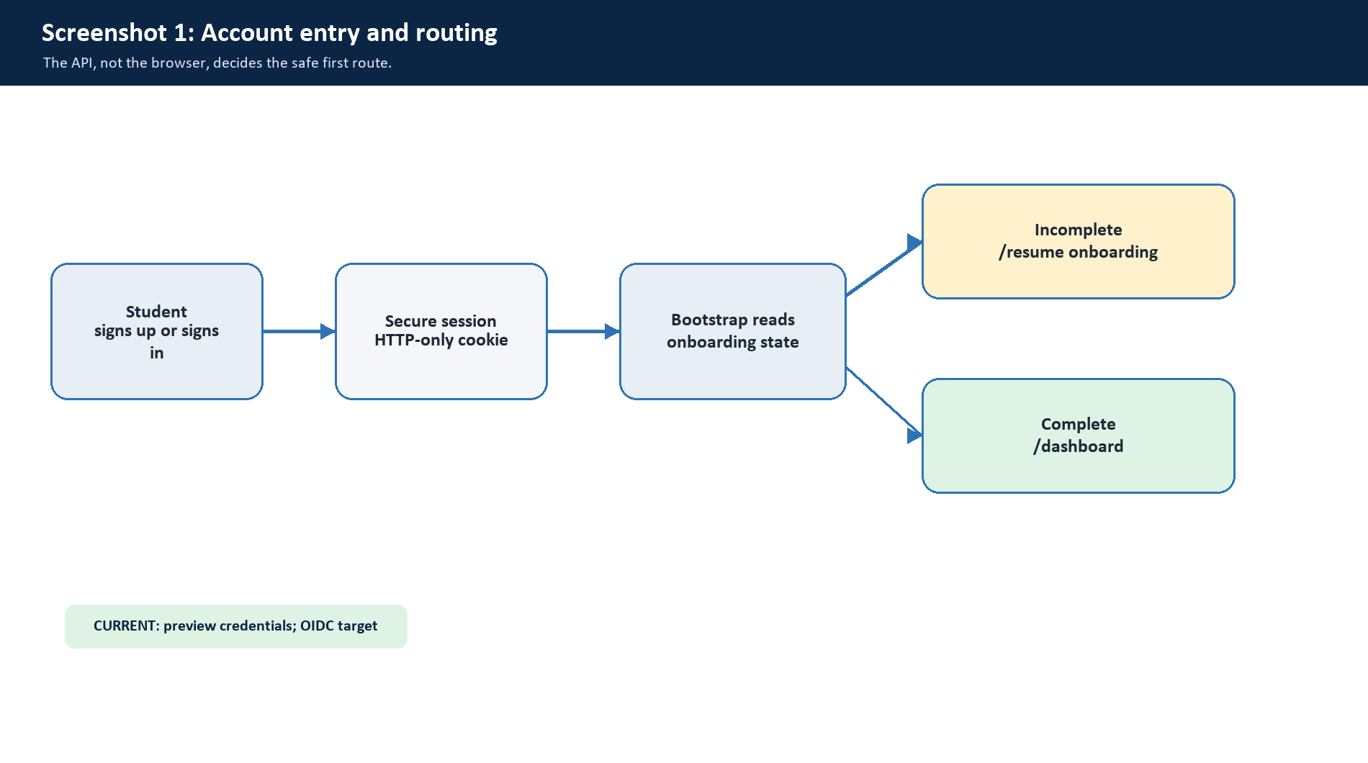
Sources: docs/03-student-portal-feature-flows.md; docs/10-student-portal-acceptance.md; docs/14-current-implementation-map.md
Eight ordered, server-versioned steps; a reload returns to the first incomplete step.
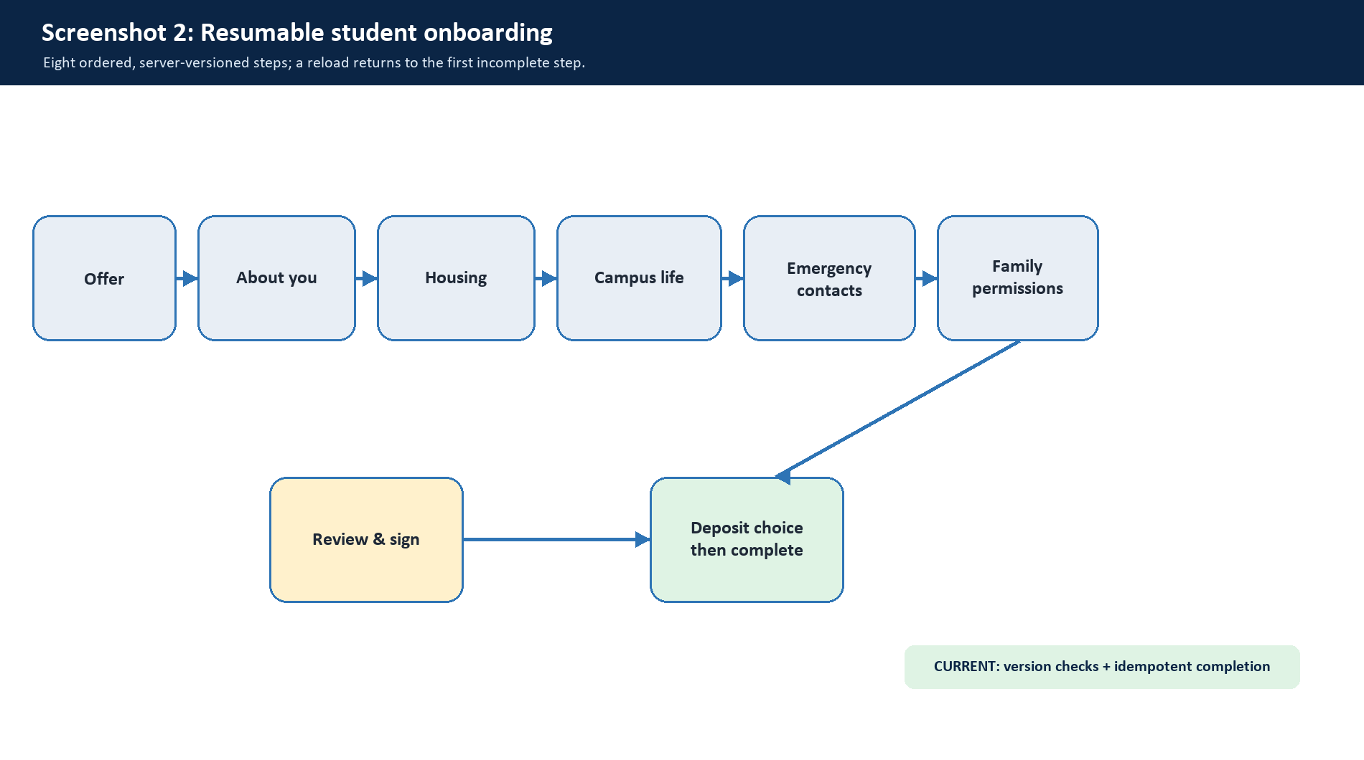
Sources: docs/03-student-portal-feature-flows.md; docs/14-current-implementation-map.md; docs/17-onboarding-question-alignment.md
The original is stored before parsing; AI output remains reviewable, not authoritative.
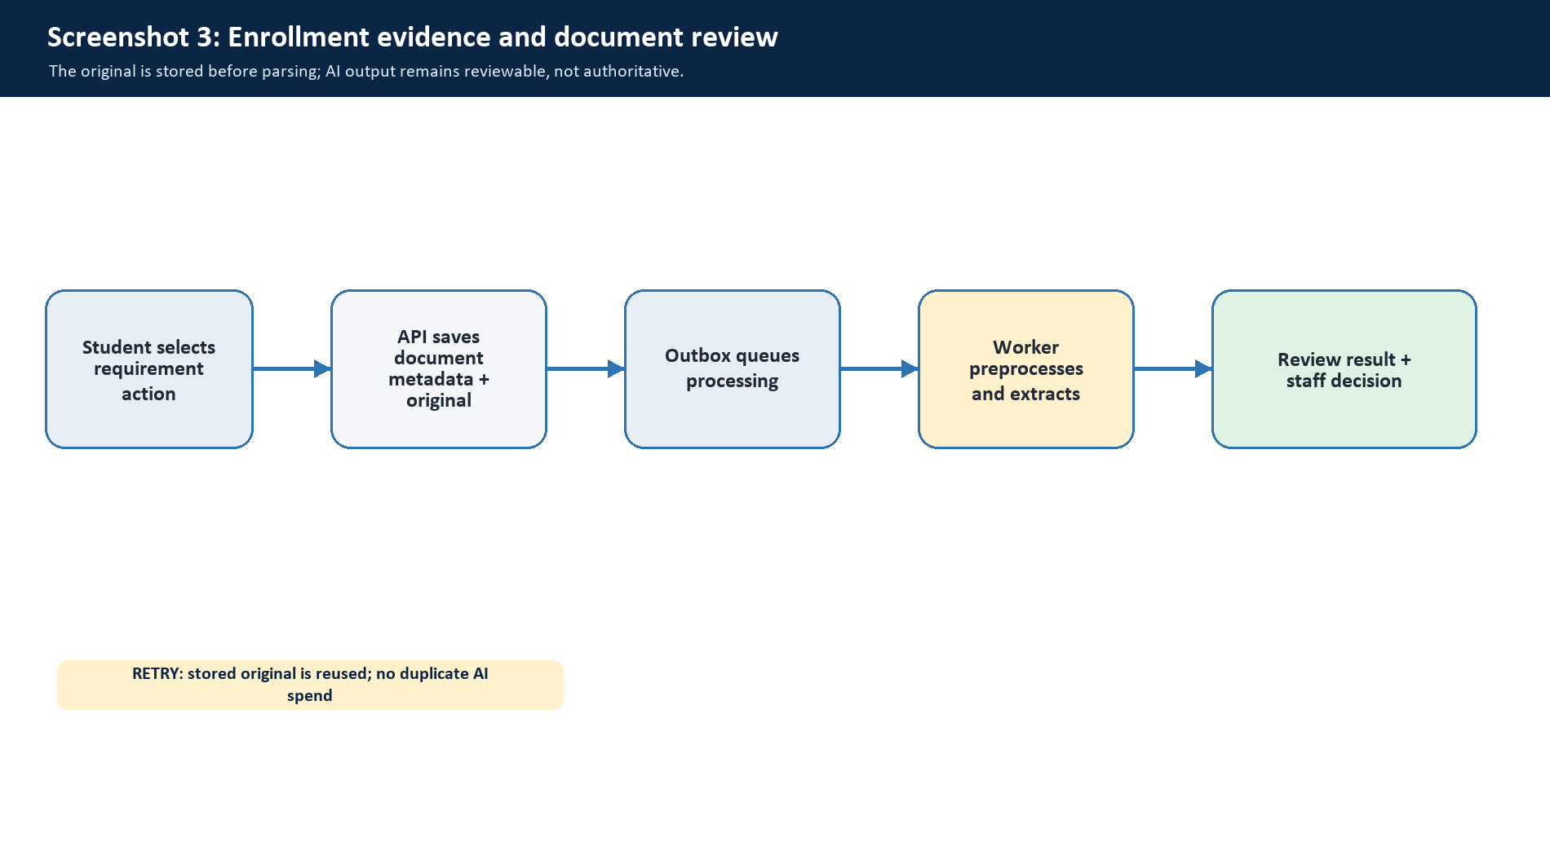
Sources: docs/11-agentic-runtime.md; docs/14-current-implementation-map.md; docs/23-student-staff-user-flows-and-contracts.md
Each route reads the same canonical record; non-GET actions refresh the portal projection.
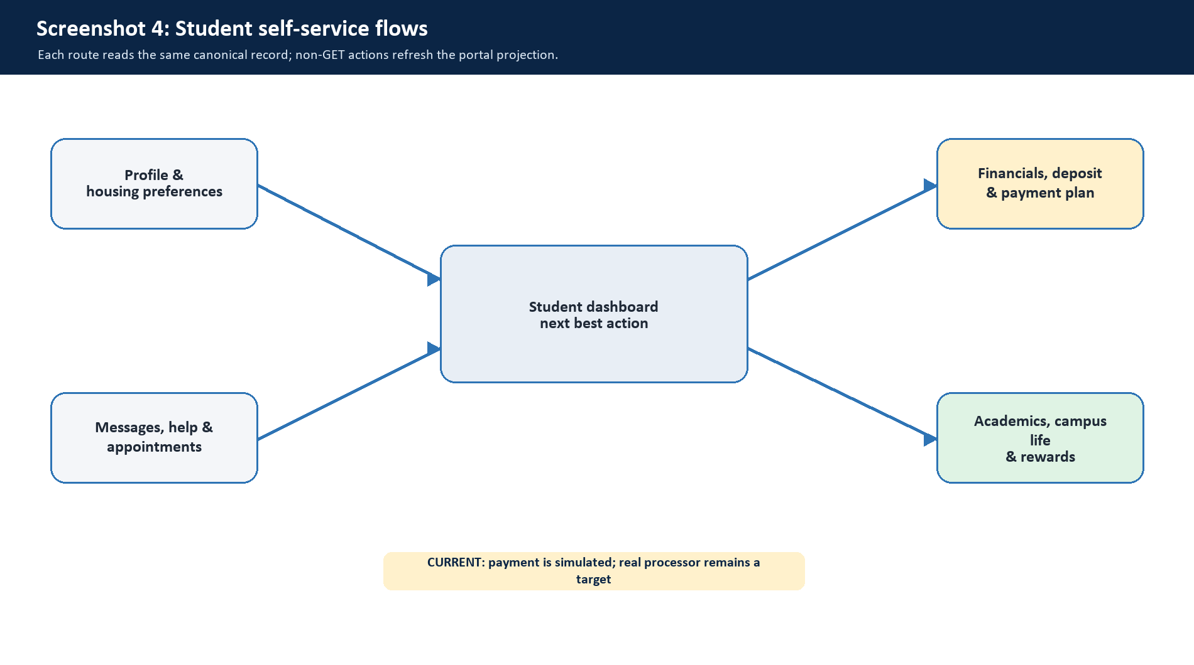
Sources: docs/14-current-implementation-map.md; docs/23-student-staff-user-flows-and-contracts.md
Edward can explain and suggest safe navigation/actions. Deterministic API commands perform official writes.
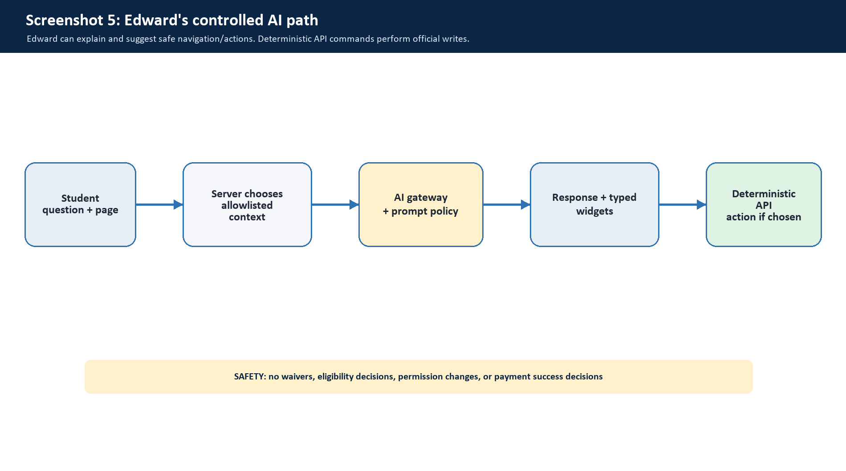
Sources: docs/05-agentic-flows-and-cost-controls.md; docs/11-agentic-runtime.md; docs/14-current-implementation-map.md
Staff views are projections over the same student records, with optimistic version conflict protection.
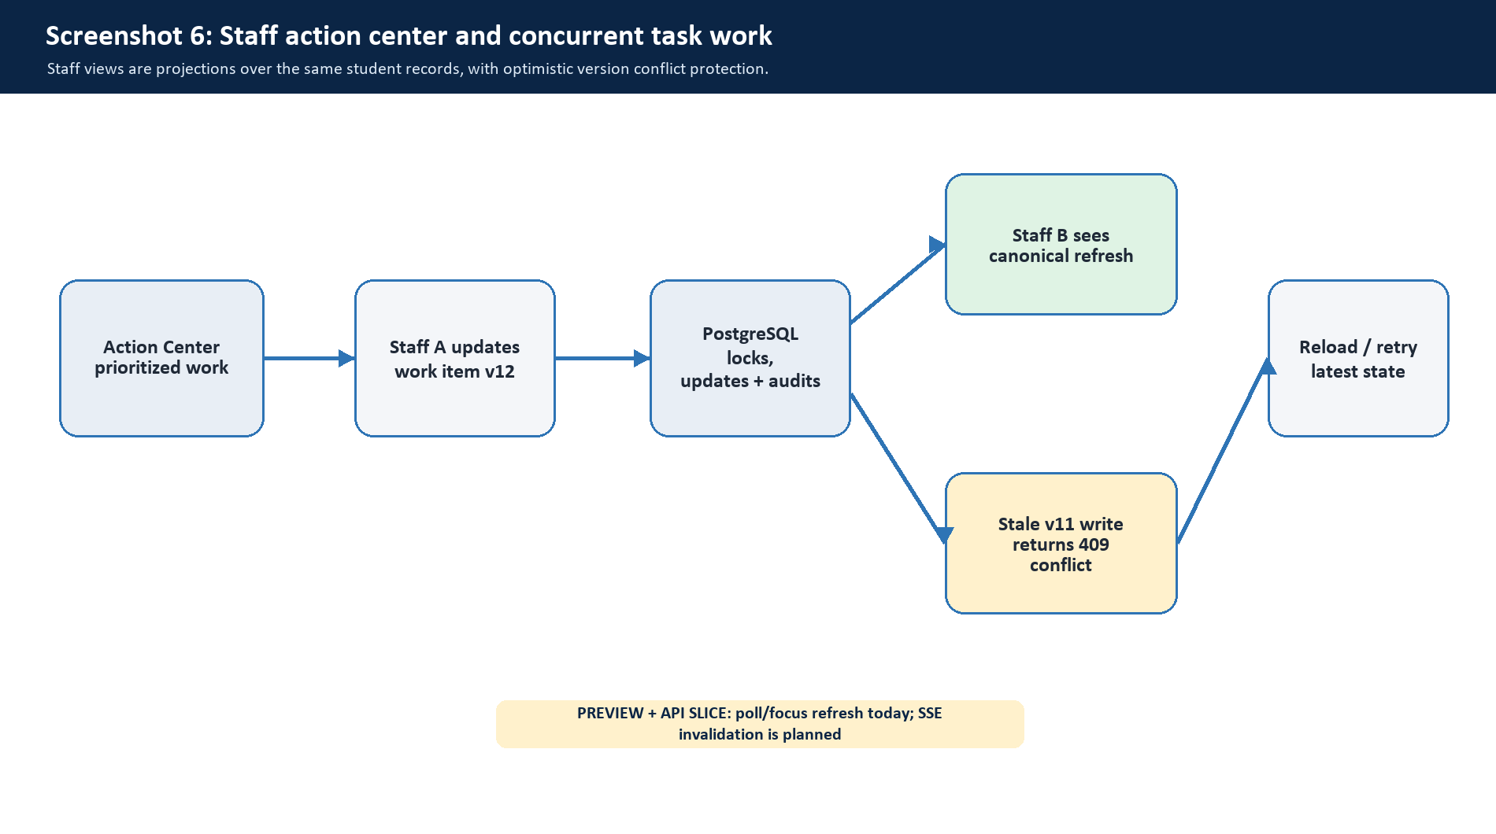
Sources: docs/22-staff-action-center-and-realtime-state.md; docs/23-student-staff-user-flows-and-contracts.md; docs/24-staff-portal-implementation-and-operations.md
Staff changes are versioned and validated before becoming a student-facing tenant projection.
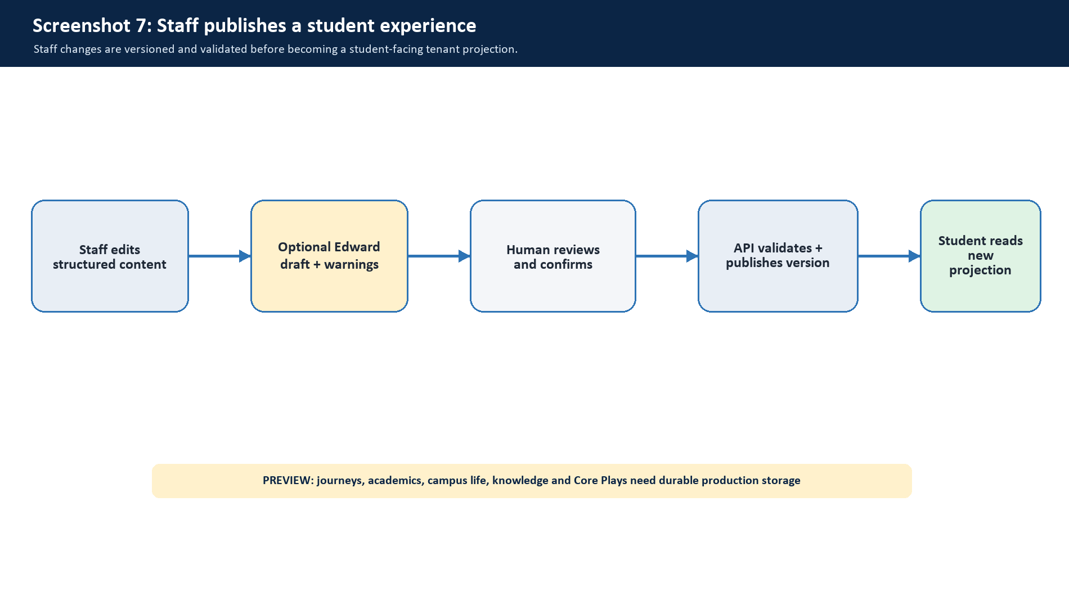
Sources: docs/23-student-staff-user-flows-and-contracts.md; docs/24-staff-portal-implementation-and-operations.md
A consequential command changes domain state, audit history, and the outbox in one transaction.
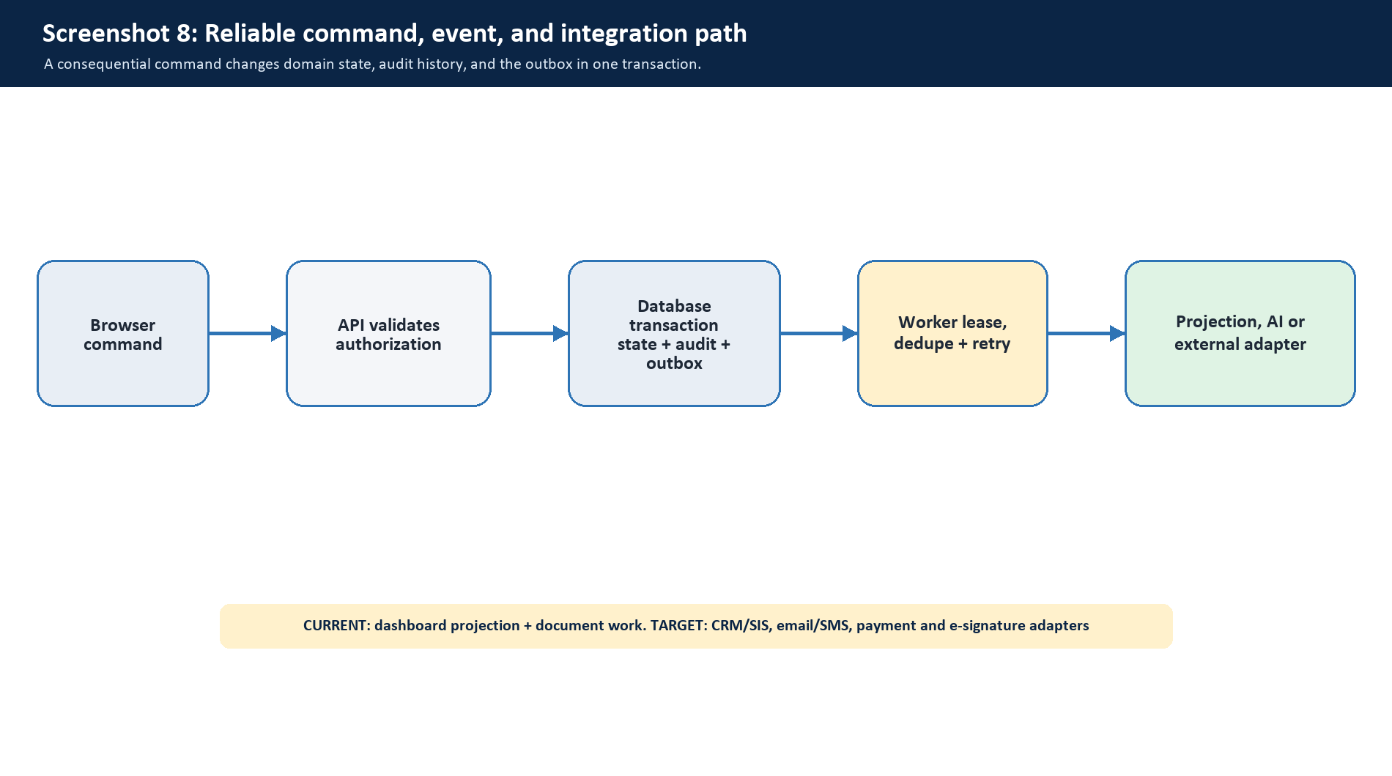
Sources: docs/01-system-architecture.md; docs/07-integrations-and-dummy-to-real.md; apps/worker/README.md
Higher-level views reuse governed student and staff records; they do not invent parallel sources of truth.
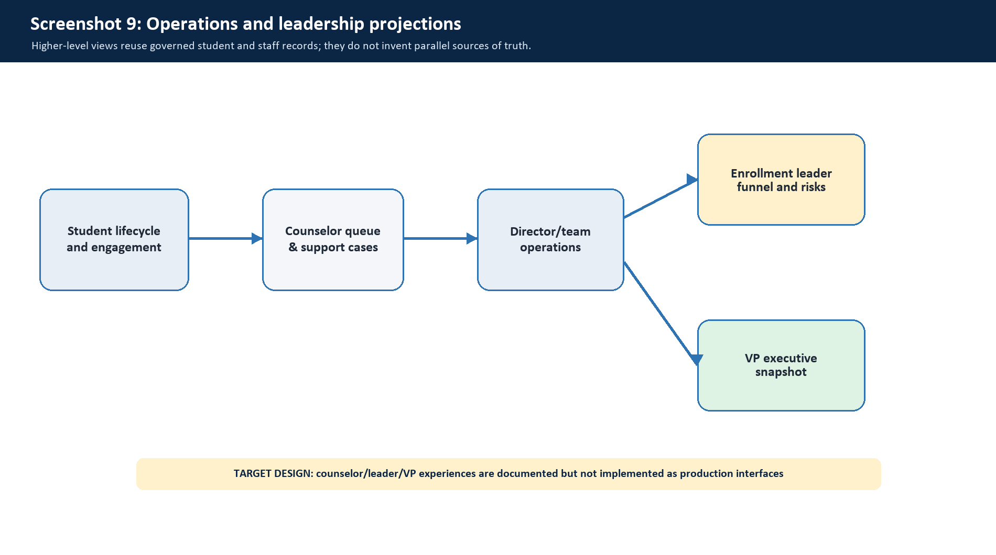
Sources: docs/06-staff-leader-vp-flows.md

