VV EDGENT
User-flow sequence diagrams
A visual onboarding reference for the student, staff, platform and leadership journeys
33 diagrams | 57 cataloged flows | 1 diagram per following page
Each sequence diagram makes the user action, front end, API, data store, async worker and staff touchpoint explicit. The coverage tags connect the diagrams to the existing 57-flow inventory.
Designed for on-screen review; zoom in when tracing individual request steps.
Diagram directory
Use the coverage IDs to cross-reference the flow catalog. Diagrams are ordered by student, staff, platform and leadership scope.
# | Journey | Sequence diagram | Coverage
01 | Student | Student sign-up, session and bootstrap routing | S01
02 | Student | Resumable, ordered onboarding | S02
03 | Student | Admission offer acceptance and journey creation | S03
04 | Student | Dashboard and next-best-action projection | S04
05 | Student | Requirement applicability, readiness and dependencies | S05
06 | Student | Profile save with optimistic concurrency | S06
07 | Student | Housing plan and roommate preferences | S07
08 | Student | Family permissions and FERPA delegation | S08
09 | Student | Onboarding signature and immutable document packets | S09
10 | Student | Document upload, parsing, staff review and student refresh | S10-S12
11 | Student | Transcript course and exemption recommendation | S13
12 | Student | Financial-aid and immunization document lanes | S14
13 | Student | Deposit and financial payment-plan selection | S15-S16
14 | Student | Student messages, unread count and read receipt | S17
15 | Student | Appointment scheduling and help request | S18-S19
16 | Student | Academics, campus life and tenant rewards | S20-S22
17 | Student | Edward student assistance and safe action widgets | S23
18 | Student | Session, retry and server-state recovery | S24
19 | Staff | Staff sign-in and tenant workspace entry | T01
20 | Staff | Staff Action Center and shared task-board coordination | T02-T03
21 | Staff | Staff student inspector and permitted preference update | T04
22 | Staff | Staff document decision and student notification | T05
23 | Staff | Staff inquiry assignment, reply and resolution | T06
24 | Staff | Staff configuration drafting, review and publication | T07-T08
25 | Staff | Staff campus content, knowledge and Core Plays | T09-T11
26 | Staff | Freshness, polling and future SSE invalidation | T12
27 | Platform | Authenticated, tenant-scoped API request lifecycle | A01, A13
28 | Platform | Domain command, audit, outbox and worker delivery | A02-A04
29 | Platform | Activity tracking and runtime lineage | A05-A06
30 | Platform | Controlled AI: explicit question, event candidate and scheduled outreach | A07-A09
31 | Platform | Inbound sync, outbound integration and verified webhook | A10-A12
32 | Platform | CI, test and hardened preview deployment | A14
33 | Leadership | Counselor, director, leader and VP projections | L01-L07
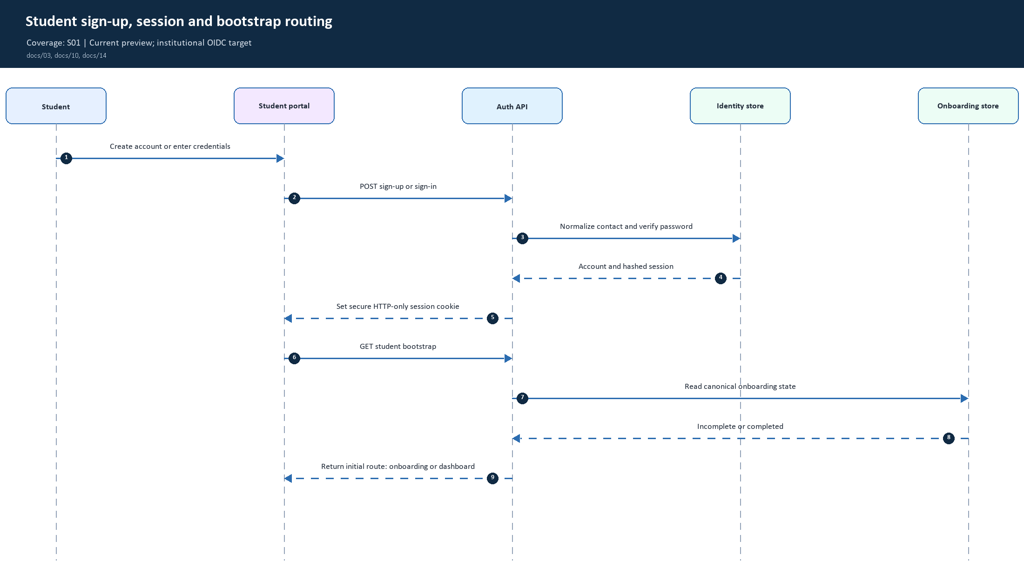
01. Student sign-up, session and bootstrap routing | Coverage: S01
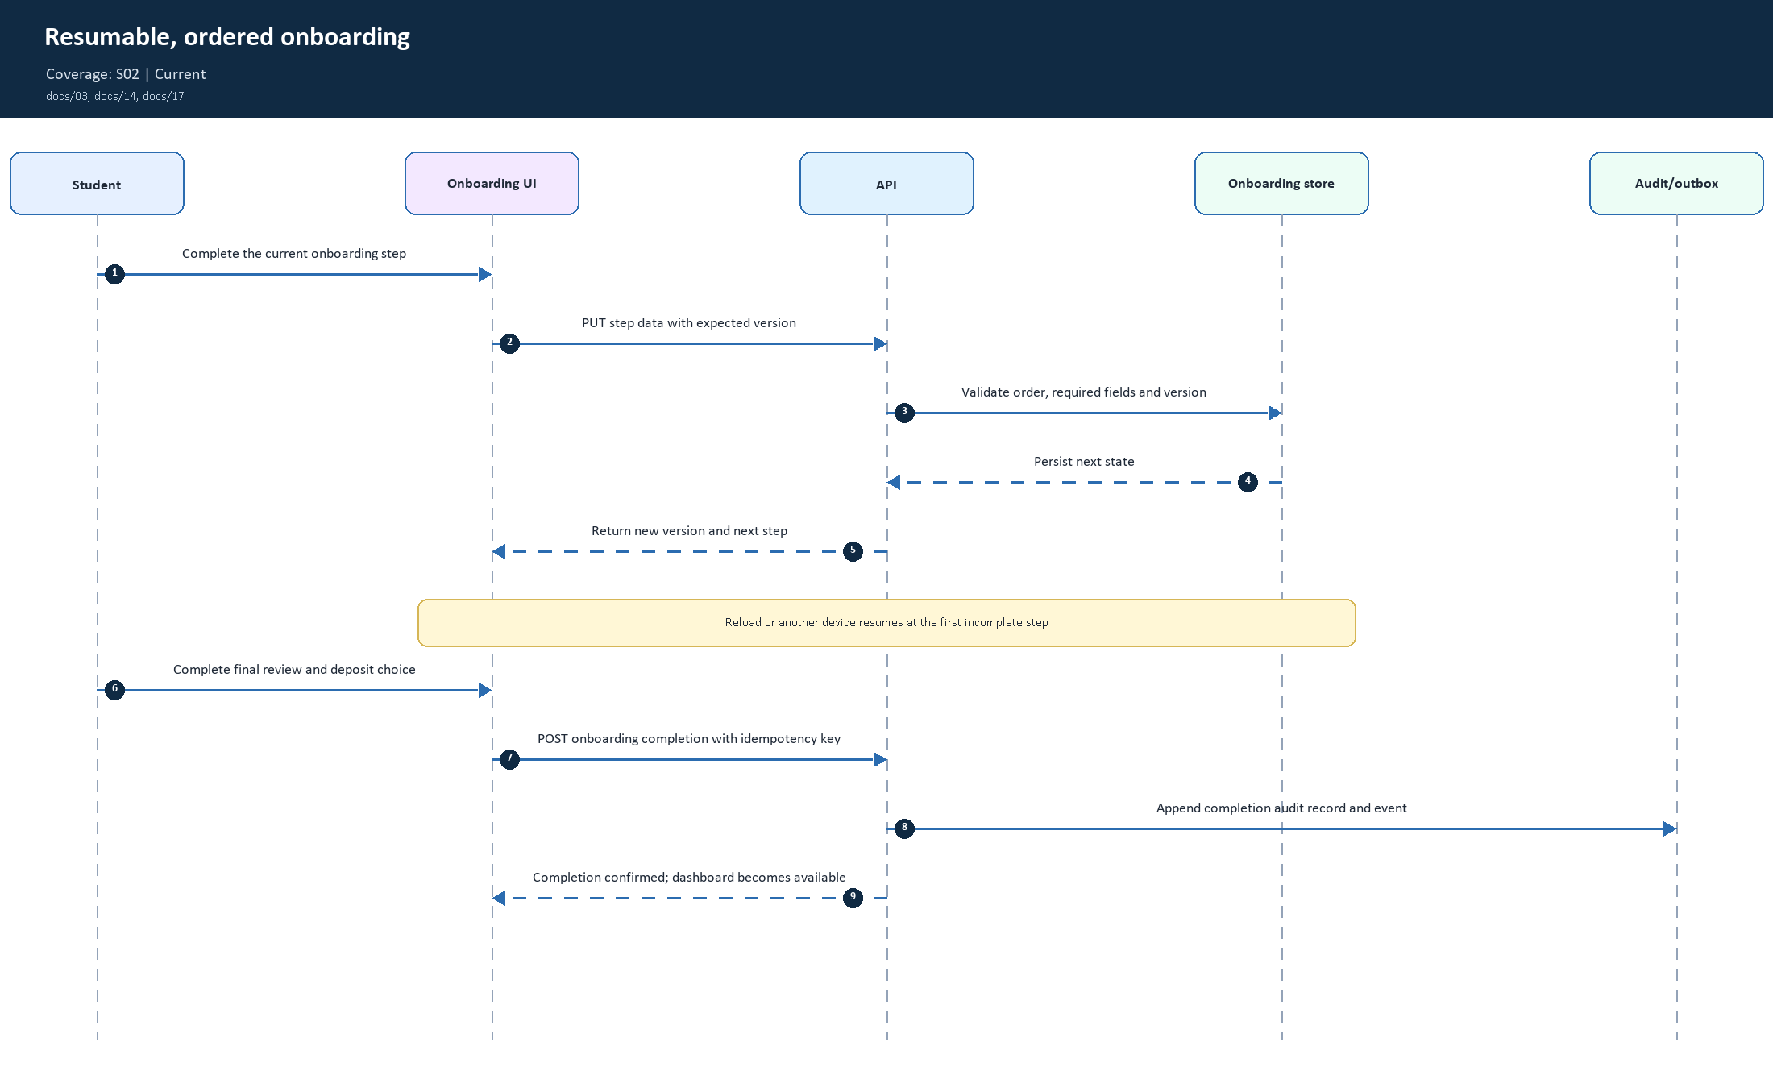
02. Resumable, ordered onboarding | Coverage: S02
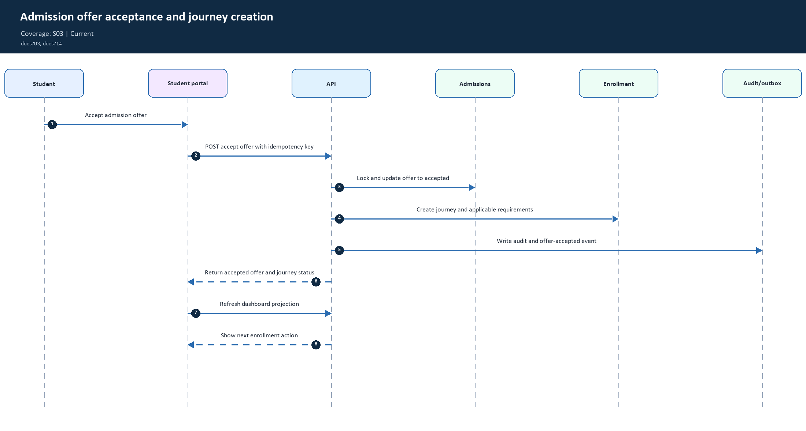
03. Admission offer acceptance and journey creation | Coverage: S03
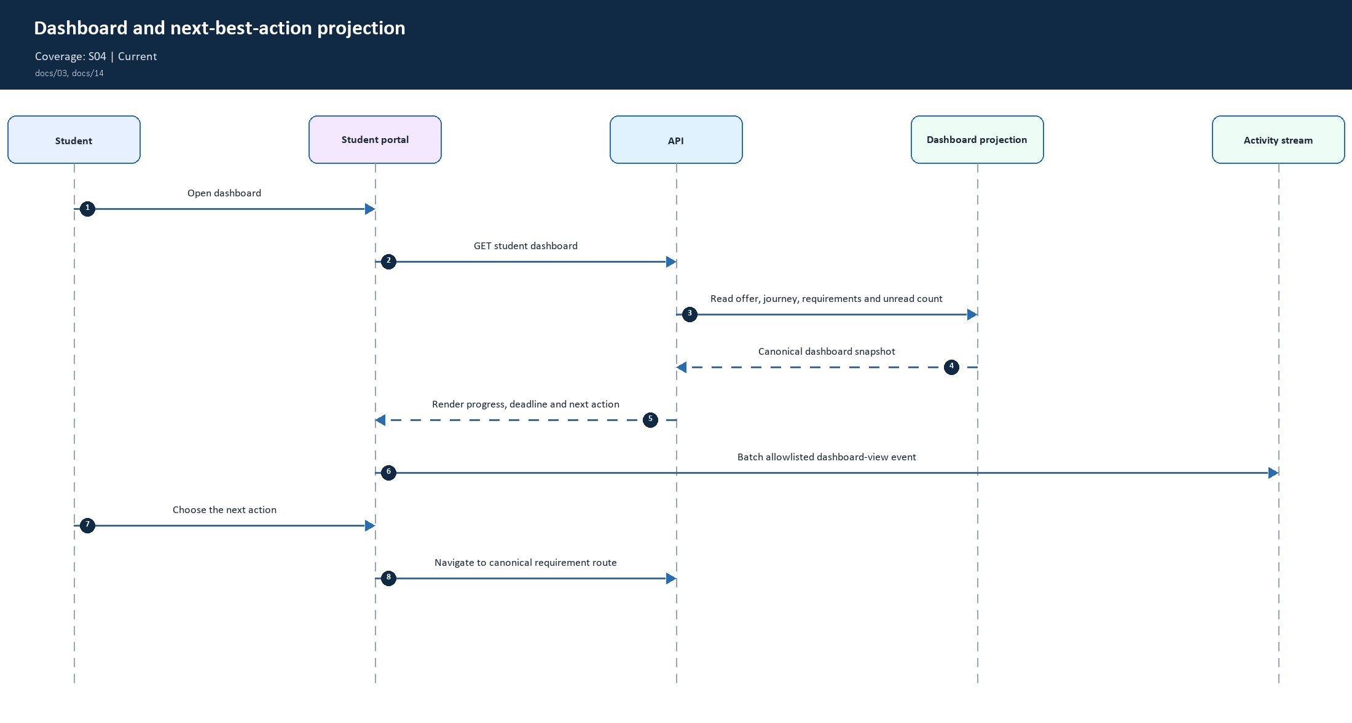
04. Dashboard and next-best-action projection | Coverage: S04
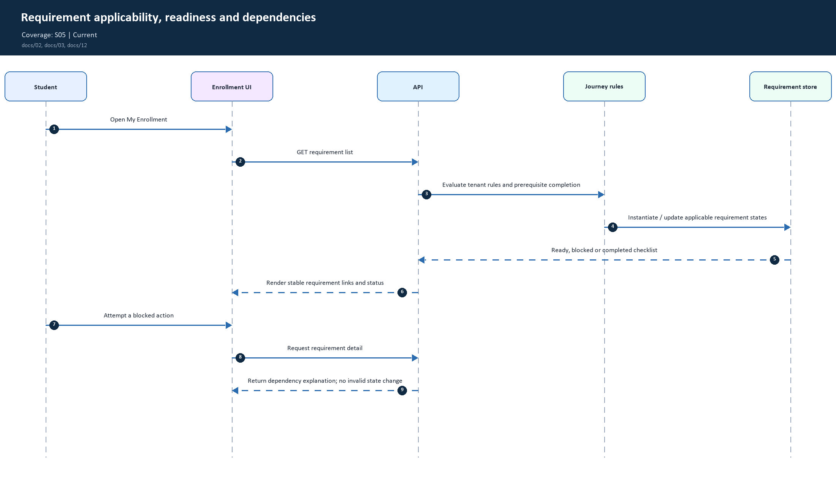
05. Requirement applicability, readiness and dependencies | Coverage: S05
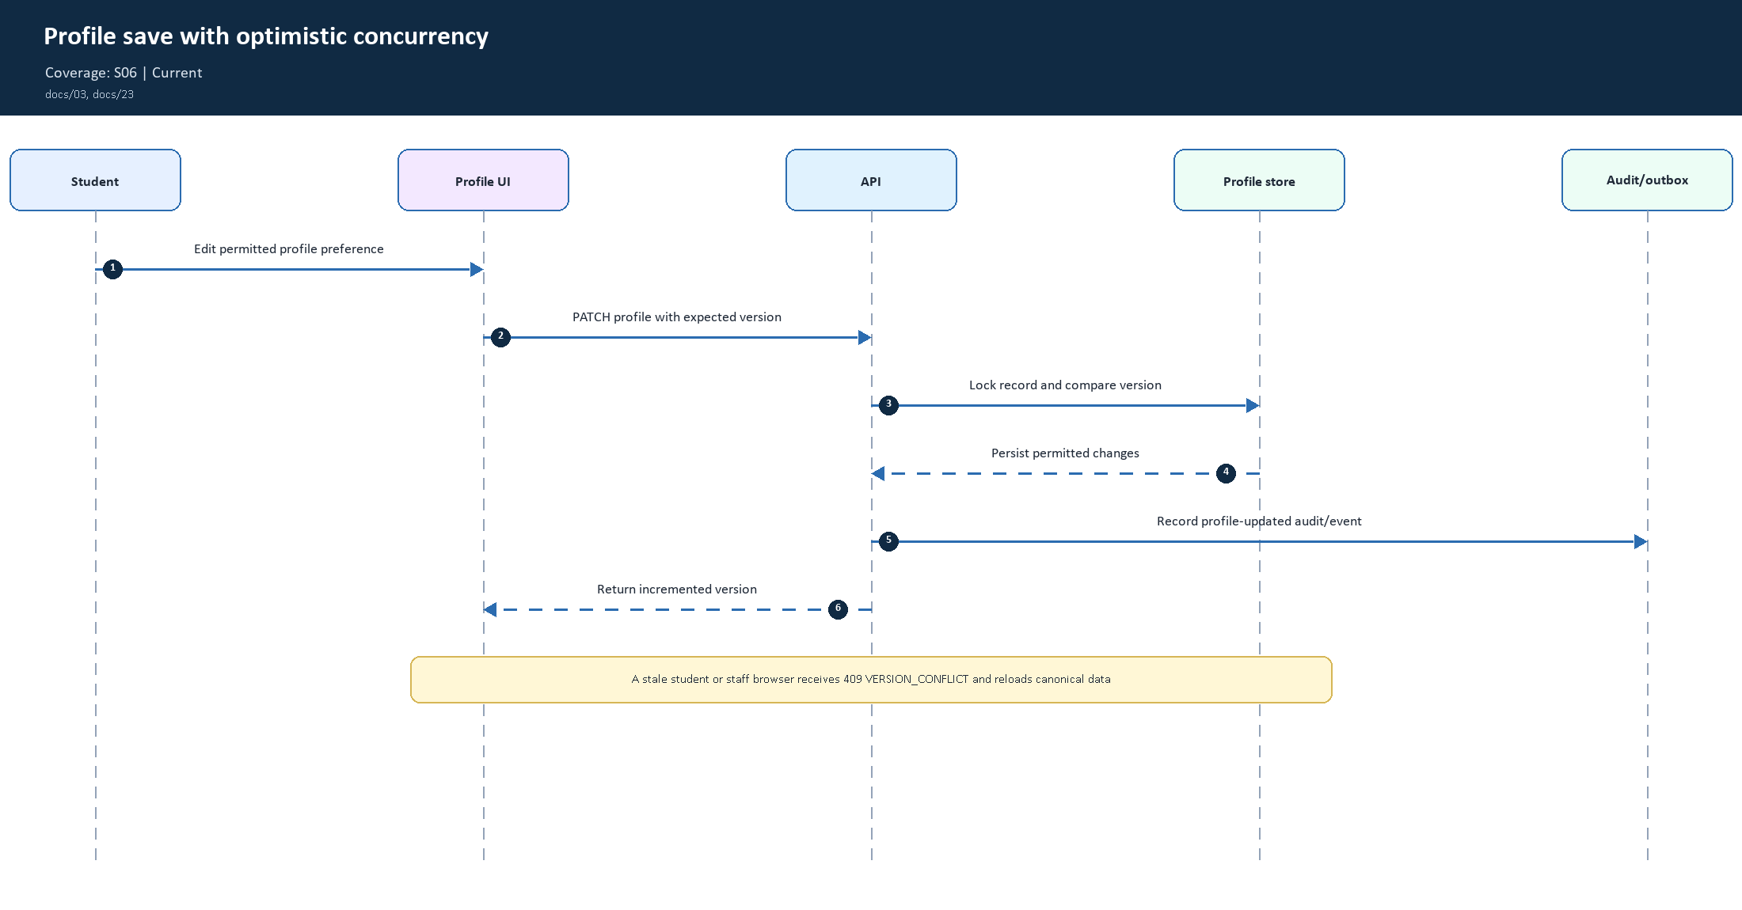
06. Profile save with optimistic concurrency | Coverage: S06
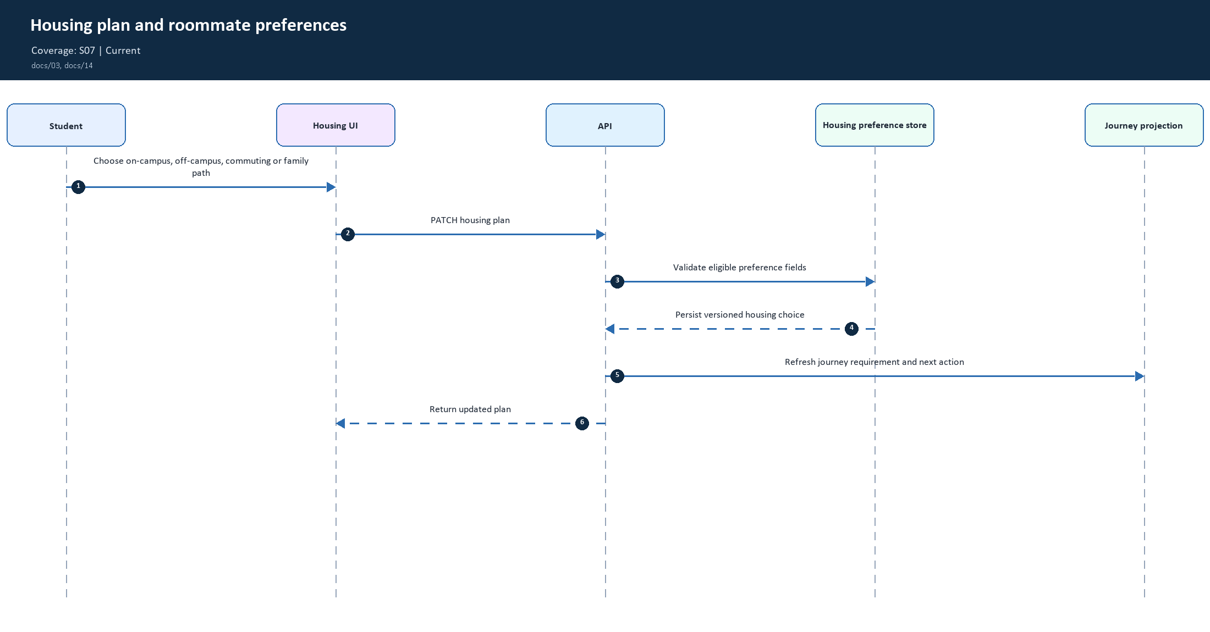
07. Housing plan and roommate preferences | Coverage: S07
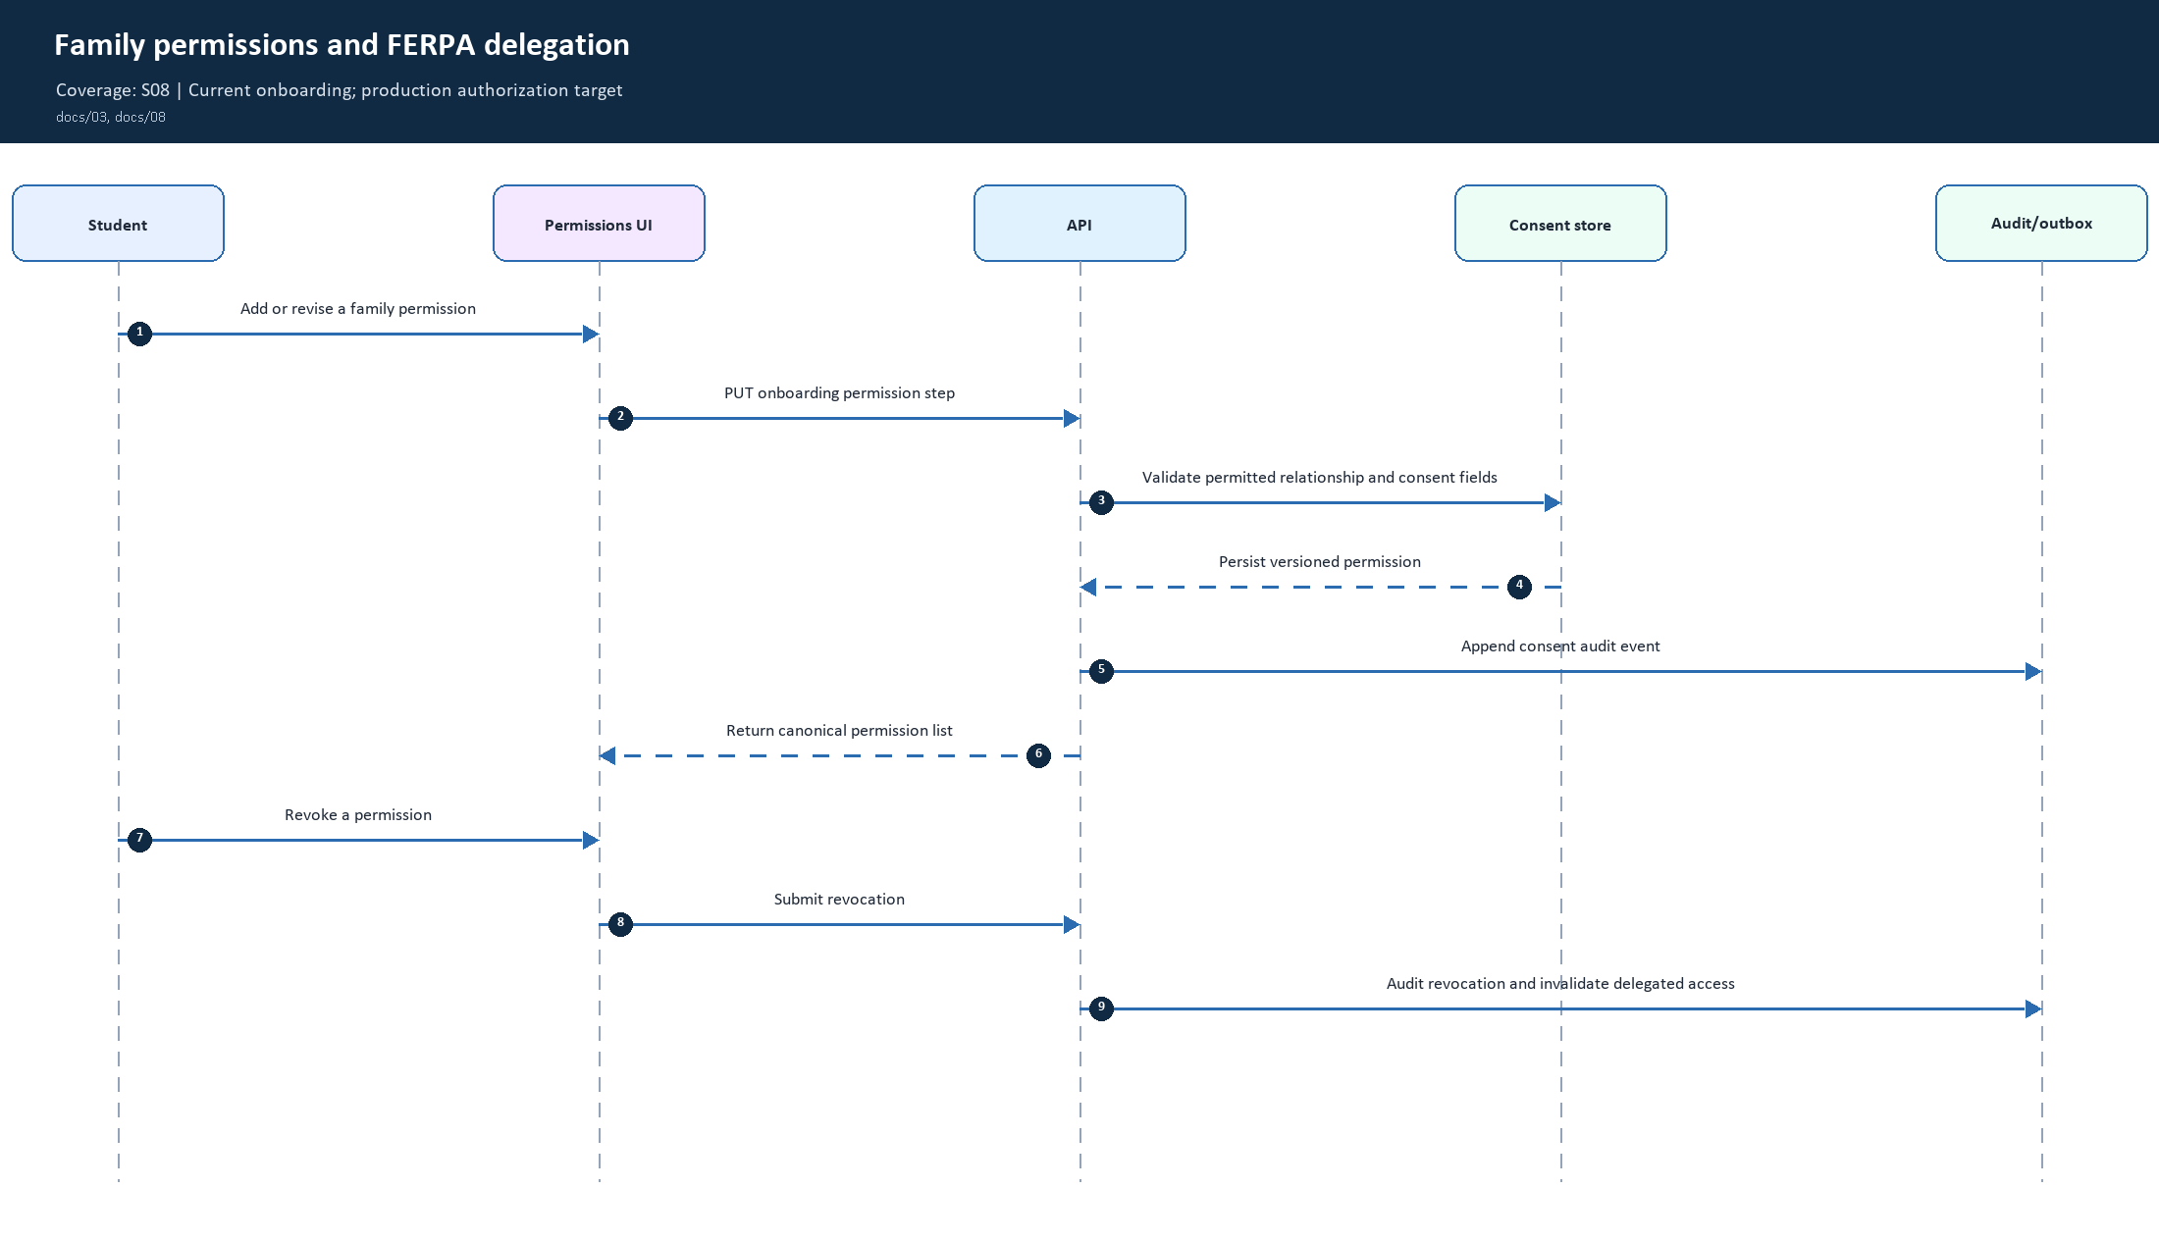
08. Family permissions and FERPA delegation | Coverage: S08
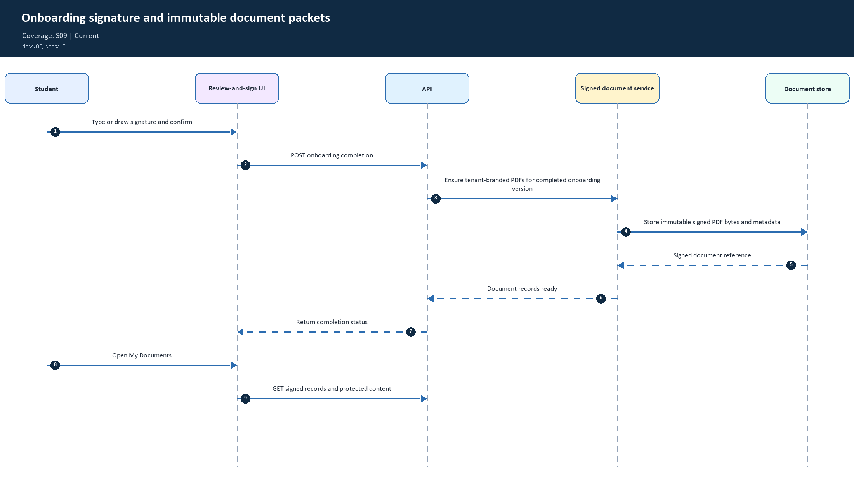
09. Onboarding signature and immutable document packets | Coverage: S09
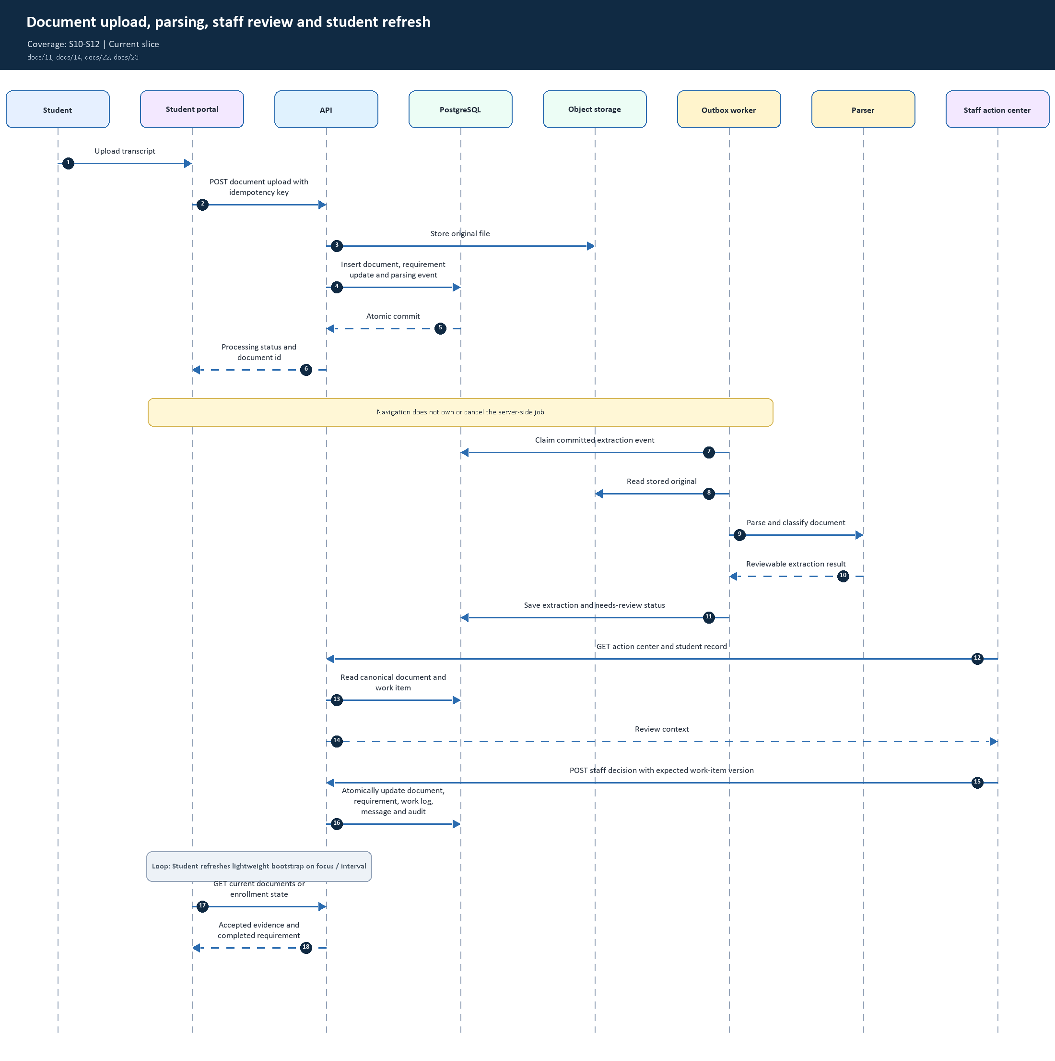
10. Document upload, parsing, staff review and student refresh | Coverage: S10-S12
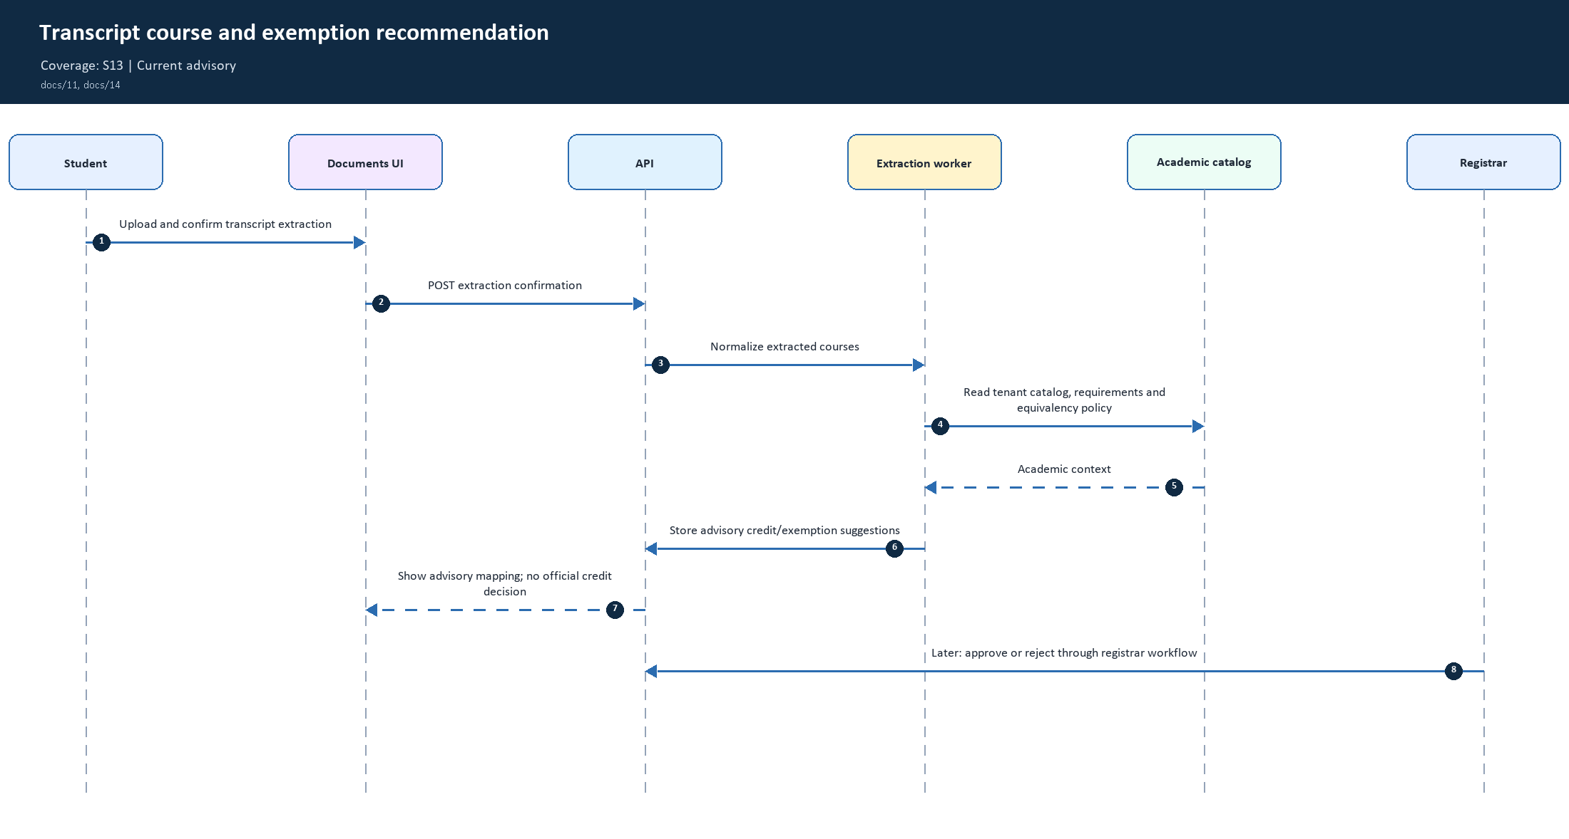
11. Transcript course and exemption recommendation | Coverage: S13
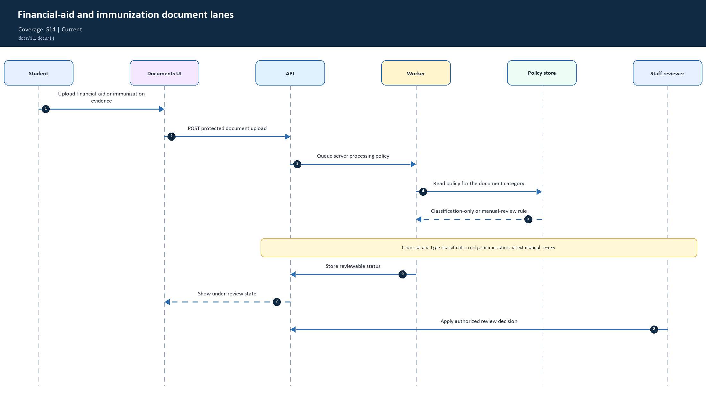
12. Financial-aid and immunization document lanes | Coverage: S14
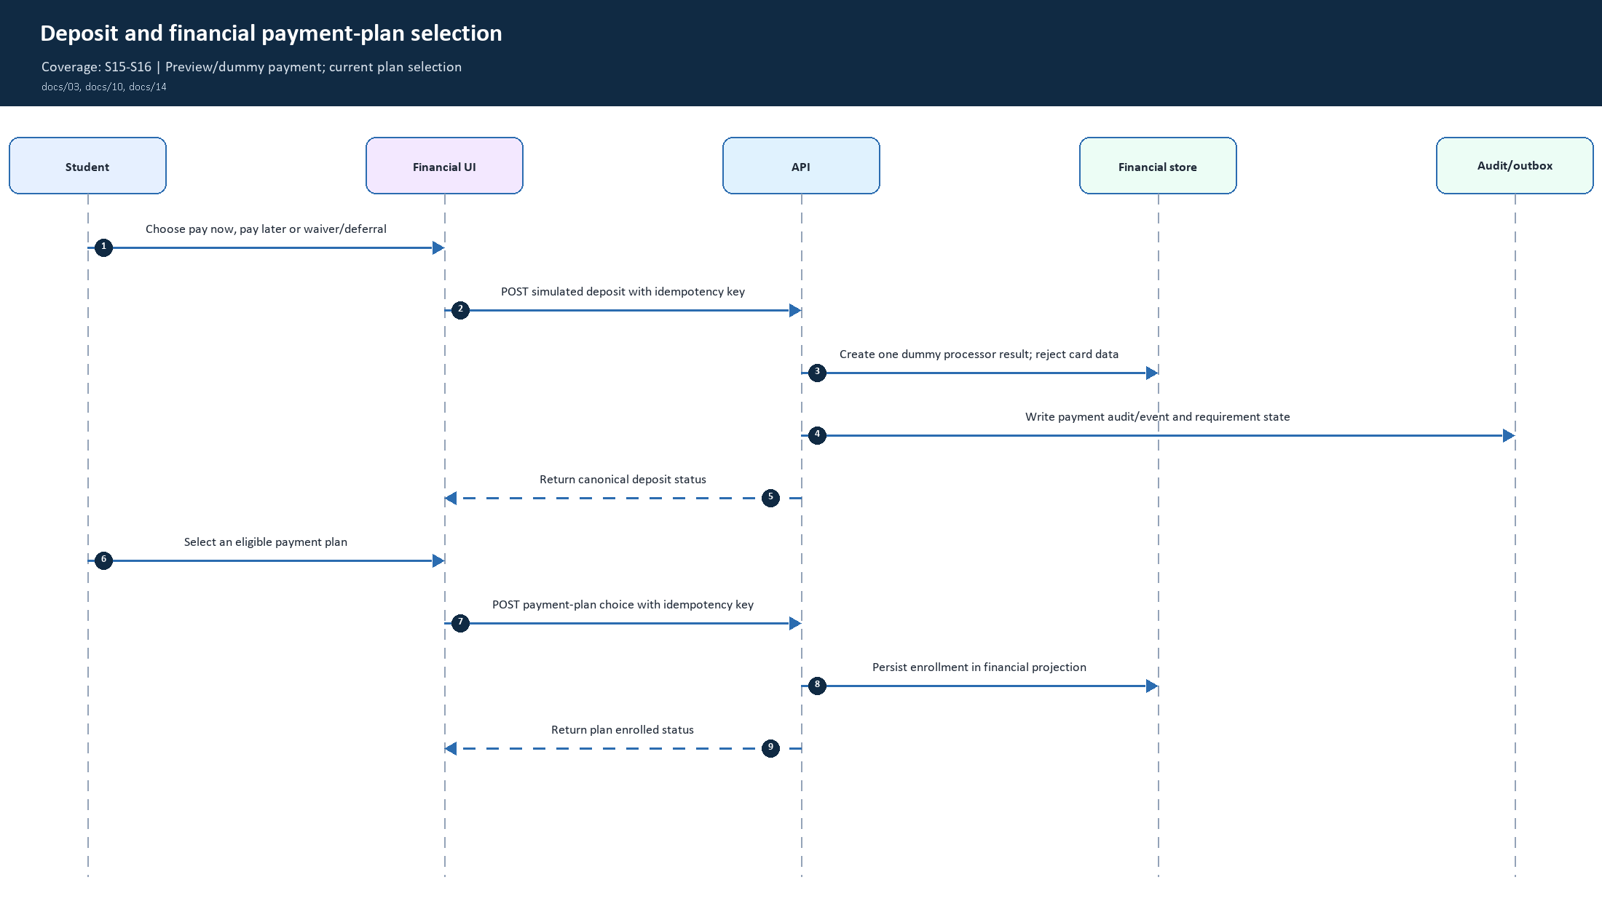
13. Deposit and financial payment-plan selection | Coverage: S15-S16
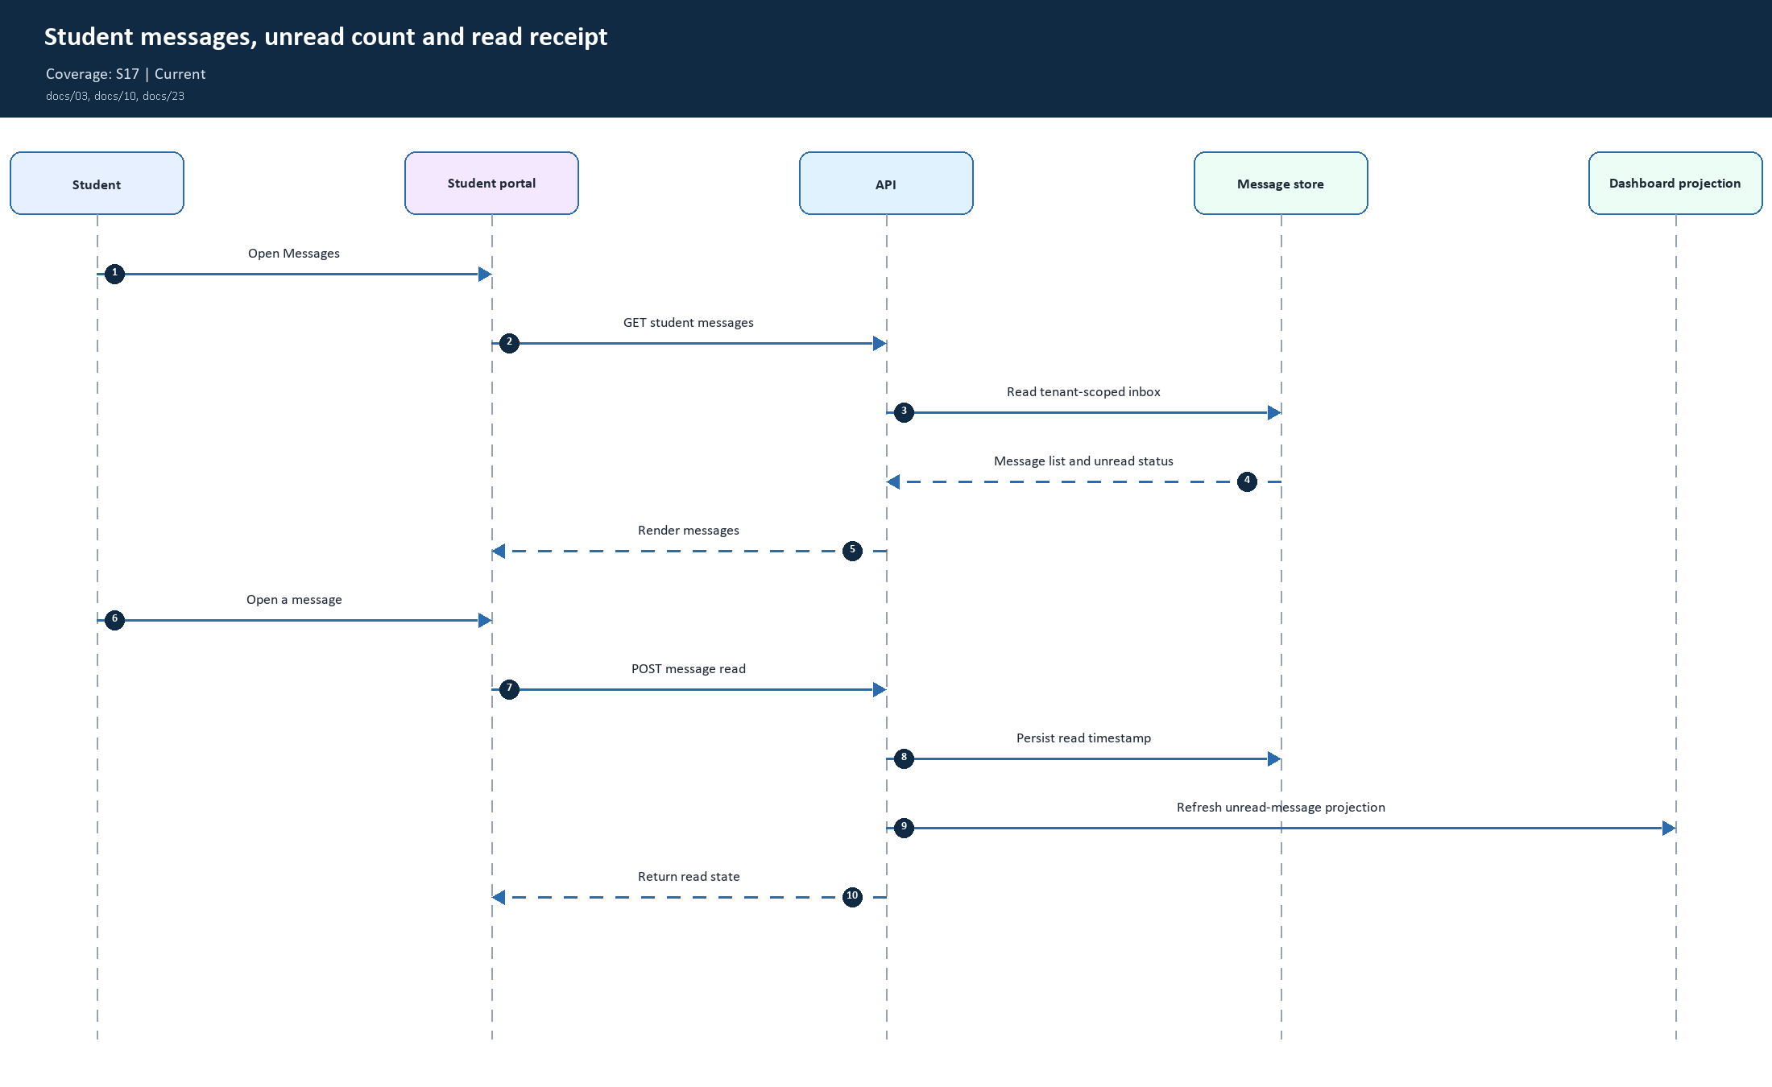
14. Student messages, unread count and read receipt | Coverage: S17
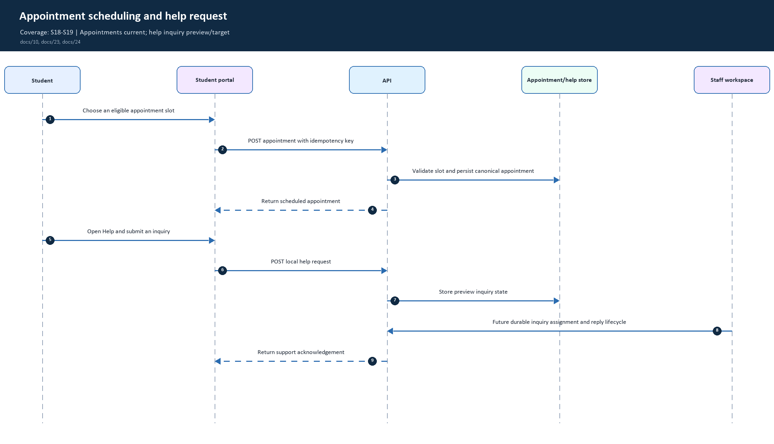
15. Appointment scheduling and help request | Coverage: S18-S19
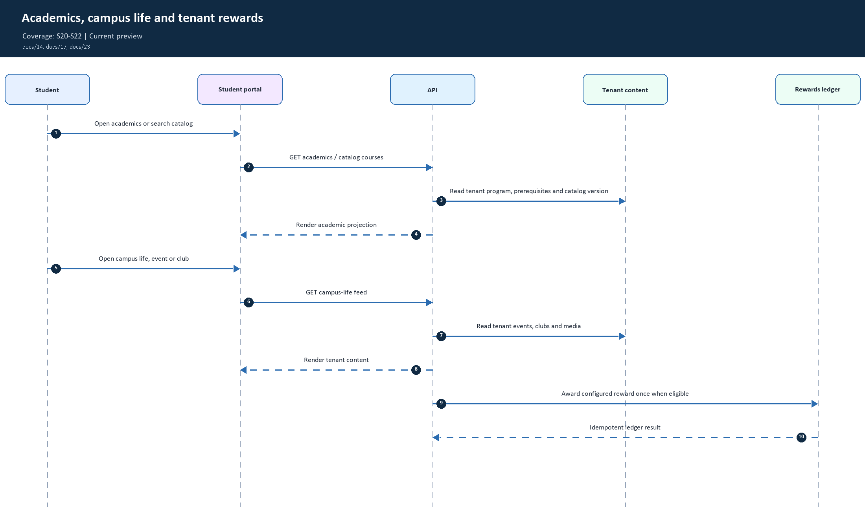
16. Academics, campus life and tenant rewards | Coverage: S20-S22
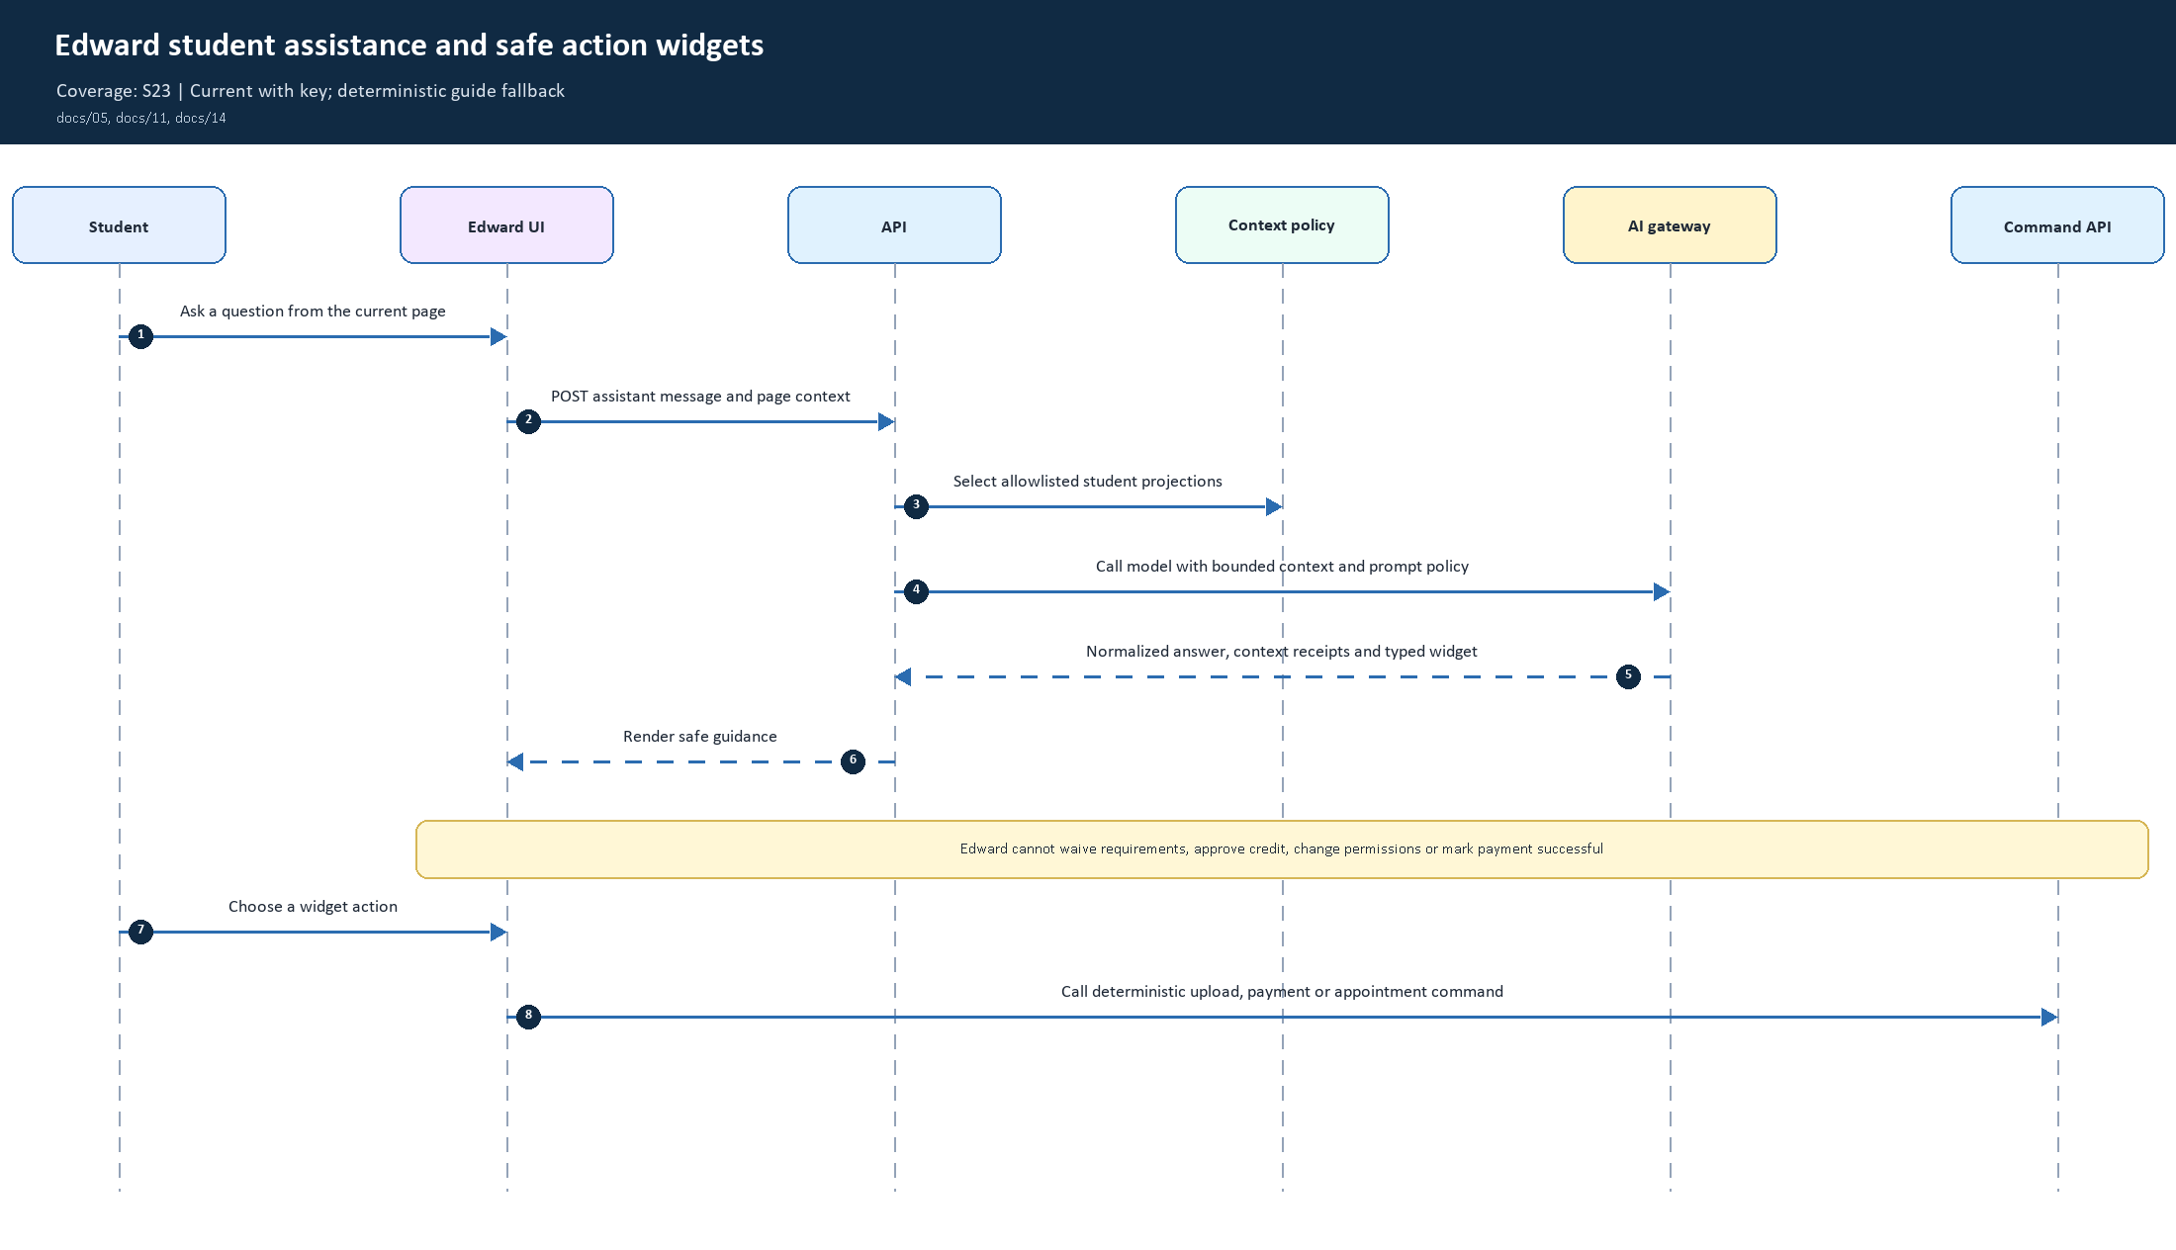
17. Edward student assistance and safe action widgets | Coverage: S23
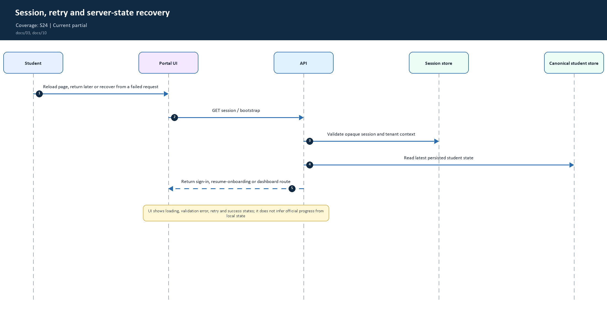
18. Session, retry and server-state recovery | Coverage: S24
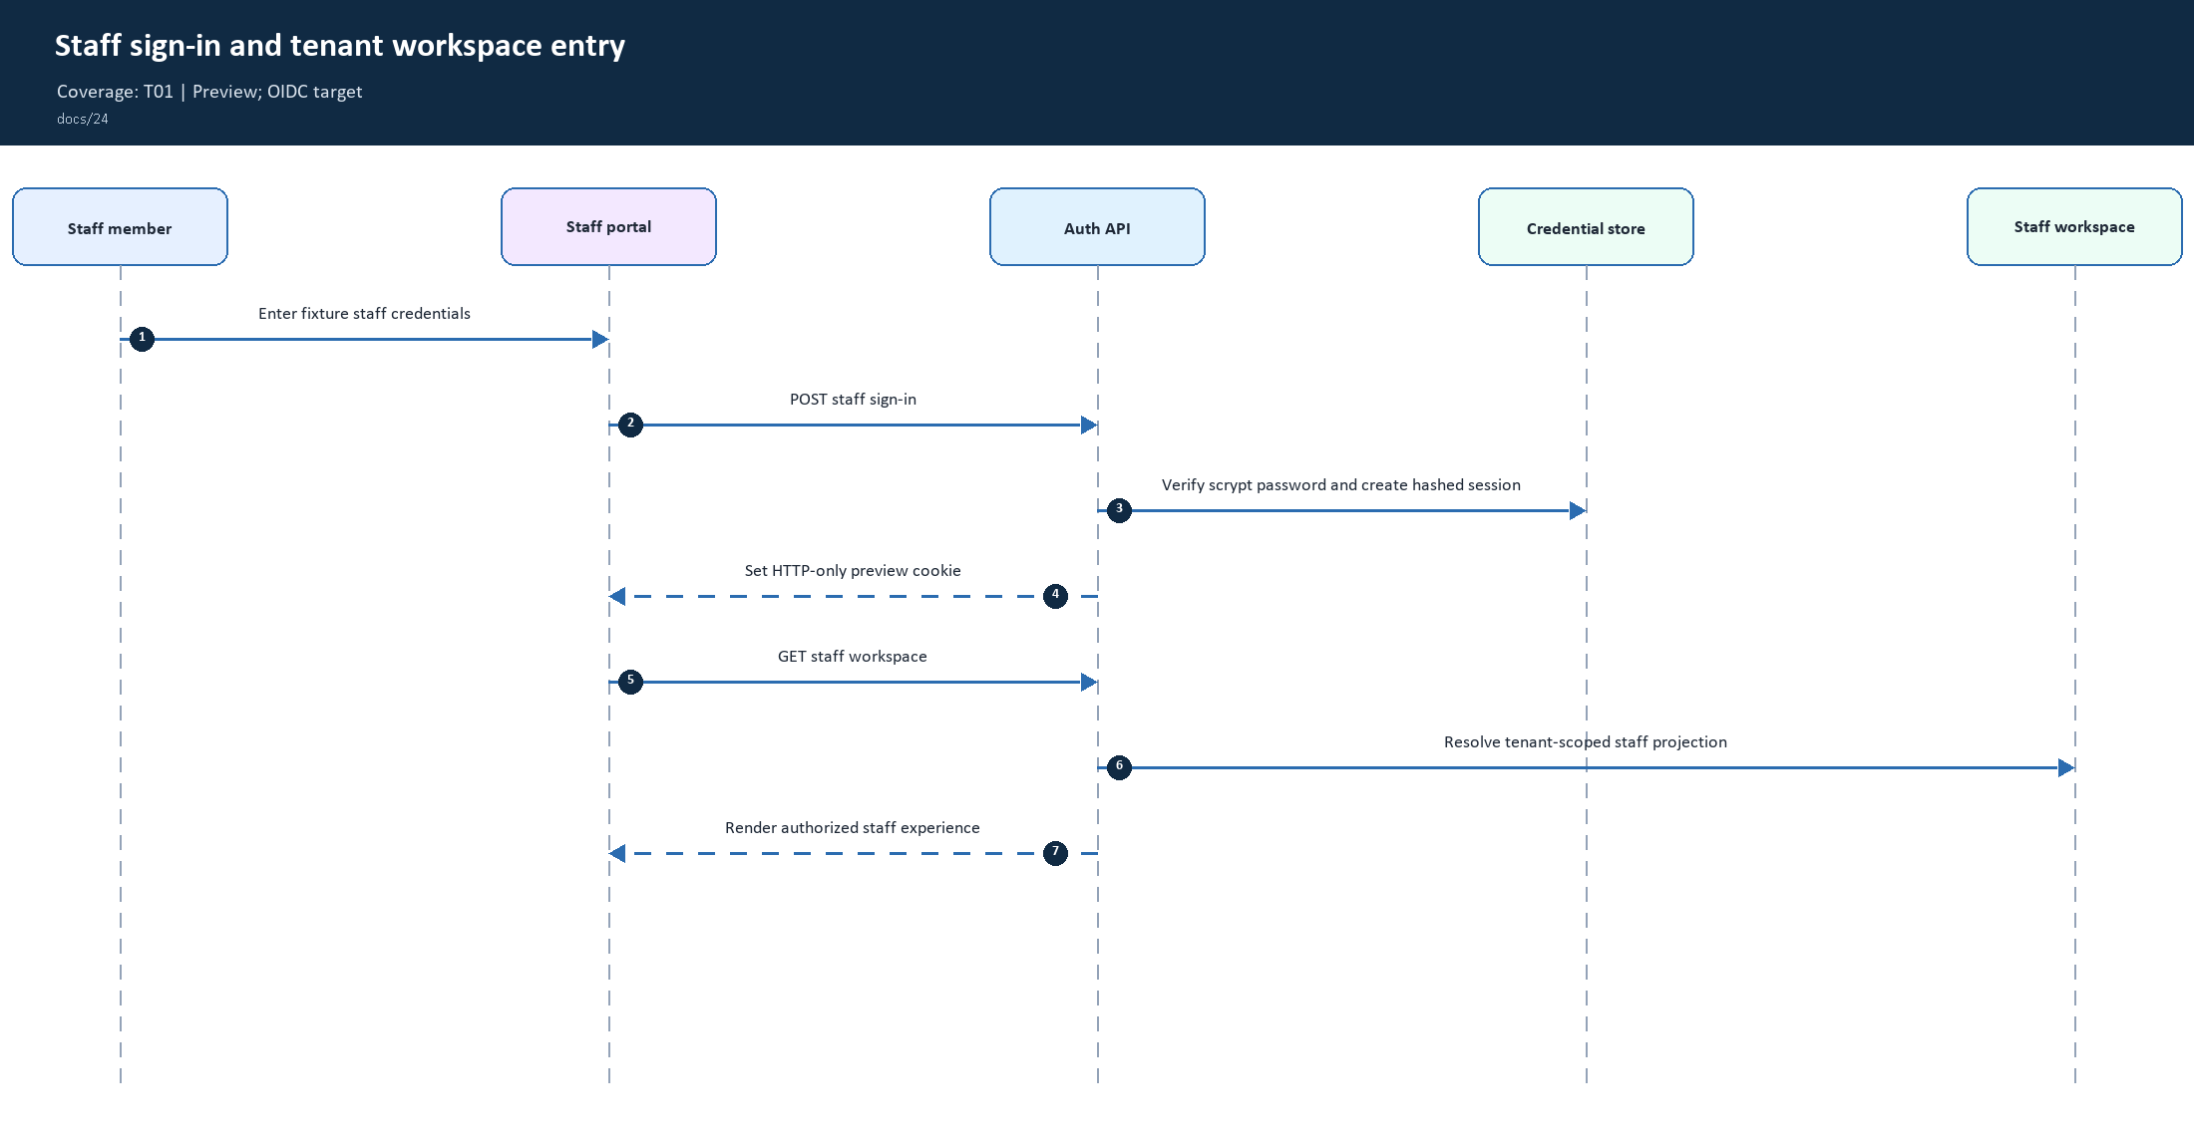
19. Staff sign-in and tenant workspace entry | Coverage: T01
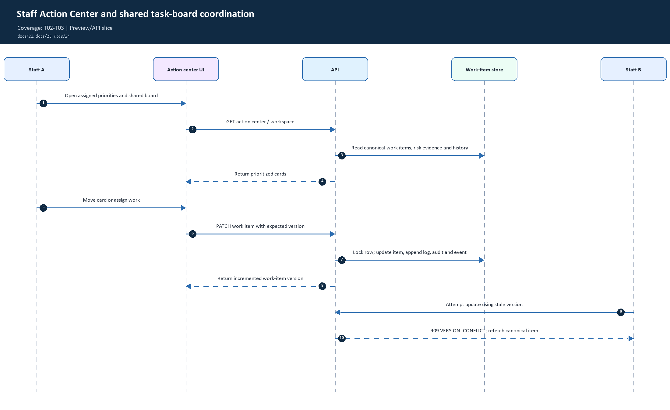
20. Staff Action Center and shared task-board coordination | Coverage: T02-T03
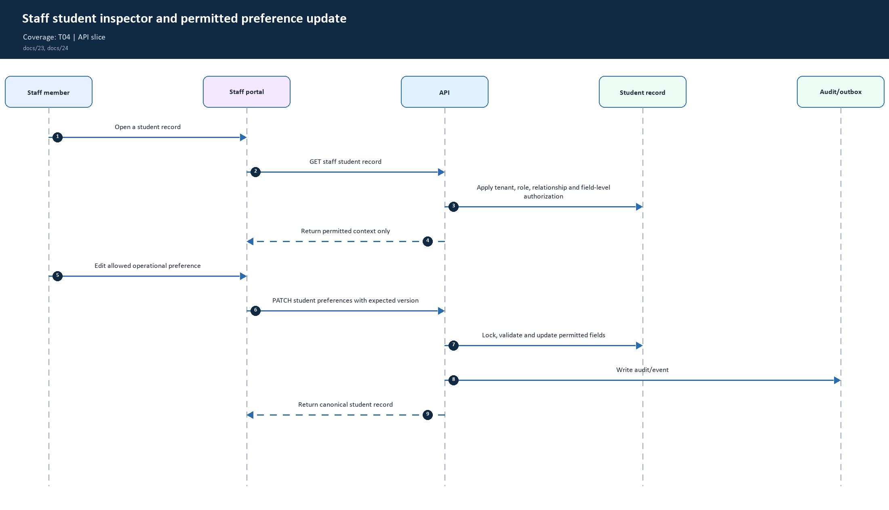
21. Staff student inspector and permitted preference update | Coverage: T04
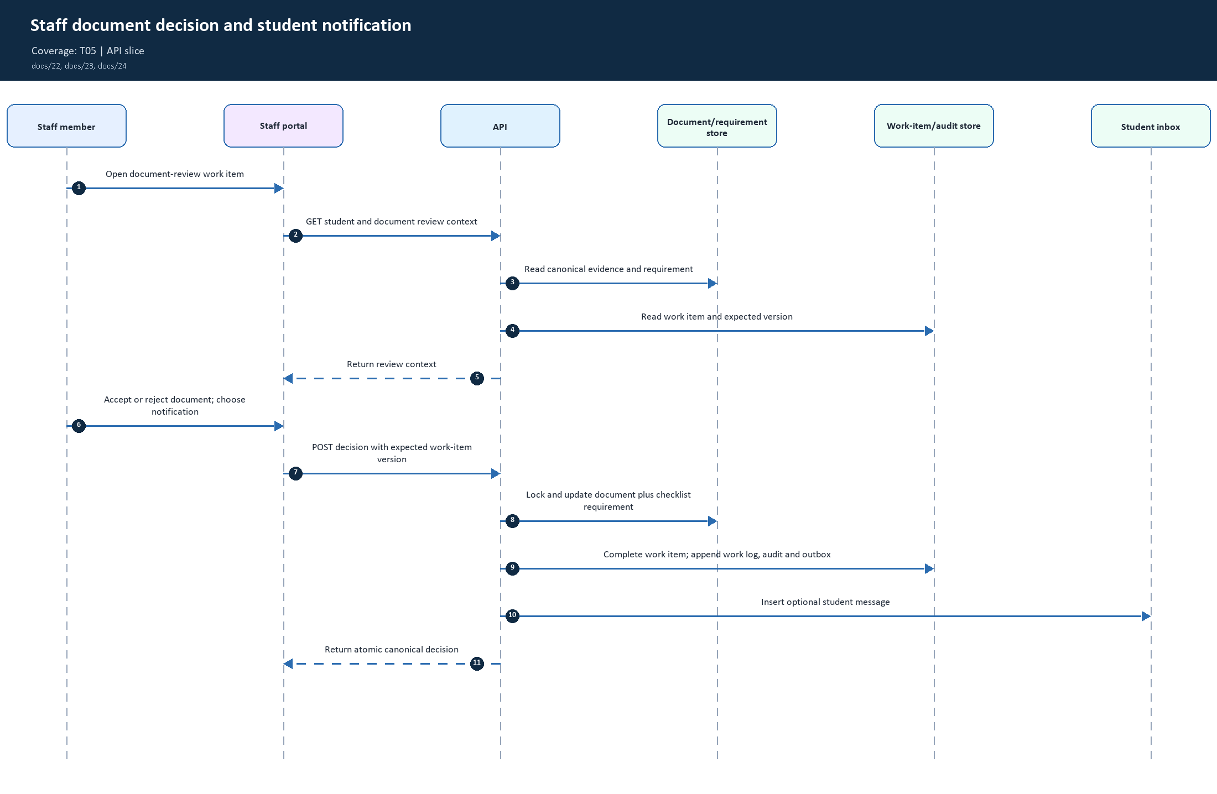
22. Staff document decision and student notification | Coverage: T05
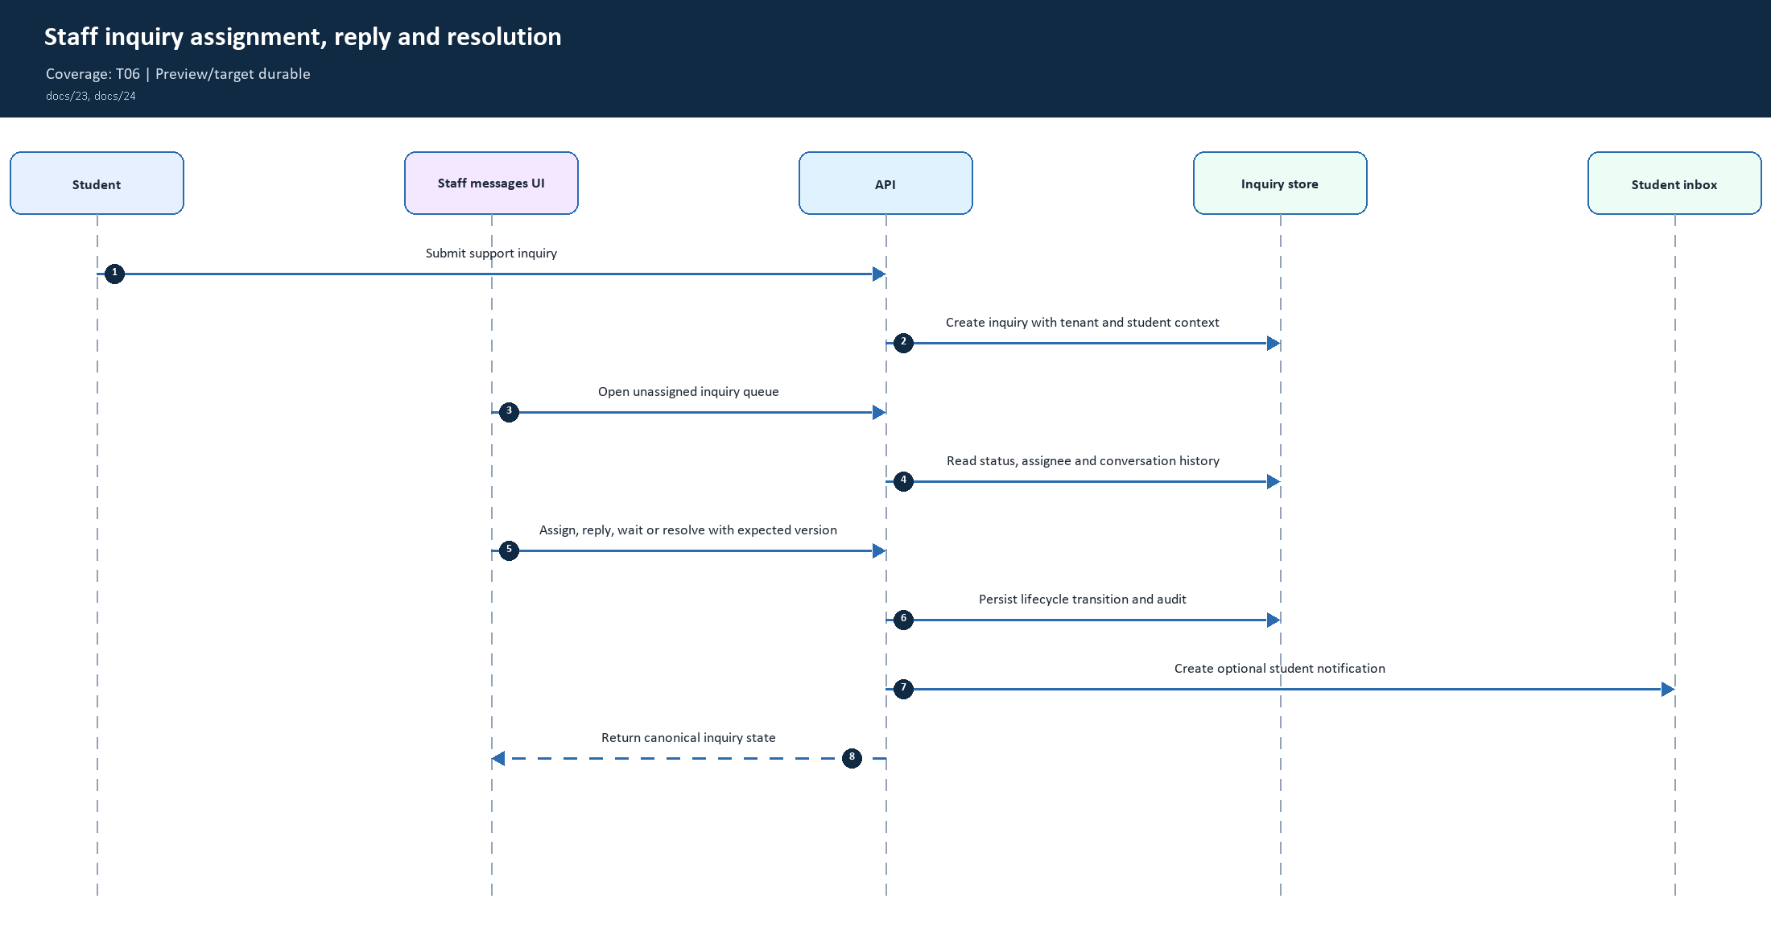
23. Staff inquiry assignment, reply and resolution | Coverage: T06
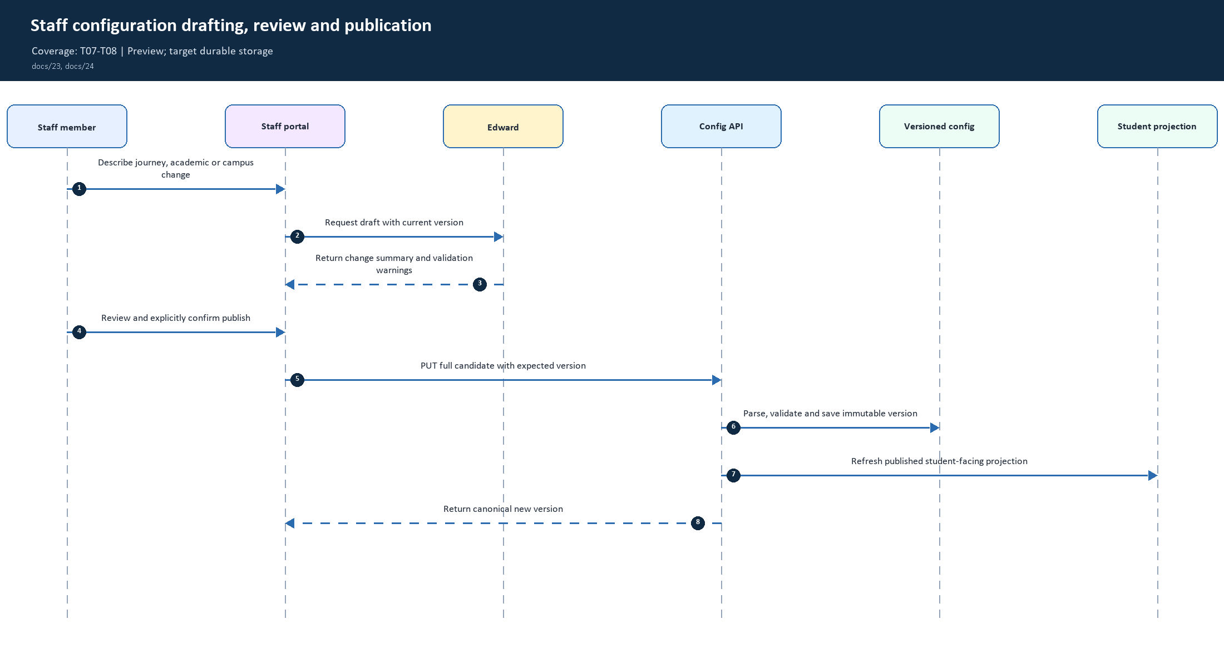
24. Staff configuration drafting, review and publication | Coverage: T07-T08
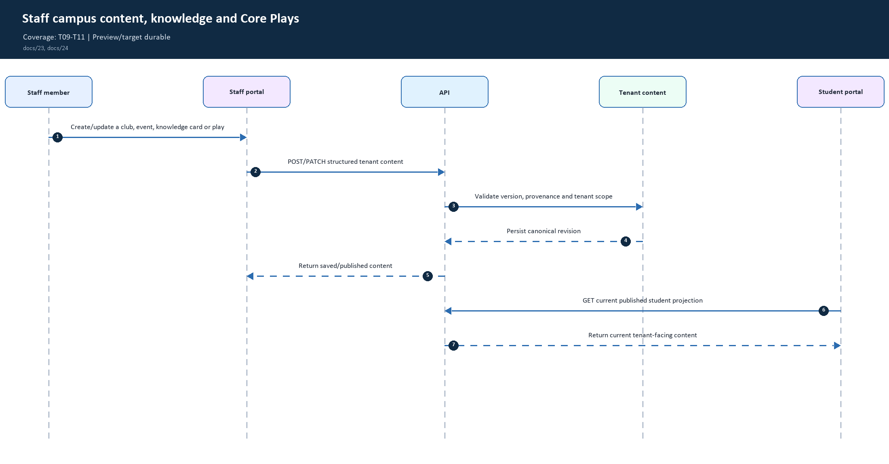
25. Staff campus content, knowledge and Core Plays | Coverage: T09-T11
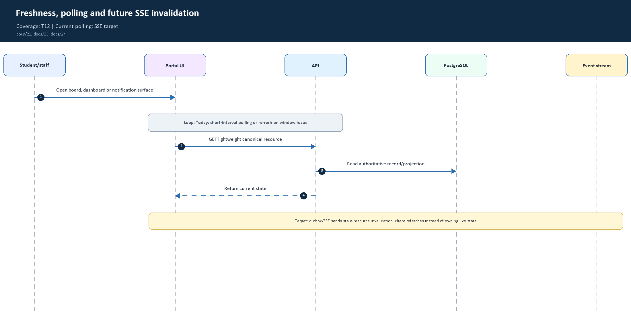
26. Freshness, polling and future SSE invalidation | Coverage: T12
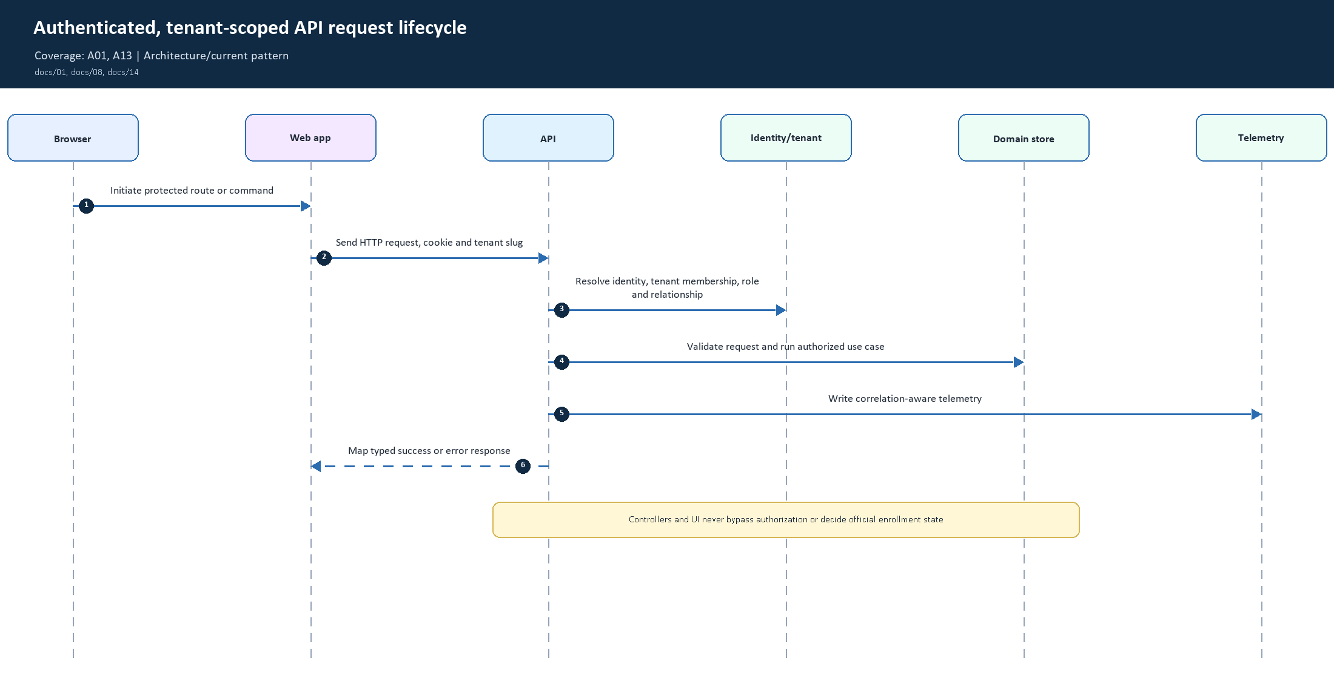
27. Authenticated, tenant-scoped API request lifecycle | Coverage: A01, A13
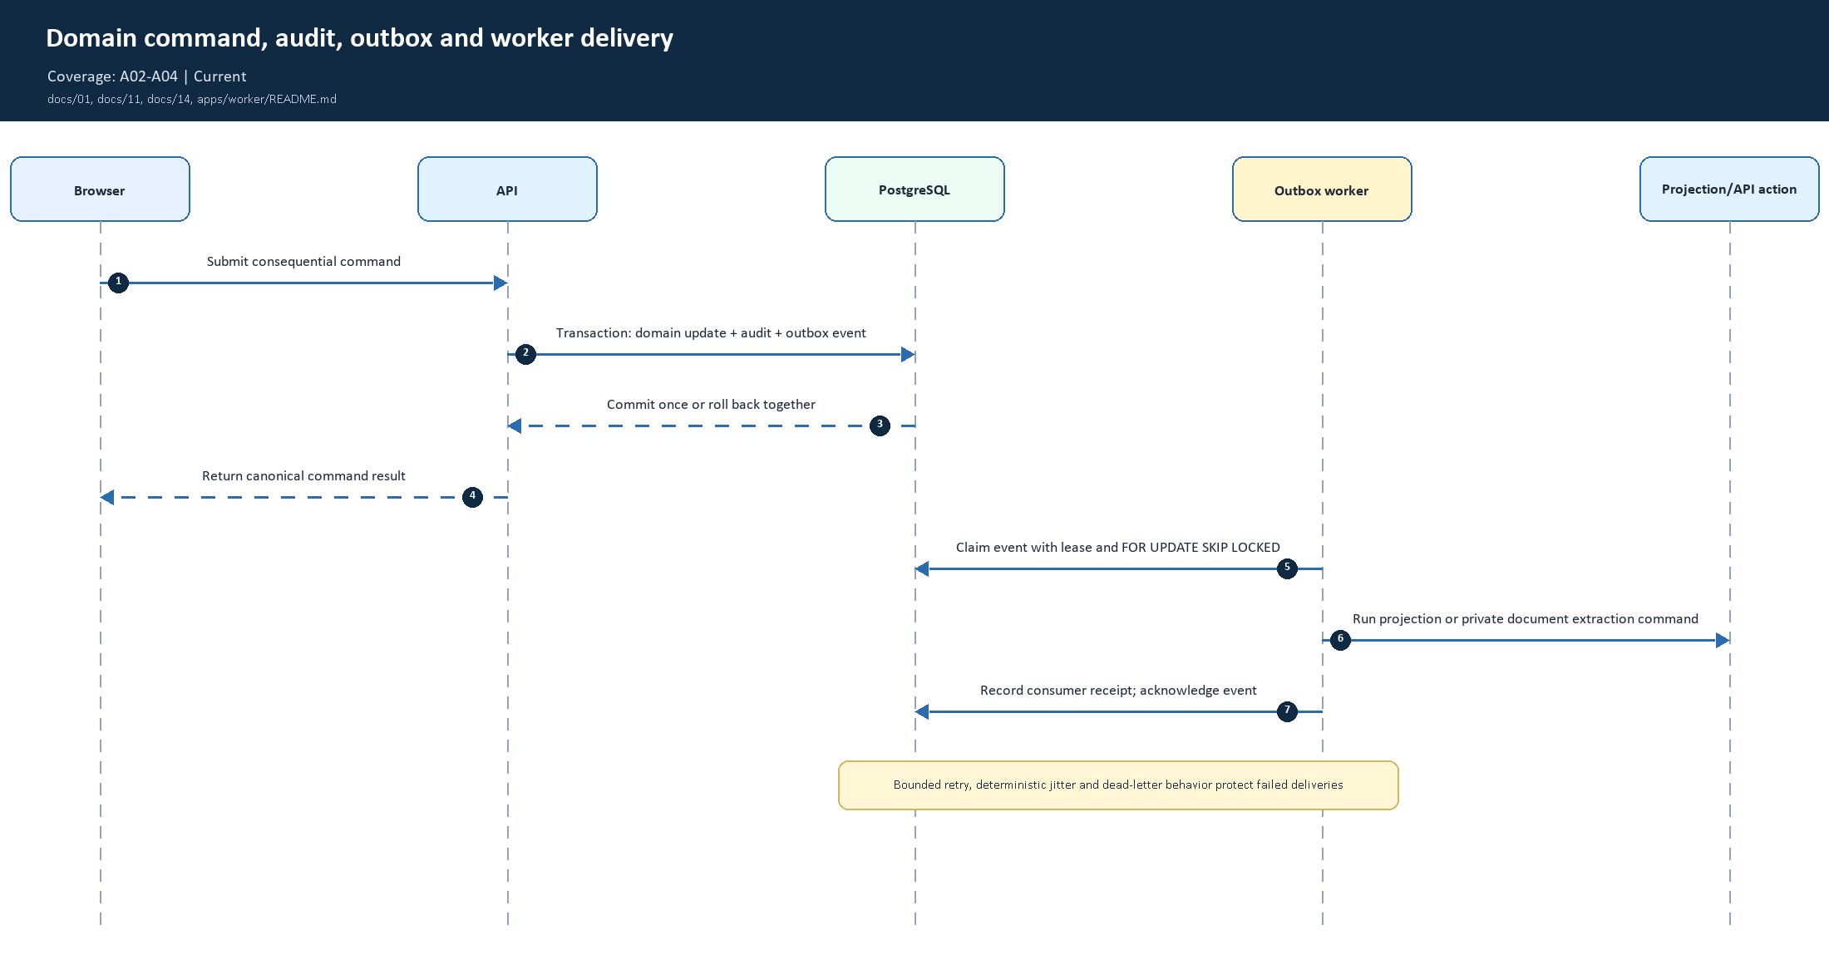
28. Domain command, audit, outbox and worker delivery | Coverage: A02-A04
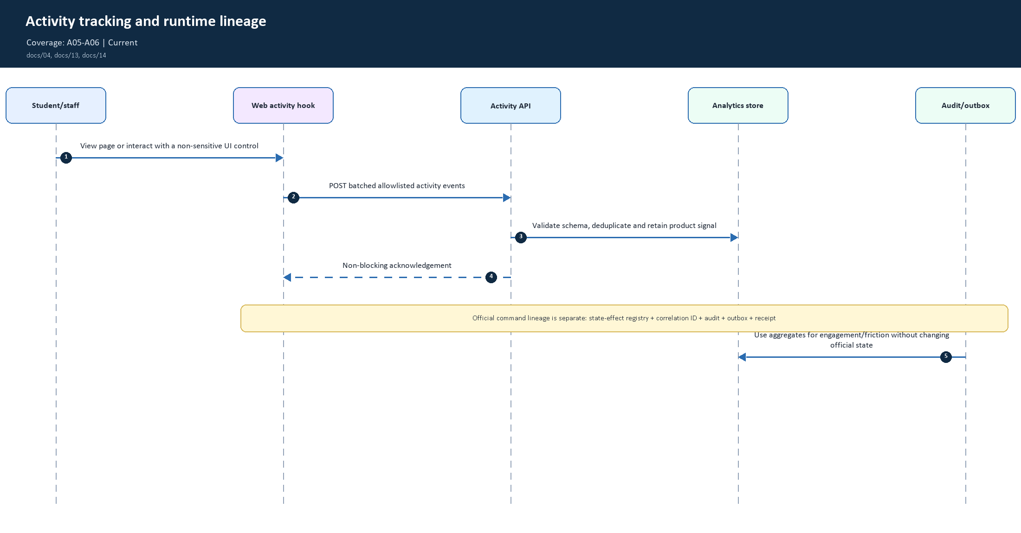
29. Activity tracking and runtime lineage | Coverage: A05-A06
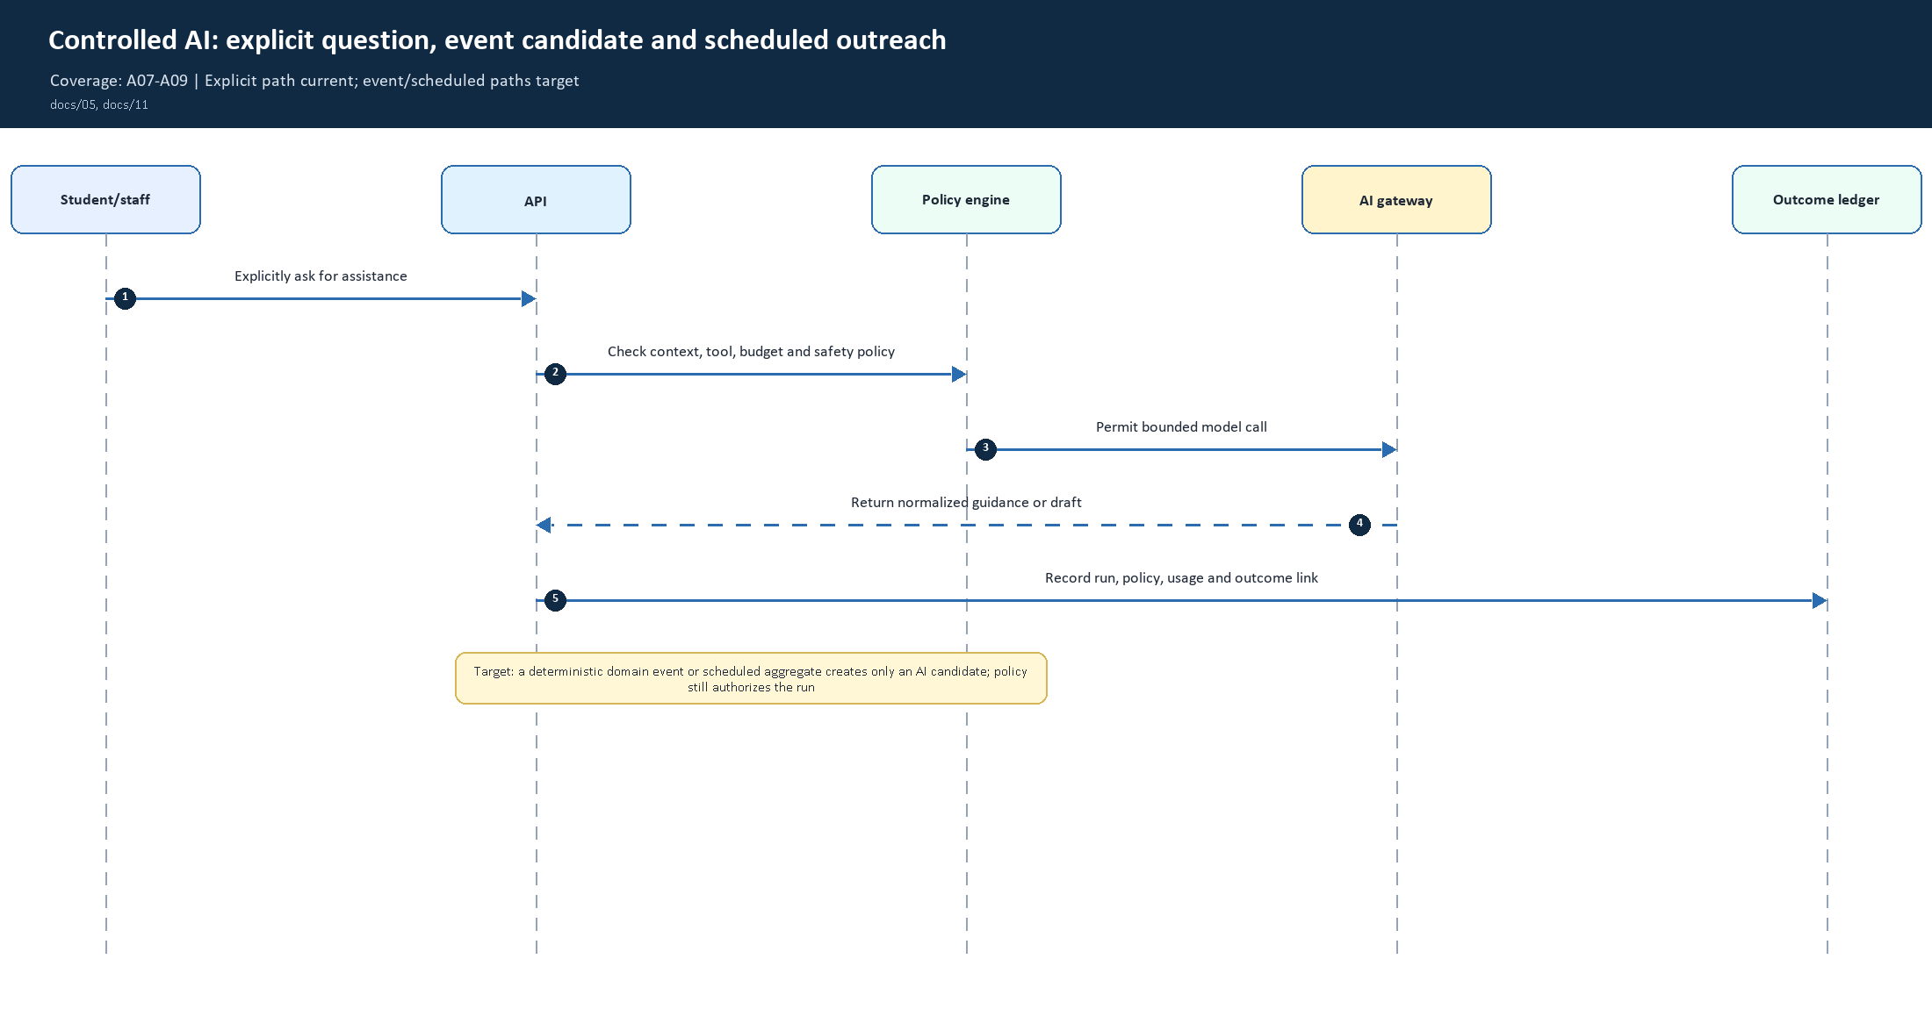
30. Controlled AI: explicit question, event candidate and scheduled outreach | Coverage: A07-A09
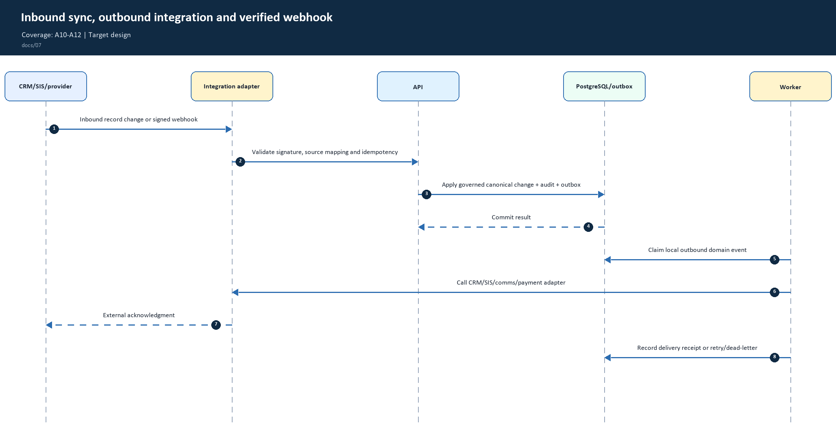
31. Inbound sync, outbound integration and verified webhook | Coverage: A10-A12
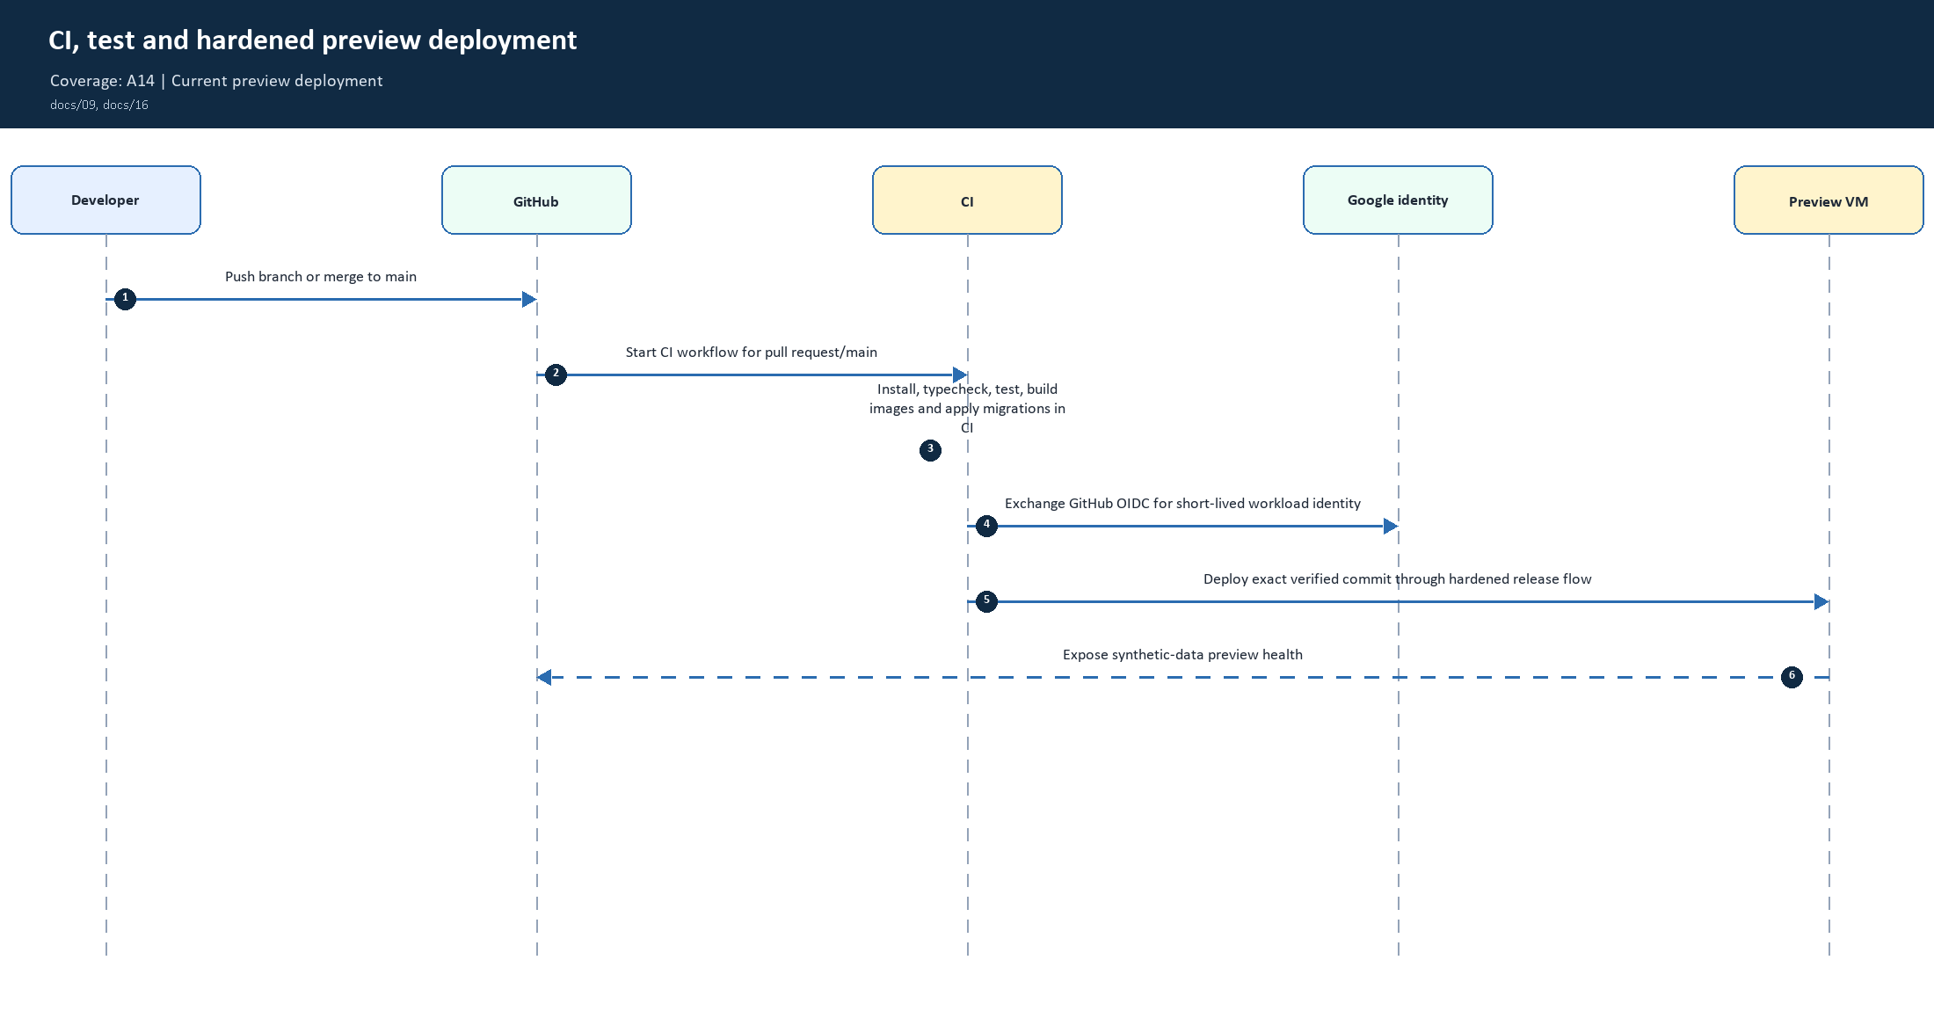
32. CI, test and hardened preview deployment | Coverage: A14
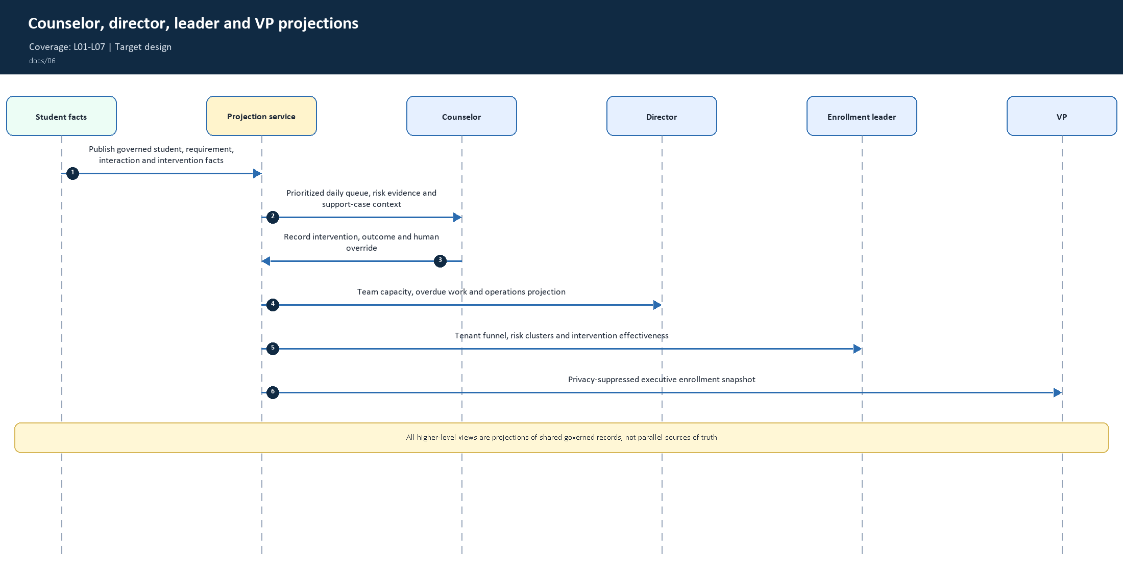
33. Counselor, director, leader and VP projections | Coverage: L01-L07

