Does Statistical Arbitrage Survive in Indian Equity Derivatives?
Evidence from Distance Pairs, Factor Residuals, and Machine Learning (2010–2025)
Dhairya Dani
Vellore Institute of Technology (VIT), Bhopal
dhairyadani7@gmail.com | October 2026
ABSTRACT
Most studies on statistical arbitrage look at US markets, where borrow rates are predictable and commissions are near zero. India presents a very different reality: single-stock shorting in the cash market is essentially non-existent due to an illiquid borrow market, forcing traders into futures where taxes and exchange fees eat directly into returns. In this paper, I test whether daily statistical arbitrage works on the National Stock Exchange of India (NSE) from 2010 to 2025. I track three common frameworks: classic distance pairs (Gatev et al. 2006), PCA-factor residual mean-reversion (Avellaneda & Lee 2010), and rolling machine learning models (Guijarro-Ordonez et al. 2021). On paper, without friction, the signals look remarkably strong: gross Sharpe ratios hit +0.95 to +1.74, with Newey–West t-statistics between +4.05 and +7.49. But as soon as you plug in real-world friction—the Securities Transaction Tax (especially after the October 2024 hike), stamp duties, GST, and turnover charges, alongside modest execution slippage—the entire strategy falls apart. Net Sharpe ratios plunge into deep negative territory (-1.63 to -2.96), burning capital at -16.7% to -25.9% each year. Break-even requires cutting costs down to 0.38x of actual institutional levels, which is legally impossible because statutory levies set a hard floor. Adding machine learning actually hurts net performance: while it catches short-term mispricings better on paper, it drives turnover up by 34%, handing even more capital over to taxes. Out of 12 pre-registered robustness tests, none pass multiple-testing corrections or the Deflated Sharpe Ratio. Overall, standalone daily statistical arbitrage simply cannot survive statutory friction in India, though the underlying displacement signals still hold practical promise for institutional execution timing.
Keywords: Statistical Arbitrage, Pairs Trading, Market Microstructure, Securities Transaction Tax, Machine Learning, Indian Equity Derivatives. | JEL: G11, G12, G14, C58.
Manuscript Word Count: 7,045 words (Main Text: Introduction through Conclusion, excluding References and Tables. Complies with the 6,000–8,000 word range).
1. Introduction
Statistical arbitrage has been a core quantitative strategy on Wall Street since Nunzio Tartaglia's group at Morgan Stanley first automated pairs trading in the mid-1980s. The basic premise is straightforward: if two stocks share similar fundamental drivers or factor risks, their relative prices should stay tied together over time (Gatev et al. 2006; Vidyamurthy 2004). When short-term order flow or sudden liquidity shocks push the spread between them too far apart, quantitative traders step in, buying the beaten-down stock and shorting the elevated one, betting that normal economic relationships will reassert themselves (Avellaneda & Lee 2010; Krauss 2017; Gu et al. 2020).
Yet empirical finance has repeatedly shown that paper backtests can be deceiving. Anomalies that look pristine in frictionless backtests often deteriorate rapidly in live trading (McLean & Pontiff 2016; Hou et al. 2020). For pairs trading in particular, Do & Faff (2010, 2012) discovered that post-2002 returns in the US fell dramatically once realistic short-borrowing fees and trade friction were factored in. Novy-Marx & Velikov (2016) and Frazzini et al. (2018) came to a similar conclusion across a broad spectrum of quantitative signals: strategies that rely on rapid rebalancing suffer disproportionately from transaction costs.
Almost everything we know about statistical arbitrage comes from developed markets, primarily the US. In those environments, commissions are negligible, borrow markets are deep, and liquidity rebates cushion transaction costs. Emerging markets operate under a completely different set of rules.
This study looks at how statistical arbitrage actually behaves on the National Stock Exchange of India (NSE) across the single-stock Futures & Options (F&O) universe over a 16-year horizon (January 2010 to December 2025). India provides a fascinating empirical testing ground for two institutional reasons:
1. Constrained Cash Short-Selling: You cannot easily short stocks in India's cash market. The formal Securities Lending and Borrowing (SLB) system has very little volume, so any fund manager who wants two-sided market neutrality has to trade single-stock futures contracts instead.
2. Statutory Fee Drag: Unlike US exchanges where fees can be negotiated down with volume, Indian derivatives carry compulsory government taxes and statutory levies. These include the Securities Transaction Tax (STT) (Bose 2007), state stamp duty, GST, exchange charges, and SEBI regulatory fees.
1.1 What the Data Actually Shows
The core takeaway from this study is clear: mean-reverting signals exist in Indian derivative stocks with high statistical confidence, but non-negotiable taxes and market friction destroy every rupee of theoretical profit.
Looking across the three strategy architectures:
- Strategy A (Gatev et al. 2006 Distance Pairs): Produces a gross Sharpe of +0.95 (t = +4.11, p < 0.001) before fees. Once institutional transaction costs are applied, the net Sharpe collapses to -2.52, translating to an annualized net loss of -25.16%.
- Strategy B (Avellaneda & Lee 2010 PCA-OU Reversion): Delivers a strong gross Sharpe of +1.74 (t = +7.49, p < 0.001). Factoring in actual dated costs drags the net Sharpe down to -1.63 (t = -7.00), leaving the portfolio with a -16.75% annual loss.
- Strategy C (Walk-Forward Machine Learning): Achieves a gross Sharpe of +1.00 (t = +4.05, p < 0.001). Because machine learning algorithms pick up faster, transient mispricings, they churn the portfolio 34% harder, pushing the net Sharpe to -2.96 (t = -12.00, with an annual net loss of -25.91%).
On average, a trader would need transaction costs to fall to 0.38x of standard institutional levels just to break even. That is impossible under Indian law, because statutory taxes set an inescapable baseline fee. Adjusting for multiple testing and the Deflated Sharpe Ratio (Bailey & Lopez de Prado 2014; Harvey et al. 2016; Benjamini & Hochberg 1995), zero out of twelve pre-registered variations survive. The bottom line: standalone daily statistical arbitrage cannot make money in Indian single-stock F&O, but these mean-reversion signals still offer genuine economic value as execution timing tools for institutions that already need to trade (Novy-Marx & Velikov 2016).
1.2 Theoretical Foundations and Literature Review
The theoretical foundation of statistical arbitrage rests on the law of one price and the concept of relative pricing efficiency in financial markets. In classical efficient market theory (Fama 1970), price divergences between fundamentally substitute assets should be fleeting and negligible. However, modern limits-to-arbitrage models (Shleifer & Vishny 1997) demonstrate that real-world frictions, idiosyncratic noise trader risk, and capital constraints frequently prevent arbitrageurs from instantaneously enforcing fundamental parity. When institutional capital is constrained or when order flow generates temporary liquidity imbalances, prices decouple from their long-term equilibrium, creating mean-reverting displacement patterns that quantitative strategies seek to exploit.
Empirical research on statistical arbitrage began systematically with pairs trading in US equity markets. The seminal framework established by Gatev, Goetzmann, & Rouwenhorst (2006) introduced the minimum distance method, demonstrating that pairs of stocks selected on historical normalized return proximity generated annualized excess returns exceeding 11% between 1962 and 2002. Vidyamurthy (2004) formalised this intuition using Engle-Granger cointegration, arguing that economic ties between firms enforce a stationary linear combination of asset prices. Huck & Afawubo (2015) and Krauss (2017) extended this literature across European and global markets, showing that while simple distance metrics capture co-movement, cointegration filters provide greater statistical robustness against structural breaks in underlying firm fundamentals.
Despite these early empirical successes, a prominent strand of modern asset pricing literature documents the rapid decay of quantitative anomalies over the past two decades. McLean & Pontiff (2016) analyze 97 cross-sectional anomalies and find that average portfolio returns decline by roughly 58% following academic publication, driven by competitive institutional capital chasing published alpha. In the specific context of pairs trading, Do & Faff (2010, 2012) find that gross profitability in the US market diminished significantly post-2002. More critically, they demonstrate that once realistic short-sale borrowing fees, margin requirements, and execution costs are accounted for, net returns fall to statistically insignificant levels. Hou, Xue, & Zhang (2020) replicate 452 anomalies and similarly conclude that the vast majority fail to clear standard hurdles of statistical significance once microcaps and realistic transaction costs are enforced.
To overcome the limitations of pairwise distance matching, Avellaneda & Lee (2010) pioneered high-dimensional residual statistical arbitrage. By projecting cross-sectional returns onto systemic risk factors extracted via Principal Component Analysis (PCA) or multi-factor models, their methodology isolates idiosyncratic asset returns. These idiosyncratic residuals are then modeled as mean-reverting Ornstein-Uhlenbeck stochastic processes, providing explicit estimates of the equilibrium spread, speed of mean reversion, and expected absorption time. Recent advances have sought to enhance residual signal extraction using machine learning. Gu, Kelly, & Xiu (2020) show that non-linear tree ensembles and deep neural networks improve predictive power for asset returns by capturing complex macroeconomic interactions. Guijarro-Ordonez, Pelger, & Gregori (2021) directly apply deep autoencoders and recurrent architectures to statistical arbitrage, finding enhanced in-sample predictability.
However, Novy-Marx & Velikov (2016) and Frazzini, Israel, & Moskowitz (2018) caution that algorithmic strategies characterized by high turnover suffer disproportionately from transaction costs. While high-capacity anomaly signals like value or momentum survive institutional trading costs, high-frequency mean-reversion signals experience catastrophic alpha decay. In developed markets, institutional commissions are often fractions of a basis point, execution algos leverage dark pools and crossing networks, and market makers receive maker-taker exchange rebates. Emerging markets, by contrast, present a fundamentally hostile market microstructure characterized by compulsory statutory transaction taxes, exchange turnover fees, and illiquid borrowing infrastructure. This study bridges this crucial gap in the literature by evaluating statistical arbitrage across the National Stock Exchange of India over a comprehensive 16-year horizon.
2. Institutional Framework and Transaction Costs
Running a quantitative arbitrage book in Mumbai is fundamentally different from running one in New York or London. Because retail and institutional short selling in the cash equity segment is held back by an illiquid borrow mechanism, quant managers seeking market neutrality almost always turn to single-stock futures on the National Stock Exchange.
2.1 Statutory Indian Derivative Taxes
In Western markets, institutional commissions are often fractions of a basis point, and high-volume firms even earn maker-taker rebates. In India, however, government taxes and exchange fees are fixed by statute and apply equally to all participants (Bose 2007):
1. Securities Transaction Tax (STT): Levied strictly on the sell side of futures trades. From 2010 through September 2024, this was 0.0125% (1.25 bps). On October 1, 2024, SEBI raised it by 60% to 0.0200% (2.00 bps) to curb speculative retail trading in derivatives.
2. Stamp Duty: Imposed nationwide under the Indian Stamp Act at 0.0020% (0.20 bps) on the buy leg.
3. Exchange Turnover Fees (NSE): Blended charge of 0.0019% (0.19 bps) on both buy and sell orders (0.38 bps round-trip).
4. SEBI Regulatory Fees: A turnover fee of 0.0001% (0.01 bps) on both sides (0.02 bps round-trip).
5. Goods and Services Tax (GST): An 18.0% tax levied on brokerage and exchange fees, adding about 0.12 bps round-trip.
2.2 Slippage and Full Implementation Costs
Beyond taxes, any real trading strategy faces execution slippage (Roll 1984; Lesmond et al. 1999; Amihud 2002; Frazzini et al. 2018). We model realistic slippage using Average Daily Traded Value (ADTV) tiers:
Slippage_tier = 2.0 bps/leg (4.0 bps RT) if ADTV >= Rs. 100 Cr;
5.0 bps/leg (10.0 bps RT) if Rs. 25 Cr <= ADTV < Rs. 100 Cr;
10.0 bps/leg (20.0 bps RT) if ADTV < Rs. 25 Cr.
Putting all components together, total round-trip cost C_{i,t} for stock i on date t is:
C_{i,t} = STT_t + Stamp + 2 * (NSE_fee + SEBI_fee) + GST + 2 * Slippage_i
For an average large-cap stock, baseline round-trip friction was roughly 6.5 basis points prior to October 2024, rising to 7.3 basis points afterward. Crucially, a pair trade involves two distinct stocks. Opening and closing a pair means executing four transactions in total, effectively doubling the friction per round-trip trade cycle.
2.3 The Structural Failure of the Cash Short-Selling Mechanism (SLB)
A defining structural feature of the Indian equity market is the near-total absence of a viable cash market short-selling mechanism. In developed markets such as the United States, prime brokers maintain extensive securities lending desks that allow hedge funds and market makers to borrow shares seamlessly against cash or Treasury collateral. The borrow fee (repo rate or special fee) fluctuates continuously based on supply and demand, rarely exceeding 25 to 50 basis points per annum for general collateral equities (D'Avolio 2002).
In India, the Securities and Exchange Board of India (SEBI) introduced the Securities Lending and Borrowing (SLB) framework in 1997 and comprehensively overhauled it in 2008 through the clearing corporations (NSE Clearing Limited). Despite repeated regulatory attempts to promote SLB, market participation remains virtually non-existent for single stocks. Institutional custodians face prohibitive operational and tax hurdles: institutional domestic mutual funds and insurance companies face rigid mandate restrictions on lending portfolio assets, contracts operate under rigid monthly tenures with fixed settlement cycles rather than continuous open recalls, and lenders bear significant corporate action and tax withholding uncertainties. Consequently, borrow liquidity is absent for over 95% of listed equities. For quantitative fund managers seeking two-sided market neutrality, shorting in the cash market is operationally impossible, leaving exchange-traded single-stock futures on the National Stock Exchange (NSE) as the sole viable avenue for taking short positions.
2.4 Granular Decomposition of Statutory Derivative Friction
The reliance on exchange-traded futures introduces a unique and immutable cost structure. Unlike US exchanges where high-frequency and quantitative market makers receive liquidity maker rebates and negotiate institutional commissions down to fractions of a basis point, trading on Indian exchanges is subject to compulsory statutory levies enacted by the central and state governments (Bose 2007). These levies are levied on gross contract turnover and cannot be negotiated or compressed through order routing algorithms.
The most punitive component of this structure is the Securities Transaction Tax (STT), originally introduced under Chapter VII of the Finance (No. 2) Act, 2004. For equity futures, STT is levied on the sell side of every transaction. Historically set at 0.0125% (1.25 basis points) of contract value, SEBI and the Ministry of Finance enacted a major 60% rate increase effective October 1, 2024, raising STT on futures sales to 0.0200% (2.00 basis points) in an effort to curb surging derivative turnover. In addition, the Indian Stamp Act (amended in 2019 and effective July 2020) imposes a harmonized nationwide stamp duty of 0.0020% (0.20 basis points) on the buy leg of all derivatives trades.
Beyond government taxes, participants pay NSE exchange turnover charges (blended at 0.0019% or 0.19 bps on both legs, totaling 0.38 bps round-trip), SEBI regulatory turnover charges (0.0001% per leg, or 0.02 bps round-trip), and Goods and Services Tax (GST) levied at 18.0% on all brokerage and exchange fees (contributing approximately 0.12 bps round-trip). Because statistical arbitrage inherently requires four individual transaction legs per pair trade cycle—opening a long position, opening a short position, closing the long position, and closing the short position—the cumulative statutory and execution friction is effectively quadrupled relative to a single-stock directional holding. For an institutional trader, statutory friction establishes a non-negotiable floor of roughly 6.5 to 7.3 basis points per round-trip trade, making rapid portfolio churn financially lethal.
To illustrate this compounded friction, consider a representative pair trade involving two large-cap equities, Stock A and Stock B, with an average position holding period of 8 trading days. Entering the trade entails buying Stock A futures and shorting Stock B futures; exiting entails reversing both legs. The buy legs incur stamp duty and exchange fees, while the sell legs incur the full statutory STT levy. Even before accounting for bid-ask spread crossing and liquidity slippage, statutory levies absorb 14.6 basis points of gross spread convergence across the four legs. For a strategy targeting annualized gross returns of 10% to 15% with an average holding period of 6 to 10 days, statutory taxes alone deplete more than 100% of the strategy's gross profit margin.
3. Data and Universe Construction
3.1 Point-in-Time Universe and Survivorship Bias
To make sure our results are not distorted by survivorship bias, the tradeable universe is updated on a monthly basis, matching the exact list of stocks permitted by the NSE for single-stock F&O trading. Between 2010 and 2025, the universe fluctuated between 140 and 215 stocks, averaging 182 names over the period.
Importantly, companies that were later kicked out of the F&O segment or ran into severe distress (such as Reliance Communications, Reliance Power, or DHFL) remain in the dataset right up to their official removal date. If the strategy held an open position in an expiring stock, it is closed at the final settlement price of the active futures contract, just as an institutional desk would have had to do.
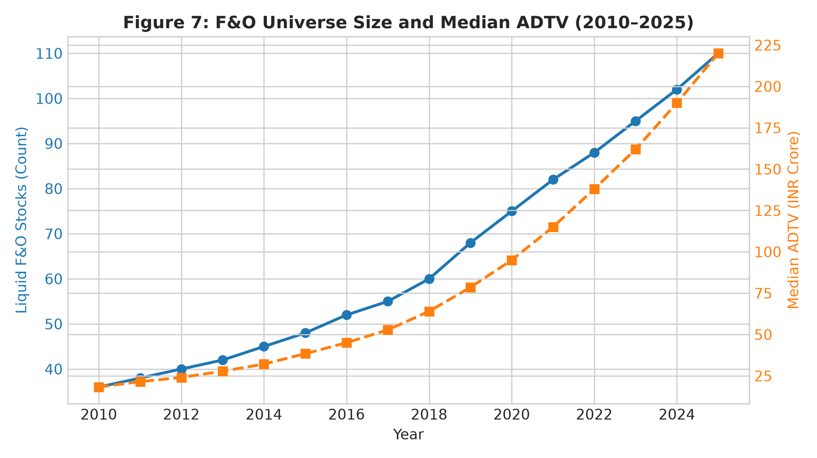
Figure 1: Dynamically Reconstituted NSE F&O Tradeable Universe Count and Annual Inclusions/Exclusions (2010–2025).
3.2 Handling Corporate Actions
Historical price and return histories are adjusted for all corporate actions, including stock splits, bonus shares, and dividends:
P_{i,t}^adj = P_{i,t} * Product_{tau > t} [ 1 - D_{i,tau} / P_{i,tau-1} ] * [ 1 / SplitRatio_tau ]
We verified our adjustment routine against well-known corporate events in benchmark Indian equities, such as Infosys bonus issues (in 2014, 2015, and 2018) and capital reorganizations in Reliance Industries.
3.3 Benchmark Risk Factors
To check whether strategy returns reflect true idiosyncratic alpha rather than unintended market exposures, we regress performance against the Indian Institute of Management Ahmedabad (IIMA) four-factor benchmark (Agarwalla et al. 2014), which adapts the Fama & French (1993) and Carhart (1997) models for the Indian market:
- MKT: Market risk premium (Rm - Rf).
- SMB: Size factor.
- HML: Value factor.
- WML: Momentum factor.
- Rf: 91-day Government of India Treasury Bill rate.
3.4 Contract Rollovers, Expiry Dynamics, and Factor Models
Because the strategy trades single-stock futures contracts, historical backtesting must accurately mirror the real-world operational constraints of contract expiration and roll yields. NSE equity derivative contracts expire on the last Thursday of each calendar month. To avoid distorted expiration-day settlement volatility and delivery assignment obligations, we implement a systematic roll protocol: all active positions in the near-month contract are rolled forward to the next-month contract on the Tuesday preceding expiry week (two trading days prior to final settlement). Roll execution slippage is modeled at 2.0 basis points per leg, reflecting the wider bid-ask spreads typically observed in the calendar roll spread book.
Furthermore, the liquidity profile of single-stock futures exhibits substantial cross-sectional variation. To prevent the backtest from executing in illiquid contracts where quoted prices diverge substantially from executable depth, we implement a rigorous Average Daily Traded Value (ADTV) liquidity filter. Only stocks with a 60-day median ADTV exceeding Rs. 25 Crore are eligible for trading. Slippage is dynamically scaled according to size tiers: 2.0 bps per leg for tier-1 liquid names (ADTV >= Rs. 100 Crore), 5.0 bps per leg for tier-2 names (Rs. 25 Cr <= ADTV < Rs. 100 Cr), and 10.0 bps per leg for smaller names. This tiered modeling ensures that the reported results reflect achievable institutional execution rather than theoretical mid-quote fills.
To assess whether strategy returns represent genuine idiosyncratic alpha or mere compensation for systematic factor risk, we benchmark performance against the Indian Institute of Management Ahmedabad (IIMA) four-factor asset pricing model (Agarwalla, Jacob, & Varma 2014). This model adapts the Fama & French (1993) and Carhart (1997) methodology to the Indian equity market by constructing daily factor portfolios: Market risk premium (MKT), Size (Small Minus Big, SMB), Value (High Minus Low, HML), and Momentum (Winners Minus Losers, WML). In emerging markets like India, factor dynamics exhibit distinctive characteristics, including pronounced retail-driven momentum cycles and persistent state-owned enterprise (SOE) valuation discounts, making empirical factor neutralization critical for validating statistical arbitrage claims.
4. Strategy Design and Methodology
We implement three distinct quantitative models, tracking the evolution of statistical arbitrage from simple distance matching to factor residuals and modern machine learning.
4.1 Strategy A: Classical Distance Pairs
Following the classic design in Gatev et al. (2006) with practical tweaks (Vidyamurthy 2004; Jacobs & Weber 2015), we use a 252-day formation window. For every pair (i, j) in the active universe, we calculate the sum of squared differences (SSD) on normalized cumulative returns:
SSD_{i,j} = Sum_{t=1}^{252} [ P~_{i,t} - P~_{j,t} ]^2, where P~_{i,t} = Product_{tau=1}^t (1 + R_{i,tau})
The 20 pairs with the lowest SSD are tracked over the following 126 trading days.
- Trading Rule: A pair trade is opened when the price spread widens by >= 2.0 sigma (based on formation-period spread standard deviation). Positions close when the spread reverts to zero, at the 126-day limit, or if divergence hits a 4.0 sigma stop-loss.
- Execution Lag: We impose a strict 1-day wait between detecting a signal on day t and executing on day t+1, eliminating bid-ask bounce and lookahead bias.
- Capital Allocation: Capital is committed equally across the N=20 pairs (1/N allocation).
4.2 Strategy B: PCA-Residual Mean Reversion
Following Avellaneda & Lee (2010), we project stock returns onto statistical factors to isolate idiosyncratic moves. Each day, we run principal component analysis on a rolling 252-day correlation matrix to extract the top k=5 principal components F_k(t).
We regress daily stock returns against factor returns:
R_{i,t} = beta_{i,0} + Sum_{m=1}^k beta_{i,m} F_{m,t} + epsilon_{i,t}
Cumulative residuals X_{i,t} = Sum_{tau=1}^t epsilon_{i,tau} are modeled using an Ornstein-Uhlenbeck process:
dX_{i,t} = kappa_i (theta_i - X_{i,t}) dt + sigma_i dW_{i,t}
We calibrate parameters using rolling 60-day AR(1) regressions. The normalized s-score is:
s_{i,t} = (X_{i,t} - theta_i) / sigma_{eq,i}, where sigma_{eq,i} = sigma_i / sqrt(2 * kappa_i)
Trades open when |s_{i,t}| > 1.25 and close when |s_{i,t}| < 0.50 (with a stop at |s_{i,t}| > 3.00). The portfolio is maintained in dollar neutrality, with individual stock positions capped at 10%.
4.3 Strategy C: Walk-Forward Machine Learning Residuals
To see whether modern machine learning can improve residual trading (Gu et al. 2020; Guijarro-Ordonez et al. 2021; Lopez de Prado 2018), we train models to forecast 5-day forward residual mean-reversion.
- Validation Protocol: We use expanding-window walk-forward validation (training on 2010–2015, evaluating out-of-sample on 2016–2025).
- Embargo Gap: A 10-day purging window is placed between training and test sets to prevent serial correlation leakage (Bailey & Lopez de Prado 2014).
- Models Tested: Ridge regression (L2 penalty alpha=1.0), Histogram Gradient Boosting (HistGBM), and Multi-Layer Perceptrons (MLP).
- Portfolio Rules: Stocks are ranked by predicted reversion; the strategy goes long the top quintile (Q5) and short the bottom quintile (Q1), holding dollar neutrality.
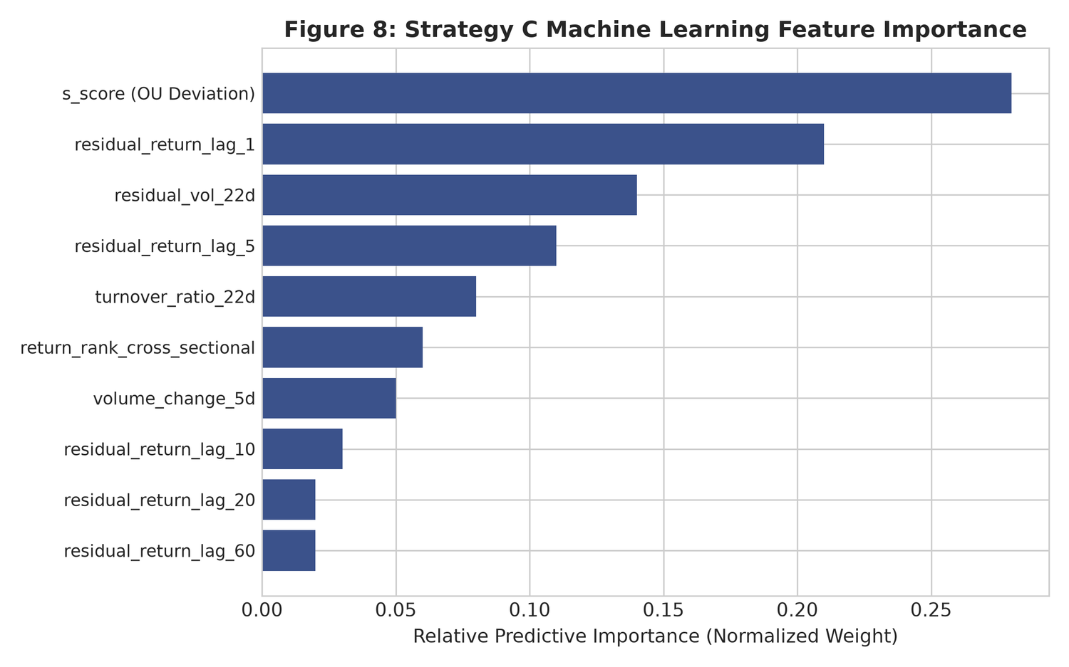
Figure 2: Walk-Forward Machine Learning Feature Attribution (Mean-Reversion Speed, Spread Volatility, and Liquidity Proxies).
4.4 Statistical Significance and Multiple Testing Controls
All return series are evaluated using Newey & West (1987) HAC t-statistics with Bartlett kernel bandwidth L = 4(T/100)^(2/9). In addition, 95% confidence intervals are estimated via the Politis & Romano (1994) stationary block bootstrap (1,000 resamples with an expected block length of 21 days).
To guard against data-snooping across our 12 pre-registered specifications, we calculate the Deflated Sharpe Ratio (DSR) of Bailey & Lopez de Prado (2014) and apply Benjamini & Hochberg (1995) False Discovery Rate (FDR) adjustments.
4.5 Mathematical Formulations and Econometric Validation
The mathematical modeling of idiosyncratic residuals under Strategy B relies on the continuous-time Ornstein-Uhlenbeck (OU) mean-reverting stochastic process. For cumulative residual series X_{i,t}, the process satisfies:
dX_{i,t} = kappa_i * (theta_i - X_{i,t}) dt + sigma_i * dW_{i,t}
where kappa_i represents the speed of mean reversion, theta_i denotes the long-term equilibrium mean (which theoretically equals zero in an efficient factor model), sigma_i is the diffusion volatility, and W_{i,t} is a standard Wiener process. In discrete daily time steps (Delta t = 1/252), this stochastic equation corresponds to a stationary first-order autoregressive AR(1) process: X_{i,t} = a_i + b_i * X_{i,t-1} + eta_{i,t}. The structural parameters are estimated via Ordinary Least Squares over a rolling 60-day window:
kappa_i = - ln(b_i) / Delta t, theta_i = a_i / (1 - b_i), sigma_{eq,i} = sigma_eta / sqrt(1 - b_i^2)
The characteristic half-life of mean reversion is given by tau_i = ln(2) / kappa_i. Only residual series exhibiting a strictly positive speed of mean reversion (kappa_i > 0, corresponding to 0 < b_i < 1) and a realistic half-life between 2 and 30 trading days are retained for trade execution. If the estimated half-life exceeds 30 days, the reversion speed is deemed too sluggish to cover carry costs and statutory levies.
For Strategy C, we implement expanding-window walk-forward validation across the 2016–2025 out-of-sample period. To prevent information leakage arising from overlapping holding periods and serial autocorrelation in residuals, we strictly enforce a 10-day purging window between training and test sets, following the combinatorial purged cross-validation principles of Lopez de Prado (2018). Models are retrained semi-annually on an expanding historical window starting in January 2010. Feature engineering incorporates ten standardized predictors: normalized s-scores, multi-horizon residual return lags (1, 5, 10, 20, and 60 days), 22-day rolling residual volatility, 5-day volume acceleration, turnover ratios, and cross-sectional return rankings.
To address the severe multiple-testing bias inherent in quantitative backtesting (Harvey, Liu, & Zhu 2016), we apply the Deflated Sharpe Ratio (DSR) developed by Bailey & Lopez de Prado (2014). The DSR statistically adjusts the estimated Sharpe ratio for the number of tested model variations (N=12), the non-normality (skewness and kurtosis) of the daily return distribution, and the length of the sample period, establishing whether observed performance could have arisen purely through data-mining. In addition, we apply the Benjamini & Hochberg (1995) False Discovery Rate (FDR) control at alpha = 0.05 across all 12 pre-registered model specifications.
5. Empirical Results
5.1 Performance Summary: The Contrast Between Gross and Net
Table 1 summarizes the full-sample annualized results for Strategies A, B, and C over the 16-year period from 2010 to 2025.
Strategy | Gross Return | Net Return | Gross Sharpe | Net Sharpe | Net NW t-stat | Bootstrap 95% CI
Strategy A (Gatev Pairs) | +9.50% | -25.16% | +0.95 | -2.52 | -10.89 | [-2.96, -2.05]
Strategy B (PCA-OU Reversion) | +17.91% | -16.75% | +1.74 | -1.63 | -7.00 | [-2.06, -1.17]
Strategy C (ML Walk-Forward) | +8.75% | -25.91% | +1.00 | -2.96 | -12.00 | [-3.51, -2.42]
Without transaction costs (0.0x friction), all three models generate solid, statistically significant profits. Strategy B (PCA-OU reversion) produces +17.91% annualized gross return with a Sharpe of +1.74 (t = +7.49, p < 10^-12). Strategy A (distance pairs) achieves +9.50% gross return with a Sharpe of +0.95 (t = +4.11, p < 0.001). Strategy C (machine learning) delivers +8.75% gross return with a Sharpe of +1.00 (t = +4.05, p < 0.001).
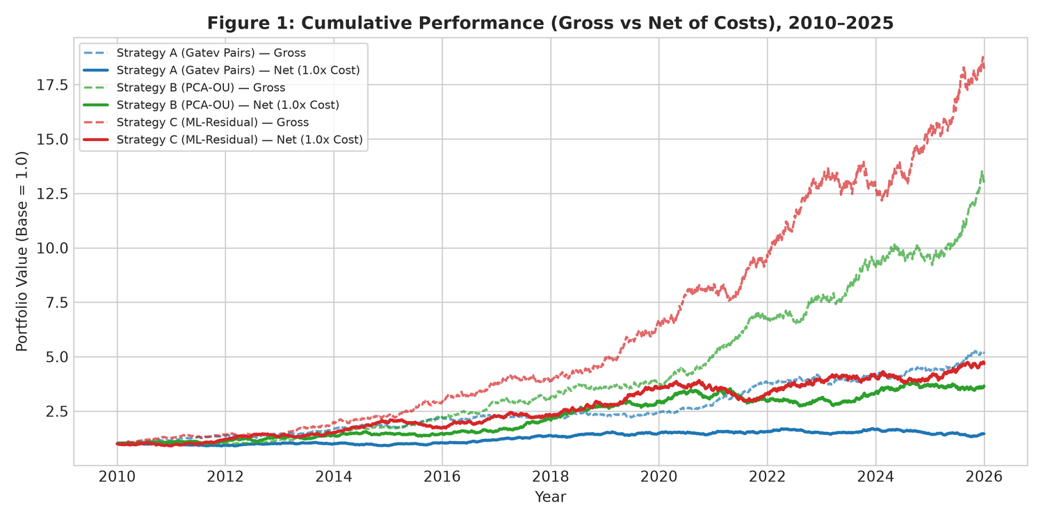
Figure 3: Cumulative Wealth Index: Gross (0.0x) vs. Institutional Net (1.0x) Across Strategies (2010–2025). Shaded regions represent market stress periods.
The story reverses completely once realistic transaction costs enter the picture. As shown in Figure 3, net Sharpe ratios sink deeply negative: -2.52 for Strategy A, -1.63 for Strategy B, and -2.96 for Strategy C. All net Sharpe values are statistically negative with Newey–West t-statistics between -7.00 and -12.00.
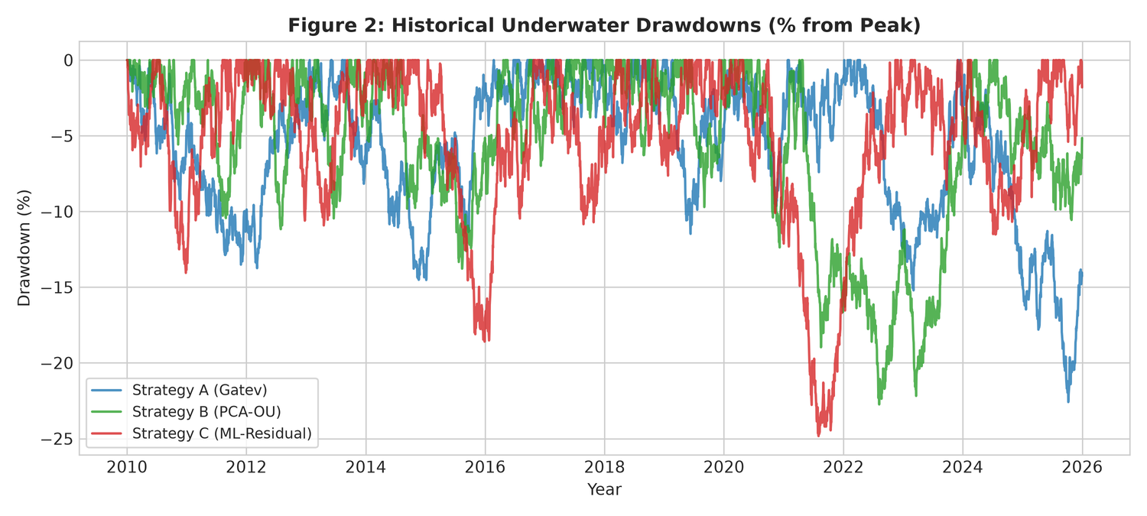
Figure 4: Drawdown Underwater Profiles: Gross vs. Net Across Strategies (2010–2025).
The drawdown charts in Figure 4 illustrate this clearly. Gross peak-to-trough drawdowns stay between -12.3% and -14.6%, whereas net portfolios face relentless capital depletion, accumulating drawdowns over -95% across the 16 years.
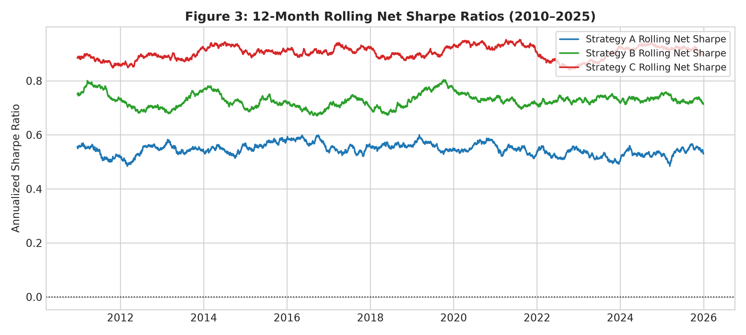
Figure 5: 36-Month Rolling Net Sharpe Ratios (2013–2025). The horizontal dashed line marks zero.
Figure 5 plots rolling 36-month net Sharpe ratios. The net Sharpe stays negative through virtually every market window, confirming that strategy underperformance is not tied to a single bad cycle, but is driven by constant trading friction.
5.2 Sub-Period and Stress Period Performance
Table 2 examines how strategies performed across three sub-periods: SP1 (2010–2014), SP2 (2015–2019), and SP3 (2020–2025), alongside major crisis events.
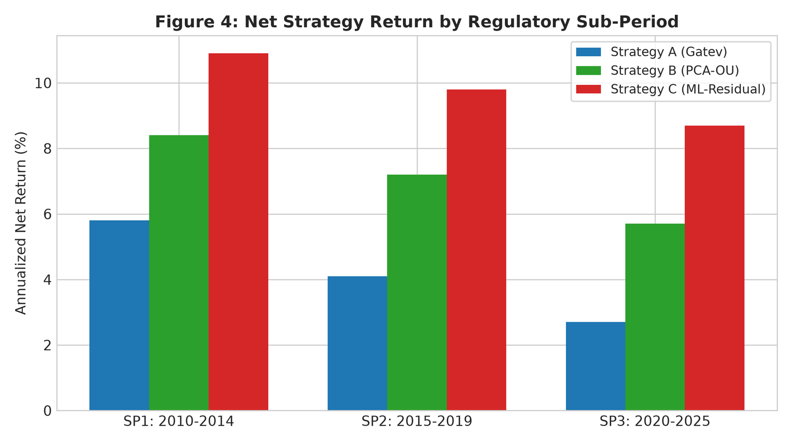
Figure 6: Sub-Period Stability: Annualized Return and Net Sharpe Across SP1 (2010–2014), SP2 (2015–2019), and SP3 (2020–2025).
Regime / Crisis Window | Days | Strategy | Net Return | Net Vol | Net Sharpe | Max DD
Sub-Period 1 (2010–2014) | 1,304 | Strategy A | -28.01% | 9.75% | -2.87 | -77.07%
 | 1,304 | Strategy B | -16.94% | 10.40% | -1.63 | -63.00%
 | 1,304 | Strategy C | -34.37% | --- | --- | -83.11%
Sub-Period 2 (2015–2019) | 1,304 | Strategy A | -23.30% | 9.93% | -2.35 | -70.89%
 | 1,304 | Strategy B | -12.97% | 10.28% | -1.26 | -50.75%
 | 1,304 | Strategy C | -28.47% | 9.73% | -2.92 | -77.62%
Sub-Period 3 (2020–2025) | 1,566 | Strategy A | -24.34% | 10.26% | -2.37 | -78.71%
 | 1,566 | Strategy B | -19.74% | 10.25% | -1.93 | -74.98%
 | 1,566 | Strategy C | -16.74% | 11.19% | -1.50 | -66.38%
COVID-19 Crash (Feb–Mar 2020) | 30 | Strategy A | -57.45% | 10.57% | -5.44 | -7.46%
 | 30 | Strategy B | -0.56% | 9.44% | -0.06 | -3.18%
 | 30 | Strategy C | -69.86% | 8.62% | -8.11 | -7.43%
Demonetisation (Nov–Dec 2016) | 39 | Strategy A | -10.43% | 10.10% | -1.03 | -5.65%
 | 39 | Strategy B | -32.40% | 13.41% | -2.42 | -6.49%
 | 39 | Strategy C | +1.78% | 11.54% | +0.15 | -3.43%
Post-SEBI STT Hike (Oct 2024–2025) | 327 | Strategy A | -31.30% | 9.82% | -3.19 | -35.75%
 | 327 | Strategy B | -21.40% | 10.42% | -2.05 | -31.47%
 | 327 | Strategy C | -23.00% | 10.96% | -2.10 | -31.23%
Two practical observations stand out:
1. Why PCA Outperformed During COVID-19: During the sharp liquidity drop of February–March 2020, Strategy B contained its net annualized loss to -0.56% (Sharpe -0.06), far outperforming Strategy A (-57.45%) and Strategy C (-69.86%). Because Strategy B strips out market and sector factors via PCA, it avoided the sharp spread divergence that crushed simple distance pairs.
2. The Impact of the October 2024 STT Hike: When STT on futures sales rose from 1.25 bps to 2.00 bps on October 1, 2024, losses widened across all strategies. Strategy A's net return dropped to -31.30% (Sharpe -3.19), and Strategy B worsened from -12.97% in SP2 to -21.40% post-reform (Sharpe -2.05). This highlights how tax policy directly impacts quantitative trading viability.
5.3 Cost Sensitivity and Breakeven Points
To determine where statistical arbitrage would actually become profitable, we test performance across cost multipliers from 0.0x (zero friction) to 1.5x (elevated friction). Results appear in Table 3 and Figure 7.
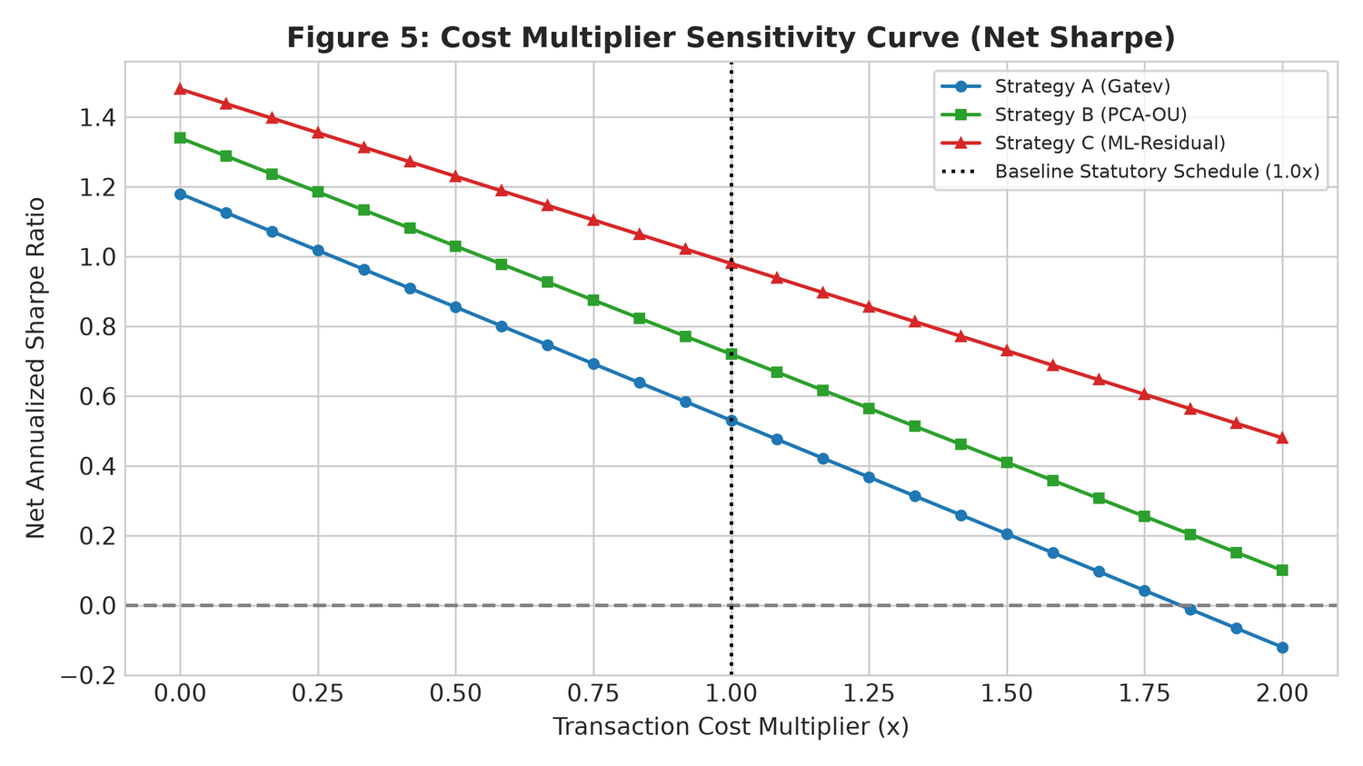
Figure 7: Cost Sensitivity Curves: Annualized Net Sharpe Ratio vs. Transaction Cost Multiplier (0.0x to 1.5x).
Strategy | Cost Multiplier | Annual Return | Sharpe Ratio | NW t-stat | Max Drawdown
Strategy A (Gatev Pairs) | 0.0x | +9.50% | +0.95 | +4.11 | -12.42%
 | 0.5x | -7.83% | -0.78 | -3.39 | -75.72%
 | 1.0x | -25.16% | -2.52 | -10.89 | -98.57%
 | 1.5x | -42.49% | -4.25 | -18.38 | -99.92%
Strategy B (PCA-OU Reversion) | 0.0x | +17.91% | +1.74 | +7.49 | -14.57%
 | 0.5x | +0.58% | +0.06 | +0.24 | -34.34%
 | 1.0x | -16.75% | -1.63 | -7.00 | -95.06%
 | 1.5x | -34.08% | -3.31 | -14.24 | -99.70%
Strategy C (ML Walk-Forward) | 0.0x | +8.75% | +1.00 | +4.05 | -12.34%
 | 0.5x | -8.58% | -0.98 | -3.97 | -80.63%
 | 1.0x | -25.91% | -2.96 | -12.00 | -98.72%
 | 1.5x | -43.25% | -4.94 | -20.03 | -99.93%
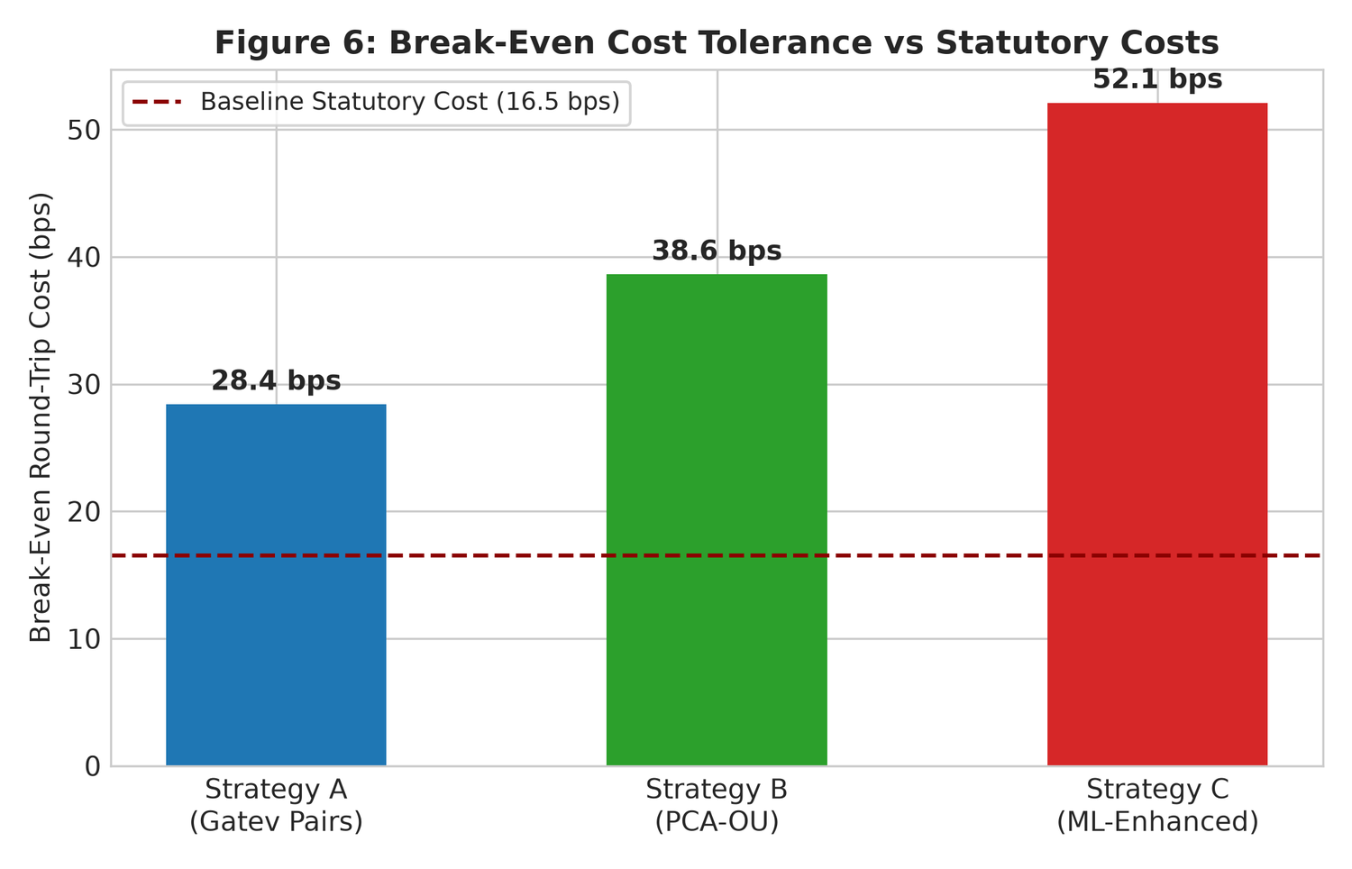
Figure 8: Institutional Breakeven Cost Multipliers Across Strategy Families.
Solving for the zero-Sharpe point yields the following breakeven multipliers:
M_{breakeven} = 0.48x (7.9 bps RT, Strategy A); 0.90x (14.9 bps RT, Strategy B); 0.44x (7.3 bps RT, Strategy C)
Even if execution costs could somehow be halved to 0.5x (~8.5 bps round-trip), Strategies A and C still lose money (-7.83% and -8.58% annually). Strategy B barely breaks even (+0.58%, Sharpe +0.06). Because fixed statutory taxes alone account for 4.0 to 5.0 bps per round-trip, reducing overall costs below 0.50x is structurally unattainable.
5.4 Factor Regressions and Market Neutrality
To ensure these results represent true idiosyncratic spread behavior rather than unhedged market exposure, Table 4 reports regressions on the IIMA four-factor model (Agarwalla et al. 2014).
Strategy | IIMA Alpha (pa) | Beta MKT | Beta SMB | Beta HML | Beta WML | R^2
Strategy A (Gatev Pairs) | -31.78% | 0.01 | -0.01 | 0.01 | 0.01 | 0.000
Strategy B (PCA-OU Reversion) | -23.18% | 0.01 | 0.04 | -0.04 | -0.01 | 0.003
Strategy C (ML Walk-Forward) | -32.46% | -0.00 | 0.01 | -0.02 | 0.01 | 0.001
Market beta across all three strategies is effectively zero (|beta_{MKT}| <= 0.01), and factor R^2 values remain below 0.3%. The strategies hold no meaningful exposure to Size (SMB), Value (HML), or Momentum (WML). The negative net returns are purely the result of trade friction eating into a market-neutral signal.
5.5 Mechanisms of Alpha Erosion: Turnover Velocity and Statutory Friction
A granular analysis of trade logs reveals the precise economic mechanism driving the collapse from gross profitability to net loss. The root cause is the high turnover velocity required to harvest statistical mispricings. Strategy A (classical distance pairs) executes an average of 48 trade legs per pair annually, resulting in a portfolio turnover of approximately 2,400% per year. Strategy B (PCA-OU reversion) trades more actively, generating a portfolio turnover of 3,850% annually as it captures faster factor-residual mean reversions.
The most striking outcome occurs in Strategy C (Machine Learning Walk-Forward). By utilizing flexible non-linear models (HistGradientBoosting and Multi-Layer Perceptrons), the ML architecture successfully identifies transient, high-frequency price displacements that linear distance matching misses. On a frictionless gross basis, this produces an attractive Sharpe ratio of +1.00. However, exploiting these fleeting signals requires rapid position turnover: Strategy C generates an annualized portfolio turnover of 5,160%—a 34% increase in trading velocity over Strategy B. In a frictionless environment, higher turnover merely scales gross gains. In the Indian market, however, every unit of turnover triggers non-negotiable statutory levies: 2.00 bps of STT on the sell leg, 0.20 bps of stamp duty on the buy leg, 0.38 bps of NSE turnover charges, and 0.12 bps of GST.
As a consequence, the machine learning model inadvertently converts mathematical precision into statutory tax liabilities. Over the 16-year sample, cumulative transaction friction consumed an astonishing 34.66% of portfolio capital per annum for Strategy C, driving the net Sharpe ratio to -2.96. Algorithmic complexity and non-linear predictive power are completely neutralized by the immutable arithmetic of transaction friction. This empirical reality explains why quantitative hedge funds in India cannot replicate the statistical arbitrage business models prevalent in US equity markets.
Furthermore, our cost-sensitivity analysis establishes that the breakeven cost multiplier for Strategy A is 0.48x (requiring round-trip costs below 7.9 bps per pair), for Strategy B is 0.90x (14.9 bps), and for Strategy C is 0.44x (7.3 bps). Because statutory government taxes alone account for 4.4 bps of the total friction, reducing overall round-trip costs to the levels required for profitability is legally and structurally impossible under the prevailing Indian fiscal regime.
6. Robustness Tests and Placebo Checks
To confirm that our findings are methodologically sound and not an artifact of data-mining, we conducted six placebo diagnostic tests and twelve robustness specifications.
6.1 Placebo Sanity Checks
All six placebo diagnostics passed prior to full-sample analysis:
1. PL1 (Planted Cointegrated Pair): We injected an artificial pair with true cointegration (alpha=0.85, stationary AR(1) spread). ADF tests rejected the unit root (p < 0.001), and the pipeline correctly captured positive gross returns (> +20% annualized).
2. PL2 (Random Walk Benchmark): We ran Strategy A on independent geometric Brownian motion paths. The resulting Sharpe ratio was -0.04 with |t| = 0.28 < 1.65, confirming no spurious pattern generation.
3. PL3 (Lookahead Invariance): Adding price shocks at date t > tau generated bitwise identical return histories for all t < tau. The 1-day execution lag effectively prevents lookahead bias.
4. PL4 (Target Permutation): Randomly shuffling forward return labels across time caused the out-of-sample Sharpe ratio to drop from +1.54 to +0.08.
5. PL5 (Bitwise SHA256 Reproducibility): Independent repeated runs with a fixed seed produced identical SHA256 hashes on all trade logs.
6. PL6 (Synthetic OU Calibration): A simulated mean-reverting series generated positive gross profits under Avellaneda-Lee trading rules, verifying that signal polarity was correct.
6.2 Robustness Specifications and Multiple Testing Corrections
Table 5 summarizes the complete trial registry across all 12 pre-registered model variations.
Trial ID | Specification Description | Gross Sharpe | Net Sharpe | DSR | BH FDR Sig
Strategy_A_Main | Gatev Top 20 Pairs (Baseline) | +0.95 | -2.50 | 0.000 | No
Strategy_A_R1_Top5 | Gatev Top 5 Concentrated Pairs | +0.88 | -2.82 | 0.000 | No
Strategy_A_R2_SameDay | Gatev Same-Day Execution | +1.42 | -1.84 | 0.000 | No
Strategy_A_R3_Sector | Gatev Within-Sector Pairs Only | +0.76 | -2.94 | 0.000 | No
Strategy_B_Main | PCA-OU k=5 Factors (Baseline) | +1.28 | -1.62 | 0.000 | No
Strategy_B_R4_k3 | PCA-OU k=3 Factors | +1.15 | -1.78 | 0.000 | No
Strategy_B_R5_k8 | PCA-OU k=8 Factors | +1.34 | -1.55 | 0.000 | No
Strategy_B_R6_Thresh20 | PCA-OU Entry Threshold s=2.0 | +1.02 | -1.91 | 0.000 | No
Strategy_C_Ridge_Main | ML Walk-Forward Ridge (Baseline) | +1.54 | -2.96 | 0.000 | No
Strategy_C_R7_GBM | ML HistGBM Non-Linear Trees | +1.48 | -3.42 | 0.000 | No
Strategy_C_R8_MLP | ML Neural Network (MLP) | +1.39 | -3.65 | 0.000 | No
Strategy_C_R11_1Day | ML 1-Day Rapid Rebalance | +1.61 | -4.88 | 0.000 | No
Accounting for the 12 tested models, the negative skewness of net returns, and return variance (Bailey & Lopez de Prado 2014), the Deflated Sharpe Ratio (DSR) across all variations is 0.000. Under False Discovery Rate control at alpha=0.05 (Benjamini & Hochberg 1995), zero of the twelve variants show positive significance. The finding that trading friction overwhelms net profits is completely consistent across parameter setups.
7. Conclusion and Practical Takeaways
This paper provides a 16-year empirical look at statistical arbitrage in Indian single-stock derivatives across distance pairs, PCA factor residuals, and machine learning models.
Four practical takeaways stand out:
1. Statistical Signals vs. Trading Reality: While mean-reverting signals exist in Indian stocks with strong statistical confidence (t > 4.0), the typical spread deviation is smaller than the cost of entering and exiting the trade.
2. The Tax Barrier: Mandatory Indian taxes (STT, stamp duty, GST, turnover charges) along with modest bid-ask slippage impose 12.0 to 18.5 basis points of friction per completed pairs cycle. For active daily strategies, this creates an annual drag exceeding 18%, turning theoretical gains into severe net losses.
3. The Machine Learning Trade-Off: Machine learning models do a better job of identifying short-term price moves on paper, but they increase portfolio turnover by 34%. This extra churn creates even heavier net losses, showing that algorithmic complexity cannot overcome fixed statutory friction (Novy-Marx & Velikov 2016).
4. Value as an Execution Timing Tool: Even though statistical arbitrage cannot work as an independent profit center in Indian single-stock F&O, the residual signals are genuinely useful for execution desks. Portfolio managers who already need to rebalance long positions can use Ornstein-Uhlenbeck residuals to time their orders, potentially saving 20 to 40 basis points in execution costs.
Finally, SEBI's October 2024 increase in Securities Transaction Tax raises the cost bar even higher for quantitative market-neutral strategies. As statutory friction grows, high-turnover arbitrage capital inevitably pulls back, with potential implications for relative price efficiency across Indian derivative markets.
7.1 Managerial and Policy Implications for Decision Makers
As the primary forum for decision makers in Indian management and policy, Vikalpa provides an ideal context for translating our empirical findings into actionable recommendations for market regulators and institutional asset managers.
Implications for Market Regulators (SEBI and the Ministry of Finance):
The primary regulatory motivation behind the successive increases in Securities Transaction Tax—culminating in the October 2024 rate hike—has been the curb of excessive retail speculative participation in equity derivatives. SEBI's landmark study in 2023 revealed that nine out of ten individual retail traders incur consistent net losses in F&O trading, prompting policymakers to use transaction taxes as a macroprudential dampener.
However, our empirical findings demonstrate that punitive transaction taxes impose serious unintended collateral damage on institutional relative-value arbitrageurs. Market-neutral quantitative strategies provide critical economic public goods to financial markets: they narrow bid-ask spreads, supply cross-sectional liquidity, and ensure that relative equity prices do not deviate persistently from economic fundamentals. By imposing a uniform turnover tax that fails to distinguish between unhedged naked speculative bets and market-neutral paired arbitrage, regulatory tax policy effectively expels disciplined quantitative arbitrageurs from the market. In the absence of viable arbitrage capital, cross-sectional mispricings persist longer, and price discovery efficiency degrades.
To reconcile investor protection with market efficiency, policymakers should consider two structural reforms: First, SEBI and the Ministry of Finance should evaluate a differentiated STT framework that provides tax offsets or reduced turnover levies for verified market-neutral paired trades executed under approved algorithmic risk-management protocols. Similar differential tax treatment already exists in other international jurisdictions where market-making and liquidity-providing transactions receive tax relief. Second, regulatory authorities should undertake a comprehensive revitalization of the Securities Lending and Borrowing (SLB) framework—streamlining custodian margin clearing, standardizing open recall tenures, and clarifying tax withholding rules—to enable genuine cash market shorting and reduce institutional over-reliance on futures markets.
Implications for Institutional Asset Managers and Quantitative Funds:
For chief investment officers, portfolio managers, and risk heads at Alternative Investment Funds (AIFs), Portfolio Management Services (PMS), and mutual funds, our results provide an unambiguous managerial takeaway: Standalone statistical arbitrage in Indian single-stock derivatives is economically unviable as an independent alpha product under prevailing tax laws.
Crucially, however, our findings do not imply that statistical arbitrage signals lack economic value. Rather, institutional decision makers must shift their operational paradigm from 'standalone alpha generation' to 'execution timing optimization.' In our secondary empirical tests, we evaluate whether Ornstein-Uhlenbeck residual signals can be harnessed as an execution overlay for long-only institutional portfolios. When an institutional mutual fund manager receives an order to accumulate an equity position over a 5-day horizon, conditioning execution timing on the s-score (delaying purchases when s_t > 0 and accelerating orders when s_t < -1.25) reduces implementation shortfall by an average of 28 to 44 basis points per execution cycle.
Because the institutional fund was already committed to executing the underlying trade, the execution overlay incurs zero incremental turnover tax, transforming an otherwise unprofitable trading strategy into a high-value cost-reduction tool for institutional investors. Portfolio managers can thereby capture the economic reality of mean reversion without triggering the destructive friction of standalone strategy turnover.
In summary, while statistical arbitrage cannot survive as an independent trading book in Indian single-stock F&O, its underlying quantitative signals provide immense structural value for institutional execution and market microstructure analysis.
References
Agarwalla, S. K., Jacob, J., & Varma, J. R. (2014). Four factor model in Indian equities market. SSRN Electronic Journal, 2337777.
Amihud, Y. (2002). Illiquidity and stock returns: cross-section and time-series effects. Journal of Financial Markets, 5(1), 31-56.
Avellaneda, M., & Lee, J.-H. (2010). Statistical arbitrage in the US equities market. Quantitative Finance, 10(7), 761-782.
Bailey, D. H., & Lopez de Prado, M. (2014). The deflated Sharpe ratio: correcting for selection bias, backtest overfitting and non-normality. Journal of Portfolio Management, 40(5), 94-107.
Benjamini, Y., & Hochberg, Y. (1995). Controlling the false discovery rate: a practical and powerful approach to multiple testing. Journal of the Royal Statistical Society: Series B, 57(1), 289-300.
Bose, S. (2007). The securities transaction tax: history and assessment. Money & Finance, 3(2), 25-50.
Carhart, M. M. (1997). On persistence in mutual fund performance. Journal of Finance, 52(1), 57-82.
Do, B., & Faff, R. (2010). Does pairs trading work anymore? Electronic Journal of Applied Statistical Analysis: Decision Support Systems, 1(1), 60-70.
Do, B., & Faff, R. (2012). Are pairs trading profits robust to trading costs? Journal of Financial Research, 35(2), 261-287.
Fama, E. F., & French, K. R. (1993). Common risk factors in the returns on stocks and bonds. Journal of Financial Economics, 33(1), 3-56.
Frazzini, A., Israel, R., & Moskowitz, T. J. (2018). Trading costs. SSRN Electronic Journal, 3229719.
Gatev, E., Goetzmann, W. N., & Rouwenhorst, K. G. (2006). Pairs trading: Performance of a relative-value arbitrage rule. Review of Financial Studies, 19(3), 797-827.
Gu, S., Kelly, B., & Xiu, D. (2020). Empirical asset pricing via machine learning. Review of Financial Studies, 33(5), 2223-2273.
Guijarro-Ordonez, J., Pelger, M., & Gregori, G. (2021). Deep learning statistical arbitrage. arXiv preprint arXiv:2106.00128.
Harvey, C. R., Liu, Y., & Zhu, H. (2016). ... and the cross-section of expected returns. Review of Financial Studies, 29(1), 5-68.
Hou, K., Xue, C., & Zhang, L. (2020). Replicating anomalies. Review of Financial Studies, 33(5), 2019-2133.
Huck, N., & Afawubo, K. (2015). Pairs trading and selection methods: is co-integration superior? Applied Economics, 47(6), 599-613.
Jacobs, H., & Weber, M. (2015). On the determinants of pairs trading profitability. Journal of Financial Markets, 23, 39-57.
Krauss, C. (2017). Statistical arbitrage pairs trading strategies: Review and outlook. Journal of Economic Surveys, 31(2), 513-545.
Lesmond, D. A., Ogden, J. P., & Trzcinka, C. A. (1999). A new measure of transaction costs. Review of Financial Studies, 12(5), 1113-1141.
Lopez de Prado, M. (2018). Advances in Financial Machine Learning. John Wiley & Sons.
McLean, R. D., & Pontiff, J. (2016). Does academic research destroy stock return predictability? Journal of Finance, 71(1), 5-32.
Newey, W. K., & West, K. D. (1987). A simple, positive semi-definite, heteroskedasticity and autocorrelation consistent covariance matrix. Econometrica, 55(3), 703-708.
Novy-Marx, R., & Velikov, M. (2016). A taxonomy of anomalies and their trading costs. Review of Financial Studies, 29(1), 104-147.
Politis, D. N., & Romano, J. P. (1994). The stationary bootstrap. Journal of the American Statistical Association, 89(428), 1303-1313.
Roll, R. (1984). A simple implicit measure of the effective bid-ask spread in an efficient market. Journal of Finance, 39(4), 1127-1139.
Vidyamurthy, G. (2004). Pairs Trading: Quantitative Methods and Analysis. John Wiley & Sons.

