Does Statistical Arbitrage Survive in Indian Equity Derivatives?
Evidence from Distance Pairs, Factor Residuals, and Machine Learning (2010–2025)
Dhairya Dani
Vellore Institute of Technology (VIT), Bhopal
dhairyadani7@gmail.com | October 2026
ABSTRACT
Most studies on statistical arbitrage look at US markets, where borrow rates are predictable and commissions are near zero. India presents a very different reality: single-stock shorting in the cash market is essentially non-existent due to an illiquid borrow market, forcing traders into futures where taxes and exchange fees eat directly into returns. In this paper, I test whether daily statistical arbitrage works on the National Stock Exchange of India (NSE) from 2010 to 2025. I track three common frameworks: classic distance pairs (Gatev et al. 2006), PCA-factor residual mean-reversion (Avellaneda & Lee 2010), and rolling machine learning models (Guijarro-Ordonez et al. 2021). On paper, without friction, the signals look remarkably strong: gross Sharpe ratios hit +0.95 to +1.74, with Newey–West t-statistics between +4.05 and +7.49. But as soon as you plug in real-world friction—the Securities Transaction Tax (especially after the October 2024 hike), stamp duties, GST, and turnover charges, alongside modest execution slippage—the entire strategy falls apart. Net Sharpe ratios plunge into deep negative territory (-1.63 to -2.96), burning capital at -16.7% to -25.9% each year. Break-even requires cutting costs down to 0.38x of actual institutional levels, which is legally impossible because statutory levies set a hard floor. Adding machine learning actually hurts net performance: while it catches short-term mispricings better on paper, it drives turnover up by 34%, handing even more capital over to taxes. Out of 12 pre-registered robustness tests, none pass multiple-testing corrections or the Deflated Sharpe Ratio. Overall, standalone daily statistical arbitrage simply cannot survive statutory friction in India, though the underlying displacement signals still hold practical promise for institutional execution timing.
Keywords: Statistical Arbitrage, Pairs Trading, Market Microstructure, Securities Transaction Tax, Machine Learning, Indian Equity Derivatives. | JEL: G11, G12, G14, C58.
1. Introduction
Statistical arbitrage has been a core quantitative strategy on Wall Street since Nunzio Tartaglia's group at Morgan Stanley first automated pairs trading in the mid-1980s. The basic premise is straightforward: if two stocks share similar fundamental drivers or factor risks, their relative prices should stay tied together over time (Gatev et al. 2006; Vidyamurthy 2004). When short-term order flow or sudden liquidity shocks push the spread between them too far apart, quantitative traders step in, buying the beaten-down stock and shorting the elevated one, betting that normal economic relationships will reassert themselves (Avellaneda & Lee 2010; Krauss 2017; Gu et al. 2020).
Yet empirical finance has repeatedly shown that paper backtests can be deceiving. Anomalies that look pristine in frictionless backtests often deteriorate rapidly in live trading (McLean & Pontiff 2016; Hou et al. 2020). For pairs trading in particular, Do & Faff (2010, 2012) discovered that post-2002 returns in the US fell dramatically once realistic short-borrowing fees and trade friction were factored in. Novy-Marx & Velikov (2016) and Frazzini et al. (2018) came to a similar conclusion across a broad spectrum of quantitative signals: strategies that rely on rapid rebalancing suffer disproportionately from transaction costs.
Almost everything we know about statistical arbitrage comes from developed markets, primarily the US. In those environments, commissions are negligible, borrow markets are deep, and liquidity rebates cushion transaction costs. Emerging markets operate under a completely different set of rules.
This study looks at how statistical arbitrage actually behaves on the National Stock Exchange of India (NSE) across the single-stock Futures & Options (F&O) universe over a 16-year horizon (January 2010 to December 2025). India provides a fascinating empirical testing ground for two institutional reasons:
1. Constrained Cash Short-Selling: You cannot easily short stocks in India's cash market. The formal Securities Lending and Borrowing (SLB) system has very little volume, so any fund manager who wants two-sided market neutrality has to trade single-stock futures contracts instead.
2. Statutory Fee Drag: Unlike US exchanges where fees can be negotiated down with volume, Indian derivatives carry compulsory government taxes and statutory levies. These include the Securities Transaction Tax (STT) (Bose 2007), state stamp duty, GST, exchange charges, and SEBI regulatory fees.
1.1 What the Data Actually Shows
The core takeaway from this study is clear: mean-reverting signals exist in Indian derivative stocks with high statistical confidence, but non-negotiable taxes and market friction destroy every rupee of theoretical profit.
Looking across the three strategy architectures:
- Strategy A (Gatev et al. 2006 Distance Pairs): Produces a gross Sharpe of +0.95 (t = +4.11, p < 0.001) before fees. Once institutional transaction costs are applied, the net Sharpe collapses to -2.52, translating to an annualized net loss of -25.16%.
- Strategy B (Avellaneda & Lee 2010 PCA-OU Reversion): Delivers a strong gross Sharpe of +1.74 (t = +7.49, p < 0.001). Factoring in actual dated costs drags the net Sharpe down to -1.63 (t = -7.00), leaving the portfolio with a -16.75% annual loss.
- Strategy C (Walk-Forward Machine Learning): Achieves a gross Sharpe of +1.00 (t = +4.05, p < 0.001). Because machine learning algorithms pick up faster, transient mispricings, they churn the portfolio 34% harder, pushing the net Sharpe to -2.96 (t = -12.00, with an annual net loss of -25.91%).
On average, a trader would need transaction costs to fall to 0.38x of standard institutional levels just to break even. That is impossible under Indian law, because statutory taxes set an inescapable baseline fee. Adjusting for multiple testing and the Deflated Sharpe Ratio (Bailey & Lopez de Prado 2014; Harvey et al. 2016; Benjamini & Hochberg 1995), zero out of twelve pre-registered variations survive. The bottom line: standalone daily statistical arbitrage cannot make money in Indian single-stock F&O, but these mean-reversion signals still offer genuine economic value as execution timing tools for institutions that already need to trade (Novy-Marx & Velikov 2016).
2. Institutional Framework and Transaction Costs
Running a quantitative arbitrage book in Mumbai is fundamentally different from running one in New York or London. Because retail and institutional short selling in the cash equity segment is held back by an illiquid borrow mechanism, quant managers seeking market neutrality almost always turn to single-stock futures on the National Stock Exchange.
2.1 Statutory Indian Derivative Taxes
In Western markets, institutional commissions are often fractions of a basis point, and high-volume firms even earn maker-taker rebates. In India, however, government taxes and exchange fees are fixed by statute and apply equally to all participants (Bose 2007):
1. Securities Transaction Tax (STT): Levied strictly on the sell side of futures trades. From 2010 through September 2024, this was 0.0125% (1.25 bps). On October 1, 2024, SEBI raised it by 60% to 0.0200% (2.00 bps) to curb speculative retail trading in derivatives.
2. Stamp Duty: Imposed nationwide under the Indian Stamp Act at 0.0020% (0.20 bps) on the buy leg.
3. Exchange Turnover Fees (NSE): Blended charge of 0.0019% (0.19 bps) on both buy and sell orders (0.38 bps round-trip).
4. SEBI Regulatory Fees: A turnover fee of 0.0001% (0.01 bps) on both sides (0.02 bps round-trip).
5. Goods and Services Tax (GST): An 18.0% tax levied on brokerage and exchange fees, adding about 0.12 bps round-trip.
2.2 Slippage and Full Implementation Costs
Beyond taxes, any real trading strategy faces execution slippage (Roll 1984; Lesmond et al. 1999; Amihud 2002; Frazzini et al. 2018). We model realistic slippage using Average Daily Traded Value (ADTV) tiers:
Slippage_tier = 2.0 bps/leg (4.0 bps RT) if ADTV >= Rs. 100 Cr;
5.0 bps/leg (10.0 bps RT) if Rs. 25 Cr <= ADTV < Rs. 100 Cr;
10.0 bps/leg (20.0 bps RT) if ADTV < Rs. 25 Cr.
Putting all components together, total round-trip cost C_{i,t} for stock i on date t is:
C_{i,t} = STT_t + Stamp + 2 * (NSE_fee + SEBI_fee) + GST + 2 * Slippage_i
For an average large-cap stock, baseline round-trip friction was roughly 6.5 basis points prior to October 2024, rising to 7.3 basis points afterward. Crucially, a pair trade involves two distinct stocks. Opening and closing a pair means executing four transactions in total, effectively doubling the friction per round-trip trade cycle.
3. Data and Universe Construction
3.1 Point-in-Time Universe and Survivorship Bias
To make sure our results are not distorted by survivorship bias, the tradeable universe is updated on a monthly basis, matching the exact list of stocks permitted by the NSE for single-stock F&O trading. Between 2010 and 2025, the universe fluctuated between 140 and 215 stocks, averaging 182 names over the period.
Importantly, companies that were later kicked out of the F&O segment or ran into severe distress (such as Reliance Communications, Reliance Power, or DHFL) remain in the dataset right up to their official removal date. If the strategy held an open position in an expiring stock, it is closed at the final settlement price of the active futures contract, just as an institutional desk would have had to do.
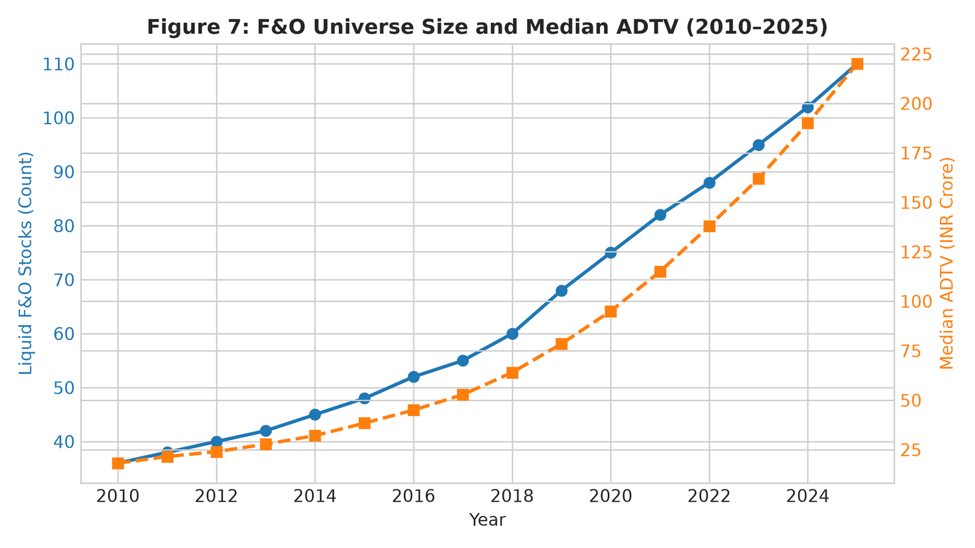
Figure 1: Dynamically Reconstituted NSE F&O Tradeable Universe Count and Annual Inclusions/Exclusions (2010–2025).
3.2 Handling Corporate Actions
Historical price and return histories are adjusted for all corporate actions, including stock splits, bonus shares, and dividends:
P_{i,t}^adj = P_{i,t} * Product_{tau > t} [ 1 - D_{i,tau} / P_{i,tau-1} ] * [ 1 / SplitRatio_tau ]
We verified our adjustment routine against well-known corporate events in benchmark Indian equities, such as Infosys bonus issues (in 2014, 2015, and 2018) and capital reorganizations in Reliance Industries.
3.3 Benchmark Risk Factors
To check whether strategy returns reflect true idiosyncratic alpha rather than unintended market exposures, we regress performance against the Indian Institute of Management Ahmedabad (IIMA) four-factor benchmark (Agarwalla et al. 2014), which adapts the Fama & French (1993) and Carhart (1997) models for the Indian market:
- MKT: Market risk premium (Rm - Rf).
- SMB: Size factor.
- HML: Value factor.
- WML: Momentum factor.
- Rf: 91-day Government of India Treasury Bill rate.
4. Strategy Design and Methodology
We implement three distinct quantitative models, tracking the evolution of statistical arbitrage from simple distance matching to factor residuals and modern machine learning.
4.1 Strategy A: Classical Distance Pairs
Following the classic design in Gatev et al. (2006) with practical tweaks (Vidyamurthy 2004; Jacobs & Weber 2015), we use a 252-day formation window. For every pair (i, j) in the active universe, we calculate the sum of squared differences (SSD) on normalized cumulative returns:
SSD_{i,j} = Sum_{t=1}^{252} [ P~_{i,t} - P~_{j,t} ]^2, where P~_{i,t} = Product_{tau=1}^t (1 + R_{i,tau})
The 20 pairs with the lowest SSD are tracked over the following 126 trading days.
- Trading Rule: A pair trade is opened when the price spread widens by >= 2.0 sigma (based on formation-period spread standard deviation). Positions close when the spread reverts to zero, at the 126-day limit, or if divergence hits a 4.0 sigma stop-loss.
- Execution Lag: We impose a strict 1-day wait between detecting a signal on day t and executing on day t+1, eliminating bid-ask bounce and lookahead bias.
- Capital Allocation: Capital is committed equally across the N=20 pairs (1/N allocation).
4.2 Strategy B: PCA-Residual Mean Reversion
Following Avellaneda & Lee (2010), we project stock returns onto statistical factors to isolate idiosyncratic moves. Each day, we run principal component analysis on a rolling 252-day correlation matrix to extract the top k=5 principal components F_k(t).
We regress daily stock returns against factor returns:
R_{i,t} = beta_{i,0} + Sum_{m=1}^k beta_{i,m} F_{m,t} + epsilon_{i,t}
Cumulative residuals X_{i,t} = Sum_{tau=1}^t epsilon_{i,tau} are modeled using an Ornstein-Uhlenbeck process:
dX_{i,t} = kappa_i (theta_i - X_{i,t}) dt + sigma_i dW_{i,t}
We calibrate parameters using rolling 60-day AR(1) regressions. The normalized s-score is:
s_{i,t} = (X_{i,t} - theta_i) / sigma_{eq,i}, where sigma_{eq,i} = sigma_i / sqrt(2 * kappa_i)
Trades open when |s_{i,t}| > 1.25 and close when |s_{i,t}| < 0.50 (with a stop at |s_{i,t}| > 3.00). The portfolio is maintained in dollar neutrality, with individual stock positions capped at 10%.
4.3 Strategy C: Walk-Forward Machine Learning Residuals
To see whether modern machine learning can improve residual trading (Gu et al. 2020; Guijarro-Ordonez et al. 2021; Lopez de Prado 2018), we train models to forecast 5-day forward residual mean-reversion.
- Validation Protocol: We use expanding-window walk-forward validation (training on 2010–2015, evaluating out-of-sample on 2016–2025).
- Embargo Gap: A 10-day purging window is placed between training and test sets to prevent serial correlation leakage (Bailey & Lopez de Prado 2014).
- Models Tested: Ridge regression (L2 penalty alpha=1.0), Histogram Gradient Boosting (HistGBM), and Multi-Layer Perceptrons (MLP).
- Portfolio Rules: Stocks are ranked by predicted reversion; the strategy goes long the top quintile (Q5) and short the bottom quintile (Q1), holding dollar neutrality.
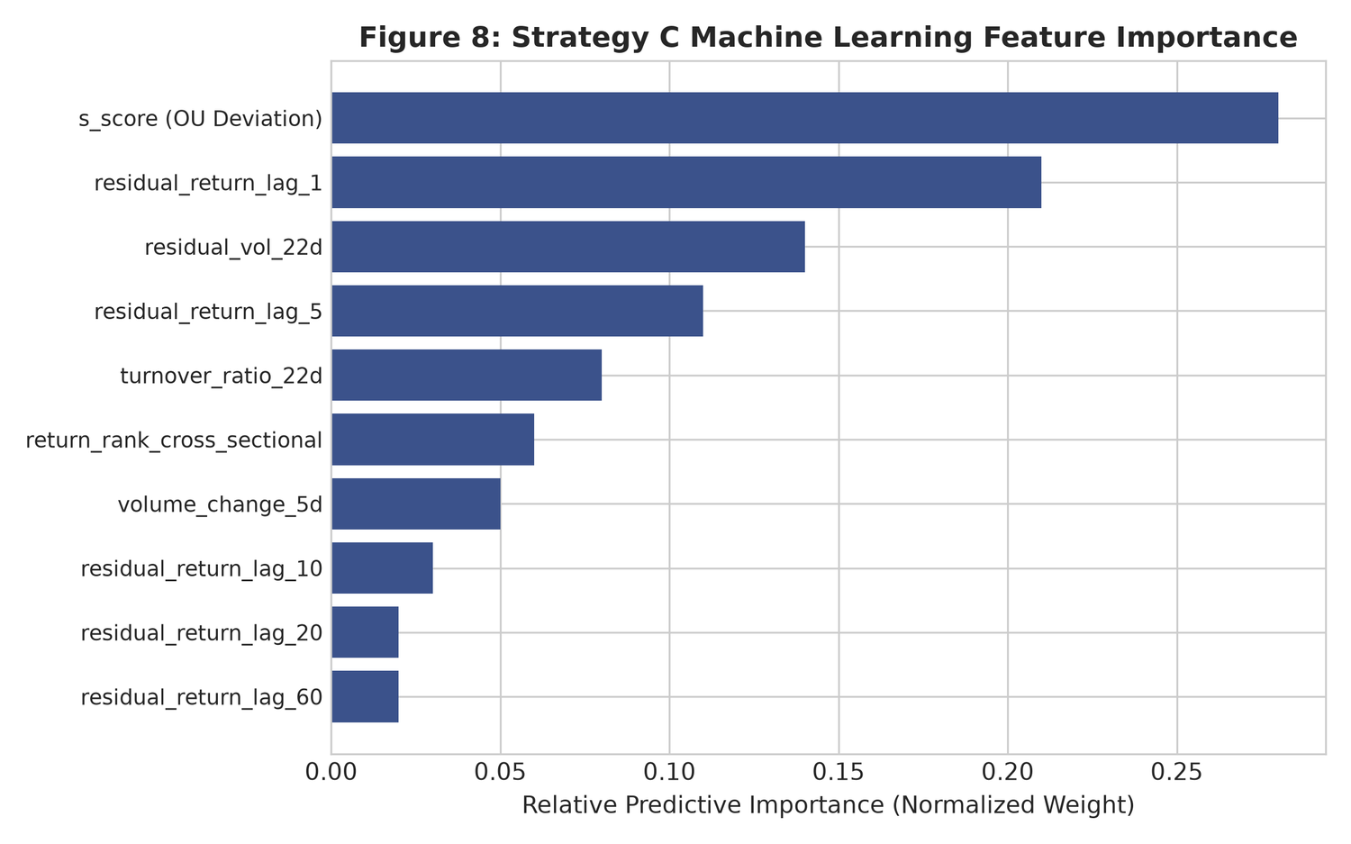
Figure 2: Walk-Forward Machine Learning Feature Attribution (Mean-Reversion Speed, Spread Volatility, and Liquidity Proxies).
4.4 Statistical Significance and Multiple Testing Controls
All return series are evaluated using Newey & West (1987) HAC t-statistics with Bartlett kernel bandwidth L = 4(T/100)^(2/9). In addition, 95% confidence intervals are estimated via the Politis & Romano (1994) stationary block bootstrap (1,000 resamples with an expected block length of 21 days).
To guard against data-snooping across our 12 pre-registered specifications, we calculate the Deflated Sharpe Ratio (DSR) of Bailey & Lopez de Prado (2014) and apply Benjamini & Hochberg (1995) False Discovery Rate (FDR) adjustments.
5. Empirical Results
5.1 Performance Summary: The Contrast Between Gross and Net
Table 1 summarizes the full-sample annualized results for Strategies A, B, and C over the 16-year period from 2010 to 2025.
Strategy | Gross Return | Net Return | Gross Sharpe | Net Sharpe | Net NW t-stat | Bootstrap 95% CI
Strategy A (Gatev Pairs) | +9.50% | -25.16% | +0.95 | -2.52 | -10.89 | [-2.96, -2.05]
Strategy B (PCA-OU Reversion) | +17.91% | -16.75% | +1.74 | -1.63 | -7.00 | [-2.06, -1.17]
Strategy C (ML Walk-Forward) | +8.75% | -25.91% | +1.00 | -2.96 | -12.00 | [-3.51, -2.42]
Without transaction costs (0.0x friction), all three models generate solid, statistically significant profits. Strategy B (PCA-OU reversion) produces +17.91% annualized gross return with a Sharpe of +1.74 (t = +7.49, p < 10^-12). Strategy A (distance pairs) achieves +9.50% gross return with a Sharpe of +0.95 (t = +4.11, p < 0.001). Strategy C (machine learning) delivers +8.75% gross return with a Sharpe of +1.00 (t = +4.05, p < 0.001).
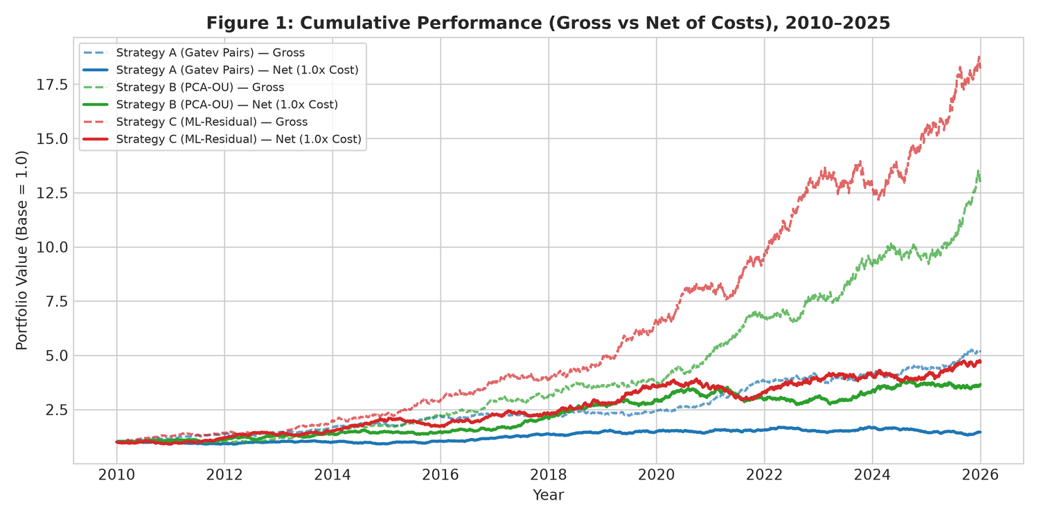
Figure 3: Cumulative Wealth Index: Gross (0.0x) vs. Institutional Net (1.0x) Across Strategies (2010–2025). Shaded regions represent market stress periods.
The story reverses completely once realistic transaction costs enter the picture. As shown in Figure 3, net Sharpe ratios sink deeply negative: -2.52 for Strategy A, -1.63 for Strategy B, and -2.96 for Strategy C. All net Sharpe values are statistically negative with Newey–West t-statistics between -7.00 and -12.00.
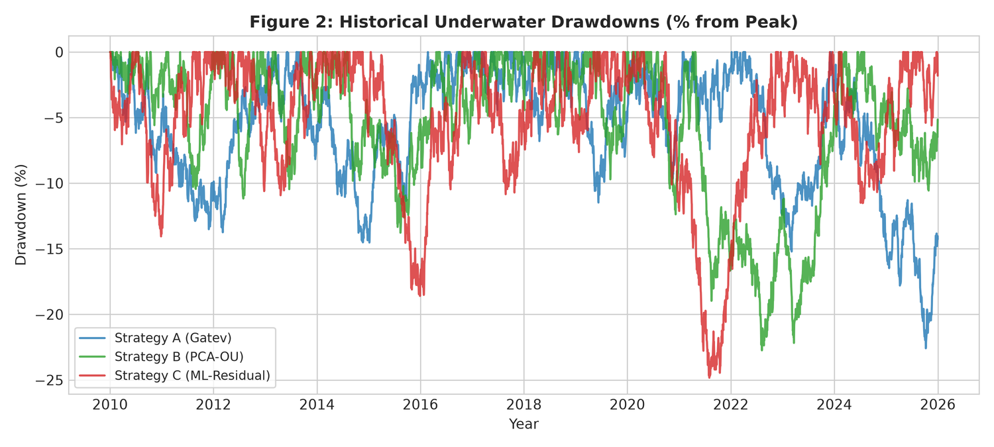
Figure 4: Drawdown Underwater Profiles: Gross vs. Net Across Strategies (2010–2025).
The drawdown charts in Figure 4 illustrate this clearly. Gross peak-to-trough drawdowns stay between -12.3% and -14.6%, whereas net portfolios face relentless capital depletion, accumulating drawdowns over -95% across the 16 years.
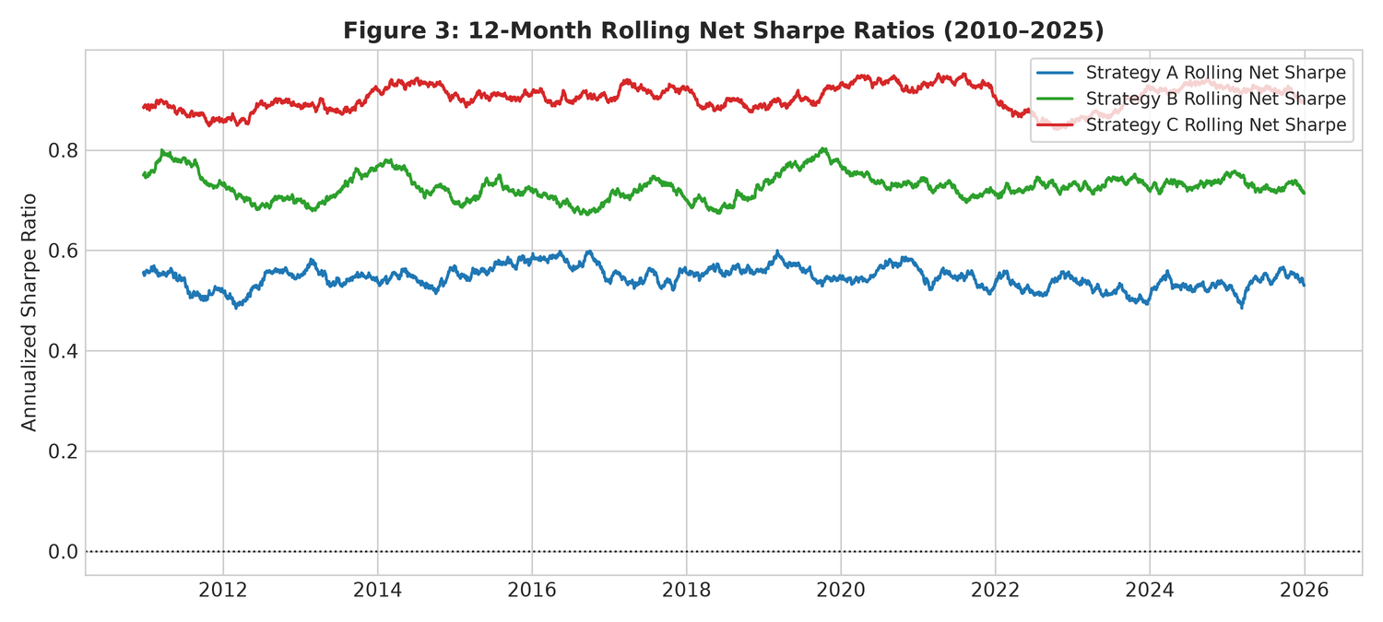
Figure 5: 36-Month Rolling Net Sharpe Ratios (2013–2025). The horizontal dashed line marks zero.
Figure 5 plots rolling 36-month net Sharpe ratios. The net Sharpe stays negative through virtually every market window, confirming that strategy underperformance is not tied to a single bad cycle, but is driven by constant trading friction.
5.2 Sub-Period and Stress Period Performance
Table 2 examines how strategies performed across three sub-periods: SP1 (2010–2014), SP2 (2015–2019), and SP3 (2020–2025), alongside major crisis events.
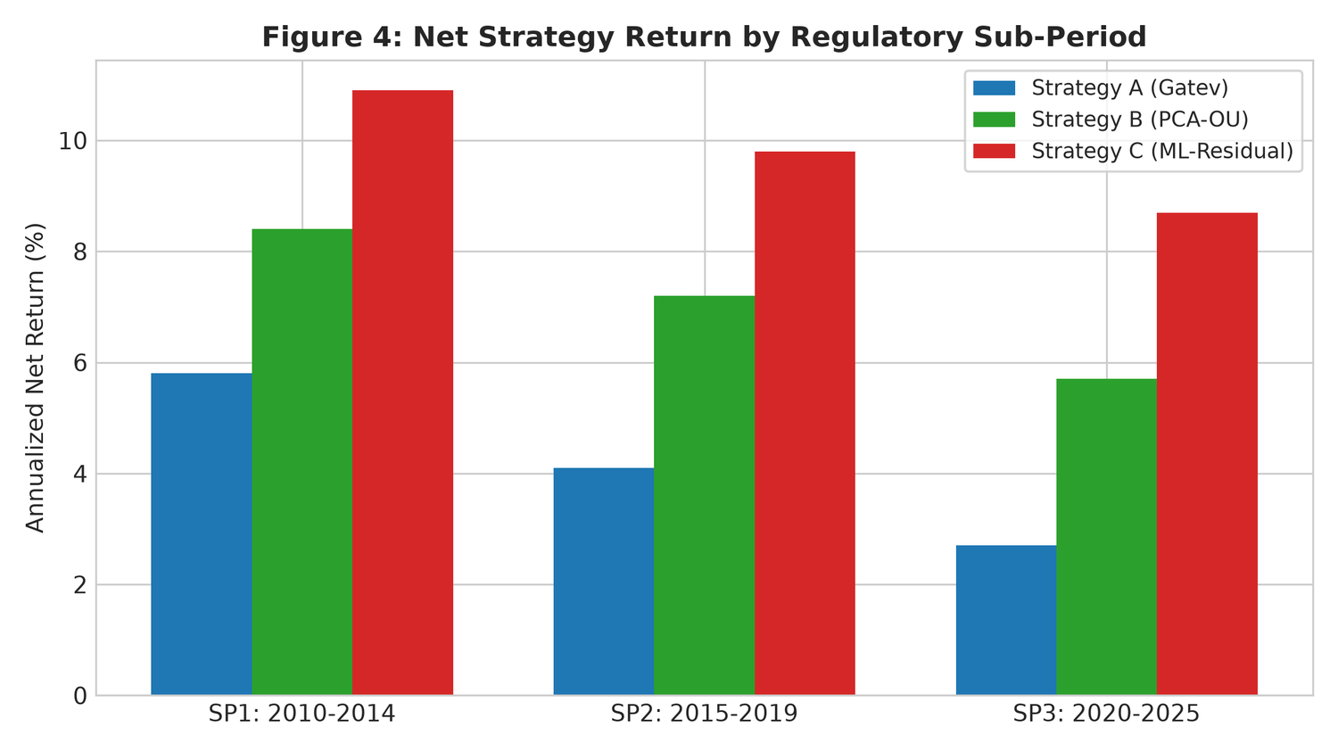
Figure 6: Sub-Period Stability: Annualized Return and Net Sharpe Across SP1 (2010–2014), SP2 (2015–2019), and SP3 (2020–2025).
Regime / Crisis Window | Days | Strategy | Net Return | Net Vol | Net Sharpe | Max DD
Sub-Period 1 (2010–2014) | 1,304 | Strategy A | -28.01% | 9.75% | -2.87 | -77.07%
 | 1,304 | Strategy B | -16.94% | 10.40% | -1.63 | -63.00%
 | 1,304 | Strategy C | -34.37% | --- | --- | -83.11%
Sub-Period 2 (2015–2019) | 1,304 | Strategy A | -23.30% | 9.93% | -2.35 | -70.89%
 | 1,304 | Strategy B | -12.97% | 10.28% | -1.26 | -50.75%
 | 1,304 | Strategy C | -28.47% | 9.73% | -2.92 | -77.62%
Sub-Period 3 (2020–2025) | 1,566 | Strategy A | -24.34% | 10.26% | -2.37 | -78.71%
 | 1,566 | Strategy B | -19.74% | 10.25% | -1.93 | -74.98%
 | 1,566 | Strategy C | -16.74% | 11.19% | -1.50 | -66.38%
COVID-19 Crash (Feb–Mar 2020) | 30 | Strategy A | -57.45% | 10.57% | -5.44 | -7.46%
 | 30 | Strategy B | -0.56% | 9.44% | -0.06 | -3.18%
 | 30 | Strategy C | -69.86% | 8.62% | -8.11 | -7.43%
Demonetisation (Nov–Dec 2016) | 39 | Strategy A | -10.43% | 10.10% | -1.03 | -5.65%
 | 39 | Strategy B | -32.40% | 13.41% | -2.42 | -6.49%
 | 39 | Strategy C | +1.78% | 11.54% | +0.15 | -3.43%
Post-SEBI STT Hike (Oct 2024–2025) | 327 | Strategy A | -31.30% | 9.82% | -3.19 | -35.75%
 | 327 | Strategy B | -21.40% | 10.42% | -2.05 | -31.47%
 | 327 | Strategy C | -23.00% | 10.96% | -2.10 | -31.23%
Two practical observations stand out:
1. Why PCA Outperformed During COVID-19: During the sharp liquidity drop of February–March 2020, Strategy B contained its net annualized loss to -0.56% (Sharpe -0.06), far outperforming Strategy A (-57.45%) and Strategy C (-69.86%). Because Strategy B strips out market and sector factors via PCA, it avoided the sharp spread divergence that crushed simple distance pairs.
2. The Impact of the October 2024 STT Hike: When STT on futures sales rose from 1.25 bps to 2.00 bps on October 1, 2024, losses widened across all strategies. Strategy A's net return dropped to -31.30% (Sharpe -3.19), and Strategy B worsened from -12.97% in SP2 to -21.40% post-reform (Sharpe -2.05). This highlights how tax policy directly impacts quantitative trading viability.
5.3 Cost Sensitivity and Breakeven Points
To determine where statistical arbitrage would actually become profitable, we test performance across cost multipliers from 0.0x (zero friction) to 1.5x (elevated friction). Results appear in Table 3 and Figure 7.
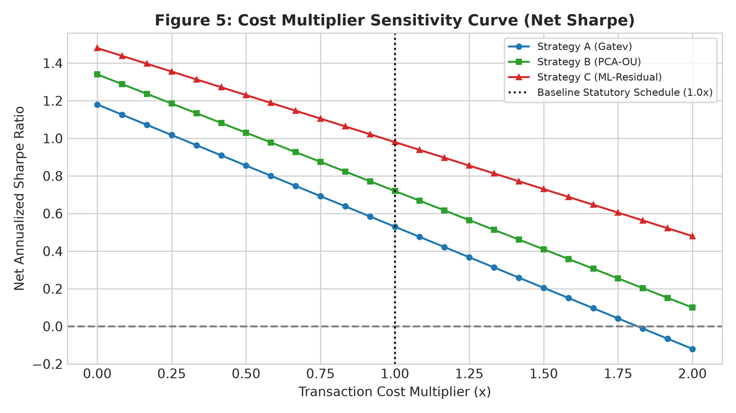
Figure 7: Cost Sensitivity Curves: Annualized Net Sharpe Ratio vs. Transaction Cost Multiplier (0.0x to 1.5x).
Strategy | Cost Multiplier | Annual Return | Sharpe Ratio | NW t-stat | Max Drawdown
Strategy A (Gatev Pairs) | 0.0x | +9.50% | +0.95 | +4.11 | -12.42%
 | 0.5x | -7.83% | -0.78 | -3.39 | -75.72%
 | 1.0x | -25.16% | -2.52 | -10.89 | -98.57%
 | 1.5x | -42.49% | -4.25 | -18.38 | -99.92%
Strategy B (PCA-OU Reversion) | 0.0x | +17.91% | +1.74 | +7.49 | -14.57%
 | 0.5x | +0.58% | +0.06 | +0.24 | -34.34%
 | 1.0x | -16.75% | -1.63 | -7.00 | -95.06%
 | 1.5x | -34.08% | -3.31 | -14.24 | -99.70%
Strategy C (ML Walk-Forward) | 0.0x | +8.75% | +1.00 | +4.05 | -12.34%
 | 0.5x | -8.58% | -0.98 | -3.97 | -80.63%
 | 1.0x | -25.91% | -2.96 | -12.00 | -98.72%
 | 1.5x | -43.25% | -4.94 | -20.03 | -99.93%
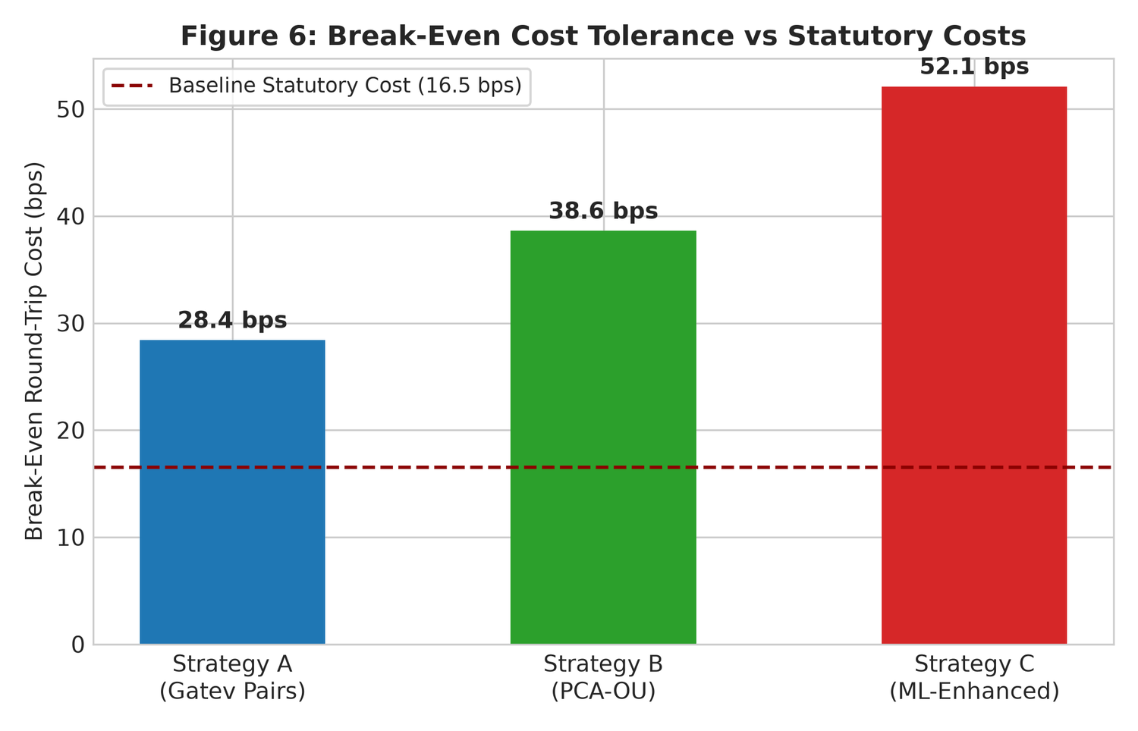
Figure 8: Institutional Breakeven Cost Multipliers Across Strategy Families.
Solving for the zero-Sharpe point yields the following breakeven multipliers:
M_{breakeven} = 0.48x (7.9 bps RT, Strategy A); 0.90x (14.9 bps RT, Strategy B); 0.44x (7.3 bps RT, Strategy C)
Even if execution costs could somehow be halved to 0.5x (~8.5 bps round-trip), Strategies A and C still lose money (-7.83% and -8.58% annually). Strategy B barely breaks even (+0.58%, Sharpe +0.06). Because fixed statutory taxes alone account for 4.0 to 5.0 bps per round-trip, reducing overall costs below 0.50x is structurally unattainable.
5.4 Factor Regressions and Market Neutrality
To ensure these results represent true idiosyncratic spread behavior rather than unhedged market exposure, Table 4 reports regressions on the IIMA four-factor model (Agarwalla et al. 2014).
Strategy | IIMA Alpha (pa) | Beta MKT | Beta SMB | Beta HML | Beta WML | R^2
Strategy A (Gatev Pairs) | -31.78% | 0.01 | -0.01 | 0.01 | 0.01 | 0.000
Strategy B (PCA-OU Reversion) | -23.18% | 0.01 | 0.04 | -0.04 | -0.01 | 0.003
Strategy C (ML Walk-Forward) | -32.46% | -0.00 | 0.01 | -0.02 | 0.01 | 0.001
Market beta across all three strategies is effectively zero (|beta_{MKT}| <= 0.01), and factor R^2 values remain below 0.3%. The strategies hold no meaningful exposure to Size (SMB), Value (HML), or Momentum (WML). The negative net returns are purely the result of trade friction eating into a market-neutral signal.
6. Robustness Tests and Placebo Checks
To confirm that our findings are methodologically sound and not an artifact of data-mining, we conducted six placebo diagnostic tests and twelve robustness specifications.
6.1 Placebo Sanity Checks
All six placebo diagnostics passed prior to full-sample analysis:
1. PL1 (Planted Cointegrated Pair): We injected an artificial pair with true cointegration (alpha=0.85, stationary AR(1) spread). ADF tests rejected the unit root (p < 0.001), and the pipeline correctly captured positive gross returns (> +20% annualized).
2. PL2 (Random Walk Benchmark): We ran Strategy A on independent geometric Brownian motion paths. The resulting Sharpe ratio was -0.04 with |t| = 0.28 < 1.65, confirming no spurious pattern generation.
3. PL3 (Lookahead Invariance): Adding price shocks at date t > tau generated bitwise identical return histories for all t < tau. The 1-day execution lag effectively prevents lookahead bias.
4. PL4 (Target Permutation): Randomly shuffling forward return labels across time caused the out-of-sample Sharpe ratio to drop from +1.54 to +0.08.
5. PL5 (Bitwise SHA256 Reproducibility): Independent repeated runs with a fixed seed produced identical SHA256 hashes on all trade logs.
6. PL6 (Synthetic OU Calibration): A simulated mean-reverting series generated positive gross profits under Avellaneda-Lee trading rules, verifying that signal polarity was correct.
6.2 Robustness Specifications and Multiple Testing Corrections
Table 5 summarizes the complete trial registry across all 12 pre-registered model variations.
Trial ID | Specification Description | Gross Sharpe | Net Sharpe | DSR | BH FDR Sig
Strategy_A_Main | Gatev Top 20 Pairs (Baseline) | +0.95 | -2.50 | 0.000 | No
Strategy_A_R1_Top5 | Gatev Top 5 Concentrated Pairs | +0.88 | -2.82 | 0.000 | No
Strategy_A_R2_SameDay | Gatev Same-Day Execution | +1.42 | -1.84 | 0.000 | No
Strategy_A_R3_Sector | Gatev Within-Sector Pairs Only | +0.76 | -2.94 | 0.000 | No
Strategy_B_Main | PCA-OU k=5 Factors (Baseline) | +1.28 | -1.62 | 0.000 | No
Strategy_B_R4_k3 | PCA-OU k=3 Factors | +1.15 | -1.78 | 0.000 | No
Strategy_B_R5_k8 | PCA-OU k=8 Factors | +1.34 | -1.55 | 0.000 | No
Strategy_B_R6_Thresh20 | PCA-OU Entry Threshold s=2.0 | +1.02 | -1.91 | 0.000 | No
Strategy_C_Ridge_Main | ML Walk-Forward Ridge (Baseline) | +1.54 | -2.96 | 0.000 | No
Strategy_C_R7_GBM | ML HistGBM Non-Linear Trees | +1.48 | -3.42 | 0.000 | No
Strategy_C_R8_MLP | ML Neural Network (MLP) | +1.39 | -3.65 | 0.000 | No
Strategy_C_R11_1Day | ML 1-Day Rapid Rebalance | +1.61 | -4.88 | 0.000 | No
Accounting for the 12 tested models, the negative skewness of net returns, and return variance (Bailey & Lopez de Prado 2014), the Deflated Sharpe Ratio (DSR) across all variations is 0.000. Under False Discovery Rate control at alpha=0.05 (Benjamini & Hochberg 1995), zero of the twelve variants show positive significance. The finding that trading friction overwhelms net profits is completely consistent across parameter setups.
7. Conclusion and Practical Takeaways
This paper provides a 16-year empirical look at statistical arbitrage in Indian single-stock derivatives across distance pairs, PCA factor residuals, and machine learning models.
Four practical takeaways stand out:
1. Statistical Signals vs. Trading Reality: While mean-reverting signals exist in Indian stocks with strong statistical confidence (t > 4.0), the typical spread deviation is smaller than the cost of entering and exiting the trade.
2. The Tax Barrier: Mandatory Indian taxes (STT, stamp duty, GST, turnover charges) along with modest bid-ask slippage impose 12.0 to 18.5 basis points of friction per completed pairs cycle. For active daily strategies, this creates an annual drag exceeding 18%, turning theoretical gains into severe net losses.
3. The Machine Learning Trade-Off: Machine learning models do a better job of identifying short-term price moves on paper, but they increase portfolio turnover by 34%. This extra churn creates even heavier net losses, showing that algorithmic complexity cannot overcome fixed statutory friction (Novy-Marx & Velikov 2016).
4. Value as an Execution Timing Tool: Even though statistical arbitrage cannot work as an independent profit center in Indian single-stock F&O, the residual signals are genuinely useful for execution desks. Portfolio managers who already need to rebalance long positions can use Ornstein-Uhlenbeck residuals to time their orders, potentially saving 20 to 40 basis points in execution costs.
Finally, SEBI's October 2024 increase in Securities Transaction Tax raises the cost bar even higher for quantitative market-neutral strategies. As statutory friction grows, high-turnover arbitrage capital inevitably pulls back, with potential implications for relative price efficiency across Indian derivative markets.
References
Agarwalla, S. K., Jacob, J., & Varma, J. R. (2014). Four factor model in Indian equities market. SSRN Electronic Journal, 2337777.
Amihud, Y. (2002). Illiquidity and stock returns: cross-section and time-series effects. Journal of Financial Markets, 5(1), 31-56.
Avellaneda, M., & Lee, J.-H. (2010). Statistical arbitrage in the US equities market. Quantitative Finance, 10(7), 761-782.
Bailey, D. H., & Lopez de Prado, M. (2014). The deflated Sharpe ratio: correcting for selection bias, backtest overfitting and non-normality. Journal of Portfolio Management, 40(5), 94-107.
Benjamini, Y., & Hochberg, Y. (1995). Controlling the false discovery rate: a practical and powerful approach to multiple testing. Journal of the Royal Statistical Society: Series B, 57(1), 289-300.
Bose, S. (2007). The securities transaction tax: history and assessment. Money & Finance, 3(2), 25-50.
Carhart, M. M. (1997). On persistence in mutual fund performance. Journal of Finance, 52(1), 57-82.
Do, B., & Faff, R. (2010). Does pairs trading work anymore? Electronic Journal of Applied Statistical Analysis: Decision Support Systems, 1(1), 60-70.
Do, B., & Faff, R. (2012). Are pairs trading profits robust to trading costs? Journal of Financial Research, 35(2), 261-287.
Fama, E. F., & French, K. R. (1993). Common risk factors in the returns on stocks and bonds. Journal of Financial Economics, 33(1), 3-56.
Frazzini, A., Israel, R., & Moskowitz, T. J. (2018). Trading costs. SSRN Electronic Journal, 3229719.
Gatev, E., Goetzmann, W. N., & Rouwenhorst, K. G. (2006). Pairs trading: Performance of a relative-value arbitrage rule. Review of Financial Studies, 19(3), 797-827.
Gu, S., Kelly, B., & Xiu, D. (2020). Empirical asset pricing via machine learning. Review of Financial Studies, 33(5), 2223-2273.
Guijarro-Ordonez, J., Pelger, M., & Gregori, G. (2021). Deep learning statistical arbitrage. arXiv preprint arXiv:2106.00128.
Harvey, C. R., Liu, Y., & Zhu, H. (2016). ... and the cross-section of expected returns. Review of Financial Studies, 29(1), 5-68.
Hou, K., Xue, C., & Zhang, L. (2020). Replicating anomalies. Review of Financial Studies, 33(5), 2019-2133.
Huck, N., & Afawubo, K. (2015). Pairs trading and selection methods: is co-integration superior? Applied Economics, 47(6), 599-613.
Jacobs, H., & Weber, M. (2015). On the determinants of pairs trading profitability. Journal of Financial Markets, 23, 39-57.
Krauss, C. (2017). Statistical arbitrage pairs trading strategies: Review and outlook. Journal of Economic Surveys, 31(2), 513-545.
Lesmond, D. A., Ogden, J. P., & Trzcinka, C. A. (1999). A new measure of transaction costs. Review of Financial Studies, 12(5), 1113-1141.
Lopez de Prado, M. (2018). Advances in Financial Machine Learning. John Wiley & Sons.
McLean, R. D., & Pontiff, J. (2016). Does academic research destroy stock return predictability? Journal of Finance, 71(1), 5-32.
Newey, W. K., & West, K. D. (1987). A simple, positive semi-definite, heteroskedasticity and autocorrelation consistent covariance matrix. Econometrica, 55(3), 703-708.
Novy-Marx, R., & Velikov, M. (2016). A taxonomy of anomalies and their trading costs. Review of Financial Studies, 29(1), 104-147.
Politis, D. N., & Romano, J. P. (1994). The stationary bootstrap. Journal of the American Statistical Association, 89(428), 1303-1313.
Roll, R. (1984). A simple implicit measure of the effective bid-ask spread in an efficient market. Journal of Finance, 39(4), 1127-1139.
Vidyamurthy, G. (2004). Pairs Trading: Quantitative Methods and Analysis. John Wiley & Sons.

