LinkedIn Job Market Analytics
Phase 1 — Data Profiling, Cleaning, and Ingestion Report
Dhairya P. Mishra (NetID: dpm8739)
Big Data Application Development — Spring 2026

1. Project Context
This project investigates whether companies that experienced public layoffs between 2020 and 2026 hire differently than the rest of the US job market in 2023-2024. The analytical thesis is operationalised as a cohort comparison between layoff-affected and non-affected employers, evaluated across three angles: salary and experience-level mix, skills mix, and geographic and remote distribution.
Phase 1, the scope of this report, covers ingestion only: profiling and cleaning each raw data source and producing a reproducible cleaned dataset for downstream analytics. All work is performed in Apache Spark (PySpark) running inside the official jupyter/pyspark-notebook Docker image. Each script is invoked via spark-submit; no notebooks or interactive shells are used. Outputs are written as Snappy Parquet (for cleaned datasets) and single-file CSV (for human-readable profile summaries and run logs).
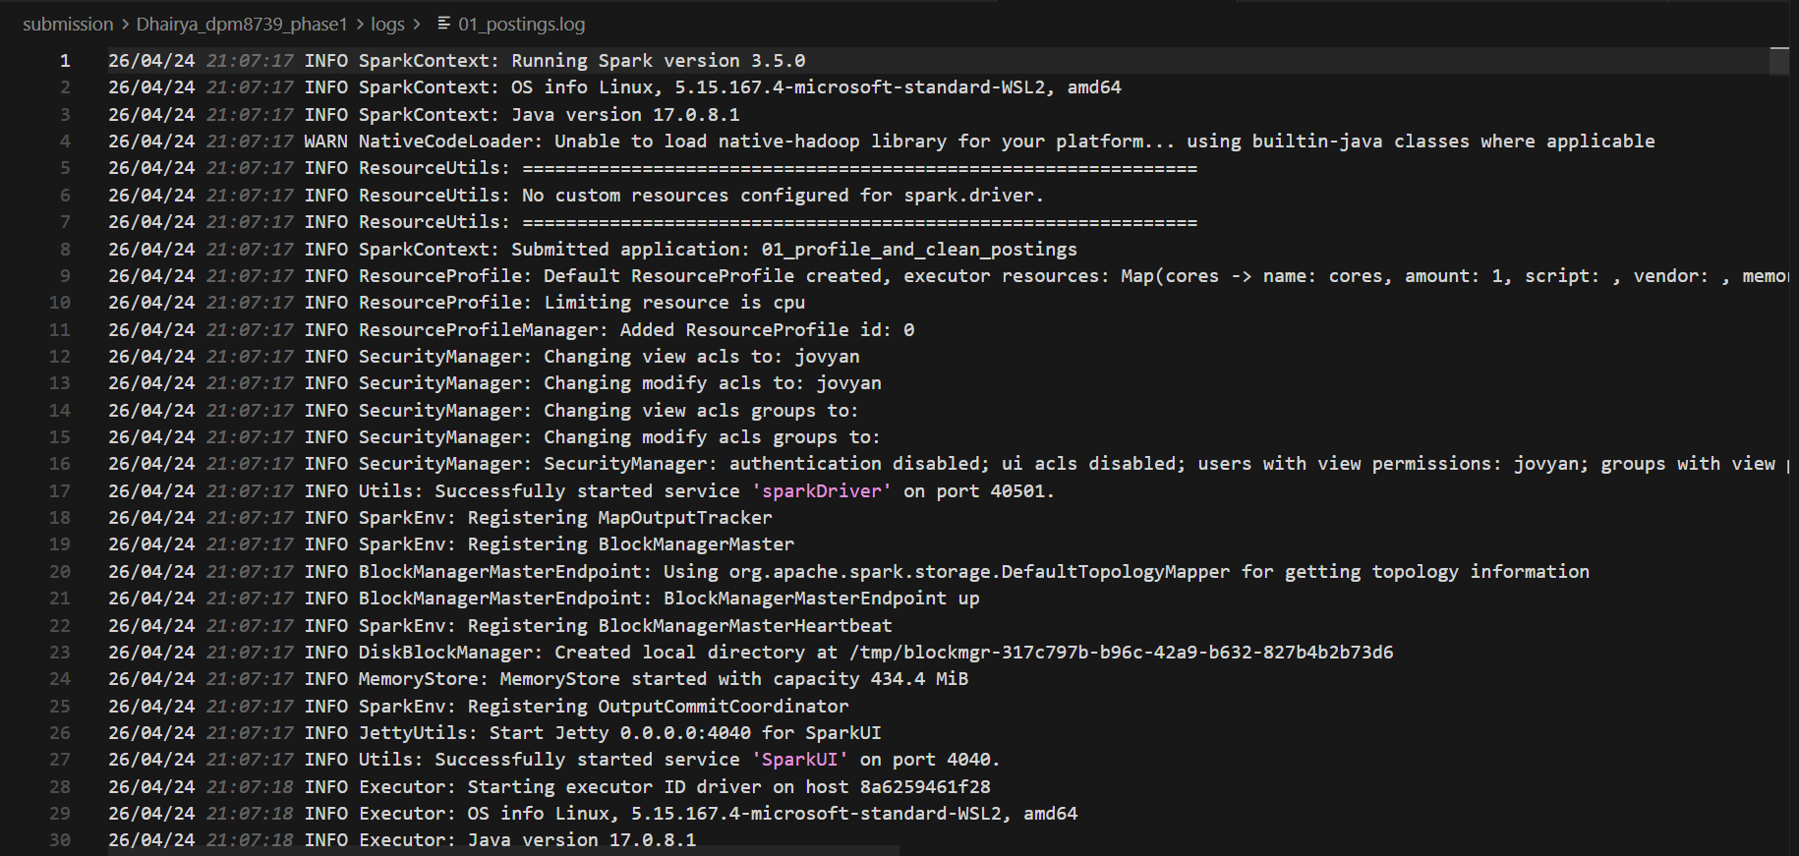
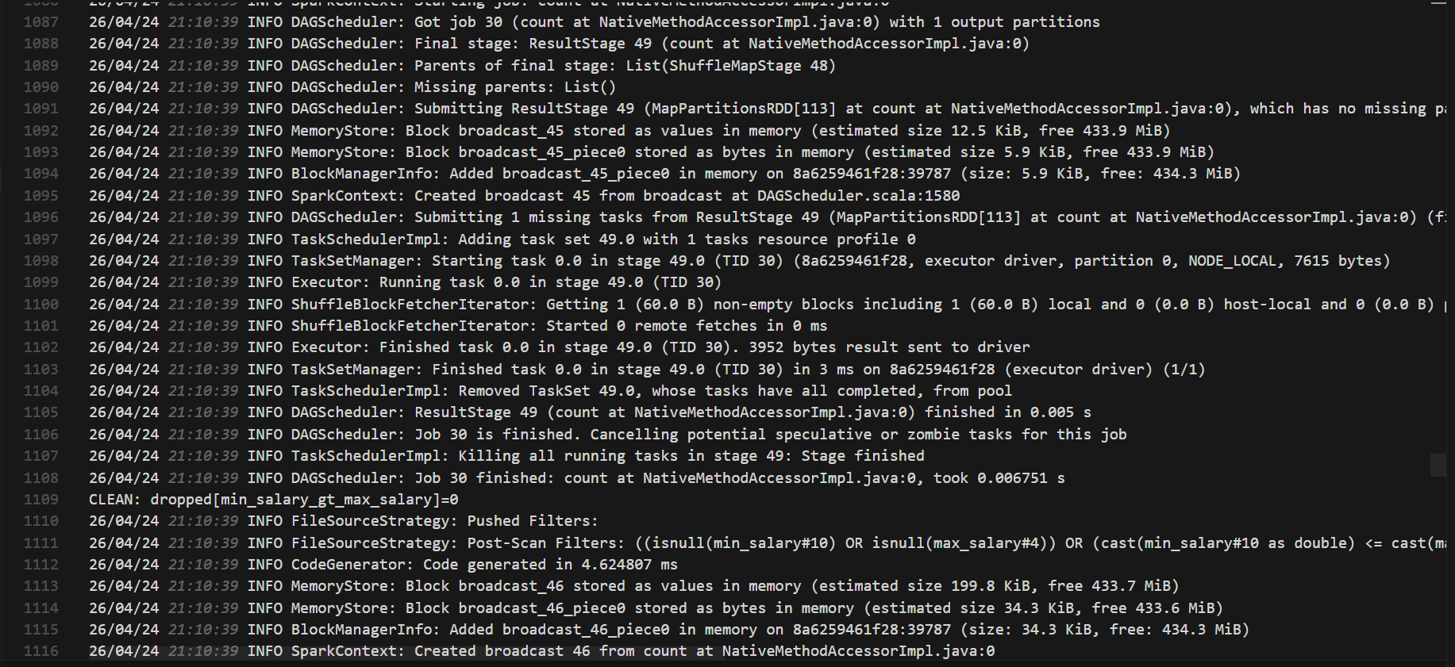
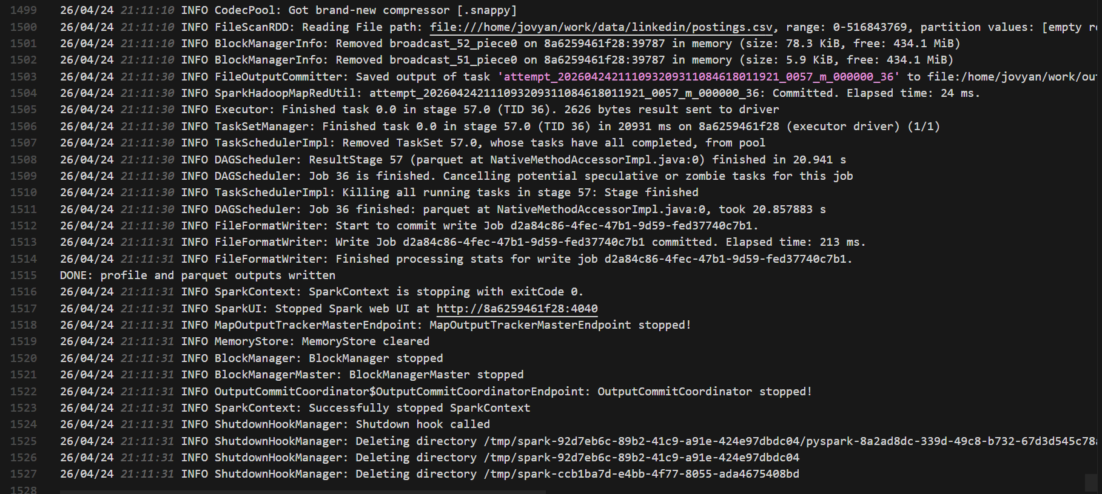
[SCREENSHOTS: Terminal showing successful spark-submit run inside the Docker container]

2. Data Sources at a Glance
Three public datasets are ingested. As a solo team (professor-approved), all three are this submitter’s responsibility.
# | Source | Origin / License | Role in the analysis
1 | LinkedIn Job Postings (2023–2024) | Kaggle: arshkon/linkedin-job-postings (~123k rows, ~500 MB CSV) | Primary observations: 2023–2024 US postings.
2 | LinkedIn Skills mapping | Same Kaggle dataset; two files: jobs/job_skills.csv and mappings/skills.csv | Maps each job_id to a normalized list of skill tags.
3 | Tech Layoffs (2020–2026) | Kaggle: swaptr/layoffs-2022 (continuously refreshed; ~4.3k rows) | Defines the layoff-affected cohort by company name.

3. Source 1 — LinkedIn Job Postings
The LinkedIn dataset contains ~123,849 raw job postings scraped during 2023-2024. The raw CSV has 31 columns and uses multi-line description fields with embedded quotes; all reads use header=True, multiLine=True, escape='"', quote='"' to parse correctly. Spark’s default CSV options misalign rows with embedded newlines.

Schema decisions
Eighteen columns are kept and thirteen are dropped. Kept columns: job_id, company_id, company_name, title, location, formatted_work_type, formatted_experience_level, remote_allowed, min_salary, max_salary, med_salary, pay_period, normalized_salary, currency, views, applies, original_listed_time, zip_code. Dropped columns: description, skills_desc, job_posting_url, application_url, posting_domain, application_type, closed_time, expiry, listed_time, sponsored, work_type, compensation_type, fips. Dropped columns are either redundant (work_type vs formatted_work_type), high-volume free text (description, skills_desc), or PII/URL fields not relevant to the analysis.

Profiling findings (raw)
- Raw row count: 123,849.
- Null-rate highlights: company_name 1.4% (1,719 rows), formatted_experience_level 23.8% (29,409 rows), remote_allowed 87.7% (108,603 rows; treated as not-remote in cleaning), normalized_salary 71% (87,776 rows), zip_code 16.8% (20,872 rows).
- Distinct value counts: 7 work types, 7 experience levels, 7 currency codes (USD dominates).
- Numeric describe: normalized_salary mean approx $94k, range from <$1k (clear data errors) to >$10M.

Cleaning rules applied (in order, with drop counts)
- Project to the 18 kept columns (drops the 13 free-text/redundant/PII columns).
- Split location on ',' to derive lower-cased, trimmed city and state columns; the original location column is retained for display.
- Cast zip_code as StringType to preserve leading zeros (never cast to integer).
- Convert original_listed_time (epoch milliseconds) to a new listed_date column via from_unixtime(col("original_listed_time")/1000).cast("date").
- Drop rows where min_salary > max_salary when both are present (dropped 0 rows).
- Drop rows where normalized_salary is outside [10,000, 1,000,000] sanity bounds; null normalized_salary rows are kept (dropped 455 rows).
- Cast remote_allowed to Boolean: 1 → true, anything else (0, null, empty) → false.
- Add company_normalized via lower(trim(regexp_replace(company_name, "(?i)\s*(inc|corp|corporation|llc|ltd|limited)\.?$", ""))) for downstream joins.

Final dataset
Cleaned row count: 123,394 (455 rows dropped, ~0.37% of raw). Output: output/parquet/postings/ as Snappy Parquet, ~6.1 MB. Profile summary: output/profiles/postings/ in long form (dataset, column, metric, value). Sample: snippets/postings_sample.csv (20 rows, 22 columns).
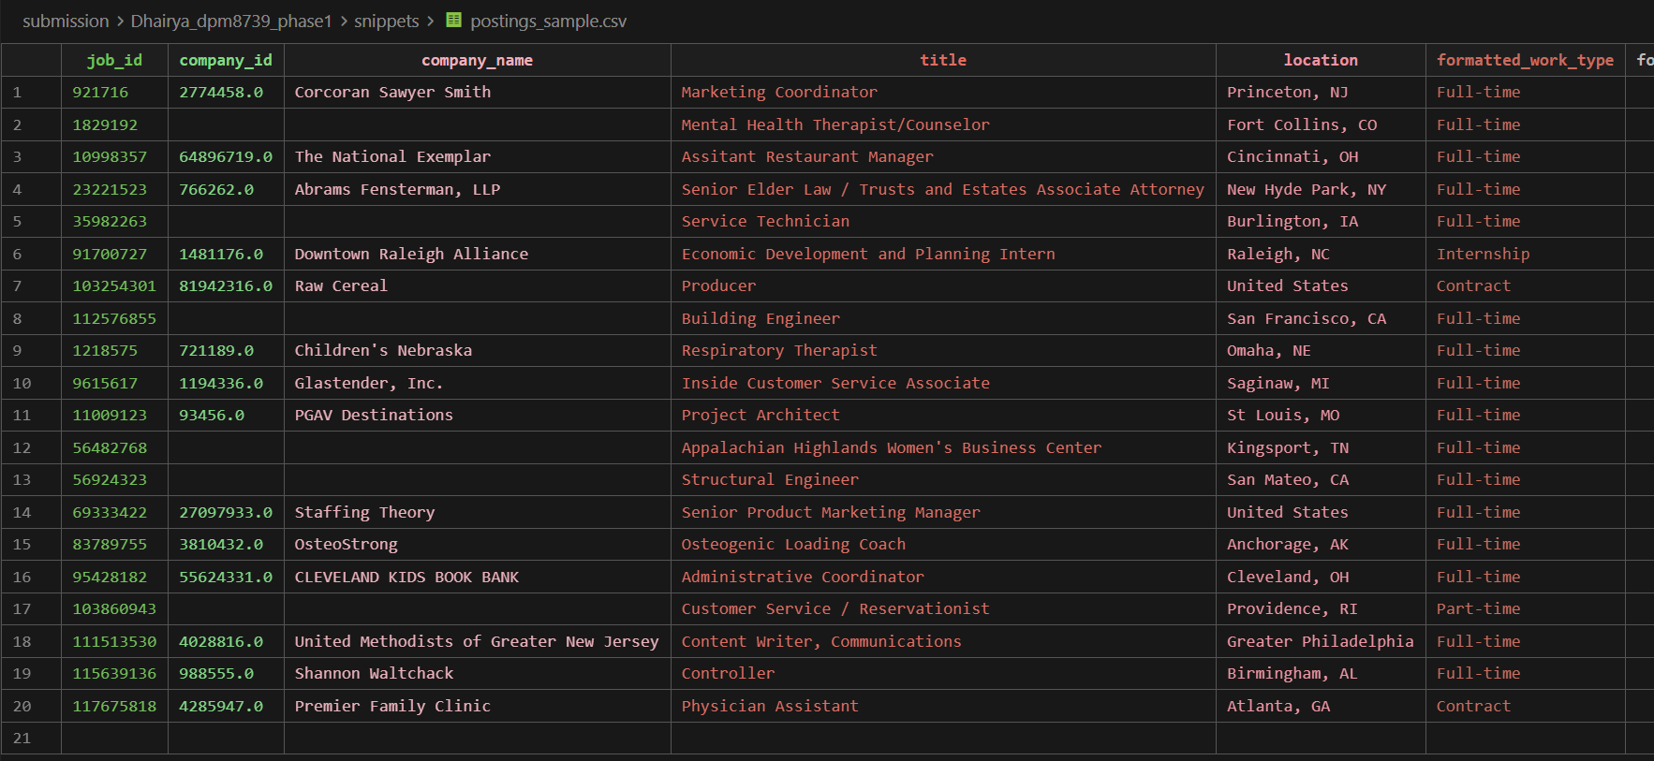
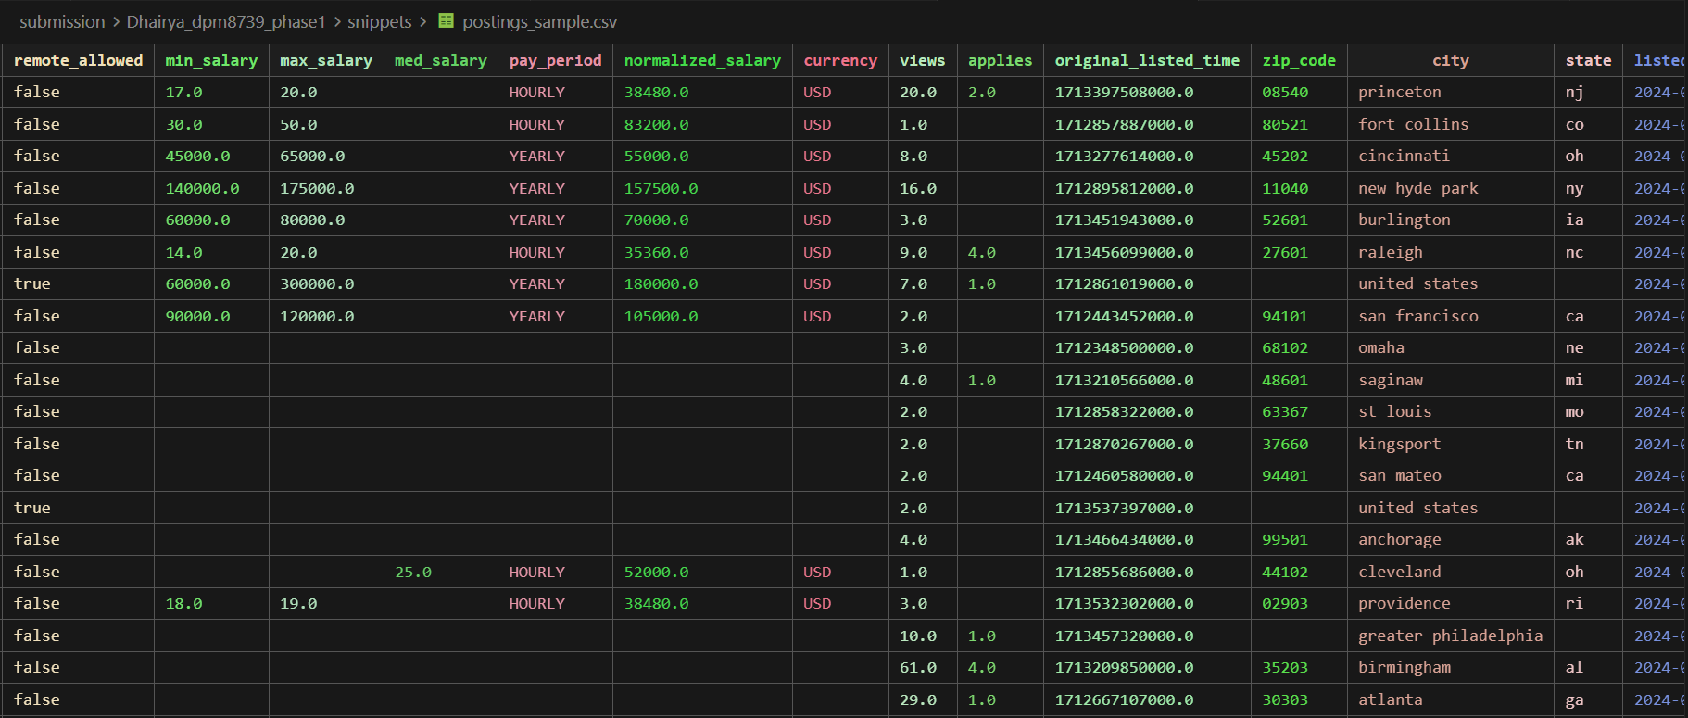
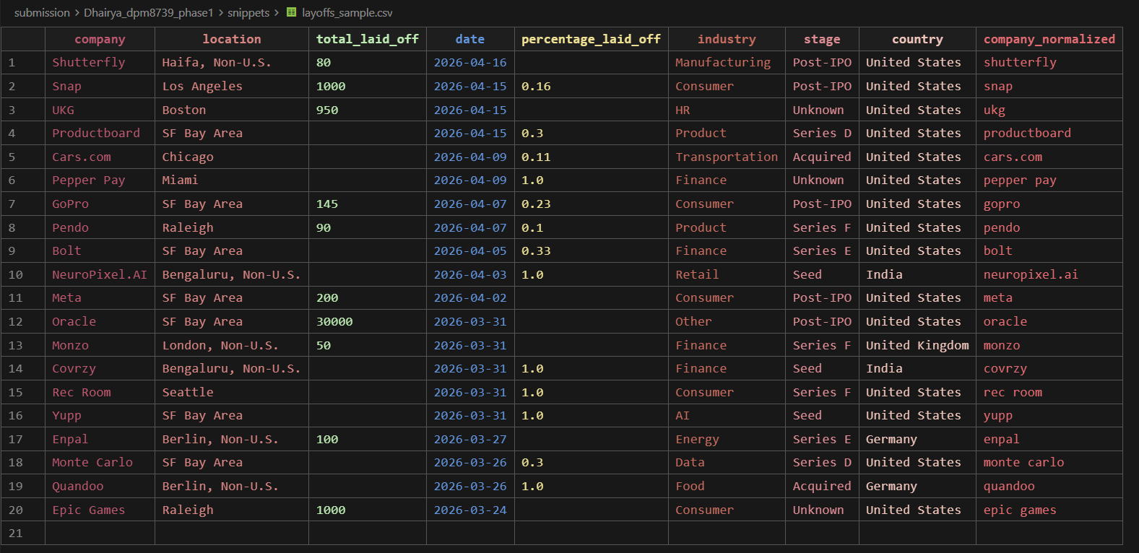
[SCREENSHOT: Sample rows from postings_sample.csv and layoffs_sample.csv]

4. Source 2 — LinkedIn Skills Mapping
Two files: jobs/job_skills.csv (job_id ↔ skill_abr, ~213,768 rows) and mappings/skills.csv (skill_abr → skill_name, 35 distinct skill codes such as ENG, IT, ANLS, MGMT). The mapping table is small and well-defined; the join is one-to-many on the skill code.

Cleaning rules applied (in order, with drop counts)
- Profile both files independently (schema, row count, null counts, distinct counts on skill_abr).
- Left join job_skills to skills on skill_abr.
- Drop rows where skill_name is null after the join (orphan skill codes; dropped 0 rows).
- Deduplicate on (job_id, skill_abr) (dropped 0 rows).

Final dataset
Cleaned row count: 213,768 with three columns (job_id, skill_abr, skill_name). No orphans and no duplicates were present in the source; the join is integrity-preserving. Output: output/parquet/skills/ as Snappy Parquet, ~1.4 MB. Sample: snippets/skills_sample.csv.

5. Source 3 — Tech Layoffs (2020–2026)
Continuously refreshed Kaggle dataset. The label “layoffs-2022” in the slug is historical; the file currently spans 2020-03-11 to 2026-04-16 (4,357 raw rows). Date strings use the M/d/yyyy format. Some rows have null total_laid_off but a non-null percentage_laid_off, and vice versa.

Schema decisions
Kept columns: company, location, total_laid_off, date, percentage_laid_off, industry, stage, country. Dropped columns: source, funds_raised, date_added (irrelevant or downstream metadata).

Cleaning rules applied (in order, with drop counts)
- Parse date with format M/d/yyyy into a DateType column (replace the original).
- Drop rows where BOTH total_laid_off AND percentage_laid_off are null (dropped 714 rows, 16.4%).
- Cast total_laid_off as IntegerType.
- Cast percentage_laid_off as DoubleType.
- Add company_normalized using the same regex as the postings source so the two datasets can be joined on a normalized key.

Final dataset
Cleaned row count: 3,643. Output: output/parquet/layoffs/ as Snappy Parquet, ~89 KB. Sample: snippets/layoffs_sample.csv (20 rows, 9 columns).

6. Spark Techniques Used
All three ingestion scripts use the high-level DataFrame API together with Spark SQL functions. RDDs are not used directly; everything is expressed as DataFrame transformations and aggregations. The full list of Spark constructs used across scripts 01–03 is summarized below.
- Cluster + session: SparkSession.builder.appName(...).getOrCreate(); spark.stop() at the end of each script for clean shutdown.
- Ingestion: spark.read.option("header", True).option("multiLine", True).option("escape", '"').option("quote", '"').csv(path) for quote-embedded CSVs.
- Profiling: df.printSchema(), df.count(), df.distinct().count(), df.describe(), df.show(n, truncate=False) for sample rows.
- Null profiling: a single aggregation that computes per-column null counts via F.sum(F.when(F.col(c).isNull(), 1).otherwise(0)).alias(c) over all columns.
- Top-N value counts on key categoricals via groupBy(col).count().orderBy(F.desc("count")).show(10).
- Transformations: select, withColumn, filter, dropDuplicates(["job_id", "skill_abr"]), join (left).
- Spark SQL functions used: F.col, F.lit, F.when, F.lower, F.trim, F.regexp_replace, F.split, F.from_unixtime, F.to_date, F.sum, F.desc.
- Type casting: .cast("int"), .cast("double"), .cast("string"), .cast("date") for explicit type control after ingestion.
- Persistence: df.write.mode("overwrite").parquet(path) for cleaned datasets; df.coalesce(1).write.mode("overwrite").option("header", True).csv(path) for human-readable single-file profile CSVs.
- Long-form profile output construction: spark.createDataFrame(metrics_list, schema=[...]) builds a (dataset, column, metric, value) DataFrame from an in-memory list of tuples, providing a uniform shape for all three sources.
Logging is grep-friendly: each script prints labelled lines such as PROFILE:, CLEAN:, and DONE: to stdout so the run log itself is the audit trail for what happened during ingestion.

7. Data Quality Notes and Limitations
- Postings: approximately 1.4% of cleaned rows (1,709) have null company_normalized. These rows are kept in the cleaned dataset but will be excluded from any cohort analysis that requires the company key.
- Postings: ~71% of rows have null normalized_salary in raw form. Salary-based queries downstream will filter to non-null USD rows; this is documented as a deferred query-time filter rather than a cleaning-time drop.
- Layoffs: dataset slug labels it “2022” but the data is continuously updated through 2026; current cut spans 2020-03-11 to 2026-04-16.
- Skills: zero orphans and zero duplicates in the raw join; this is convenient and likely reflects Kaggle’s upstream curation rather than a robust property of LinkedIn data in general.
- All three sources are static snapshots/refreshes. The project does not yet integrate streaming or live data.

8. How to Run
From the project root, in PowerShell:
docker run --rm -v "${PWD}:/home/jovyan/work" --memory=8g jupyter/pyspark-notebook bash -lc "set -e; cd /home/jovyan/work && spark-submit scripts/01_profile_and_clean_postings.py 2>&1 | tee output/logs/01_postings.log && spark-submit scripts/02_profile_and_clean_skills.py 2>&1 | tee output/logs/02_skills.log && spark-submit scripts/03_profile_and_clean_layoffs.py 2>&1 | tee output/logs/03_layoffs.log"
Total runtime: approximately 5 minutes on a laptop with 8 GB RAM allocated to Docker. Outputs land under output/parquet/, output/profiles/, and output/logs/.
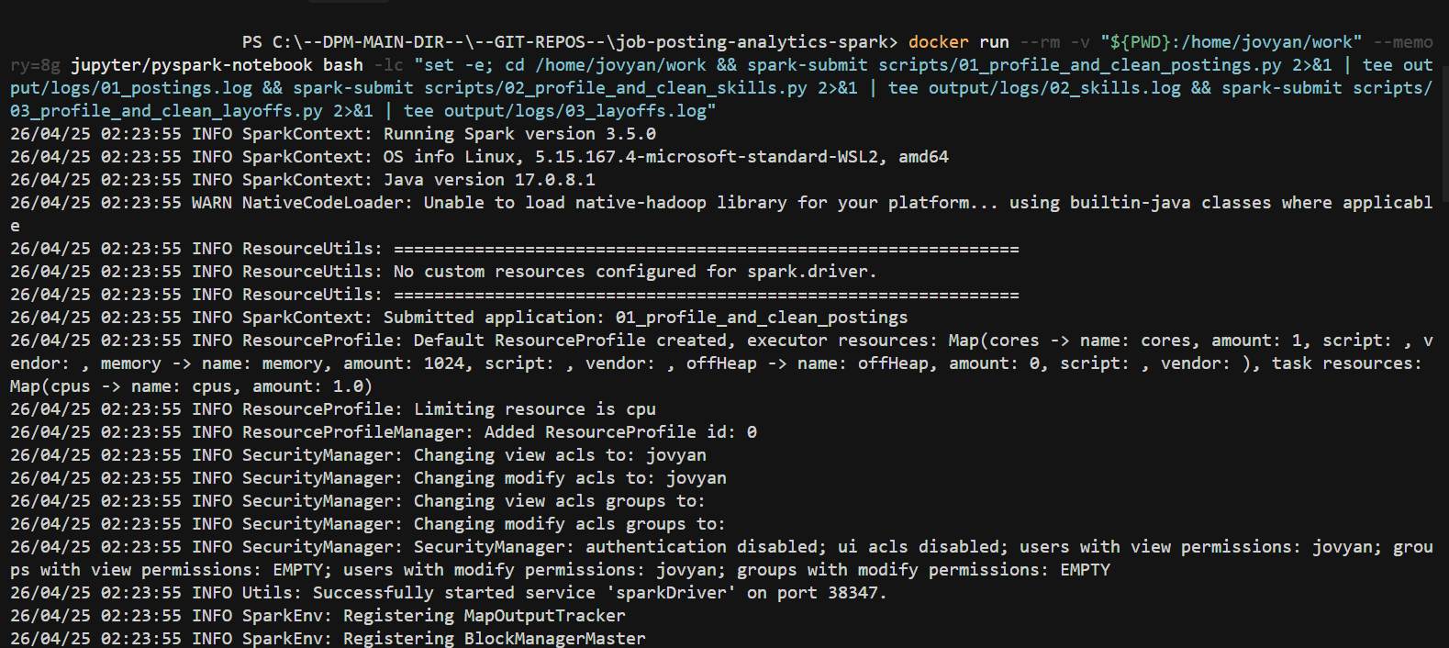
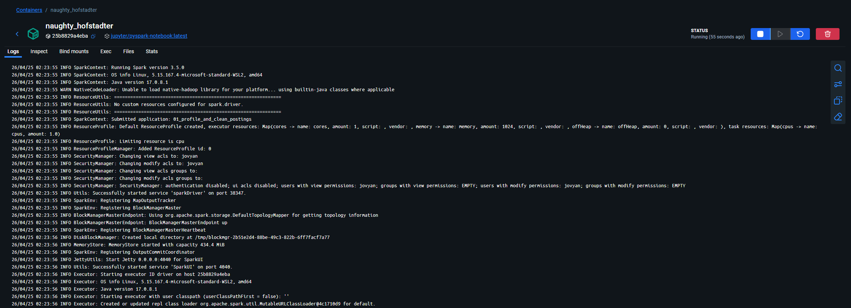
[SCREENSHOTS: Terminal showing the three scripts completing successfully end-to-end]

9. Submission File Inventory
- scripts/ — three .py ingestion scripts (01, 02, 03), each runnable standalone via spark-submit.
- profiles/ — three single-file CSVs (one per source) in long form (dataset, column, metric, value).
- logs/ — three full stdout logs from a successful spark-submit run, with grep-friendly labels.
- snippets/ — three 20-row CSVs sampled from the cleaned Parquet datasets to illustrate final shape.

