Name: Dhairya Ramani
Roll: 92400527212

Hackerrank

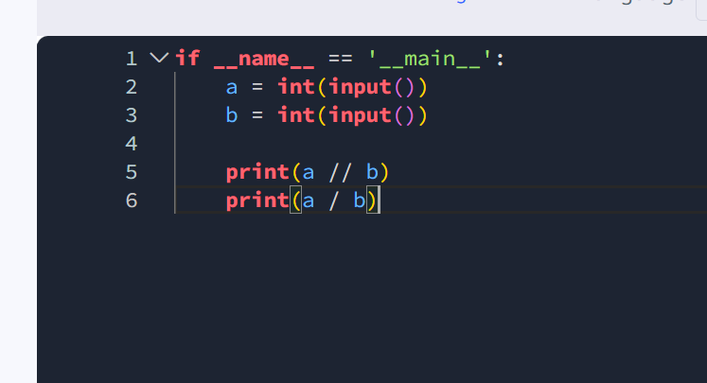
Code
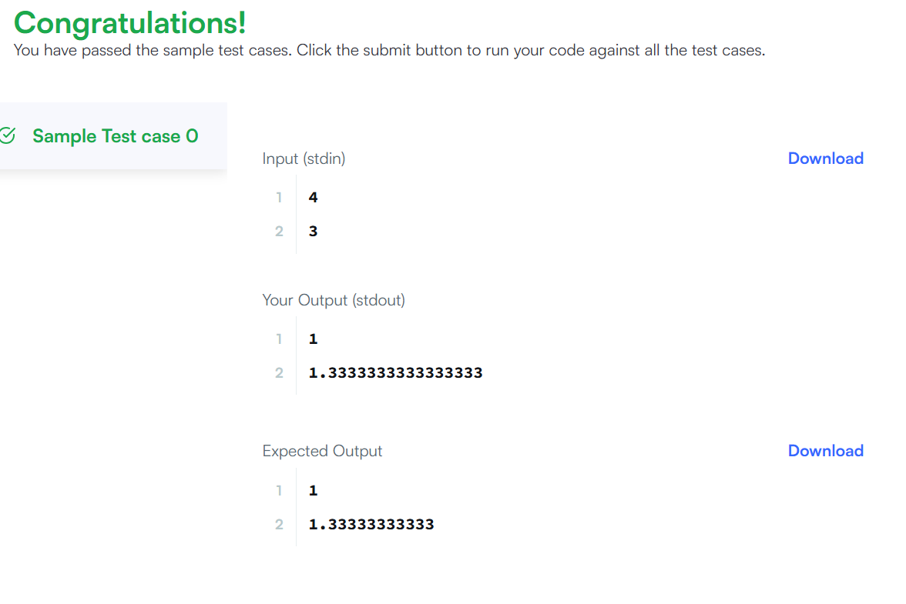
Output

