**Acknowledgement**

We have found this rare opportunity to evince a word of thanks to all those who played a key role in the successful completion of our project .We sincerely thank our Head of Department Dr**.** Parth Shah Sir for giving the chance as well as support for all the time being. And his able guidance and continuous encouragement made us work in all the challenges during project development. We express deep gratitude to assistant Prof. Jalpesh Vasa internal project guide from Faculty of Engineering, CHARUSAT for their valuable suggestions, help and moral support. We also thank to all those who could not find a separate name but have helped directly and indirectly.

# Abstract

Steganography is the art of hiding information within other information in such a way that it is hard or even impossible to identify the existence of any hidden information. There are many different carriers for steganography. Of which, most popular ones are digital images. Due to recent developments in steganalysis, providing security to personal contents, messages, or digital images using steganography has become difficult. By using steganalysis, one can easily reveal existence of hidden information in carrier files. This project introduces a novel steganographic approach for covert communications between two private parties. The approach introduced in this project makes use of both steganographic as well as cryptographic techniques. The process involves converting a secret image into a text document, then encrypting the generated text into a ciphertext using a key (password) based encryption algorithm, and finally embedding the ciphertext on to a cover image. This embedding process is carried out using a threshold based scheme that inserts secret message bits into the cover image only in selected pixels. The security to maintain secrecy of message is achieved by making it infeasible for a third person to detect and retrieve the hidden message.

# Table of Contents

* Acknowledgement 01
* Abstract 02
* Chapter 1 Introduction 05

Project Overview 05

Scope 05

Objective 05

* Chapter 2 System Analysis 06

User Characteristics 06

Tools & Technology……………………………………………………………… 06

* Chapter 3 Implementation……………………………………………………….. 08

Code 08

Snapshots of output 09

* Chapter 5 Conclusion 13
* References 14

**List of figures**

Figure 1 8

Figure 2 9

Figure 3 10

**CHAPTER 1**

**INTRODUCTION**

* 1. **Project Overview**

steganography is the art of hiding the fact that communication is taking place, by hiding information in other information. This project is developed for hiding information in any image file. The scope of the project is implementation of steganography tools for hiding information includes any type of information file and image files and the path where the user wants to save Image and extruded file.

## Scope

### What it can do

* + - It can hide the important message and maintains security.

### What it can’t do

we cannot see the hidden message without typing the code. So if we forgot the code hidden message can’t be seen.

* 1. **Objective**

The main objectives of the project are. Requirement of this steganography system is that the hider message carried by stego-media should not be sensible to human beings. The other goal of steganography is to avoid drawing suspicion to the existence of a hidden message.

**CHAPTER 2**

**SYSTEM ANALYSIS**

## Tools and Technology

* + 1. **Software requirement**

1 Operating system : Windows XP/7.

2 Coding Language : ASP.net, C#.net

3 Tool : Visual Studio 2010

4 Database : SQL SERVER 2008

**HARDWARE REQUIREMENTS:**

* System : Pentium IV 2.4 GHz.
* Hard Disk : 40 GB.
* Floppy Drive : 1.44 Mb.
* Monitor : 15 VGA Colour.
* Mouse : Logitech.
* Ram : 512 Mb.

## Programming Language

1. C#(.net)

# CHAPTER3

# IMPLEMENTATION

* 1. **C# Code:**

1. using System.Data;
2. using System.Drawing;
3. using System.Linq;
4. using System.Text;
5. using System.Threading.Tasks;
6. using System.Windows.Forms;
7. namespace steganography
8. {
9. public partial class Form1 : Form
10. {
11. public Form1()
12. {
13. InitializeComponent();
14. }
15. private void textBox1_TextChanged(object sender, EventArgs e)
16. {
17. }
18. private void button1_Click(object sender, EventArgs e)
19. {
20. OpenFileDialog openDialog = new OpenFileDialog();
21. openDialog.Filter = "Image Files (*.png, *.jpg, *.jpeg) | *.png; *.jpg; *.jpeg";
22. openDialog.InitialDirectory = @"C:\Users\Dhairya\Desktop";
23. if(openDialog.ShowDialog() == DialogResult.OK)
24. {
25. textBox1.Text = openDialog.FileName.ToString();
26. pictureBox1.ImageLocation = textBox1.Text;
27. }
28. }
29. private void pictureBox1_Click(object sender, EventArgs e)
30. {
31. }
32. private void label1_Click(object sender, EventArgs e)
33. {
34. }
35. private void textBox2_TextChanged(object sender, EventArgs e)
36. {
37. }
38. private void button2_Click(object sender, EventArgs e)
39. {
40. Bitmap image = new Bitmap(pictureBox1.Image);
41. int i, j;
42. for (i = 0; i<image.Width;i++)
43. {
44. for(j=0;j<image.Height;j++)
45. {
46. Color pixel = image.GetPixel(i, j);
47. if (i < 1 && j < textBox2.Text.Length)
48. {
49. Console.WriteLine("R[" + i + "][" + j + "]: " + pixel.R);
50. Console.WriteLine("G[" + i + "][" + j + " ]: " + pixel.G);
51. Console.WriteLine("B[" + i + "][" + j + "]: " + pixel.B);
52. char letter = Convert.ToChar(textBox2.Text.Substring(j, 1));
53. int value = Convert.ToInt32(letter);
54. Console.WriteLine("letter :" + letter + "\n value :" + value);
55. image.SetPixel(i, j, Color.FromArgb(pixel.R, pixel.G, value));
56. }
57. if(i==image.Width -1 && j == image.Height -1)
58. {
59. image.SetPixel(i, j, Color.FromArgb(pixel.R, pixel.G, textBox2.Text.Length));
60. }
61. }
62. }
63. SaveFileDialog saveDialog = new SaveFileDialog();
64. saveDialog.Filter = "Image Files (*.png, *.jpg, *.jpeg) | *.png; *.jpg; *.jpeg";
65. saveDialog.InitialDirectory = @"C:\Users\Dhairya\Desktop";
66. if (saveDialog.ShowDialog() == DialogResult.OK)
67. {
68. string filename = saveDialog.FileName;
69. image.Save(filename);
70. }
71. }
72. private void button3_Click(object sender, EventArgs e)
73. {
74. Bitmap image = new Bitmap(textBox1.Text);
75. string message = "";
76. Color lpixel = image.GetPixel(image.Width - 1, image.Height - 1);
77. int messl = lpixel.B;
78. int i, j;
79. for (i = 0; i < image.Width; i++)
80. {
81. for(j = 0; j< image.Height; j++)

84. {
85. Color pixel = image.GetPixel(i, j);
86. if (i < 1 && j < messl)
87. {
88. Console.WriteLine("................");
89. Console.WriteLine("R[" + i + "][" + j + "]: " + pixel.R);
90. Console.WriteLine("G[" + i + "][" + j + " ]: " + pixel.G);
91. Console.WriteLine("B[" + i + "][" + j + "]: " + pixel.B);
92. int value = pixel.B;
93. Console.WriteLine("value is" + value);
94. char c = Convert.ToChar(value);
95. string letter = System.Text.Encoding.ASCII.GetString(new byte[] { Convert.ToByte(c) });
96. message = message + letter;
97. }
98. }
99. }
100. textBox1.Text = message;
101. }
102. }
103. }

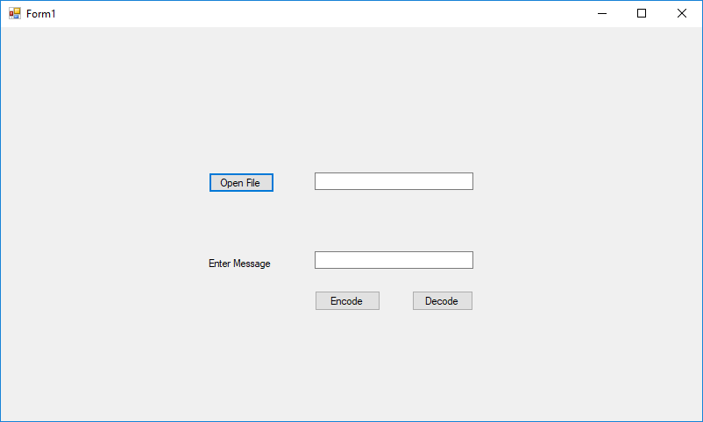

Figure 1

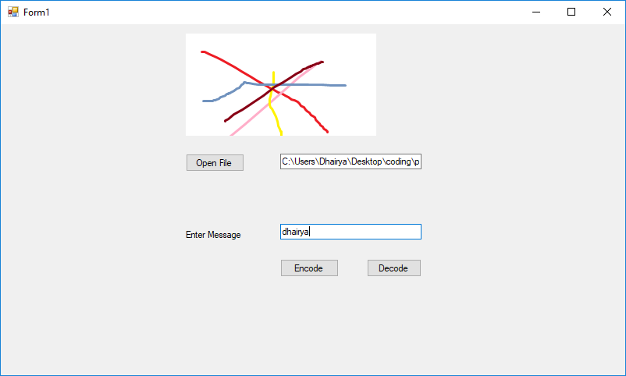

Figure 2

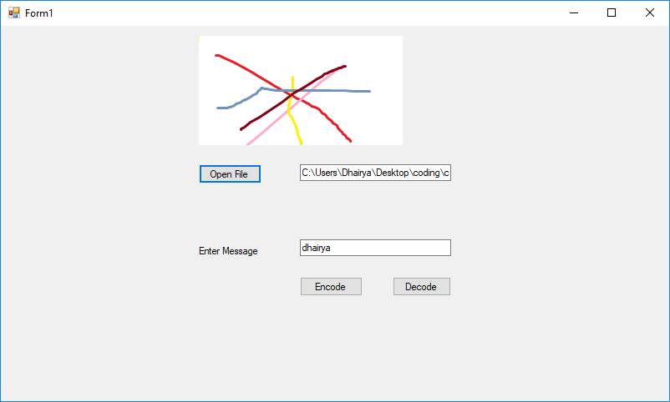

# CHAPTER 5

**Conclusion**

The chief purpose of our system is to recommend online payment to its users based on their viewing history and ratings that they provide. Personalized recommendation using stegenography help millions of people to secure their data.. Collaborative filtering and content based filtering are the are prime approaches to provide recommendation to users. In this module, Steganography uses characteristics of English language such as inflexion, fixed word order and use of periphrases for hiding data rather than using properties of a sentence. This gives flexibility and freedom from the point view of sentence construction but it increases computational complexity

# References

* <https://www.sciencedirect.com/science/article/pii/S1110866515000341>
* <http://recommender-systems.org/content-based-filtering/>
* https://www.1000sciencefairprojects.com/Computer-Science/Image-Steganography.php