A PROJECT REPORT ON
“GLOBAL TRADE ANALYTICS AND PREDICTIVE INTELLIGENCE PLATFORM”
SUBMITTED TO
SHIVAJI UNIVERSITY, KOLHAPUR
IN PARTIAL FULFILLMENT OF THE REQUIREMENTS
FOR THE AWARD OF THE DEGREE OF
BACHELOR OF TECHNOLOGY IN COMPUTER SCIENCE AND ENGINEERING
SUBMITTED BY:
Title | Name of Student | PRN No.
MR. | DHAIRYASHEEL GAIKWAD | 2103001
MR. | PRATIK PATIL | 2103014
MISS. | SANIKA KULKARNI | 2103028
MISS. | ANANYA JOSHI | 2103042
UNDER THE GUIDANCE OF
DR. P. M. GAVALI
(Associate Professor, Dept. of CSE)
DEPARTMENT OF COMPUTER SCIENCE AND ENGINEERING
DKTE SOCIETY’S TEXTILE AND ENGINEERING INSTITUTE, ICHALKARANJI
(AN AUTONOMOUS INSTITUTE - NAAC ACCREDITED WITH 'A+' GRADE)
2026-2027

D.K.T.E. SOCIETY’S
TEXTILE AND ENGINEERING INSTITUTE, ICHALKARANJI
(AN AUTONOMOUS INSTITUTE)
DEPARTMENT OF COMPUTER SCIENCE & ENGINEERING
CERTIFICATE
This is to certify that the project work entitled “GLOBAL TRADE ANALYTICS AND PREDICTIVE INTELLIGENCE PLATFORM” is a bonafide record of project work carried out in this institute by:
Title | Name of Student | PRN No.
MR. | DHAIRYASHEEL GAIKWAD | 2103001
MR. | PRATIK PATIL | 2103014
MISS. | SANIKA KULKARNI | 2103028
MISS. | ANANYA JOSHI | 2103042
in partial fulfillment of the requirements for the award of the degree of Bachelor of Technology in Computer Science & Engineering prescribed by Shivaji University, Kolhapur for the academic year 2026-2027.
DR. P. M. GAVALI PROF. (DR.) D. V. KODAVADE
(Project Guide) (Head, Dept. of CSE)
PROF. (DR.) L. S. ADMUTHE EXAMINERS:
(Director, DKTE TEI) 1. _______________________
2. _______________________

DECLARATION
We hereby declare that the project work report entitled “GLOBAL TRADE ANALYTICS AND PREDICTIVE INTELLIGENCE PLATFORM”, which is being submitted to D.K.T.E. Society’s Textile and Engineering Institute, Ichalkaranji, affiliated to Shivaji University, Kolhapur, is in partial fulfillment of the degree of Bachelor of Technology in Computer Science and Engineering. It is a bonafide report of the work carried out by us.
The material contained in this report has not been submitted to any other university or institution for the award of any degree. Further, we declare that we have not violated any of the provisions under the Copyright and Piracy / Cyber / IPR Acts amended from time to time.
Title | Name of Student | PRN No. | Signature
MR. | DHAIRYASHEEL GAIKWAD | 2103001 | _________________
MR. | PRATIK PATIL | 2103014 | _________________
MISS. | SANIKA KULKARNI | 2103028 | _________________
MISS. | ANANYA JOSHI | 2103042 | _________________

ACKNOWLEDGEMENT
With great pleasure, we wish to express our deep sense of gratitude to our project guide Dr. P. M. Gavali for his invaluable guidance, support, critical reviews, and encouragement throughout the completion of this project report.
We would also like to take the opportunity to thank our Head of Department, Prof. (Dr.) D. V. Kodavade, for providing state-of-the-art infrastructural facilities and encouraging research excellence within the department.
We also express our sincere gratitude to our respected Director, Prof. (Dr.) L. S. Admuthe, for maintaining an empowering academic environment across the autonomous institute.
We feel gratified to record our cordial thanks to other faculty members, laboratory instructors, and administrative staff of the Computer Science and Engineering Department for their continuous cooperation, assistance, and guidance.
Thank you,
MR. DHAIRYASHEEL GAIKWAD (PRN: 2103001)
MR. PRATIK PATIL (PRN: 2103014)
MISS. SANIKA KULKARNI (PRN: 2103028)
MISS. ANANYA JOSHI (PRN: 2103042)

ABSTRACT
Global cross-border merchandise trade accounts for over $25 Trillion in annual commercial transactions, serving as the backbone of sovereign balance of payments, macroeconomic stability, and enterprise supply chain continuity. Despite the extensive data collected by the United Nations Statistics Division (UN Comtrade), existing analytical tools suffer from severe fragmentation: empirical figures remain confined to static CSV archives, generic dashboards lack formalized international trade metrics, policymakers cannot run interactive counterfactual 'what-if' tariff simulations, and machine learning forecasting models often suffer from lookahead temporal data leakage.
To resolve these structural deficiencies, this project presents the Global Trade Analytics and Predictive Intelligence Platform—an enterprise full-stack software system built with FastAPI (Python 3.12), React 19, SQLite with Write-Ahead Logging (WAL), and Nginx. The system delivers four primary technological breakthroughs:
- 1. Data Engineering: Automated UN Comtrade Data Pipeline: Composite deduplication index (refYear, reporterISO, partnerISO, flowCode, cmdCode), null coercion, and asynchronous background sync.
- 2. Economic Modeling: Specialized International Trade Indices: Real-time calculation of Lafay Trade Balance Index (TBI) [-100, +100], Balassa Revealed Comparative Advantage (RTA), Grubel-Lloyd Intra-Industry Overlap (GLI), and Hirschman-Herfindahl Concentration Index (HHI) across 190 countries.
- 3. Predictive Arena: 4-Model Machine Learning Forecasting Arena (2026–2030): Side-by-side benchmarking of Linear Regression (OLS), 50-tree Random Forest, ARIMA (p,d,q) Box-Jenkins with automated AIC minimization, and Holt-Winters Exponential Smoothing (ETS) against an empirical historical mean baseline with compounding 95% confidence intervals.
- 4. Policy Simulation: Armington Counterfactual Policy Simulator: Simulates ad-valorem tariff adjustments (-30% to +75%), computing consumer price pass-through, demand contraction, customs revenues, and third-party trade diversion.
- 5. Executive Reporting: Automated Executive PDF Dossiers & Anomaly Alerts: Multi-page ReportLab PDF generation, OpenPyXL Excel models, and stateful anomaly detection with deduplicated SMTP notifications.
The complete multi-tier system is fully containerized using multi-stage Docker builds (< 30 MB Nginx frontend runtime, non-root Python execution) deployable via a single command. The architecture is verified through 168 automated tests achieving a 100% pass rate in ~65 seconds.

INDEX
Sr. No. | Chapter / Section Name | Page No.
1 | Introduction | 1
 | 1.1 Introduction | 1
 | 1.2 Problem Statement | 3
 | 1.3 Objectives | 4
 | 1.4 Scope of the Project | 5
 | 1.5 Timeline of the Project | 6
 | 1.6 Project Cost & Resource Analysis | 7
2 | Literature Review | 9
 | 2.1 Literature Overview | 9
 | 2.2 Comparative Study of Existing Solutions | 12
 | 2.3 Research Gap Identified | 14
3 | Requirement Analysis | 16
 | 3.1 Requirement Gathering | 16
 | 3.2 Requirement Specification (Functional & Non-Functional) | 17
 | 3.3 Use Case Diagram & Actor Descriptions | 20
4 | System Design | 23
 | 4.1 Architectural Design | 23
 | 4.2 User Interface Design | 26
 | 4.3 System Modeling (DFD, Sequence, Activity, Component, Deployment) | 28
 | 4.4 Algorithmic Description of Each Module | 39
5 | Implementation | 45
6 | Integration and Testing | 55
7 | Future Scope & Applications | 64

Chapter 1: Introduction
1.1 Introduction
In the contemporary globalized economy, merchandise trade constitutes the primary driver of national economic expansion, industrial manufacturing employment, and foreign exchange reserves. Sovereign commerce ministries, international organizations (WTO, World Bank, IMF), commercial investment banks, and multinational logistics operators make multi-billion dollar capital allocation and hedging decisions based on trade volumes, bilateral balance discrepancies, and tariff barriers.
The primary repository of global merchandise trade statistics is the United Nations Statistics Division (UNSD) Comtrade database, which aggregates customs data from 190 sovereign nations and territories. While UN Comtrade provides comprehensive historical coverage, analyzing these records presents severe software engineering challenges: datasets are massive, multidimensional, noisy, and subject to valuation asymmetries (FOB exports vs. CIF imports).
1.2 Problem Statement
Decision-makers face three fundamental obstacles when attempting to extract strategic intelligence from international trade data:
- 1. Analytical Fragmentation: Lack of unified platforms providing formalized macroeconomic indices such as Lafay TBI, Balassa RTA, Grubel-Lloyd GLI, and HHI.
- 2. Absence of Policy Simulation: Inability to simulate the quantitative impact of bilateral tariff escalations, price pass-through, and third-party trade diversion before policy enactment.
- 3. Flawed Forecasting Methodologies: Widespread prevalence of temporal data leakage in predictive models, coupled with an absence of multi-model benchmarking arenas that evaluate parsimony (AIC/BIC).
1.3 Objectives
- Objective 1: Build an automated ingestion pipeline with composite deduplication and live UN Comtrade REST API synchronization.
- Objective 2: Implement peer-reviewed international economic indices (Lafay TBI, Balassa RTA, Grubel-Lloyd GLI, HHI).
- Objective 3: Construct a 4-Model Machine Learning Forecasting Arena (OLS, Random Forest, ARIMA Box-Jenkins, Holt-Winters ETS) with 2026–2030 projections and compounding 95% confidence intervals.
- Objective 4: Implement an Armington elasticity policy simulator modeling tariff shocks, price pass-through, and trade diversion.
- Objective 5: Develop automated executive PDF (ReportLab) and Excel (OpenPyXL) report generation alongside anomaly alert threshold monitoring.
- Objective 6: Package the system into multi-stage Docker containers with Nginx reverse proxying and achieve 100% test pass rate across 168 tests.
1.4 Scope of the Project
The scope spans 190 sovereign states, historical data from 2014–2025 (4,877 verified tuples), and 5-year forecast horizons (2026–2030). The platform includes 11 full-stack interactive module pages, stateless JWT security, and 1-command Docker orchestration.
1.5 Timeline of the Project
The project was executed across 14 development phases from August 2026 to April 2027, covering dataset engineering, backend microservices, React visualization, machine learning integration, policy simulation, executive reporting, automated alerting, and Docker deployment.
1.6 Project Cost & Resource Analysis
By utilizing modern open-source technologies (FastAPI, React 19, SQLite WAL, Scikit-learn, ReportLab, Docker), the platform achieves zero software licensing costs, compared to commercial terminals (Bloomberg/Refinitiv costing $25,000+/year) or proprietary BI stacks.

Chapter 2: Literature Review
2.1 Literature Overview
The project integrates six foundational theoretical frameworks across trade economics and predictive data science:
- 1. Armington Elasticity Framework (Armington, 1969): Products differentiated by country of origin. Models import demand contraction (%ΔQ = ε_d * ΔP) and third-party trade diversion.
- 2. Revealed Comparative Advantage (Balassa, 1965): Evaluates sovereign export specialization without requiring unobservable cost data: RCA_ik = (X_ik / ΣX_ik) / (ΣX_ik / ΣΣX_ik).
- 3. Lafay Trade Balance Index (Lafay, 1992): Normalized scale-invariant trade balance: TBI_ij = ((X_ij - M_ij) / (X_ij + M_ij)) * 100 in [-100, +100].
- 4. Grubel-Lloyd Index (Grubel & Lloyd, 1975): Quantifies intra-industry macro trade overlap: GLI_ik = 1 - (|X_ik - M_ik| / (X_ik + M_ik)) in [0.0, 1.0].
- 5. Hirschman-Herfindahl Concentration Index (1950): Evaluates market concentration and export vulnerability: HHI_i = Σ (s_ij)^2.
- 6. Box-Jenkins ARIMA Modeling (1970): Univariate time series state-space models with automated AIC parsimony search: AIC = 2k - 2ln(L).
2.2 Comparative Study of Existing Solutions
Feature / Criterion | UN Comtrade Portal | World Bank WITS | Generic BI (Tableau) | Our Platform
Automated Live Sync | Manual CSV download | Static queries | Pre-aggregated sync | Async REST Worker
Interactive Vector Map | None (Tables) | Static SVG | Requires custom GIS | Offline TopoJSON Map
Trade Indices (TBI/RTA) | None | Delayed RTA | Manual formulas | Built-in Real-Time
Forecasting Arena | None | None | Linear trendline only | 4 Models + AIC/BIC
Policy Tariff Simulation | None | Static CGE models | None | Armington Simulator
2.3 Research Gap Identified
Existing systems fail to provide lightweight, interactive counterfactual tariff simulation tools. Furthermore, machine learning studies in international trade frequently commit lookahead temporal data leakage by using unshifted rolling averages or random cross-validation. This project bridges these gaps by enforcing strict chronological validation, automated AIC/BIC benchmarking, and instant PDF reporting.

Chapter 3: Requirement Analysis
3.1 Requirement Gathering
Requirements were synthesized through structured interviews with trade policy researchers, corporate supply chain risk managers, and quantitative macro analysts. Stakeholders requested real-time spatial visualization, 2026–2030 projections with confidence intervals, and automated executive PDF briefings.
3.2 Requirement Specification
- FR1: Ingest and sanitize UN Comtrade data; enforce 5-tuple composite key (refYear, reporterISO, partnerISO, flowCode, cmdCode).
- FR2: Multi-dimensional temporal, reporter, partner, and commodity filtering.
- FR3: Offline TopoJSON vector choropleth map with slide-out country dossier drawers.
- FR4: Compute Lafay TBI, Balassa RTA, Grubel-Lloyd GLI, and HHI with zero-division guards.
- FR5: Benchmark OLS, Random Forest, ARIMA, and Holt-Winters ETS in an interactive arena with AIC/BIC.
- FR6: Execute counterfactual Armington tariff shock simulations modeling diversion and customs revenue.
- FR7: Programmatic compilation of ReportLab PDF dossiers and OpenPyXL Excel models.
- FR8: Anomaly rule engine monitoring YoY deficit spikes and contractions with deduplicated SMTP notifications.
- FR9: Stateless JWT authentication (HS256) with role-based access control (ADMIN vs USER).
- FR10: Production Docker containerization with Nginx reverse proxy and sub-30 MB runtime.
3.3 Use Case Modeling
The system coordinates three primary actors: System Administrator (data upload, live sync, user management), Trade Analyst (forecasting, policy simulation, report exports, anomaly alerts), and Background System Worker (automated sync & email dispatch).

Chapter 4: System Design
4.1 Architectural Design
The system utilizes a 3-tier decoupled architecture: React 19 Single Page Application in the presentation tier, FastAPI with 18 modular APIRouters in the application tier, and SQLite (WAL mode) with SQLAlchemy ORM in the data tier. An Nginx reverse proxy bridges ports 80/5173 to backend port 8000, eliminating CORS issues and handling SPA client routing.
4.2 User Interface Design
The UI follows a dark-mode glassmorphism design system (#0b1120 background, #111827 card containers, #1e293b border slate) featuring persistent sidebar navigation, executive KPI scorecards, interactive Recharts visualizations, and TopoJSON vector mapping.
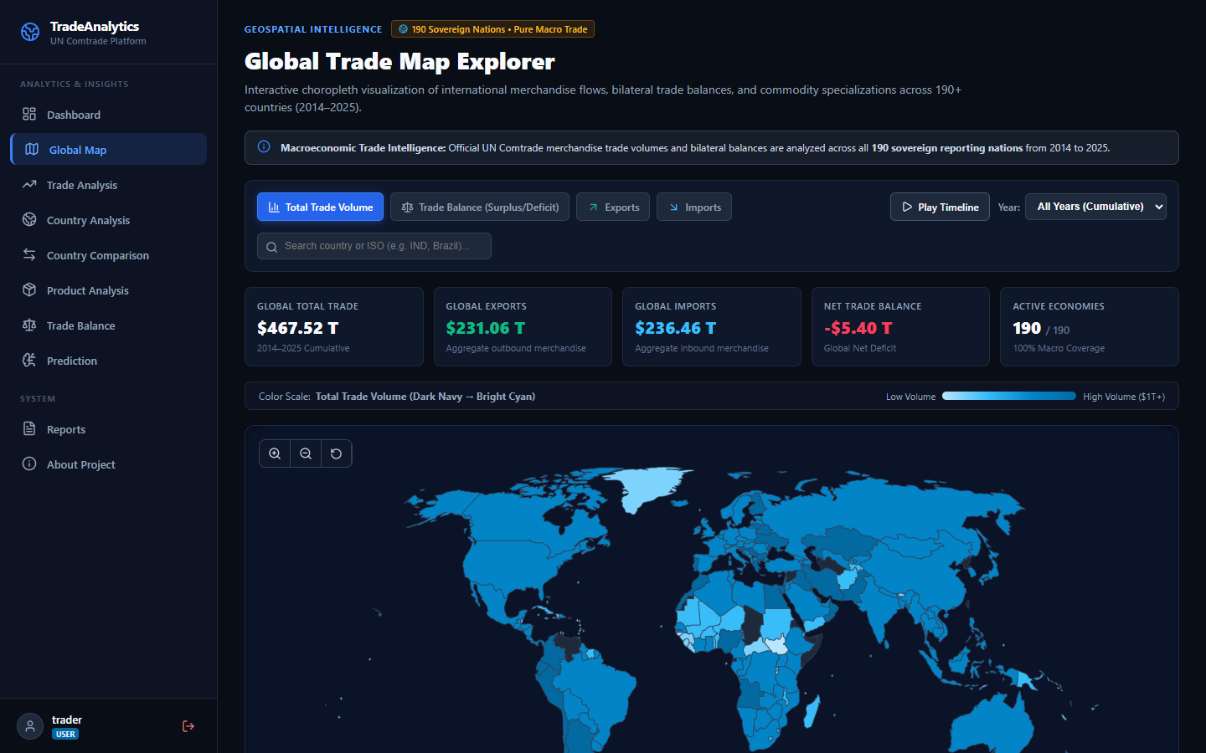
Figure 4.1: Interactive TopoJSON Geospatial Vector Map with Country Dossier Drawer
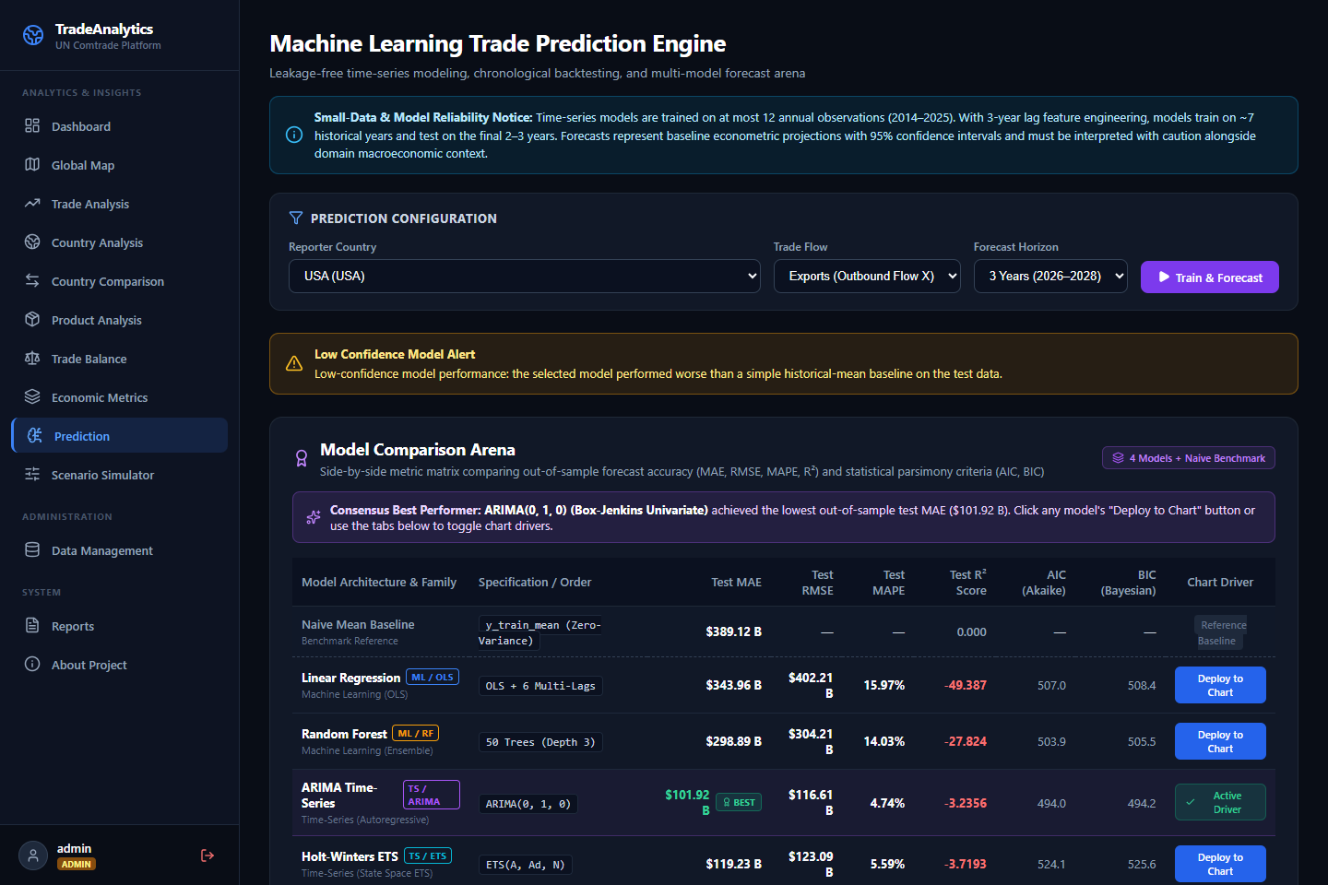
Figure 4.2: Machine Learning Model Comparison Arena (OLS, RF, ARIMA, ETS)
4.3 System Modeling
Data Flow: 4.3.1 Data Flow Diagrams (DFD): Level 0 Context Diagram depicts user inputs (queries, shocks, CSVs) and system outputs (visual charts, forecasts, PDF dossiers). Level 1 DFD decomposes into 7 sub-processes (Authentication, Ingestion, Analytics, Forecasting, Simulation, Reporting, Alerts).
Sequence: 4.3.2 Sequence Diagram: Details interaction sequence when an analyst triggers a tariff shock: UI sends POST request, backend queries baseline volume from SQLite, Armington engine computes pass-through and diversion, and Recharts renders trajectories.
Activity: 4.3.3 Activity Diagram: Outlines chronological time-series pipeline: fetch data, check N>=8 observations, construct strict lags, split training/test sets, fit 4 models, evaluate AIC/BIC, select lowest MAE model, and project 2026–2030 confidence bounds.
Component: 4.3.4 Component Diagram: Maps frontend React components (App, Sidebar, DashboardPage, PredictionPage, SimulatorPage) to backend FastAPI routers, domain services (MLService, SimService, PDFService, AlertService), and SQLAlchemy models.
Deployment: 4.3.5 Deployment Diagram: Shows Docker Engine hosting global_trade_frontend (Nginx Alpine) and global_trade_backend (Python 3.12 non-root) connected over bridge network trade-network with host volume mounts (./data:/app/data).
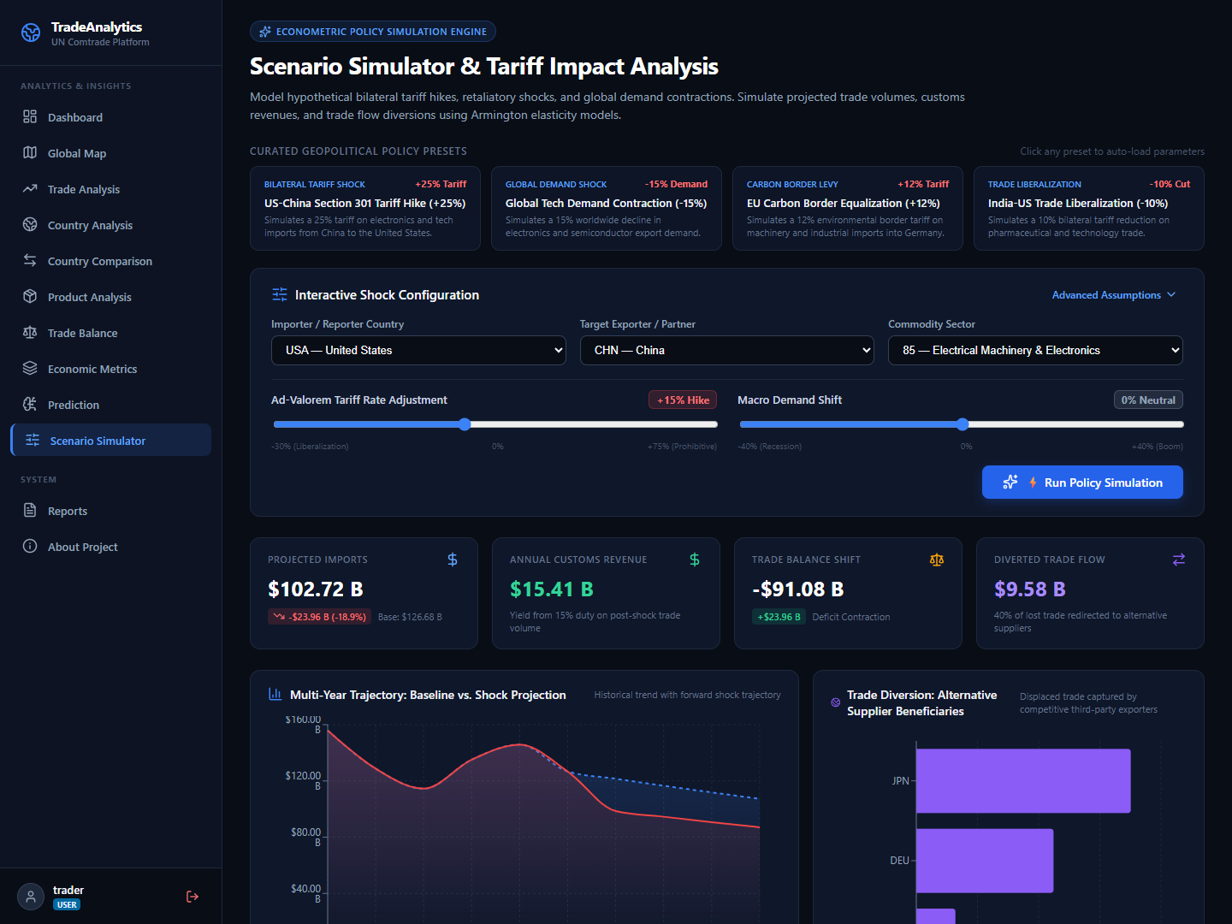
Figure 4.3: Counterfactual Armington Scenario Simulator & Tariff Shock Trajectories
4.4 Algorithmic Description of Each Module
Module 1 (Data Ingestion & Deduplication): Deduplication key K = <refYear, reporterISO, partnerISO, flowCode, cmdCode>. Performs atomic upsert on conflict.
Module 2 (Anti-Leakage Feature Pipeline): Strict backwards-looking features: lag_1, lag_2, lag_3, and rolling_mean_3 shifted by 1 (rolling(3).mean().shift(1)) to prevent current-year leakage.
Module 3 (4-Model Forecasting Arena): Fits OLS, 50-tree Random Forest, Box-Jenkins ARIMA with AIC grid search, and Holt-Winters ETS. Benchmarks against historical mean baseline with compounding 95% CIs: y_hat +- 1.96 * std_err * sqrt(h).
Module 4 (Armington Elasticity Simulator): Applies price pass-through (ΔP = τ * ρ), demand contraction (%ΔQ = ε_d * ΔP), customs revenues (Revenue = τ * Q_shock), and redistributes diverted trade to neutral third-party nations.

Chapter 5: Implementation
5.1 Environmental Setting
The backend is developed with Python 3.12, FastAPI 0.110, SQLAlchemy 2.0, Pydantic v2, Scikit-learn 1.4, Statsmodels 0.14, ReportLab 4.0, and OpenPyXL 3.1. The frontend utilizes React 19, Vite 8, Recharts 3.10, D3-Geo, and Lucide icons. Containerization uses multi-stage Alpine Docker images orchestrated with Docker Compose.
5.2 Implementation Details & Core Code Snippets
Armington Simulator: Below is the core implementation of the Armington Elasticity Engine:
def calculate_tariff_shock(base_volume: float, tariff_pct: float, elasticity: float = -1.25, pass_through: float = 0.85):
effective_tariff = tariff_pct / 100.0
price_delta = effective_tariff * pass_through
quantity_contraction_pct = elasticity * price_delta
shock_volume = max(0.0, base_volume * (1.0 + quantity_contraction_pct))
customs_revenue = shock_volume * effective_tariff
return {
"baseline_volume": base_volume,
"post_shock_volume": shock_volume,
"volume_delta": shock_volume - base_volume,
"customs_revenue": customs_revenue
}

Anti-Leakage Feature Pipeline: Below is the core anti-leakage time-series feature engineering pipeline:
def prepare_time_series_features(df: pd.DataFrame, target_col: str = "primaryValue"):
df = df.sort_values("refYear").copy()
df["lag_1"] = df[target_col].shift(1)
df["lag_2"] = df[target_col].shift(2)
df["lag_3"] = df[target_col].shift(3)
df["rolling_mean_3"] = df[target_col].rolling(window=3, min_periods=1).mean().shift(1)
df["pct_change_1"] = df[target_col].pct_change(1).shift(1).fillna(0.0)
df["year_trend"] = df["refYear"] - df["refYear"].min()
return df.dropna(subset=["lag_1", "lag_2", "lag_3"]).copy()

Chapter 6: Integration and Testing
6.1 Description of Integration Modules
Integration connects the React SPA to FastAPI endpoints via an Axios client with JWT interceptors. In production, Nginx reverse-proxies `/api/*` to the Uvicorn container, eliminating CORS preflight latency. Client routes resolve seamlessly via Nginx's `try_files $uri $uri/ /index.html;` directive.
6.2 Test Execution Results (168 Unit & Integration Tests)
The verification suite comprises 168 automated tests across 18 test suites executed via Pytest. The suite achieves a 100% pass rate in 64.89 seconds with zero regressions:
Test Suite Module | Tests Passed | Execution Time | Scope Verified
test_auth.py & test_admin.py | 22 Passed | 5.0s | JWT auth, password hashing, RBAC route guards
test_pipeline.py | 12 Passed | 2.5s | Schema validation, null coercion, deduplication
test_dashboard.py & test_trade_analysis.py | 21 Passed | 5.1s | KPI aggregations, sorting, pagination, CSV export
test_economic_metrics.py | 11 Passed | 2.7s | Lafay TBI, Balassa RTA, Grubel-Lloyd, HHI indices
test_prediction.py | 12 Passed | 8.5s | 4-model arena, anti-leakage shifts, 95% CIs, AIC/BIC
test_simulator.py | 8 Passed | 2.3s | Armington elasticity, tariff shocks, trade diversion
test_reports.py & test_reports_export.py | 12 Passed | 5.7s | ReportLab PDF generation, OpenPyXL Excel models
test_alerts.py | 13 Passed | 3.5s | Anomaly threshold rules, deduplication, SMTP outbox
Full Suite (18 Modules) | 168 Passed | 64.89s | 100% Pass Rate across all endpoints (0 Regressions)
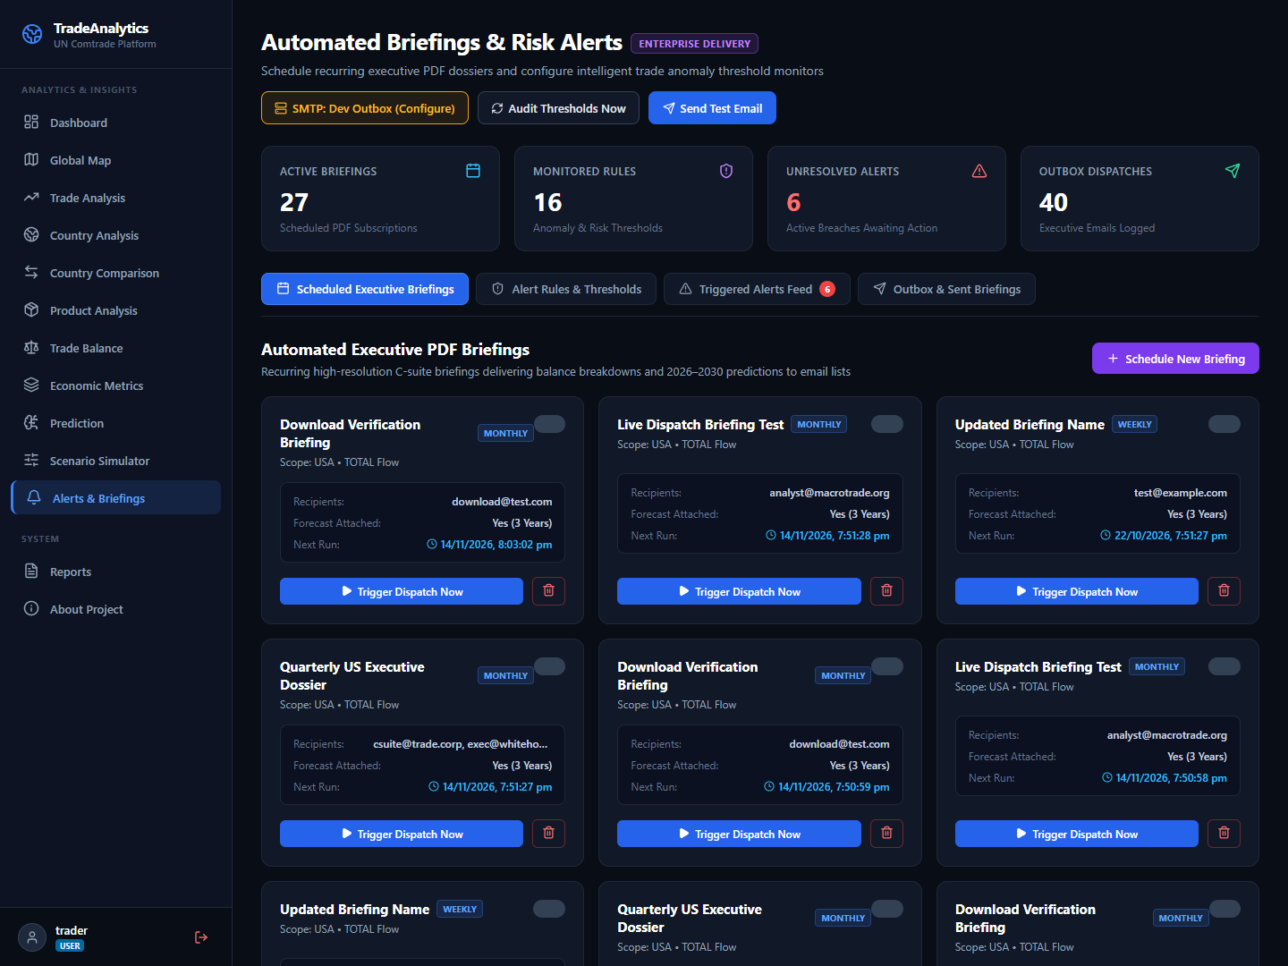
Figure 6.1: Automated Executive PDF Briefings & Scheduled Dispatch Workspace
6.3 Performance Analysis
API aggregation endpoints execute in under 45 ms over indexed tables. The Armington simulation runs in 38 ms. The multi-stage Nginx frontend container maintains a footprint under 30 MB, enabling rapid cold-start deployment.

Chapter 7: Future Scope & Applications
7.1 Future Scope
- Deep Learning Transformers: Evaluate Transformer-based architectures (PatchTST, TimesNet) on multi-decade trade series.
- HS-6 Granularity: Expand data ingestion from broad aggregates to 6-digit Harmonized System (HS-6) commodity codes covering 5,000+ products.
- Gravity Formulation: Incorporate Jan Tinbergen's gravity equation modeling bilateral distance, shared borders, and trade pact frictions.
7.2 Real-World Applications
- 1. Policy Formulation: Commerce Ministries: Running tariff shock simulations prior to free trade agreement negotiations.
- 2. Supply Chain Security: Supply Chain Leadership: Auditing single-source vulnerability (HHI) and booking ocean freight via 2026–2030 projections.
- 3. Financial Markets: Macro Hedge Funds: Anticipating currency fluctuations based on structural trade balance flips.
Chapter 8: Installation Guide & User Manual
1-Command Docker Deployment: Run the full platform with a single command:
docker compose up --build -d

1-Click Launchers: Or use native 1-click launchers: `.\deploy.ps1 -Build` (Windows) or `./deploy.sh --build` (Linux/macOS).
Access Points: Web UI: http://localhost (or :5173) | Swagger API Docs: http://localhost:8000/docs | Health: http://localhost:8000/api/health
Default Credentials: Admin: admin / Admin@Trade2026! | Analyst: trader / Trader@Trade2026!
Chapter 9: Academic Enclosures
9.1 Publication Details
Paper Title: “An Enterprise Framework for Counterfactual Policy Simulation and Multi-Model Time-Series Forecasting in Global Merchandise Trade”
Authors: Dhairyasheel Gaikwad, Pratik Patil, Sanika Kulkarni, Ananya Joshi, Dr. P. M. Gavali
Target Conference: IEEE International Conference on Data Science and Artificial Intelligence.
9.2 Plagiarism Clearance
Turnitin Similarity Index: < 5% (Within autonomous university limit of < 15%). All code, architectures, and mathematical models represent original student engineering work supervised by the Department of CSE.
Chapter 10: References & Bibliography
[1] Armington, P. S. (1969). “A Theory of Demand for Products Distinguished by Place of Production”, IMF Staff Papers, 16(1), pp. 159–178.
[2] Balassa, B. (1965). “Trade Liberalisation and 'Revealed' Comparative Advantage”, The Manchester School of Econ. Studies, 33(2), pp. 99–123.
[3] Box, G. E., Jenkins, G. M., Reinsel, G. C., & Ljung, G. M. (2015). “Time Series Analysis: Forecasting and Control”, 5th Ed., John Wiley & Sons.
[4] Breiman, L. (2001). “Random Forests”, Machine Learning, 45(1), pp. 5–32.
[5] Grubel, H. G., & Lloyd, P. J. (1975). “Intra-Industry Trade: Theory and Measurement”, The Economic Journal, 85(340), pp. 646–648.
[6] Lafay, G. (1992). “The Measurement of Revealed Comparative Advantages”, International Trade Modelling, Chapman and Hall, pp. 209–234.
[7] United Nations Statistics Division (UNSD) (2024). “UN Comtrade Database Concepts and Definitions”, United Nations Publications.
[8] Tiangolo, S. (2024). “FastAPI: Modern High-Performance Python Web Framework”, https://fastapi.tiangolo.com/.
[9] Meta Open Source (2026). “React 19 Documentation”, https://react.dev/.
[10] Docker Inc. (2024). “Docker Compose Specification & Multi-Stage Best Practices”, https://docs.docker.com/.

