Problem : Ek github repo hai mera and usme mere ko code laptop se code upload karna hai … using git bash command

Answer :

========

1. Git bash download <https://git-scm.com/downloads>
2. Us folder me chale jaa jaha se tere ko code upload karna hai github par.
3. Now us folder me git bash open kar.
4. Now agar wo folder me already .git file nahi h matalab ye kabhi upload nahi huaa hai files.
5. So **git init** command chala. 🡪 Isse ek .git file ban jayega us folder me.
6. By default master branch hota hai.. Ham log branch change kar sakte hai using

**git checkout <your_branch_name>**

**Here changing from master to main**

**git branch --unset-upstream**

**git branch -m master main**

1. Now git status kar. 🡪 Isse ye pata chlata ha kon sa file github ke repo me ha ikon sa nahi.
2. **Git add .** ( agar sare files upload karna hai toh ) else git add file1_name file2_name file3 name…
3. Git commit -m “your message”
4. Ye commit karne par username and user email puchega wo de dena.

git config --global user.email "you@example.com"

git config --global user.name "Your Name"

1. Uske baad fir se **git commit -m “your_msg”** chala… 🡪 Is baar chal jayega.
2. Use baad ye command chala jiska matalb hai ham log kaha par file upload karna chahte hai wo batana hota hai .

**git remote add origin** [**https://github.com/dhairyde/pyspark_learnings.git**](https://github.com/dhairyde/pyspark_learnings.git)

**git remote add origin <ye chij ham log repo se pata laga sakte hai.>**

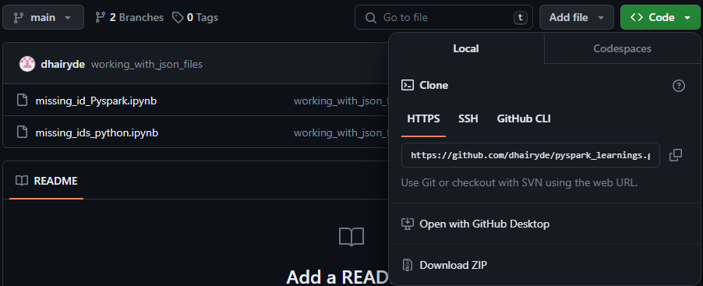

1. Uske bad git push command chala do..

**git push --set-upstream origin master**

**Note :** here master is our branch name.