**After-School Parent/Guardian Workshops**

**Parent-Family Involvement and Education**

**PURPOSE**

We, at Saraswati Middle school, consider our parents & families as an important part of child’s life and learning. This year one of our major goals is to educate our students and families around the issue of tobacco, alcohol, and drug use. As a school we recognize that we can achieve improvement by collaborating with parents and families, especially with such an important issue. Parents and families will have an extremely important role in this program as most, if not all, drug and alcohol use happens in or around the home.

**OBJECTIVE**

1. To increase the partnership between school, parents/guardians, families & community
2. To include parents & families as equal contributors in students’ success and wellbeing
3. To empower and share ideas around prevention as a means of intervention
4. To understand student needs that are being filling with substance use.

**CURRICULUM**

10 lessons centered on Tobacco, Alcohol and Drug use from CSAP’S WESTERN CENTER FOR THE APPLICATION OF PREVENTION TECHNOLOGIES would be used. The lessons provided will help aid parents in the discussion and prevention of drug and alcohol use. CSAP was founded to help Americans lead healthier and longer lives through promoting structured, community-based approaches to substance abuse prevention. The framework “promotes youth development, reduces risk-taking behaviors, builds assets and resilience, and prevents problem behaviors.” Sustainability throughout the community and school essential for success.  
  
**DELIVERY**

Saraswati Middle school is part of SUN Community Schools. Under their Family Involvement and Support, this after-school event has been organized based on the need assessments done by the school counseling department. Two parent/guardian representatives from PTO along with SUN coordinator will facilitate these workshops.

This event is an open for all parents/guardians event who are interested in learning how to prevent or redirect with the individual, family or child’s use of tobacco, alcohol or drugs. These workshops are designed as interactive so that parents and guardians can share their concerns and expertise with the group as equal contributors to their child’s learning and life.   
  
At the trainings, counselors will lead discussions and practical application strategies. Along with the prevention techniques provided, counselors will facilitate role plays with parents to simulate various situations that may arise when parents work with teens. Importance will be placed on being specific with family desires and factual information that will be delivered to students. Families will have opportunities to debrief successful intervention stories as well as things that have happened. Events will be recorded by the SUN coordinator and will have videos available for viewing at the school at other times.  
  
**SEQUENCE**

This event will be organized every 2nd & 4th Friday of the month from 4 to 5 pm in the school cafeteria. Please note, if there is no school on the given Friday, the meeting will be pushed back in the schedule. The program will commence in January 2013 and run until June 2013.   
  
**COST**

Cost of Snacks, bus tickets for families in need.  
  
**RECRUITING**

Parents/guardians would be informed about this event via emails, website newsletter, as well as a letter sent home with the students. The school, PTO and SUN coordinator will spread the word around using flyers and emails. The School Counselors will suggest parents/guardians of students who have had discipline issues around any of these substances to attend these workshops. School Counselor will help parents/guardians see this as an empowering moment to be part of their child’s life to help them make better choices.  
      
**ASSESSMENT** (Appendix VI)

Since this is an open event assessment would be done at the end of each workshop. Parents/guardians will write their feedback as well as their reflection.

Parents/guardians who would come for the next session, would be asked to share their practice and the co-facilitator would take the notes. Overall, our goal as school counselors with this program in particular, is to communicate effectively with parents/guardians to coordinate student achievement and gain feedback for program improvement. The rate of referral due to these issues will be measured along with the attendance percentage rate.

To determine the effectiveness of the program, we will review attendance data, school referrals, and OAKS test results. We will continue to work with students and families as we work towards higher attendance, fewer referrals, and more students meeting and exceeding OAKS test scores.

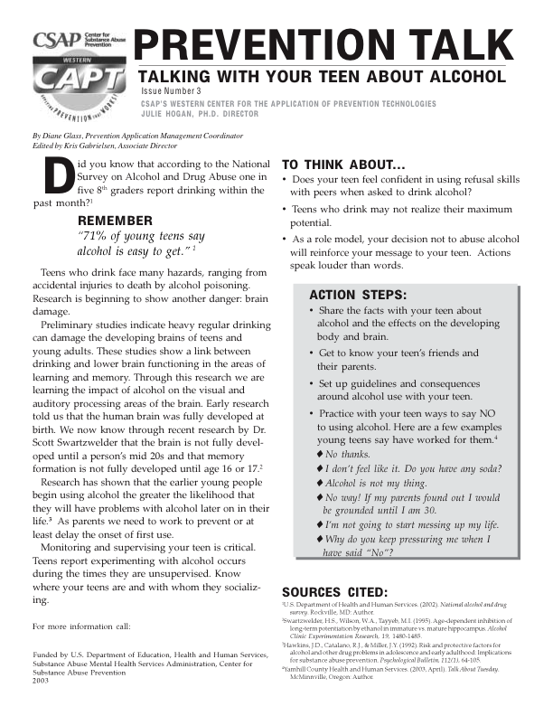

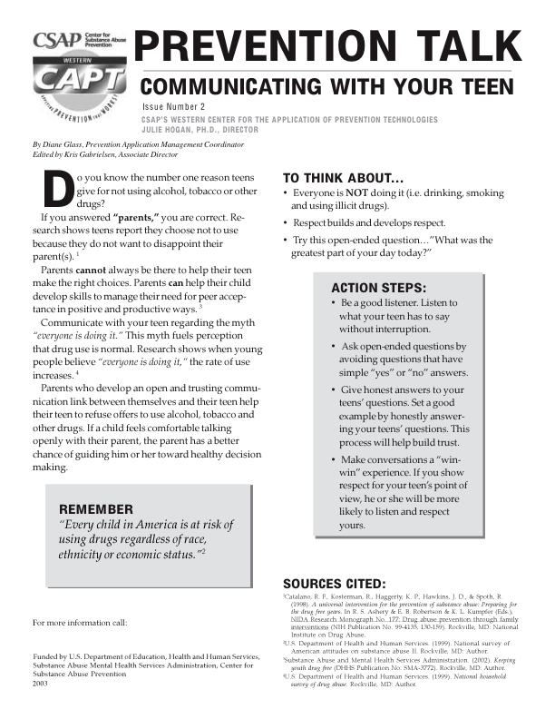

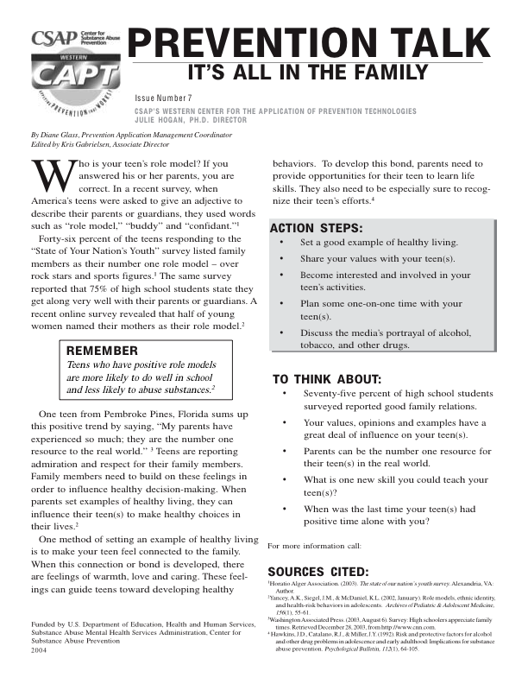

**After-school Workshop reflection and measurement**

Reflections after each session:

What did I learn today?  
______________________________________________________________________________  
  
What goals/skills I have to practice until next meeting?  
______________________________________________________________________________  
  
Rate your ability in dealing with ______________ (session’s objective)  
(1 being not at all competent 10 being highly competent)  
  
1 --------------------------------------------------------5--------------------------------------------------10