**TRACKSPEED APPLICATION**

In this app I have used OkHttp for connecting with the WebSocket. I choose OkHttp because its very easy to use and its request/response API is designed with fluent builders and immutability. It supports both synchronous blocking calls and async calls with callbacks.

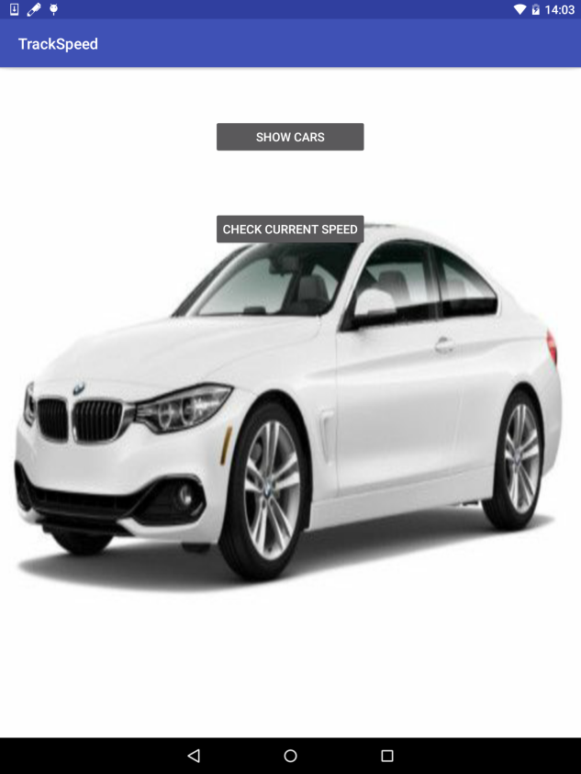 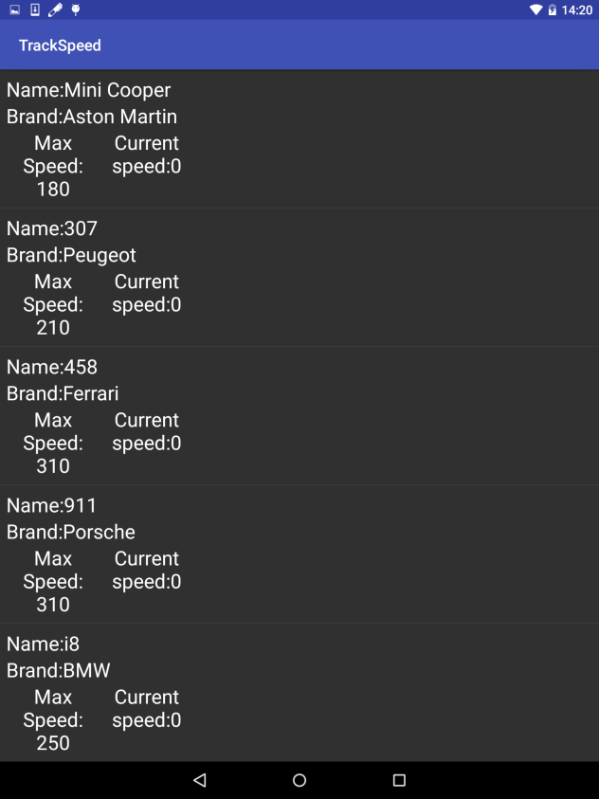

The Right image shows the first screen of the app when clicked on the “SHOW CARS” button the json request is send and the response json is shown in a listView in second activity shown as the Left Image.

The “CHECK CURRENT SPEED” button directly takes to the first screen on the bottom. Where you can directly put the name of the car whose current speed you want to know.

For the second and the third json request I am not getting replay form the server.

When you click on the listView items the screen on the below right is shown. Here ,user enters the Name of the car and hits enter Button .When clicked on the “Show Details” button the details of the car with its current speed is shown. But for now , without getting response from the server this app is crashing here.

