***WEB***

***SCRAPPING***



AIR CONDITIONER

|  |  |  |
| --- | --- | --- |
| Brands | Sum of Original Price Sum of Discounts Sum of Discounted Price   | |
| Lloyd | ₹622.90K 3.61 22,500K% | |
| Sansui | ₹341.94K 2.94 16,827K% | |
| Daikin | ₹260.40K 0.72 6,243K% | |
| SAMSUNG | ₹129.98K 0.80 5,200K% | |
| LG | ₹121.98K 0.92 5,600K% | |
| HISENSE | ₹99.98K 0.64 3,200K% | |
| **Total** | **₹1,577.18K** | **9.63 59,570K%** |

**Brands** Lloyd

Sansui

Daikin

SAMSUNG

LG

HISENSE

AIR CONDITIONER

Symphony

Havells

Kelvinator

Hindware

Sansui

₹24K

₹19K

₹17K

₹12K

₹6K

**Brands**

**Symphony**

**Havells**

**Kelvinator**

**Hindware**

**Sansui**

AIR CONDITIONER

255K

116K

S

u

m

of

P

r

i

c

e

# 47K

Dyson Philips Honeywell

Brands

**Washing Machines**

180

K

Sum of Prices

Sum of Prices by Brands

**Candy 10K (5.57%)**

**LG 91K (50.67%)**

**18**

**K (10.02%**

**)**

**26**

**K (14.75%**

**)**

**Whirlpool 34K (18.99%)**

**Samsung**

**Sansui**

TOTAL SALES

:

**Vaccum Cleaner**

 Brands × Count of Offers' by original prices and Discouned Price

**Sum of Dis…**

1420

Kent

102

iRobot

96

Prestige

86

Eufy

78

**Dyson**

56



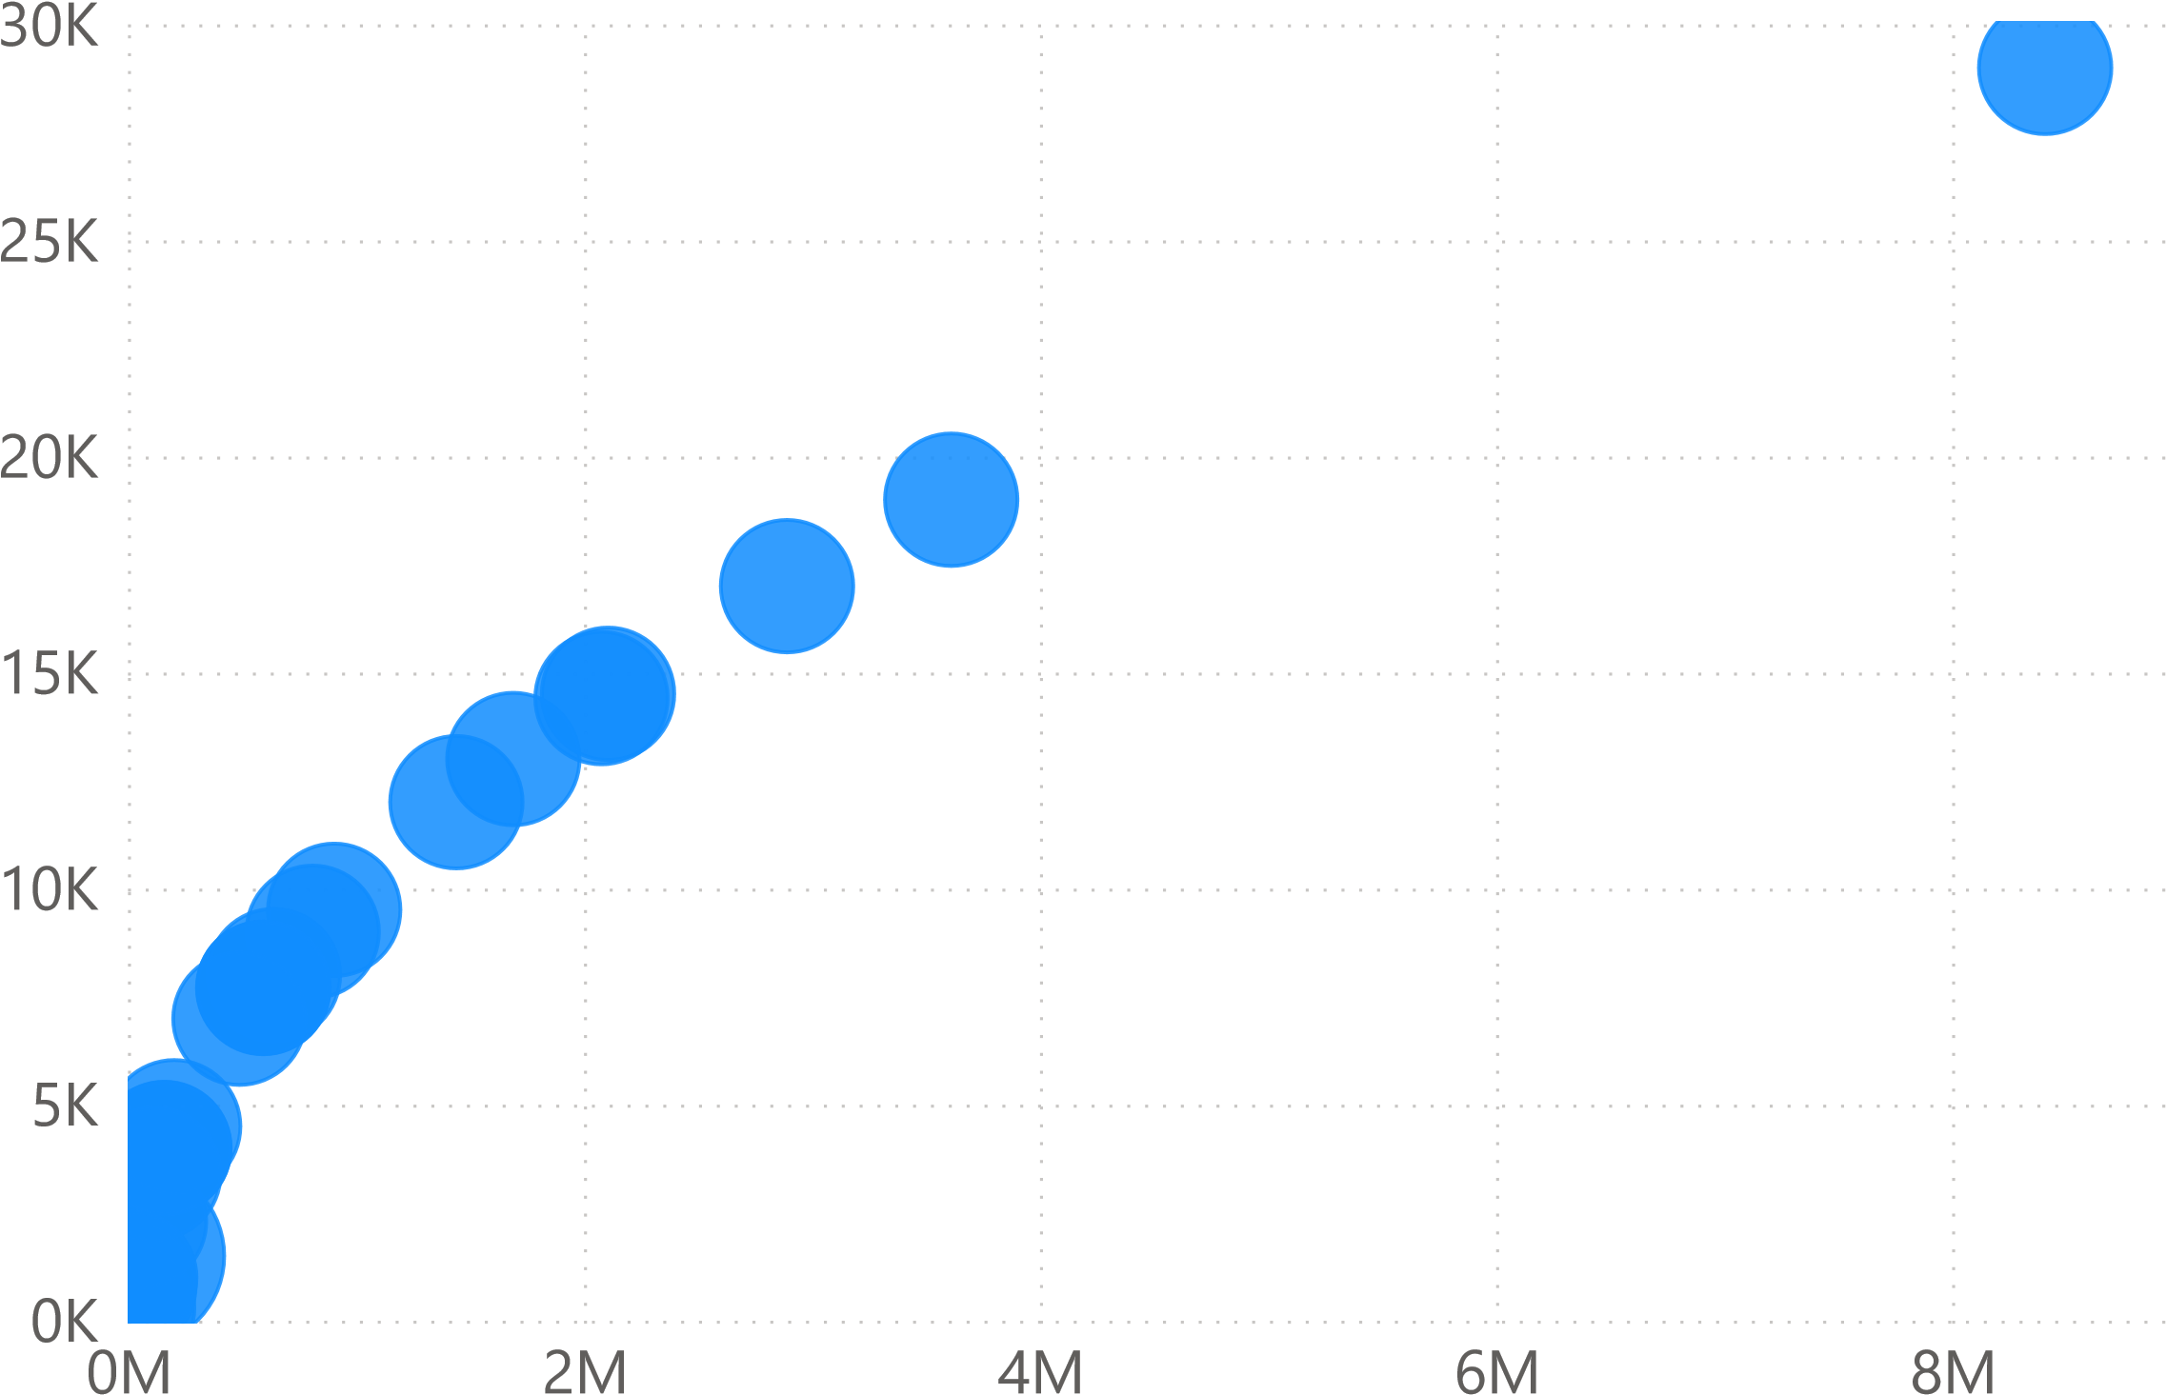

D

i

s

c

ou

ned

P

r

i

c

e

original prices

**Refrigerators**

# 100%

|  |
| --- |
| 9 |

Voltas

|  |
| --- |
| 8 |

LG

|  |
| --- |
| 5 |

Godrej

|  |
| --- |
| 4 |

Candy

|  |
| --- |
| 2 |

Whirlpool

# 22.2%

**Room Heaters**

Brands Discounted price Sum of Discounts Products Discription

Bajaj ₹ 230 0.19 1000W Flashy Halogen Rod Room Heater with Compact Design

Bajaj ₹ 300 0.13 Blow Hot Fan-based Room Heater with Auto Thermal Safety Cutout

Bajaj ₹ 2,901 0.42 Room Heater RHT2C 900 Watts With Carbon Rod

Bajaj ₹ 6,300 0.36 Vienna 9 Fins Oil Filled Radiator 2400 W

Bajaj ₹ 6,900 0.36 Vienna 11 Fins Oil Filled Radiator 2900 W

Candes ₹ 1,350 0.50 Infra3 Noiseless 1200 Watts Halogen Room Heater

Havells ₹ 1,026 0.26 Inclino RH 1200 Watts Halogen Heater

Havells ₹ 1,076 0.26 Cista Fan-Based Room Heater with Adjustable Height

Havells ₹ 1,746 0.27 Walthero Carbon 1000 Watts Room Heater with Dual Heat Setting (Bla

Havells ₹ 2,696 0.26 Pacifio RH 1500 Watts Mica Heater

Havells ₹ 5 096 0 27 Hestio 11 Fins 2900 Watts Oil Filled Radiator

**Total 6.81**

**DSLR Camers**

Sum of Original price by ProductDescription

# 100%

D850 DSLR Camera with 24-120 mm Lens Kit 272K D780 DSLR Camera with 24-120 mm Lens Kit 242K

|  |
| --- |
| 165K |

D750 DSLR Camera with 24-120 mm Lens Kit

|  |
| --- |
| 127K |

EOS 90D DSLR Camera with 18-135 mm Lens Kit

D7500 DSLR Camera with AF-S DX NIKKOR 18-140mm f/3.5-5.… 95K

|  |
| --- |
| 69K |

EOS 200D II DSLR Camera with 18-55 mm Lens Kit

|  |
| --- |
| 67K |

D5600 DSLR Camera with AF-P 18-55 mm + AF-P 70-300 mm …

|  |
| --- |
| 48K |

EOS 1500D DSLR Camera with 18-55 mm Lens Kit

17.6%

# **Action Camera Accessories**

|  |  |  |  |  |  |
| --- | --- | --- | --- | --- | --- |
| |  | | --- | | Brands    GoPro AKTAC-001 Action Camera Sports Kit   GoPro AKTES-001 Adventure Kit   GoPro AKTTR-001 Action Camera Travel Kit   GoPro Casey Kit   GoPro Chest Mount Chesty, AGCHM-001   GoPro Grab Bag   GoPro Head Strap plus QuickClip   GoPro Helmet Front and Side Mount   GoPro Max Protective Lens Cap, ACCPS-001   GoPro Metal Handlebar, Seatpost, Pole Mount   GoPro Smart Remote   GoPro Supercharger (International Dual-Port Ch… | | |  |  |  | | --- | --- | --- | | |  | | --- | | 1.15K  **Sum of Discounted Price** | | 3  **Warranty** | |
| |  |  |  | | --- | --- | --- | |  | Targeted Price |  | |  | 1  .  15  K | **1.60K** | | 0.00K |  | 2.29K | |