Exercise 1:
Create an Android app Converter for the given below screen design using linear layout.


My Temperature Converter - Portrait Mode
Enter Fahrenheit Temp Below
Enter Celsius Temp Below
Convert Temp

Display the answer in textview and toast message.

Main Activity.kt

package com.example.sample
import android.os.Bundle
import android.widget.Button
import android.widget.EditText
import androidx.appcompat.app.AppCompatActivity
class MainActivity : AppCompatActivity() {
override fun onCreate(savedInstanceState: Bundle?) {
super.onCreate(savedInstanceState)
setContentView(R.layout.activity_main)
val etCelsius = findViewById<EditText>(R.id.etCelsius)
val etFahrenheit = findViewById<EditText>(R.id.etFahrenheit)
val btnToFahrenheit = findViewById<Button>(R.id.btnToFahrenheit)
val btnToCelsius = findViewById<Button>(R.id.btnToCelsius)
btnToFahrenheit.setOnClickListener {
val celsius = etCelsius.text.toString().toDoubleOrNull()
if (celsius != null) {
val fahrenheit = (celsius * 9 / 5) + 32
etFahrenheit.setText(fahrenheit.toString())
}
}
btnToCelsius.setOnClickListener {
val fahrenheit = etFahrenheit.text.toString().toDoubleOrNull()
if (fahrenheit != null) {
val celsius = (fahrenheit - 32) * 5 / 9
etCelsius.setText(celsius.toString())
}
}
}
}

activity_main.xml

<?xml version="1.0" encoding="utf-8"?>
<LinearLayout xmlns:android="http://schemas.android.com/apk/res/android"
android:layout_width="match_parent"
android:layout_height="match_parent"
android:orientation="vertical"
android:padding="20dp">
<EditText
android:id="@+id/etCelsius"
android:layout_width="match_parent"
android:layout_height="wrap_content"
android:hint="Enter Celsius"
android:inputType="numberDecimal" />
<Button
android:id="@+id/btnToFahrenheit"
android:layout_width="match_parent"
android:layout_height="wrap_content"
android:text="Convert to Fahrenheit"
android:layout_marginTop="10dp" />
<EditText
android:id="@+id/etFahrenheit"
android:layout_width="match_parent"
android:layout_height="wrap_content"
android:hint="Enter Fahrenheit"
android:inputType="numberDecimal"
android:layout_marginTop="20dp" />
<Button
android:id="@+id/btnToCelsius"
android:layout_width="match_parent"
android:layout_height="wrap_content"
android:text="Convert to Celsius"
android:layout_marginTop="10dp" />
</LinearLayout>

Exercise 2:

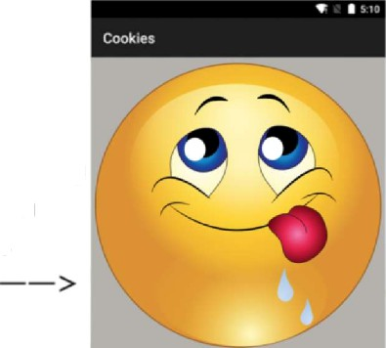
Create the app shown below. Users are initially presented with an "unhappy" character with the corresponding text "I'm so hungry". After hitting the button "EAT COOKIE", the character becomes "happy" with corresponding text "I'm so full".

After pressing the button becomes

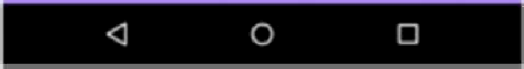
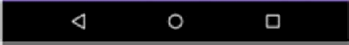
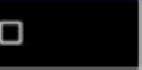
EAT COOKIE DONE
< O

y
manifests
app
}ava
com.example.trishcornez.Iab2exercise1 @ CookieMonster
@ MainActivity
,res
drawable
full.png
! hungry.png
„ ic_launcher_background.xml
„ ic_launcher_foreground.xml (v2^) layout
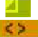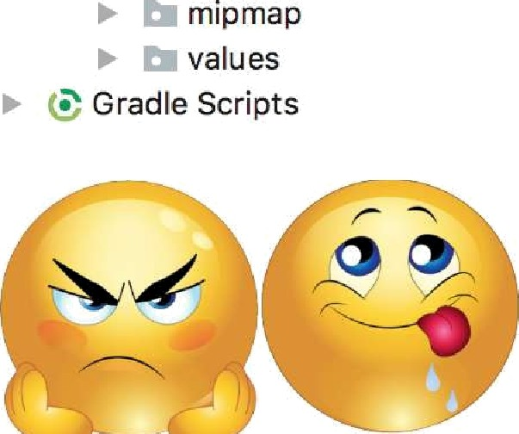
main_Iayout.xml

CODE:
Mainactivity.kt
package com.example.image
import android.os.Bundle
import android.widget.Button
import android.widget.ImageView
import android.widget.TextView
import androidx.appcompat.app.AppCompatActivity
class MainActivity : AppCompatActivity() {
private lateinit var imgCookie: ImageView
private lateinit var txtStatus: TextView
private lateinit var btnEat: Button
private var isHungry = true
override fun onCreate(savedInstanceState: Bundle?) {
super.onCreate(savedInstanceState)
setContentView(R.layout.activity_main)
imgCookie = findViewById(R.id.imgCookie)
txtStatus = findViewById(R.id.txtStatus)
btnEat = findViewById(R.id.btnEat)
btnEat.setOnClickListener {
if (isHungry) {
imgCookie.setImageResource(R.drawable.full)
txtStatus.text = "I'm so full"
btnEat.text = "DONE"
isHungry = false
}
}
}
}

activity_main.xml
<?xml version="1.0" encoding="utf-8"?>
<LinearLayout xmlns:android="http://schemas.android.com/apk/res/android"
android:layout_width="match_parent"
android:layout_height="match_parent"
android:orientation="vertical"
android:gravity="center"
android:background="#CCCCCC">
<ImageView
android:id="@+id/imgCookie"
android:layout_width="250dp"
android:layout_height="250dp"
android:src="@drawable/hungry"
android:layout_marginTop="20dp" />
<TextView
android:id="@+id/txtStatus"
android:layout_width="match_parent"
android:layout_height="wrap_content"
android:text="I'm so hungry"
android:textSize="20sp"
android:textColor="#FFFFFF"
android:gravity="center"
android:padding="20dp"
android:background="#B388FE"
android:layout_marginTop="20dp"/>
<Button
android:id="@+id/btnEat"
android:layout_width="wrap_content"
android:layout_height="wrap_content"
android:text="EAT COOKIE"
android:layout_marginTop="10dp"/>
</LinearLayout>

