Project Proposal

On

**School Management System**



Dha Lhamu Lama

00172890

Computing Project

Level 5 Diploma in Computing

Softwarica College of IT and E-Commerce

Kathmandu, Nepal

Submission date 4-01-2019

Submitted to: Kiran Rana

Contents

Contents 1

List of figures 2

1. Introduction 3

1.1 Project Introduction 3

1.2 Justification for project 4

1.2.1 Background of the project 4

1.2.2 Problem Statement 4

1.3 Description of the project 4

1.3.1 Features 4

2. Project Scope 5

2.1 Scope and Limitation of project 5

2.2 Aims and Objectives 5

3. Development Methodology 6

3.1 Methodology used 6

3.2 Design Pattern 7

3.3 System Architecture 7

4. Work Breakdown Structure (WBS) / Scheduling 8

4.1 Work Breakdown Structure 8

4.2 Milestones 10

4.3 Scheduling / Gantt chart 11

5. Risk Management 13

6. Configuration Management 14

7. Conclusion of the project 15

8. References 15

List of figures

Figure 1:Waterfall Module 6

Figure 2: Design pattern for school management system 6

Figure 3:3-tier system architecture 7

Figure 4: Work Breakdown Structure 8

Figure 5: Gantt chart 11

Figure 6: configuration Management 14

# 1. Introduction

## 1.1 Project Introduction

DNS SoftwareCompany is well reputed company of software that provides service to the individual as well as to the company since many years. This company is making software for school management at present time for the schools since many schools are not be able to manage the school system. So, we are developing software for the school so that they can easily manage the system by using the system where it automates the details of students, teachers, classes, library, exams, results and many more related to the school

## 1.2 Justification for project

### 1.2.1 Background of the project

### Our company is running with good prestige and has served numerous companies and schools with many projects. The project is done since many schools are not implementing the latest technical methods of using the system. Since schools are having difficulty in managing the schools management. The project is introduced and it has to be done to overcome the problem faced by the schools and we can create the project by understanding and researching the requirements of the schools and after the project is ready, we have to understand whether the project is user friendly and good to use to the schools or not.

### 1.2.2 Problem Statement

### School was facing the problem in recording the attendances and the report in salary and fees and there was not clear idea of how many students are enrolled every year. To have accurate data on students, teachers and clear account of fees and salary, school management system is done so that the management can be out of problem.

## 1.3 Description of the project

### 1.3.1 Features

Following are the main features of our project

* Admission Process: This software helps the visitor hoe to complete admission process. One can easily do the process of admission in easy way
* Thorough Attendance: It keeps the full record of the attendance of the students as well as the staff or teachers of the school.
* Maintaining Examination: The main feature of this software is also maintaining the exams of the students that keeps full record of the student record.
* Cloud Facilitation:  It helps in tracking of all the data and stores all the data in the cloud format. So that there is no any loss of any files or data and is useful whenever we needed.
* Communication: It gives notice to the users, which includes the staff and the students of the institute about fees dues, holiday declaration, exam and the ongoing activities. This serves just like a notice board.
* Staff Management: Like student staff also has to be managed like from attendance to salary. So to make easy in managing the salary and attendance such software has vital role.
* Library Management: It manages all the detail collection of books in numerical as well as alphabetical order so that one can easily access to the book one wanted.

# 2. Project Scope

## 2.1 Scope and Limitation of project

**Scope:**

This project will manage the attendance process which will be saved in the database. User can search and also calculate the attendance of the students and teachers. Calculation of fees and salary is easily done.

The project will make the handprint system so that they can detect whether the students or teachers are present in the school or not and if they are absent, it will automatically sent the message to the mobiles of the parents and the teachers that they are absent

**Limitations:**

* If the system crashes this application will be corrupted.
* Backend can be accessed for the storage but there is limit in storage.
* It is not online software.
* This application can be used only by school management.

## 2.2 Aims and Objectives

**Aim:** The main aim is to meet the requirements of the users for their benefit as well as for the school management system. The required analysis of data of students, teachers, fees, salary etc. can be possible by making software in the computer where one can access easily and get the required answers wanted by them

**Objectives:** The main objectives of developing this software is for the following reasons.

(a) Record Keeping

The main objective of system is to maintain the data of all the student and teacher in database system. It maintains the personal record as well as the academic record of the student. It maintains student fee record and dues record. Teacher personal record and salary record are also store in the software. It also manages class record, subject record, examination record.

(b) Reports Generating

Reports are the essential outcomes of school management system (SMS).Reports includes the given points

* Total number of student in the class
* Student admission reports
* Character certificate of the student
* Submitted due reports
* Teacher Appointment Letter
* Teacher Experience reports
* Salary reports
* Bonus reports
* Examination report
* Detail Marks Certificate

# 3. Development Methodology

## 3.1 Methodology used

Here, I have chosen Waterfall Method for the development of this software. Since it is traditional System Development Life Cycle (SDLC), this method involves a complete set of steps that a team follows. The main idea is to divide the development process into a series of phases or stages, each of which finishes before next one starts. Below is shown the diagram of waterfall module which has been used in this school management system.

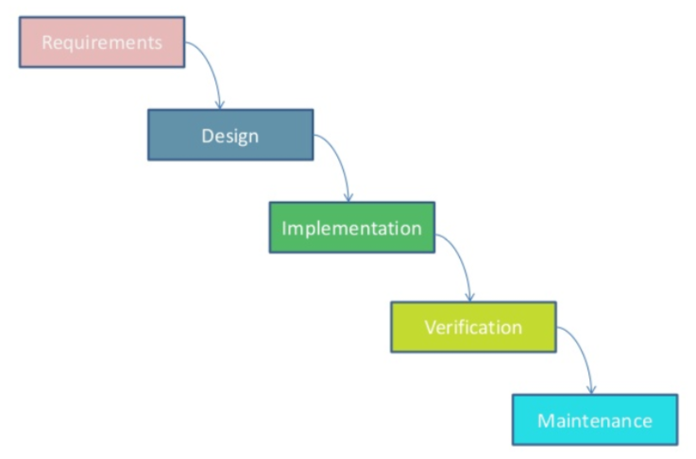

Figure 1: Waterfall Module

**Requirements:** all requirements are gathered and analyzed in this phase and documented for next phase

**Design:** After gathering the requirements, it is studied and design process takes place

**Implementation:** After designing, project start to be developed in small programs (units) and are integrated for next phase.

**Verification**: After integration process, verification of the project is needed which is done to test the faults and failures.

**Maintenance**: Once test is done, if there is any faults and failures, then comes the step of maintenance which is important

## 3.2 Design Pattern

I am using here MVC design pattern in this project. MVC consists of data model, presentation information and control information and I have chosen PHP Laravel framework which is free and open source software that is widely used and famous.

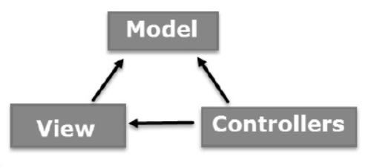

Figure 2: Design pattern for school management system

Model: It corresponded related logic data where user works on it. For example, a Customer retrieves customer information from the database, manipulates it and updates its data back to the database or uses it to render data.

View: It is used in all UI logic of the application. For example, the Customer view includes all UI components like text box, dropdown, etc. in which final user will be using it.

Controller: It plays role of interface between Model and View components which process all business logic, requested data incoming request and manipulate and interact with the Views to render the final output. For example, the Customer Controller handles all interactions and inputs from customer view and updates the database using customer model.

## 3.3 System Architecture

System architecture is defined as conceptual model that includes the structure, behavior, and more views of a system. I am going to use 3-tier system architecture. For example internet banking system, and the diagram is given below.

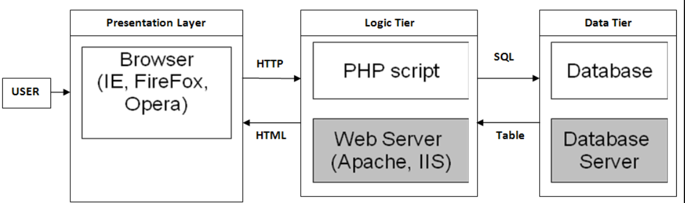

Figure 3:3-tier system architecture

Presentation Layer: This tier communicates with other tiers by sending results to the browser and other tiers in the network.

Logic Tier: It is also called as middle tier, presentation tier, business logic or logic tier, this tier is pulled from the presentation tier. It does control application functionality by performing detailed processing.

Data Tier: Houses database servers where information is stored and retrieved. Data in this tier is kept independent of application servers or business logic.

# 4. Work Breakdown Structure (WBS) / Scheduling

## 4.1 Work Breakdown Structure

Work breakdown structure is a project management and systems where works are divided into smaller projects. It is also known as tree structure where work is divided into smaller sub projects that makes easier in completing task. I have shown the work breakdown of school management system which defines all the projects into smaller components. 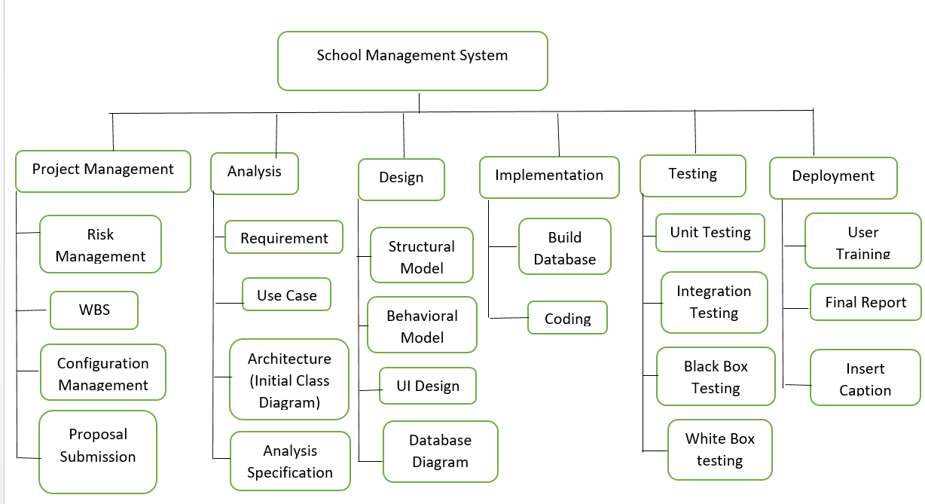

Figure 4: Work Breakdown Structure

## 4.2 Milestones

|  |  |
| --- | --- |
| **Milestones** | **Date** |
| **Project Management**  Risk Management  WBS  Configuration Management  Proposal Submission | Start date Finish date  12/21/18 12/25/18  12/26/18 12/27/18  12/28/18 1/1/19  1/2/19 1/3/19 |
| **Analysis**  Feasibility Study  Requirement analysis  Planning  Use Case  Architecture ( Initial Class Diagram) | Start date Finish date  12/21/18 12/25/18  12/26/18 12/27/18  12/28/18 1/1/19  1/2/19 1/3/19  1/2/19 1/3/19 |
| **Design**  Structural Diagram  Behavioral Diagram  UI Design  Database Design (ER , Data Dictionary) | Start date Finish date  12/21/18 12/25/18  12/26/18 12/27/18  12/28/18 1/1/19  1/2/19 1/3/19 |
| **Implementation**  Building Database  Coding | Start date Finish date  12/21/18 12/25/18  12/26/18 12/27/18 |
| **Testing**  Unit Testing  Integration Testing  Black box Testing  White box Testing | Start date Finish date  12/21/18 12/25/18  12/26/18 12/27/18  12/28/18 1/1/19  1/2/19 1/3/19 |
| **Deployment**  User Training  Final Report  Insert Caption | Start date Finish date  4/11/19 4/13/19  4/14/19 4/17/19  4/18/19 4/20/19 |

**Description of Milestones:**

**Project Management**

* I havetakentotal 14 days for Project Management
* I havetaken5 days for risk Management
* I havetaken2 days for WBS
* I havetaken5 days for Configuration Management
* I havetaken2 days for Proposal Submission

**Analysis**

* I havetakentotal 25 days for Analysis
* I havetaken6 days for Requirement
* I havetaken5 days for Use Case
* I havetaken7 days for Architecture (Initial Class Diagram)
* I havetaken7 days for Analysis Specification

**Design**

* I havetakentotal 30 days forDesign
* I havetakentotal 7 days forStructural Diagram
* I havetakentotal 7 days forBehavioral Diagram
* I havetakentotal 8 days for UI Design
* I havetakentotal 8 days for Database Design (ER , Data Dictionary)

**Implementation**

* I havetakentotal 32 days for Implementation
* I havetakentotal 15 days for Building database
* I havetakentotal 17 days for Coding

**Testing**

* I havetaken10 days for Testing
* I havetaken3 days for Unit Testing
* I havetaken3 days for Integration Testing
* I havetaken2 days for Black Box Testing
* I havetaken2 days for White Box Testing

**Deployment**

* I havetaken total 10 days for deployment
* I havetaken3 days for User Training
* I havetaken4 days for Final Report
* I havetaken3 days for Insert Caption

## 4.3 Scheduling / Gantt chart

Schedulling is the process of managing the task by allocating the suitable time. It helps the project to complete in time and we can say that it is just like planning.

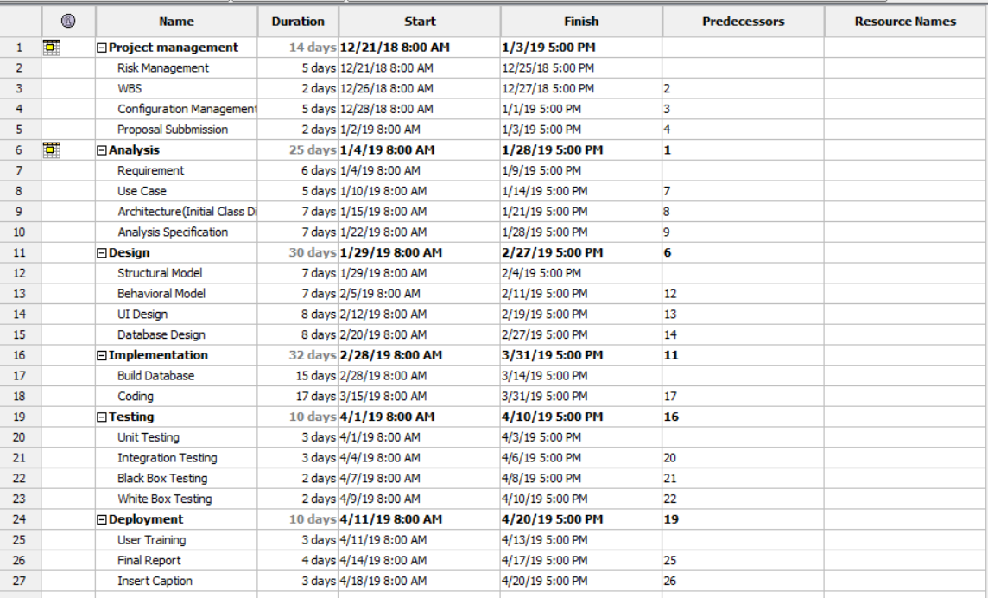

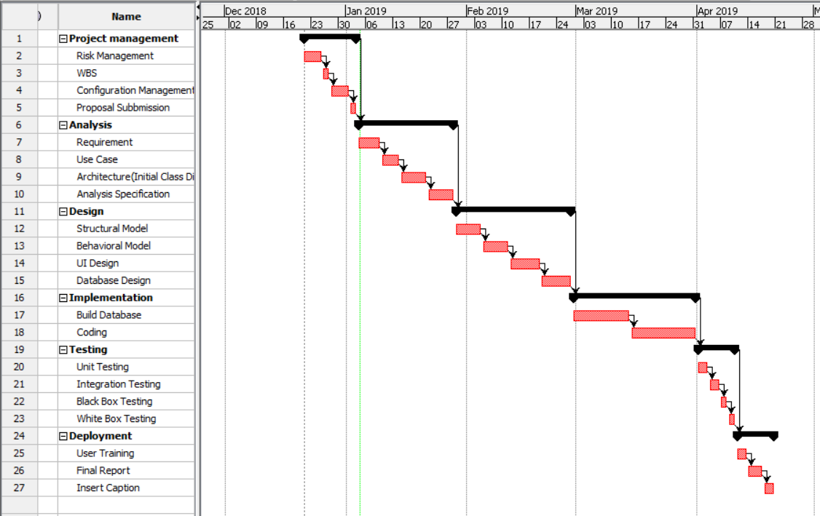

Figure 5: Gantt chart

# 5. Risk Management

Risk Management is the process of identifying, evaluating, and the prioritizing of the risks seen in the management**.** Risk can be controlled by the given points below

* Identify the reason of risks
* Understand who gets harmed and how
* Follow the steps of evaluating the risks and follow precautions measures
* review the project risks and update if needed

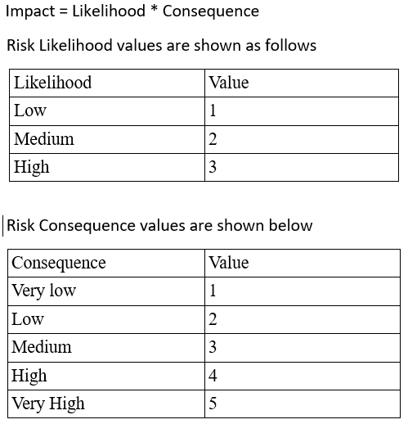

|  |  |  |  |  |  |
| --- | --- | --- | --- | --- | --- |
| S. No | Risks | Likelihood | Consequences | Impact | Solution |
| 1 | Unavailable of resources | 3 | 2 | 6 | All resources should be properly managed and available for the good management. |
| 2 | Problem in hard disk | 2 | 4 | 8 | Data should be backed up in external disks and cloud for the recovery |
| 3 | Requirement failure | 2 | 5 | 10 | Requirements should be analyzed and find out the solutions for every steps. |
| 4 | Emails | 2 | 3 | 6 | Emails are important matters in this management so use of antivirus is recommended to be safe from phishing and email hacking. |
| 5 | Website information | 3 | 3 | 9 | Website information are very delicate and can be hacked by unauthorized user so need to keep the password of the application strong and update of firewall and antivirus is important. |
| 6 | Cloud application | 3 | 2 | 6 | Cloud information is good for the storage of data and can be lost and hacked so |
| 7 | Students and Teachers data | 4 | 3 | 12 | Back up data is needed for the recon=very incase there is loss of data. |

# 6. Configuration Management

The process for the establishment and maintenance of the existing of the projects performance and its function and physical attributes along with its requirements, its design and information in its lifetime. Given two diagrams are the schools configuration management that defines how the configuration takes place.

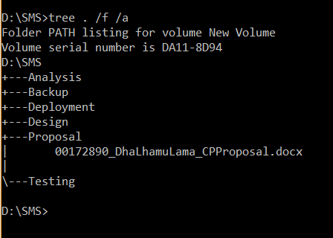

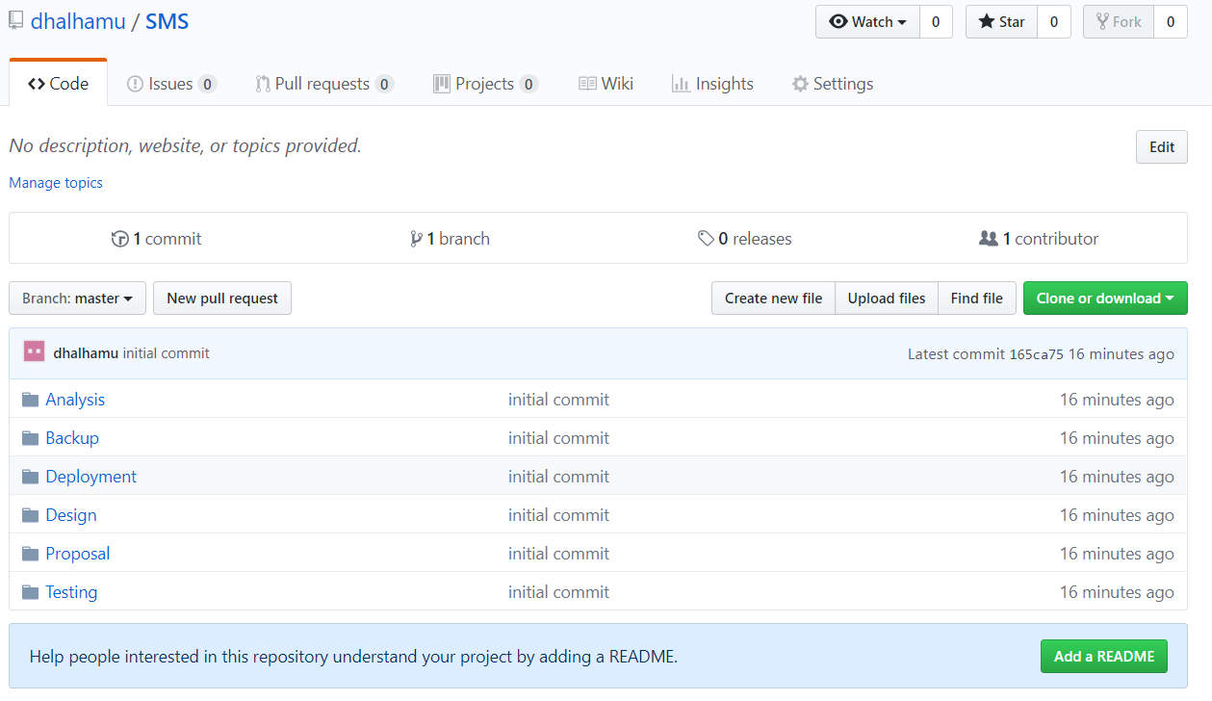

Figure 6: configuration Management

# 

# 7. Conclusion of the project

So the main thing in this project is that I have used various design to develop which has made the system very reliable and user friendly and any school management can have good use of this system. Now with this system school have very much benefit in running school management.

# 8. References

[**https://www.workbreakdownstructure.com/**](https://www.workbreakdownstructure.com/)

<https://en.wikipedia.org/wiki/Configuration_management>

https://www.tutorialspoint.com/mvc_framework/mvc_framework_introduction.htm/