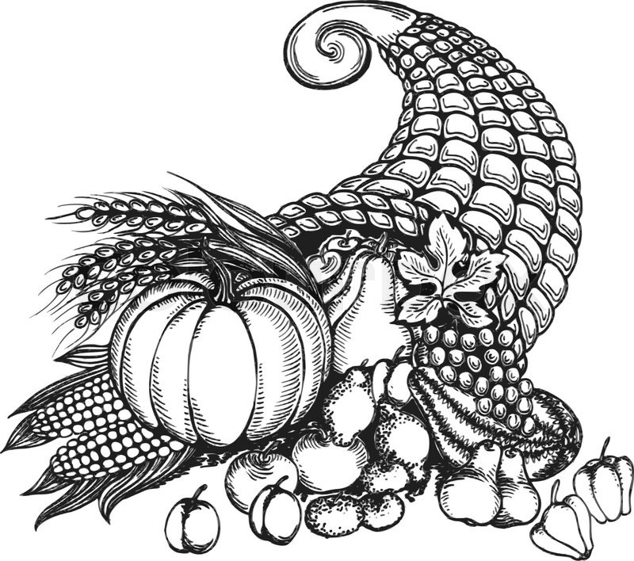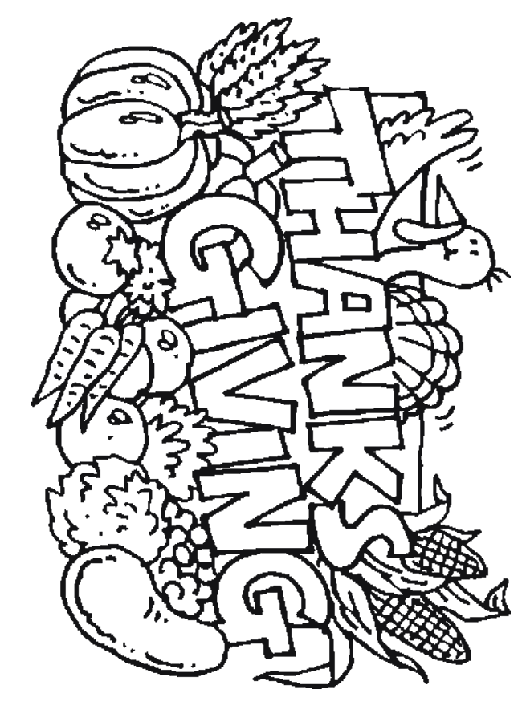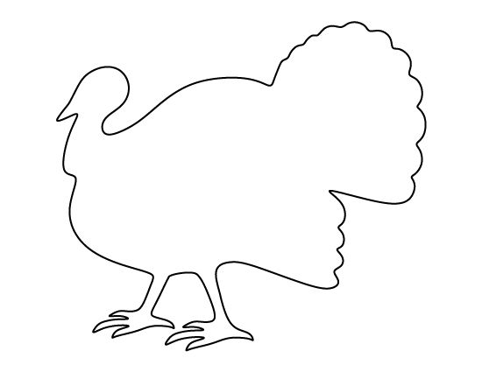

NORBEST TURKEYS

**10-12# HEN TURKEY 4/PK**

**12-14# HEN TURKEY 4/PK**

**14-16# HEN TURKEY 4/PK**

**16-18# TOM TURKEY 2/PK**

**20-22# TOM TURKEY 2/PK**

**22-24# TOM TURKEY 2/PK**

ORDER YOUR THANKSGIVING TURKEYS NOW!!!

**MARY’S TURKEYS**

FREE RANGE

+

ORGANIC

**LIMITED QUANTITIES!**

PLEASE ORDER BY OCT. 16TH!

Please Contact Your Salesperson!!!

GET YOUR ORDERS IN EARLY!