The current version of the plugin relies on an animation consisting of each shape spaced the same number of frames apart. This will need to be created by you before it can be used effectively in the game engine.

If a shape animation is determined to take 8 frames, all shape animations must be 8 frames. For example, if using A,B, and C shapes, A would start at frame 0, end at frame 7. B would start at frame 7, end at 15, etc.

The end frame property in the animation window must then be set to the total number of shapes * frames per shape. So, if 10 shapes were setup, using 8 frames each, set the end frame to 80.

The order of sounds in the animation timeline must match the Julius order in the addon. IE – “a” must be first in the timeline, followed by “e”, then “f”, “l”,”n” and so on based on the image below.

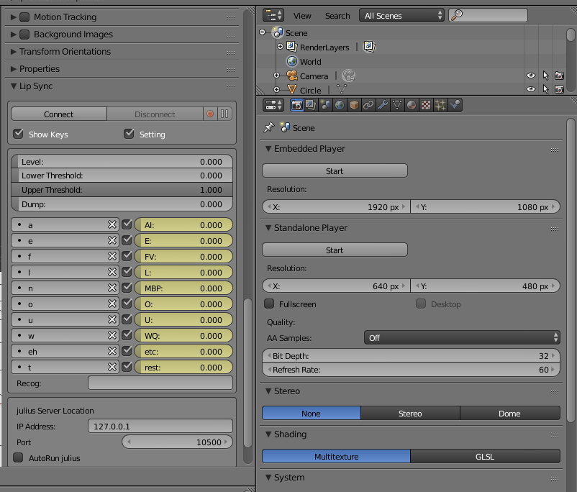

The “Create Game Logic” creates logic bricks and sets some properties needed for the game run time. You will need to go to this button to update game logic if changes are made after creation.

You will need to set the action on the actuator that will be handled automatically in a future release.

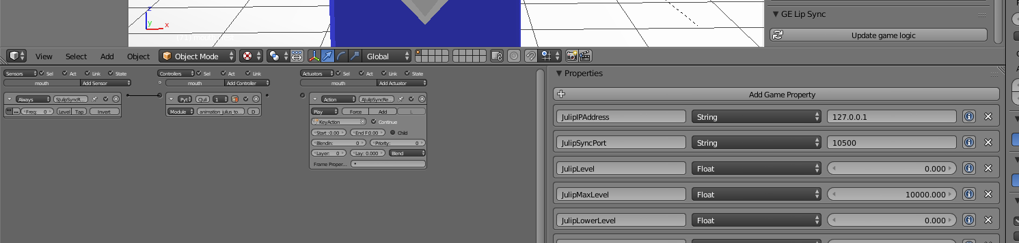

To Use:

1) Modify julius.bat

Replace (Full Path to Julius) to the full path of your local copy of julius.exe (found in .\julis_win32\Release) Replace (Full Path to julian.jconf) to the full path of your local copy of julian.jconf (found in .\AcousticModels)

2) Install and enable the animation_julius_tools.py addon in Blender Directions and general use of the original addon can be found here https://sites.google.com/site/khuuyjblend/home/blender/script/lipsync

a) When working with an object that has shape keys, a "Lip Sync" panel automatically appears

b) To use in Blender, you will either need to start julis.bat, or set the Julius properties in this panel

c) Click "connect" and say a variety of words into the mic, this will populate the Julius side of the shape key mapping on the Lip Sync Panel say a wide range of sounds ie - Bob, a socks, Jonathan, Dog, etc

d) Click disconnect

e) Click the empty box to the left of the shape key name in the lip sync panel, Julius sound options will be available to map to the shape key

3) If running Julius through the .bat file, close the command prompt and re-run the bat file

4) Click connect again, and say words with the mapped sounds in them. You should see the object react

5) Once satisfied, Click the "Create Game Logic" button to create a sensor, controller, and actuator

**TODO - make sure the "KeyAction" value exisits in the actuator

**6) To view in the game engine, you need to run Julius via the bat file first, then start BGE**

Thanks to youle on blenderartists.org to point me in the direction of playAction for shape key animation and for his continued responses and feedback.

Thanks to the artist at blendswap who shared this <http://www.blendswap.com/blends/view/74591> - it provided enough different shapes for me to have a workable proof of concept.