Sybase PowerDesigner
Physical Data Model Report

Model: Physical Data
Report: webhob



Author: lvchunhua
Version:
Date: 2012/7/12
Summary:

List of tables
Name | Code
db_builds | db_builds
db_group | db_group
db_history | db_history
db_images | db_images
db_layers | db_layers
db_operator | db_operator
db_permissions | db_permissions
db_project | db_project
db_role | db_role
db_settings | db_settings
db_systemConfig | db_systemConfig
db_building | db_building
db_user_settings | db_user_settings
db_recipe_model  db_package_model | db_recipe_model  db_package_model

Diagram PhysicalDiagram
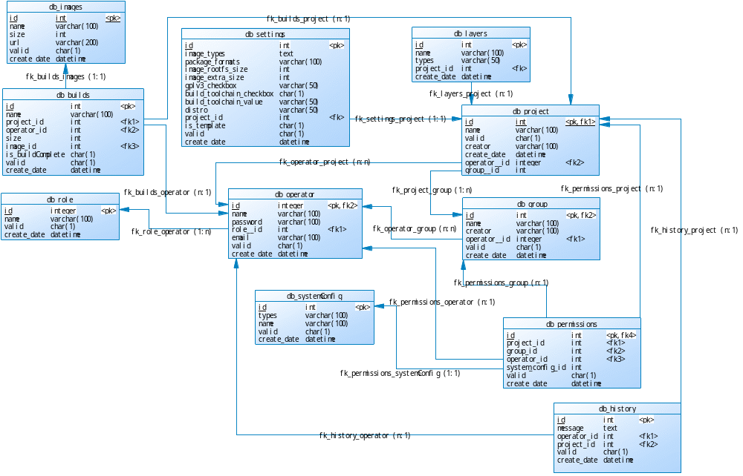

Table db_builds

List of columns of the table db_builds
Name | Fieldtype | Note
id | int | primary key
name | varchar(100) | build’s name
project_id | int | foreign key
operator_id | int | foreign key
size | int | image’s size
image_id | int | foreign key
is_buildComplete | boolean | build’s result (true/false)
valid | boolean | valid
create_date | datetime | create_date

Table db_group

List of columns of the table db_group
Name | Fieldtype | Note
id | int | primary key
name | varchar(100) | group’s name
creator | varchar(100) | creator
operator__id | int | foreign key
valid | boolean | valid
create_date | datetime | create_date

Table db_history

List of columns of the table db_history
Name | Fieldtype | Note
id | int | primary key
message | text | message
operator_id | int | foreign key
project_id | int | foreign key
valid | boolean | valid
create_date | datetime | create_date

Table db_images

List of columns of the table db_images
Name | Fieldtype | Note
id | int | primary key
name | varchar(100) | image’s name
size | int | image’s size
url | varchar(100) | download url
valid | boolean | valid
create_date | datetime | create_date

Table db_layers

List of columns of the table db_layers
Name | Fieldtype | Code
id | int | primary key
name | varchar(100) | layer’s name
types | varchar(50) | layer’s type (core layer/user’s layer)
project_id | int | foreign key
create_date | datetime | create_date

Table db_operator

List of columns of the table db_operator
Name | Fieldtype | Code
id | int | primary key
name | varchar(100) | operator’s name
password | varchar(100) | login password
role__id | int | foreign key
email | varchar(100) | login username
valid | boolean | valid
create_date | datetime | create_date

Table db_permissions

List of columns of the table db_permissions
Name | Fieldtype | Code
id | int | primary key
project_id | int | foreign key
group_id | int | foreign key
operator_id | int | foreign key
system_config_id | int | foreign key
valid | boolean | valid
create_date | datetime | create_date

Table db_project

List of columns of the table db_project
Name | Fieldtype | Code
id | int | primary key
name | varchar(100) | project’s name
valid | boolean | valid
creator | varchar(100) | creator
create_date | datetime | create_date
operator__id | int | foreign key
group__id | int | foreign key

Table db_role

List of columns of the table db_role
Name | Fieldtype | Code
id | int | primary key
name | varchar(100) | role’s name
valid | boolean | valid
create_date | datetime | create_date

Table db_settings

List of columns of the table db_settings
Name | Fieldtype | Code
id | int | primary key
image_types | text | image_types
package_formats | varchar(100) | package_formats
image_rootfs_size | int | image_rootfs_size
image_extra_size | int | image_extra_size
gplv3_checkbox | varchar(50) | gplv3_checkbox’s value
build_toolchain_checkbox | boolean | build_toolchain is checked
build_toolchain_value | varchar(50) | build_toolchain’s value
distro | varchar(50) | distro
project_id | int | foreign key
is_template | boolean | settings config is saved as a template
valid | boolean | valid
create_date | datetime | create_date

Table db_systemConfig

List of columns of the table db_systemConfig
Name | Fieldtype | Code
id | int | primary key
types | varchar(100) | types (distro,pkg format,image type,build toolchain)
name | varchar(100) | name
valid | boolean | valid
create_date | datetime | create_date

Table db_building

List of columns of the table db_build_logs
Name | Fieldtype | Code
id | int | primary key
guid  name | varchar(100)  varchar(300) | global unique id (baseimage+timerstamp)  builds name
current_build_task  build_percent  estimated_size  estimated_time  is_finished | varchar(100)  decimal(5,2)  decimal(5,2)  decimal(5,2)  tinyint(1) | current task (parse recipe/build pkg or image)  current build progress  estimated size  estimated time  finished flag
valid | boolean | valid
create_date | datetime | create_date
operator__id | int | foreign key
project_id | int | foreign key

Table db_ user_settings

List of columns of the table db_ mgt_bitbake_servers
Name | Fieldtype | Code
id | int | primary key
settings_id | varchar(200) | foreign key
guid | varchar(100) | global unique id (baseimage+timerstamp)
machine_selected | varchar(100) | machine selected
baseimage_selected | varchar(100) | baseimage selected
recipe_selected  packages_selected  layers_selected  is_customize_baseImage  fast_build_image  build_start  build_conf  build_error  operator_id  valid  create_date | longtext  longtext  longtext  tinyint(1)  varchar(20)  varchar(100)  longtext  longtext  int(11)  tinyint(1)  datetime | recipes selected  packages selected  layers selected  is checked recipes or packages item  fast build image flag  build start flag  build config  build error log  foreign key  valid flag  create time

Table db_ recipe_model

List of columns of the table db_ build_temp
Name | Fieldtype | Code
id | int | primary key
guid | varchar(100) | global unique id (baseimage+timerstamp)
name  desc | varchar(200)  varchar(4000) | recipe or task name  description
lic  group  deps  binb  type  is_inc  is_img  install | varchar(200)  varchar(1000)  varchar(5000)  varchar(5000)  varchar(100)  int(11)  int(11)  varchar(1000) | licence  group  dependencies  dependency packages  type  is checked  is image  is install

Table db_ package_model

List of columns of the table db_ build_temp
Name | Fieldtype | Code
id | int | primary key
guid | varchar(100) | global unique id (baseimage+timerstamp)
name  pnpvpr  pkgv  pkgr  pkg_rename  summary  section  rdep  rprov  size  binb | varchar(200)  varchar(1000)  varchar(1000)  varchar(1000)  varchar(1000)  varchar(1000)  varchar(1000)  longtext  varchar(1000)  varchar(200)  varchar(5000) | package name  package description  package version  package group  package name repeat  package summary  section  dependencies  recipe dependency  package size  package item dependency
is_inc | Int(11) | is checked

