1.

a. An estimator for a certain quantity being unbiased means that the distribution of estimates has a mean that is the true quantity.

b. 1/5 for the first cue and 4/5 for the second cue. The variance would be 1*4/(1 + 4) = 4/5 (which is lower than either individually).

c. The variance would then be (.5^2 * 1) + (.5^2 * 4) = 2.5 which is 3.125x more variable than the best estimator.

d. He would be better off than averaging but not better off than the optimal weight combination.

2.

a. Since your X and Y measurements are independent, the probability of being within the circle of radius 1 is the probability mass of a multivariate Gaussian within a Mahalnobis distance of 1. This is given by 1 – e^(-d^2/2) so, plugging in 1, we get a 39% chance of getting it right

b. He should put 2/3 weight on X1, Y1 and 1/3 on X2, Y2. Then the total variance of the X estimate would be ((2/3)^2 * 1) + ((1/3)^2* 2) = 2/3 (and same for the Y estimate) so 1 SD is sqrt(2/3). The probability mass within a circle with a radius of 1 is given by the above equation with d = 1/sqrt(2/3) so d^2 = 3/2. So Mike has a 52% chance of getting it right.

3.

a. If we assume that the prior is also Gaussian, then we get that the posterior over Denis’ location has is also Gaussian with mean_posterior = (mean_prior/var_prior + mean_lik/var_lik) * var_posterior where 1/var_posterior = 1/var_prior + 1/var_lik. Plugging in, we get that 1/var_posterior = 1/10 + 1/100 = 11/100 and mean_posterior = (5 + .4) * 100/11 = 49.0909…so most of the information in the data gets swamped by the prior. In addition the variance gets slightly smaller because the posterior always has smaller variance than the prior if it’s a conjugate prior.

Here is a plot with the prior in red, the likelihood in blue and the posterior in green

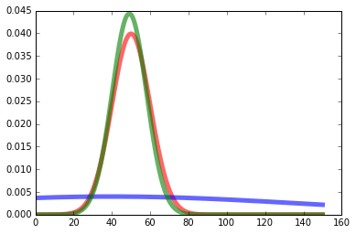

b. Now we get that 1/var_posterior = 1/10 + 1/40 = 1/8 and mean_posterior = (5 + 1) * 8 = 48 so we shift more in the direction of the likelihood. This makes sense because we have less noise in our new estimate so we don’t need to rely as heavily on the prior.

Here is the same plot as above

