Railway Station Passenger Flow
Submission 2 – Final Report
EEI6373 – Performance Modelling
Akila Dhambure Liyanage | 320267120

Abstract
This report models passenger flow through the ticket concourse of a major railway station during the morning peak period (07:00 – 09:00) using M/M/c queueing theory (Erlang-C), Little's Law and a passenger-level discrete-event simulation. A simulated data set of 400 passengers (180 Normal, 220 Online) is used to estimate utilisation, waiting times and queue lengths. The analysis identifies the ticket counters as the bottleneck of the system: at the baseline peak load the utilisation is ρ = 0.75 and the expected wait Wq = 1.14 min, rising to ρ = 0.9167 and Wq = 5.08 min in a busy morning. The results show that adding two counters (c = 5) reduces the wait to 0.12 min, while faster service (μ = 50/hour) reduces it to 0.81 min. The simulated data set validates the analytical model (simulated mean wait 1.22 min vs analytical 1.14 min).

1. Introduction and System Description
Railway stations in the morning peak behave as coupled queueing networks. Passengers arrive stochastically, join queues at ticket counters and gates, and accumulate on platforms before boarding. The ticket counters serve only Normal ticket passengers while Online ticket passengers bypass them, so the counter subsystem carries a class-dependent and highly concentrated load.
This project studies the flow of passengers through the stages: ticket acquisition (Normal class only), entry gates, platform and boarding. The performance objectives are to identify the bottleneck stage, quantify waiting times and queue lengths, establish the capacity limit of the current configuration, and evaluate what-if interventions that reduce congestion.

2. Modelling Approach and Assumptions
The ticket-counter subsystem is modelled as an M/M/c queue: arrivals follow a Poisson process with rate λ, service times are exponential with rate μ per counter, and c identical counters operate in parallel with a FIFO discipline. The Erlang-C formula provides the probability of waiting and the expected waiting time, and Little's Law (Lq = λ × Wq) is used as a consistency check. The entry gates are modelled as an independent M/M/c queue for comparison.
Key assumptions:
- Arrivals are Poisson; the peak period is modelled as 2 hours of steady demand (07:00 – 09:00).
- Service times at the counters are exponential with mean 1/μ = 1.5 min (μ = 40/hour).
- The queue discipline is FIFO and there is no balking or reneging.
- The passenger-level data set is generated by a discrete-event simulation consistent with these assumptions and is simulated, not real observations.

2.1 Parameters
Parameter | Symbol | Value
Normal arrival rate | λ | 90 passengers/hour (180 / 2 h)
Online arrival rate | λ | 110 passengers/hour (220 / 2 h)
Counter service rate | μ | 40 passengers/hour per counter
Number of counters | c | 3 (baseline)
Entry gate service rate | μ | 100 passengers/hour per gate
Number of gates | c | 3

3. Data and Methodology
The data set (data/passenger_flow_peak_hours.csv) contains 400 passengers: 180 Normal (45.0%) and 220 Online (55.0%). It was produced by a FIFO M/M/c discrete-event simulation (c = 3, μ = 40/hour) with Poisson arrivals sampled as order statistics of a uniform distribution, giving an exact 07:00 – 09:00 window and a reproducible seed. Each passenger record captures counter wait, counter service, gate wait, gate service, boarding wait and total time.
The scenario analysis is run as a controlled experiment: 20 independent 2-hour replications of each scenario, same random seed per replication, with one parameter changed at a time. The analytical M/M/c values and the simulated means are compared to validate the model.

4. Analysis and Results

4.1 Baseline (Normal Peak)
Measure | Formula | Value
Utilisation | ρ = λ/(c·μ) = 90/(3×40) | 0.75
Probability of waiting | Erlang-C P(wait) | 0.626
Expected queue length | Lq | 1.703 passengers
Expected wait | Wq = Lq/λ | 1.14 min

Little's Law check: Lq = λ × Wq = 90 × 1.14/60 = 1.71 ≈ 1.703 passengers (matches within rounding).

4.2 Busy Morning (High Load)
Measure | Value
Arrival rate λ | 110 passengers/hour
Utilisation ρ | 0.9167
Expected wait Wq | 5.08 min
Status | Stable, but heavily congested (ρ close to 1)

At ρ = 0.9167 the system is only just stable; with c = 3 counters the capacity limit is λ < 120 passengers/hour.

4.3 What-if Interventions
Scenario | λ | μ | c | ρ | Wq (min)
Baseline (Normal Peak) | 90 | 40 | 3 | 0.750 | 1.14
Busy Morning | 110 | 40 | 3 | 0.9167 | 5.08
Busy + 5 Counters | 110 | 40 | 5 | 0.55 | 0.12
Busy + Faster Service | 110 | 50 | 3 | 0.7333 | 0.81

Adding two counters (c = 5) reduces the busy-morning wait from 5.08 min to 0.12 min, and increasing the service rate to μ = 50/hour reduces it to 0.81 min. Both interventions bring utilisation below 0.75 and restore stable, short queues. The entry gates (ρ = 0.667, Wq = 0.27 min) are not the bottleneck.

4.4 Model Validation
The simulated data set reproduces the analytical model: the simulated mean counter service time is 1.46 min (μ ≈ 41.2/hour vs target 40), and the simulated mean counter wait of 1.22 min is within 7.2% of the analytical Wq = 1.14 min. The finite 2-hour window starts empty, so simulated waits include the transient warm-up and sit at or below the steady-state M/M/c values; the gap grows with utilisation (e.g. Busy Morning: simulated ≈ 2.99 min vs steady-state 5.08 min).

4.5 Sensitivity Analysis
Sweeping the arrival rate from λ = 70 to 130 passengers/hour shows that Wq grows sharply as ρ approaches 1. With three counters the system becomes unstable above λ = 120; with five counters the same load stays comfortably within stable utilisation.

5. Visualisations
The following figures are generated by the analysis pipeline (see outputs/):
- Figure 01: Utilisation of ticket counters (baseline and busy) and entry gates, with the high-congestion threshold.
- Figure 02: Effect of the number of counters on the expected wait Wq under λ = 110/hour.
- Figure 03: Arrival intensity across 07:00 – 09:00 (passengers per 10-minute bin).
- Figure 04: Counter wait, gate wait and total time for Normal vs Online passengers.
- Figure 05: Sensitivity of Wq to the arrival rate for c = 3, 4 and 5 counters.
- Figure 06: Average counter waiting time per 10-minute bin, with the analytical Wq as reference.
- Figure 07: System flow diagram: Normal passengers queue at counters, Online passengers bypass them; both proceed through gates, platform and boarding.
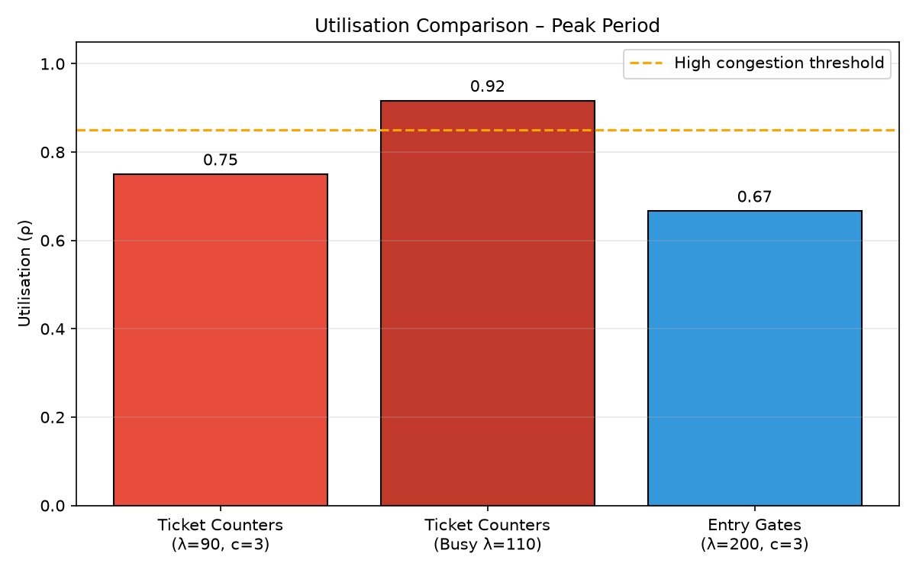
01_utilisation_comparison
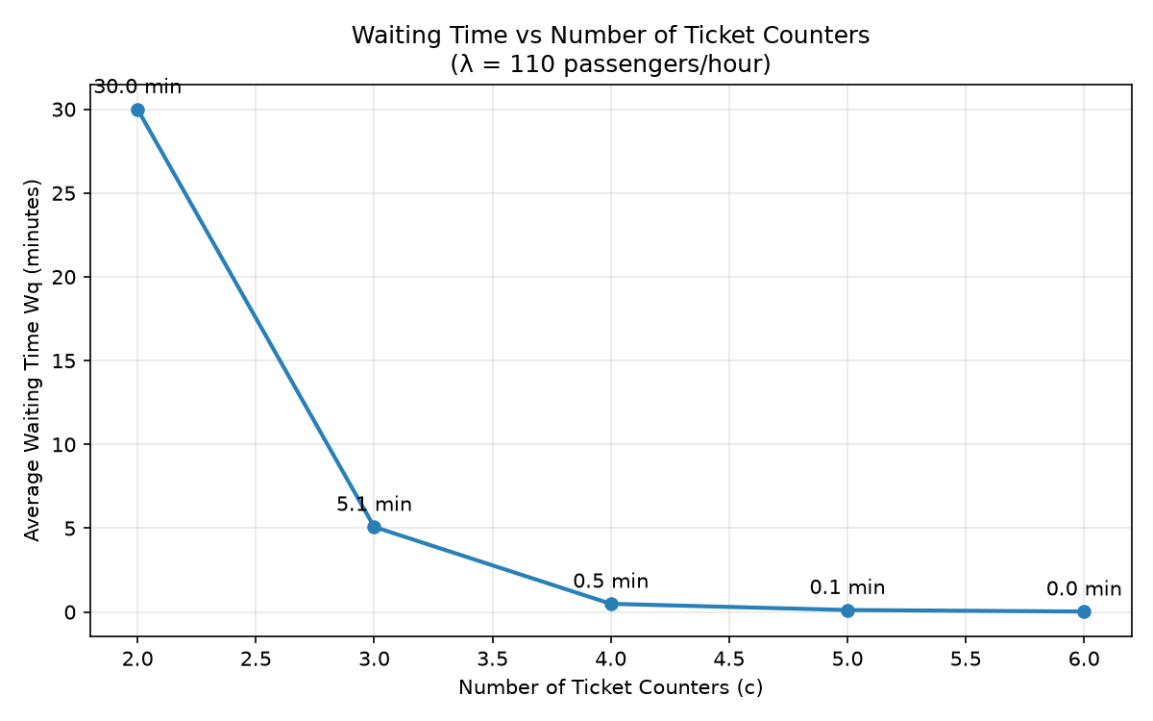
02_waiting_vs_counters
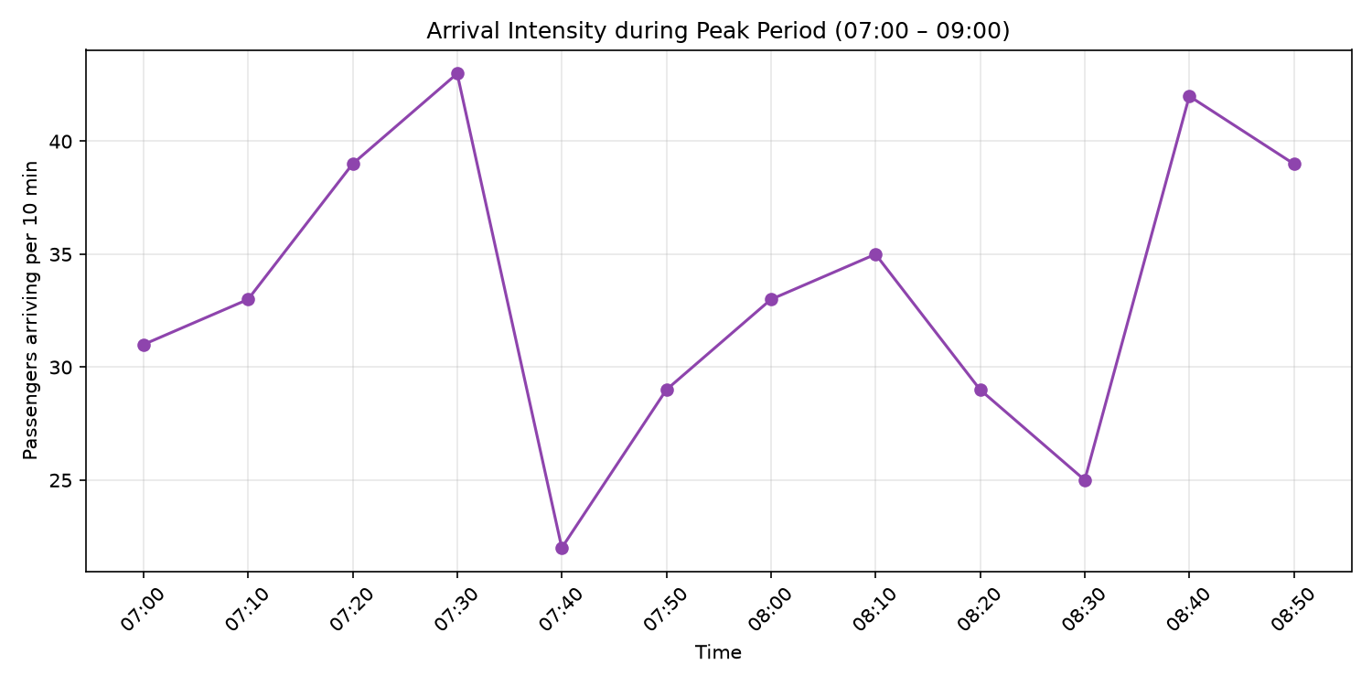
03_arrival_intensity
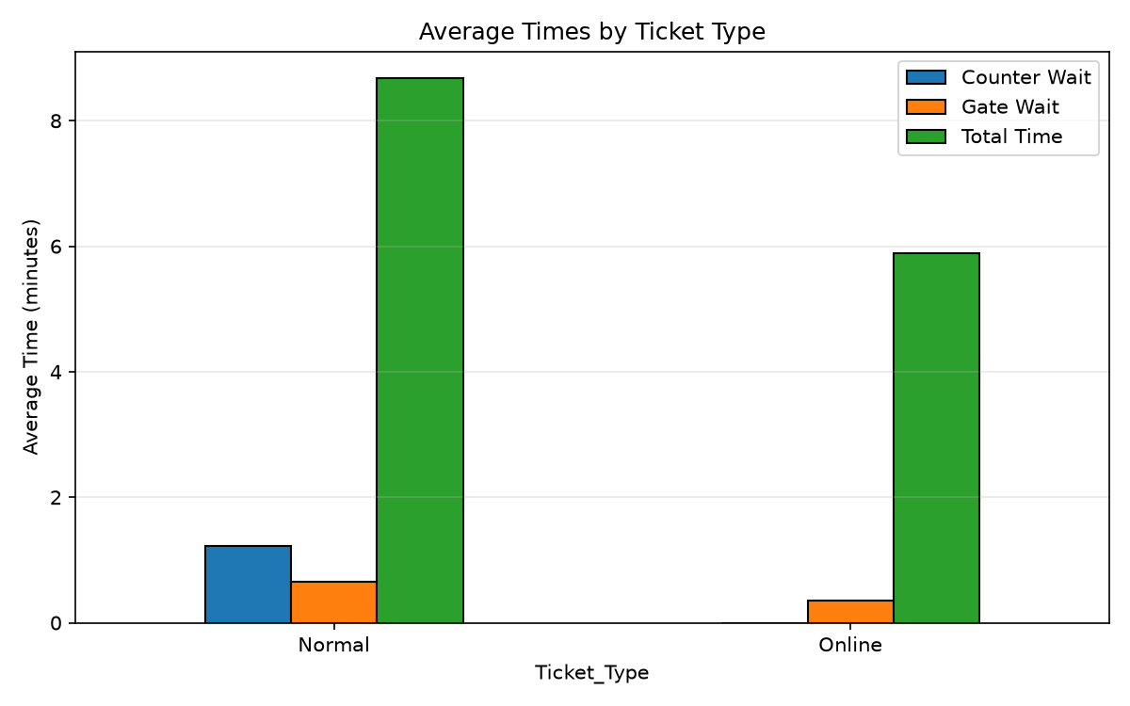
04_ticket_type_comparison
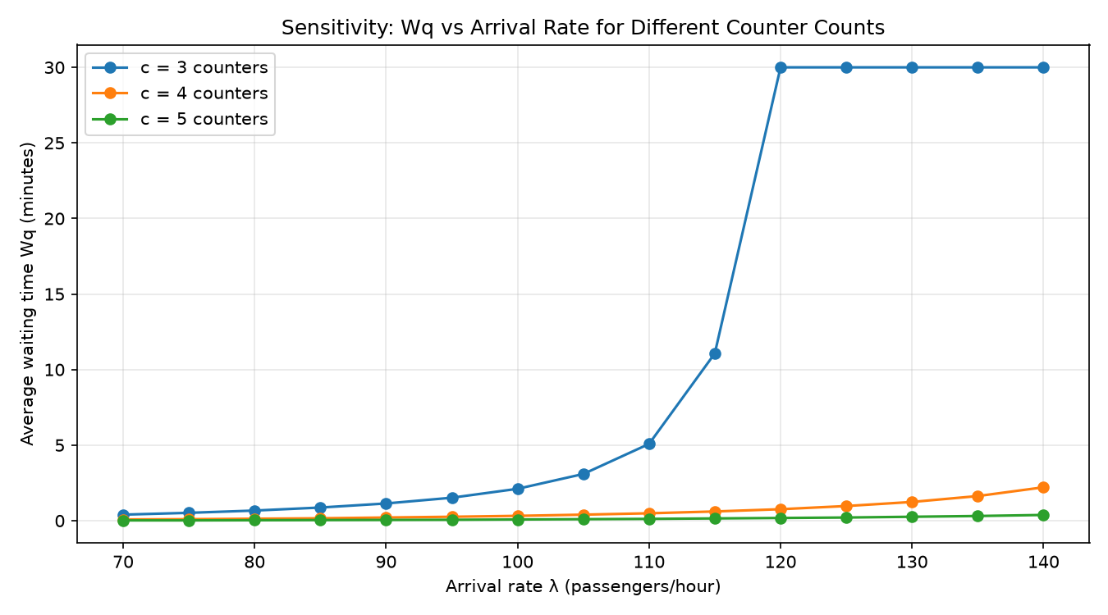
05_sensitivity_analysis
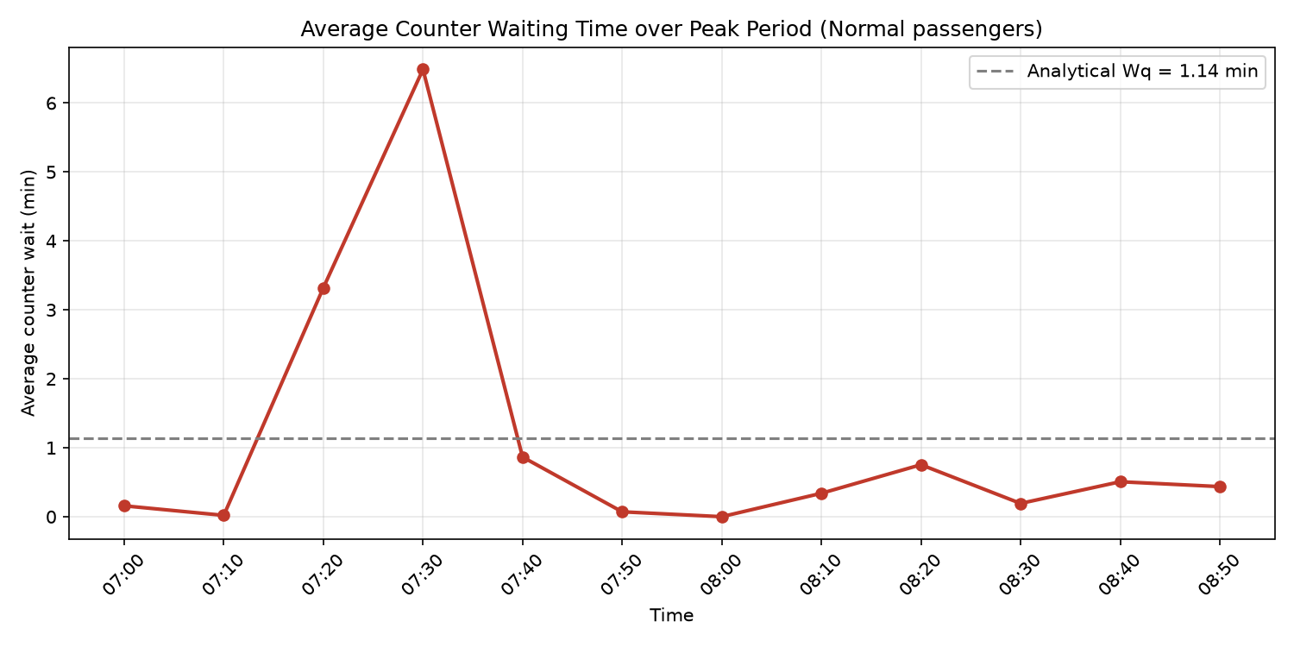
06_waiting_trend
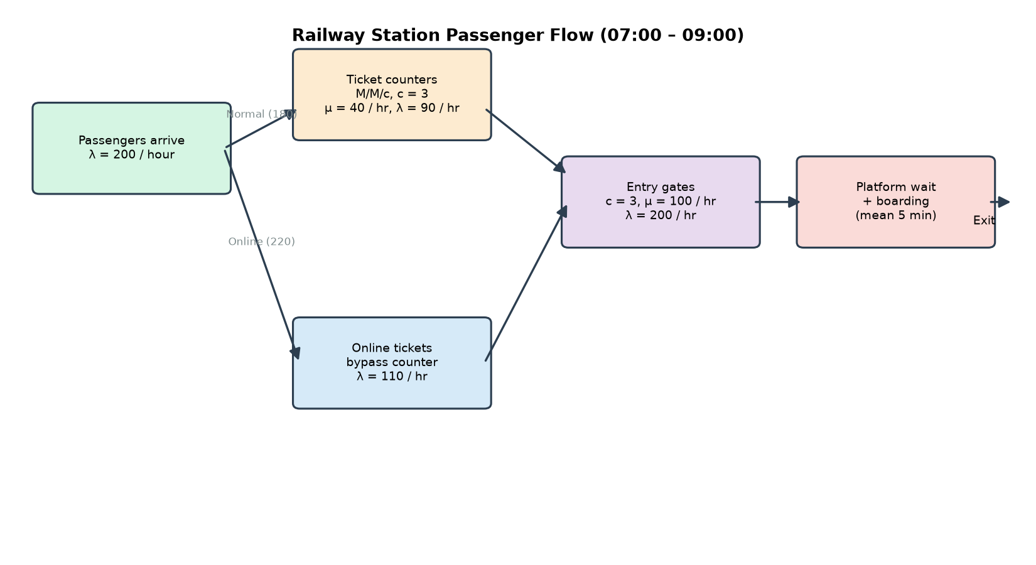
07_system_flow_diagram

6. Limitations and Future Work
- The data are simulated, not real station observations; the results should be confirmed with measured arrival and service data.
- The 2-hour window introduces a transient effect that the steady-state M/M/c model does not capture; a time-varying (transient) queueing model would remove this gap.
- Assumptions of Poisson arrivals, exponential service and no balking simplify real passenger behaviour.
- Only two passenger classes are distinguished; future work could add season tickets, family groups and platform capacity constraints.

7. Conclusion
The ticket counters are the bottleneck of the peak-period passenger flow. At the baseline load of λ = 90/hour the expected wait is 1.14 min at ρ = 0.75, but a busy morning at λ = 110/hour pushes utilisation to 0.9167 and the wait to 5.08 min. Adding two counters is the most effective intervention (Wq = 0.12 min), and the analytical model is validated by the simulated data set. The project demonstrates a complete performance-modelling chain from data, through an analytical M/M/c model and validation, to capacity recommendations.

8. References
- [1] D. G. Kendall, "Stochastic processes occurring in the theory of queues and their analysis by the method of the imbedded Markov chain," The Annals of Mathematical Statistics, vol. 24, no. 3, pp. 338–354, 1953.
- [2] A. K. Erlang, "Solution of some problems in the theory of probabilities of significance in automatic telephone exchanges," The Post Office Electrical Engineers' Journal, vol. 10, pp. 189–197, 1917.
- [3] J. D. C. Little, "A proof for the queuing formula: L = λW," Operations Research, vol. 9, no. 3, pp. 383–387, 1961.
- [4] D. Gross, J. F. Shortle, J. M. Thompson, and C. M. Harris, Fundamentals of Queueing Theory, 4th ed. Hoboken, NJ, USA: Wiley, 2008.
- [5] L. Kleinrock, Queueing Systems, Volume 1: Theory. New York, NY, USA: Wiley, 1975.
- [6] K. S. Trivedi, Probability and Statistics with Reliability, Queuing, and Computer Science Applications, 2nd ed. New York, NY, USA: Wiley, 2002.

Repository
The full project (data set, scripts, results and this report) is available in the git repository: https://github.com/dhambure98/PM-MP-Railway-Station.git.

