A REPORT ON

**Automation Of Sewage Treatment Plant**

By

Sridhar Dhamija – 2018A8PS0707G

Anoop Adusumilli – 2018AAPS1240H

Abhik Santra – 2018A8PS0612H

# At

RMJ Automation Solution & Training Pvt. Ltd.

(Industrial Control & Automation)

**A Practice School-I Station of**

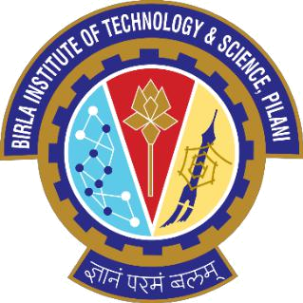

# BIRLA INSTITUTE OF SCIENCE AND TECHNOLOGY, PILANI

**( May 2020 - June 2020 )**

A REPORT ON

**Automation Of Sewage Treatment Plant**

|  |  |  |
| --- | --- | --- |
|  | By |  |
| Sridhar Dhamija | 2018A8PS0707G | Electronics & Instrumentation |
| Anoop Adusumilli | 2018AAPS1240H | Electronics & Communication |
| Abhik Santra | 2018A8PS0612H | Electronics & Instrumentation |

***Prepared in partial fulfilment of the Practice School-I Course Nos.***

***BITS C221/ BITS C231/ BITS C241***

## At

RMJ Automation Solution & Training Pvt.Ltd

(Industrial Control & Automation)

**A Practice School-I Station of**



# BIRLA INSTITUTE OF TECHNOLOGY AND SCIENCE, PILANI

**( May 2020 - June 2020 )**

**ACKNOWLEDGEMENTS:**

We would like to express our deepest appreciation to all those who provided us with the necessary guidance to complete the project report. We owe our deep gratitude to the Practise School Instructor ​Prof. Vinay Belde, who took a ​keen interest and guided us all along, till the completion of our report by providing all the necessary and invaluable inputs and took out an effort in sharing their precious time to participate in our study, providing us with his vital response, and without whose contribution this report could not have been successful. Finally, we would like to thank the Industry Expert from RMJ Automation Solution & Training Pvt. Ltd, Mrs Kiran Pathak, for giving us the opportunity to work on this report which gave us an insight and knowledge from various perspectives and to understand and implement the project.

**BIRLA INSTITUTE OF TECHNOLOGY AND SCIENCE, PILANI**

**(RAJASTHAN)**

**Practice School Division**

**Station**:​ RMJ Automation Solution & Training Pvt. Ltd **Centre**​ :​ Mysore

**Duration**:​ 6 weeks **Date of Start**:​ 18th May 2020

**Date of Submission**:27th June 2020

**Title of the Project:** Automation of Sewage Treatment Plant​

## ID No. of student Name of student Discipline of student

|  |  |  |
| --- | --- | --- |
| Sridhar Dhamija | 2018A8PS0707G | Electronics & Instrumentation |
| Anoop Adusumilli | 2018AAPS1240H | Electronics & Communication |
| Abhik Santra | 2018A8PS0612H | Electronics & Instrumentation |

**Name(s) and Designation(s) of the expert(s)**:​

Kiran Pathak (Managing Director at RMJ Automation Solution & Training Pvt. Ltd )

Vinay Belde ( Professor at BITS Pilani )

**Name of the PS Faculty**:​ Vinay Belde ( Professor at BITS Pilani )

**Key Words:** Automation, PLC, SCADA, Control Expert, Schneider​

**Project Areas:** Automation, Industrial Control, Networking, Sewage Plant​

**ABSTRACT**

Sewage treatment plants in a city are as important as kidneys in a human. They are very much essential to properly deal with waste before releasing into lands & rivers; because eventually, we are the ones who’ll be facing all the consequences.

In India itself, the population is increasing at a rapid rate. The growing number of industries across the country has also led to the rise of sewage waste.

Through multiple processes, the harmful substances in the wastewater are removed and made good enough to be released to the environment. This includes physical, biological and chemical treatment of sewage.

These processes occur in a dedicated facility called as the sewage treatment plant.

Signature of Student: Signature of PS Faculty

Sridhar Dhamija; Anoop Adusumilli; Abhik Santra Vinay Belde

Date: 26/06/2020 Date: 26/06/2020

**ABSTRACT**

Sewage treatment plants in a city are as important as kidneys in a human. They are very much essential to properly deal with waste before releasing into lands & rivers; because eventually, we are the ones who will be facing all the consequences.

In India itself, the population is increasing at a rapid rate. The growing number of industries across the country has also led to the rise of sewage waste.

Through multiple processes, the harmful substances in the wastewater are removed and made good enough to be released to the environment. This includes physical, biological and chemical treatment of sewage.

These processes occur in a dedicated facility called as the sewage treatment plant.

Table of Contents

**Introduction** 7

**Industrial Automation** 8

Programmable Logic Controller (PLC) 8

Supervisory Control and Data Acquisition (SCADA) 9

Human Machine Interface (HMI) 10

Distributed Control System (DCS) 10

Redundancies 11

Communication in PLC 12

PLC Architecture & Wiring Diagram: 13

Ladder Logic 14

**Sewage Treatment Plant** 15

**Software** 20

EcoStruxure™ Control Expert (by Schneider Electric) 20

Citect SCADA (by Schneider Electric) 21

**Project Implementation** 23

**Conclusion** 28

**References** 29

**GLOSSARY** 30

# **Introduction**

Over the years, there has been increasing competition in the industry over the demand for high-quality products and services, along with the perpetual need for increased productivity. Industrial Automation is one of the key parts of the solution to this problem, along with process engineering. Industrial automation is a set of technologies that uses control systems and devices, such as computer software, to control industrial processes and machinery by removing as much labour intervention as possible and replacing dangerous assembly operations with automated ones. Doing this not only reduces costs and saves time, but also eliminates the possibility of human error, which facilitates higher quality goods and consistency among these produced goods. Some of the other advantages of automation include - efficient use of raw materials, reduced energy consumption, increased safety, better data collection, and assisted remote monitoring. Industrial automation is closely linked to control engineering.

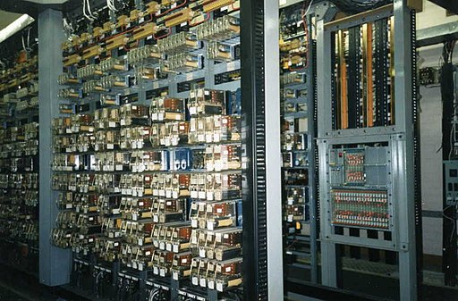 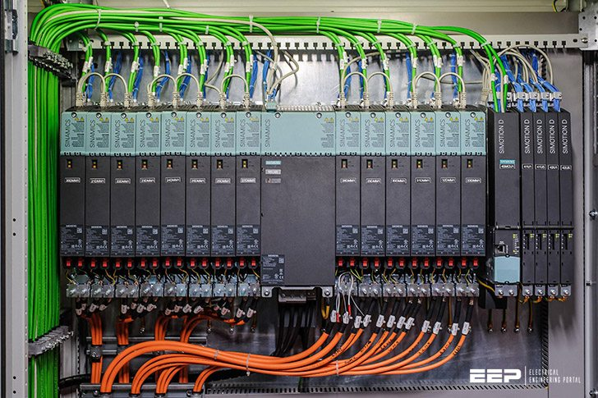

# **Industrial Automation**

**Some of the key tools used in industrial automation are:**

## Programmable Logic Controller (PLC)

A PLC is an industrial computer used to monitor inputs and depending upon their state to make decisions based on its program or logic, to control (turn on/off) its outputs to automate a machine or a process.

* It acts as an intermediate between sensors (level 0) and SCADA (level 2) and acts as a background for SCADA which runs on the information and values given and processed by PLC. It is a special computer that controls certain processes in industries.
* It takes the input through input modules processes it and produces output. It is made up of I/P module, CPU with microprocessor, O/P module, Bus System and Power Supply.
* There are basically 2 types of PLC: Compact PLC (nano plc, micro plc) and Modular PLC (medium plc and large plc). The basic criteria of types are on Memory, I/O range/Nos., packing and cost per unit. PLC Scan: this process has several steps which goes on in a loop such as: read i/p, execute program, diagnostics & communication, and update o/p.
* PLC programming can be done in 5 different languages: Ladder Logic, Structured Text, Instruction List, Sequential Function Chart, Function Block Diagram.
* Moreover, through the PLC Architecture you can also locate PLC on the system which is connected to the control bus for o/p and to the sensors and i/p modules for the i/p.

Advantages Of PLC:

1. To make any changes no rewiring is required.
2. Can perform operations like time delay, counter, comparison, arithmetic operators etc.
3. Both Online and Offline programming can be performed.
4. Has high processing speed, flexibility of Analog and Digital Signal Processing.
5. Closed loops with several loops & high sampling frequencies.

## Supervisory Control and Data Acquisition (SCADA)

SCADA systems control and monitor industrial processes. SCADA is a combination of telemetry (collection of measurements or data and their automatic transmission to the receiving equipment) and data acquisition (process of sampling signals and converting them into digital numeric values). It is a combination of hardware, software, and specific protocols. The system acquires and processes real-time data through direct interaction with devices, such as sensors and PLCs, and records events into a log file. This helps in monitoring equipment like motors, valves, pumps, relays, and sensors etc.

Hardware used by SCADA: field level instruments, RTU’s, master stations, communication systems.

Some of the protocols used in SCADA are DNP, Modbus, Device Networking, Modbus Ethernet. It also has a feature for Instant Messaging.

Thus, SCADA is vital for data analysis and enables effective decision-making for optimization in industrial processes.

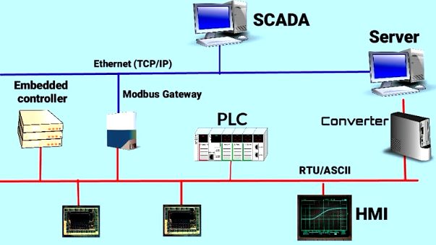

## Human Machine Interface (HMI)

An HMI is a software application that enables interaction and communication between a human operator and the machine, or production system. It translates complex data into accessible information, allowing better control of the production process and its various applications.

## Distributed Control System (DCS)

A DCS is a central monitoring network that interconnects devices to control different elements within an automated system.

## Redundancies

Redundancy is the duplication of critical components or functions of a system with the intention of increasing reliability of the system, usually in the form of a backup or fail-safe.

In many safety-critical systems some parts of the control system may be Duplicated or triplicated, which is formally termed as Double Modular Redundancy (DMR) or Triple Modular Redundancy (TMR).

The different redundancy components are as follows –

* CPU Redundancy
* Power Supply Redundancy
* Network Redundancy
* Server Redundancy
* Input/Output Redundancy

The different types of redundancy are:

1. Cold Redundancy: It is for non-critical processes where time is not a high priority, and human intervention is acceptable.
2. Warm Redundancy: If time and response to a failure are more important but not critical, and a temporary outage is acceptable, a warm redundancy strategy may suffice.
3. Hot Redundancy: This is similar to warm redundancy in terms of architecture, but it offers instant process correction when a failure is detected.

## Communication in PLC

Some common protocols used in the industrial area include:

* Modbus RTU
* EtherNet/IP
* Ethernet TCP/IP
* Modbus TCP/IP
* Profinet

Perhaps the most common industrial serial communication protocol is Modbus RTU, developed by Modicon (now Schneider Electric), which usually runs on an RS-485 network. This and other popular serial protocols are supported by a wide variety of suppliers, and are very familiar to a wide group of automation professionals. But performance is limited, making serial protocols a poor choice for high speed and other demanding applications.

Modbus is an open protocol, meaning that it's free for manufacturers to build into their equipment without having to pay royalties. It has become a very common protocol used widely by many manufacturers throughout many industries.

How does it work?

Modbus is transmitted over serial lines between devices. The simplest setup would be a single serial cable connecting the serial ports on two devices, a Master and a Slave. 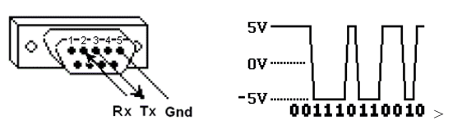

The data is sent as series of 1s and 0s called bits. Each bit is sent as a voltage. 0s are sent as positive voltages and a 1s as negative. The bits are sent very quickly. A typical transmission speed is 9600 bits per second. Thus, MODBUS is a master/slave protocol.

There are other types of protocols like token-passing protocols (e.g. GENIUS). Token-passing protocol is dedicated for communication between many nodes (peer-to-peer) and guarantees reliability at high speed.

## PLC Architecture & Wiring Diagram:

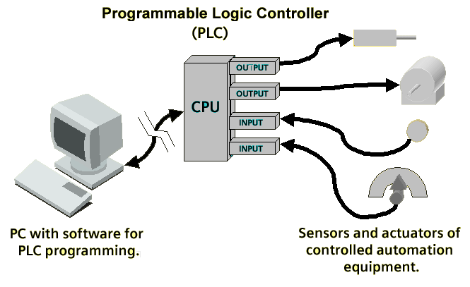

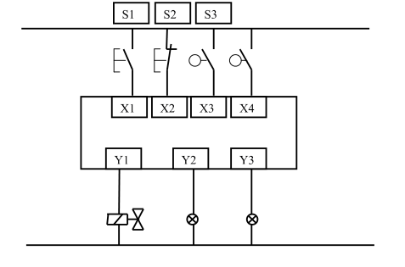

## Ladder Logic

Ladder logic (also known as ladder diagram or LD) is a programming language used to program a PLC (Programmable Logic Controller). It is a graphical PLC programming language which expresses logic operations with symbolic notation. Ladder logic is made out of rungs of logic, forming what looks like a ladder – hence the name ‘Ladder Logic’.

Ladder logic is mainly for bit logic operations, although it is possible to scale a PLC analog input. Even simple bit logic operations can be beneficial in more advanced PLC programs and SCADA system programming.

Ladder logic is a graphical programming language which means that instead of text, the programming is done by combining different graphic elements. These graphic elements are called symbols.

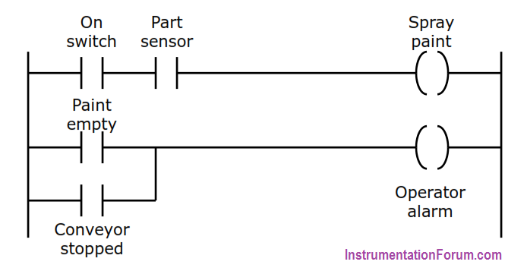

Two-rung ladder logic program

# **Sewage Treatment Plant**

Wastewater can be divided into two major groups:

* Sewage water is all wastewater used in domestic dwellings (e.g. originating from toilets, showers or sinks).
* Industrial wastewater originates from production, industrial and commercial activities, and has a different chemical composition to sewage water.

Sewage treatment refers to the process of removing contaminants, micro-organisms and other types of pollutants from wastewater influent. The main objective of sewage treatment is to produce an effluent (treated wastewater) and a solid waste/sludge suitable for discharge into the natural environment.

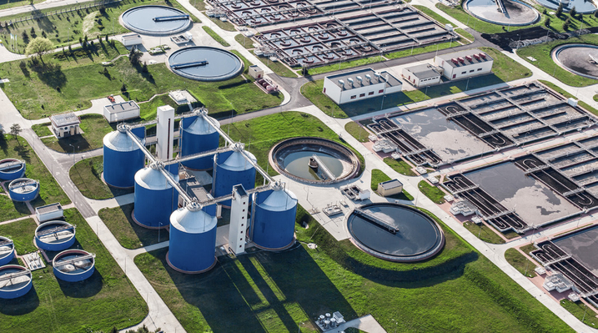

**Sewage Treatment Plant**

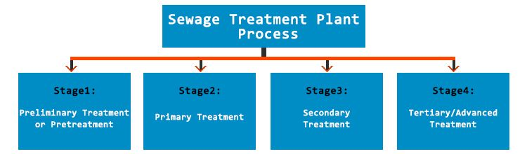

1. The first mechanical stage is called **preliminary treatment** or rather pre-treatment. Water flows through gravel chamber for settling out the grit from water. Afterwards, gravel is disposed of at the dump. Water further reaches the bar screens used to remove large objects from the wastewater. At first come the coarse screens and then the fine screens which remove smaller objects such as matches, cigarette butts or undigested foods.
2. The next sedimentation stage is called **primary treatment** during which the wastewater flows to primary settling tanks/clarifiers. Water is driven towards the hopper in the base of the tank. Hopper arm moves around the edge of the tank at the velocity of 4cm/s. Treated water heads toward edges and the particulates of higher sedimentation velocity than the flow velocity settle on the bottom of the tank.

**Primary treatment** removes about **60%** of suspended solids from wastewater.

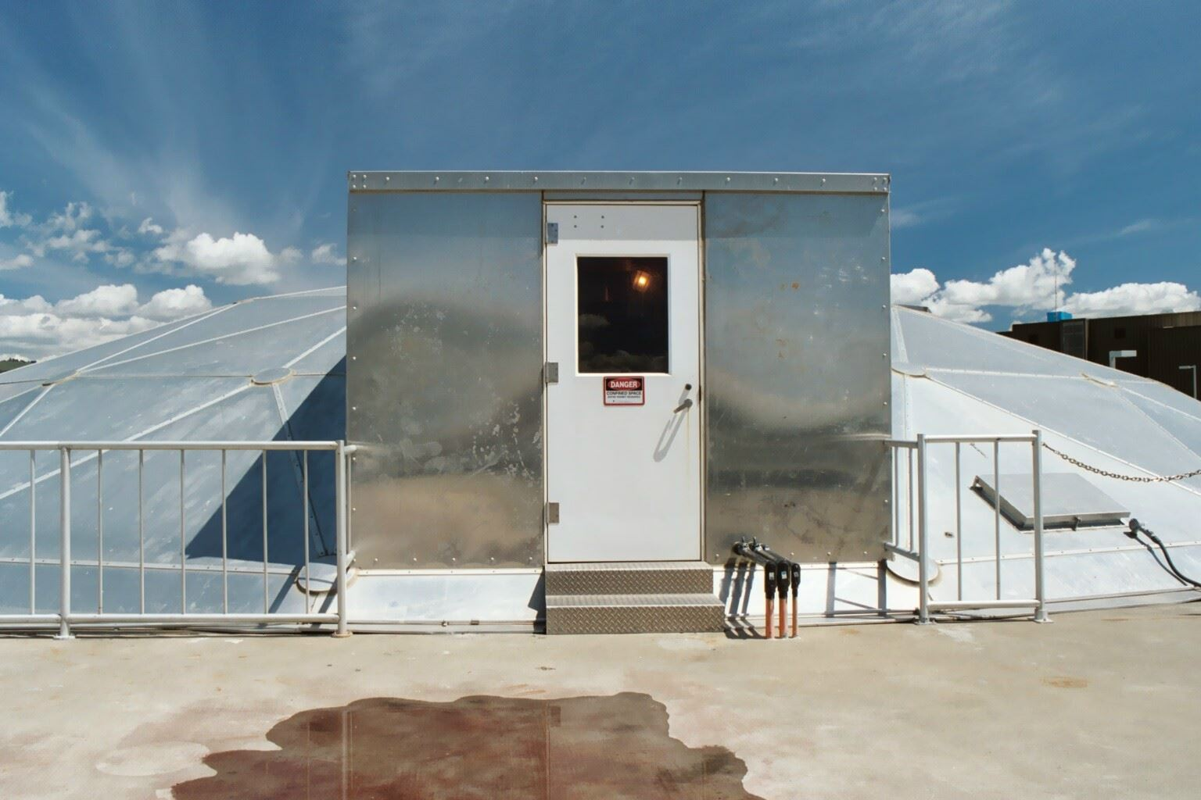

**Primary Clarifier**

1. The **secondary treatment**, also called ***biological stage***, is based on natural processes.  The wastewater now flows into large, rectangular tanks called Aeration Basins, where a biological treatment called the “activated sludge process” occurs. The wastewater flows slowing through a series of chambers as large volumes of air are bubbled up through the water. There is so much air added that it looks as if the water is boiling. In these basins, the wastewater is mixed with the “activated sludge”; hundreds of millions of actively growing single-celled microorganisms (mostly bacteria and protozoa) referred to as “bugs.”

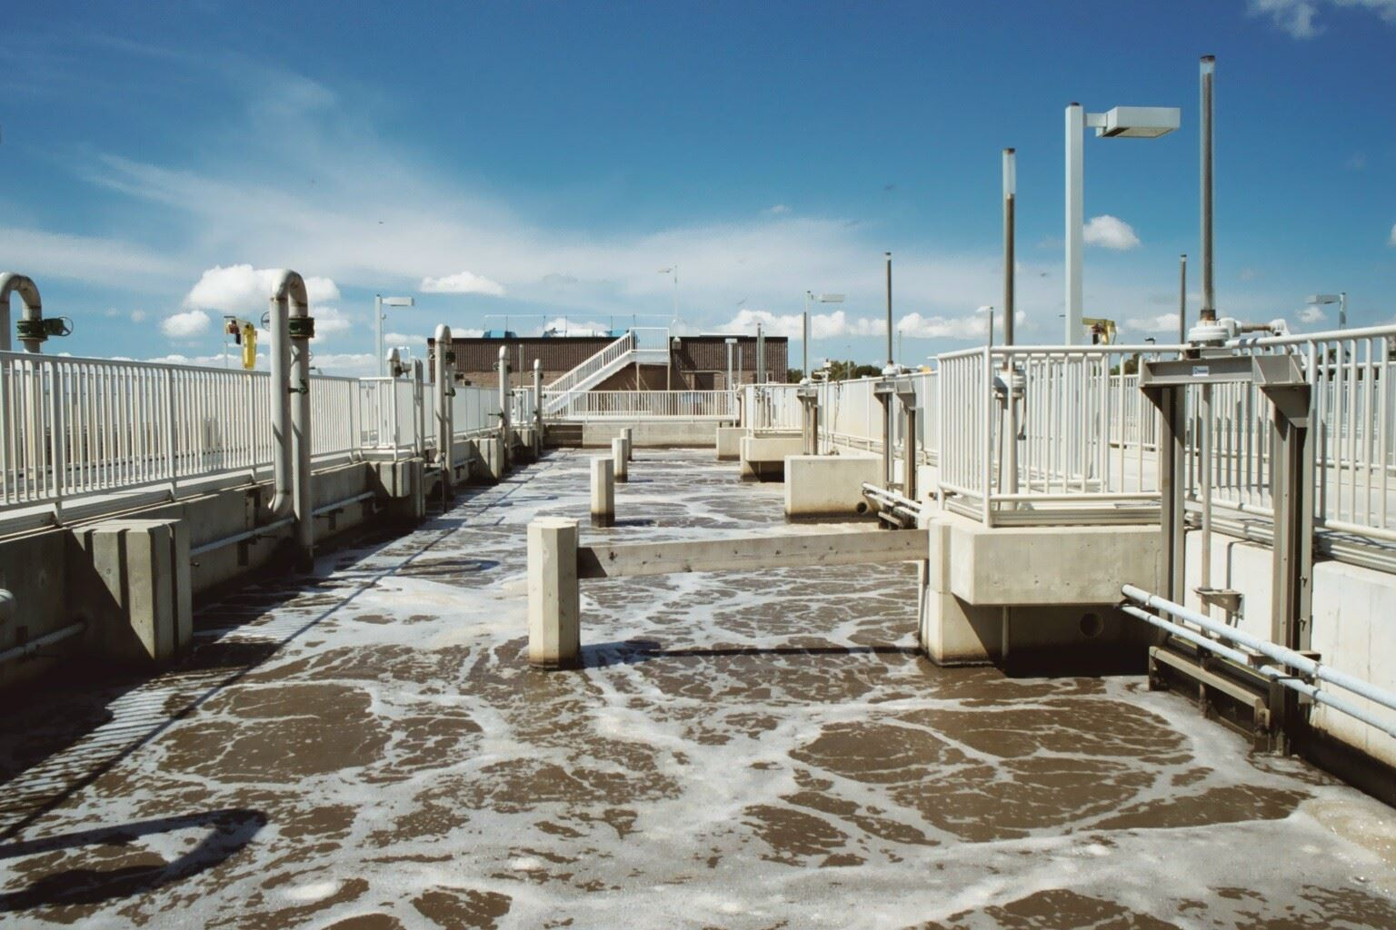

**Aeration Basin**

During the biological stage, the excess sludge (i.e. excess bacteria) is pumped out and moved before the settling tanks.

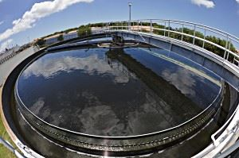

Secondary Clarifier

Here the sludge settles and is transported to digestion tanks for further treatment.

Over **90%** of the suspended solids are removed in the ***biological stage.***

1. **Advanced Treatment**: Advanced treatment generally follows ***the biological stage***and aids the removal of those wastewater constituents which cannot be removed in the *biological stage*. Treated wastewater is sometimes disinfected chemically or physically (for example, by lagoons and microfiltration) prior its discharge into the receiving environment (sea, river, lake, wetlands, ground, etc.)

The final step of wastewater treatment is the deep inspection of service water. Aim of this inspection is to analyse the contamination level and ensure that the treated water complies with the highest standards, defining its release or reuse for domestic and/or industrial purposes.

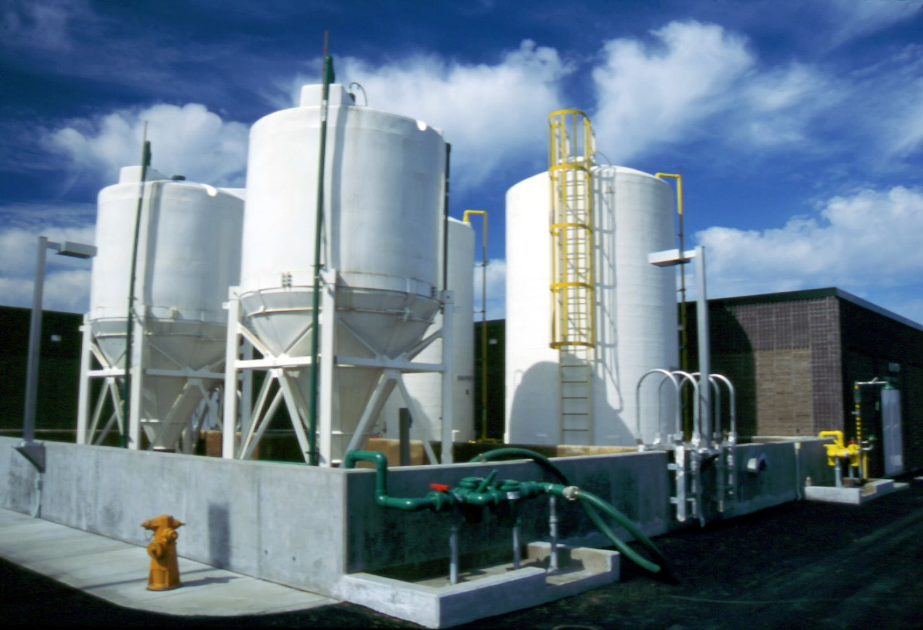

**Chemical Storage**

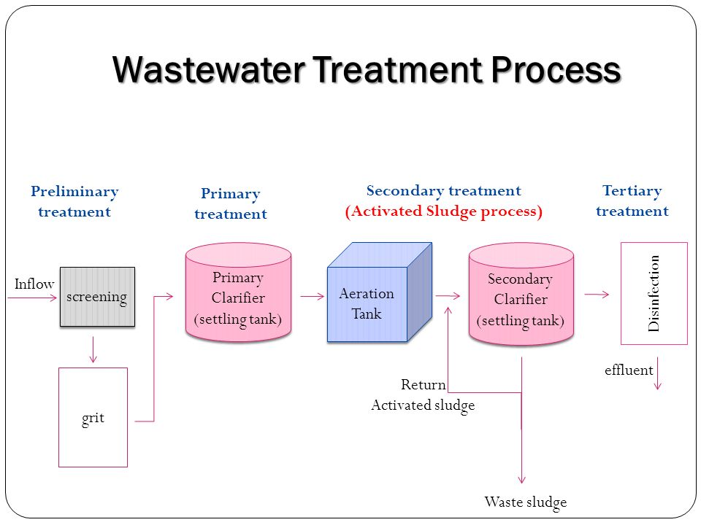

# **Software**

## EcoStruxure™ Control Expert (by Schneider Electric)

EcoStruxure Control Expert (formerly known as Unity Pro) is a unique software platform to increase design productivity and performance of your Modicon M340, M580, Momentum, Premium, Quantum and Quantum Safety applications.

Features:

* PLC simulator on PC, built-in test and diagnostics.
* Standard objects and libraries.
* Cybersecurity and traceability
* Customizable integrated Function Block Library (DFB)
* Animation tables, Operator Screens and Trending Tools.

It was used for the construction of Ladder Diagrams and simulation.

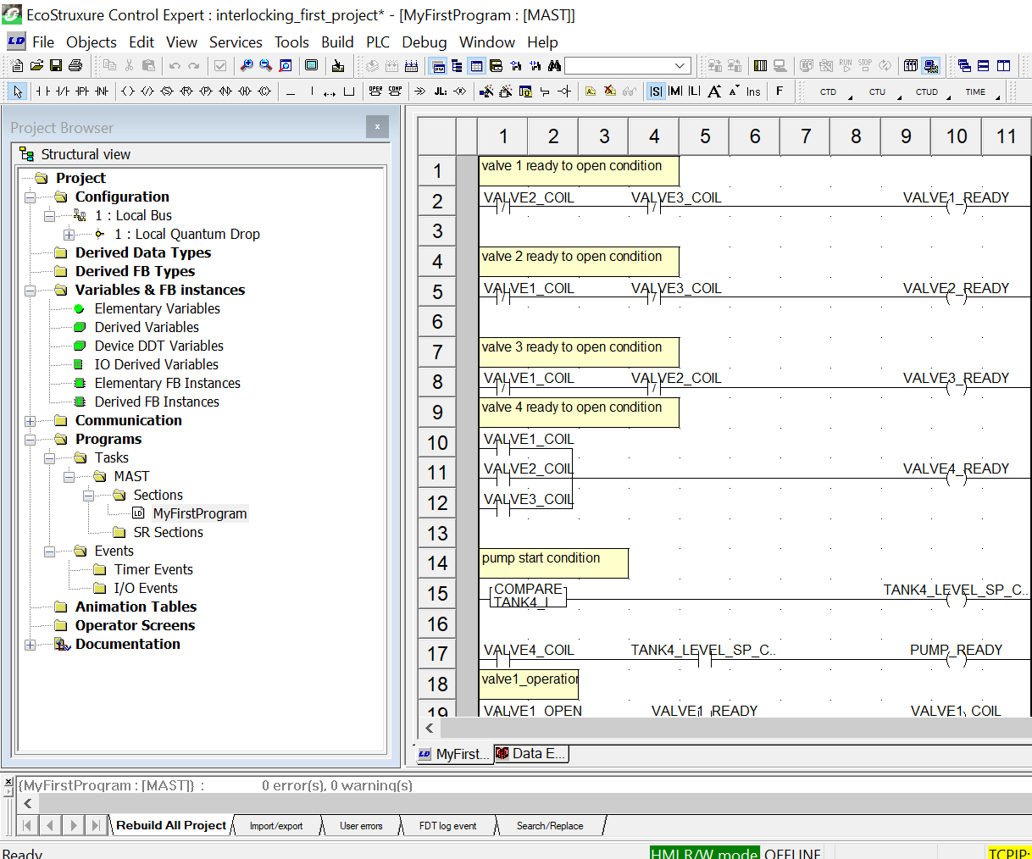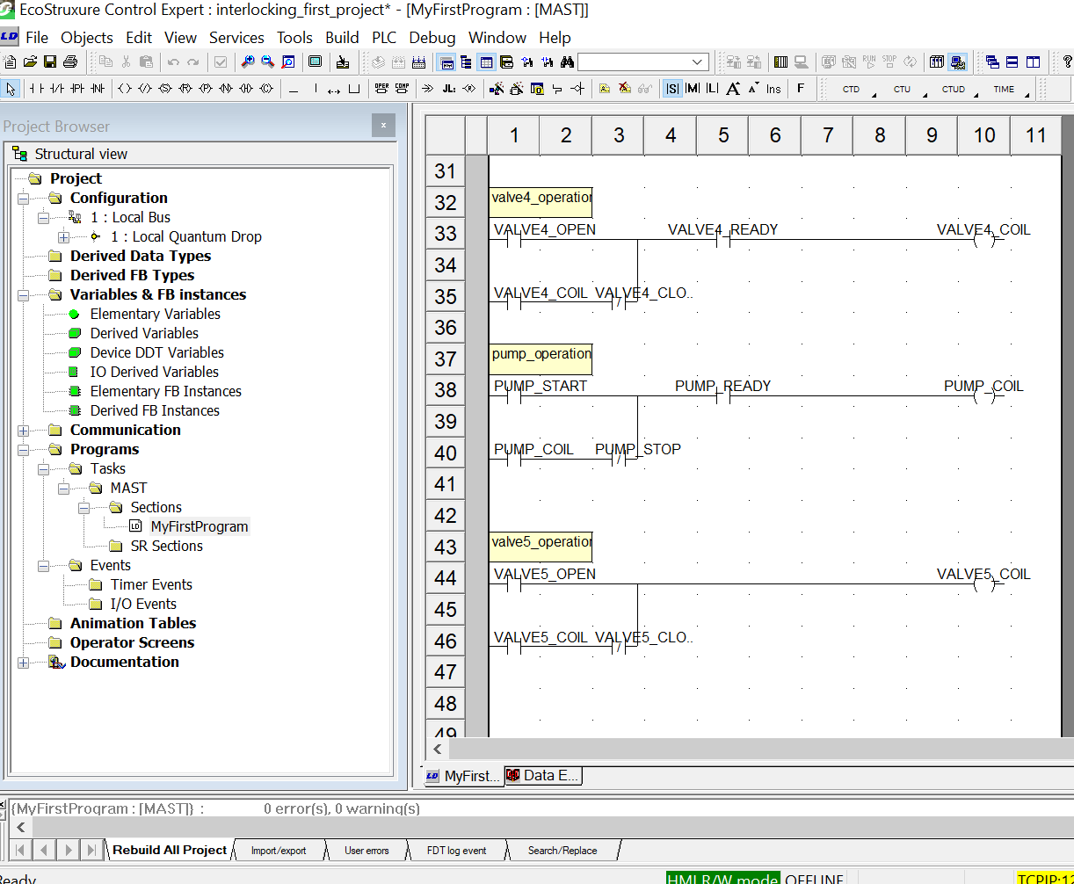

## Citect SCADA (by Schneider Electric)

Citect SCADA is a reliable, flexible and, high performance Supervisory Control and Data Acquisition (SCADA) software solution for industrial process customers.

**Features:**

The easy-to-use configuration tools and powerful features help customers to develop and deploy solutions for any size application, with robust visualization and operational capabilities driving operational efficiency, helping to mitigate risk and deliver actionable insights faster.

Functionalities/Benefits:

* Simplified Topology Management – streamlined and centralised server configuration, offering a graphical holistic view and configuration of server infrastructure with the ability to view topology by machine or by cluster.
* Easy, fast & secure deployment.
* Shortened learning curve, accelerating time to value.
* Reduced risks & unscheduled downtime.

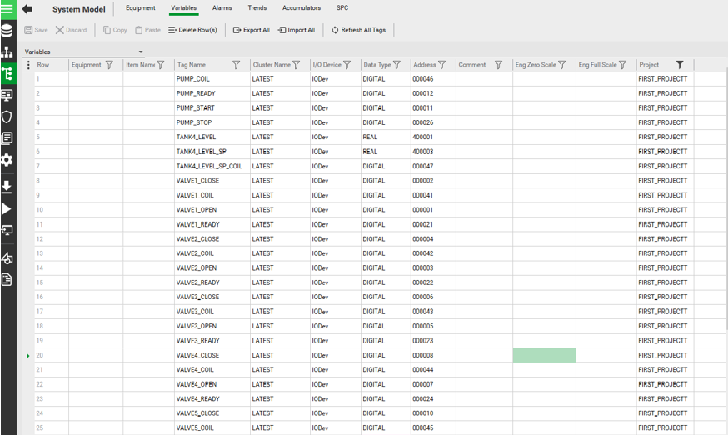

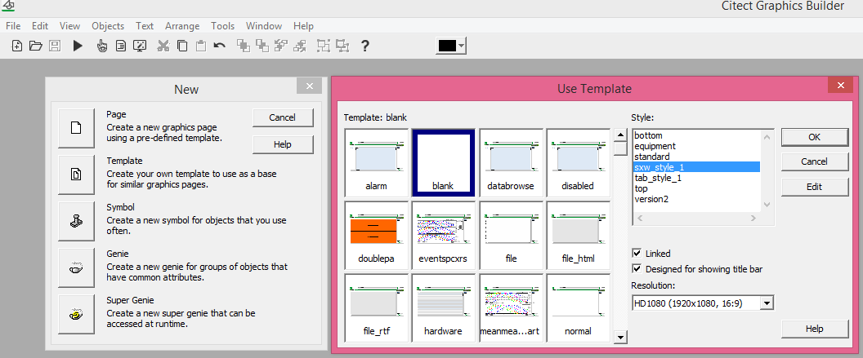

# **Project Implementation**

# **Conclusion**

The conclusion addressed that potency of the sewage treatment plant is risen by the rise in automation level. A completely automated Sewage treatment plant is safe and secure with the able technology of PLC controller.

Economic benefits of such systems are:

1. Reduction in downtime and maintenance costs

2. Depletion in operation costs

3. Greater environmental compliance and values

4. Uplift the performance of sewage treatment plant

5. Support the efficient operation and optimization of plants

As we move towards Industry 4.0, IoT enabled PLC and other such peripherals will lead towards an even more efficient Industrial Control and Automation. This will be valid for all kinds of industrial process including sewage treatment plants.

# **References**

1. <https://www.electricaltechnology.org/2015/09/what-is-industrial-automation.html#what-is-industrial-automation>
2. <https://unitronicsplc.com/what-is-industrial-automation/>
3. <https://www.automation.com/en-us/articles/2003-1/redundancy-in-automation>
4. <https://instrumentationtools.com/plc-redundancy/>
5. <https://startupandroid.com/what-is-plc-communication-protocols-and-explain-its-types/>
6. <http://www.neoakruthi.com/blog/sewage-treatment-plant-process.html>
7. WILP Videos by BITS Pilani Goa Campus
8. Study Material by RMJ Automation Solution and Training
9. Instructional Videos by Schneider Electric &
10. AUTOMATION AND TREATMENT OF SEWAGE PLANT by Miss. Rachana R. Sangitrao Assistant Professor, Dept. of Instrumentation & Control, D. Y. Patil Engineering College, Akurdi, Pune

# **GLOSSARY**

1. ***Automation***: Making tasks in a facility to run without human intervention

2. ***Control***: Manipulation of process variables as means to achieve a desired output/ outcome.

3. ***PLC***: A device used to take over automation of a process using programmable logic.

4. ***SCADA***: A software used to remotely monitor a process whose data is fed by an intermediary like a PLC gather by an HMI at the site.

5. ***HMI:*** A device used by humans to control the process parameters via an integrated GUI.

6. ***MODBUS:*** Modbus is a communication protocol developed by Modicon systems. It is a method used for transmitting information over serial lines between electronic devices.

7. ***Master:*** The device requesting the information is called the MODBUS Master.

8. ***Slave***: The devices supplying information are MODBUS Slaves.

9. ***Latching***: PLC Latching function is a self-maintaining circuit in that, after being energized, it maintains that state until another input is received.

10. ***Interlocking:*** An interlock is a feature that makes the state of two mechanisms or functions mutually dependent.